Supplementary Table 1 Subgroup analyses according to age (age < 65 years VS. age ≥ 65).
Metabolism status | Age < 65 years |  |  | Age ≥ 65 years
Metabolism status | HR (95%) | P |  | HR (95%) | P
All-cause mortality
Normoglycemia
TyG index | 1.59 (1.29, 1.97) | < 0.001 |  | 0.93 (0.74, 1.16) | 0.507
Q2 vs. Q1 | 1.25 (0.78, 2.00) | 0.347 |  | 1.06 (0.68, 1.65) | 0.805
Q3 vs. Q1 | 1.76 (1.15, 2.71) | < 0.001 |  | 1.18 (0.77, 1.81) | 0.442
Q4 vs. Q1 | 2.12 (1.40, 3.22) | < 0.001 |  | 1.00 (0.65, 1.54) | 0.994
Dysglycemia
TyG index | 1.59 (1.29, 1.97) | < 0.001 |  | 0.93 (0.74, 1.16) | 0.507
Q2 vs. Q1 | 1.25 (0.78, 2.00) | 0.347 |  | 1.06 (0.68, 1.65) | 0.805
Q3 vs. Q1 | 1.76 (1.15, 2.71) | 0.009 |  | 1.18 (0.77, 1.81) | 0.442
Q4 vs. Q1 | 2.12 (1.40, 3.22) | < 0.001 |  | 1.00 (0.65, 1.54) | 0.994
Diabetes
TyG index | 1.22 (1.04, 1.44) | 0.015 |  | 0.95 (0.82, 1.10) | 0.505
Q2 vs. Q1 | 0.79 (0.47, 1.33) | 0.371 |  | 0.65 (0.51, 0.82) | < 0.001
Q3 vs. Q1 | 1.12 (0.71, 1.78) | 0.627 |  | 0.67 (0.53, 0.85) | 0.001
Q4 vs. Q1 | 1.54 (1.01, 2.34) | 0.045 |  | 0.86 (0.67, 1.10) | 0.219
Cardiovascular mortality
Normoglycemia
TyG index | 1.93 (1.19, 3.12) | 0.008 |  | 0.88 (0.56, 1.38) | 0.580
Q2 vs. Q1 | 0.84 (0.23, 3.06) | 0.789 |  | 0.65 (0.29, 1.44) | 0.288
Q3 vs. Q1 | 1.65 (0.55, 4.96) | 0.372 |  | 1.00 (0.49, 2.05) | 0.991
Q4 vs. Q1 | 2.08 (0.74, 5.85) | 0.166 |  | 0.79 (0.38, 1.64) | 0.532
Dysglycemia
TyG index | 1.93 (1.19, 3.12) | 0.008 |  | 0.88 (0.56, 1.38) | 0.580
Q2 vs. Q1 | 0.84 (0.23, 3.06) | 0.789 |  | 0.65 (0.29, 1.44) | 0.288
Q3 vs. Q1 | 1.65 (0.55, 4.96) | 0.372 |  | 1.00 (0.49, 2.05) | 0.991
Q4 vs. Q1 | 2.08 (0.74, 5.85) | 0.166 |  | 0.79 (0.38, 1.64) | 0.532
Diabetes
TyG index | 1.24 (0.91, 1.69) | 0.174 |  | 0.99 (0.75, 1.29) | 0.918
Q2 vs. Q1 | 0.73 (0.26, 2.04) | 0.554 |  | 0.62 (0.41, 0.94) | 0.026
Q3 vs. Q1 | 1.50 (0.60, 3.71) | 0.385 |  | 0.51 (0.33, 0.78) | 0.002
Q4 vs. Q1 | 1.82 (0.77, 4.31) | 0.175 |  | 0.86 (0.57, 1.31) | 0.486
COX regression analysis was used to assess the association between TyG and mortality.
Model: adjusted for gender, age, race, education level, BMI, blood pressure status, hyperlipemic status, smoking, drinking.
TyG, triglyceride–glucose; BMI, body mass index.

Supplementary Table 2 Subgroup analyses according to gender (male VS. female).
Metabolism status | Male |  |  | Female
Metabolism status | HR (95%) | P |  | HR (95%) | P
All-cause mortality
Normoglycemia
TyG index | 1.08 (0.88, 1.32) | 0.449 |  | 1.97 (1.60, 2.42) | < 0.001
Q2 vs. Q1 | 1.32 (0.84, 2.06) | 0.225 |  | 1.55 (0.99, 2.41) | 0.053
Q3 vs. Q1 | 1.72 (1.14, 2.59) | 0.010 |  | 2.36 (1.56, 3.57) | < 0.001
Q4 vs. Q1 | 1.31 (0.86, 1.98) | 0.206 |  | 3.20 (2.12, 4.84) | < 0.001
Dysglycemia
TyG index | 0.88 (0.76, 1.02) | 0.085 |  | 1.23 (1.02, 1.48) | 0.031
Q2 vs. Q1 | 0.95 (0.71, 1.27) | 0.723 |  | 1.29 (0.93, 1.80) | 0.124
Q3 vs. Q1 | 1.17 (0.89, 1.55) | 0.259 |  | 1.31 (0.94, 1.83) | 0.112
Q4 vs. Q1 | 0.92 (0.69, 1.24) | 0.588 |  | 1.39 (1.01, 1.91) | 0.046
Diabetes
TyG index | 0.93 (0.81, 1.06) | 0.260 |  | 1.03 (0.88, 1.21) | 0.688
Q2 vs. Q1 | 0.75 (0.54, 1.02) | 0.068 |  | 0.69 (0.50, 0.97) | 0.030
Q3 vs. Q1 | 0.75 (0.55, 1.03) | 0.072 |  | 0.85 (0.62, 1.16) | 0.297
Q4 vs. Q1 | 0.85 (0.63, 1.13) | 0.261 |  | 0.94 (0.69, 1.30) | 0.722
Cardiovascular mortality
Normoglycemia
TyG index | 1.03 (0.66, 1.61) | 0.899 |  | 2.35 (1.65, 3.33) | < 0.001
Q2 vs. Q1 | 1.00 (0.38, 2.64) | 0.996 |  | 0.86 (0.31, 2.41) | 0.772
Q3 vs. Q1 | 1.69 (0.73, 3.88) | 0.218 |  | 2.07 (0.82, 5.20) | 0.122
Q4 vs. Q1 | 0.94 (0.40, 2.21) | 0.881 |  | 3.54 (1.45, 8.62) | 0.005
Dysglycemia
TyG index | 0.98 (0.75, 1.27) | 0.860 |  | 1.11 (0.78, 1.58) | 0.580
Q2 vs. Q1 | 1.08 (0.61, 1.92) | 0.783 |  | 1.89 (0.98, 3.63) | 0.057
Q3 vs. Q1 | 1.41 (0.82, 2.43) | 0.216 |  | 1.02 (0.49, 2.09) | 0.962
Q4 vs. Q1 | 1.09 (0.60, 1.96) | 0.786 |  | 1.42 (0.74, 2.73) | 0.294
Diabetes
TyG index | 1.02 (0.79, 1.31) | 0.902 |  | 0.91 (0.70, 1.18) | 0.487
Q2 vs. Q1 | 0.85 (0.49, 1.47) | 0.560 |  | 0.52 (0.30, 0.92) | 0.025
Q3 vs. Q1 | 0.71 (0.40, 1.24) | 0.231 |  | 0.70 (0.40, 1.20) | 0.192
Q4 vs. Q1 | 0.99 (0.57, 1.70) | 0.967 |  | 0.78 (0.46, 1.31) | 0.345
COX regression analysis was used to assess the association between TyG and mortality.
Model: adjusted for gender, age, race, education level, BMI, blood pressure status, hyperlipemic status, smoking, drinking.
TyG, triglyceride–glucose; BMI, body mass index.

Supplementary Table 3 Subgroup analyses according to blood pressure status (hypertension and normal blood pressure).
Metabolism status | Hypertension (+) |  |  | Hypertension (-)
Metabolism status | HR (95%) | P |  | HR (95%) | P
All-cause mortality
Normoglycemia
TyG index | 0.94 (0.77, 1.16) | 0.583 |  | 1.52 (1.24, 1.85) | < 0.001
Q2 vs. Q1 | 1.59 (1.01, 2.50) | 0.046 |  | 1.08 (0.69, 1.71) | 0.728
Q3 vs. Q1 | 1.59 (1.03, 2.44) | 0.035 |  | 1.81 (1.19, 2.74) | 0.005
Q4 vs. Q1 | 1.22 (0.79, 1.86) | 0.367 |  | 1.99 (1.31, 3.02) | 0.001
Dysglycemia
TyG index | 0.74 (0.64, 0.87) | < 0.001 |  | 1.15 (0.96, 1.39) | 0.137
Q2 vs. Q1 | 0.94 (0.71, 1.24) | 0.658 |  | 1.10 (0.76, 1.59) | 0.615
Q3 vs. Q1 | 0.87 (0.67, 1.14) | 0.325 |  | 1.43 (0.99, 2.06) | 0.058
Q4 vs. Q1 | 0.75 (0.57, 0.98) | 0.036 |  | 1.31 (0.90, 1.90) | 0.162
Diabetes
TyG index | 0.99 (0.88, 1.12) | 0.875 |  | 0.90 (0.74, 1.10) | 0.291
Q2 vs. Q1 | 0.69 (0.53, 0.89) | 0.004 |  | 0.83 (0.52, 1.35) | 0.461
Q3 vs. Q1 | 0.75 (0.59, 0.95) | 0.019 |  | 0.87 (0.53, 1.42) | 0.578
Q4 vs. Q1 | 0.90 (0.71, 1.14) | 0.372 |  | 0.80 (0.50, 1.28) | 0.353
Cardiovascular mortality
Normoglycemia
TyG index | 1.12 (0.73, 1.72) | 0.596 |  | 1.39 (0.91, 2.12) | 0.129
Q2 vs. Q1 | 1.11 (0.40, 3.07) | 0.844 |  | 0.64 (0.22, 1.91) | 0.424
Q3 vs. Q1 | 1.39 (0.54, 3.57) | 0.493 |  | 1.76 (0.76, 4.06) | 0.186
Q4 vs. Q1 | 1.22 (0.48, 3.08) | 0.674 |  | 1.42 (0.60, 3.38) | 0.427
Dysglycemia
TyG index | 0.79 (0.60, 1.04) | 0.090 |  | 1.11 (0.72, 1.70) | 0.642
Q2 vs. Q1 | 1.35 (0.81, 2.26) | 0.252 |  | 1.00 (0.46, 2.17) | 0.996
Q3 vs. Q1 | 0.87 (0.52, 1.46) | 0.606 |  | 1.53 (0.68, 3.43) | 0.308
Q4 vs. Q1 | 0.94 (0.56, 1.59) | 0.818 |  | 0.95 (0.41, 2.21) | 0.910
Diabetes
TyG index | 1.01 (0.81, 1.26) | 0.917 |  | 0.88 (0.57, 1.36) | 0.569
Q2 vs. Q1 | 0.65 (0.42,1.00) | 0.050 |  | 0.81 (0.34, 1.91) | 0.629
Q3 vs. Q1 | 0.77 (0.50,1.17) | 0.221 |  | 0.36 (0.13, 1.04) | 0.060
Q4 vs. Q1 | 0.93 (0.61, 1.42) | 0.729 |  | 0.76 (0.33, 1.72) | 0.504
COX regression analysis was used to assess the association between TyG and mortality.
Model: adjusted for gender, age, race, education level, BMI, blood pressure status, hyperlipemic status, smoking, drinking.
TyG, triglyceride–glucose; BMI, body mass index.

Supplementary Figure 1 ROC curve for evaluating the diagnostic power of TyG and AIP (time cutoff value of 60 months).
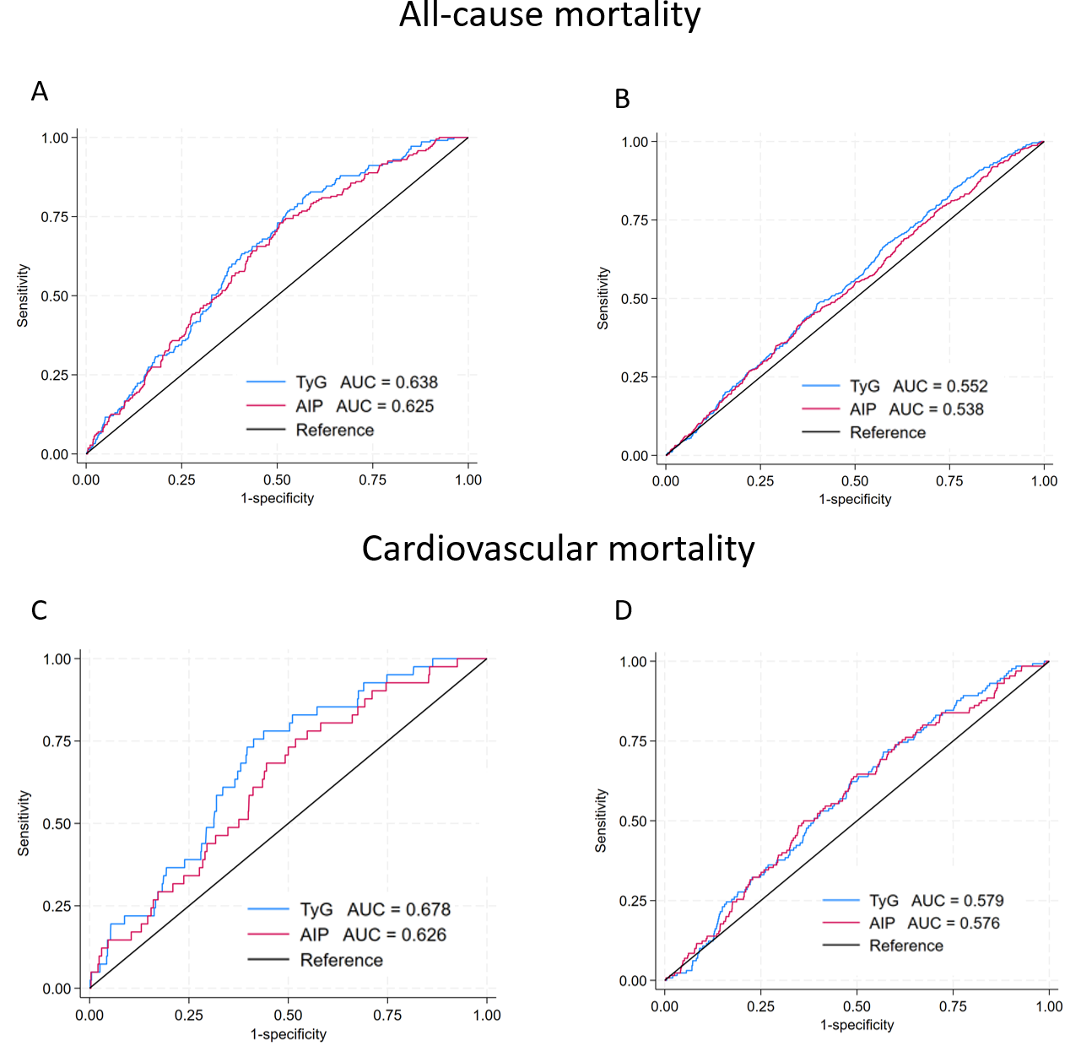
(A)all-cause mortality, normoglycemia; (B)all-cause mortality, diabetes; (C)cardiovascular mortality, normoglycemia; (D)cardiovascular mortality, diabetes.
Time-dependent ROC curve was used to construct the model, with a time cutoff value of 60 months.
ROC Receiver operating characteristic; TyG triglyceride glucose index.

Supplementary Figure 2 ROC curve for evaluating the diagnostic power of TyG and AIP (time cutoff value of 120 months).
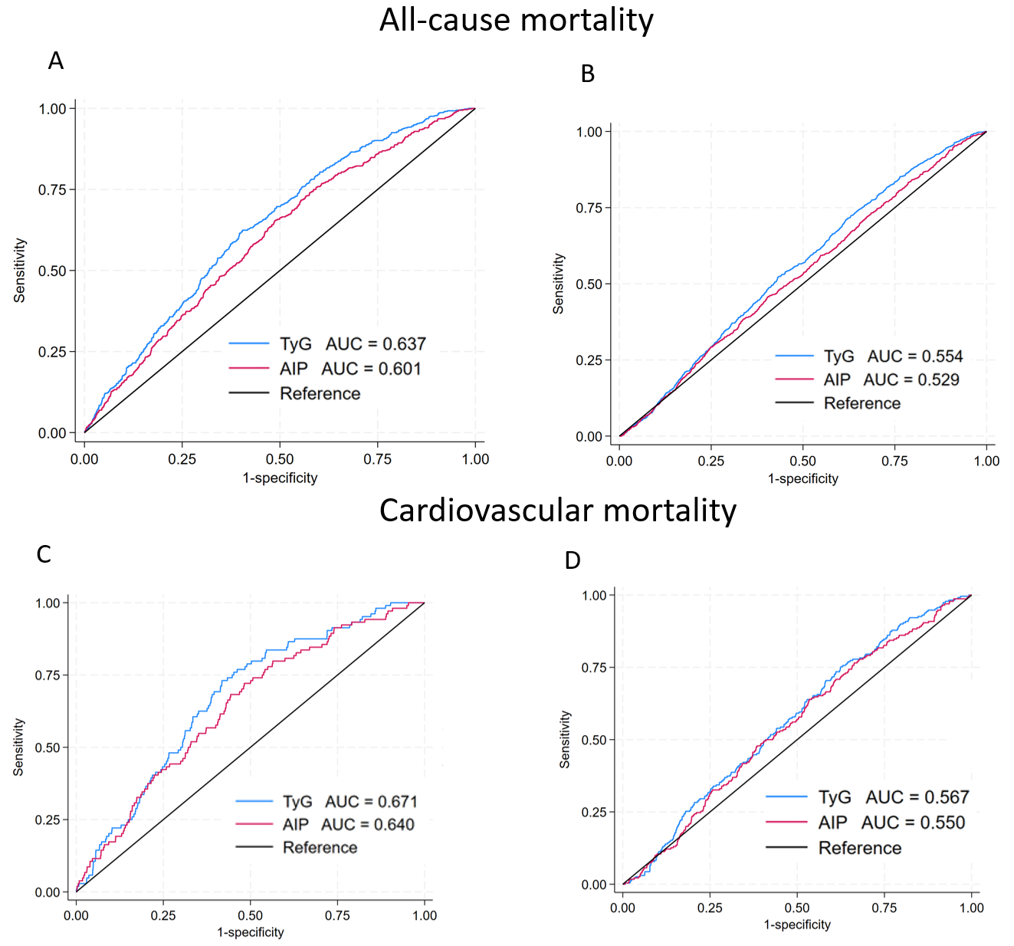
(A)all-cause mortality, normoglycemia; (B)all-cause mortality, diabetes; (C)cardiovascular mortality, normoglycemia; (D)cardiovascular mortality, diabetes.
Time-dependent ROC curve was used to construct the model, with a time cutoff value of 60 months.
ROC Receiver operating characteristic; TyG triglyceride glucose index.

