Graphical abstract
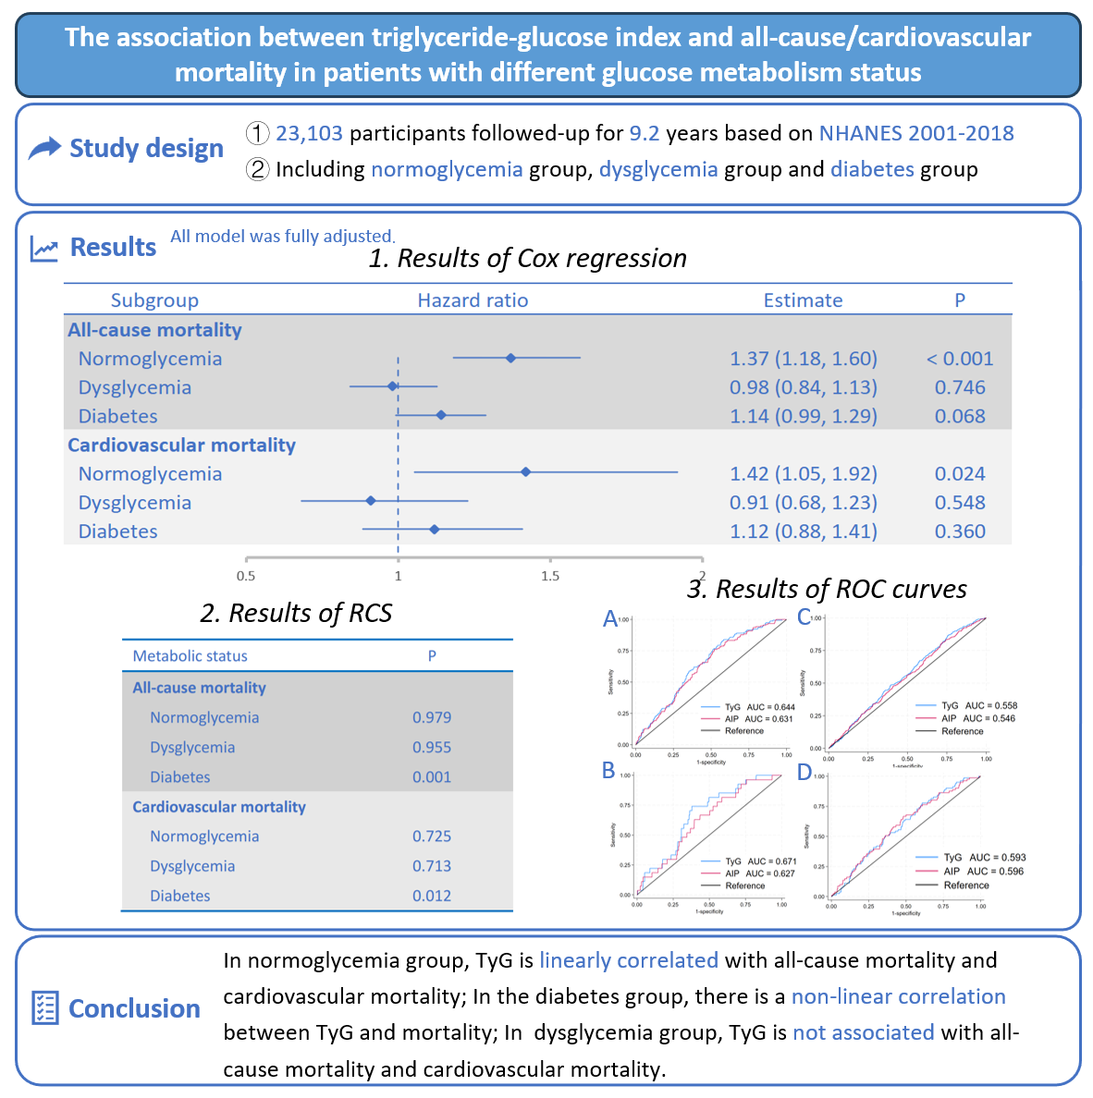
A total of 23,103 participants with normoglycemia (n=10,078), dysglycemia (n=8,748), and diabetes (n=4,277) were included. The median follow-up time was 9.2 years. Weighted COX regression results (upper), restricted cubic spline results (lower left), and time-dependent (cut-off value of 36 months) receiver operating characteristic curve results (lower right).
TyG triglyceride glucose index; AIP atherogenic index of plasma; RCS restricted cubic spline; ROC receiver operating characteristic.
*The results of the Cox regression used TyG as a continuous variable.

