Supplementary Materials

Table 1(S1). The primer sequence of the target gene used for the PCR analysis
Gene | Forward primer, 5'-3' | Reverse primer, 5'-3'
ß-actin | 5’-TAAAGACCTCTATGCCAACACAGT-3’ | 5’- CACGATGGAGGGGCCGGACTCATC-3’
BDNF | 5’- TCATACTTCGGTTGCATGAAGG -3’ | 5’-AGACCTCTCGAACCTGCCC -3’
NGF | 5’- CCAAGGACGCAGCTTTCTAT -3’ | 5-’CTCCGGTGAGTCCTGTTGAA-3’
SYP | 5’-AGACATGGACGTGGTGAATCA-3’ | 5’- ACTCTCCGTCTTGTTGGCAC-3’

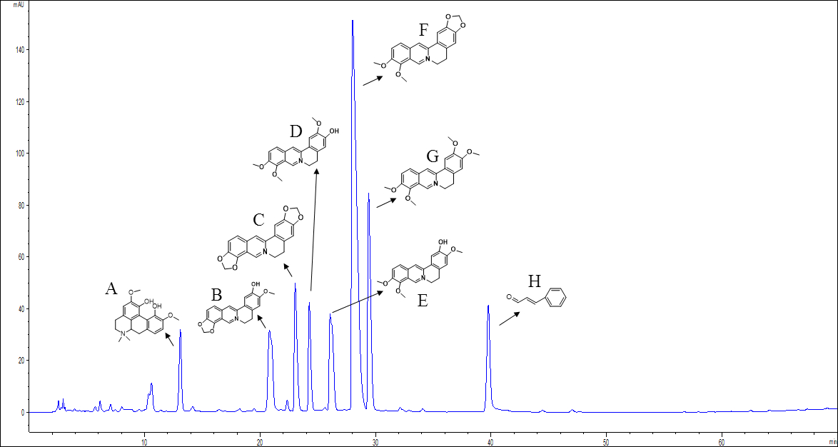
（a）
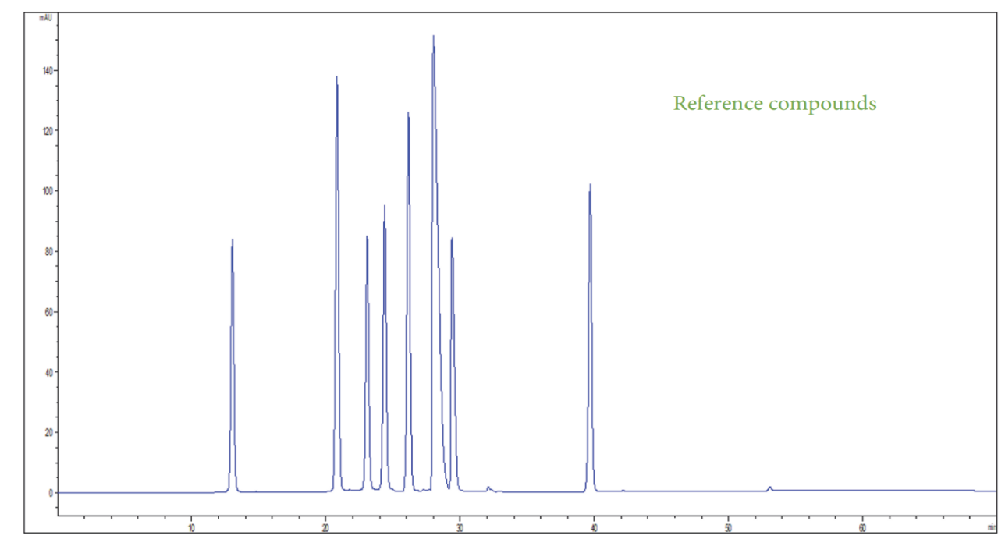
（b）
Figure 1(S2). HPLC of JTW. HPLC profiles were applied to analyzed chemical standardization of JTW and reference compounds. (a) JTW samples; (b) reference compounds[9].（Have published）

