Additional File 1
Supplemental Figure 1: Diagram of Yoga Class Setup
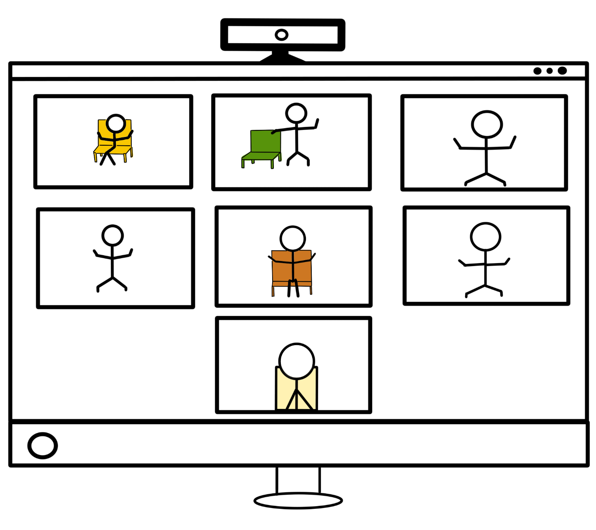
2nd Yoga Instructor, usually hidden from view
Veteran from Fremont, CA
Veteran from Santa Clara, CA
Veteran from Stockton, CA
Yoga Instructor in Palo Alto, CA
Veteran from San Jose, CA
Veteran from Salinas, CA

Supplemental Table 1: Phase 2 Screening and Baseline Scores
 | In-person |  |  | Teleyoga |  |  | Group Difference
 | N | Mean | SD | N | Mean | SD | Effect Size (Cohen's d) | p-val (2-tailed)
SCREENING
SC_DVPRS_Q1_activity | 16 | 6.063 | 1.569 | 18 | 5.889 | 1.530 | -0.112 | 0.747
SC_DVPRS_Q2_sleep | 16 | 5.875 | 1.746 | 18 | 5.667 | 2.765 | -0.089 | 0.792
SC_DVPRS_Q3_mood | 16 | 5.813 | 2.588 | 18 | 5.667 | 2.376 | -0.059 | 0.866
SC_DVPRS_Q4_stress | 16 | 6.125 | 2.277 | 18 | 6.167 | 2.792 | 0.016 | 0.962
SC_PEG_Q1 | 16 | 6.000 | 2.280 | 18 | 5.889 | 2.139 | -0.050 | 0.885
SC_PEG_Q2 | 16 | 5.813 | 2.689 | 18 | 6.056 | 2.413 | 0.095 | 0.784
SC_PEG_Q3 | 16 | 6.000 | 2.394 | 18 | 5.889 | 1.997 | -0.051 | 0.885
SC_PEG_average | 16 | 5.938 | 2.329 | 18 | 5.944 | 2.020 | 0.003 | 0.993
BASELINE
BL_PEG_average | 16 | 5.688 | 1.926 | 18 | 6.241 | 1.763 | 0.300 | 0.391
BL_BPI_severity | 16 | 4.953 | 1.980 | 18 | 5.458 | 1.563 | 0.285 | 0.420
BL_BPI_interference | 16 | 4.854 | 2.309 | 18 | 5.142 | 2.141 | 0.130 | 0.710
BL_BDI2_total | 16 | 6.000 | 6.501 | 18 | 5.333 | 5.269 | -0.113 | 0.747
BL_PROMIS6b_total | 16 | 16.313 | 6.819 | 18 | 16.056 | 6.235 | -0.039 | 0.910
Supplemental Table 1 shows the screening and baseline characteristics of Teleyoga and In-Person groups using means and standard deviations for the continuous, and frequencies and percentages for categorical variables. Although unnecessary given our RCT design, group differences were examined using two-sample t-test for continuous and chi-square test for categorical variables. The two groups did not show significant differences in any of these baseline variables.
Supplemental Table 2: Attrition rates
Protocol Type | Attrition
 | In-Person  PP n=11  ITT n=16 | Teleyoga PP n=16  ITT n=18 | Combined  PP n=27  ITT n=34
PP | 3 (27%) | 3 (19%) | 6 (22%)
ITT | 8 (50%) | 3 (17%) | 11 (32%)
PP – Per Protocol – Participants who received the intervention and completed EOT assessments
ITT – Intention to Treat – Participants who were randomized to the study regardless of whether they received any intervention or completed EOT assessments
Supplemental Table 3: Teacher Fidelity to the Yoga Protocol
Yoga Protocol Fidelity
IP Fidelity | 91%
TY Fidelity | 90%
Overall Fidelity | 91%

Supplemental Table 4: Missing Data (PEG and Promis-6b)
 | Teleyoga (n=18) |  | In-person (n=16)
 | Baseline n items (%) | Post-Treatment n (%) | Baseline n (%) | Post-Treatment n (%)
Missing Data | 6 (4.2) | 7 (4.9) | 7 (8) | 14 (15.9)
Baseline (BL) and EOT missing data for the PEG and Promis-6b combined.

Supplemental Table 5: Symptom improvement based on average scores (Per Protocol)
 |  | Teleyoga  (n=13) | In Person  (n=8) | Difference  Teleyoga vs In-Person
PEG average (SD) | Baseline  EOT  Change | 6.28 (1.87)  4.79 (1.53)  -1.49 | 5.50 (1.62)  4.54 (2.27)  -.96 | .53
BPI severity (SD) | Baseline  EOT  Change | 5.62 (1.58)  4.15 (1.51)  -1.47 | 4.28 (1.90)  4.28 (2.0)  -.16 | 1.31
BPI interference (SD) | Baseline  EOT  Change | 5.23 (2.19)  4.15 (2.21)  -1.08 | 3.93 (2.0)  4.29 (2.53)  +.36 | 1.44
PROMIS6b total (SD) | Baseline  EOT  Change | 14.23 (5.49)  13.42 (5.77)  -.81 | 14.25 (7.50)  16.67 (5.62)  +2.42 | 3.23
BDI total (SD) | Baseline  EOT  Change | 5 (4.17)  5 (4.67)  0 | 4.63 (5.1)  3.71 (3.57)  -.92 | -.92

Experimental Measures
Supplemental Table 6: Homework (HW) Practice and HW Log
 | In-Person (n=8) | Teleyoga (n=13)
Completed any weekly HW log: | 6 (75%) | 9 (69%)
Did ≥1 HW practice over 12 weeks | 5 (63%) | 9 (69%)
Range (in days/week) of practice | 0-6 | 0-6
Range (in minutes) of practice | 0-2200 | 0-1694
Average weeks with ≥ 1 practice | 1.6 | 5.31 (44%) p=4.5
Average weekly minutes practiced | 49 | 39 p=45
Total days practiced | 159 | 252
Total minutes practiced | 6595 | 6483
Used homework packet | 7 | 9
Reported use of youtube videos | 2 | 2
Breathing practice | 7 | 9
Other homework practice | 1 | 2
Unknown type of homework | 2 | 3

Supplemental Figure 2: Usage Data for Homework Videos from Youtube
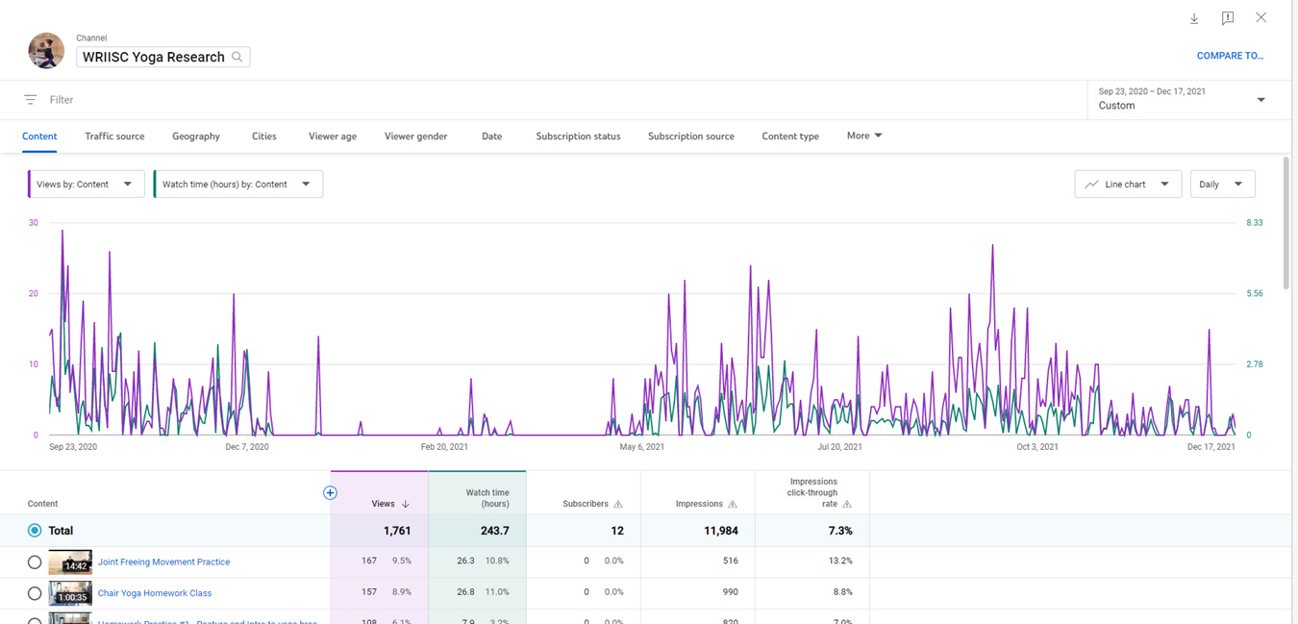

Supplemental Table 7: Medication Usage at Baseline
Reported Medication Usage at Baseline
Medication Type | Total (n=34) |  | In-Person n=16 |  | Teleyoga n=18
 | n | % | n | % | n | %
Anti-hypertensive | 10 | 29% | 2 | 13% | 8 | 44%
OTC Pain relief/NSAID | 9 | 26% | 4 | 25% | 5 | 28%
Statin | 8 | 24% | 0 | 0% | 8 | 44%
Anti-depressant | 5 | 15% | 2 | 13% | 3 | 17%
Gabapentin | 4 | 12% | 0 | 0% | 4 | 22%
Prostate Meds | 4 | 12% | 0 | 0% | 4 | 22%
No Medication Listed | 4 | 12% | 2 | 13% | 2 | 11%
Beta blocker | 2 | 6% | 0 | 0% | 2 | 11%
Thyroid Meds | 2 | 6% | 0 | 0% | 2 | 11%
Anti-Gout | 2 | 6% | 0 | 0% | 2 | 11%
Opioid | 1 | 3% | 1 | 6% | 0 | 0%
Skeletal muscle relaxant | 1 | 3% | 1 | 6% | 0 | 0%

Supplemental Table 8: Non-Yoga Therapies at Baseline
Reported Therapy Usage at Baseline
Therapy Type | Total (n=34) |  | In-Person (n=16) |  | Teleyoga (n=18)
 | n | % | n | % | n | %
Physical Therapy | 4 | 12% | 3 | 19% | 1 | 6%
Chiropractic | 4 | 12% | 3 | 19% | 1 | 6%
Acupuncture | 4 | 12% | 3 | 19% | 1 | 6%
Psychotherapy | 1 | 3% | 0 | 0% | 1 | 6%
Art Therapy | 1 | 3% | 1 | 6% | 0 | 0%
TNS Unit | 2 | 6% | 1 | 6% | 1 | 6%
H-Wave | 1 | 3% | 1 | 6% | 0 | 0%
Compression | 1 | 3% | 1 | 6% | 0 | 0%
Psychotherapy | 3 | 9% | 1 | 6% | 3 | 17%
Water/Pool therapy | 1 | 3% | 0 | 0% | 1 | 6%
Exercise (includes sports) | 6 | 18% | 4 | 25% | 2 | 11%
No Therapy Listed | 13 | 38% | 5 | 31% | 8 | 44%
Ice | 1 | 3% | 1 | 6% | 0 | 0%
Biofeedback | 1 | 3% | 1 | 6% | 0 | 0%
Podiatry | 1 | 3% | 1 | 6% | 0 | 0%
Whole Health Coaching | 1 | 3% | 1 | 6% | 0 | 0%
No Form Submitted | 3 | 9% | 2 | 13% | 1 | 6%

Supplemental Table 9: Yoga Protocol Summary
Target | Yoga Tool | Weekly Class Themes
Breath and sensation awareness | Natural breath, body scan, thoracic diaphragm breathing | - Breath  - Self-Compassion and self-love  - Starting where you are  - Start small and move slowly - with comfort.  - Linking movement with breath  - Focus on the positive – what is going right for us in this moment.  - Notice how pain has become familiar - like a protective shell - but you don't need it, let it go.  - Focus on slow breath - in and out - throughout the yoga practice.  - Have fun, laugh at yourself and your teacher - love who you are right now.  - Breath and movement as one  - Yoga is the ability to direct attention to a chosen object without wavering - Yoga Sutra 1.2 - reemphasize living with compassion towards yourself and others.  - Review how to bring what we’ve learned in class into daily living and options for yoga in the community
Balancing, calming, activating breath practices | Even (Sama Vritti), cooling (Sheetkari), alternate nostril (Nadi Shodhana), ocean (Ujayii), lion’s (Simha), humming (Brahmari), skull shining (Kapalabhati), Breath of Joy, Soft Belly breath
Posture and alignment | Seated or standing mountain (Tadasana)
Musculoskeletal strength, balance and flexibility, Posture, alignment, moving with the pace of the breath | Warrior (Virabhadrasana) I & II, 5 pointed start (Utthita Tadasana), chair (Utkatasana), horse (Vatayanasana), upward salute (Urdhva Hastasana) with lateral bend, wide leg forward fold (Prasarita Padottanasana), pyramid (Parvostanasana), tree (Vrikshasana), Heel rise in mountain balance, modified reclining bound angle (Supta Padangusthasana), figure 4 stretch (Ardha Matsyendrasana), side plank (Vasisthasana), modified locust (Salabhasana), child’s pose (Balasana), Bent Knee/Tabletop internal oblique strengthen, modified, bridge (Setu Bandha Sarvangasana)
Calming | Crocodile (Makarasana), bent knee spinal twist (Jathara Parivartanasana), legs up the wall (on a chair) (Viparita Karani), corpse (Savasana)
Hand Gestures | Prayer (Anjali), sun (Surya), deer (Mrigi) Mudras

