Supplementary Information

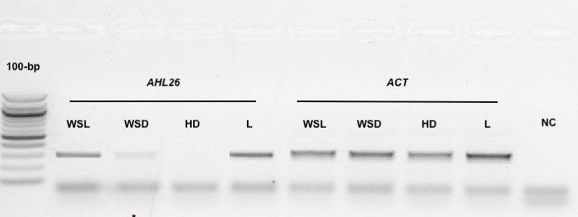

Figure S1. Semi-quantitative PCR showing AHL26 expression pattern in 8-day-old whole seedlings grown at 20 μmol m⁻² s⁻¹ continuous light (WSL), dark-grown 8-day-old whole seedlings (WSD), hypocotyls plus roots from 8-day-old dark-grown seedlings (HD), adult flowering plant rosette leaf (L). An actin (ACT) housekeeping gene was used as an internal control. A reaction without a reverse transcriptase treatment serves as a negative control (NC).

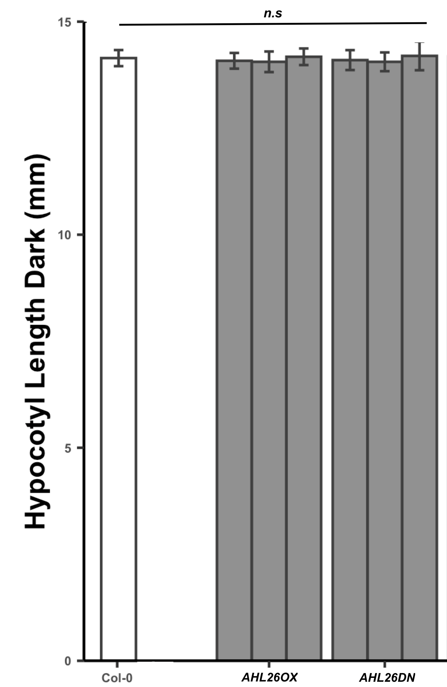
Figure S2. Quantitative analysis of hypocotyl lengths of 8 days old seedlings under dark conditions. Seeds were treated with red light for 4 hours after the four days of cold treatment. n ≥ 20. The error bar donates the SEM.

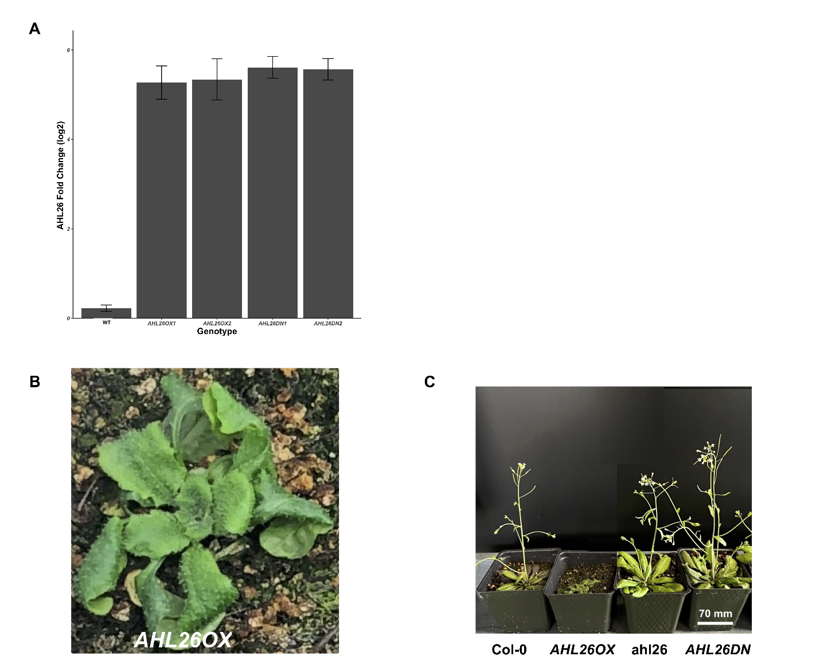

Figure S3. The effect of AHL26 overexpression on the plant phenotype. (A) mRNA expression level of AHL26 in overexpression, and dominant-negative mutants determined by quantitative real-time PCR. Error bars for (A) represent the standard deviation (n = 3). (B) The overexpression of AHL26 results in deformed leaves. (C) The phenotypic comparison of overexpression, and dominant-negative mutants at the flowering stage.

Name | Sequence (5’-3’) | Description
AHL 26-DN-F | AGGCCAAGAGGACACCCAGCAGGATCC | Dominant-negative mutants
AHL 26-DN-R | GGATCCTGCTGGGTGTCCTCTTGGCCT | Dominant-negative mutants
AHL26-RT-F2 | GGGTCCTGTGGTGGTTATGGCG | Gene expression analysis
AHL26-RT-R2 | CTGCTGATCATTCTGTTG | Gene expression analysis
AHL26-GUS-1F | CTAGTAGAATTCGTGAATTAATGTAACTCAATAGAGG | GUS fusion
AHL26-GUS-1R | GTACGTCCATGGGATACGGTGGCCGACCCG | GUS fusion

Table S1. The sequence of primers used. The pair of primers used to generate constructs for the generation of transgenic material used in the study as well as for gene expression analysis.

Category | Description | GeneRatio | pvalue | geneName | Count
MF | sequence-specific double-stranded DNA binding | 6/171 | 0.01751318 | -/AHL19/AHL2/-/FLC/HSFA6B | 6
MF | AT DNA binding | 2/171 | 0.0232996 | AHL19/AHL2 | 2

Table S2. Downregulated molecular function GO terms in AHL26DN transgenic lines.

