Supplementary Materials for
Yield improvements reduced global crop water footprint (1972–2018), but further action needed for water sustainability
Betelhem W Demeke^{1*}, Mesfin M Mekonnen^{1*}, Kate A. Brauman², Nicholas Magliocca³
¹ Department of Civil, Construction and Environmental Engineering, The University of Alabama, Tuscaloosa, AL, USA
² Global Water Security Center, Alabama Water Institute, University of Alabama, Tuscaloosa, AL, USA
³ Department of Geography, University of Alabama, Tuscaloosa, AL, USA
*E-mail : bwdemeke@crimson.ua.edu; mesfin.mekonnen@ua.edu

Supplementary Results
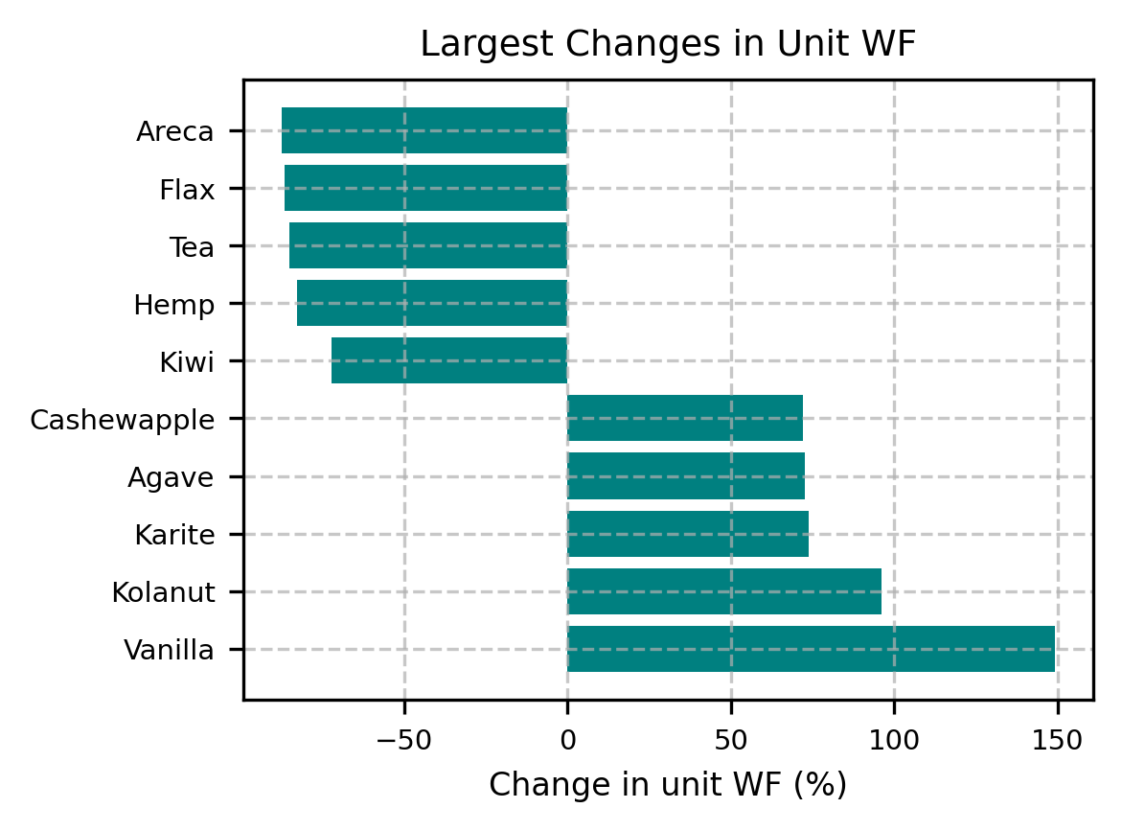
Figure S1: Largest changes (reductions and increases) in unit WF in the last five years of the study period (2014-2018) compared to the first five years of the study period (1972-1976).
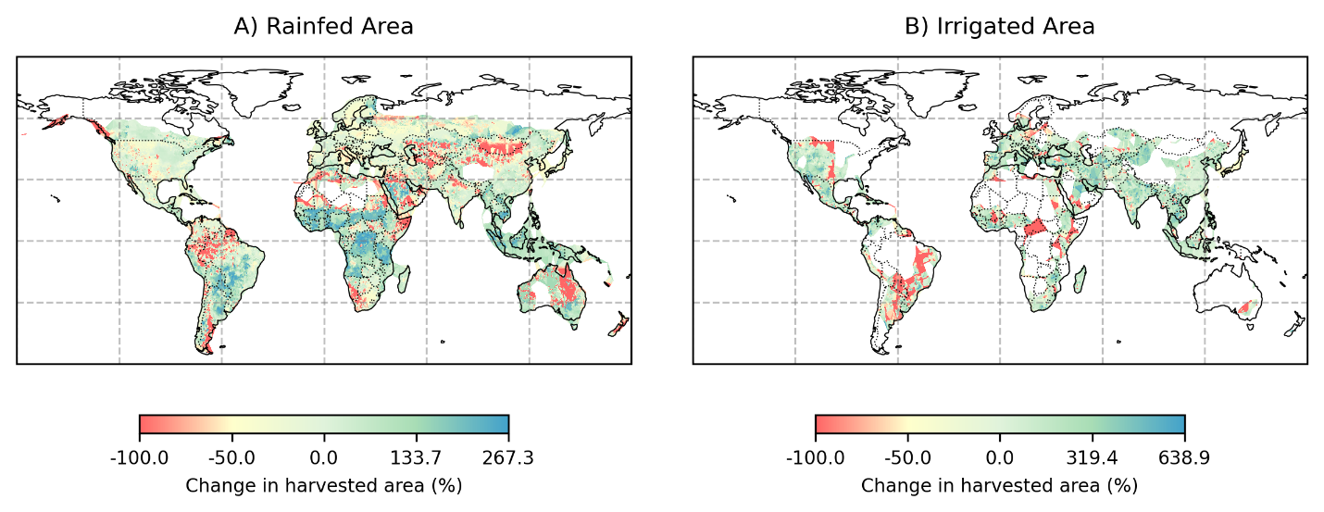
Figure S2: Percent change in harvested area from 1972-1976 to 2014-2018. Irrigated area expansion is observed in the western parts of the United States, India, and parts of China. In the United States and China, maize is the largest contributor to irrigated area expansion. In the United States, this is followed by other crops, such as soybean, and alfalfa, which also substantially contribute to the growth of irrigated areas. Wheat, rice, and soybean are the top contributors to irrigated area expansion in India. Large, irrigated area reductions are seen in parts of South America and, Africa. Rainfed area expansion is mainly seen within the tropics, largely dominated by oil crops such as soybeans, rapeseed, and oil palm.

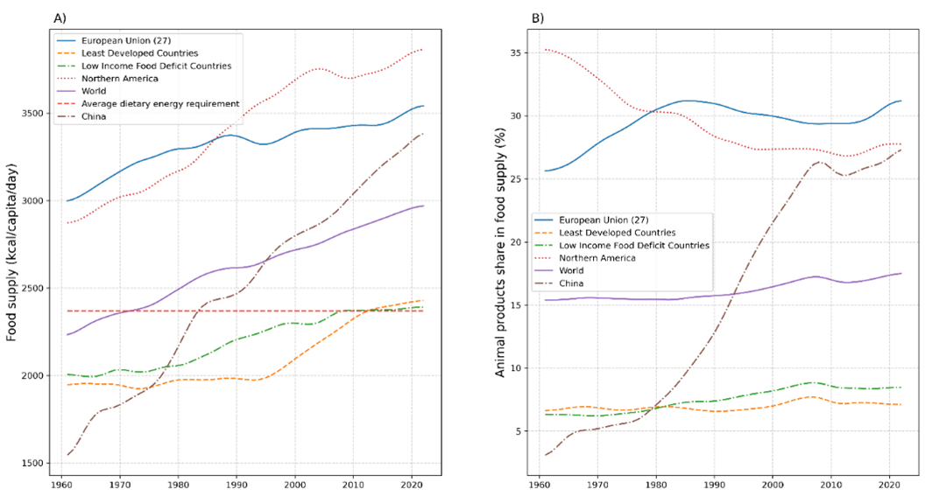
Figure S3: Trends in global food supply: A) Trends in food supply for selected regions and global average nutrient requirements, and B) Animal products contribution in food supply for the selected regions. [Data source: FAO (2024) Food Balance Sheet]. While North America and the European Union consume 1.5-1.6 times the dietary energy requirements, many least-developed countries barely meet minimum needs. Rapid growth in food consumption in countries like China, where per capita supply rose from 1,348 to 3,441 kcal/day, highlights changing consumption patterns (Figure S3A). The share of animal products in China's food supply has surged, increasing 12-fold, while in North America, the share of animal products in the food supply has declined, from 35% to 28% (Figure S3B).

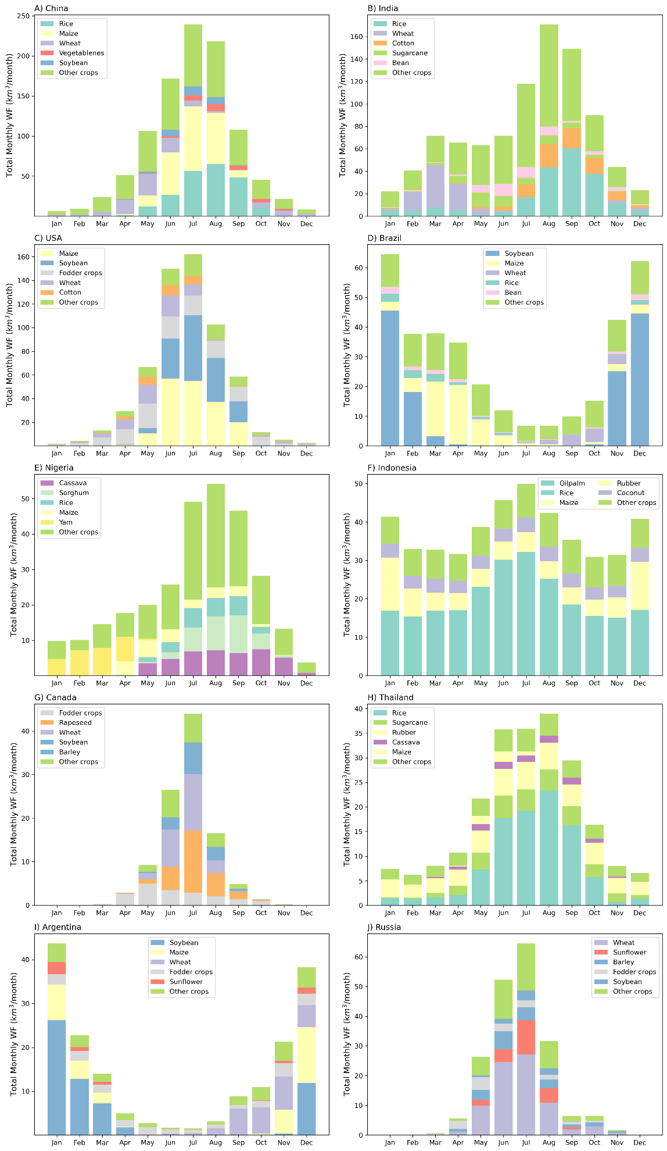
Figure S4: Monthly Water Footprint (WF) of the top ten water user countries.

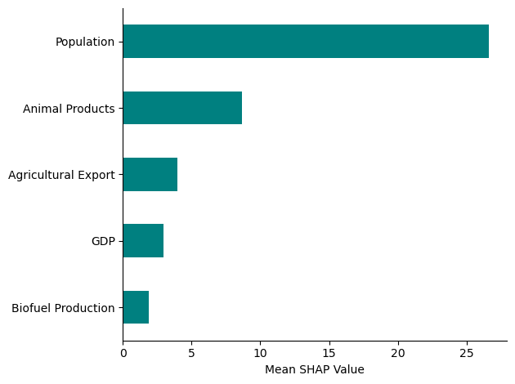
Figure S5: The relative importance of socio-economic factors on the spatiotemporal variation of the water footprint of crop production.

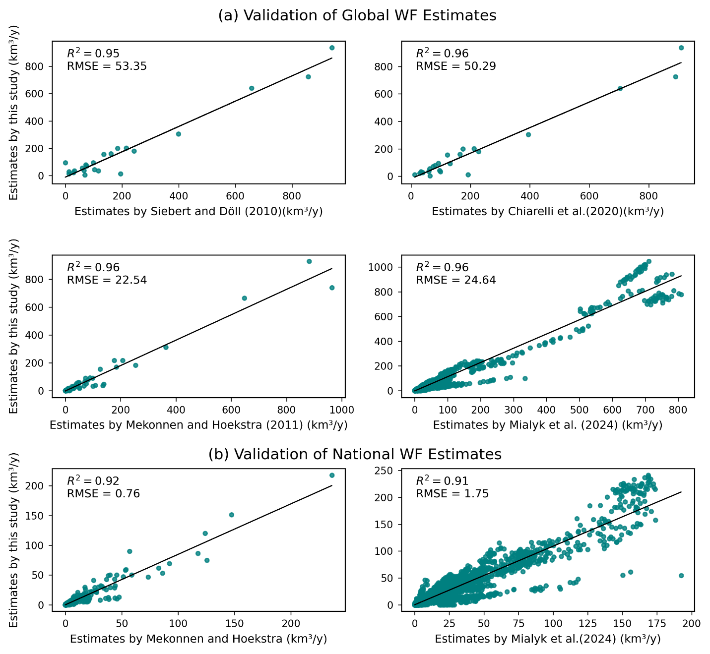

Figure S6. Comparison of global and national water footprint (WF) of different crops from the current study with estimates of previous studies. Comparisons of WF with that of Siebert and Döll (2010) and Chiarelli et al. (2020) is for the year 2000. Comparison with Mekonnen and Hoekstra (2011) is for an average WF of the years 1996-2005. The comparison with Mialyk et al. (2024) is a yearly WF comparison from 1990-2018.

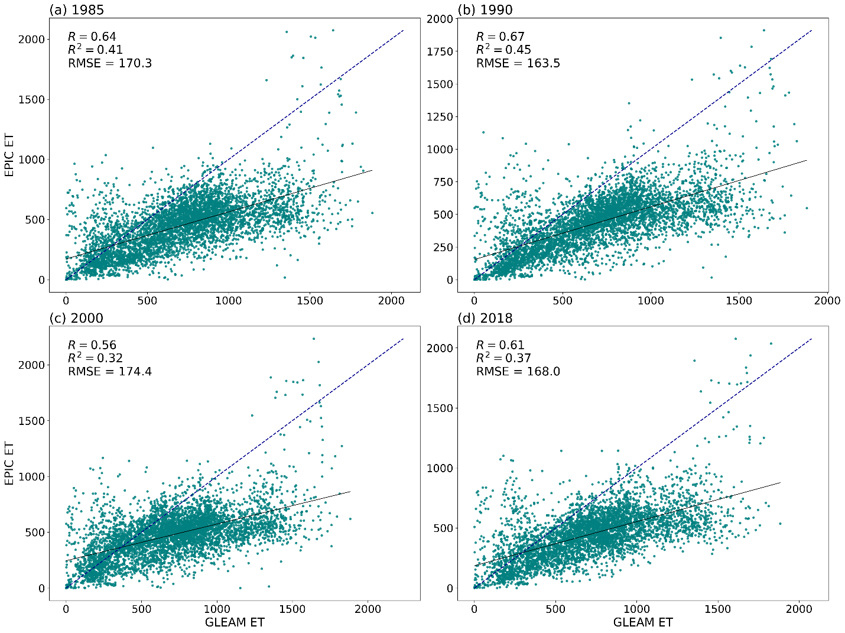
Figure S7: Comparison of ET estimated with EPIC crop model with ET from satellite observation called The Global Land Evaporation Amsterdam Model (Gleam). The comparison of annual ET for the years 1985, 1990, 2000, and 2018 is given.

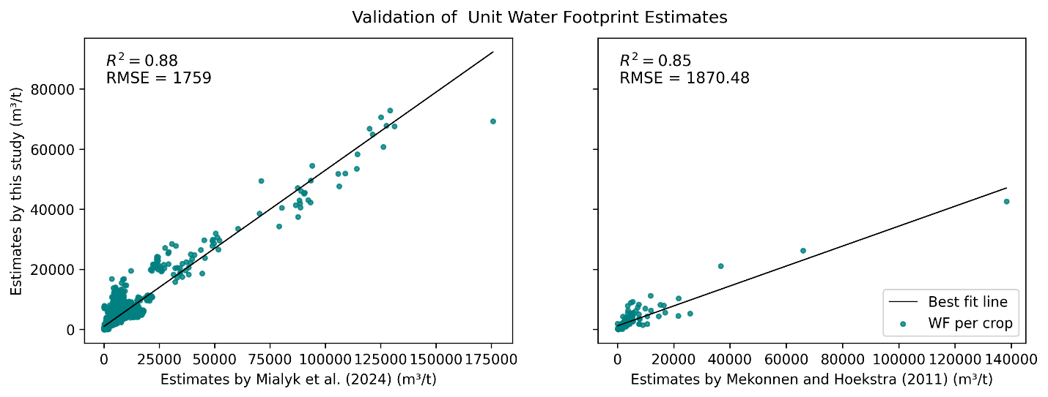
Figure S8: Comparison of the unit WF (uWF) of different crops from the current study with estimates of Mialyk et al. (2024) and Mekonnen and Hoekstra (2011). Comparison with Mekonnen and Hoekstra (2011) is for an average WF of the years 1996-2005. The comparison with Mialyk et al. (2024) is a yearly WF comparison from 1990-2018.

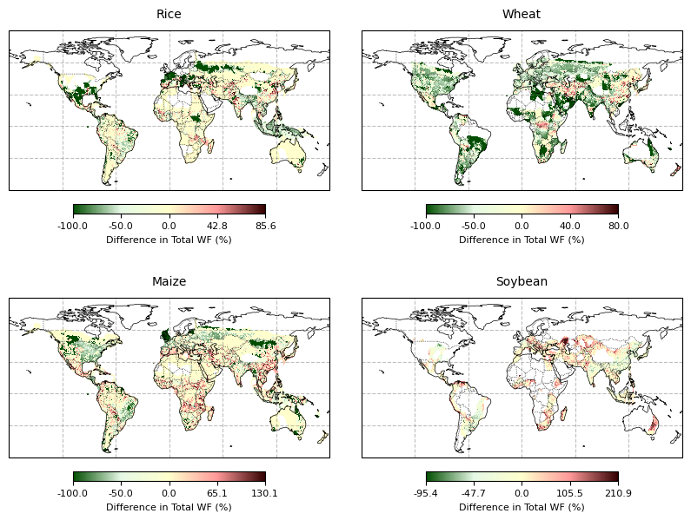
Figure S9: Comparison of grid-level WF of selected crops from the current study with estimates of Chiarelli et al. (2020) for the year 2016.

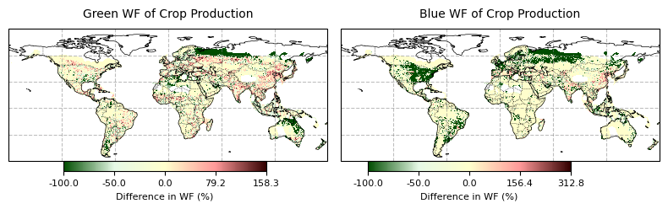
Figure S10: Comparison of grid-level WF of crop production with estimates from Mialyk et al. (2024) for the year 2018.

Potential Heat Unit
Potential heat unit (PHU) represents the cumulative heat energy available to a crop over a specific growth period and is calculated using equation (1) (Mcmaster, 1997).
$$PHU=\sum_{i=plt}^{i=hvt}{\left(\frac{T_{max}+T_{min}}{2}\right)-T_{b}}$$ | (S1)

Soil Water Balance

ET is partitioned into blue and green components using a physically based numerical soil water balance model (Chukalla et al., 2015; Hoekstra, 2019a). This model captures various inflows and outflows within a soil layer, where inflows include capillary rise from groundwater and the infiltration of precipitation and irrigation, while outflows consist of ET and percolation to groundwater. The model equations are formulated in a numerical framework and then rearranged to get equations 2, 3, and 4, which calculate the green soil moisture change resulting from rainfall and blue soil moisture change from irrigation or capillary rise at time t (Hoekstra, 2019b). These equations provide a dynamic assessment of the soil’s green and blue water content over time, based on specific inflow and outflow interactions for each component.

$S_{g}\left(t\right)= S_{g}\left(t-dt\right)+P\left(t\right)-\frac{P\left(t\right)}{P\left(t\right)+I\left(t\right)})RO(t)-\frac{S_{g}\left(t-dt\right)}{S\left(t-dt\right)}(GWR(t)+ET\left(t\right))$ | (s2)
$$S_{b,i}\left(t\right)= S_{b,i}\left(t-dt\right)+I\left(t\right)-\frac{I\left(t\right)}{P\left(t\right)+I\left(t\right)}RO\left(t\right)-\frac{S_{b,i}\left(t-dt\right)}{S\left(t-dt\right)}\left(GWR\left(t\right)+ET\left(t\right)\right)$$ | (s3)
$S_{b,c}\left(t\right)= S_{b,c}\left(t-dt\right)+CR\left(t\right)- \frac{S_{b,c}\left(t-dt\right)}{S\left(t-dt\right)}(GWR\left(t\right)+ET\left(t\right))$ | (s3)

Where, t = the current time step, t-1 = the previous time step, $S_{g}$ = soil moisture from green water, S = the total soil moisture, P = precipitation, I = infiltration, RO = runoff, GWR = ground water recharge, ET= evapotranspiration, $S_{b,i}$= the blue soil moisture from irrigation, $S_{b,c}$= the blue soil moisture from capillary rise, $CR=$capillary rise
Green and blue soil moisture are then used to calculate the green ET from rainfall and blue ET from irrigation and capillary rise using equation 5. The blue ET from irrigation and from capillary rise are added to get the total blue ET.

${ET}_{g}=ET×\frac{S_{g}}{S}$ , | ${ET}_{b,i}=ET×\frac{S_{b,i}}{S}$ , | $${ET}_{b,c}=ET×\frac{S_{b,c}}{S}$$ | (s4)

Where, ${ET}_{g}$= Green ET from rain, ${ET}_{b,i}$= Blue ET from irrigation, ${ET}_{b,c}$ = Blue ET from capillary rise.
To apply the soil water balance model for tracking blue and green ET, inflows and outflows data at each time step t, preferably daily, is required. This information was derived from the EPIC model’s daily output files, which provided data on variables such as precipitation, ET, irrigation, percolation, runoff, capillary rise, and root zone soil moisture. For initialization, we assumed all the root-zone soil moisture as green, with blue water contributions from irrigation and capillary rise set to zero. To mitigate potential errors from these assumptions, the first year of simulation (1971) served as a model spin-up period, allowing the soil-water balance model to stabilize before the main analysis period.

