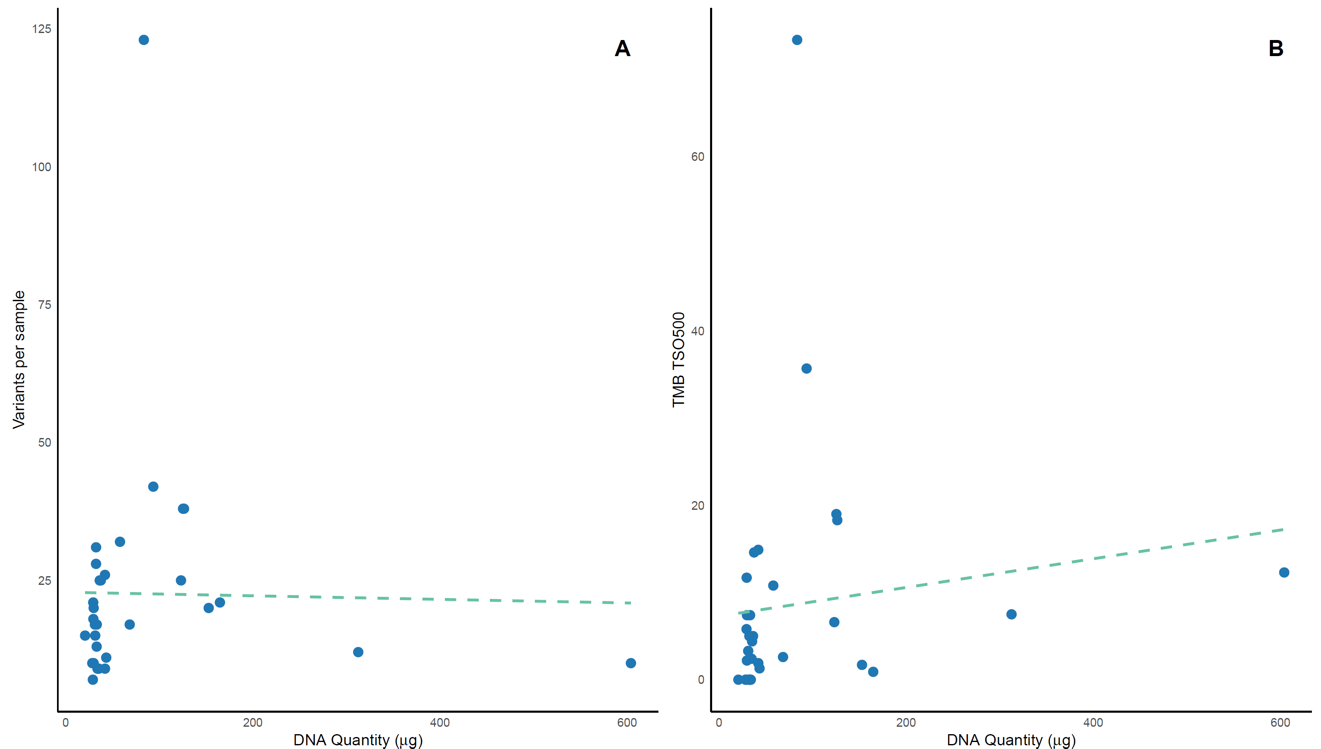
Supplementary Figure 1. A: Scatterplot (blue dots) with a linear regression line, showing the correlation between the number of variants per sample and ctDNA quantity (Pearson’s r = -0.017, p = 0.92). B: Correlation between Tumor Mutational Burden (TMB) and ctDNA quantity (Pearson’s r = 0.132, p = 0.47).
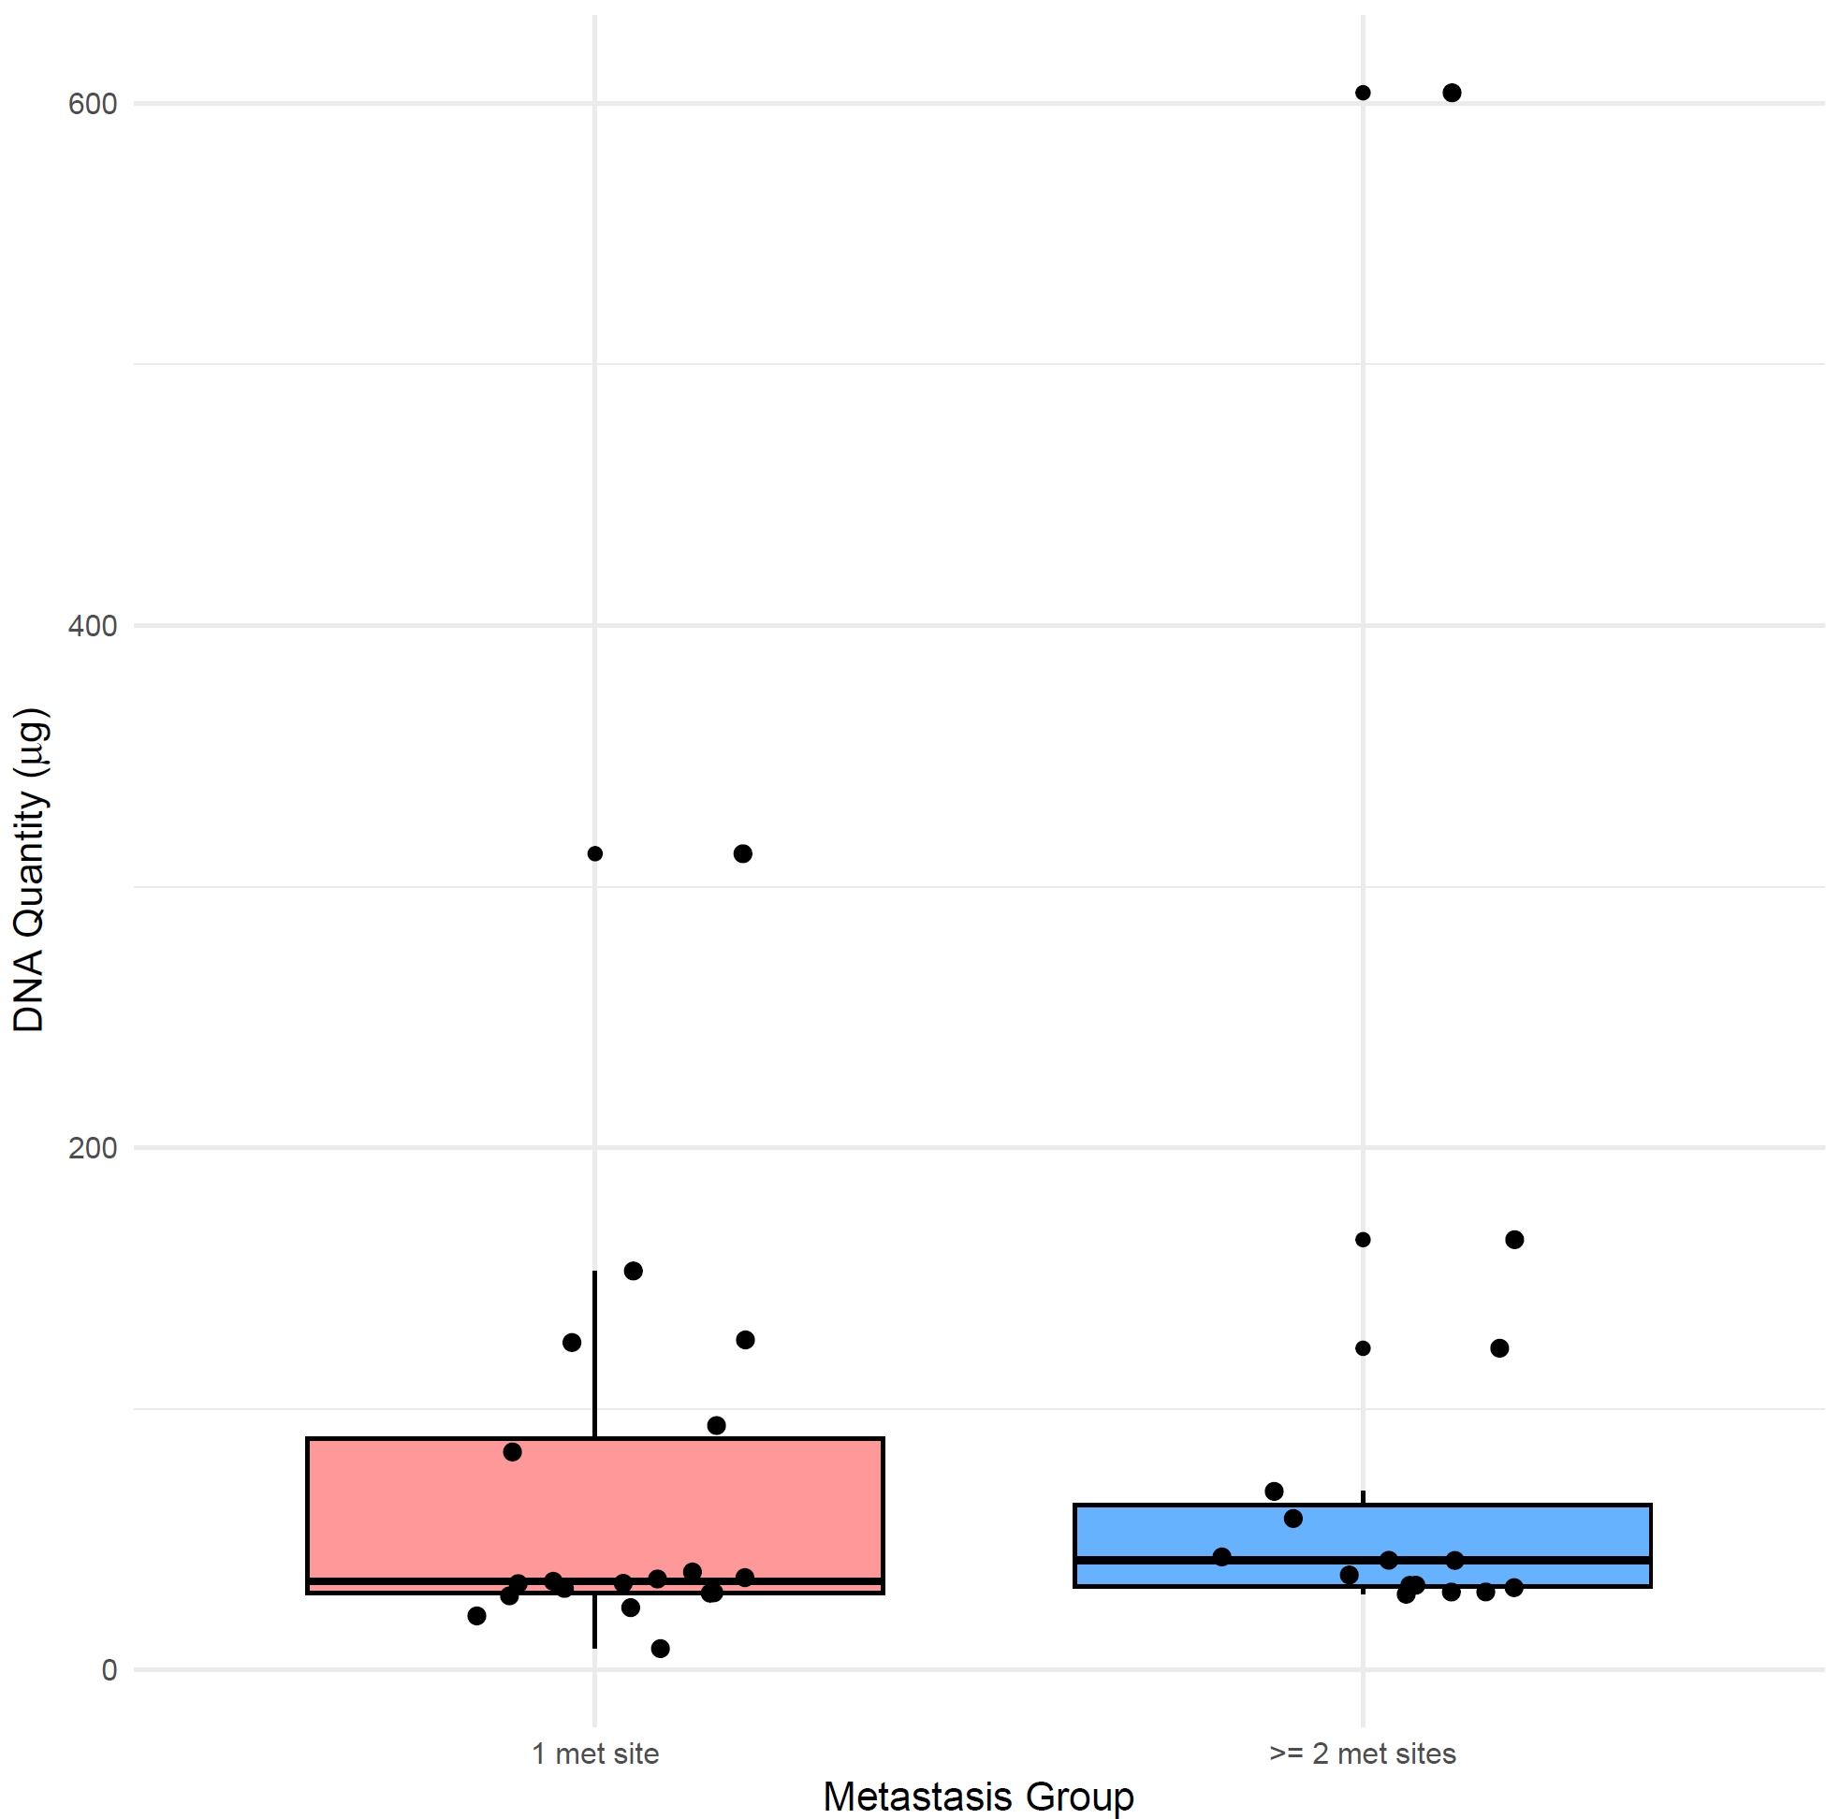
Supplementary Figure 2: Boxplots showing the distribution of ctDNA quantity among patients with 1 or 2 and more metastatic sites.

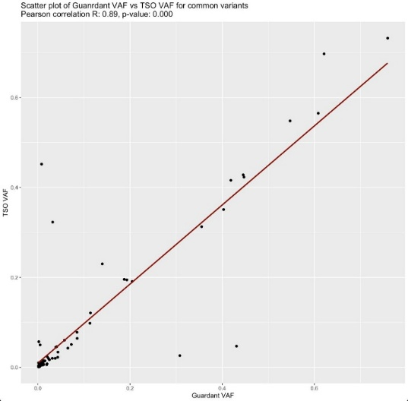
Supplementary Figure 3: scatter plot showing the correlation between variant allele frequencies identified by G360 (x-axis) and TSO500 (y-axis)
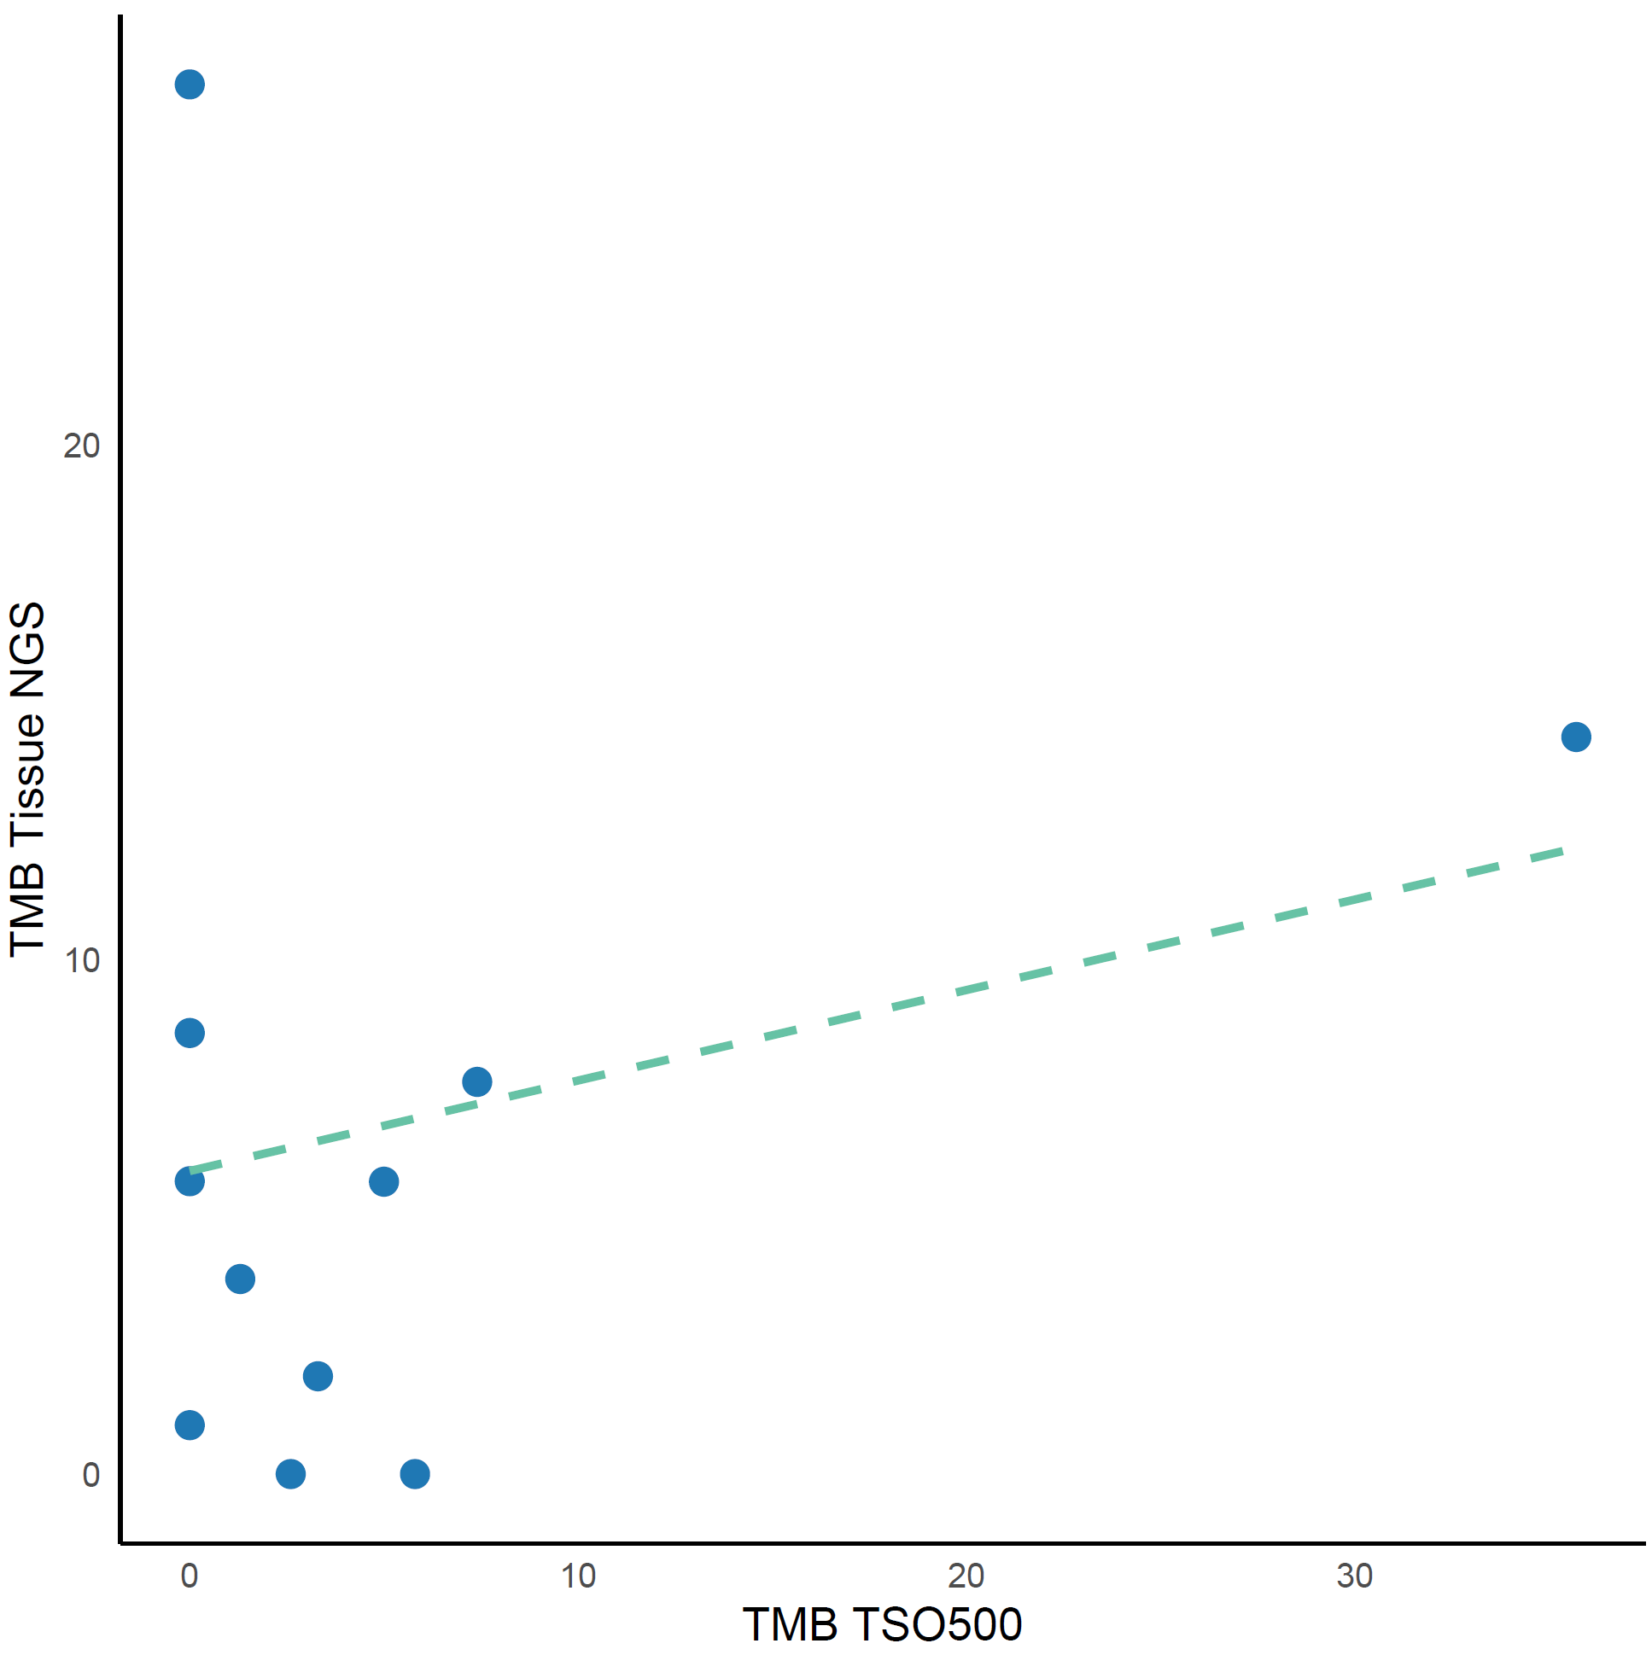
Supplementary Figure 4: Scatterplot (blue dots) with a linear regression line, showing the correlation between TMB values by TSO500 and tissue NGS (Pearson’s r = 0.228, p = 0.498)

