Title

Sex determination of the Pampas deer (Ozotoceros bezoarticus) via high-resolution melting analysis

Authors
Guillermo Morera^{1,2} https://orcid.org/0000-0001-9290-459X , Mariana Cosse ^{1,2} https://orcid.org/0000-0001-9644-1633, Susana González^{1,2} https://orcid.org/0000-0001-6470-6182

¹Departamento de Biodiversidad y Genética –Instituto de Investigaciones Biológicas Clemente Estable. Av. Italia 3318 Montevideo 11600, Uruguay. -
² Centro de Investigación en Ciencias Ambientales –Instituto de Investigaciones Biológicas Clemente Estable. Av. Italia 3318 Montevideo 11600, Uruguay. -

Corresponding author:
Susana González Departamento de Biodiversidad y Genética –Instituto de Investigaciones Biológicas Clemente Estable. Av. Italia 3318 Montevideo 11600, Uruguay. sugonza@iibce.edu.uy

Key words
Amelogenin, KY1/KY2 Cervidae, Neotropical, HRM

Table 1. Detailed information of each sample, including origin (Los Ajos, Rocha: LA; El Tapado, Salto: ET; Santa Julia, Salto: SJ and ECFA, Maldonado: ECFA), type of samples, previously assigned sex, presence/absence of each allele band and PCR-Agarose Gel assigned sex. Sample types: blood, hair and faeces were collected from living animals and tissues from muscle and skin form death animals.

Sample ID | Population | Type | Subspecies | Assigned sex | X band (202 bp) | Y Band (156 bp) | Gel bands assigned sex
SG 131 | LA | Blood | O. b. uruguayensis | Female | Yes | No | Female
SG 134 | LA | Blood | O. b. uruguayensis | Female | Yes | No | Female
SG 147 | LA | Tissue | O. b. uruguayensis | Female | Yes | No | Female
SG 157 | LA | Tissue | O. b. uruguayensis | Male | Yes | Yes | Male
SG 245 | LA | Tissue | O. b. uruguayensis | ND | Yes | Yes | Male
SG 320 | ECFA | Tissue | O. b. arerunguaensis | Female | Yes | No | Female
SG 323 | ECFA | Faeces | O. b. arerunguaensis | Male | Yes | Yes | Male
SG 330 | ECFA | Hair | O. b. arerunguaensis | Female | Yes | No | Female
SG 331 | ECFA | Muscle | O. b. arerunguaensis | ND | Yes | No | Female
SG 339 | ET | Faeces | O. b. arerunguaensis | ND | Yes | Yes | Male
SG 368 | ECFA | Hair | O. b. arerunguaensis | Female | Yes | No | Female
SG 369 | ECFA | Hair | O. b. arerunguaensis | Female | Yes | No | Female
SG 372 | ECFA | Hair | O. b. arerunguaensis | Female | Yes | No | Female
SG 377 | ET | Blood | O. b. arerunguaensis | Male | Yes | Yes | Male
SG 378 | ET | Blood | O. b. arerunguaensis | Male | Yes | Yes | Male
SG 379 | ET | Blood | O. b. arerunguaensis | Male | Yes | Yes | Male
SG 380 | ET | Blood | O. b. arerunguaensis | Male | Yes | Yes | Male
SG 381 | ET | Blood | O. b. arerunguaensis | Male | Yes | Yes | Male
SG 383 | ECFA | Blood | O. b. arerunguaensis | Female | Yes | No | Female
SG 384 | ECFA | Blood | O. b. arerunguaensis | Female | Yes | No | Female
SG 385 | ECFA | Blood | O. b. arerunguaensis | Female | Yes | No | Female
SG 387 | ECFA | Skin Tissue | O. b. arerunguaensis | Male | Yes | Yes | Male
SG 388 | ECFA | Skin Tissue | O. b. arerunguaensis | Female | Yes | No | Female
SG 389 | ECFA | Skin Tissue | O. b. arerunguaensis | Male | Yes | Yes | Male
SG 390 | ECFA | Skin Tissue | O. b. arerunguaensis | Male | Yes | Yes | Male
SG 391 | ECFA | Skin Tissue | O. b. arerunguaensis | Male | Yes | Yes | Male
SG 392 | ECFA | Skin Tissue | O. b. arerunguaensis | Female | Yes | No | Female
SG 393 | ECFA | Skin Tissue | O. b. arerunguaensis | Male | Yes | Yes | Male
SG 394 | ECFA | Skin Tissue | O. b. arerunguaensis | Male | Yes | Yes | Male
SG 395 | ECFA | Skin Tissue | O. b. arerunguaensis | Female | Yes | No | Female
SG 396 | ECFA | Skin Tissue | O. b. arerunguaensis | Female | Yes | No | Female
SG 397 | ECFA | Skin Tissue | O. b. arerunguaensis | Male | Yes | Yes | Male
SG 398 | ECFA | Skin Tissue | O. b. arerunguaensis | Female | Yes | No | Female
SG 400 | ECFA | Skin Tissue | O. b. arerunguaensis | Male | Yes | Yes | Male
SG 401 | ECFA | Skin Tissue | O. b. arerunguaensis | Male | Yes | Yes | Male
SG 402 | ECFA | Skin Tissue | O. b. arerunguaensis | Male | Yes | Yes | Male
SG 403 | ET | Blood | O. b. arerunguaensis | Male | Yes | Yes | Male
SG 404 | ET | Hair | O. b. arerunguaensis | Male | Yes | Yes | Male
SG 405 | SJ | Blood | O. b. arerunguaensis | Male | Yes | Yes | Male
SG 407 | ET | Hair | O. b. arerunguaensis | Male | Yes | Yes | Male

Table 2. Detailed information of each sample, including origin (Los Ajos, Rocha: LA; El Tapado, Salto: ET; Santa Julia, Salto: SJ and ECFA, Maldonado: ECFA), type of samples, previously assigned sex assignation by PCR-RT. Sample types: hair and faeces were collected from living animals and tissues from muscle, skin and bones form death animals.

Sample ID | Population | Type | Subspecies | Assigned sex | X linked product peak (°C) | Y linked product peak (°C) | PCR-RT
SG 13 | LA | Muscle | O. b. uruguayensis | Female | 83.84 | - | Female
SG 19 | LA | Muscle | O. b. uruguayensis | Male | 85.66 | 87.65 | Male
SG 58 | LA | Skin tissue | O. b. uruguayensis | Female | 85.09 | - | Female
SG 61 | ET | Skin tissue | O. b. arerunguaensis | Female | 85.42 | - | Female
SG 62 | ET | Skin tissue | O. b. arerunguaensis | Male | 85.07 | 87.85 | Male
SG 63 | ET | Skin tissue | O. b. arerunguaensis | Female | 85.82 | - | Female
SG 77 | ET | Skin Tissue | O. b. arerunguaensis | Female | 82.85 | - | Female
SG 79 | ET | Skin Tissue | O. b. arerunguaensis | Female | 81.66 | - | Female
SG 80 | ET | Skin Tissue | O. b. arerunguaensis | Female | 83.71 | - | Female
SG 95 | ET | Skin Tissue | O. b. arerunguaensis | Male | 85.57 | 88.2 | Male
SG 108 | ET | Skin tissue | O. b. arerunguaensis | Female | 84.36 | - | Female
SG 138 | LA | Skin tissue | O. b. uruguayensis | Female | 84.49 | - | Female
SG 146 | ECFA | Skin Tissue | O. b. arerunguaensis | Male | 84.23 | 88.33 | Male
SG 238 | ET | Skin tissue | O. b. arerunguaensis | Male | 78.39 | 89.74 | Male
SG 251 | ECFA | Skin Tissue | O. b. arerunguaensis | Female | 83.6 | - | Female
SG 319 | ECFA | Skin Tissue | O. b. arerunguaensis | Female | 84.06 | - | Female
SG 320 | ECFA | Skin Tissue | O. b. arerunguaensis | Female | 83.58 | - | Female
SG 330 | ECFA | Hair | O. b. arerunguaensis | Female | 83.62 | - | Female
SG 334 | ET | Bones and skin tissue | O. b. arerunguaensis | Female | 83.13 | - | Female
SG 336 | ET | Faeces | O. b. arerunguaensis | Female | 83.61 | - | Female
SG 337 | ET | Faeces | O. b. arerunguaensis | Nd | 82.52 | 89.22 | Male
SG 339 | ET | Faeces | O. b. arerunguaensis | Nd | - | 89.01 | Male
SG 340 | ET | Faeces | O. b. arerunguaensis | Nd | 83.88 | 87.97 | Male
SG 341 | ET | Faeces | O. b. arerunguaensis | Nd | - | 88.79 | Male
SG 342 | ET | Faeces | O. b. arerunguaensis | Nd | 83.3 | 87.64 | Male
SG 343 | ET | Faeces | O. b. arerunguaensis | Nd | 83.51 | 88.83 | Male
SG 344 | ET | Faeces | O. b. arerunguaensis | Nd | 85.63 | 88.68 | Male
SG 345 | ET | Faeces | O. b. arerunguaensis | Nd | 85.76 | 88.68 | Male
SG 351 | ET | Faeces | O. b. arerunguaensis | Nd | 83.27 | - | Female
SG 356 | ET | Faeces | O. b. arerunguaensis | Nd | 83.49 | - | Female
SG 366 | ET | Faeces | O. b. arerunguaensis | Female | 82.94 | - | Female
SG 374 | ECFA | Faeces | O. b. arerunguaensis | Female | 83 | - | Female
SG 376 | ECFA | Faeces | O. b. arerunguaensis | Female | 83.56 | - | Female
SG 378 | ET | Skin Tissue | O. b. arerunguaensis | Male | 85.76 | 88.35 | Male
SG 379 | SJ | Skin Tissue | O. b. arerunguaensis | Male | 85.69 | 88.25 | Male
SG 380 | ET | Skin Tissue | O. b. arerunguaensis | Male | 85.87 | 88.22 | Male
SG 381 | ET | Skin Tissue | O. b. arerunguaensis | Male | 85.66 | 88.5 | Male
SG 387 | ECFA | Skin Tissue | O. b. arerunguaensis | Male | 83.8 | 88.06 | Male
SG 388 | ECFA | Skin Tissue | O. b. arerunguaensis | Female | 83.68 | - | Female
SG 389 | ECFA | Skin Tissue | O. b. arerunguaensis | Male | 83.91 | 87.56 | Male
SG 390 | ECFA | Skin Tissue | O. b. arerunguaensis | Male | 84.19 | 88.74 | Male
SG 391 | ECFA | Skin Tissue | O. b. arerunguaensis | Male | 84.05 | 88.31 | Male
SG 393 | ECFA | Skin Tissue | O. b. arerunguaensis | Male | 84.08 | 88.12 | Male
SG 394 | ECFA | Skin Tissue | O. b. arerunguaensis | Male | 83.82 | 88.32 | Male
SG 395 | ECFA | Skin Tissue | O. b. arerunguaensis | Female | 83.9 | - | Female
SG 396 | ECFA | Skin Tissue | O. b. arerunguaensis | Female | 83.58 | - | Female
SG 397 | ECFA | Skin Tissue | O. b. arerunguaensis | Male | 85.54 | 88.24 | Male
SG 398 | ECFA | Skin Tissue | O. b. arerunguaensis | Female | 83.66 | - | Female
SG 399 | ECFA | Skin Tissue | O. b. arerunguaensis | Male | 85.71 | 88.27 | Male
SG 400 | ECFA | Skin Tissue | O. b. arerunguaensis | Male | 84.07 | 88.21 | Male
SG 401 | ECFA | Skin Tissue | O. b. arerunguaensis | Male | 82.55 | 86.83 | Male
SG 402 | ECFA | Skin Tissue | O. b. arerunguaensis | Male | 83.79 | 88.62 | Male
SG 403 | ET | Skin Tissue | O. b. arerunguaensis | Male | 84.68 | 88.21 | Male
SG 404 | ET | Faeces | O. b. arerunguaensis | Male | 83.73 | 87.6 | Male
SG 407 | ET | Faeces | O. b. arerunguaensis | Male | 83.56 | 88.17 | Male
 |  |  |  | Average | 84.04 | 88.3
 |  |  |  | StDev | 1.34 | 0.55

Table 3. Observed polymorphisms, positions, and sequence comparisons between Ozotoceros bezoarticus and Brinkman and Hundertmark (2009) sequences for the X- and Y-linked products.

Genbank Accesion Number | Nucleotide Position

 | 10 |  | 46 | 51 | 54 | 57 | 68 | 74 | 94 | 112 | 133 | 136
FJ434497.1 Alces alces chromosome Y |  | T | T | T | A | T | C | C | C | C | G | T
PV166110 Ozotoceros.bezoarticus chromosome Y. |  | A | T | T | G | C | C | C | C | C | T | T
PV166111 Ozotoceros.bezoarticus. chromosome.Y |  | A | T | T | G | C | C | C | C | C | G | T
FJ434491.1 Odocoileus hemionus chromosome Y |  | A | T | T | G | T | C | C | C | A | G | T
FJ434495.1 Rangifer tarandus chromosome Y |  | A | T | T | G | T | C | C | C | C | G | T
FJ434493.1 Oreamnos americanus chromosome Y |  | A | C | C | G | T | G | T | T | C | G | C

 | Genbank Accesion Number |  |  |  |  |  |  |  |  |  |  |  |  | Nucleotide Position
 |  | 42 |  | 43 |  | 52 |  |  | 56 | 61 |  | 70 |  |  | 93 |  | 96 |  | 123 |  | 140 |  | 156 |  | 157 |  | 160
FJ434496.1 Alces alces chr X |  |  | C |  | C |  | C | - |  |  | - |  | C |  |  | A |  | C |  | G |  | C |  | G |  | C |  | T
PV130448 MX400 Ozotoceros bezoarticus chr X |  |  | C |  | T |  | R | T |  |  | C |  | C |  |  | G |  | C |  | G |  | C |  | A |  | A |  | T
PV130447 HX395_Ozotoceros bezoarticus chr X |  |  | C |  | R |  | R | A |  |  | C |  | C |  |  | G |  | C |  | G |  | C |  | G |  | C |  | T
PV130449 HX320_Ozotoceros bezoarticus chr X |  |  | R |  | T |  | C | A |  |  | C |  | C |  |  | G |  | C |  | G |  | G |  | G |  | C |  | T
FJ434490.1 Odocoileus hemionus chr X |  |  | C |  | C |  | C | A |  |  | T |  | C |  |  | G |  | C |  | G |  | C |  | G |  | C |  | T
FJ434494.1 Rangifer tarandus chrX |  |  | C |  | C |  | C | A |  |  | T |  | C |  |  | G |  | C |  | G |  | C |  | G |  | C |  | T
FJ434492.1 Oreamnos americanus chrX |  |  | C |  | C |  | C | A |  |  | T |  | T |  |  | A |  | T |  | A |  | C |  | G |  | C |  | C

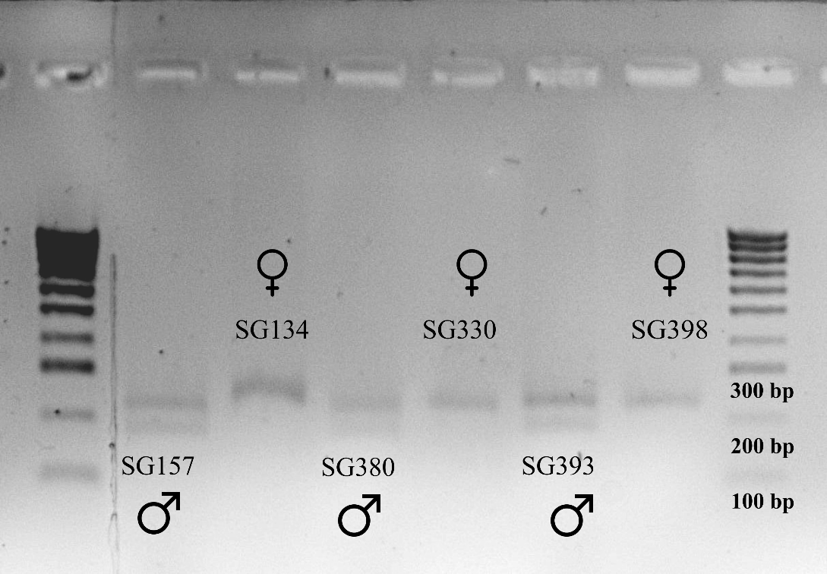

Fig. 1 Agarose gel shows the amplification of X- and Y-linked alleles of the Amelogenin gene in Ozotoceros bezoarticus using KY1/KY2 primers.

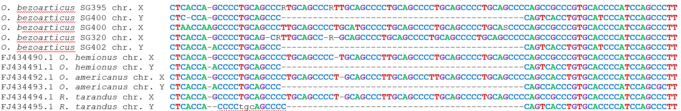
Fig. 2 Comparison of the DNA sequences of the X and Y Amelogenin fragments from Ozotoceros bezoarticus (SG395♀, SG400♂, SG320♀, SG402♂) in this study with those of Alaskan ungulates (Odocoileus hemionus, Oreamnos americanus, and Rangifer tarandus) reported by Brinkman and Hundertmark (2009) using KY1 and KY2 primers.

References
Brinkman, T, & Hundertmark, K (2009) Sex identification of northern ungulates using low quality and quantity DNA. Conserv Genet 10(4), 1189-1193. https://doi.org/10.1007/s10592-008-9747-2

