Supporting Information for

Spatio-temporal dynamics of Hendra virus in Pteropus bats in Australia reveals high evolutionary diversity linked with spillover

Authors
Claude Kwe Yinda^{1#}, John-Sebastian Eden^{2#}, Erica Prates³, Anna Vlot³, Sarah L. Anzick⁴, Jianning Wang⁵, Kim Halpin⁵, Benny Borremans⁶, Tamika J. Lunn^{7,8}, Kent Barbian⁴, Benjamin Greene¹, Kimberly Meade-White¹, Trenton Bushmaker¹, Caylee A. Falvo⁹, Daniel E. Crowley⁹, Devin N. Jones-Slobodian¹⁰, Manesh Shah³, Mirko Pavicic³, William Carr³, Craig Martens⁴, Daniel Jacobson³, Bat One Health group, Raina K. Plowright⁹, Alison J. Peel^{11,12$}, Vincent J. Munster¹*$ ($ Joint last author)

Affiliations
¹Laboratory of Virology, Division of Intramural Research, National Institutes of Health, Hamilton, MT, USA
²Westmead Institute for Medical Research - Centre for Virus Research, Sydney Institute for Infectious Diseases, The University of Sydney
³Oak Ridge National Laboratory, Oak Ridge, TN, USA
⁴Genomics Research Section, Research Technologies Branch, Division of Intramural Research, National Institute of Allergy and Infectious Diseases, National Institutes of Health, Hamilton, MT, USA
⁵Australian Centre for Disease Preparedness, Commonwealth Scientific and Industrial Research Organisation (CSIRO), Canberra, Australia
⁶Wildlife Health Ecology Research
⁷Odum School of Ecology, University of Georgia, Athens GA, USA
⁸Center for the Ecology of Infectious Diseases, University of Georgia, Athens GA, USA
⁹Department of Public and Ecosystem Health, College of Veterinary Medicine, Cornell University, Ithaca NY, USA
¹⁰Department of Ecology, Montana State University, Bozeman, MT, USA
¹¹Centre for Planetary Health and Food Security, Griffith University, Nathan, Queensland, Australia
¹²Sydney School of Veterinary Science, University of Sydney, Sydney, NSW, Australia

# contributed equally

* Corresponding author: Vincent Munster
Rocky Mountain Laboratories, NIAID, NIH
903 S 4th St, Hamilton, MT 59840
Email: vincent.munster@nih.gov

Supporting Information Text
Supporting results
We tested the temporal structure in the presence of different clades using a permutation test to address two specific questions: (1) How unlikely is it that clade B is not observed before 2018 if it was in fact present throughout the sampling period, and (2) Do the relative proportions of clades change over time? The results showed that the proportion of permutations for which clade B is not observed before 2018 was 0.022, which means that it is statistically unlikely that clade B was present before 2018.
Supp Fig. 8 show the permuted and observed proportions of each clade out of the four clades within each 6-month period (excluding years before 2017 due to low sample sizes. There is no statistical support for the existence of periods during which the proportion of a clade is different from that expected given a constant distribution of clades over time (with the exception of clade B samples in Jul-Dec 2017).

Supporting discussion
After identifying the lineage-defining (LD) mutations for the newly identified clade B, we conducted a preliminary examination of potential functional effects of these mutations, in particular, P352S, in the P/V/W proteins (Fig. 4b). Like all other LD mutations in P/V/W, P352S is located in their extensive IDR, but we hypothesize that it may not be functionally silent. Even though proline and serine are both abundant amino acids in IDRs, they exert very different effects in conformational flexibility and compactness (1). It is also possible that this substitution may introduce a new phosphorylation site. Moreover, the substitution is positioned immediately next to a region with a medium predicted propensity to form a helical structure, based on the AlphaFold predicted local model quality score, pLDDT. This confidence metric is not only used to access the local quality of the model but to infer local conformational flexibility (2). The medium values of pLDDT in the predicted ɑ-helix next to site 352 may indicate the formation of a transient secondary structure, which is a common feature of target-binding motifs in IDRs (3). Therefore, this substitution may impact critical interactions with host proteins. In particular, the region surrounding this substitution is highly conserved between HeV and NiV. These viruses share 87% identity among the 10 amino acids that flank position 352, with S352 also being present in NiV (Supp Fig. 10). Both viruses employ the V protein as an immune evasion strategy to evade STAT1/STAT4-dependent interferon responses. Thus, the P352S change may likely have functional consequences. Lastly, given its proximity to a phase-transition region (aa. 200-310) that forms amyloid-like fibrils, we hypothesize that it may impact the virus's lifecycle and immune evasion (4).
In contrast to the P/V/W P352S mutation, the clade B-defining substitutions in protein L appear less significant at a first glance. They are neither located near known functional sites, like catalytic domains or protein-binding interfaces, nor seem to be structurally disruptive (Supp Fig. 11). Future research leveraging experiments and advanced deep learning methods to predict viral and host protein-protein interactions (5, 6) that could be influenced by these, or other LD mutations is recommended. A detailed analysis of other persistent mutations in this protein can be of interest as well. For example, the clade C and D-defining mutation Q321H in the L protein, is located at the nucleoside triphosphate (NTP) entrance in the RNA-dependent RNA polymerase domain. The addition of a positively charged amino acid to that region may, for example, enhance affinity to the NTPs used for RNA synthesis (Supp Fig. 11).
Further examination of other present LD mutations and tracking emergent mutations at the phylogenetic tree's tips is crucial, as these may be functional and begin circulating in the population. For instance, a R248G mutation in the G glycoprotein, found in a bat sample (ID: ARRED004_AVL_U_23_1), poses a radical chemical change that could disrupt the local secondary structure, remove a salt bridge, and indirectly affect the interaction with the host receptor protein, warranting further investigation (Supp Fig. 9).
Supporting methods
- Library preparation
Libraries were prepared using either the HyperPrep DNA library kit, or RNA HyperPrep workflow (Roche Sequencing Solutions, Pleasanton, CA). Using the HyperPrep DNA library kit, 11 μL viral RNA was used as template for first strand cDNA synthesis using the Superscript IV First-Strand Synthesis system (ThermoFisher Scientific, Waltham, MA). Second-strand synthesis was performed by combining the RNAse-treated 1st-strand cDNA product with 20 Units exo-Klenow Fragment and 1X NEB Buffer 2 (New England Biolabs, Inc), combined with 0.5 mM dNTPs and 3.35 μM random hexamers (ThermoFisher Scientific, Waltham, MA), and then incubated at 37⁰C for 45 minutes. The resulting double-stranded cDNA (ds-cDNA) products were purified with AMPure XP beads, following the manufacturer’s recommended procedure (Beckman Coulter Life Sciences, Pasadena, CA). Sequencing libraries were generated from ds-cDNA following the SeqCap EZ HyperCap Workflow User’s Guide, version 2.3 (Roche Sequencing Solutions, Pleasonton, CA). Briefly, ds-cDNA was sheared in 50 μL microtubes using the Covaris LE220 Focused Ultrasonicator (Covaris, Woburn, MA) to an average fragment size of 180-220 bp and converted to sequence ready libraries using the Kapa HyperPrep DNA kit and Dual-Indexed Adapters (Roche Sequencing Solutions, Pleasonton, CA).
For RNA HyperPrep workflow, sequencing libraries were generated from 11 μL viral RNA stock viral RNA using the RNA HyperPrep kit and Dual-Indexed Adapters, according to the manufacturer’s instructions (Roche Sequencing Solutions, Pleasonton, CA). Additional PCR cycles were added if final product yields were low.

- Library preparation and sequencing for PCR based amplicon
Following visual assessment on a Tape Station HS D1000 (Agilent Technologies, Santa Clara, CA), a total of 100-400ng of positive PCR product was taken directly into TruSeq DNA PCR-Free Library Preparation Guide, Revision D. (Illumina, USA) beginning with the Repair Ends step (q.s. to 50ul with RSB). Subsequent cleanup consisted of a double 1:1 AmPure XP/reaction ratio and all steps followed the manufacturer's instructions including the Illumina TruSeq CD (96) Indexes. Final libraries were visualized on either a TapeStation HS D5000 or BioAnalyzer HS chip (Agilent Technologies, USA) and quantified using KAPA Library Quant Kit - Illumina Universal qPCR Mix (Kapa Biosystems, USA) on a CFX96 Real-Time System (BioRad, Hercules, USA). Libraries were diluted to 2 nM stock, pooled together in equimolar concentrations, and sequenced on the Illumina MiSeq instrument (Illumina, USA) as paired-end 2 X 250 base pair reads.

- Bioinformatic pipeline

The pipeline consisted of removing host, ribosomal, and repeat sequences and mapping remaining PE reads to databases containing all known viruses and bacteria. De novo assembly was also performed on host/rRNA/repeat-depleted PE reads using Spades assembly program (7). Similarly, PE reads were also processed through a custom metavirs pipeline (8).
To generate full and partial consensus sequences from samples with > 50% of bases above 15X coverage, the following workflow was implemented: (i) adapter-trimmed/quality filtered fastq files were mapped to the best-matched Hendra virus reference sequence using Bowtie2 v 2.2.9 with --local --very sensitive --no-unal -X 1500 parameter settings (9). The sam alignments were converted to bam files using samtools (10) (ii) variant calling was performed using GATK v4.2.5.0 HaplotypeCaller with -ploidy 1 (11), (iii) indels and snp variants were filtered using BCFtools and QD > 10 (12), (iv) SNPs were inserted into the original reference to generate an initial consensus sequence using BCFtools consensus (10), (v) adapter-trimmed/quality filtered fastq files were mapped back to the initial consensus sequence as described above, (vi) BEDtools genomcov was used to generate bed files of regions with no or >4X coverage, and (vii) BEDtools maskfasta was used to generate the final consensus sequence. Consensus sequences have been deposited GenBank.
- Determination of temporal structure
We tested for temporal structure in the presence of different clades using a permutation test to address two specific questions: (1) How unlikely is it that clade B is not observed before 2018 if it was in fact present throughout the sampling period, and (2) Do the relative proportions of clades change over time.
Both questions were addressed using a permutation test in which the clade labels were shuffled randomly amongst all samples, taking into account region and species. This random shuffling simulated a situation where all clades were present at the same relative proportions throughout the sampling period. By repeating this permutation many times, it was possible to generate a distribution of metric (see below) values that could arise in this situation, which was then used to compare with the observed value of the metric of interest. If the observed value fell outside a chosen interval of the permuted distribution, it indicated statistical support for the notion that it was unlikely to obtain the observed value if the relative proportions of clades were consistent throughout the sampling period.
To address the two questions, we selected two metrics: (1) a binary number (0 or 1) indicating whether clade B was present before 2018, and (2) the relative proportions of each clade during each 6-month period. During each permutation iteration, the clade labels were randomly shuffled between samples, with shuffling allowed only between samples from the same host species and from the same region. This ensured that the host and spatial structure of the dataset were maintained. The two metrics were calculated during each iteration and stored for later comparison with the observed values. We performed 1,000 iterations.

- Map creation
Maps were created in R version 4.3.0 (13), using the following packages; tidyverse (14), magrittr (15), maps (16), mapproj (17), ozmaps (18), sf (19, 20), scatterpie (21), stringr (22), ggnewscale (23), ggforce (24), and ggspatial (25).

Supplementary Table 1: List of flying fox roost sites at which sampling was conducted in Queensland (Qld) and New South Wales (NSW) Australia, their latitude and longitude (rounded to 2 decimal places), the number of samples screened, their HeV-g1 result (where positive is Ct ≤40), and the number of genomes recovered in total and across each clade. The name and location of one site is anonymized for privacy reasons.

Roost site | Lat | Long | Total samples screened | HeV-g1 positive | HeV-g1 negative | Total Genomes | Clade A | Clade B | Clade C | Clade D
Bundaberg, Qld | -24.87 | 152.37 | 66 | 3 | 63
Hervey Bay, Qld | -25.29 | 152.89 | 191 | 11 | 180 | 1 |  |  |  | 1
Gympie (Commissioner's Gully), Qld | -26.18 | 152.66 | 58 | 6 | 52
Gympie (Township), Qld | -26.18 | 152.64 | 71 | 5 | 66
Redcliffe, Qld | -27.23 | 153.1 | 1927 | 126 | 1801 | 5 | 1 | 1 | 2 | 1
Mount Ommaney, Qld | -27.54 | 152.93 | 86 | 9 | 77 | 1 |  |  |  | 1
Sunnybank, Qld | -27.58 | 153.05 | 1368 | 67 | 1301 | 3 |  | 1 |  | 2
Toowoomba, Qld | -27.6 | 151.94 | 1914 | 121 | 1793 | 17 | 2 | 4 | 2 | 9
Canungra, Qld | -28.04 | 153.18 | 261 | 11 | 250 | 1 | 1
Burleigh, Qld | -28.08 | 153.44 | 632 | 23 | 609
Currumbin, Qld | -28.15 | 153.47 | 53 | 8 | 45 | 1 |  | 1
Anchorage, NSW | -28.19 | 153.53 | 50 | 3 | 47
Banora Green, NSW | -28.22 | 153.54 | 32 | 5 | 27
Tyalgum, NSW | -28.35 | 153.2 | 57 | 2 | 55
Stokers Siding, NSW | -28.4 | 153.41 | 63 | 5 | 58
Mullumbimby, NSW | -28.55 | 153.49 | 44 | 6 | 38
Simpson's Creek, NSW | -28.64 | 153.58 | 97 | 20 | 77 | 2 |  |  | 2
Byron Bay, NSW | -28.64 | 153.62 | 45 | 2 | 43
Doroughby, NSW | -28.68 | 153.36 | 59 | 1 | 58
Clunes, NSW | -28.73 | 153.42 | 1788 | 202 | 1586 | 12 | 4 | 3 |  | 5
Lismore, NSW | -28.81 | 153.3 | 364 | 31 | 333 | 2 |  |  | 1 | 1
Maclean, NSW | -29.47 | 153.2 | 122 | 0 | 122
Nambucca Heads, NSW | -30.64 | 153 | 315 | 36 | 279 | 3 | 1 |  | 2
Stewarts Brook, NSW | -32 | 151.23 | 174 | 0 | 174
IP | NA | NA | 32 | 0 | 32
TOTAL |  |  | 9869 | 703 | 9166 | 48 | 9 | 10 | 9 | 20

Supplementary Table 2: Metadata for sequences used in the analysis (this will be provided as an Excel spread sheet).

ID | % of genome with >2 reads | Ct | species | state | site | date | lat | long | label | Clade
ACCLU001_AVL_U_16_1 | 100.0% | 29 | Bat | NSW | Clunes | 8/12/17 | -28.734 | 153.417 | ACCLU001_AVL_U_16_1/Bat/NSW/Clunes/2017-08-12 | C
ACTOW001_AVL_U_13_1 | 100.0% | 22 | Bat | QLD | Toowoomba | 6/3/17 | -27.601 | 151.943 | ACTOW001_AVL_U_13_1/Bat/QLD/Toowoomba/2017-06-03 | C
ACTOW001_AVL_U_26_1 | 100.0% | 21 | Bat | QLD | Toowoomba | 6/3/17 | -27.601 | 151.943 | ACTOW001_AVL_U_26_1/Bat/QLD/Toowoomba/2017-06-03 | C
ACTOW013_VTM_u_34_2 | 89.1% | 31 | Bat | QLD | Toowoomba | 9/8/18 | -27.601 | 151.943 | ACTOW013_VTM_U_34_2/Bat/QLD/Toowoomba/2018-09-08 | B
ARCAN002_AVL_U_33_1 | 99.5% | 29 | Bat | QLD | Canugra | 8/28/17 | -28.04 | 153.182 | ARCAN002_AVL_U_33_1/Bat/QLD/Canugra/2017-08-28 | A
ARCLU001_AVL_U_023_A | 89.5% | 29 | Bat | NSW | Clunes | 7/17/17 | -28.734 | 153.417 | ARCLU001_AVL_U_023_A_1/Bat/NSW/Clunes/2017-07-17 | C
ARCLU002_AVL_U_7_1 | 100.0% | 29 | Bat | NSW | Clunes | 8/8/17 | -28.734 | 153.417 | ARCLU002_AVL_U_7_1/Bat/NSW/Clunes/2017-08-08 | C
ARCLU003_AVL_U_1_1 | 100.0% | 26 | Bat | NSW | Clunes | 9/4/17 | -28.734 | 153.417 | ARCLU003_AVL_U_1_1/Bat/NSW/Clunes/2017-09-04 | C
ARCLU003_AVL_U_16_1 | 98.7% | 28 | Bat | NSW | Clunes | 9/4/17 | -28.734 | 153.417 | ARCLU003_AVL_U_16_1/Bat/NSW/Clunes/2017-09-04 | A
ARCLU007_AVL_U_11_1 | 100.0% | 25 | Bat | NSW | Clunes | 8/1/18 | -28.734 | 153.417 | ARCLU007_AVL_U_11_1/Bat/NSW/Clunes/2018-08-01 | A
ARCLU007_AVL_U_43_1 | 93.0% | 29 | Bat | NSW | Clunes | 8/1/18 | -28.734 | 153.417 | ARCLU007_AVL_U_43_1/Bat/NSW/Clunes/2018-08-01 | A
ARCLU008_AVL_U_17_1 | 86.3% | 30 | Bat | NSW | Clunes | 8/30/18 | -28.734 | 153.417 | ARCLU008_AVL_U_17_1/Bat/NSW/Clunes/2018-08-30 | A
ARCLU015_VTM_U_41_1 | 98.4% | 29 | Bat | NSW | Clunes | 3/22/19 | -28.734 | 153.417 | ARCLU015_VTM_U_41_1/Bat/NSW/Clunes/2019-03-22 | C
ARCLU023_VTM_u_56_1 | 99.7% | 29 | Bat | NSW | Clunes | 11/27/19 | -28.734 | 153.417 | ARCLU023_VTM_U_56_1/Bat/NSW/Clunes/2019-11-27 | B
ARCLU025_VTM_u_32_1 | 97.8% | 30 | Bat | NSW | Clunes | 1/23/20 | -28.734 | 153.417 | ARCLU025_VTM_U_32_1/Bat/NSW/Clunes/2020-01-23 | B
ARCLU029_VTM_u_41_1 | 87.9% | 32 | Bat | NSW | Clunes | 5/28/20 | -28.734 | 153.417 | ARCLU029_VTM_U_41_1/Bat/NSW/Clunes/2020-05-28 | B
ARCUR001_AVL_U_3_1 | 100.0% | 27 | Bat | QLD | Currumbin | 10/4/18 | -28.145 | 153.467 | ARCUR001_AVL_U_3_1/Bat/QLD/Currumbin/2018-10-04 | B
ARHVB001_AVL_U_11_1 | 99.7% | 25 | Bat | QLD | Hervey_Bay | 7/23/18 | -25.289 | 152.893 | ARHVB001_AVL_U_11_1/Bat/QLD/Hervey_Bay/2018-07-23 | C
ARLIS002_AVL_U_36_1 | 100.0% | 28 | Bat | NSW | Lismore | 8/27/18 | -28.81 | 153.296 | ARLIS002_AVL_U_36_1/Bat/NSW/Lismore/2018-08-27 | C
ARLIS002_AVL_U_50_1 | 99.7% | 23 | Bat | NSW | Lismore | 8/27/18 | -28.81 | 153.296 | ARLIS002_AVL_U_50_1/Bat/NSW/Lismore/2018-08-27 | C
ARMOM001_AVL_U_21_1 | 99.6% | 30 | Bat | QLD | Mount_Ommaney | 1/15/19 | -27.544 | 152.925 | ARMOM001_AVL_U_21_1/Bat/QLD/Mount_Ommaney/2019-01-15 | C
ARNAM001_AVL_U_21_1 | 99.9% | 30 | Bat | QLD | Nambuca_Heads | 7/26/17 | -30.643 | 153.004 | ARNAM001_AVL_U_21_1/Bat/NSW/Nambuca_Heads/2017-07-26 | C
ARNAM002_AVL_U_46_1 | 100.0% | 30 | Bat | NSW | Nambuca_Heads | 9/2/17 | -30.643 | 153.004 | ARNAM002_AVL_U_46_1/Bat/NSW/Nambuca_Heads/2017-09-02 | A
ARNAM006_AVL_U_14_1 | 99.6% | 28 | Bat | NSW | Nambuca_Heads | 7/22/18 | -30.643 | 153.004 | ARNAM006_AVL_U_14_1/Bat/NSW/Nambuca_Heads/2018-07-22 | C
ARRED004_AVL_U_23_1 | 99.5% | 30 | Bat | QLD | Redcliffe | 7/26/18 | -27.231 | 153.099 | ARRED004_AVL_U_23_1/Bat/QLD/Redcliffe/2018-07-26 | C
ARRED005_AVL_U_14_1 | 100.0% | 28 | Bat | QLD | Redcliffe | 8/28/18 | -27.231 | 153.099 | ARRED005_AVL_U_14_1/Bat/QLD/Redcliffe/2018-08-28 | A
ARRED007_AVL_U_49_1 | 99.4% | 29 | Bat | QLD | Redcliffe | 10/31/18 | -27.231 | 153.099 | ARRED007_AVL_U_49_1/Bat/QLD/Redcliffe/2018-10-31 | C
ARRED028_VTM_u_4_1 | 91.9% | 32 | Bat | QLD | Redcliffe | 8/5/20 | -27.231 | 153.099 | ARRED028_VTM_U_4_1/Bat/QLD/Redcliffe/2020-08-05 | C
ARRED030_VTM_u_8_1 | 88.2% | 31 | Bat | QLD | Redcliffe | 9/23/20 | -27.231 | 153.099 | ARRED030_VTM_U_8_1/Bat/QLD/Redcliffe/2020-09-23 | B
ARSIM001_AVL_U_25_1 | 97.9% | 24 | Bat | NSW | Simpsons_Creek | 8/23/17 | -28.639 | 153.575 | ARSIM001_AVL_U_25_1/Bat/NSW/Simpsons_Creek/2017-08-23 | C
ARSUN014_AVL_U_4_1 | 99.4% | 26 | Bat | QLD | Sunnybank | 10/27/18 | -27.583 | 153.052 | ARSUN014_AVL_U_4_1/Bat/QLD/Sunnybank/2018-10-27 | C
ARSUN036_VTM_u_20_1 | 99.5% | 27 | Bat | QLD | Sunnybank | 7/20/20 | -27.583 | 153.052 | ARSUN036_VTM_U_20_1/Bat/QLD/Sunnybank/2020-07-20 | C
ARSUN038_VTM_u_48_1 | 99.9% | 26 | Bat | QLD | Sunnybank | 9/25/20 | -27.583 | 153.052 | ARSUN038_VTM_U_48_1/Bat/QLD/Sunnybank/2020-09-25 | B
ARTOW002_AVL_U_54_1 | 100.0% | 22 | Bat | QLD | Toowoomba | 6/1/18 | -27.601 | 151.943 | ARTOW002_AVL_U_54_1/Bat/QLD/Toowoomba/2018-06-01 | C
ARTOW003_VTM_u_52_1 | 100.0% | 31 | Bat | QLD | Toowoomba | 6/28/18 | -27.601 | 151.943 | ARTOW003_VTM_U_52_1/Bat/QLD/Toowoomba/2018-06-28 | C
ARTOW004_AVL_U_3_1 | 99.4% | 30 | Bat | QLD | Toowoomba | 7/20/18 | -27.601 | 151.943 | ARTOW004_AVL_U_3_1/Bat/QLD/Toowoomba/2018-07-20 | C
ARTOW004_AVL_U_38_1 | 96.6% | 29 | Bat | QLD | Toowoomba | 7/20/18 | -27.601 | 151.943 | ARTOW004_AVL_U_38_1/Bat/QLD/Toowoomba/2018-07-20 | C
ARTOW004_AVL_U_39_1 | 99.0% | 30 | Bat | QLD | Toowoomba | 7/20/18 | -27.601 | 151.943 | ARTOW004_AVL_U_39_1/Bat/QLD/Toowoomba/2018-07-20 | C
ARTOW004_AVL_U_4_1 | 94.1% | 31 | Bat | QLD | Toowoomba | 7/20/18 | -27.601 | 151.943 | ARTOW004_AVL_U_4_1/Bat/QLD/Toowoomba/2018-07-20 | C
ARTOW005_AVL_U_16_1 | 100.0% | 27 | Bat | QLD | Toowoomba | 8/29/18 | -27.601 | 151.943 | ARTOW005_AVL_U_16_1/Bat/QLD/Toowoomba/2018-08-29 | B
ARTOW006_AVL_U_10_1 | 100.0% | 25 | Bat | QLD | Toowoomba | 9/28/18 | -27.601 | 151.943 | ARTOW006_AVL_U_10_1/Bat/QLD/Toowoomba/2018-09-28 | A
ARTOW006_AVL_U_14_1 | 100.0% | 24 | Bat | QLD | Toowoomba | 9/28/18 | -27.601 | 151.943 | ARTOW006_AVL_U_14_1/Bat/QLD/Toowoomba/2018-09-28 | C
ARTOW006_AVL_U_6_1 | 100.0% | 26 | Bat | QLD | Toowoomba | 9/28/18 | -27.601 | 151.943 | ARTOW006_AVL_U_6_1/Bat/QLD/Toowoomba/2018-09-28 | B
ARTOW006_VTM_u_14_1 | 100.0% | 24 | Bat | QLD | Toowoomba | 9/28/18 | -27.601 | 151.943 | ARTOW006_VTM_U_14_1/Bat/QLD/Toowoomba/2018-09-28 | B
ARTOW007_AVL_U_11_1 | 100.0% | 25 | Bat | QLD | Toowoomba | 10/26/18 | -27.601 | 151.943 | ARTOW007_AVL_U_11_1/Bat/QLD/Toowoomba/2018-10-26 | C
ARTOW022_VTM_u_51_1 | 93.3% | 31 | Bat | QLD | Toowoomba | 1/28/20 | -27.601 | 151.943 | ARTOW022_VTM_U_51_1/Bat/QLD/Toowoomba/2020-01-28 | C
ARTOW023_VTM_u_21_1 | 92.5% | 30 | Bat | QLD | Toowoomba | 2/28/20 | -27.601 | 151.943 | ARTOW023_VTM_U_21_1/Bat/QLD/Toowoomba/2020-02-28 | A
HM044317 | NA | NA | Horse | QLD | Redlands | 6/26/08 | -27.581 | 153.277 | HM044317/Horse/QLD/Redlands/2008-06-26 | U
HM044318 | NA | NA | Horse | NSW | Murwillumbah | 10/31/06 | -28.333 | 153.383 | HM044318/Horse/NSW/Murwillumbah/2006-10-31 | U
HM044319 | NA | NA | Horse | QLD | Peachester | 6/6/07 | -26.845 | 152.883 | HM044319/Horse/QLD/Peachester/2007-06-06 | U
HM044320 | NA | NA | Horse | QLD | Proserpine | 7/11/08 | -20.402 | 148.582 | HM044320/Horse/QLD/Proserpine/2008-07-11 | U
HM044321 | NA | NA | Horse | QLD | Clifton_Beach | 7/18/07 | -16.766 | 145.667 | HM044321/Horse/QLD/Clifton_Beach/2007-07-18 | U
HORSE001 | NA | 18.6 | Horse | NSW | Clunes | 9/3/15 | -28.726 | 153.406 | HORSE001/Horse/NSW/Clunes/2015-09-03 | C
HORSE002 | NA | 14.5 | Horse | QLD | Tamborine_Mt | 5/25/17 | -27.928 | 153.194 | HORSE002/Horse/QLD/Tamborine_Mt/2017-05-25 | C
HORSE003 | NA | 15.6 | Horse | QLD | South_Kolan | 3/17/14 | -24.932 | 152.168 | HORSE003/Horse/QLD/South_Kolan/2014-03-17 | A
HORSE004 | NA | 17.4 | Horse | QLD | Currumbin_Valley | 8/22/11 | -28.202 | 153.4 | HORSE004/Horse/QLD/Currumbin_Valley/2011-08-22 | C
HORSE005 | NA | 17.9 | Horse | NSW | Newrybar | 8/15/11 | -28.721 | 153.529 | HORSE005/Horse/NSW/Newrybar/2011-08-15 | C
HORSE006 | NA | 17.9 | Horse | NSW | Mullumbimby | 7/26/11 | -28.553 | 153.5 | HORSE006/Horse/NSW/Mullumbimby/2011-07-26 | C
HORSE007 | NA | 18.7 | Horse | NSW | Pimlico | 8/15/11 | -28.91 | 153.478 | HORSE007/Horse/NSW/Pimlico/2011-08-15 | C
HORSE008 | NA | 20.8 | Horse | NSW | Tintenbar | 8/28/11 | -28.8 | 153.517 | HORSE008/Horse/NSW/Tintenbar/2011-08-28 | C
HORSE009 | NA | 14.5 | Horse | NSW | South_Arm | 6/6/13 | -30.673 | 152.789 | HORSE009/Horse/NSW/South_Arm/2013-06-06 | C
JN255800 | NA | NA | Bat | QLD | Yeppoon | 8/15/09 | -23.133 | 150.733 | JN255800/Bat/QLD/Yeppoon/2009-08-15 | C
JN255801 | NA | NA | Bat | QLD | Yeppoon | 8/13/09 | -23.133 | 150.733 | JN255801/Bat/QLD/Yeppoon/2009-08-13 | C
JN255802 | NA | NA | Bat | QLD | Tolga | 8/24/09 | -17.233 | 145.483 | JN255802/Bat/QLD/Tolga/2009-08-24 | C
JN255803 | NA | NA | Bat | QLD | Cedar_Grove | 8/5/09 | -27.847 | 152.975 | JN255803/Bat/QLD/Cedar_Grove/2009-08-05 | C
JN255804 | NA | NA | Horse | QLD | Clifton_Beach | 7/18/07 | -16.766 | 145.667 | JN255804/Horse/QLD/Clifton_Beach/2007-07-18 | U
JN255805 | NA | NA | Human | QLD | Redlands | 7/15/08 | -27.581 | 153.277 | JN255805/Human/QLD/Redlands/2008-07-15 | U
JN255806 | NA | NA | Horse | QLD | Cawarral | 7/28/09 | -23.247 | 150.672 | JN255806/Horse/QLD/Cawarral/2009-07-28 | A
KY425627 | NA | NA | Human | QLD | Brisbane | 9/27/94 | -27.421 | 153.079 | KY425627/Human/QLD/Brisbane/1994-09-27 | U
MN062017 | NA | NA | Horse | QLD | Mackay | 8/1/94 | -21.143 | 149.187 | MN062017/Horse/QLD/Mackay/1994-08-01 | U
NC_001906 | NA | NA | Horse | QLD | Brisbane | 9/25/94 | -27.421 | 153.079 | NC_001906/Horse/QLD/Brisbane/1994-09-25 | U
RSIM001_NB-U-25 | 100.0% | 30 | Bat | NSW | Simpsons_Creek | 8/23/17 | -28.639 | 153.575 | RSIM001_NB_U_25/Bat/NSW/Simpsons_Creek/2017-08-23 | C
PQ660692 | NA | NA | Horse | NSW | Cardiff_Heights | 7/15/23 | -32.911 | 151.619 | PQ660692/Horse/NSW/Cardiff_Heights/2023-07-15 | B
G gene sequences recovered by LRPCR only
strain |  | Ct | Species | site_site | state_site | date | lat | long
ARCLU007_AVL_U_63_1 | NA | 23 | Bat | NSW | Clunes | 8/1/18 | -28.04 | 153.182 | ARCLU007_AVL_U_63_1/Bat/NSW/Clunes/2018-08-01 | B
ARCLU008_AVL_U_11_1 | NA | 33 | Bat | NSW | Clunes | 8/30/18 | -28.04 | 153.182 | ARCLU008_AVL_U_11_1/Bat/NSW/Clunes/2018-08-30 | A
ARLIS002_AVL_U_22_1 | NA | 33 | Bat | NSW | Lismore | 8/27/17 | -28.81 | 153.296 | ARLIS002_AVL_U_22_1/Bat/NSW/Lismore/2017-08-27 | U
ARCAN002_AVL_U_29_1 | NA | 31 | Bat | QLD | Canungra | 8/28/17 | -28.03 | 153.16 | ARCAN002_AVL_U_29_1/Bat/QLD/Canungra/2017-08-28 | C
ARSIM001_AVL_U_33_1 | NA | 29 | Bat | NWS | Simpson's Creek | 8/23/17 | -28.639 | 153.575 | ARSIM001_AVL_U_33_1/Bat/NWS/Simpson's Creek/2017-08-23 | D
ARMUL001_AVL_U_1_1_2 | NA | 28 | Bat | NSW | Mullumbimby | 9/5/17 | -28.553 | 153.5 | ARMUL001_AVL_U_1_1_2/Bat/NSW/Mullumbimby/2017-09-05 | C
ARCUR001_AVL_U_21_1 | NA | 34 | Bat | QLD | Currumbin_Valley | 10/4/18 | -28.202 | 153.4 | ARCUR001_AVL_U_21_1/Bat/QLD/Currumbin_Valley/2018-10-04 | A
ARNAM002_AVL_U_42_1 | NA | 27 | Bat | NSW | Nambuca_Heads | 9/2/17 | -30.643 | 153.004 | ARNAM002_AVL_U_42_1/Bat/NSW/Nambuca_Heads/2017-09-02 | B
RCLU001_NB_U_05_023 | NA | 34 | Bat | NSW | Clunes | 7/17/17 | -28.04 | 153.182 | RCLU001_NB_U_05_023/Bat/NSW/Clunes/2017-07-17 | A
RCLU003_NB_U_16 | NA | 36 | Bat | NSW | Clunes | 9/4/17 | -28.04 | 153.182 | RCLU003_NB_U_16/Bat/NSW/Clunes/2017-09-04 | A
ARRED001_AVL_U_19_1 | NA | 33 | Bat | QLD | Redcliffe | 4/27/18 | -27.231 | 153.099 | ARRED001_AVL_U_19_1/Bat/QLD/Redcliffe/2018-04-27 | D
ARRED005_AVL_U_23 | NA | 32 | Bat | QLD | Redcliffe | 8/28/18 | -27.231 | 153.099 | ARRED005_AVL_U_23/Bat/QLD/Redcliffe/2018-08-28 | D
ARSUN014_AVL_U_9_1 | NA | 28 | Bat | QLD | Sunnybank | 10/27/18 | -27.583 | 153.052 | ARSUN014_AVL_U_9_1/Bat/QLD/Sunnybank/2018-10-27 | D
JN255813 | NA | NA | Horse | QLD | Peachester | 6/1/07 | -26.84 | 152.88 | JN255813/Horse/QLD/Peachester/2007-06-01 | U
JN255817 | NA | NA | Human | QLD | Redlands | 7/1/08 | -27.6 | 153.32 | JN255817/Human/QLD/Redlands/2008-07-01 | U
JN255815 | NA | NA | Human | QLD | Redlands | 7/1/08 | -27.6 | 153.32 | JN255815/Human/QLD/Redlands/2008-07-01 | U
JN255814 | NA | NA | Bat | QLD | Gordonvale | 11/20/08 | -17.09 | 145.77 | JN255814/Bat/QLD/Gordonvale/2008-11-20 | U
JN255812 | NA | NA | Horse | QLD | Bowen | 9/1/09 | -20.01 | 148.25 | JN255812/Horse/QLD/Bowen/2009-09-01 | U
JN255818 | NA | NA | Human | QLD | Cawarral | 8/1/09 | -23.247 | 150.672 | JN255818/Human/QLD/Cawarral/2009-08-01 | A

Supplementary Table 3: Clades and their sub-clade-defining mutations. Letters from A to U represent individual clades. The denominators indicate the total number of Hendra Virus (HeV) genotypes within each clade, and the numerators specify the number of genotypes that exhibit the mutation listed in each row.

Protein | Substitution | A | B | C | D | U
C | T94I | 10/10 | 8/11 | 10/10 | 26/28 | 8/13
F | S88L |  |  | 3/10
F | A141T |  |  |  | 3/28
G | N12D |  | 3/11
G | S175T |  |  |  | 24/28
G | T311I |  |  |  | 3/28
G | A336T |  |  | 10/10 | 28/28 | 3/13
G | T373I |  | 3/11
L | Q141R |  | 10/11
L | V215I |  | 10/11
L | S260P |  |  |  | 28/28
L | Q321H |  |  | 10/10 | 26/28
L | G325E | 10/10 | 11/11 | 10/10 | 27/28 | 10/13
L | M645T | 10/10
L | K658R |  |  |  | 28/28
L | M693T | 10/10 | 11/11 | 10/10 | 28/28 | 9/13
L | A1655T |  | 11/11
L | H2081R | 10/10
L | I2110T | 10/10
L | P2178S |  |  |  | 4/28
L | V2244I |  |  | 9/10 | 26/28 | 3/13
M | N31D | 10/10 | 11/11 | 10/10 | 28/28 | 12/13
N | D6E | 9/10 | 8/11 | 9/10 | 27/28 | 10/13
N | E498G | 10/10 | 11/11 | 10/10 | 28/28 | 9/13
N | R512G | 10/10 | 11/11 | 10/10 | 27/28 | 7/13
N | P518S | 10/10 | 11/11 | 10/10 | 27/28 | 9/13
P/V/W | H139Y |  |  |  | 3/28
P/V/W | R149C | 10/10
P/V/W | R170G | 10/10 | 11/11 | 10/10 | 21/28 | 10/13
P/V/W | G219E |  |  | 10/10 | 27/28
P/V/W | E251K |  |  |  | 5/28
P/V/W | V278A |  |  | 5/10
P/V/W | D304G | 10/10
P/V/W | K317E |  |  | 10/10 | 28/28 | 3/13
P/V/W | P352S |  | 10/11
P | L612V |  |  | 9/10

Supplementary Table 4. Positive selection in HeV-g1genome (codon) dataset

Site | Gene | Codon | FUBAR | MEME | SLAC
2882 | L | 141 | + | - | -
P values of <0.05 or posterior probability values of >0.95 were considered to provide significant evidence of positive selection.

Supplementary Table 5. Model selection for HeV-g1 genome (codon) dataset

Model | PS-logML | SS-logML | PS-Rank | SS-Rank | PS-BF | SS-BF
Relaxed, SkyGrid | -27932.3 | -27932.88 | 1 | 1 | 0 | 0
Relaxed, Constant | -27936.61 | -27936.73 | 2 | 2 | 4.3 | 3.84
Strict, SkyGrid | -27938.79 | -27939.06 | 3 | 3 | 6.48 | 6.18
Strict, Constant | -27942.08 | -27942.06 | 4 | 4 | 9.77 | 9.18

#PS=Path sampling, SS= Stepping-stone sampling, BF=Bayes Factor

Supplementary Table 6: Long range PCR assay (primers, cycling program and reaction mix).
Primers
Name | Sequence | Position | Tm | %GC | nt
HeV_G_F1 | TAGGACCCAAGTCCTTAACCACATTCTA | 8679 | 68.1 | 42.9 | 28
HeV_G_F2 | GATCTAAAACTAGTATGATGGCTGATTCCAA | 8899 | 67.5 | 35.5 | 31
HeV_G_RB | GCTCTTTTGGTCAATCAACTCTCTGA | 10741 | 67.8 | 42.3 | 26
Reaction mix
PrimeSTAR GXL Buff | 5X | 10 | uL | 40
dNTP Mix | 2.5mM | 4 | uL | 16
primer 1 | 10uM | 1 | uL | 4
primer 2 | 10uM | 1 | uL | 4
Template cDNA | UNK | 5 | uL | NA
PrimeSTAR GXL Polymerse | 1.25U/uL | 1 | uL | 4
PCR grade H2O | NA | 28 |  | 112
 | total | 50 | uL
Reaction condition
Thermal cycling | (°C) | Time
step 1 | 98 | 2:00
step 2 | 98 | 0:10
step 3 | 66 | 0:15 | (-2C per cycle)
step 4 | 72 | 10:00
step 5 | got to step 2 four times
step 6 | 98 | 0:10
step 7 | 56 | 0:15
step 8 | 72 | 10:00
step 9 | go to step 6 thirty-one times
step 10 | 4 | forever

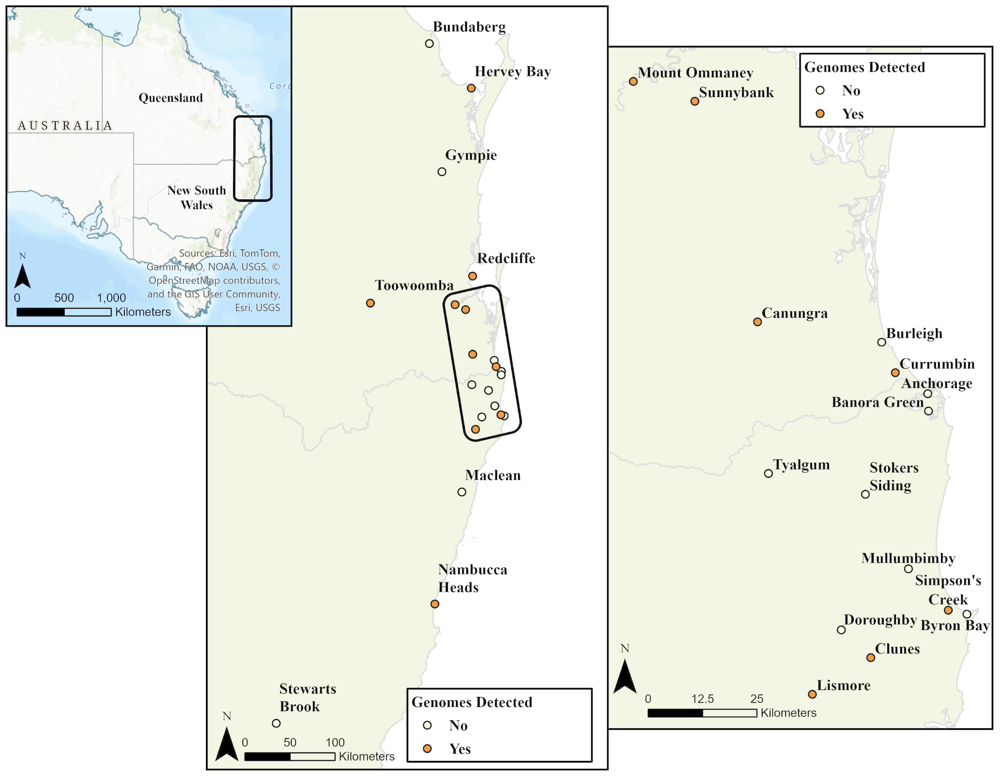
Supplementary Fig. 1: Maps of the study area and bat sampling locations. Left: Eastern Australia, with the study area for bat sample collection highlighted by the black rectangle. Centre: Study area, showing bat sample collection sites (brown circles). Right: Enlarged view of a subset of bat sampling locations from the area highlighted in the center map.

Supplementary Fig. 2: Genetic variation and base composition in HeV-g1. The genome organization of HeV-g1 and the relative position of each gene are shown at the top of the graph. The genetic variation in the HeV-g1 genome was determined by plotting the average nucleotide identity of 100 bases using a sliding window in steps of 5 bases (left y axis, colored brown) across the genome (x axis). Genome base composition also was plotted using a sliding window that calculated the average GC content over 100 bases in steps of 5 bases (right y axis, colored blue).

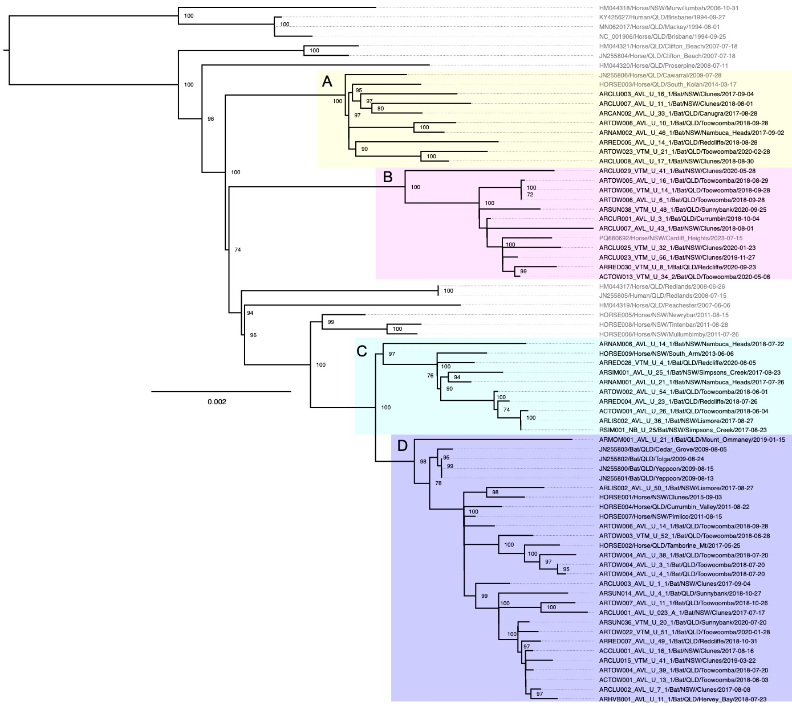

Supplementary Fig. 3: Whole genome phylogeny of HeV-g1. Of the 72 genomes used in the phylogeny, 57 were newly generated in this study. The alignments were built with MAFFT (FFT-NS-1 algorithm (26), with the best model for distance estimates identified with the ModelFinder function (27) as the one with the lowest Bayesian information criterion (BIC). Maximum likelihood phylogenetic tree was constructed using IG-TREE2 (28) and branch support was assessed using both ultrafast bootstrap approximation (ufBoot, 1000 replicates) (29) and SH-like approximate likelihood ratio test (SH-aLRT). The tree was visualized in FigTree (http://tree.bio.ed.ac.uk/software/figtree/), and midpoint rooted for purposes of clarity. Only bootstrap support values greater of 69 are shown. Bars indicate nucleotide substitutions per site.
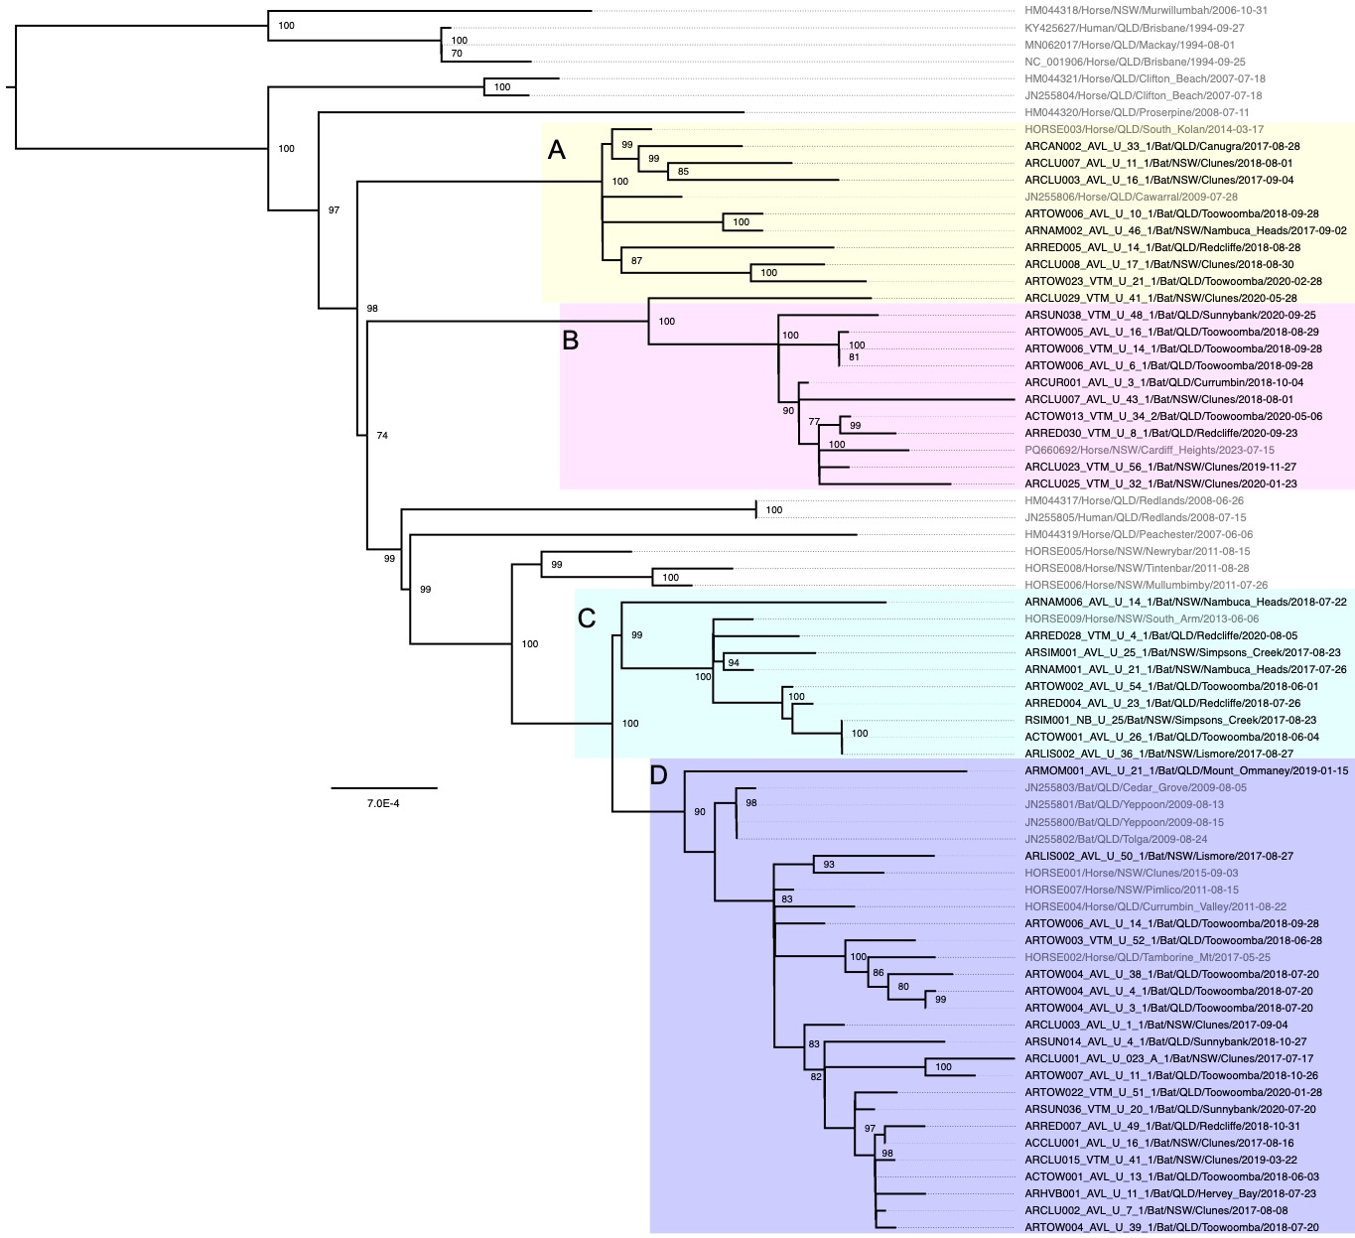
Supplementary Fig. 4: Coding sequence phylogeny of HeV-g1. Of the 72 genomes used in the phylogeny, 57 were newly generated in this study. The alignment was built with MAFFT (FFT-NS-1 algorithm (26), with the best model for distance estimates identified with the ModelFinder function (27) as the one with the lowest Bayesian information criterion (BIC). Maximum likelihood phylogenetic tree was constructed using IG-TREE2 (28) and branch support was assessed using both ultrafast bootstrap approximation (ufBoot, 1000 replicates) (29) and SH-like approximate likelihood ratio test (SH-aLRT). The tree was visualized in FigTree (http://tree.bio.ed.ac.uk/software/figtree/), and midpoint rooted for purposes of clarity. Only bootstrap support values greater of 69 are shown. Bars indicate nucleotide substitutions per site.

Supplementary Fig. 5: HeV-g1 clades circulating in Australia between 1994 and 2020. (a) Clade distribution by month and year. (b) The cumulative total distribution of the identified clades at specific points in time. (c) A series of time-ordered snapshots indicating the spatial distribution of identified clades at different points in time. (d) The cumulative clade distribution in September 2020; arrows indicate potential migration paths. An arrow is drawn if the same clade was detected at a different location in the month prior. We did not include 2023 horse sequence in this analysis.

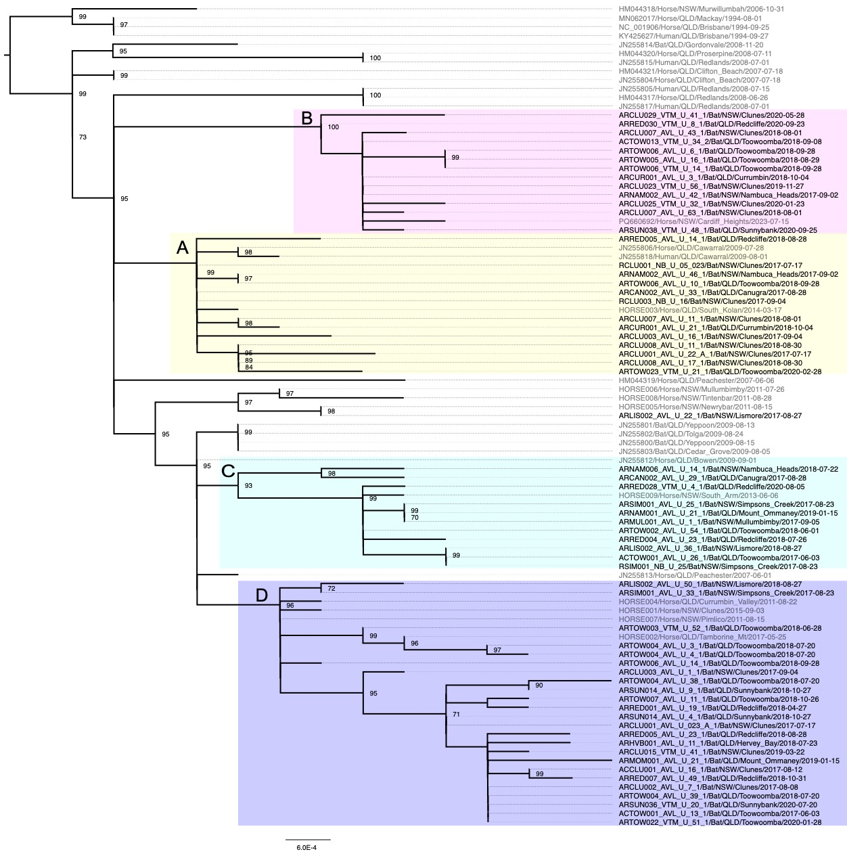

Supplementary Fig. 6: Glycoprotein G sequence phylogeny of HeV-g1. The alignment was built with MAFFT (FFT-NS-1 algorithm (26), and the best model for distance estimates identified with the ModelFinder function (27) as the one with the lowest Bayesian information criterion (BIC). Maximum likelihood phylogenetic tree was constructed using IG-TREE2 (28) and branch support was assessed using both ultrafast bootstrap approximation (ufBoot, 1000 replicates) (29) and SH-like approximate likelihood ratio test (SH-aLRT). The tree was visualized in FigTree (http://tree.bio.ed.ac.uk/software/figtree/), and midpoint rooted for purposes of clarity. Only bootstrap support values greater of 69 are shown. Bars indicate nucleotide substitutions per site.

Supplementary Fig. 7: Temporal signal in the HeV-g1 sequence data. (a) whole genome sequence, (b) coding sequence, (c) complete G gene. The root-to-tip genetic distances from the ML phylogeny were plotted against sampling time, and a linear regression was performed to compare the clock-like structure.

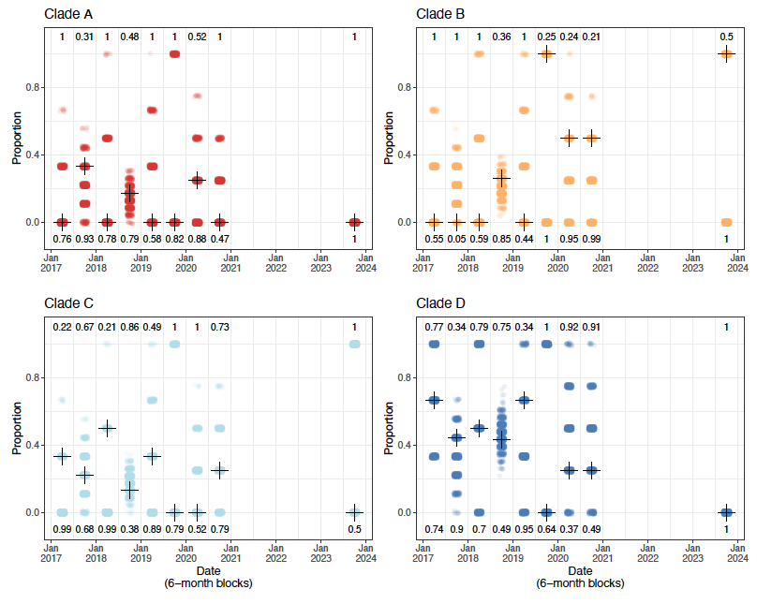

Supplementary Fig. 8: Temporal structure using permutations methods. Permuted and observed (black plus sign) relative proportions of clade samples for each 6-month period. Numbers at the top and bottom are the proportions of permuted values ≥ and ≤ observed value, respectively.

Supplementary Fig. 9: Clade-defining mutations are depicted in an AlphaFold model of protein V as van der Waals spheres. Backbone atoms C, O, and N are omitted. The clade defining mutations, including P352S in clade B, are highlighted with a bold label. The protein backbone is colored to reflect the predicted local model quality score, pLDDT (2), ranging from 0-100 (red-blue).

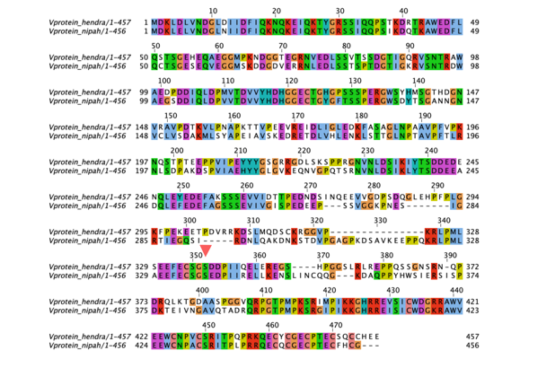
Supplementary Fig. 10: V protein sequence alignment of HeV and NiV. In a sequence alignment of the V protein, the proximal regions flanking position 352 (indicated by the red arrow) are highly conserved between HeV and Nipah virus (NiV) with S being present at this position in NiV.

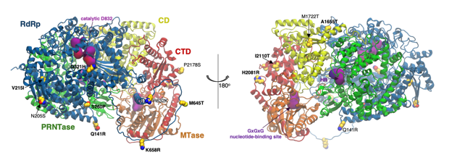
Supplementary Fig. 11: Structure prediction and potential effect of clade defining mutations in the L-protein. Persistent mutations in the HeV L protein are depicted as van der Waals spheres (yellow carbons) on its AlphaFold model, represented as ribbons. Backbone atoms C, O, and N are omitted. The clade-defining mutations are highlighted with a bold label. The protein domains were inferred based on the structural alignment with the parainfluenza virus 5 (PIV5) L protein (PDB ID: 6V85 (30)) and based on the UniProt annotation for HeV L (ID: O89344). The RNA-dependent RNA-polymerase (RdRp) domain is shown in blue, the polyribonuleotidyl-transferase (PRNTase) domain, in green, the connector domain (CD), in yellow, the methyltranferase (MTase) domain in orange, and the C-terminal domain (CTD), in red. The catalytic residues in RdRp (D832) and in PRNTase (H1347, R1348), and the conserved GxGxG motif that is the hallmark of the nucleotide-binding site in MTase were inferred based on the respiratory syncytial virus L protein (31) and are represented as violet surfaces.

References
1. B. Mateos et al., The Ambivalent Role of Proline Residues in an Intrinsically Disordered Protein: From Disorder Promoters to Compaction Facilitators. J Mol Biol 432, 3093-3111 (2020).
2. V. Mariani, M. Biasini, A. Barbato, T. Schwede, lDDT: a local superposition-free score for comparing protein structures and models using distance difference tests. Bioinformatics 29, 2722-2728 (2013).
3. D. H. Kim, K. H. Han, Transient Secondary Structures as General Target-Binding Motifs in Intrinsically Disordered Proteins. Int J Mol Sci 19 (2018).
4. E. Salladini et al., Identification of a Region in the Common Amino-terminal Domain of Hendra Virus P, V, and W Proteins Responsible for Phase Transition and Amyloid Formation. Biomolecules 11 (2021).
5. M. Gao, D. Nakajima An, J. M. Parks, J. Skolnick, AF2Complex predicts direct physical interactions in multimeric proteins with deep learning. Nat Commun 13, 1744 (2022).
6. T. Ibrahim et al., AlphaFold2-multimer guided high-accuracy prediction of typical and atypical ATG8-binding motifs. PLoS Biol 21, e3001962 (2023).
7. A. Bankevich et al., SPAdes: a new genome assembly algorithm and its applications to single-cell sequencing. J Comput Biol 19, 455-477 (2012).
8. S. Kuhn, P. Schaughency (2022) OpenOmics/metavirs:v1.0.0.
9. B. Langmead, S. L. Salzberg, Fast gapped-read alignment with Bowtie 2. Nat Methods 9, 357-359 (2012).
10. P. Danecek et al., Twelve years of SAMtools and BCFtools. Gigascience 10 (2021).
11. A. McKenna et al., The Genome Analysis Toolkit: a MapReduce framework for analyzing next-generation DNA sequencing data. Genome Res 20, 1297-1303 (2010).
12. H. Li, A statistical framework for SNP calling, mutation discovery, association mapping and population genetical parameter estimation from sequencing data. Bioinformatics 27, 2987-2993 (2011).
13. R. D. C. Team (2023) R: A language and Environment for Statistical computing. (R Foundation for Statistical Computing).
14. H. Wickham et al., Welcome to the Tidyverse. 10.21105/joss.01686 (2019).
15. S. M. Bache, H. Wickham, magrittr: A Forward-Pipe Operator for R. (2022).
16. O. S. C. by Richard A. Becker, A. R. W. R. V. b. R. B. E. by Thomas P Minka, A. Deckmyn, maps: Draw Geographical Maps. (2022).
17. D. M. P. F. R. by Ray Brownrigg, T. P. Minka, T. t. P. C. by Roger Bivand, mapproj: Map Projections. (2023).
18. M. Sumner, ozmaps: Australia Maps. (2021).
19. E. Pebesma, R. Bivand, Spatial Data Science: With applications in R. 10.1201/9780429459016 (2023).
20. E. Pebesma, Simple Features for R: Standardized Support for Spatial Vector Data. The R Journal 10, 439-446 (2018).
21. G. Yu, scatterpie: Scatter Pie Plot. (2023).
22. H. Wickham, stringr: Simple, Consistent Wrappers for Common String Operations. (2022).
23. E. Campitelli, ggnewscale: Multiple Fill and Colour Scales in 'ggplot2'. (2023).
24. T. L. Pedersen, ggforce: Accelerating 'ggplot2'. (2022).
25. D. Dunnington, ggspatial: Spatial Data Framework for ggplot2. (2023).
26. K. Katoh, D. M. Standley, MAFFT multiple sequence alignment software version 7: improvements in performance and usability. Mol Biol Evol 30, 772-780 (2013).
27. S. Kalyaanamoorthy, B. Q. Minh, T. K. F. Wong, A. von Haeseler, L. S. Jermiin, ModelFinder: fast model selection for accurate phylogenetic estimates. Nat Methods 14, 587-589 (2017).
28. B. Q. Minh et al., IQ-TREE 2: New Models and Efficient Methods for Phylogenetic Inference in the Genomic Era. Molecular Biology and Evolution 37, 1530-1534 (2020).
29. D. T. Hoang, O. Chernomor, A. von Haeseler, B. Q. Minh, L. S. Vinh, UFBoot2: Improving the Ultrafast Bootstrap Approximation. Mol Biol Evol 35, 518-522 (2018).
30. R. Abdella, M. Aggarwal, T. Okura, R. A. Lamb, Y. He, Structure of a paramyxovirus polymerase complex reveals a unique methyltransferase-CTD conformation. Proc Natl Acad Sci U S A 117, 4931-4941 (2020).
31. P. Sutto-Ortiz, J. F. Eléouët, F. Ferron, E. Decroly, Biochemistry of the Respiratory Syncytial Virus L Protein Embedding RNA Polymerase and Capping Activities. Viruses 15 (2023).

