Association of Physical Activity from Wearable Devices and Chronic Disease Risk: Insights from the All of Us Research Program
Yu Hou^{1,2}, Erjia Cui³, Kelvin Lim⁴, Lisa Chow⁵, Michael Howell⁶, Sayeed Ikramuddin² and Rui Zhang^{1,2,7}
¹Division of Computational Health Sciences, University of Minnesota, Minneapolis, Minnesota, USA
²Department of Surgery, University of Minnesota, Minneapolis, Minnesota, USA
³Division of Biostatistics & Health Data Science, University of Minnesota, Minneapolis, Minnesota, USA
⁴Department of Psychiatry & Behavioral Sciences, University of Minnesota Medical School, Minneapolis, Minnesota, USA
⁵Division of Diabetes, Endocrinology and Metabolism, Department of Medicine, University of Minnesota, Minneapolis, Minnesota, USA
⁶Department of Neurology, University of Minnesota, Minneapolis, Minnesota, USA
⁷Center for Learning Health System Sciences, University of Minnesota, Minneapolis, Minnesota, USA
Corresponding Author: Rui Zhang, PhD, Division of Computational Health Sciences, University of Minnesota, Minneapolis, Minnesota, USA (ruizhang@umn.edu)

Supplementary Figures
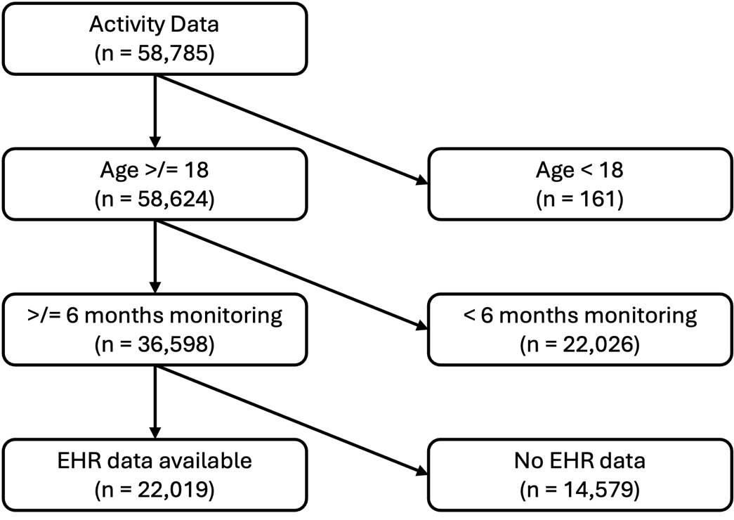
Supplementary Figure. 1 Inclusion/exclusion cascade of patients in the dataset.
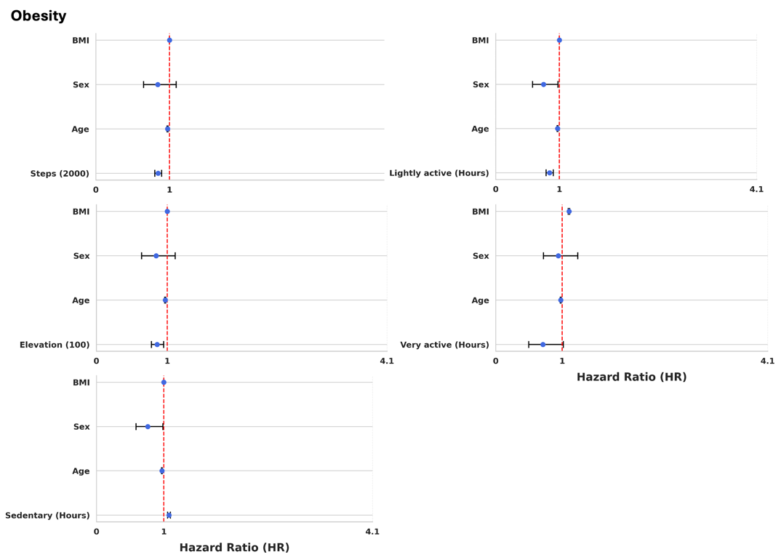
Supplementary Figure. 2 Forest plots from Cox proportional hazard models for associations between Fitbit activity metric and obesity.
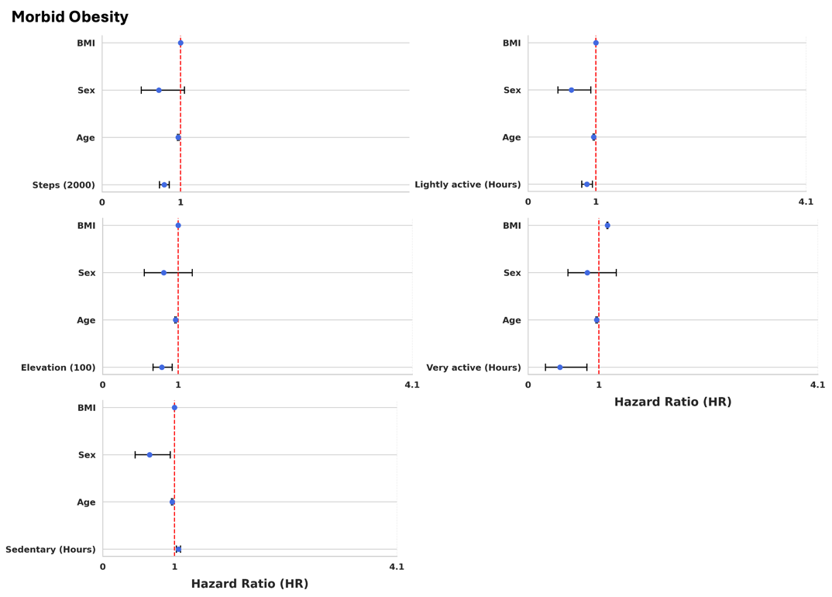
Supplementary Figure. 3 Forest plots from Cox proportional hazard models for associations between Fitbit activity metric and morbid obesity.
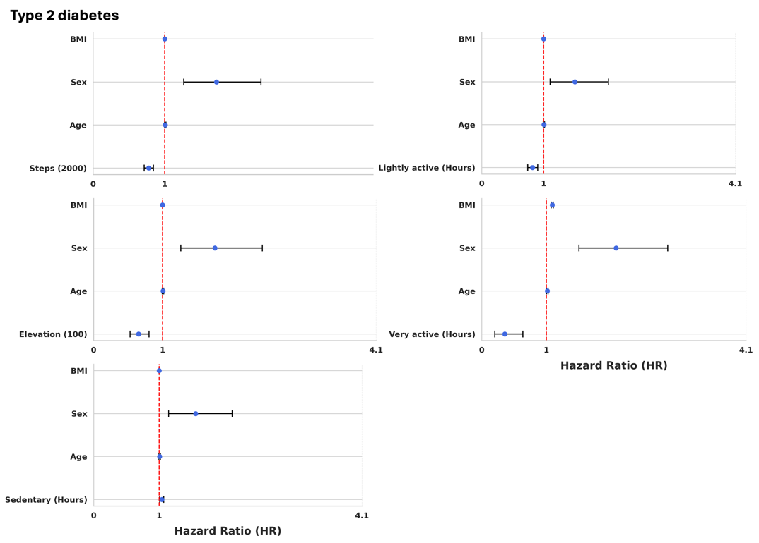
Supplementary Figure. 4 Forest plots from Cox proportional hazard models for associations between Fitbit activity metric and Type 2 diabetes.
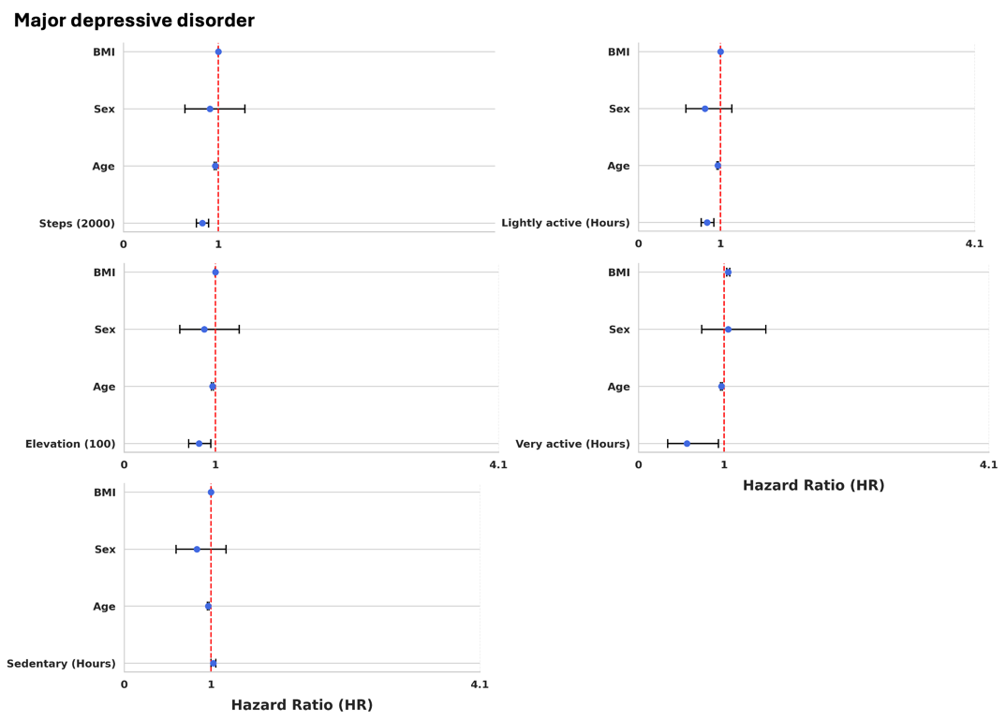
Supplementary Figure. 5 Forest plots from Cox proportional hazard models for associations between Fitbit activity metric and major depressive disorder.
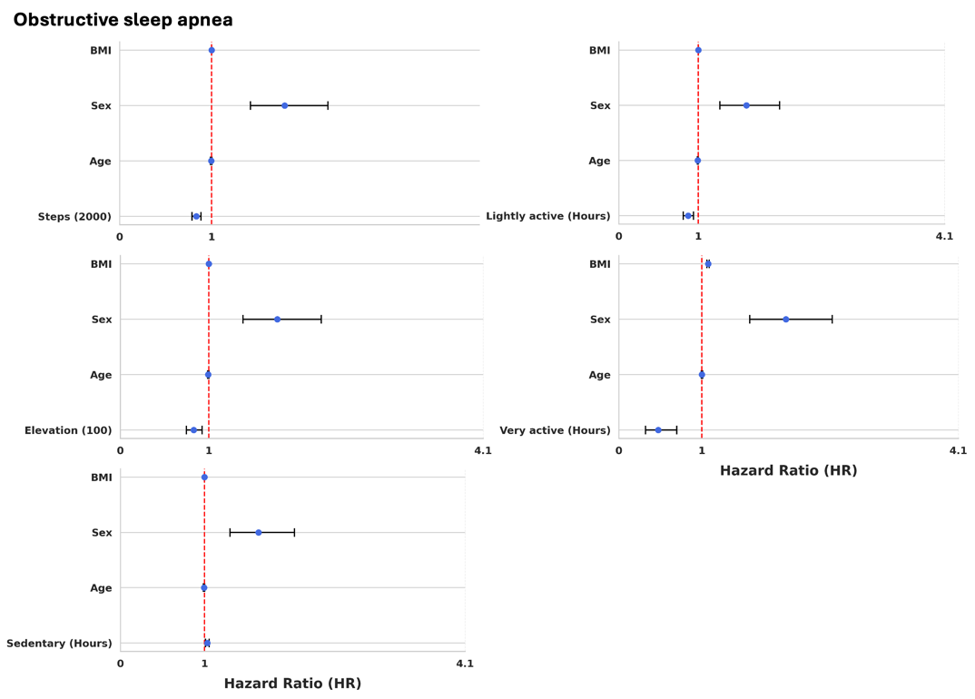
Supplementary Figure. 6 Forest plots from Cox proportional hazard models for associations between Fitbit activity metric and obstructive sleep apnea.
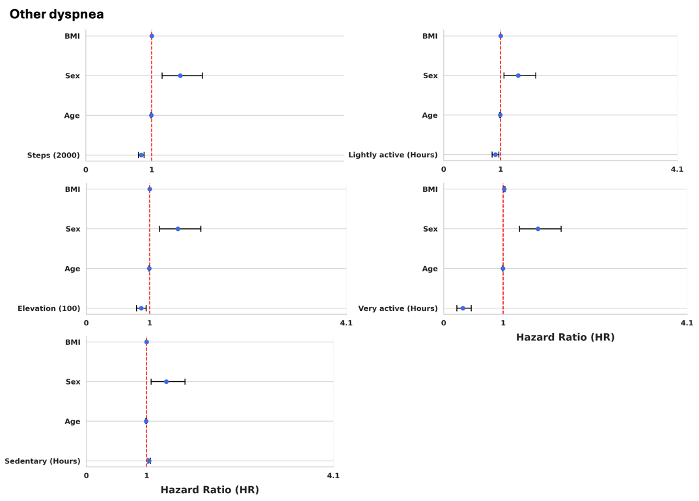
Supplementary Figure. 7 Forest plots from Cox proportional hazard models for associations between Fitbit activity metric and other dyspnea.
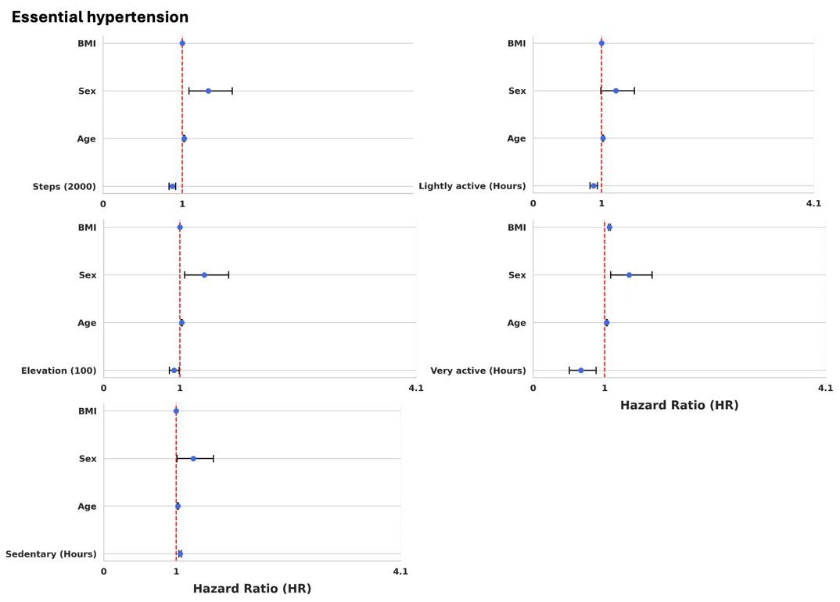
Supplementary Figure. 8 Forest plots from Cox proportional hazard models for associations between Fitbit activity metric and essential hypertension.
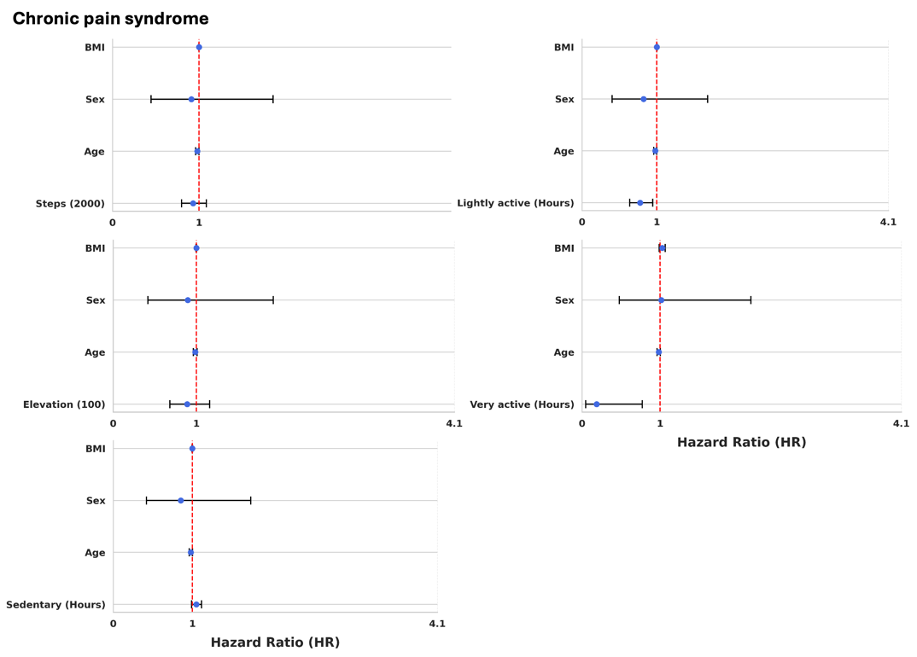
Supplementary Figure. 9 Forest plots from Cox proportional hazard models for associations between Fitbit activity metric and chronic pain syndrome.
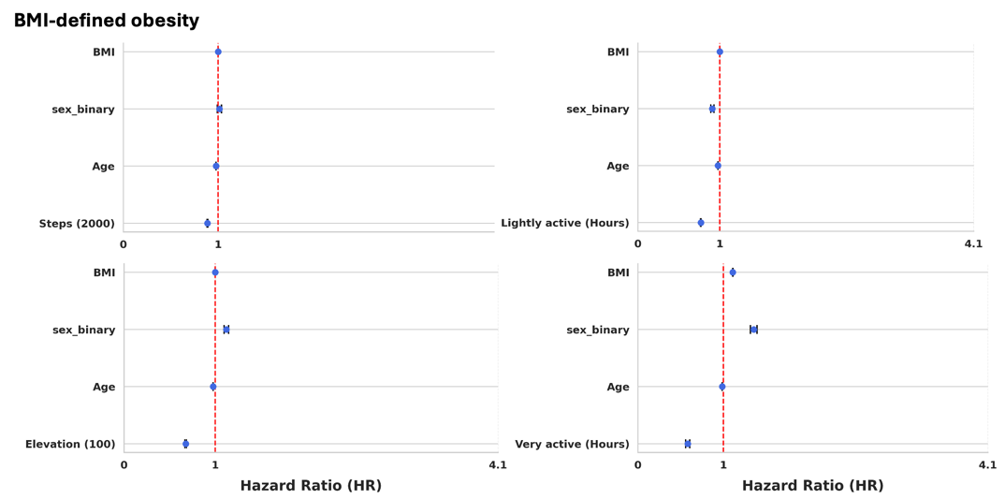
Supplementary Figure. 10 Forest plots from Cox proportional hazard models for associations between Fitbit activity metric and BMI-defined obesity.

