Digitally Immune-Optimised Next-Generation Influenza H5Nx Vaccination Provides Protection with Broad Cross-Clade Neutralisation Against Global Threats.
Joanne Marie M. Del Rosario¹, Sneha Vishwanath², Simon Frost^{1,3,4}, Sneha B. Sujit¹, Sruthika K. Ashokan¹, Matteo Ferrari¹, George William Carnell^{1,2}, Lucrezia Vianello⁵,
Matteo Pagliari^{5,6}, Sami Ramzi^{5,7}, Valentina Maria Panzarin⁵, Elisa Mazzacan⁵,
Andrea Fortin⁵, Marta Vascellari⁸, Paul Tonks², Ana Liza Ortiz⁹, Chloe Huang², Sebastian Einhauser¹⁰, Michael Schachtner¹⁰, Benedikt Asbach¹⁰, Nigel J. Temperton¹¹, Ron Moss¹, Matthew Davies¹, David Moss¹, Rebecca Kinsley^{1,2}, Ralf Wagner^{1,0,12},
Francesco Bonfante⁵, and Jonathan L. Heeney^{1,2}

¹DIOSynVax, Madingley Road, Cambridge, United Kingdom
²Lab of Viral Zoonotics, Department of Veterinary Medicine, University of Cambridge, Cambridge, United Kingdom
³London School of Hygiene and Tropical Medicine, London, UK
⁴Microsoft Health Futures, Redmond, WA, USA
⁵Division of Comparative Biomedical Sciences, Istituto Zooprofilattico Sperimentale delle Venezie (IZSVe), Legnaro Padua, Italy
⁶Department for Women’s and Children’s Health, University of Padua, Padova, Italy
⁷Department of Animal Medicine, Production and Health, University of Padua, Legnaro, Italy
⁸Diagnostic Services Histopathology and Parasitology Department and Animal Experimentation and Welfare Division, Istituto Zooprofilattico Sperimentale delle Venezie (IZSVe), Legnaro Padua, Italy
⁹Department of Veterinary Medicine, University of Cambridge, Cambridge, United Kingdom
¹⁰Institute of Medical Microbiology and Hygiene, University of Regensburg, Regensburg, Germany
¹¹Viral Pseudotype Unit, Medway School of Pharmacy, The Universities of Greenwich and Kent at Medway, Chatham, United Kingdom
¹²Institute of Clinical Microbiology & Hygiene, University Hospital, University of Regensburg, Regensburg, Germany

*Correspondence: Jonathan Heeney, jlh66@cam.ac.uk

Supplementary File
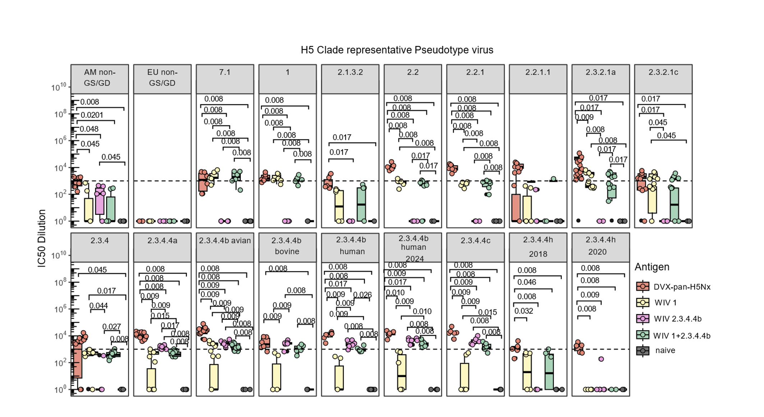
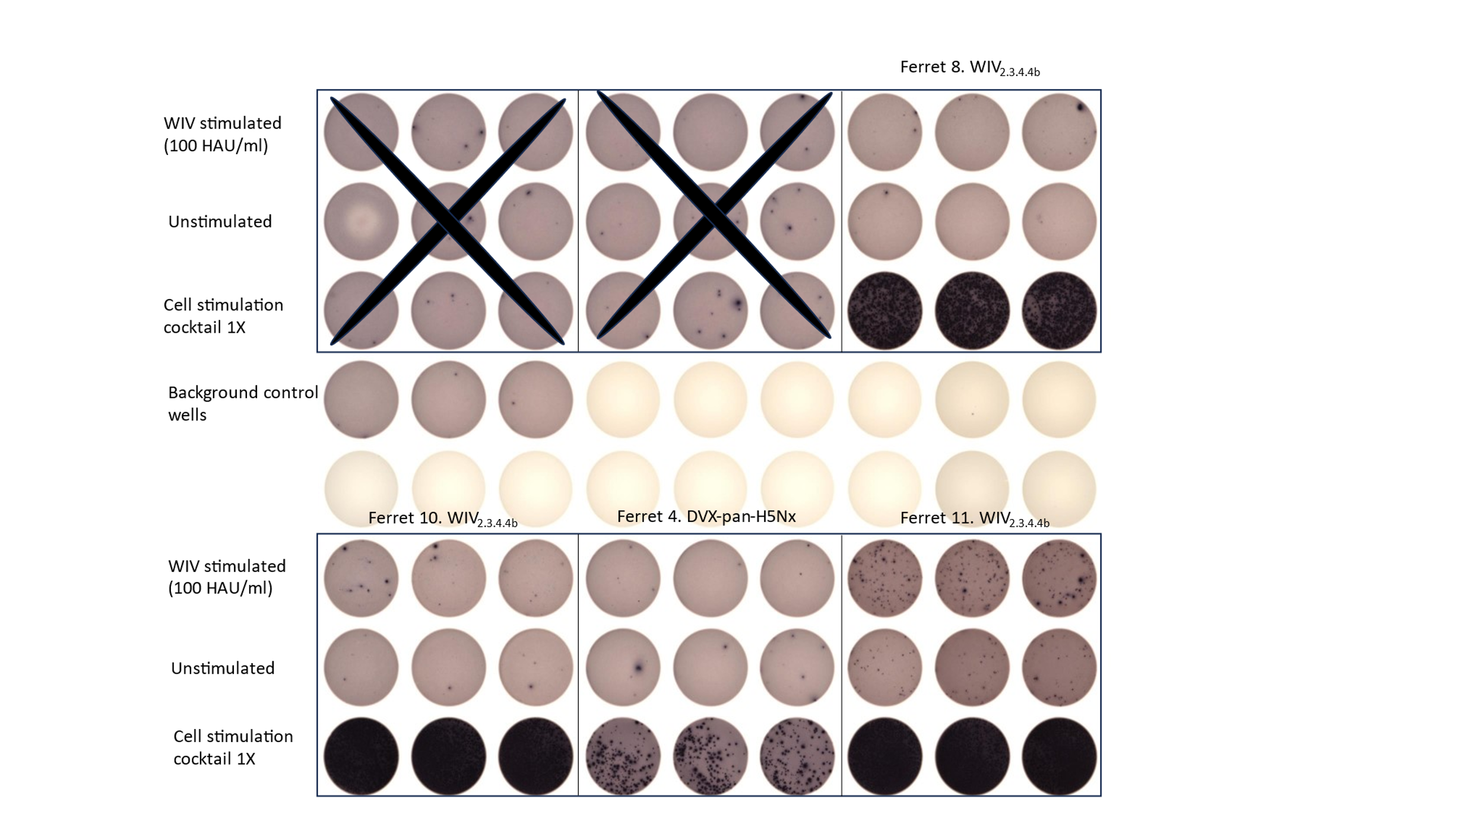
Supplementary Figure 1. Immunogenicity profile of the DVX-pan-H5Nx and WIVs in BALB/c mice.
Neutralising titres as shown by terminal bleed serum IC₅₀ (half-maximal dilution resulting in 50% neutralisation) values against a H5 pseudotype virus panel (Supplementary Table 4). The mice (n=6 per vaccination group) were immunised as per Supplementary Table 3. Dashed line indicates an IC₅₀ value of 1000. Statistical significance shown by the indicated p values was determined via two-way Wilcoxon rank test with Benjamini-Hochberg correction.

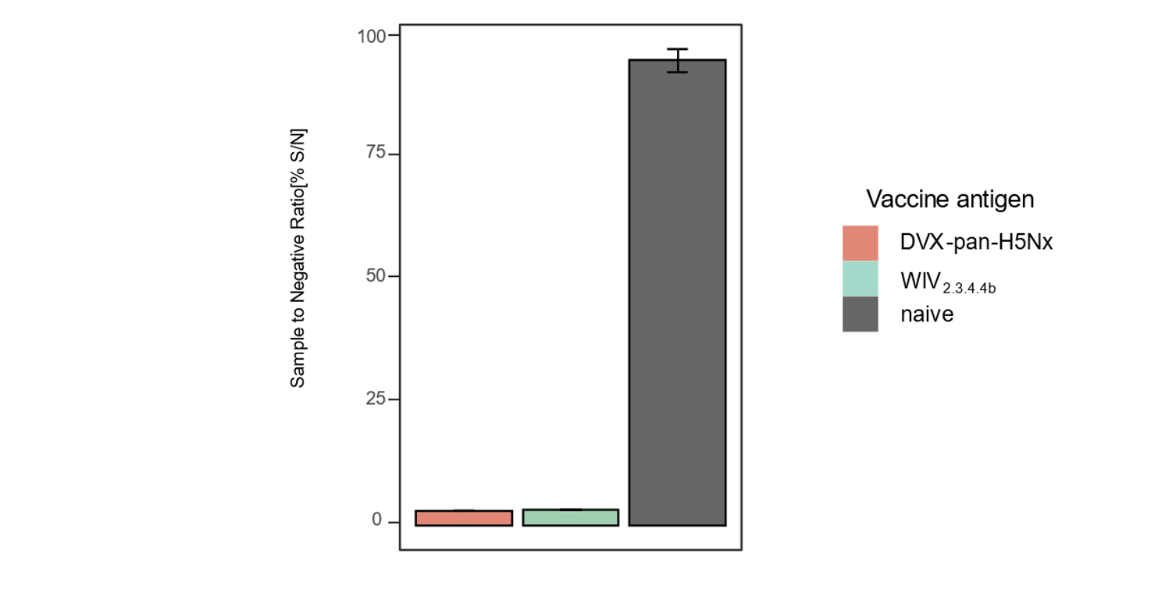

Supplementary Figure 2. Competition ELISA to detect binding antibodies in ferret serum samples on day 42.
Ferret serum samples were assessed by an ID Screen® Influenza H5 Antibody Competition ELISA. Competition is indicated by percent Sample to Negative Ratio (S/N %). Results over the 50% threshold are considered negative.

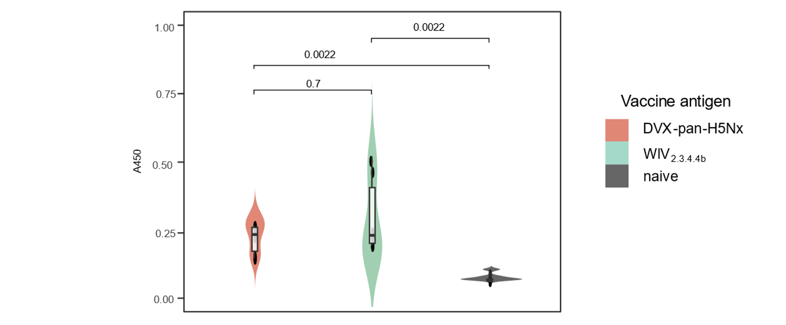

Supplementary Figure 3. Indirect ELISA to detect binding antibodies in ferret serum samples on day 42.
Ferret serum samples used to detect binding antibodies as shown by Absorbance at 450 nm (y axis) against avian H5 from all vaccine groups were detected via an ID Screen® Influenza H5 Indirect ELISA. Statistical significance shown by the indicated p values was determined via two-way Wilcoxon rank test with Benjamini-Hochberg correction.

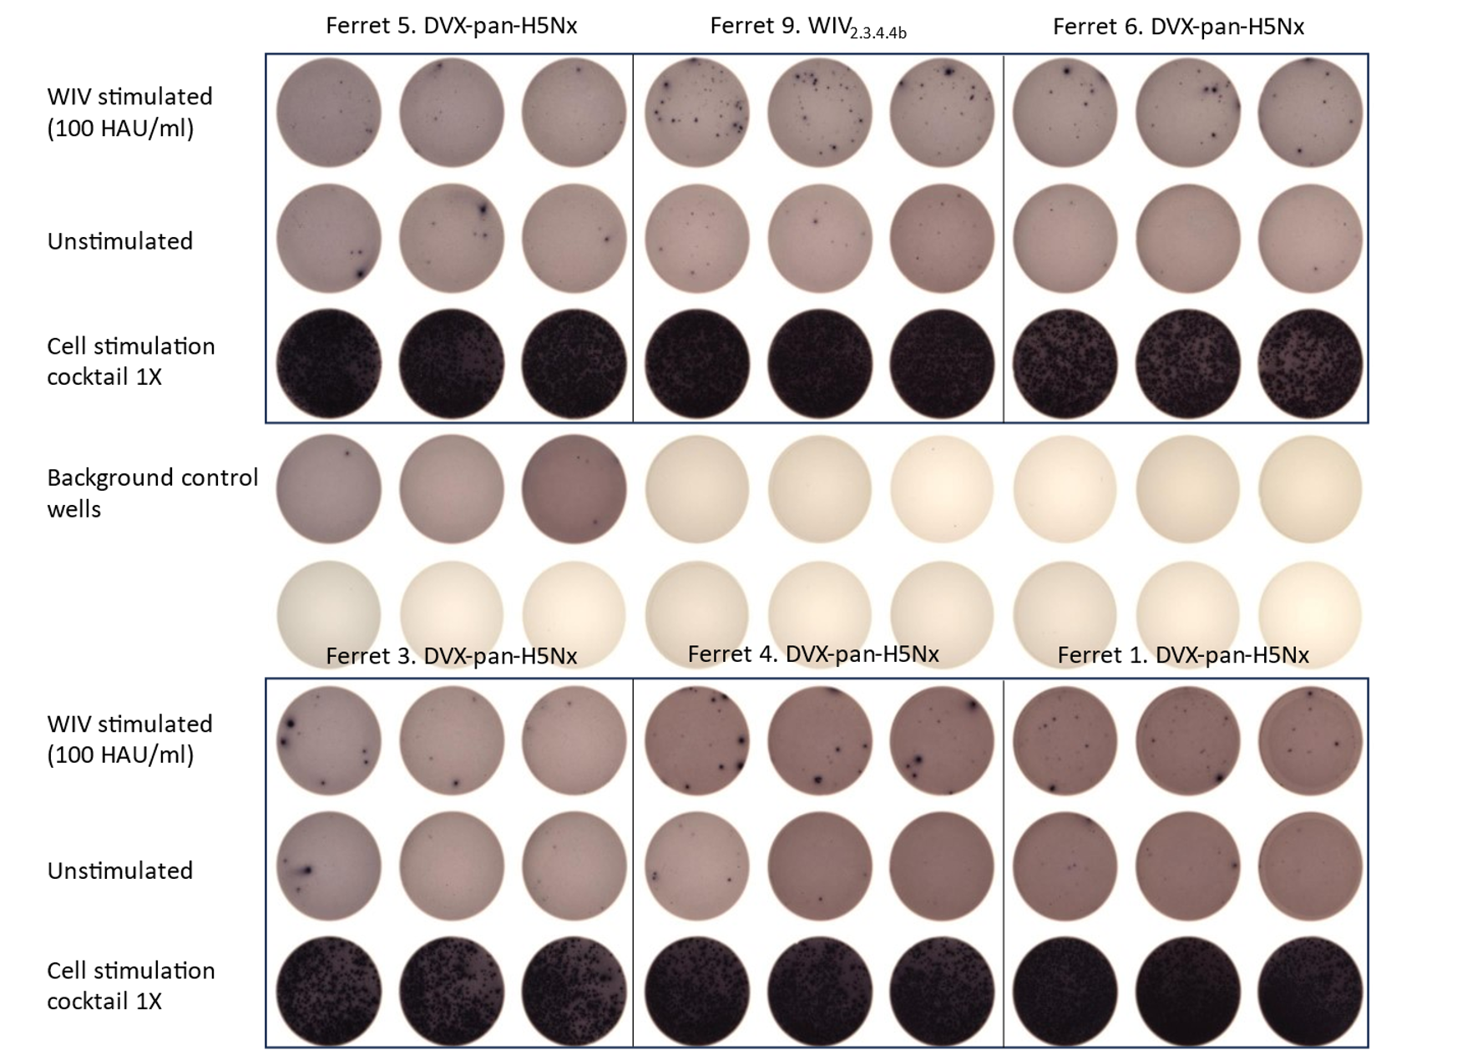

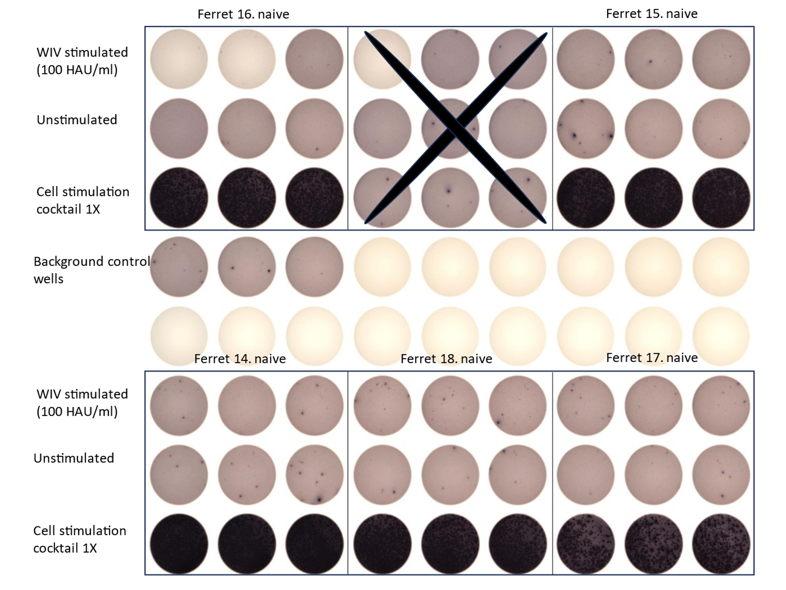

Supplementary Figure 4. Determination of T cell response in ferrets on day 42 by ELISpot.
Representative wells showing the absence or presence of spot-forming units (SFU) are presented here to evaluate the induction of T-cell responses due to stimulation with whole inactivated challenge virus (WIV_{stimulated}), A/chicken/Italy/23VIR3799-1/2023 (H5N1). Wells marked with cross could not be read due to technical error
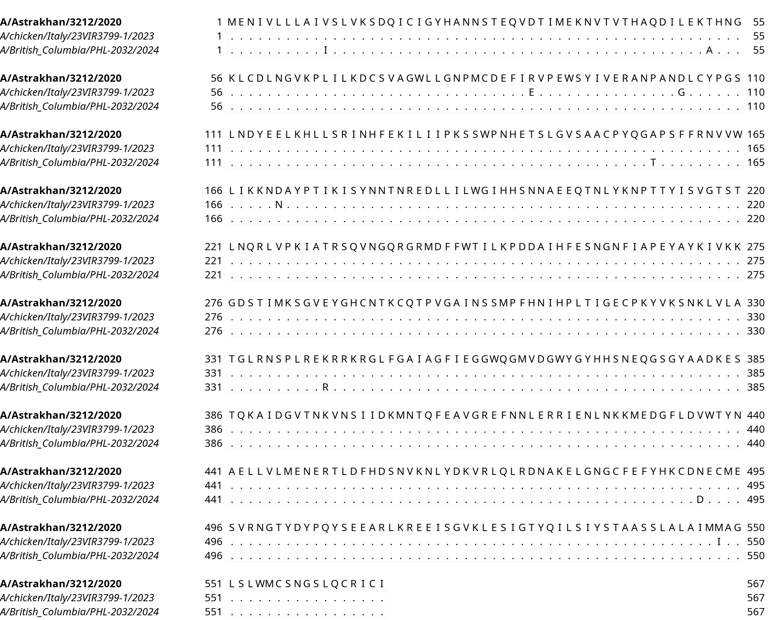
Supplementary Figure 5. Multiple Sequence alignment of selected relevant H5 2.3.4.4b HA sequences.
Multiple sequence alignment of HA sequences from strains A/Astrakhan/3212/2020 (H5N8) (clade 2.3.4.4b), A/chicken/Italy/23VIR3799-1/2023 (H5N1) (clade 2.3.4.4b), and A/British Columbia/PHL-2032/2024 (H5N1) (clade 2.3.4.4b) are shown. The top sequence is used as reference and the conserved amino acids in the rest of the sequences are represented as dots. The alignment was generated using Mafft.

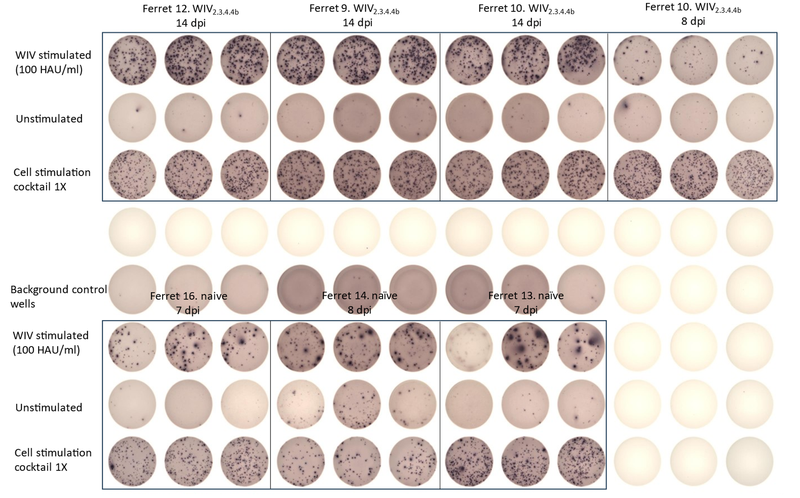
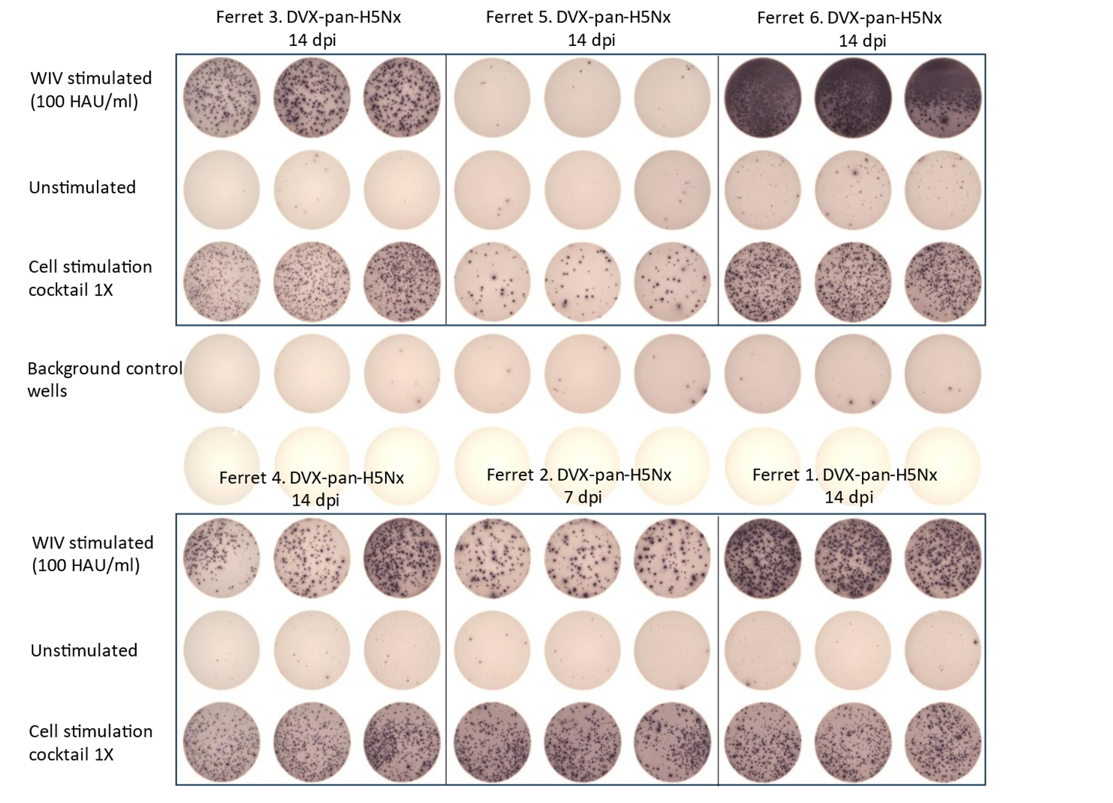
Supplementary Figure 6. Determination of T cell response in ferrets post-challenge (on the day of culling) by ELISpot.
Representative wells showing the absence or presence of spot-forming units (SFU) are presented here to evaluate the induction of T-cell responses due to stimulation with whole inactivated challenge virus (WIV_{stimulated}), A/chicken/Italy/23VIR3799-1/2023 (H5N1). The T cell responses were evaluated at different time points during the challenge window as indicated.
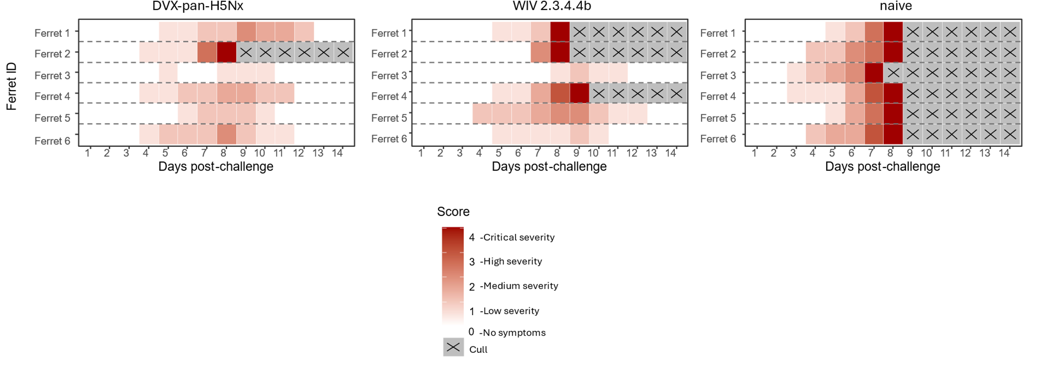

Supplementary Figure 7. Clinical scoring of ferrets during challenge window.
Clinical signs of infection in ferrets were recorded twice daily during the challenge window. Parameters such as i) Alertness, ii) Breathing, iii) Ocular and Nasal discharge, and iv) Appetite were observed, with a Clinical Score of 0 given to ferrets with no symptoms, and 4 to ferrets with severe symptoms resulting in culling (indicated by X) as humane endpoints were reached.
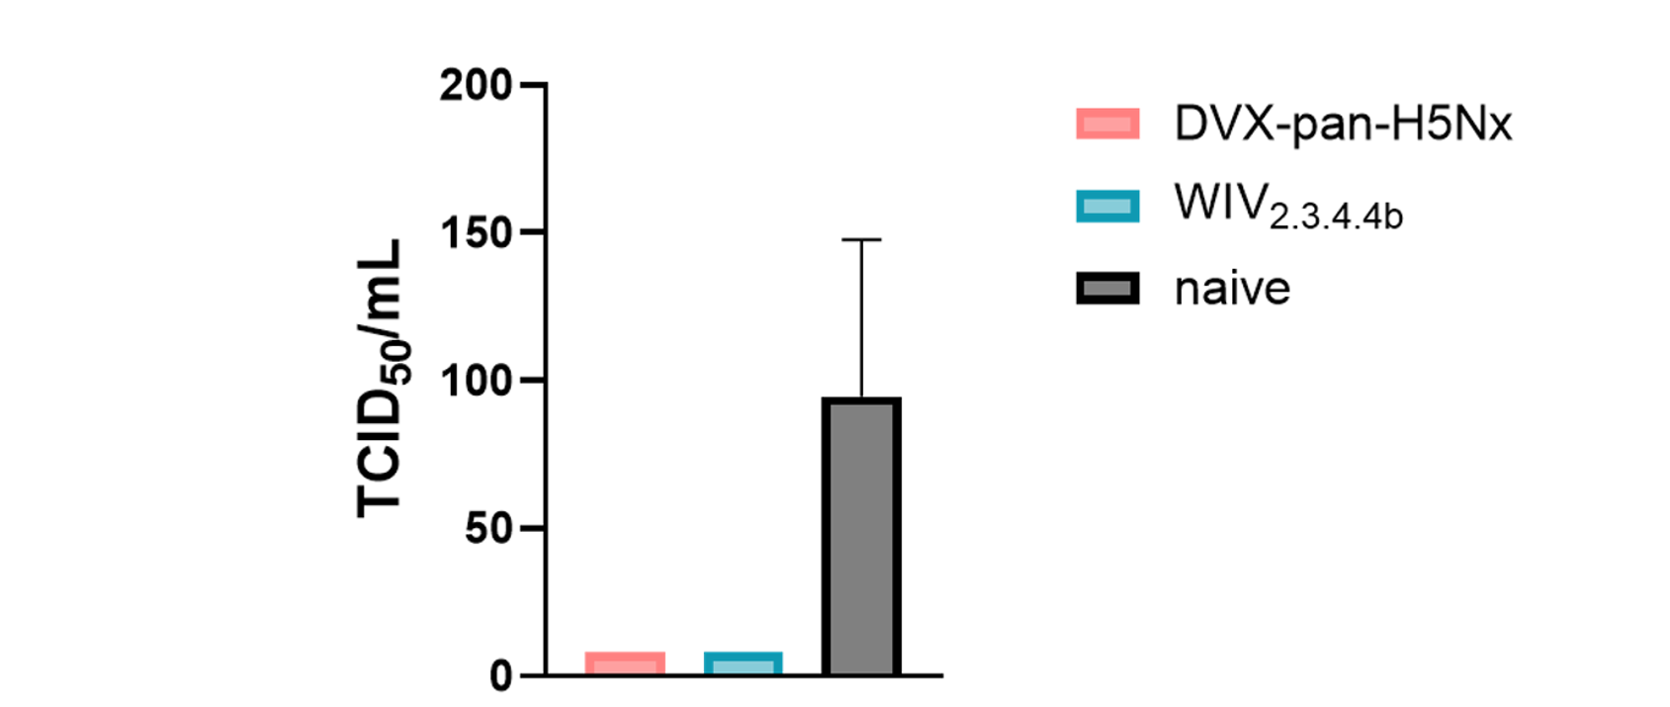
Supplementary Figure 8. Evaluation of viral titres via 50% tissue culture infectious dose (TCID₅₀) obtained from harvested ferret lung tissues post challenge.
Viral titres determined from homogenised lung tissues post challenge with A/chicken/Italy/23VIR3799-1/2023 (H5N1) (clade 2.3.4.4b). Representative viral titres indicated as TCID₅₀/mL on y axis and vaccinated groups on x axis. The plot shows median with interquartile range of individual ferret samples (n=6 per vaccination group). No statistical significance was observed in the recovered viral titres between vaccinated groups and naive groups as determined by Wilcoxon rank test with Benjamini-Hochberg correction (p>0.05).

Supplementary Table 1. Accession id of the HA sequences used to generate Figure 1.

Strain | Subtype | Clade | Accession ID
A/swine/Mexico/GtoDMZC02/2014 | H5N2 | AM non-Gs/GD | EPI837661
A/HongKong/483/1997 | H5N1 | 0 | EPI4349
A/HongKong/481/1997 | H5N1 | 0 | EPI4347
A/HongKong/156/1997 | H5N1 | 0 | EPI4186
A/HongKong/4847232/1997 | H5N1 | 0 | EPI1328385
A/HongKong/97/1998 | H5N1 | 0 | EPI5495
A/swine/Shandong/2/2003 | H5N1 | 0 | EPI22691
A/HongKong/213/2003 | H5N1 | 1 | EPI1161
A/Thailand/16/2004 | H5N1 | 1 | EPI152380
A/Thailand/5(KK-494)/2004 | H5N1 | 1 | EPI21925
A/Vietnam/CL02/2004 | H5N1 | 1 | EPI228832
A/Thailand/NKNPHA/2005 | H5N1 | 1 | EPI226841
A/Cambodia/JP52a/2005 | H5N1 | 1 | EPI115185
A/Cambodia/S1211394/2008 | H5N1 | 1.1.1 | EPI284001
A/Cambodia/V0606311/2011 | H5N1 | 1.1.1 | EPI341364
A/Cambodia/U0417030/2010 | H5N1 | 1.1.2 | EPI341369
A/Cambodia/V0203306/2011 | H5N1 | 1.1.2 | EPI341368
A/Cambodia/W0329318/2012 | H5N1 | 1.1.2 | EPI542914
A/Cambodia/W0526301/2012 | H5N1 | 1.1.2 | EPI542922
A/Cambodia/X0502302/2013 | H5N1 | 1.1.2 | EPI542964
A/Cambodia/X0628313/2013 | H5N1 | 1.1.2 | EPI531266
A/Cambodia/Y0304301/2014 | H5N1 | 1.1.2 | EPI956090
A/Cambodia/Y0314301/2014 | H5N1 | 1.1.2 | EPI957382
A/Cambodia/Y0305306/2014 | H5N1 | 1.1.2 | EPI956098
A/swine/Banten/UT3062/2005 | H5N1 | 2.1.1 | EPI271674
A/swine/EastJava/UT6003/2006 | H5N1 | 2.1.3 | EPI271706
A/Indonesia/CDC624E/2006 | H5N1 | 2.1.3.2 | EPI41668
A/Indonesia/CDC739/2006 | H5N1 | 2.1.3.2 | EPI41915
A/Indonesia/CDC610/2006 | H5N1 | 2.1.3.2 | EPI41592
A/Indonesia/NIHRD10459/2010 | H5N1 | 2.1.3.2 | EPI1377636
A/Indonesia/NIHRD14122/2014 | H5N1 | 2.1.3.2a | EPI531959
A/Indonesia/NIHRD9160/2009 | H5N1 | 2.1.3.2b | EPI1377772
A/Indonesia/NIHRD11931/2012 | H5N1 | 2.1.3.2b | EPI356472
A/cat/Dagestan/87/2006 | H5N1 | 2.2 | EPI106416
A/Azerbaijan/2-115/2006 | H5N1 | 2.2 | EPI124626
A/Azerbaijan/6-207/2006 | H5N1 | 2.2 | EPI124618
A/Azerbaijan/11-162/2006 | H5N1 | 2.2 | EPI124622
A/Azerbaijan/1-161/2006 | H5N1 | 2.2 | EPI124624
A/domesticcat/Iraq/820/2006 | H5N1 | 2.2 | EPI102988
A/Iraq/207-NAMRU3/2006 | H5N1 | 2.2 | EPI102992
A/Iraq/756/2006 | H5N1 | 2.2 | EPI124632
A/Iraq/1/2006 | H5N1 | 2.2 | EPI124616
A/cat/Romania/TL/2007 | H5N1 | 2.2 | EPI221713
A/Egypt/902782/2006 | H5N1 | 2.2.1 | EPI124610
A/Egypt/7021-NAMRU3/2006 | H5N1 | 2.2.1 | EPI255357
A/Egypt/2991-NAMRU3/2006 | H5N1 | 2.2.1 | EPI122749
A/Egypt/2630-NAMRU3/2007 | H5N1 | 2.2.1 | EPI255357
A/Egypt/2331-NAMRU3/2007 | H5N1 | 2.2.1 | EPI116464
A/Egypt/N6774/2011 | H5N1 | 2.2.1.2 | EPI372883
A/Egypt/N01400/2012 | H5N1 | 2.2.1.2 | EPI460365
A/India/SARI4571/2021 | H5N1 | 2.3.2.1a | EPI2116742
A/Nepal/19FL1997/2019 | H5N1 | 2.3.2.1a | EPI1435662
A/Victoria/149/2024 | H5N1 | 2.3.2.1a | EPI3317786
A/HongKong/5923/2012 | H5N1 | 2.3.2.1b | EPI375432
A/Alberta/1/2014 | H5N1 | 2.3.2.1c | EPI500771
A/Cambodia/Y0219302/2014 | H5N1 | 2.3.2.1c | EPI954450
A/lion/Hubei/1-2/2016 | H5N1 | 2.3.2.1c | EPI896339
A/tiger/China/HDHZ03/2016 | H5N1 | 2.3.2.1c | EPI2258325
A/mink/China/CY/2017 | H5N1 | 2.3.2.1c | EPI1536858
A/Indonesia/NIHRD17109/2017 | H5N1 | 2.3.2.1c | EPI1079019
A/Cambodia/2311257/2023 | H5N1 | 2.3.2.1c | EPI2804266
A/Cambodia/KSH230332/2023 | H5N1 | 2.3.2.1c | EPI2804247
A/Cambodia/NPH230032/2023 | H5N1 | 2.3.2.1c | EPI2419700
A/Vietnam/KhanhhoaRV1005/2024 | H5N1 | 2.3.2.1c | EPI3181128
A/tiger/Vietnam/24AS1667/2024 | H5N1 | 2.3.2.1c | EPI3624844
A/tiger/Vietnam/24AS1668/2024 | H5N1 | 2.3.2.1c | EPI3624854
A/tiger/Vietnam/24AS1716/2024 | H5N1 | 2.3.2.1c | EPI3624878
A/Cambodia/KSH250004/2025 | H5N1 | 2.3.2.1c | EPI3785019
A/Fujian/1/2005 | H5N1 | 2.3.4 | EPI181299
A/Anhui/33162/2016 | H5N6 | 2.3.4.4 | EPI1098355
A/greyseal/361-10/BalticPL/2016 | H5N8 | 2.3.4.4b | EPI1297287
A/Guangdong/lgf/2021 | H5N6 | 2.3.4.4b | EPI2255267
A/Hunan/9285/2021 | H5N6 | 2.3.4.4b | EPI1918708
A/GXguilin/11151/2021 | H5N6 | 2.3.4.4b | EPI1887789
A/fox/Finland/284421VIR96191/2021 | H5N1 | 2.3.4.4b | EPI2197216
A/England/215201407/2021 | H5N1 | 2.3.4.4b | EPI1958565
A/redfox/Netherlands/21040099006/2021 | H5N1 | 2.3.4.4b | EPI1988009
A/redfox/Norway/20220717682T/2022 | H5N1 | 2.3.4.4b | EPI2782179
A/fox/Ireland/386622VIR20641/2022 | H5N1 | 2.3.4.4b | EPI1998138
A/polecat/Netherlands/22000516003/2022 | H5N1 | 2.3.4.4b | EPI1958457
A/vulpesvulpes/Belgium/147750001/2022 | H5N1 | 2.3.4.4b | EPI2297256
A/mink/Spain/3691222VIR105868/2022 | H5N1 | 2.3.4.4b | EPI2220613
A/mink/Spain/3691322VIR105869/2022 | H5N1 | 2.3.4.4b | EPI2220621
A/mink/Spain/22VIR127741338692/2022 | H5N1 | 2.3.4.4b | EPI2291510
A/mink/Spain/22VIR127741438693/2022 | H5N1 | 2.3.4.4b | EPI2291518
A/mink/Spain/36911022VIR1058611/2022 | H5N1 | 2.3.4.4b | EPI2220605
A/mink/Spain/3691822VIR1058610/2022 | H5N1 | 2.3.4.4b | EPI2220597
A/lynx/Finland/Vi2092222VIR31272/2022 | H5N1 | 2.3.4.4b | EPI2197224
A/Colorado/18/2022 | H5N1 | 2.3.4.4b | EPI2042405
A/canine/China/GX30/2023 | H5N6 | 2.3.4.4b | EPI2676672
A/walrus/Norway/1/2023 | H5N5 | 2.3.4.4b | EPI3598353
A/SouthAmericanseaLion/Peru/LIMSER036/2023 | H5N1 | 2.3.4.4b | EPI2745234
A/lion/Peru/AIS0554/2023 | H5N1 | 2.3.4.4b | EPI2597244
A/sealion/Brazil/KU3584/2023 | H5N1 | 2.3.4.4b | EPI2919521
A/sealion/Brazil/KU3594/2023 | H5N1 | 2.3.4.4b | EPI2919538
A/sealion/LosLagos/247932/2023 | H5N1 | 2.3.4.4b | EPI3550220
A/Jiangsu/NJ210/2023 | H5N1 | 2.3.4.4b | EPI2455058
A/feline/SouthKorea/SNU01/2023 | H5N1 | 2.3.4.4b | EPI2780151
A/feline/SouthKorea/SNU02/2023 | H5N1 | 2.3.4.4b | EPI2780162
A/vulpesvulpes/Belgium/017840010/2023 | H5N1 | 2.3.4.4b | EPI2468396
A/fox/France/23P002844/2023 | H5N1 | 2.3.4.4b | EPI2467145
A/mink/Finland/735/2023 | H5N1 | 2.3.4.4b | EPI2755659
A/arcticfox/Finland/678/2023 | H5N1 | 2.3.4.4b | EPI2755643
A/arcticfox/Finland/574/2023 | H5N1 | 2.3.4.4b | EPI2697385
A/arcticfox/Finland/HVVI5032323VIR68036/2023 | H5N1 | 2.3.4.4b | EPI2760286
A/rat/Egypt/STK003/2023 | H5N1 | 2.3.4.4b | EPI3276057
A/rat/Egypt/STK001/2023 | H5N1 | 2.3.4.4b | EPI3276049
A/domesticcat/Poland/H253/2023 | H5N1 | 2.3.4.4b | EPI2610789
A/domesticcat/Poland/H249/2023 | H5N1 | 2.3.4.4b | EPI2610773
A/domesticcat/Poland/H248/2023 | H5N1 | 2.3.4.4b | EPI2610805
A/domesticcat/Poland/Kot1/2023 | H5N1 | 2.3.4.4b | EPI2610821
A/domesticcat/Poland/H247/2023 | H5N1 | 2.3.4.4b | EPI2610813
A/domesticcat/Poland/H252/2023 | H5N1 | 2.3.4.4b | EPI2610781
A/domesticcat/Poland/H254/2023 | H5N1 | 2.3.4.4b | EPI2610797
A/pinemarten/Netherlands/1/2024 | H5N5 | 2.3.4.4b | EPI3522541
A/lynx/Norway/20240436256/2024 | H5N5 | 2.3.4.4b | EPI3786642
A/otter/Norway/202480165/2024 | H5N5 | 2.3.4.4b | EPI3873519
A/goat/Minnesota/24007234003original/2024 | H5N1 | 2.3.4.4b | EPI3162317
A/goat/Minnesota/24007234006original/2024 | H5N1 | 2.3.4.4b | EPI3162325
A/goat/Minnesota/24007234009original/2024 | H5N1 | 2.3.4.4b | EPI3162333
A/Texas/37/2024 | H5N1 | 2.3.4.4b | EPI3171488
A/cat/Minnesota/24-018452-002/2024 | H5N1 | 2.3.4.4b | EPI3433955
A/Missouri/121/2024 | H5N1 | 2.3.4.4b | EPI3556416
A/California/150/2024 | H5N1 | 2.3.4.4b | EPI3641366
A/HeFei/4171/2024 | H5N6 | 2.3.4.4b | EPI3520918
A/Washington/240/2024 | H5N1 | 2.3.4.4b | EPI3630049
A/Washington/239/2024 | H5N1 | 2.3.4.4b | EPI3630041
A/domesticcat/Italy/25VIR3921/2025 | H5N1 | 2.3.4.4b | EPI3849410
A/redfox/Netherlands/25000776001/2025 | H5N1 | 2.3.4.4b | EPI3864052
A/fox/USA/000628001/2025 | H5N1 | 2.3.4.4b | EPI3885597
A/England/480160/2025 | H5N1 | 2.3.4.4b | EPI3863023
A/Quanzhou/1/2024 | H5N6 | 2.3.4.4h | EPI3786561
A/swine/Fujian/F1/2001 | H5N1 | 8 | EPI25223

Supplementary Table 2. Immunisation schedule of the designed antigens and the control antigens as DNA immunogen in BALB/c mice.

Antigen | Legend in Fig. 2b | Dose/  animal (µg) | Days of Immunisation (D)
DVX-H5-1 | DVX-H5-1 | 50 | D0, D28
DVX-H5-2 | DVX-H5-2 | 50 | D0, D28
A/Sichuan/26221/2014 | 2.3.4.4a | 50 | D0, D28
A/gyrfalcon/Washington/41088-6/2014 | 2.3.4.4c | 50 | D0, D28
A/Anhui/2021-00011/2020 | 2.3.4.4h | 50 | D0, D28
DVX-N1 | DVX-N1 | 50 | D0, D14, D28, D42
A/Brisbane/02/2018 | BNE/2018 | 50 | D0, D14, D28, D42
DVX-N6 | DVX-N6 | 50 | D0, D14, D28, D42
A/yellow-billed teal/Chile/8/2013 | ye/CHL/2013 | 50 | D0, D14, D28, D42
DVX-M2 | DVX-M2 | 50 | D0, D21, D42, D63
A/Brisbane/2/2018 | BNE/2018 | 50 | D0, D21, D42, D63
A/Kansas/14/2017 | KS/2017 | 50 | D0, D21, D42, D63
PBS | PBS | - | Same as respective antigens in the study group

Supplementary Table 3. Immunisation schedule of the VAP as mRNA immunogen and the control antigens as WIV in BALB/c mice.

Antigen | Test/Control | Dose/  animal | Days of Immunisation
DVX-pan-H5Nx | pan-H5Nx vaccine candidate | 10 µg | D0, D21
A/Vietnam/1194/2004 (H5N1) (NIBRG-14) | WIV₁ | 1.5 µg | D0
A/Astrakhan/3212/2020 (H5N8) (CBER-RG8A) | WIV_{2.3.4.4b} | 1.5 µg | D0
A/Vietnam/1194/2004 (H5N1) (NIBRG-14) + A/Astrakhan/3212/2020 (H5N8) (CBER-RG8A) | WIV_{1+2.3.4.4b} | 0.75 µg each antigen | D0
naive | mRNA diluent | - | D0, D21

Supplementary Table 4. Accession id of the HA protein of the virus strains used for generating the H5 pseudovirus panel.

Strain | Clade | Abbreviation used in text | Accession
A/chicken/Mexico/07/2007 | AM non-GS/GD | ch/MX/2007 | KJ729343
A/mallard/Netherlands/41/2015 | EU non-GS/GD | ma/NLD/2015 | MF694083
A/Vietnam/1203/2004 | 1 | VNM/2004 | ABP51977.1
A/Indonesia/5/2005 | 2.1.3.2 | IDN/2005 | ABW06108.1
A/whooper swan/Mongolia/244/2005 | 2.2 | wh/MNG/2005 | GU186700.1
A/turkey/Turkey/1/2005 | 2.2.1 | tu/TUR/2005 | ABD73284.1
A/Egypt/3300-NAMRU3/2008 | 2.2.1.1 | EGY/2008 | FJ226061.1
A/Hubei/1/2010 | 2.3.2.1a | HUB/2010 | CY098758.1
A/Cambodia/NPH230032/2023 | 2.3.2.1e | KHM/2023 | EPI2419700
A/Anhui/1/2005 | 2.3.4 | AN/2005 | ABD28180.1
A/Sichuan/26221/2014 | 2.3.4.4a | SC/2014 | EPI533583
A/muteswan/England/053054/2021 | 2.3.4.4b | mu/ENG/2021 | EPI1924123
A/Hangzhou/01/2021 | 2.3.4.4b | HGH/2021 | EPI1946730
A/Colorado/109/2024 | 2.3.4.4b | CO/2024 | EPI3437006
A/BritishColumbia/PHL-2032/2024 | 2.3.4.4b | BC/2024 | EPI3650014
A/gyrfalcon/Washington/41088-6/2014 | 2.3.4.4c | gy/WA/2014 | EPI569390
A/Guangdong/18SF020/2018 | 2.3.4.4h | GD/2018 | EPI1352813
A/Anhui/2021-00011/2020 | 2.3.4.4h | AN/2020 | EPI1848299
A/chicken/Vietnam/NCVD-016/2008 | 7.1 | ch/VNM/2008 | FJ842476.1

Supplementary Table 5. Accession id of the NA proteins of the virus strains used for generating the pseudovirus panel for pseudotype enzyme-linked lectin assay (pELLA).

Strain | Subtype | Abbreviation | Accession
A/California/7/2009 | N1 | CA/2009 | NC_026434.1
A/England/195/2009 | N1 | ENG/2009 | EPI178509
A/swine/England/1353/2009 | N1 | sw/ENG/2009 | EPI640886
A/mink/China/CY/2017 | N1 | mi/CHN/2017 | MH127651.1
A/Brisbane/02/2018 | N1 | BNE/2018 | EPI1312565
A/Victoria/2454/2019 | N1 | VIC/2019 | EPI1701883
A/swine/NorthCarolina/A02478985/2020 | N1 | sw/NC/2020 | EPI1785488
A/muteswan/England/053054/2021 | N1 | mu/ENG/2021 | EPI1924125
A/MecklenburgVorpommern/1A/2021 | N1 | MV/2021 | EPI1868544
A/harbor seal/Maine/22-020983-007-original/2022 | N1 | ha/ME/2022 | EPI2110524
A/Victoria/4897/2022 | N1 | VIC/2022 | EPI2447515
A/British_Columbia/PHL-2032/2024 | N1 | BC/2024 | EPI3650016
A/yellow-billed teal/Chile/8/2013 | N6 | ye/CHL/2013 | EPI775314
A/Sichuan/26221/2014 | N6 | SC/2014 | EPI533584
A/duck/NgheAn/5382VTC/2019 | N6 | du/NgheAn/2019 | EPI1665322
A/Anhui/2021-00011/2020 | N6 | AN/2020 | EPI1848297

Supplementary Table 6. Immunisation and challenge schedule for the vaccine candidate and control WIV in ferrets.

Vaccine | Test/Control | Dose/  animal (µg) | Day of Immunisation /Challenge
DVX-pan-H5Nx | pan-H5Nx vaccine candidate | 100 | D0, D21
A/Astrakhan/3212/2020 (H5N8) (NIBSC-CBER-RG8A), adjuvanted 1:1 with MF59 | WIV_{2.3.4.4b} control | 3.8 | D0, D21
mRNA diluent | Naïve control | - | D0, D21
CHALLENGE
A/chicken/Italy/23VIR3799-1/2023 (H5N1) |  | 1E+05 TCID₅₀/mL | D49

Supplementary Table 7. Isolate id of the viruses used for hemagglutination inhibition (HAI) panel.

Strain | Isolate id | Abbreviation | Clade
A/Vietnam/1194/2004 (H5N1) (NIBRG-14) | EPI_ISL_30632 | VNM/2004 | 1
A/turkey/Turkey/2005 (H5N1) (NIBRG-23) | EPI_ISL_19530537 | tu/TUR/2005 | 2.2.1
A/duck/Bangladesh/17D1012/2018 (H5N1) | EPI_ISL_331119 | du/BGD/2018 | 2.3.2.1a
A/Astrakhan/3212/2020 (H5N8) (CBER-RG8A) | EPI_ISL_13655139 | AST/2020 | 2.3.4.4b
A/duck/Vietnam/NCVD-1584/2012 (H5N1) (NIBRG-301) | EPI_ISL_136169 | du/VNM/2012 | 2.3.2.1c
A/Anhui/1/2005 (H5N1) | EPI_ISL_24603 | AN/2005 | 2.3.4
A/chicken/Italy/23VIR3799-1/2023 (H5N1) | EPI_ISL_19767156 | ch/ITA/2023 | 2.3.4.4b
A/gyrfalcon/Washington/41088-6/2014 (H5N1) | EPI_ISL_173878 | gy/WA/2014 | 2.3.4.4c

Supplementary Table 8. Main findings on histopathological evaluation of the cranial lung lobe and brain in all experimental groups (number and percentage of animals affected in each experimental group).

Main histopathology findings |  | Experimental groups
 |  | DVX-pan-H5Nx  n=6 | WIV 2.3.4.4b  n=6 | Vehicle  n=6
Cranial lung lobe | Alveolar inflammation  Mild  Moderate  Marked | 6/6 (100%)  1/6 (16.7%)  3/6 (50%)  2/6 (33.3%) | 6/6 (100%)  1/6 (16.7%)  2/6 (33.3%)  3/6 (50%) | 6/6 (100%)  1/6 (16.7%)  2/6 (33.3%)  3/6 (50%)
Cranial lung lobe | Intrabronchial inflammation  Mild  Moderate  Marked | 0/6 (0%)  0/6 (0%)  0/6 (0%)  0/6 (0%) | 3/6 (50%)  2/3 (66.7%)  1/3 (33.3%)  0/3 (0%) | 0/6 (0%)  0/6 (0%)  0/6 (0%)  0/6 (0%)
Cranial lung lobe | Intrabronchiolar inflammation  Mild  Moderate  Marked | 2/6 (33.3%)  2/2 (100%)  0/2 (0%)  0/2 (0%) | 4/6 (66.7%)  3/4 (75%)  1/4 (25%)  0/4 (0%) | 3/6 (50%)  3/3 (100%)  0/3 (0%)  0/3 (0%)
Cranial lung lobe | Bronchial epithelial cell necrosis  Mild  Moderate  Marked | 0/6 (0%)  0/6 (0%)  0/6 (0%)  0/6 (0%) | 2/6 (33.3%)  2/2 (100%)  0/2 (0%)  0/2 (0%) | 1/6 (16.7%)  1/1 (100%)  0/1 (0%)  0/1 (0%)
Cranial lung lobe | Bronchiolar epithelial cell necrosis  Mild  Moderate  Marked | 0/6 (0%)  0/6 (0%)  0/6 (0%)  0/6 (0%) | 2/6 (33.3%)  1/2 (50%)  1/2 (50%)  0/2 (0%) | 2/6 (33.3%)  2/2 (100%)  0/2 (0%)  0/2 (0%)
Brain- rostral cerebral cortex | Inflammatory infiltrate in the leptomeninges  Mild  Moderate  Marked | 6/6 (100%)  2/6 (33.3%)  2/6 (33.3%)  2/6 (33.3%) | 6/6 (100%)  2/6 (33.3%)  4/6 (66.7%)  0/6 (0%) | 6/6 (100%)  3/6 (50%)  3/6 (50%)  0/6 (100%)
Brain- rostral cerebral cortex | Inflammatory infiltrate in the neuroparenchyma  Mild  Moderate  Marked | 5/6 (83.3%)  2/5 (40%)  1/5 (20%)  2/5(40%) | 4/6 (66.7%)  1/4 (25%)  2/4 (50%)  1/4 (25%) | 6/6 (100%)  3/6 (50%)  3/6 (50%)  0/6 (0%)
Brain- rostral cerebral cortex | Perivascular infiltration of lymphocytes  Mild  Moderate  Marked  Lymphocytic infiltrate in the choroid plexus  Mild  Moderate  Marked | 6/6 (100%)  2/6 (33.3%)  3/6 (50%)  1/6 (16.7)  5/6 (83.3%)  4/5 (80%)  1/5 (20%)  0/5 (0%) | 4/6 (36.4%)  0/4 (0%)  4/4 (100%)  0/4 (0%)  3/6 (50%)  2/3(66.75)  1/3 (33.3%)  0/3 (0%) | 6/6 (100%)  4/6 (66.7%)  2/6 (33.3 %)  0/6 (0%)  4/6 (66.7%)  3/4 (75%)  1/4 (25%)  0/4 (0%)

Supplementary Table 9. NIBSC ID of the HA antigens used for ELISA in animal immunogenicity studies

Strain | NIBSC ID | Clade
A/Vietnam/1194/2004 (H5N1) (NIBRG-14) | 09/184 | 1
A/duck/Vietnam/NCVD-1584/2012 (H5N1) (NIBRG-301) | 17/142 | 2.3.2.1c
A/Astrakhan/3212/2020 (H5N8) (CBER-RG8A) (H5N8) | 23/178 | 2.3.4.4b

