Supporting Information (SI)
Disease Landscape-Guided Design of Neutrophil-Specific Reporters for Early and Accurate Pneumonia Detection in Vivo and in Urine
Zhen Li ¹, Tong Li ¹, Keyang Li ¹, Maocha Zheng ¹, Lili Chen ², Jialong Sun ¹, Yanhui Li ³, Shasha He ¹*, Huayu Tian ¹*
¹State Key Laboratory of Physical Chemistry of Solid Surfaces, College of Chemistry and Chemical Engineering, Innovation Laboratory for Sciences and Technologies of Energy Materials of Fujian Province (IKKEM), Xiamen University, Xiamen 361005, China
²Department of Radiology, Xiang’an Hospital of Xiamen University, Xiamen, 361005, China
³School of Materials Science and Engineering, Xiamen University of Technology, Xiamen, 361024, China
*Corresponding author. Email: hss@xmu.edu.cn, thy@xmu.edu.cn

Materials and methods
Reagents
2-Chlorotrityl Chloride Resin, Fmoc-Ala-OH, Fmoc-Pro-OH and Fmoc-Val-OH were purchased from GL Biochem Ltd. (Shanghai, China). 3-Methyl-[1,3'-biazetidin]-3-ol dihydrochloride (EEDQ), 4-Aminobenzyl alcohol (PABA), Copper(II) sulfate pentahydrate (CuSO4·5H₂O), Sodium ascorbate, 1-Hydroxybenzotriazole (HOBT), 1-[bis(dimethylamino)methylene]-1H-benzotriazolium 3-Oxide Hexafluorophosphate (HBTU), ultra-dry dichloromethane (DCM), ultra-dry tetrahydrofuran (THF), ultra-dry acetonitrile, ultra-dry dimethyl sulfoxide (DMSO) were purchased from Innochem (Beijing, China). N,N-Diisopropylethylamine (DIPEA) and propargyl bromide were purchased from Macklin (Shanghai, China). Ulinastatin, dexamethasone, sivelestat were purchased from Aladdin (Shanghai, China). Trifluoroacetic acid (TFA), sodium bicarbonate, sodium sulfate anhydrous and phosphorus tribromide were purchased from MERYER (Shanghai, China). Tris-HCl was purchased from Yuanye (Shanghai, China). Neutrophil elastase antibody, TNF-α ELISA kit, GMZB ELISA kit, IL-β ELISA kit, IL-2 ELISA kit and IL-6 ELISA kit were purchased from Thermo Fisher Scientific (USA). Anti-rabbit Alexa Fluor® 488 conjugated, anti-rabbit IgG antibody (#4412), and anti-rat Alexa Fluor® 488 conjugated anti-rat IgG antibody (#4416) were purchased from Cell Signaling Technology (USA). Anti-PKC antibody (ab278787), anti-PADI4/PAD4 antibody (ab214810), and anti-histone H3 antibody (ab219407) were purchased from Abcam (England). Brilliant violet (BV) 650 anti-mouse/human CD11b antibody (101237), allophycocyanin/Cyanine7 (APC/Cy7) anti-mouse Ly-6G antibody (127623), phycoerythrin (PE) anti-mouse CD45 antibody (103106), anti-mouse TLR4 (CD284)/MD2 complex antibody (117601), mouse neutrophil isolation kit (480058), and mouse CD3 T cell isolation kit (480023) were purchased from BioLegend (USA). Resatorvid, ruboxistaurin, acetylcysteine, simvastatin, and glutamyltransferase (GGT) were purchased from Med. Chem. Express (USA). Lipopolysaccharides from Escherichia coli O111:B4 (L2630), didecyldimethylammonium bromide, cathepsin B (CTSB), nitroreductase (NTR), and elastase from porcine pancreas (D1250) were purchased from Sigma (USA). Poly(ethylene glycol) (PEG, average Mw 2000 Da), 2-distearoyl-sn-glycero-3-phosphoethanolamine-PEG-alkyne (DSPE-PEG-alkyne, average Mw 2000 Da), 1,2-dioctadecanoyl-sn-glycero-3-phosphocholine (DSPC), and cholesterol (CHO) were purchased from Ponsure Biotechnology (Shanghai, China). Dichloromethane, hexane, methanol, N,N-Dimethylformamide (DMF), and ethyl acetate (analytically pure) were purchased from Energy chemical (Anhui, China). Piperidine, acetic anhydride, and ether (analytically pure) were purchased from Hushi (shanghai, China). Xuebijing injection was purchased from Chase sun (Tianjin, China). Low molecular weight heparin calcium injection was purchased from Changshan biochemical (Hebei, China). The myeloperoxidase (MPO) assay kit was purchased from Nanjing Jiancheng Bioengineering Institute (Jiangsu, China). Dulbecco's Modified Eagle Medium (DMEM), DMEM/Nutrient Mixture F-12 (DMEM/F12), Roswell Park Memorial Institute (RPMI) 1640, and Fetal Bovine Serum (FBS) were purchased from Gibco (USA). Penicillin-streptomycin solution and trypsin-ethylene diamine tetraacetic acid (EDTA) solution were purchased from Seven Biotech. (Beijing, China). Cell counting kit-8 (CCK-8) and hoechst 33342 staining solution were purchased from Meilun Biotech. (Liaoning, China). The reactive oxygen species assay kit and membrane and cytosol protein extraction kit were purchased from Beyotime Biotechnology (Shanghai, China). Granzyme B (GZMB) was purchased from novoprotein (Jiangsu, China). Legumain (LGMN) and matrix metallopeptidase 2 (MMP2) were purchased from R&D System (USA).
Instruments
Ultraviolet-visible (UV-vis) spectra were recorded on a PerkinElmer UV/VIS Lambda 365+ spectrophotometer. Fluorescence spectra were recorded on a PerkinElmer FL8500 fluorescence spectrometer. High performance liquid chromatography (HPLC) curves were measured on an Agilent 1260 infinity II system equipped with a UV detector, G7111B pump, and an Agilent Zorbax Extend-C18 (4.6× 250 mm) column, with CH3OH containing TFA (0.1%) and water containing TFA (0.1%) as the eluent. HPLC purification was performed on an Agilent 1260 infinity II preparative system equipped with a G7161A pump, UV detector, and an Agilent Zorbax SB-C18 (21.2 × 150 mm) column, with CH3OH containing TFA (0.1%) and water containing TFA (0.1%) as the eluent. Proton nuclear magnetic resonance (¹H NMR) spectra were recorded on a Bruker 500 MHz NMR. Fluorescence imaging of cells was acquired on a Leica stellaris 5 laser scanning microscope. Electron spray ionization-mass spectrometry (ESI-MS) was obtained on Agilent 1290-6545-XT ultra-high performance liquid chromatography-quadrupole time-of-flight mass spectrometer. Matrix-assisted laser desorption/ionization time of flight (MALDI-TOF) mass spectrometry was obtained on Bruker ultrafleXtreme mass spectrometer. The absorbance was detected by the Tecan infinite F50 microplate reader. Flow cytometry assay was measured on Beckman Coulter Cytoflex LX. In vivo animal fluorescence images were taken via a PerkinElmer IVIS lumina LT Series III in vivo imaging system. Transmission electron microscope (TEM) image was obtained by FEI Tecnai G2 Spirit BioTwin. The size and zeta potential were measured using a Malvern Zetasizer Nano ZS90. Intratracheal (i.t.) injection was accomplished through a pulmonary administration BioJane BJ-PW-M. Computed tomography (CT) imaging was conducted using a Neusoft NeuViz Extra CT scanner. The CT scan parameters were as follows: 80 kVp, 400 mA; collimation, 64x0.625 mm; slice thickness, 0.625 mm; and rotation time, 0.4 s.
Genetic analysis data sources and processing
Healthy and pneumonia patient human whole blood data GSE42830 was obtained from the Gene Expression Omnibus (GEO) database (http://www.ncbi.nlm.nih.gov/geo), and the dataset consisted of 38 healthy controls and 8 pneumonia patients human whole blood samples. Transcriptome gene sequencing of lung tissue from healthy and acute lung injury (ALI) mice was obtained through the BGI Corporation DNBSEQ sequencing platform, and the dataset included lung samples from 3 healthy controls and 3 ALI mice. Differentially expressed genes (DEGs) were screened using the limma package in R, and the thresholds for statistical significance were absolute log2 fold change (logFC) >1.5 and P value <0.05. In addition to this, the samples were analyzed by selecting genes related to immune response in the Gene Ontology (GO) database (http://geneontology.org/). Then, the Kyoto Encyclopedia of Genes and Genomes (KEGG) enrichment analysis was conducted online using Metascape (http://metascape.org) to predict the signaling pathways in NETs formation. Protein-protein interaction (PPI) network was based on the Retrieval of Interacting Genes (STRING) database (https://string-db.org) and the results of this analysis were visualized using Cytoscape (version 3.8.0) software.
Synthesis of CyOH, AAPV, AAPV-PABA, and AAPV-PABA-Br
CyOH was synthesized according to the previous method. Peptide N-acetyl-Ala-Ala-Pro-Val (AAPV) was synthesized by solid-phase peptide synthesis. AAPV (796 mg, 2 mmol), N-Ethoxycarbonyl-2-ethoxy-1,2-dihydroquinoline (EEDQ, 742 mg, 3 mmol) and 4-aminobenzyl alcohol (PABA, 369 mg, 3 mmol) were dissolved in ultra-dry dichloromethane (DCM, 20 mL) and stirred at room temperature for 4 h. AAPV-PABA was obtained by settling the mixture with ether and washing the mixture thrice. AAPV-PABA (200 mg, 0.4 mmol ) was dissolved in ultra-dry tetrahydrofuran (THF) and reacted with PBr₃ (112 μL, 1.2 mmol) at 0 ºC for 2 h. The mixture was extracted using saturated NaHCO₃ aqueous solution and ethyl acetate, and the ethyl acetate was removed under reduced pressure to obtain AAPV-PABA-Br. Mass spectrometry (MS) of CyOH: m/z 467.24. ¹H NMR (500 MHz, MeOD): δ (ppm): 8.72 (d, J = 15.0 Hz, 1H), 7.62 (d, J = 5.0 Hz, 1H), 7.50 (s, 1H), 7.48 (t, J = 5.0 Hz, 2H), 7.45 (d, J = 10.0 Hz, 1H), 7.40 (t, J = 5.0 Hz, 1H), 6.85-6.82 (m, 2H), 6.41 (d, J = 15.0 Hz, 1H), 4.32 (t, J = 5.0 Hz, 2H), 3.46 (t, J = 5.0 Hz, 2H), 2.80 (t, J = 5.0 Hz, 2H), 2.74 (t, J = 5.0 Hz, 2H), 1.98-1.92 (m, 4H),1.81 (s, 6H), 1.78-1.73 (m, 2H). Mass spectrometry (MS) of Ac-AAPV: m/z 389.22. ¹H NMR (500 MHz, MeOD): δ (ppm): 4.62-4.58 (m, 1H), 4.55 (d, J=5.0 Hz, 1H), 4.35-4.31 (m, 1H), 4.29 (d, J = 5.0 Hz, 1H), 3.80-3.60 (m, 2H), 2.24-2.10 (m, 2H), 2.09-1.98 (m, 3H), 1.96 (s, 3H), 1.36 (d, J =10.0 Hz, 3H), 1.32 (d, J =10.0 Hz, 3H), 0.99 (d, J=5.0 Hz, 6H). Mass spectrometry (MS) of Ac-AAPV-PABA: m/z 503.28. ¹H NMR (500 MHz, MeOD): δ (ppm): 7.55 (d, J = 10.0 Hz, 2H), 7.31 (d, J = 10.0 Hz, 2H), 4.61-4.52 (m, 4H), 4.32-4.25 (m, 2H), 3.80-3.64 (m, 2H), 2.21-2.13 (m, 2H), 2.12-2.00 (m, 3H), 1.96 (s, 3H), 1.37 (d, J =10.0 Hz, 3H), 1.32 (d, J =10.0 Hz, 3H), 1.03(t, J=5.0 Hz, 6H).
Synthesis of NERP, ATRP_{H}, and NERPD
To ultra-dry acetonitrile, CyOH (15 mg, 0.03 mmol), N,N-Diisopropylethylamine (DIPEA, 17 μL, 0.1 mmol), and AAPV-PABA-Br obtained in the previous step were added and reacted under nitrogen atmosphere at 55 ºC, protected from light, for 8 h. After the solvent was removed by reduced-pressure distillation, the crude product obtained was purified by preparative HPLC to obtain pure AAPV-CyOH (NERP). Alkynyl-PEG (Mw 2000) was synthesized according to the previous method. The Alkynyl-PEG (17.6 mg, 0.88 μmol), NERP (5 mg, 0.88 μmol), CuSO₄·5H₂O (3 mg, 12 μmol), and sodium ascorbate (6 mg, 0.03 mmol) were dissolved in a mixed solution of 2.5 mL DMSO and 1 mL deionized water and reacted under nitrogen atmosphere for 12 h. AAPV-CyOH-PEG (ATRP_{H}) was obtained by dialysis lyophilization. By a similar approach, AAPV-CyOH-PEG (NERPD) could be obtained using DSPE-PEG-alkyne and NERP. Mass spectrometry (MS) of NERP: m/z 552.51. ¹H NMR (500 MHz, MeOD): δ (ppm): 8.78 (d, J = 15.0 Hz, 1H), 7.67-7.43 (m, 12H), 6.49 (d, J=15.0 Hz, 1H), 5.25 (s, 2H), 4.61-3.61 (m, 6H), 3.64 (t, J = 5.0 Hz, 4H), 2.80 (t, J = 10.0 Hz, 3H), 2.75 (t, J = 10.0 Hz, 2H), 2.16-1.86 (m, 12H), 1.80-1.77 (m, 2H), 1.75-0.90 (m, 14H). ¹H NMR (500 MHz, CDCl₃) of PEG-alkenyl: δ (ppm): 4.21 (s, 2H), 3.65 (s, 180H), 3.38 (s, 3H), 2.44 (s, 1H).
Synthesis of ATRP_{L} and ATRP_{M}
ATRP_{L} was obtained by the thin-film hydration method. Briefly, NERPD (2 mg, 0.69 μmol), DSPC (0.4 mg, 0.5 μmol), DDAB (3.4, 6.8, 13.6 μmol for ATRP_{L}1-3), and cholesterol (0.4 mg, 1.0 μmol) were first dissolved in 1 mL chloroform and then evaporated using a rotary evaporator at 50 °C 200 rpm to obtain a thin lipid film. Subsequently, 1 mL water was added and sonicated for 2 min at 100 W. The ATRP_{L} was then concentrated by centrifugation using a 3 KDa ultrafiltration tube.
ATRP_{M} was obtained by membrane fusion extrusion. Briefly, mouse leukemia cells of monocyte macrophage (RAW 264.7) cells were stimulated with LPS (1 μg/mL) for 24 h according to the previous method, and activated macrophage membranes were extracted using a membrane and cytosol protein extraction kit. Then, 0.5 mL of cracked macrophage membrane dispersion (1 mg/mL) was co-incubated with 0.5 mL of NERPD (4 mg/mL) for 2 h at 4 ºC. Subsequently the suspension was extruded through a 200 nm polycarbonate membrane for 5 times, and concentrated by ultrafiltration tube to obtain ATRP_{M}.
Animal
Animal experiments were approved by the Animal Care and Use Committee of Xiamen University (AP: XMULAC20230020) and followed by the guidelines for laboratory animals established. Balb/C mice (female, 6~8 weeks) were purchased from Jiangsu GemPharmatech.
Establishment and characterization of ALI model
ALI was established in mice by i.t. injection of LPS (8 mg/kg) according to the previous method. The healthy group was injected with the same volume of phosphate buffered saline (PBS) i.t. and the modeling group was sacrificed after intratracheal administration for 3, 6, 12, and 24 h. Afterward, a portion of lungs from the healthy and ALI 12 h groups were collected for gene sequencing analysis. One part was homogenized with nylon gauze to obtain a single-cell suspension, which was stained using anti-CD45-PE, anti-CD11b-BV650, anti-Ly6G-APC-Cy7, primary NE antibody, and secondary Alexa Fluor 488 conjugated anti-rabbit IgG antibody and analyzed with a BD FACS Celesta multicolor cell analyzer. Data were analyzed with FlowJo software X. One part was made into lung tissue homogenate to test NE, TNF-α, IL-2, IL-6, and MPO content in mouse lungs using kits. One part was given to Nanjing Freethinking Biotechnology Co., Ltd. (China) to make sections and then stained for stained with hematoxylin and eosin (H&E), TUNEL, and immunofluorescence staining. Lung injury score: a double-blind method based on alveolar capillary congestion, hemorrhage, inflammatory cell infiltration, and alveolar wall thickness. 0, no injury; 1, mild injury (<25% of the lesion range); 2, moderate injury (25%-50% of the lesion range); 3, severe injury (51%-75% of the lesion range); and 4, very severe injury (>75% of the lesion range), and the lung injury was scored as the sum of the scores of the four indicators. The score is the sum of the four index scores. Mean Fluorescence Intensity (MFI) was quantified using image J 1.52a.
Optical measurement
NERP (100 μM), ATRP_{H} (100 μM), ATRP_{L} (100 μM, or ATRP_{M} (200 μM) was incubated with NE (100 mU) in buffer (50 mM Tri-HCl, 1 mM NaCl, pH=7.5) at 37 ºC for 2 h. Upon completion, UV-vis absorption and fluorescence spectra (E_{x} 640 nm) of the enzyme solutions, and fluorescence photographs (E_{x} 690 nm, E_{m} 740 nm) were recorded.
Enzyme kinetic assay
NE (4 mU) and various concentrations of NERP (5, 10, 20, 40, 80, 120, 160, 200,400, 800 μM) were added to the buffer (50 mM Tri-HCl, 1 mM NaCl, pH=7.5) and incubated at 37 ºC for 5 min. Afterwards, the mixtures were determined using HPLC. The enzymatic reaction velocity (picomoles per second) was calculated, plotted as a function of NERP concentrations, and fitted using the Michaelis-Menten equation: V=V_{max}×[S]/(K_{m}+[S]), where V denotes the reaction rate, V_{max} denotes the maximum theoretical reaction rate, S denotes the substrate concentration, and K_{m} is a Michaelis constant. The K_{cat} was fitted using the K_{cat} equation: V=E_{t}×K_{cat}×[S]/ (K_{m}+[S]), where E_{t} is the concentration of the enzyme catalyzed site.
In vitro selectivity studies
NERP (0.01 μmol) was co-incubated with various enzymes including cathepin B (CTSB, 2 μg), matrix metallopeptidase 2 (MMP2, 0.5 μg), nitroreductase (NTR, 2 μg), glutamyltransferase (GGT, 0.5 U), legumain (LGMN, 0.1 μg), and granzyme B (GZMB, 0.35 μg), NE (100 mU) for 2 h at 37 ºC in PBS. After completion of the experiment, the fluorescence intensity of the enzymatic solution was measured by fluorescence spectrometer (E_{x} 640 nm, E_{m} 720 nm).
Cell culture and cytotoxicity test
Mouse macrophage cell line RAW 264.7 cells and Lung epithelial cell line MLE-12 cells were purchased from the American Type Culture Collection. Bone marrow macrophage (BMDM) and bone marrow derived cells (BMDC) were extracted from mice. Neutrophils were extracted from mouse bone marrow using the mouse neutrophil extraction kit. CD3⁺ T cells were extracted from mouse spleen using the CD3 T cell isolation kit. All cells were cultured at 37 ºC containing 5% carbon dioxide (CO₂) and 95% air. RAW 264.7 cells were cultured in DMEM with 10% FBS and 1% antibiotics. MLE-12 cells were cultured in DMEM/F12 with 10% FBS and 1% antibiotics. BMDM, BMDC, CD3 T cells, and neutrophils were cultured in RPMI 1640 with 10% FBS and 1% antibiotics. Cytotoxicity of NERP was tested using the CCK-8 kit. RAW 264.7 or MLE-12 cells were inoculated in 96-well plates at a density of 2×10⁴ cells/well, and after 12 h, NERP was added to make the concentration of 100, 80, 60, 40 and 20 μg/mL, and after 24 h of incubation, the medium was replaced with a growth medium containing 10% CCK-8 for 2 h. Cell viability was calculated by measuring the OD 450 nm using a microplate reader.
For cellular imaging of probes, neutrophils, BMDM, BMDC, RAW 264.7, CD3 T and MLE-12 cells were inoculated in confocal cell culture dishes at a density of 5×10⁴ cells/dishe, and after 12 h, CyOH, NERP, and ATRP_{H} (10μM) were added and incubated for 2 h. For inhibition experiments, the inhibitor sivelestat (20 μM) was added for 4 h, and then the probes were added and incubated for 2 h. Upon completion, cells were stained with hoechst, and fluorescent pictures of the cells were obtained using a laser confocal microscope. Mean fluorescence intensity (MFI) was quantified using image J.
Pharmacokinetic studies and urinalysis
After i.t. administration of ATRP_{H} (2 μM) to mice, blood was taken from mice at 5, 10, 15, 20, 60, 90, 180, 360 min post-administration of ATRP_{H} using heparinized capillary tubes. The serum was obtained by centrifugation and then tested using UV-vis absorption and calculated the concentration of ATRP_{H} in the blood.
In vivo real-time imaging and ex vivo organ imaging
The hair was removed from the chest and hind legs of the mice using depilatory cream, and then the healthy group, ALI group, drug treatment group, and pathway validation group were established according to the corresponding methods.
ALI modeling was performed 12 h later and in the healthy group by i.t. injection of ATRP_{H} (2 μmol/kg), and real-time NIRF imaging was performed 2, 10, 20, 30, 45, 60, 90, and 120 min post-injection. ALI modeling was performed 12 h later and in the healthy group by i.v. injection of NERPD (4 μmol/kg), ATRP_{L}(4 μmol/kg) or ATRP_{M} (4 μmol/kg), and real-time NIRF imaging was performed 0, 5, 10, 20, 30, 45, and 60 min post-injection. ATRP_{H} (2 μmol/kg) was i.t. injected 3, 6, 12, and 24 h after ALI modeling, and real-time NIRF imaging was performed 2, 10, 20, 30, 45, 60, 90, and 120 min after injection.
The treatment group received i.t. injections of ulinastatin (2 mg/kg), low molecular weight heparin (LMWH, 300 U/kg), xuebijing (1.25 mL/kg), dexameth (10 mg/kg), and siveletat (10 mg/kg), respectively, 1 h after ALI modeling. The dose screening group was injected with 5, 10, and 20 mg/kg of Ulinastatin (1, 2, and 3) i.t. after 1 h of ALI modeling.
The pathway validation group had intratracheal injections of resatorvid (TLR4 inhibitor, I-TLR4, 3 mg/kg), ruboxistaurin (PKC inhibitor, I-PKC, 5 mg/kg), acetylcysteine (ROS inhibitor, I-ROS, 100 mg/kg), and simvastatin (PAD4 inhibitor, I-PAD4, 5 mg/kg) after 1 h of ALI modeling. 24 h later, real-time NIRF imaging was performed by i.t. injection of ATRP_{H} (2 μmol/kg) in the treatment, dose screening, and mechanism validation groups at 2, 10, 20, 30, 45, 60, 90, and 120 min.
After imaging, live mice were killed, and the heart, liver, spleen, lungs, and kidneys were collected for imaging. Fluorescence images were all acquired using the IVIS spectral imaging system, and NIRF fluorescence signals from the lung and bladder in living mice were analyzed by the region of interest (ROI) analysis using the Living Image 4.3 software.
Renal clearance efficiency studies and urinalysis
After i.t. administration of ATRP_{H} (2 μM/kg) to mice, mice were placed into metabolic cages and urine was collected at 3, 8, 12, 24 h. The urine samples were centrifuged at 8000 rpm for 15 min and renal clearance of these probes was calculated by HPLC analysis. Urine was collected 12 h after i.t. injection of ATRP_{H} (2 μM/kg) or i.v. injection of ATRP_{L} (4 μM/kg) or ATRP_{M} (4 μM/kg) in the ALI 12 h and healthy groups. The ALI 3, 6, 12, 24 h and healthy groups collected urine at 12h and 24h after i.t. injection of ATRP_{H} (2 μM/kg). Urine was collected at 24 h after i.t. injection of ATRP_{H} (2 μM/kg) in the treatment, dose screening, and pathway validation groups. The collected urine samples were imaged using the IVIS spectral imaging system (E_{x} 690 nm, E_{m} 740 nm) and analyzed using Living Image 4.3 software for ROI.
Ex vivo flowcytometry analysis
Lungs were collected from the healthy and ALI 12 h groups after in vivo injection of ATRPs for imaging. Lung tissues were prepared into single-cell suspensions, stained with anti-CD45-PE, anti-CD11b-BV650, and anti-Ly6G-APC-Cy7 antibodies, and analyzed for Ly6G⁺ and CyOH co-localization using flow cytometry. Lung tissues from the treatment, dose screening, and healthy groups were collected after in vivo imaging with injected ATRP_{H}, prepared into single-cell suspensions, stained with anti-CD45-PE, anti-CD11b-BV650, anti-Ly6G-APC-Cy7, primary NE antibody, and secondary Alexa Fluor 488 conjugated anti-rabbit IgG antibody, and analyzed for Ly6G⁺ and NE⁺ cell content using flow cytometry. Lung tissues from the pathway validation and healthy groups after in vivo injection of ATRP_{H} imaging were collected, prepared into single-cell suspensions, and analyzed for the expression of each pathway in the lung tissues using primary TLR4, PKC, PAD4, ROS, CiH3, or NE antibody and secondary Alexa Fluor 488 conjugated anti-rabbit or anti-rat IgG antibody staining. All data were analyzed with FlowJo software X.
NE, cytokine, and MPO content assay
Lung tissues (50 mg) from the treatment, dose screening, and healthy groups were weighed and 0.5 mL PBS was added to make lung tissue homogenates, which were assayed for NE, cytokine, and MPO content in the lungs using kits.
Biosafety evaluation
Heart, liver, spleen, lungs, and kidneys were taken from mice three days after tracheal injection of ATRP_{H} for HE analysis.
Statistics and reproducibility
All statistical calculations were performed using Origin2017 and Graphpad Prism 8.0.1, including model fitting and assumptions of tests used. Quantification of fluorescence signals in all in vivo and ex vivo ROI regions was accomplished by Living Image 4.3 software. The average fluorescence intensity of confocal and immunofluorescent images was determined using image J 1.52a. For all data, the mean ± s.d. was expressed. Statistical comparisons between the two groups were tested by a two-tailed Student’s t-test. For all tests, P values less than 0.05 were considered statistically significant. *P < 0.05, **P < 0.01 and ***P < 0.001.

Tables and figures
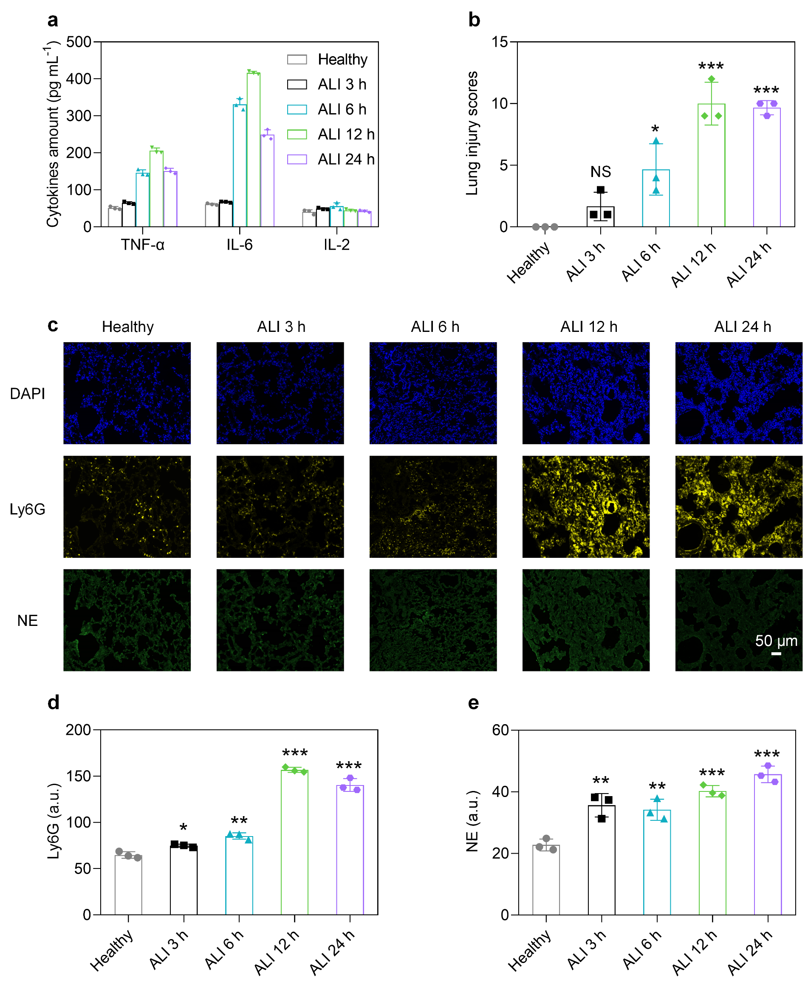
Figure S1. (a) Cytokine content in lung tissue, including TNF-α, IL-6, and IL-2. (b) Lung injury scores in different treatment groups. (c) Immunofluorescence section of lung tissue, blue signal from DAPI, yellow signal from Ly6G, green signal from NE. Mean fluorescence intensities (MFI) of Ly6G (d) and NE (e) in immunofluorescence image. Data were expressed as mean ± s.d. and analyzed using a two-tailed Student's t-test. The values relative to the healthy groups, NS: not significant, *P < 0.05, **P < 0.01, ***P < 0.001 (n = 3).
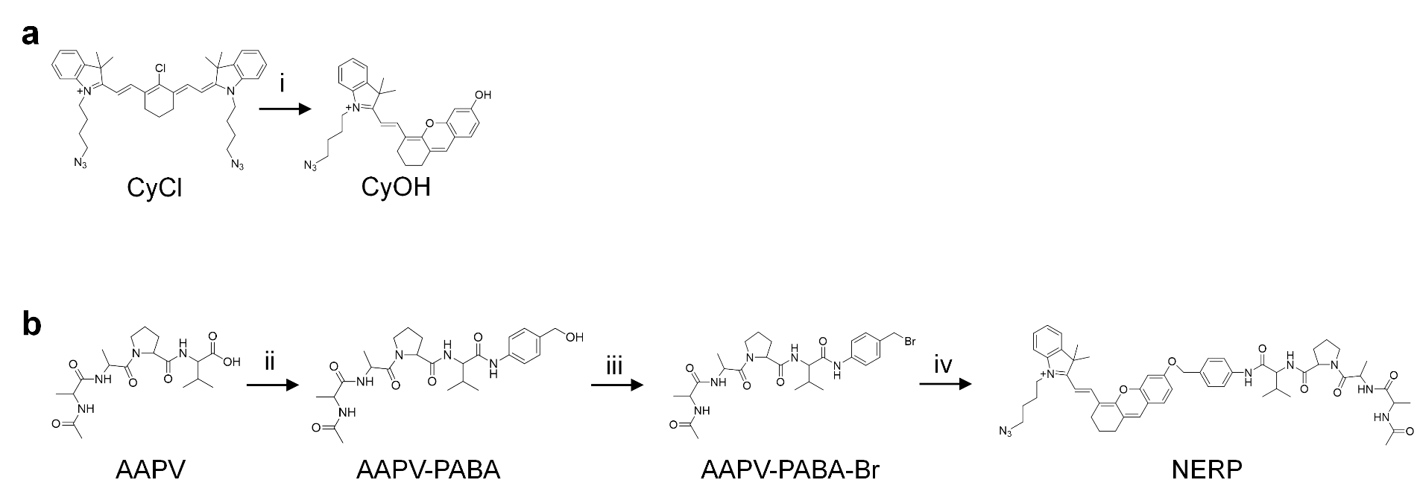
Figure S2. (a) Synthesis of the fluorescent signaling moiety CyOH. i, resorcinol, K₂CO₃, acetonitrile, 55 °C, 6 h. (b) Synthesis of NERP. ii, PABA, N-ethoxycarbonyl-2-ethoxy-1,2- dihydroquinoline (EEDQ), dichloromethane, 6 h. iii, phosphorus tribromide, tetrahydrofuran, 0 °C, 2 h. iv, CyOH, N,N-diisopropylethylamine (DIPEA), acetonitrile, 55 °C, 7 h.
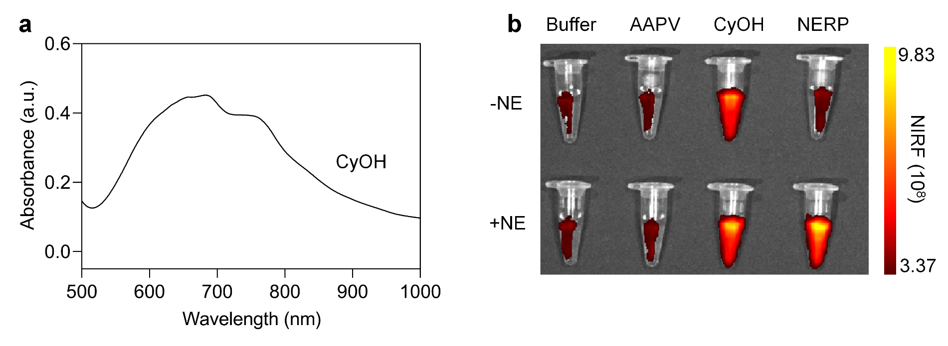
Figure S3. (a) UV spectra of CyOH. (b) NIRF images of buffer (50 mM Tri-HCl, 1 mM NaCl, pH=7.5), AAPV (100 μg/mL), CyOH (100 μM), and NERP (100 μM) with and without the addition of NE. The mixed solution was incubated for 2 h at 37 ºC. Ex= 690 nm, Em= 740 nm.
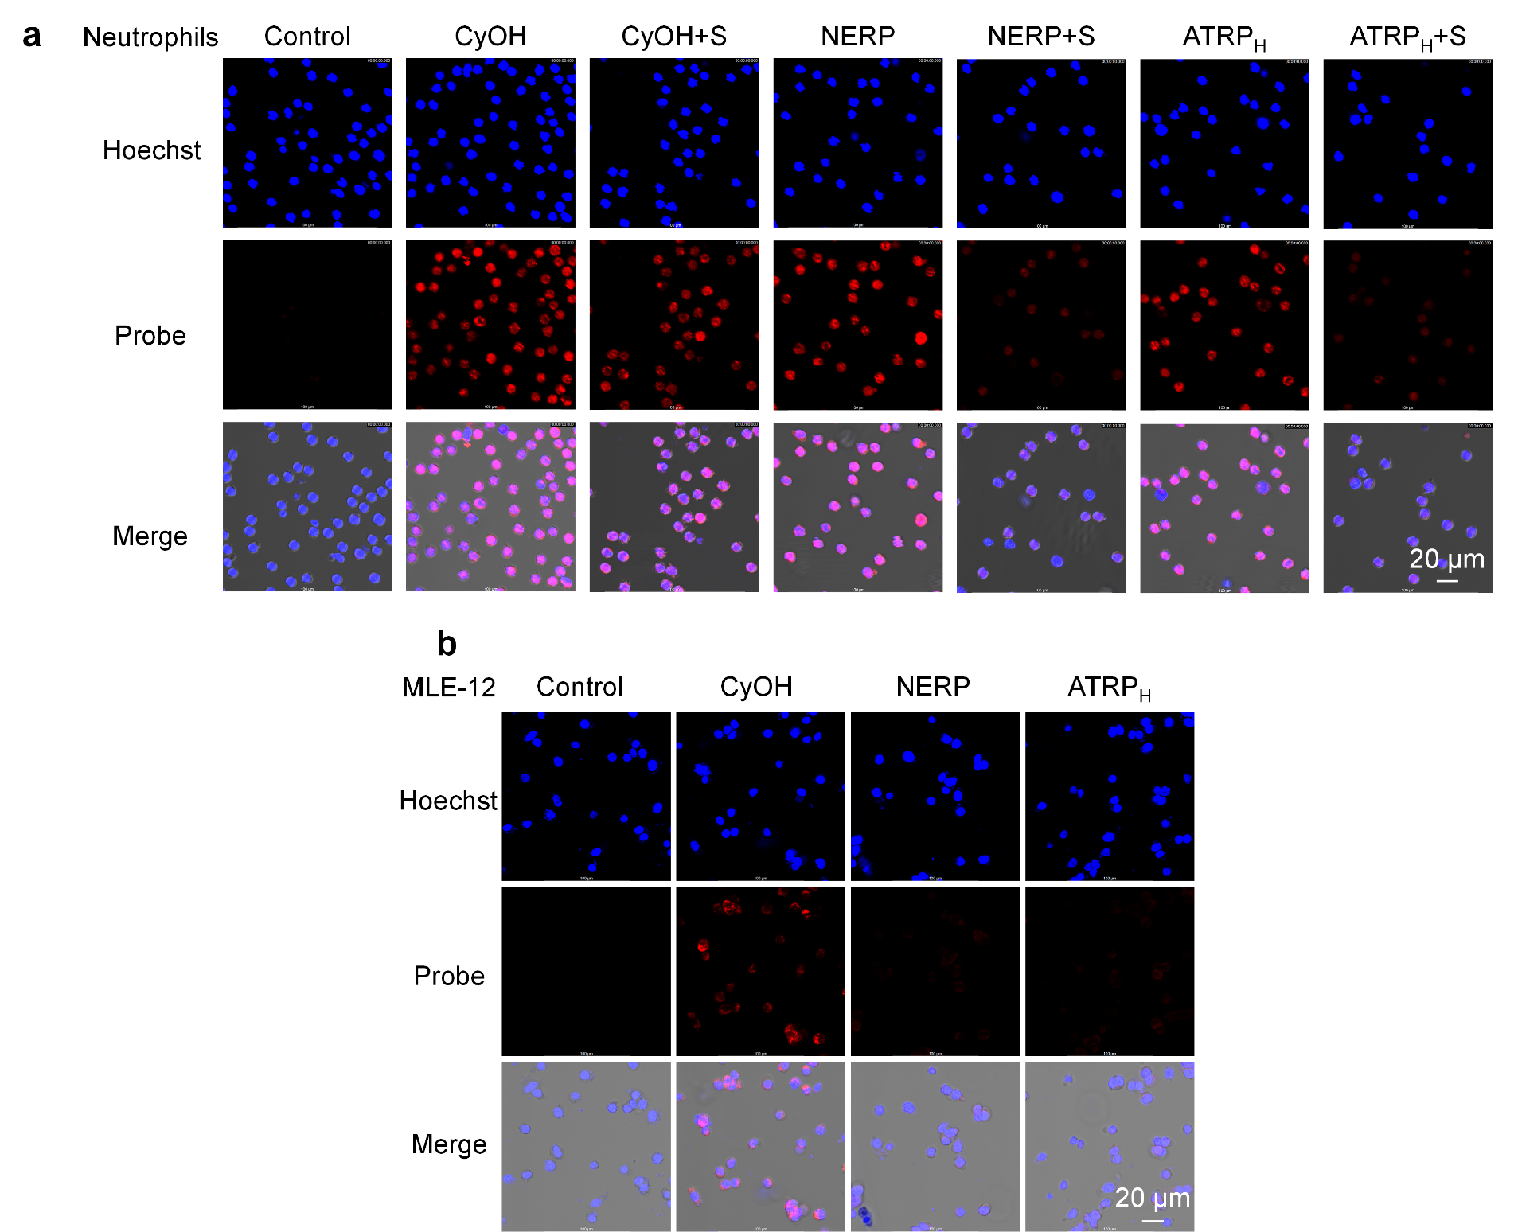
FigureS4. Confocal imaging of neutrophils (a), neutrophils and inhibitors (sivelestat, 20 μM) and MLE-12 (b) cells after 2 h of co-incubation with PBS, CyOH (10 μM), NERP (10 μM), ATRP_{H} (10 μM). Blue signals are from hoechst and red signals are from CyOH and activated NERP and ATRP_{H}. Scale bar: 20 µm.
Figure S5. Confocal imaging of RAW 264.7 (a), BMDC (b), BMDM (c), CD3⁺ T (d) cells after 2 h of co-incubation with PBS, CyOH (10 μM), NERP (10 μM), ATRP_{H} (10 μM). Blue signals are from hoechst and red signals are from CyOH and activated NERP and ATRP_{H}. Scale bar: 20 µm.
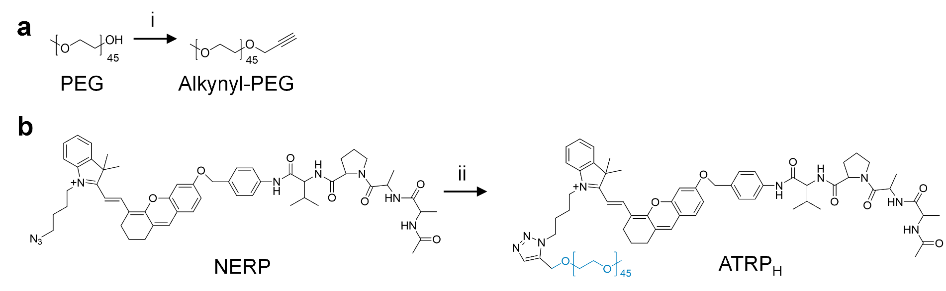
Figure S6. Synthesis of PEG- alkynyl (a) and ATRP_{H} (b). i, propargyl bromide, sodium hydride, tetrahydrofuran, 12 h. ii, PEG_{2k}-alkynyl, CuSO₄·5H₂O, sodium ascorbate, DMSO/H2O (2:1), 12 h.
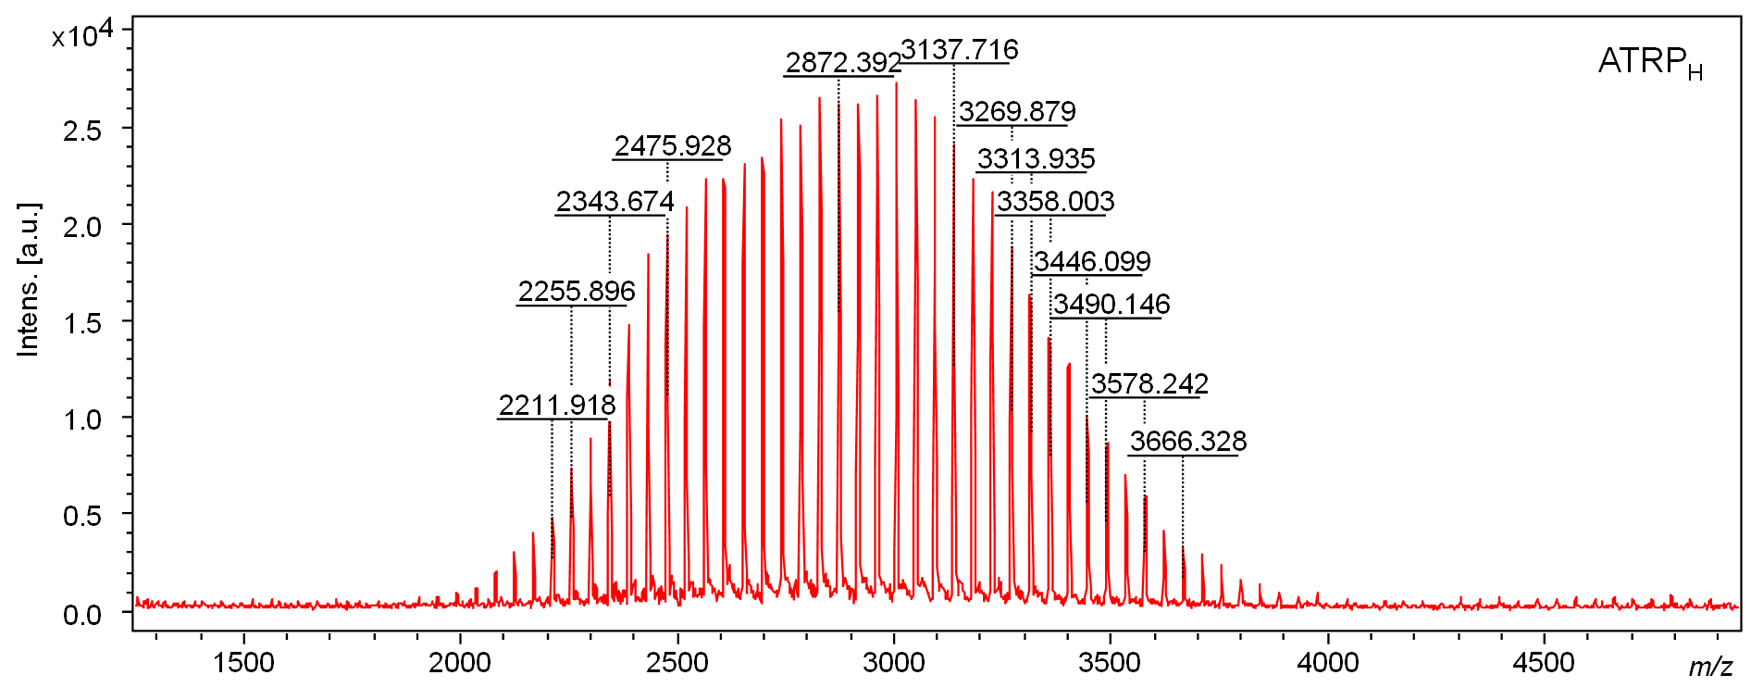
Figure S7. MALDI-TOF spectra of excreted ATRP_{H}.

Figure S8. UV spectra (a), fluorescence spectra (b), HPLC spectra (c) and NIRF images (d) of ATRP_{H} (100 μM) with and without the addition of NE (10 mM) in PBS at 37 ºC for 2 h. Ex= 690 nm, Em= 740 nm.
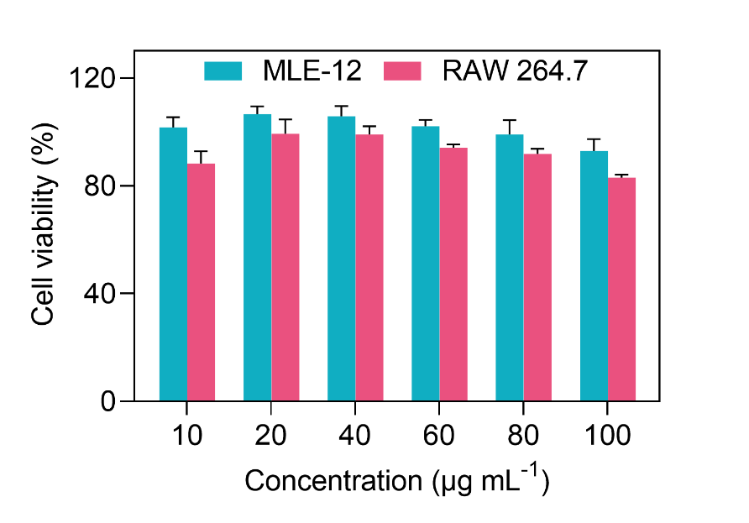
Figure S9. Cytotoxicity of ATRP_{H} to MLE-12 and RAW 264.7 cells. Data were expressed as mean ± s.d. (n = 3).
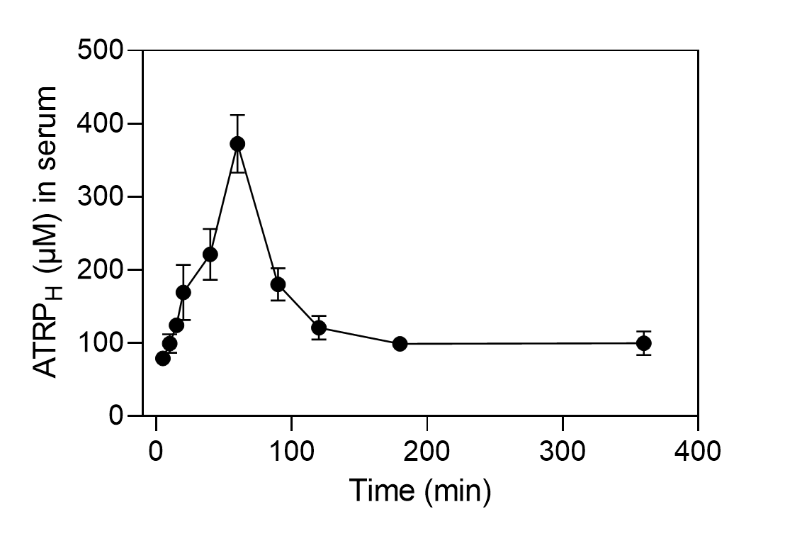
Figure S10. Changes in plasma concentration of ATRP_{H} over time in mice after i.t. injection, as determined by UV. Data were expressed as mean ± s.d. (n = 3).
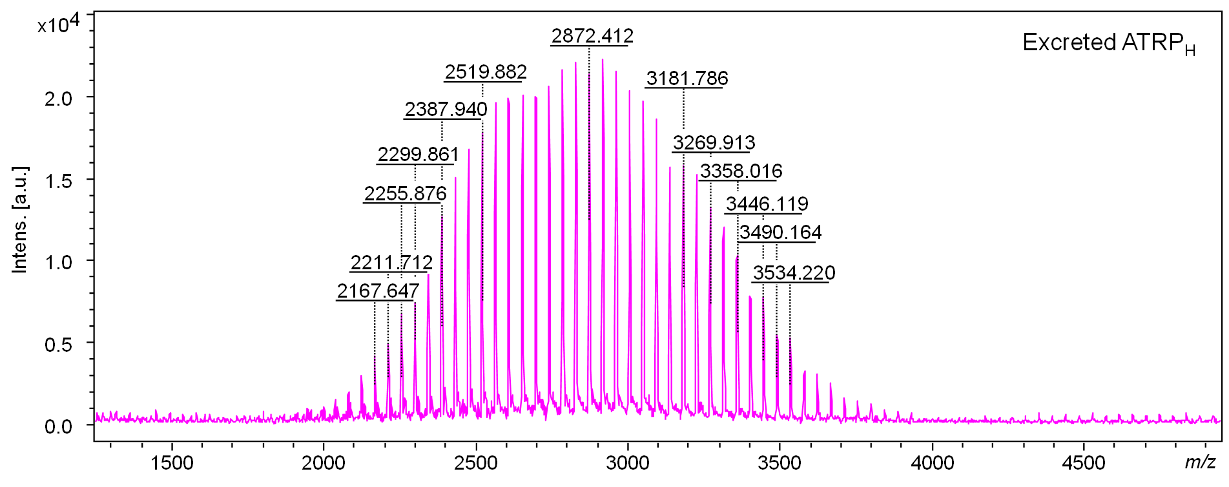
Figure S11. MALDI-TOF spectra of excreted ATRP_{H}.
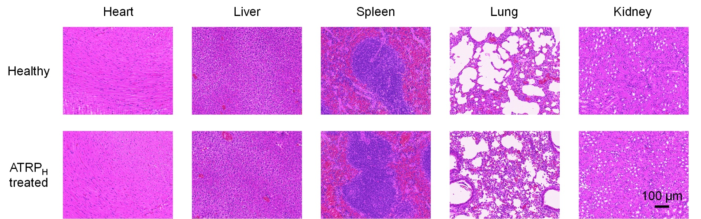
Figure S12. Heart, liver, spleen, lung and kidney from healthy and i.t. injected ATRP_{H} mice with Hematoxylin and eosin (H&E) staining image.
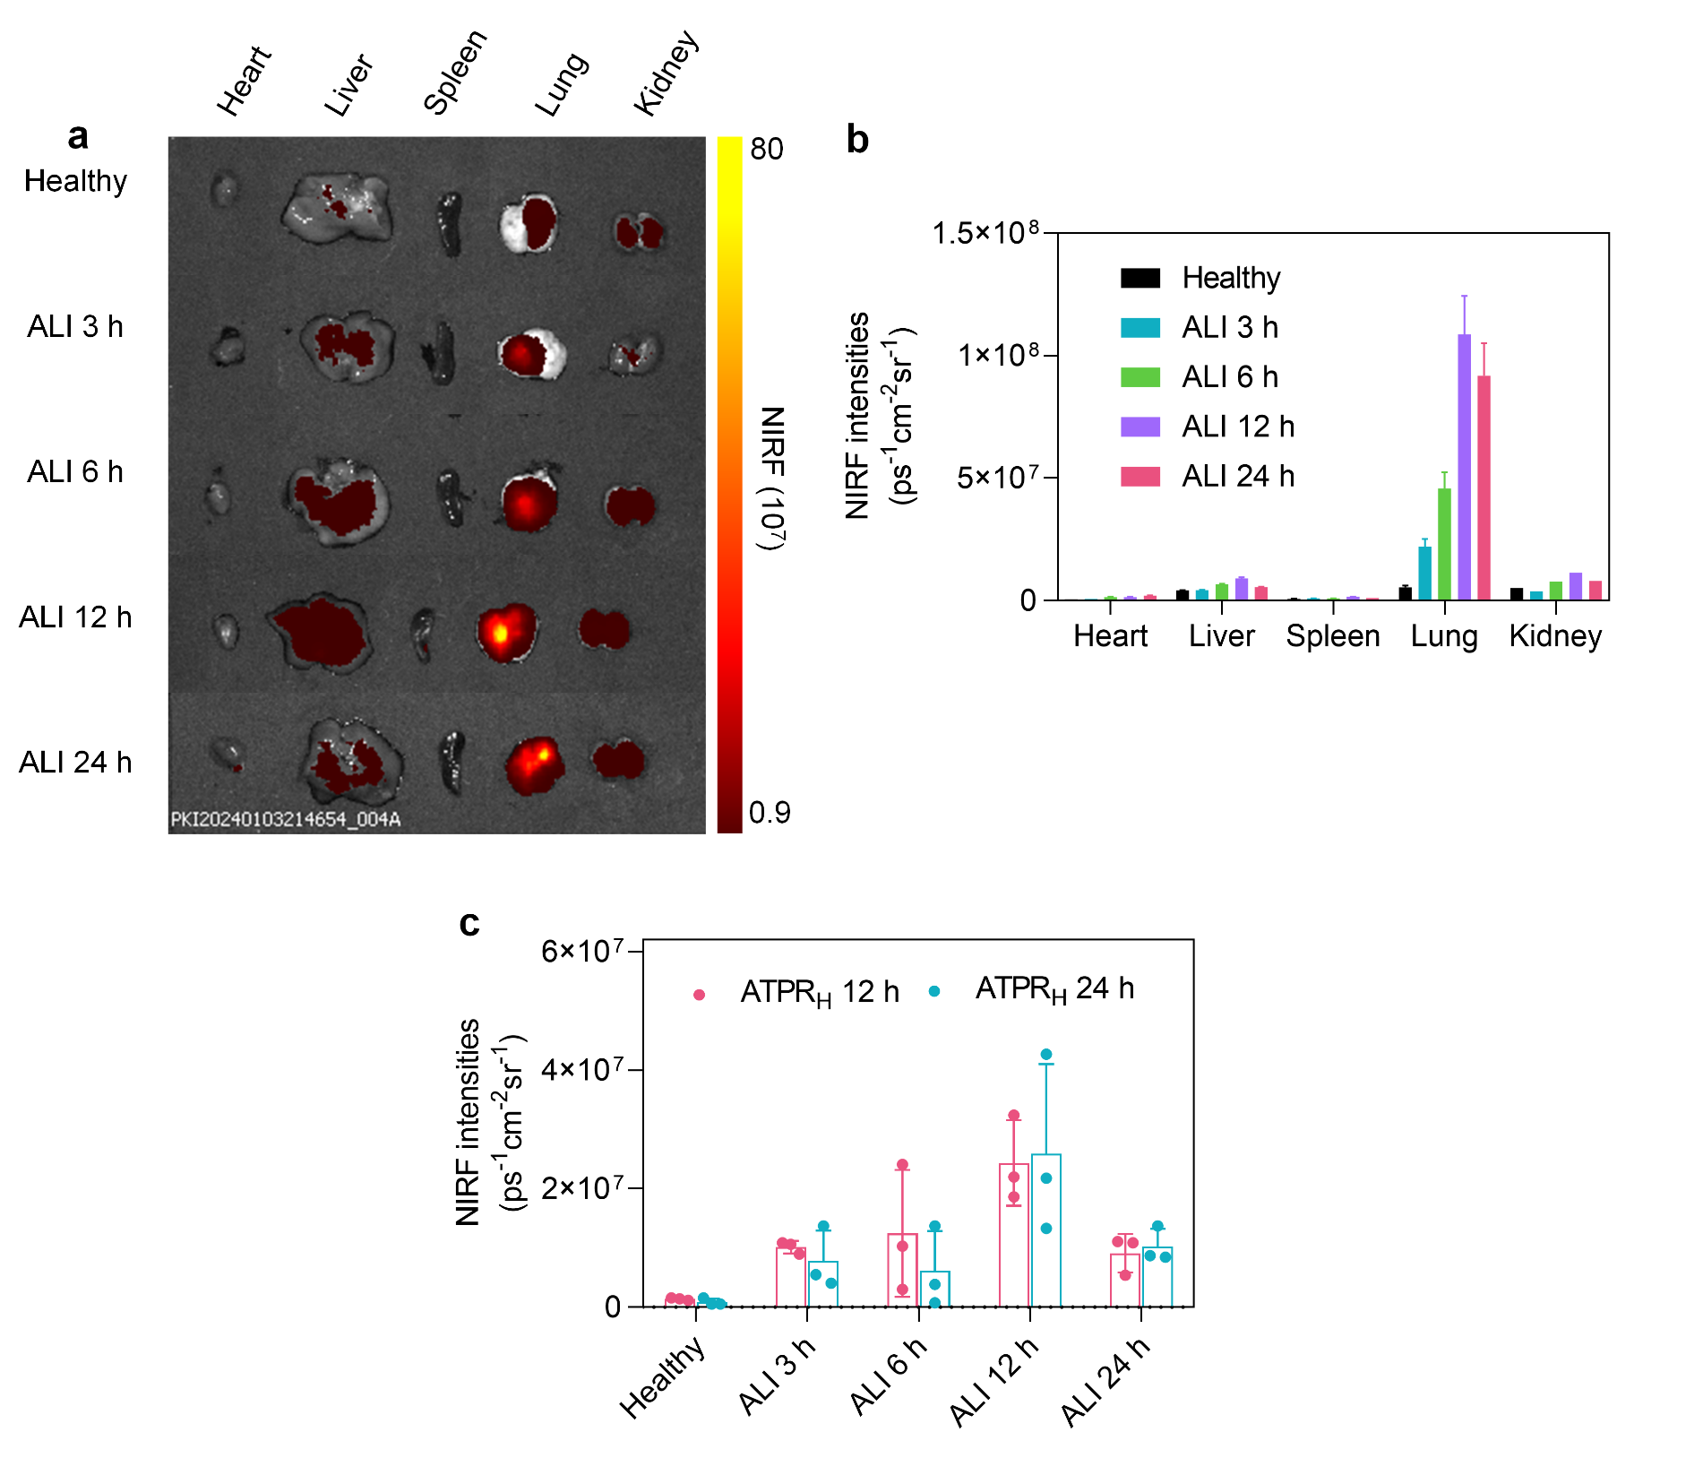
Figure S13. NIRF images (a) and intensity quantification (b) of ex vivo organs after i.t. injected ATRP_{H} 120 min. Ex= 690 nm, Em= 740 nm. (C) Quantification of NIRF signaling in urine after i.t. injection of ATRP_{H} 12 h and 24 h. Data were expressed as mean ± s.d. (n = 3).
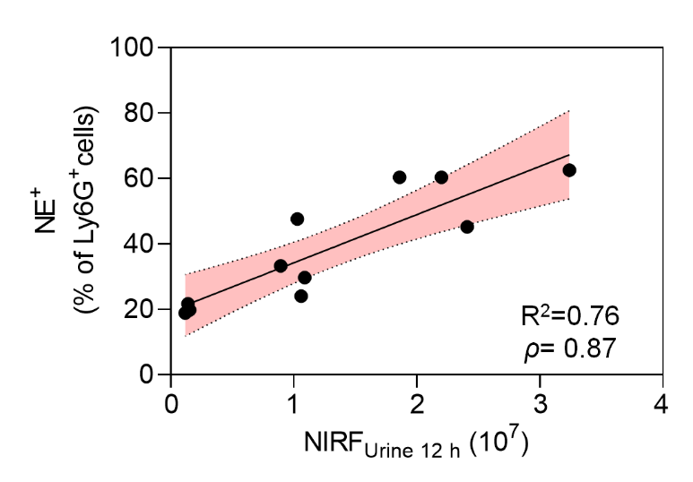
Figure S14. Correlation between lung tissue NE⁺ cells content and urine NIRF signal after i.t. injection of ATRP_{H} 12 h.
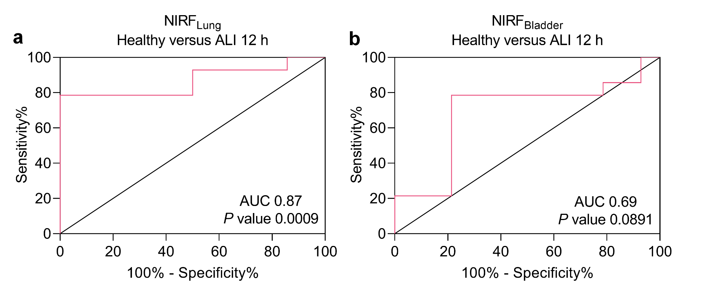
Figure S15. ROC curves of in vivo lung (a) and bladder (b) NIRF signal at 45 min post-injection in differentiating between healthy and ALI mice.
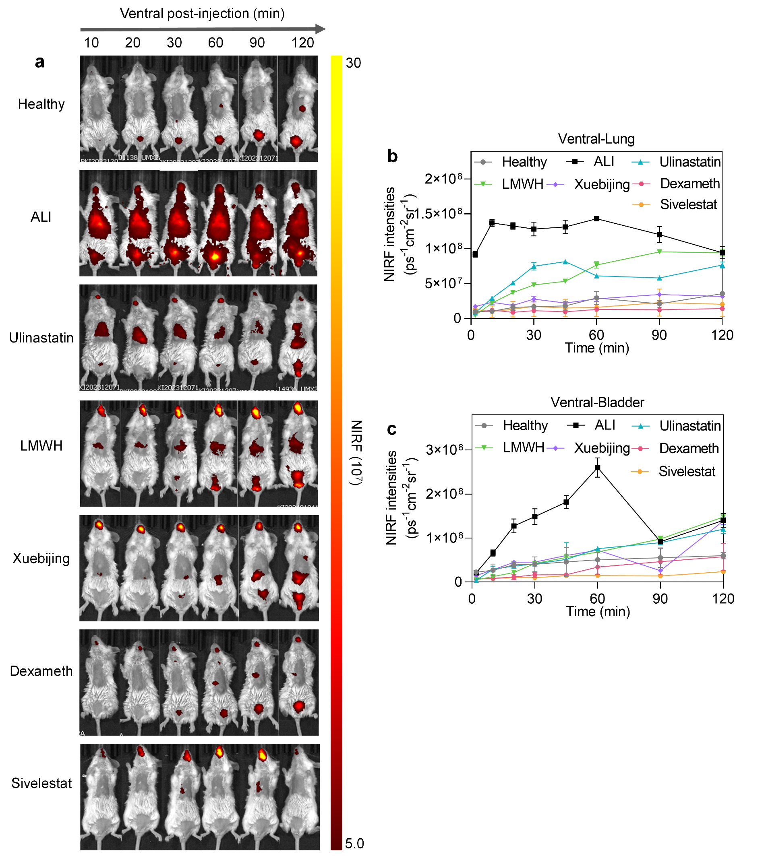
Figure S16. (a) NIRF images at 10, 20, 30, 60, 90 and 120 min after i.t. injection of ATRP_{H}. NIRF intensity of ventral lung (b) and bladder (c) in living mice with injection time. Data were expressed as mean ± s.d. (n = 3).
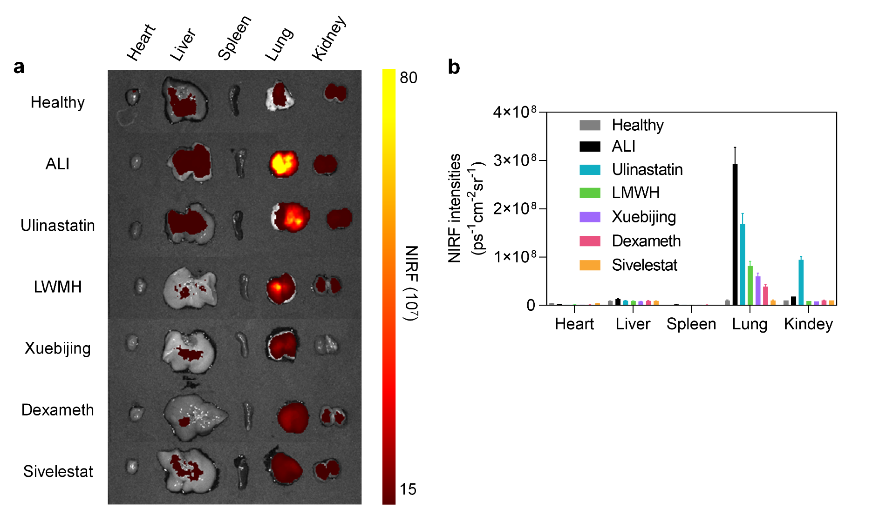
Figure S17. NIRF images (a) and intensity quantification (b) of ex vivo organs after i.t. injected ATRP_{H} 120 min. Ex= 690 nm, Em= 740 nm. Data were expressed as mean ± s.d. (n = 3).
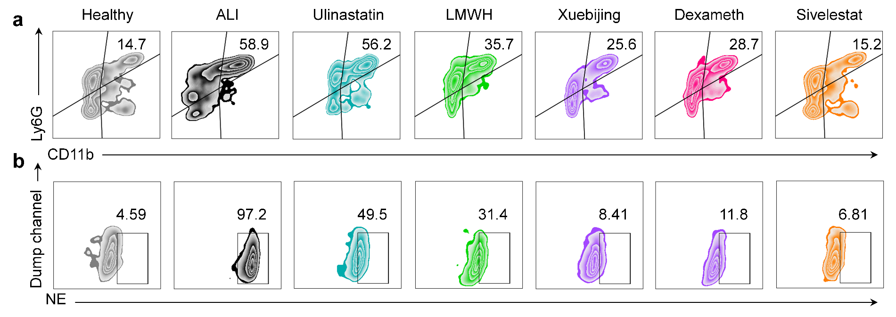
Figure S18. Representative flow cytometry plots of Ly6G⁺ CD11b⁺ cells as a percentage of CD45⁺ cells (a) and NE⁺ cells as a percentage of Ly6G⁺ CD11b⁺ CD45⁺ cells (b) in mouse lung tissue.

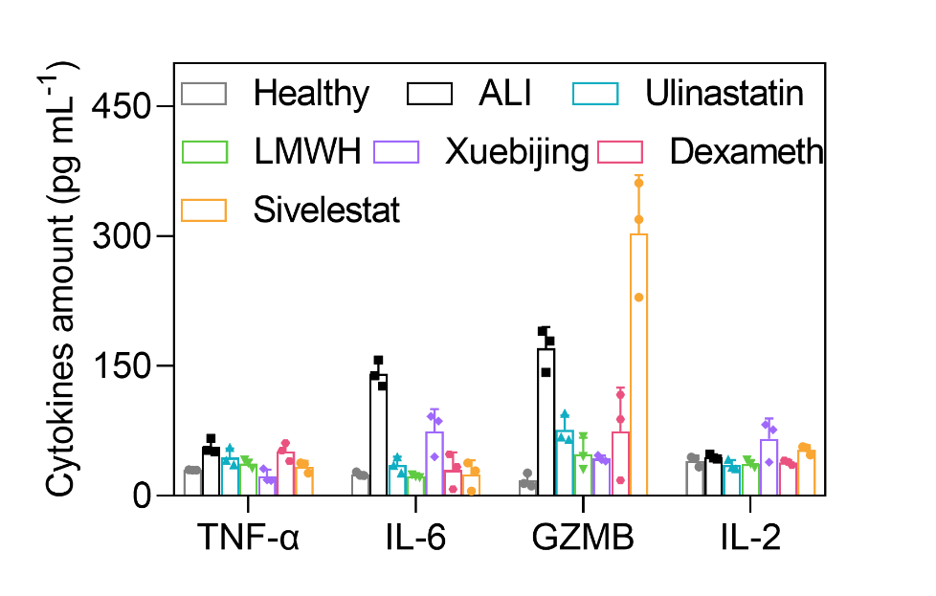
Figure S19. Cytokine content in lung tissue, including TNF-α, IL-6, GMZB and IL-2. Data were expressed as mean ± s.d. (n = 3).
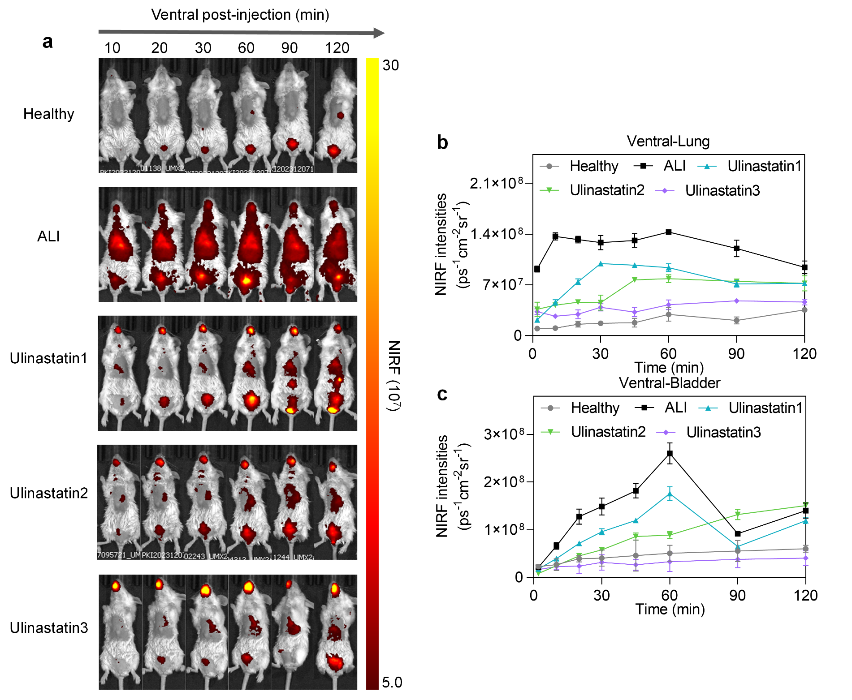
Figure S20. (a) NIRF images at 10, 20, 30, 60, 90 and 120 min after i.t. injection of ATRP_{H}. NIRF intensity of ventral lung (b) and bladder (c) in living mice with injection time. Data were expressed as mean ± s.d. (n = 3).
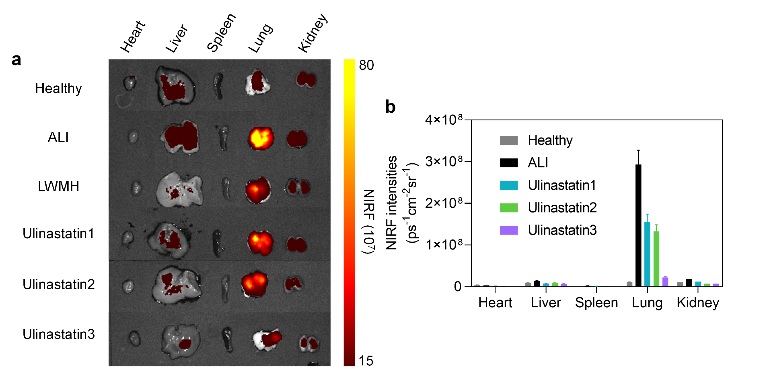
Figure S21. NIRF images (a) and intensity quantification (b) of ex vivo organs after i.t. injected ATRP_{H} 120 min. Ex= 690 nm, Em= 740 nm. Data were expressed as mean ± s.d. (n = 3).
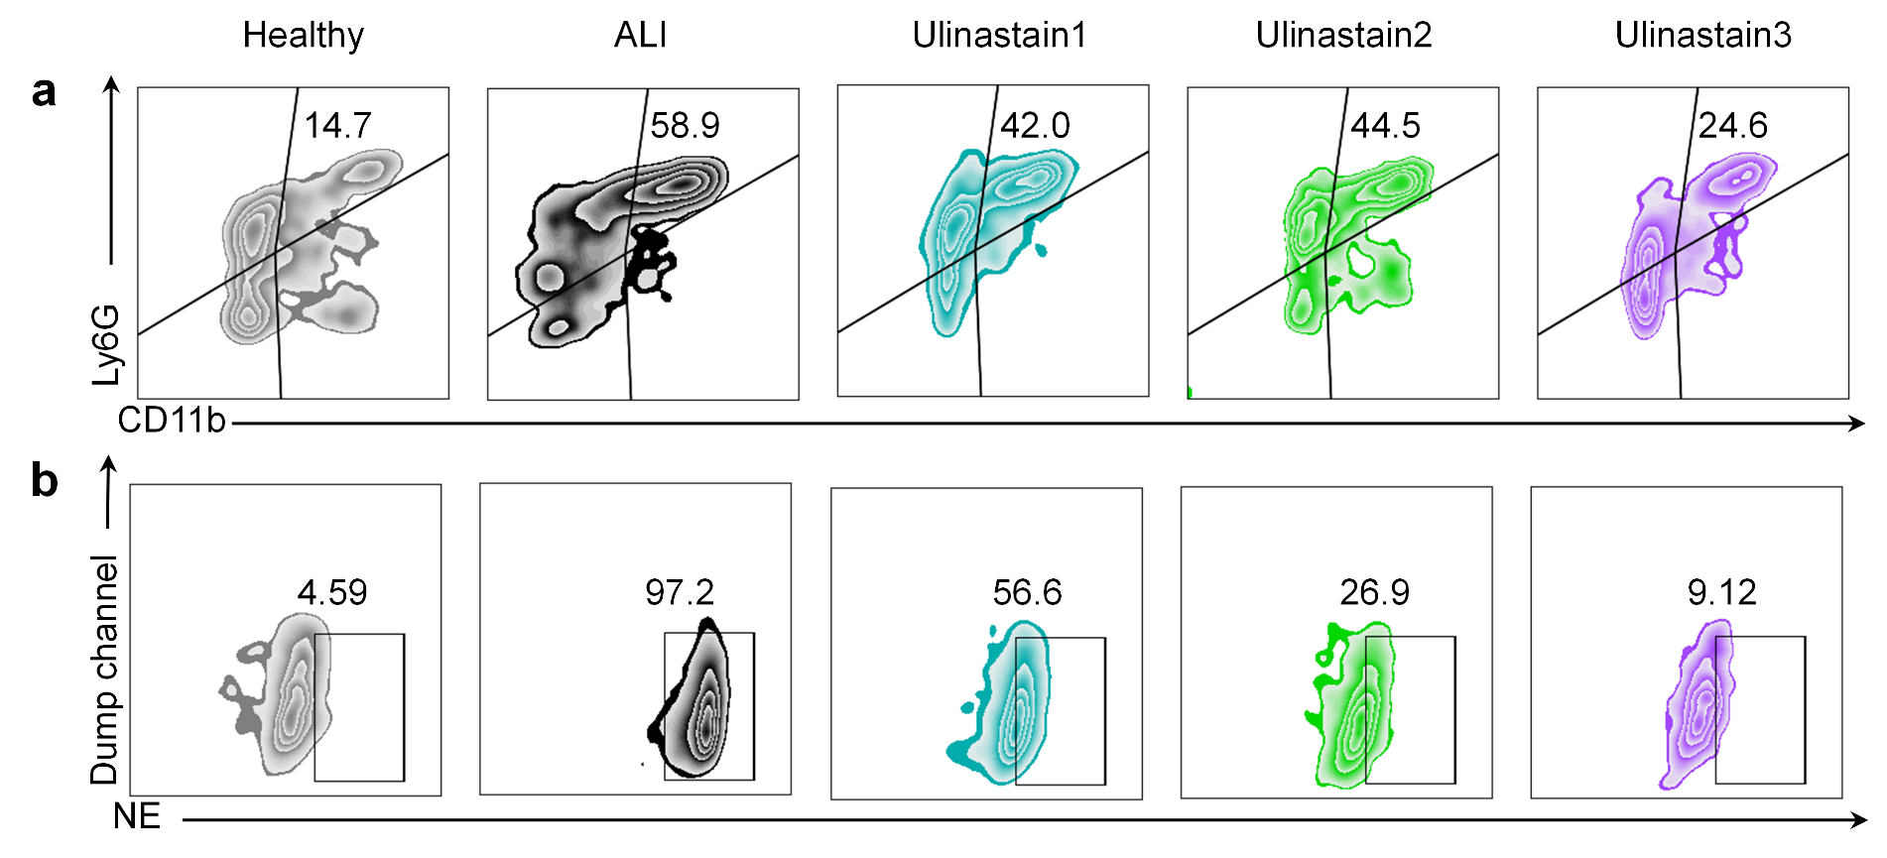
Figure S22. Representative flow cytometry plots of Ly6G⁺ CD11b⁺ cells as a percentage of CD45⁺ cells (a) and NE⁺ cells as a percentage of Ly6G⁺ CD11b⁺ CD45⁺ cells (b) in mouse lung tissue.
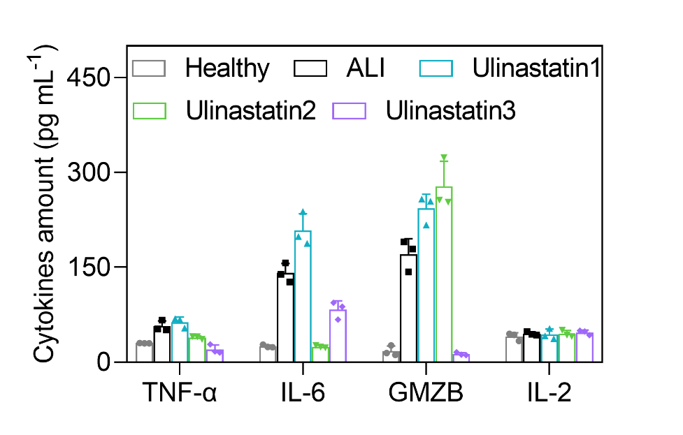
Figure S23. Cytokine content in lung tissue, including TNF-α, IL-6, GMZB and IL-2. Data were expressed as mean ± s.d. (n = 3).
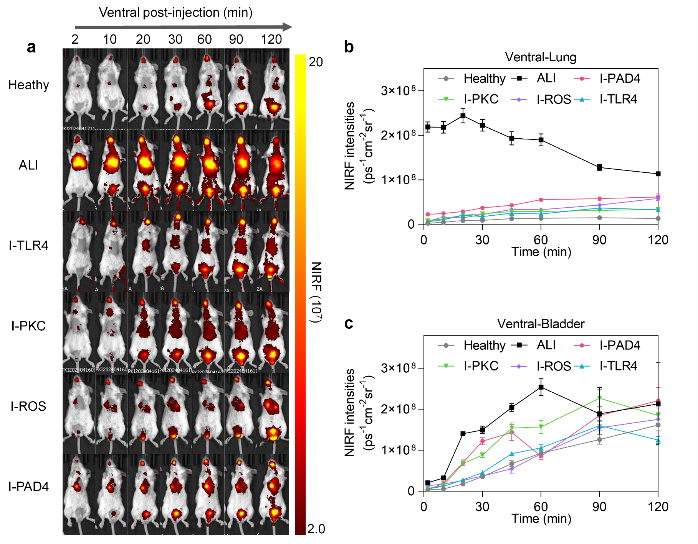
Figure S24. (a) NIRF images at 2, 10, 20, 30, 60, 90 and 120 min after i.t. injection of ATRP_{H}. NIRF intensity of ventral lung (b) and bladder (c) in living mice with injection time. Data were expressed as mean ± s.d. (n = 3).
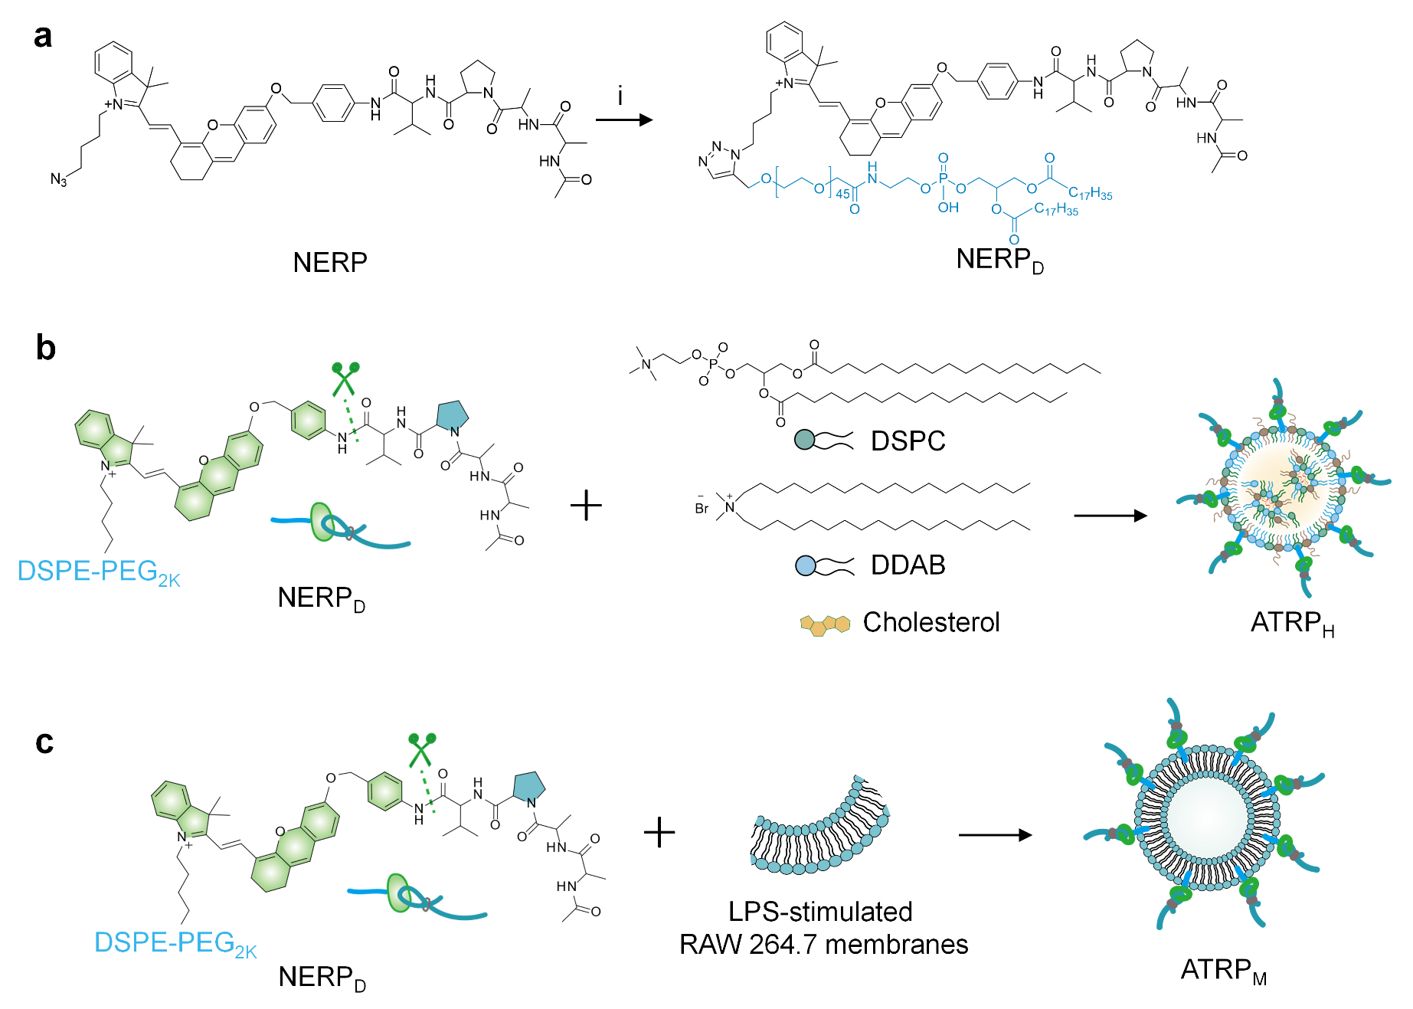
Figure S25. Synthesis of NERPD, ATRP_{H} and ATRP_{L}. i, DSPE-PEG_{2k}-alkynyl, CuSO₄·5H₂O, sodium ascorbate, DMSO/H₂O (2:1),12 h.
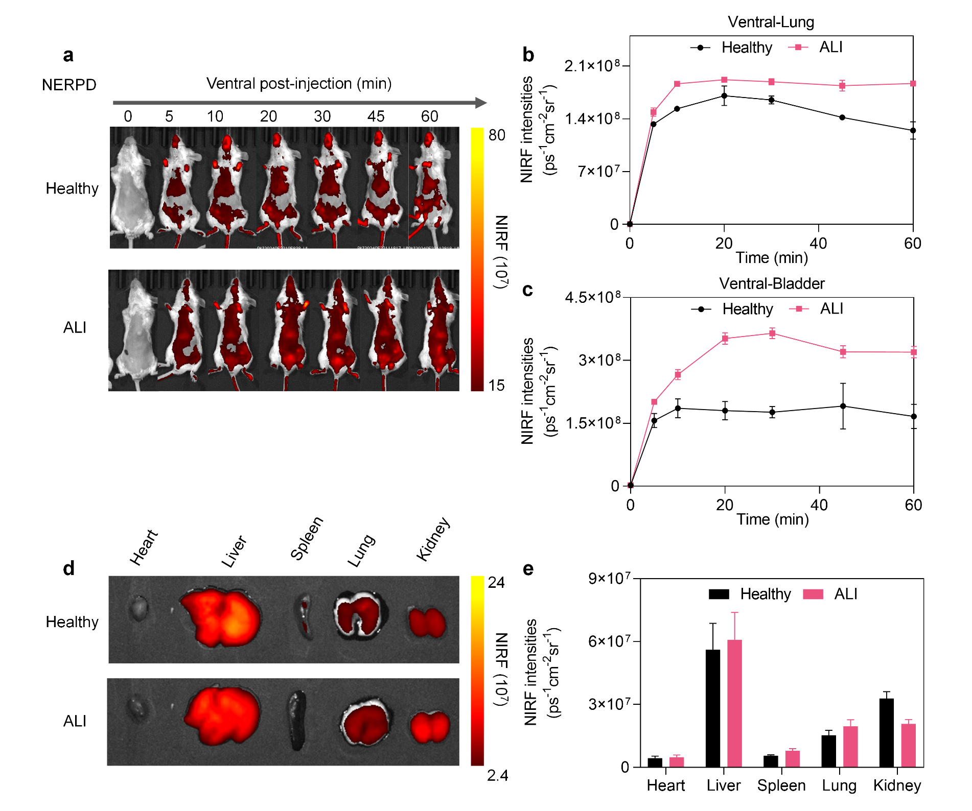
Figure S26. (a) NIRF images at 0, 5, 10, 20, 30, 45, and 60 min after i.v. injection of NRPRD (4 μmol/kg). NIRF intensity of ventral lung (b) and ventral bladder (c) in living mice with injection time. NIRF images (d) and intensity quantification (e) of ex vivo organs after i.v. injection NRPRD 60 min. Ex= 690 nm, Em= 740 nm. Data were expressed as mean ± s.d. (n = 3).
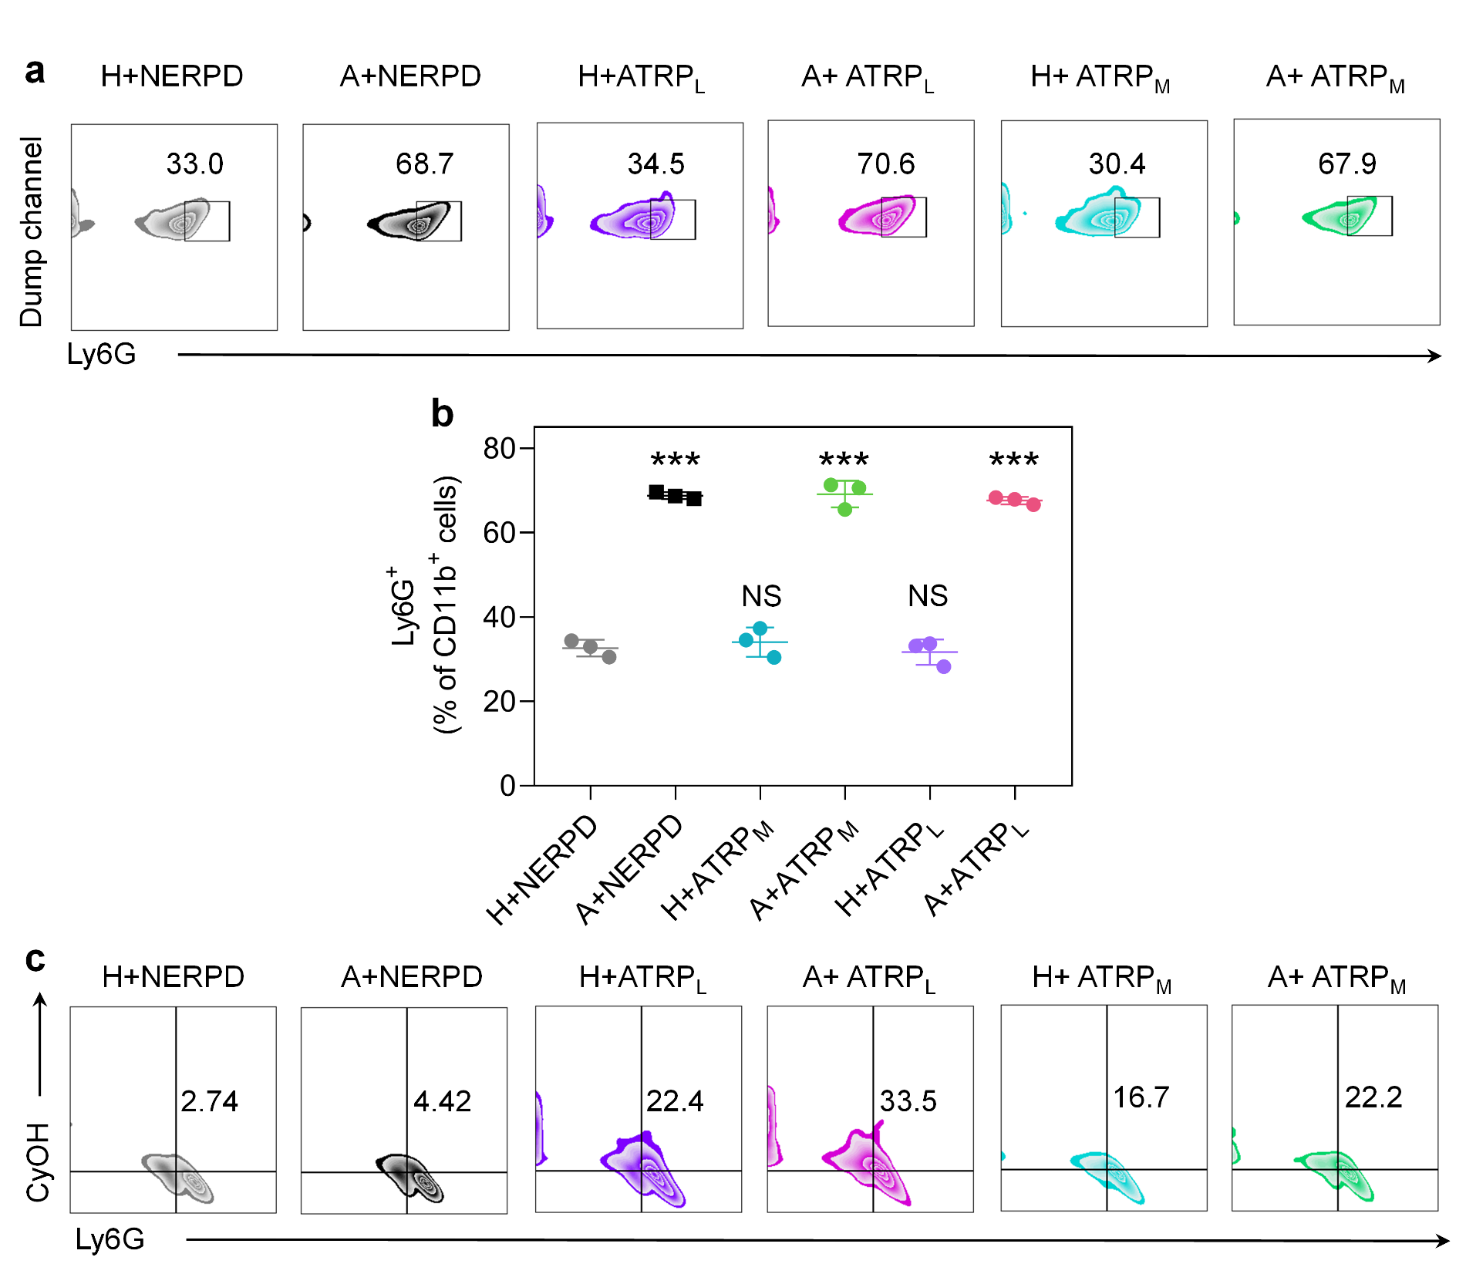
Figure S27. Representative flow cytometry plots (a) and quantification of Ly6G⁺ (b) cells as a percentage of CD11b⁺ CD45⁺ cells in mouse lung tissue. Representative flow cytometry plots (c) of Ly6G⁺ CyOH⁺ cells to CD11b⁺ CD45⁺ cells in the lungs of mice. H: healthy, A: ALI-12 h. Data were expressed as mean ± s.d. and analyzed using a two-tailed Student's t-test. The values relative to the healthy groups, NS: not significant, *P < 0.05, **P < 0.01, ***P < 0.001 (n = 3).
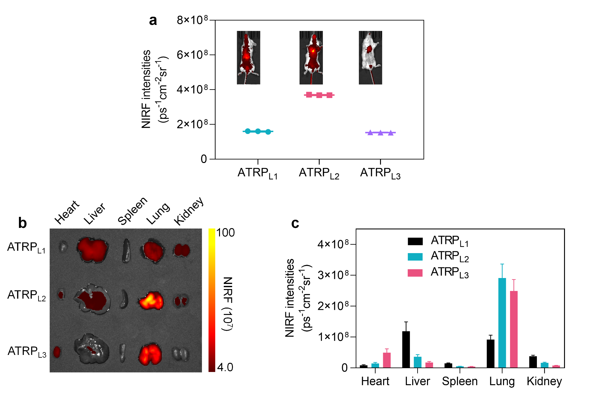
Figure S28. (a) NIRF images and intensity quantification of ventral lung NIRF after i.v. injection ATRP_{L}s 10 min in healthy mice. NIRF images (b) and intensity quantification (c) of ex vivo organs after i.v. injection ATRP_{L}s 60 min in healthy mice. Ex= 690 nm, Em= 740 nm. Data were expressed as mean ± s.d. (n = 3).
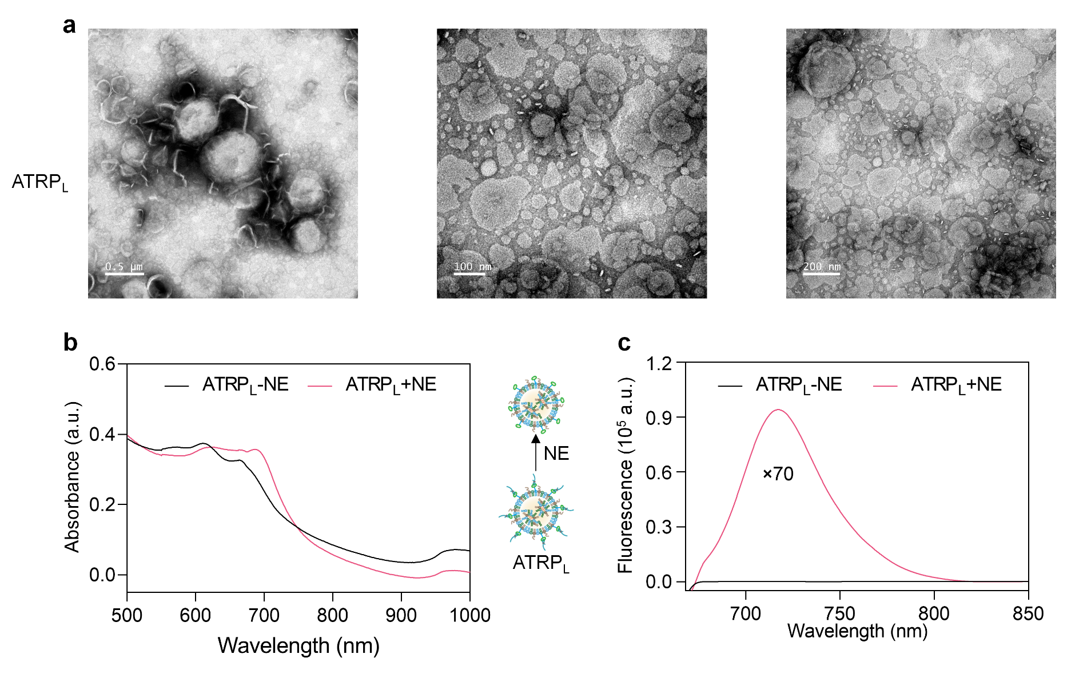
Figure S29. (a) TEM images of ATRP_{L}. (b) UV and fluorescence spectra of ATRP_{L} (100 μM) after incubation with NE (100 mU) in PBS at 37 ºC for 2 h. Ex= 690 nm, Em= 740 nm.
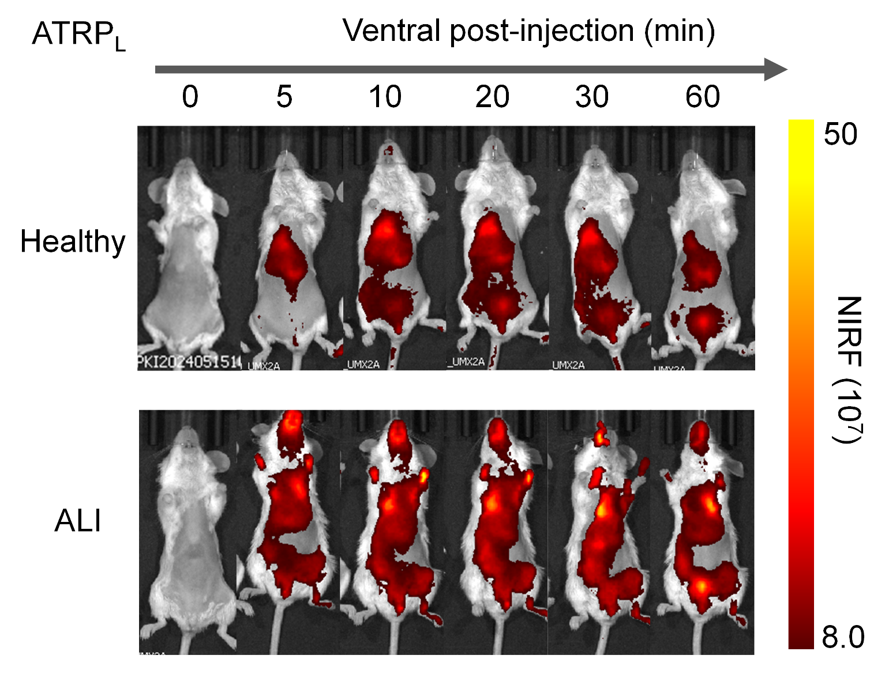
Figure S30. NIRF images at 0, 5, 10, 20, 30, and 60 min after i.v. injection of ATRP_{L}.
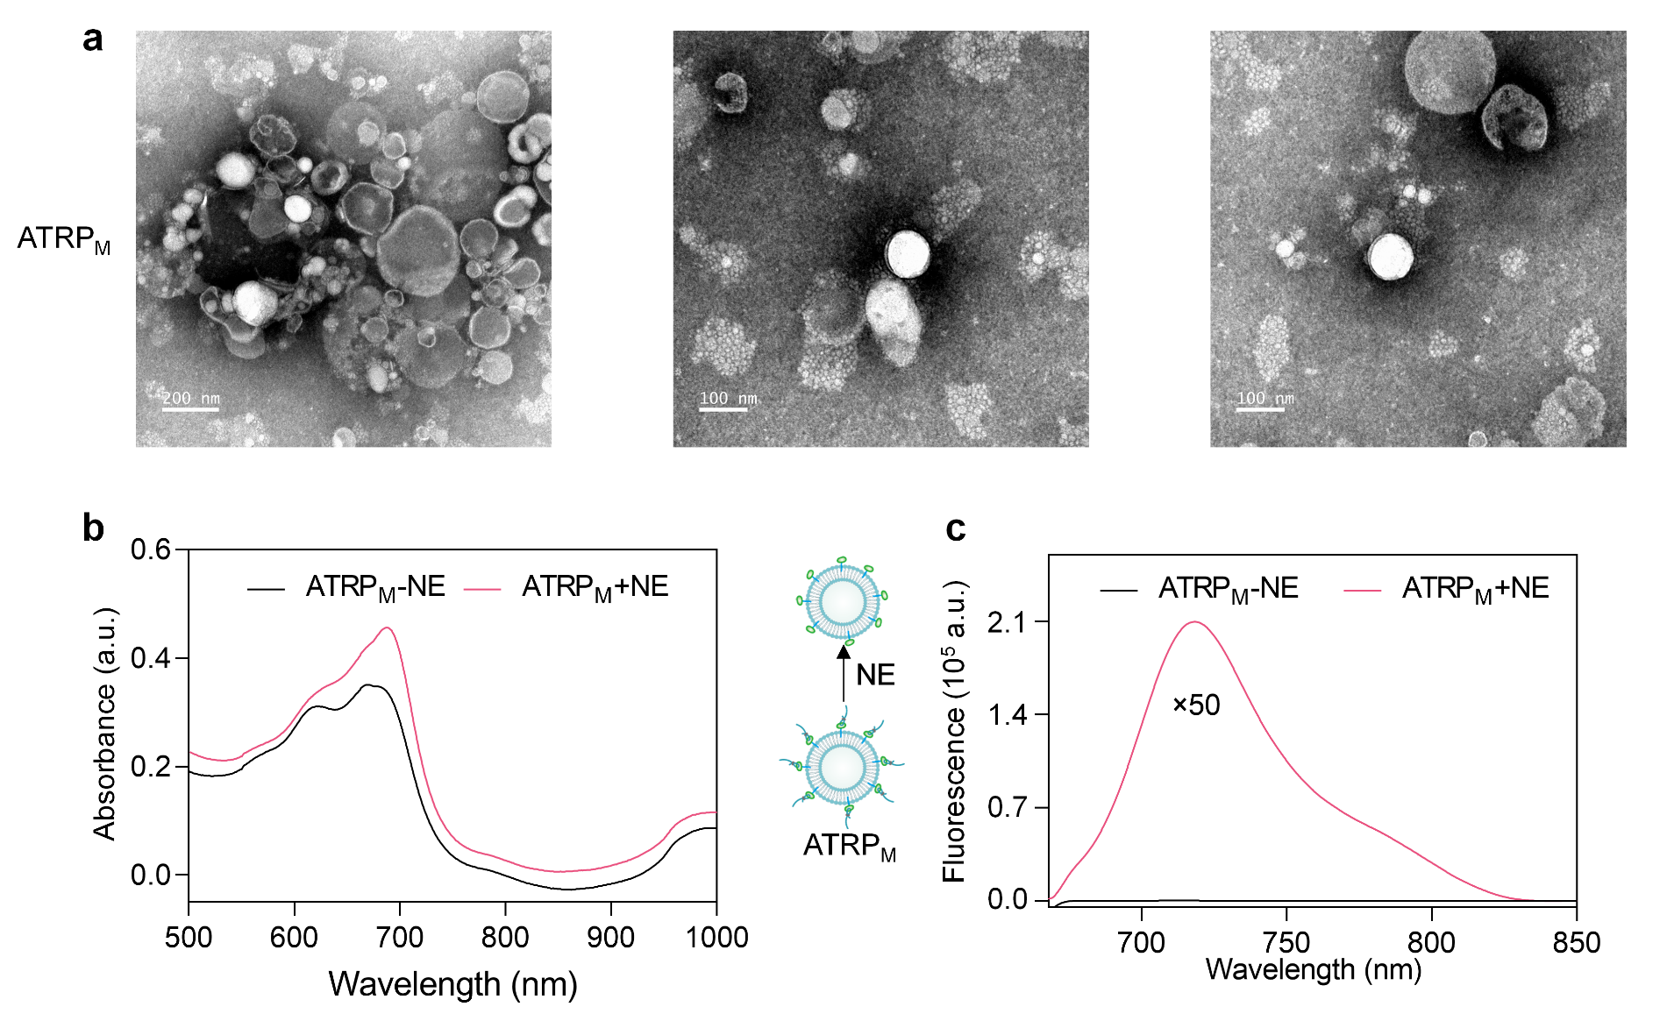
Figure S31. (a) TEM images of ATRP_{M}. (b) UV and fluorescence spectra of ATRP_{M} (200 μM) after incubation with NE (100 mU) in PBS at 37 ºC for 2 h. Ex= 690 nm, Em= 740 nm.
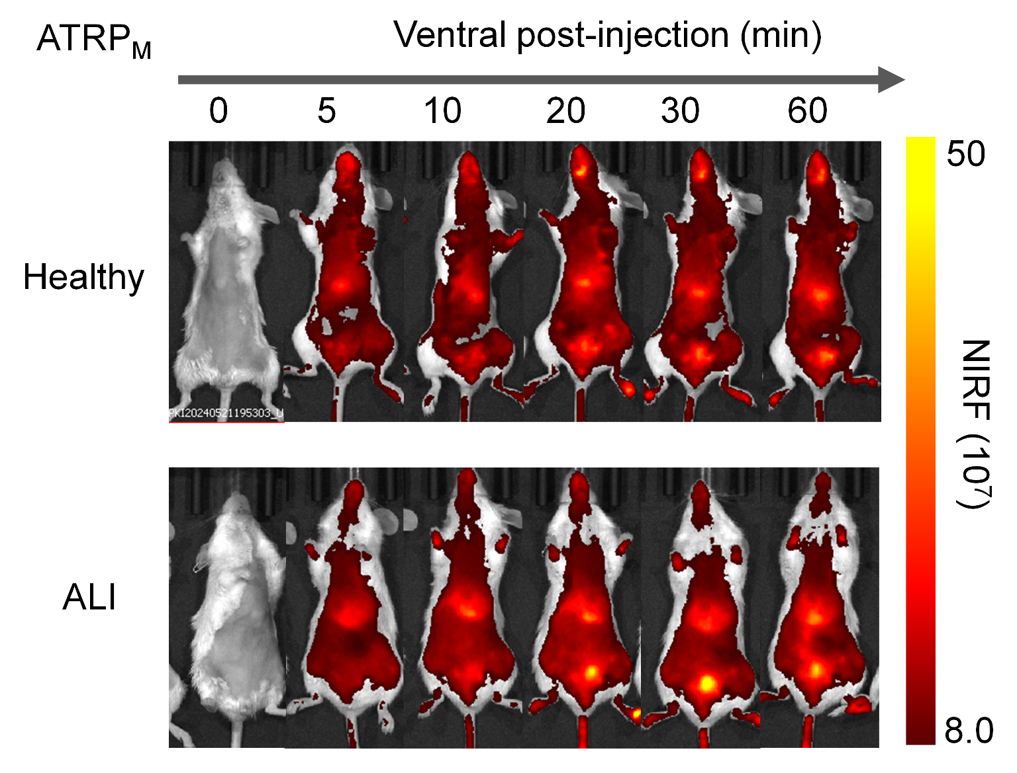
Figure S32. NIRF images at 0, 5, 10, 20, 30, and 60 min after i.v. injection of ATRP_{M}.
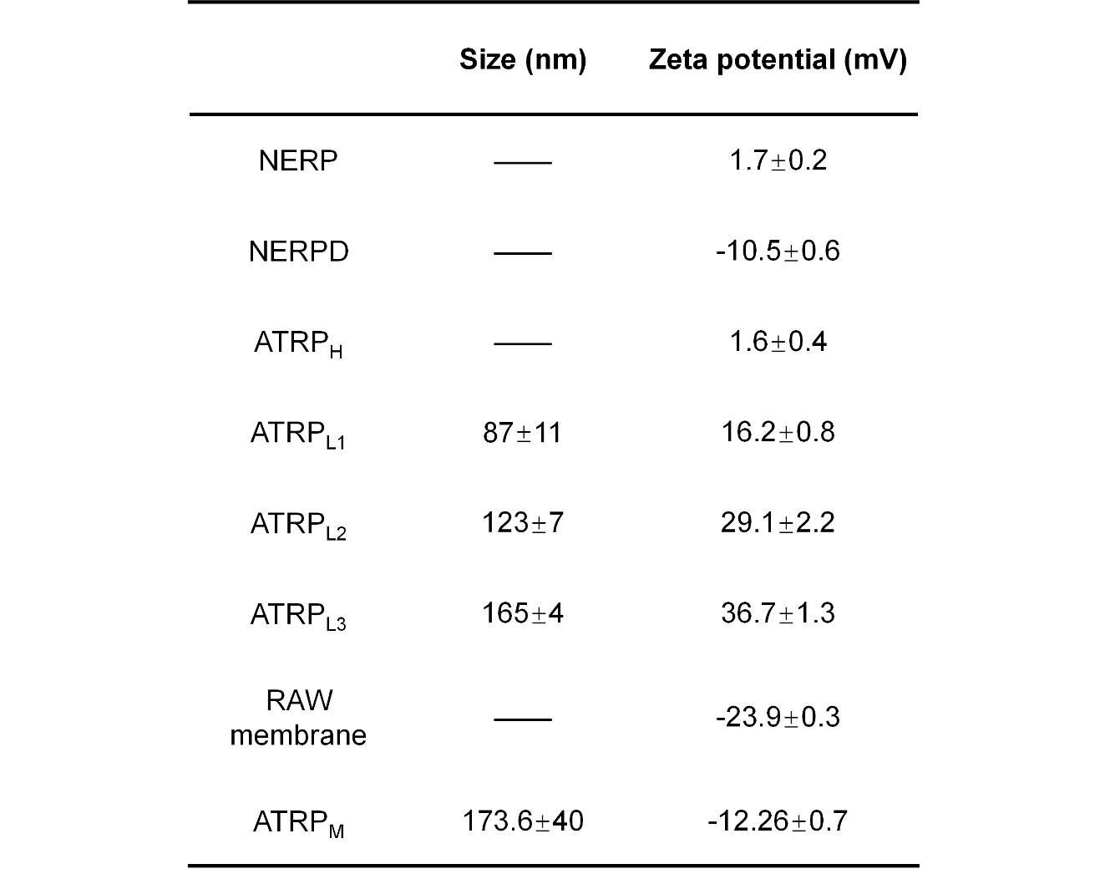
Table S1. Size and Zeta potential.
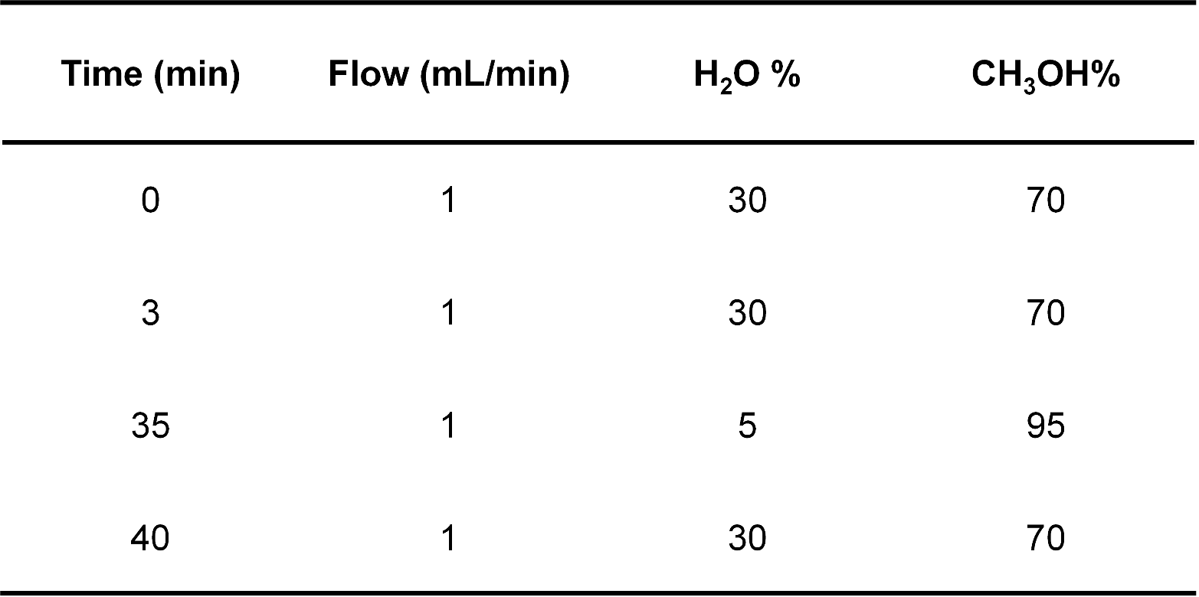
Table S2. HPLC condition for the enzymatic analysis.
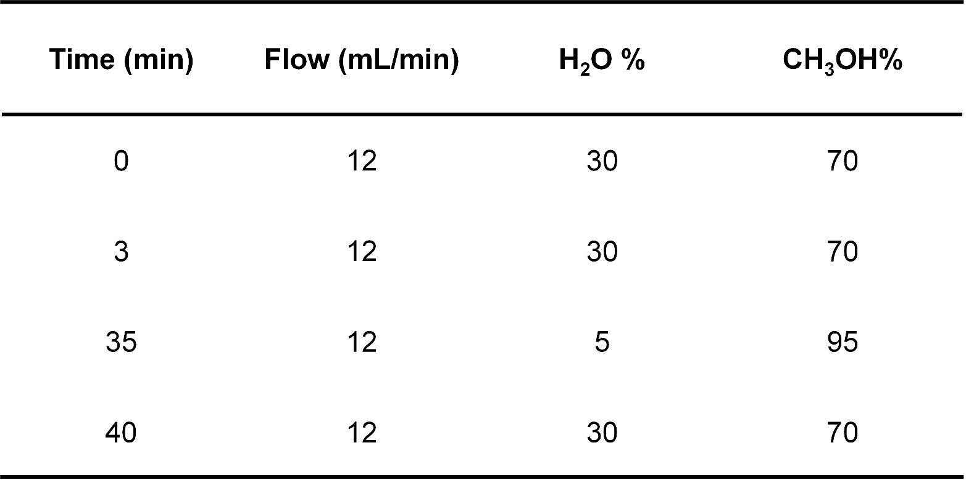
Table S3. HPLC condition for the purification of NERP.
Models | Imaging characteristics | Activatable detection | Induction method | Assay time | Probe | Reference
Magnetic resonance imaging (MRI) | Non-intrusive,  in situ | No | 50 μg, Intratracheal instillation (i.t.) | 4 h | ³He gaseous  contrast agent | Am. J. Respir. Cell Mol. Biol. 2011, 44, 648
Ultrasound (US) | Non-intrusive,  in situ | No | 6 mg/kg, i.t. | 2 h | N.A. | J. Thorac. Dis. 2016, 8, 1443
Positron emission tomography /computed Tomography (PET/CT) | Non-intrusive, radioactive,  in situ | No | 2.5 mg/kg, i.t. | 2 d | 2-deoxy-2-[¹⁸F] fuoro-D-glucose  ( 7.52±0.03 MBq), i.t. | Mol. Imaging Biol. 2023, 25, 681
Near-Infrared I (NIR-I) fluorescence imaging | Non-intrusive, in situ | Yes | 5 mg/kg, intravenous injection (i.v.) | 48 h | NE-sensitive small-molecule-based NIR fluorogenic probe  (10 μM), i.t. | Anal. Chem. 2019, 91, 3877
Electron paramagnetic resonance (EPR) | Intrusive,  ex vivo | Yes | 10 mg/kg, intraperitoneal injection (i.p.) | 24 h | Superoxide-sensitive EPR signal enhancement probe  (9 mg/kg), i.p. | Mol. Imaging Biol. 2024, 26, 495
Magnetic particle imaging (MPI) | Non-intrusive,  in situ | No | 250 μg, i.t. | 6 h | Small-sized vascular cell adhesion molecule-1-targeted magnetic particle imaging nanoprobe  (3.07 mg/kg), i.t. | Eur. J. Nucl. Med. Mol. Imaging 2024, 51, 1233
NIR-I fluorescence resonance energy transfer (FRET) imaging | Non-intrusive,  in situ | Yes | 25 ug, nasal drip | 4 h | NIR-FRET matrix metalloproteinases2-based probe (25ug), nasal drip | ACS Omega 2024, 9, 3609
NIR-I fluorescence imaging | Intrusive, ex vivo | Yes | Exposed to a real-ambient atmosphere  whole-body PM2.5 inhalation system | 3 months | H₂O₂ sensing fluorescent probe  Staining (20 μM) | Anal. Chem. 2024, 96, 10488
NIR-I fluorescence imaging | Non-intrusive,  in situ, urinalysis | Yes | 8 mg/kg, i.t. | 3 h | NE-responsive probe  (2 μmol/kg), i.t. | ours

Table S4. Detection of ALI

¹H NMR
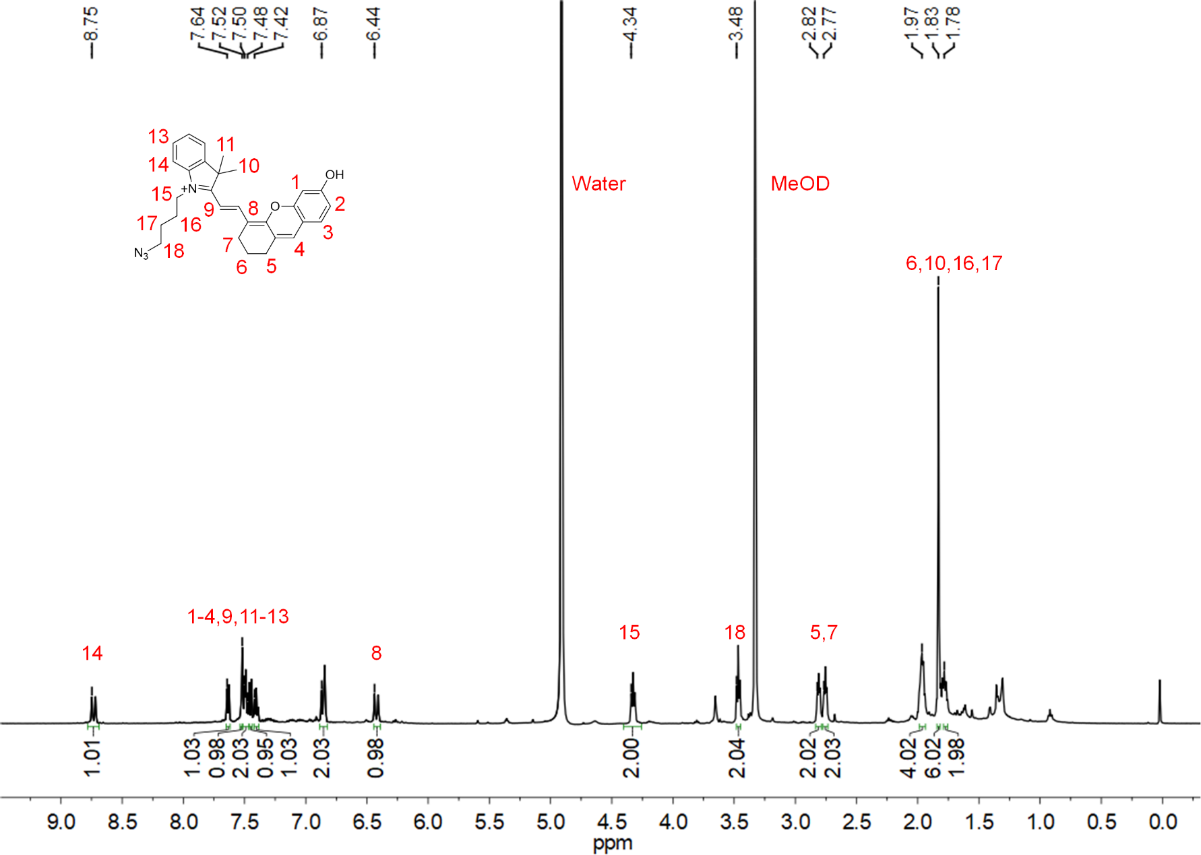
¹H NMR spectrum of CyOH in MeOD.
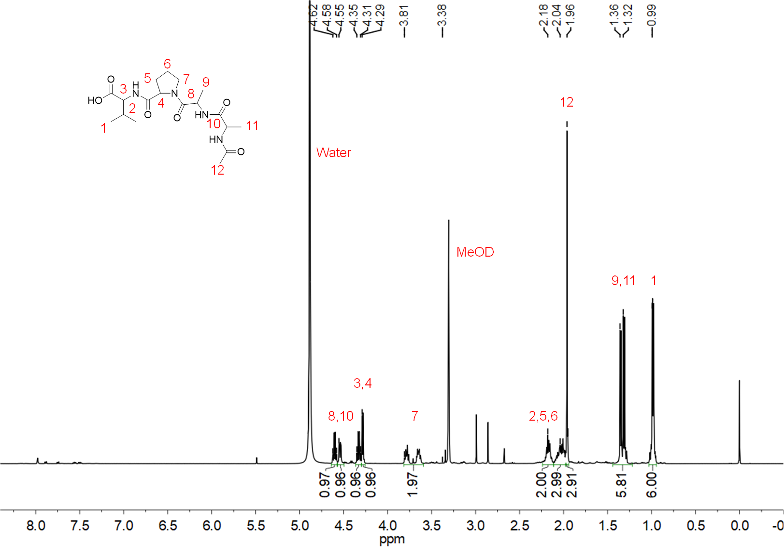
¹H NMR spectrum of AAPV in MeOD.
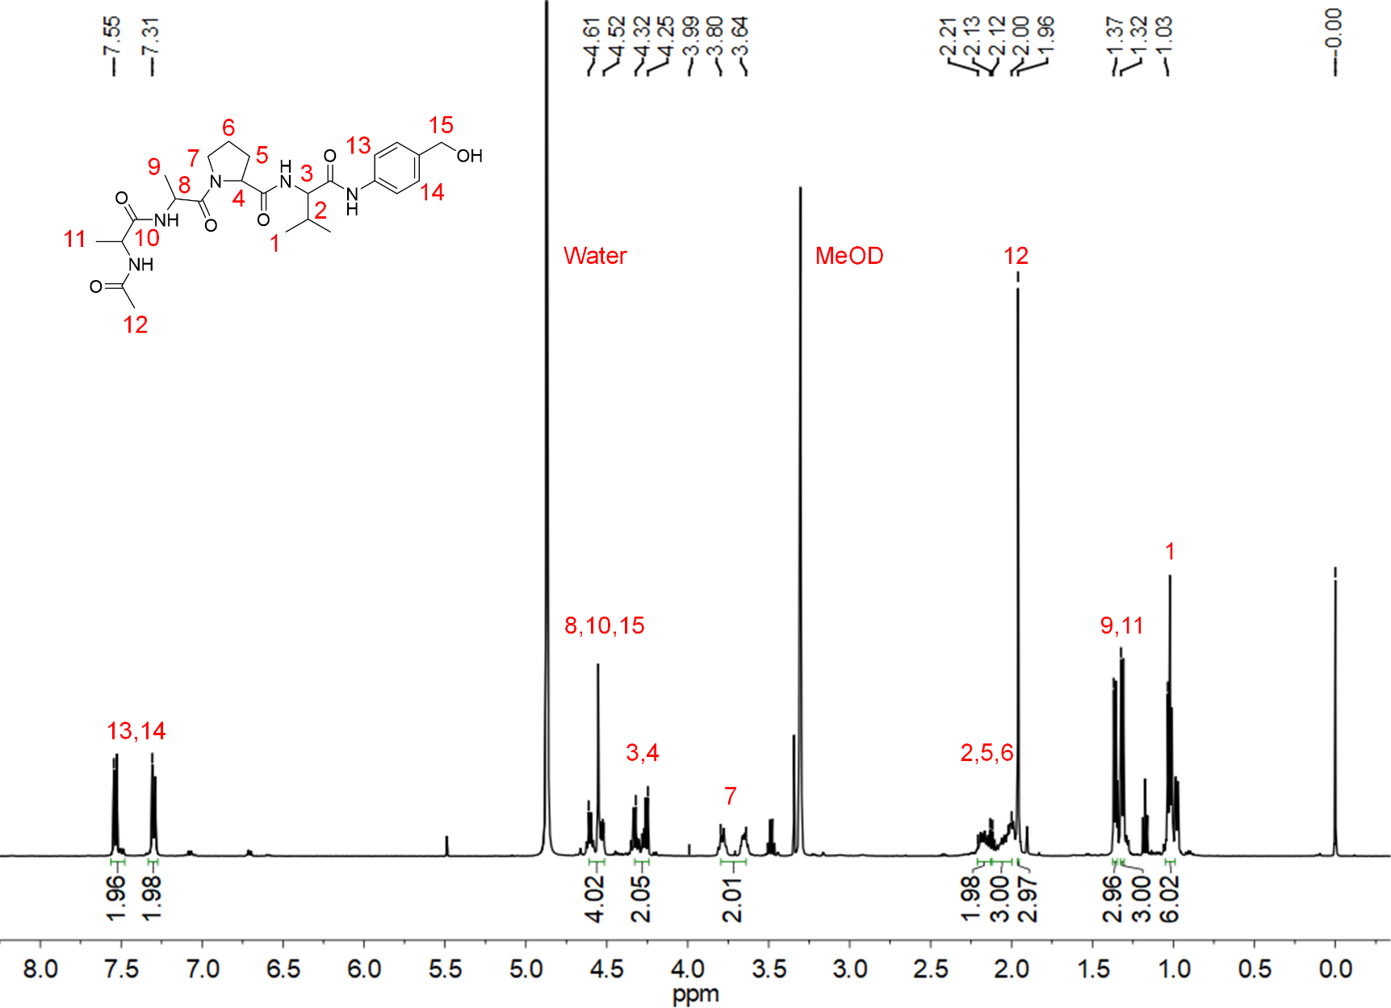
¹H NMR spectrum of AAPV-PABA in MeOD.
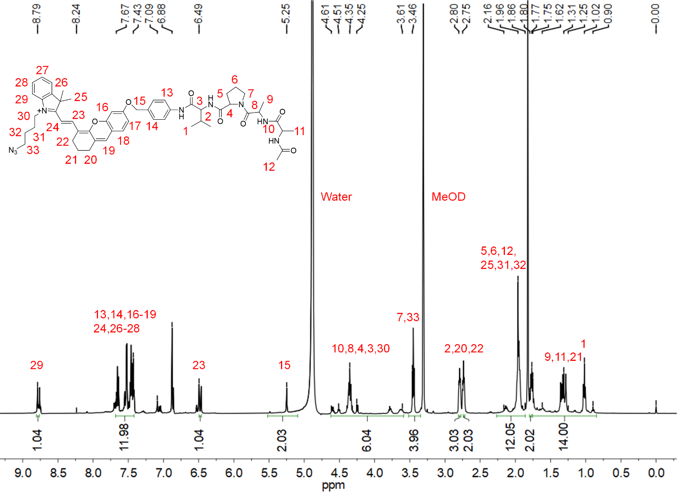
¹H NMR spectrum of NERP in MeOD.
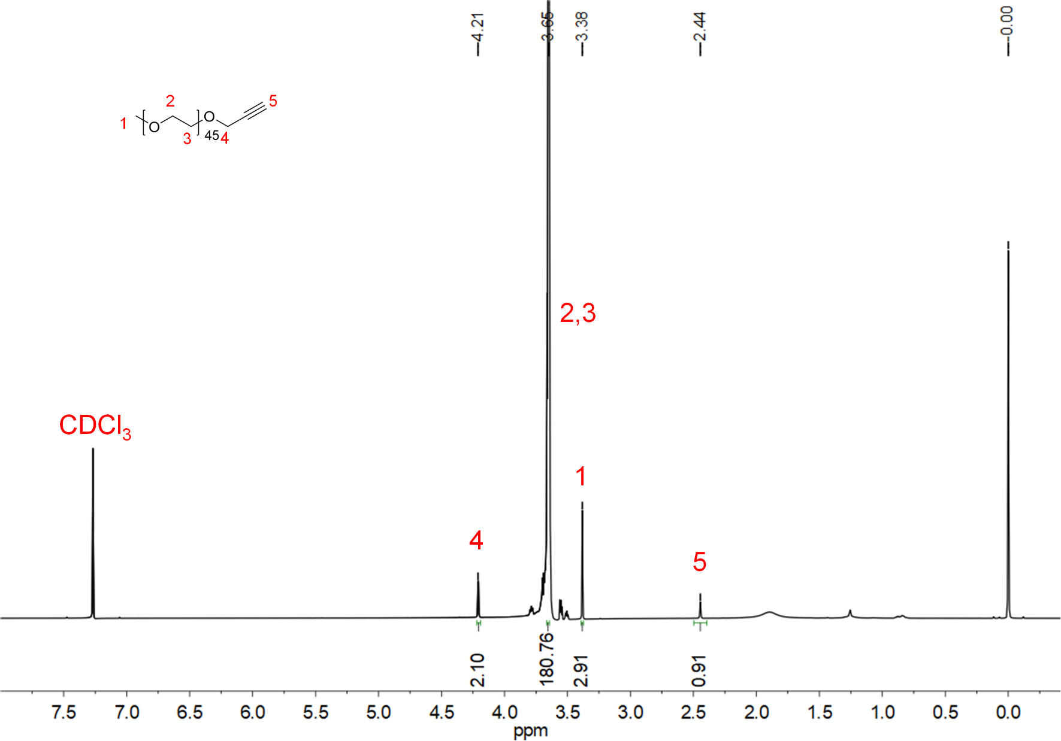
¹H NMR spectrum of PEG-alkynyl in CDCl₃.

ESI-MS 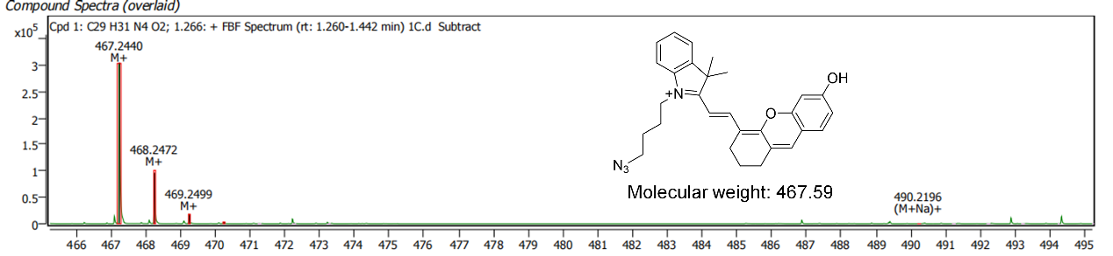
ESI-MS spectrum of CyOH.
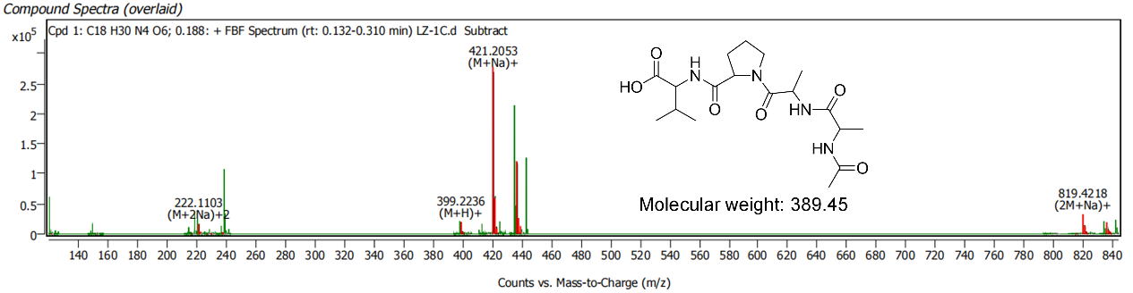
ESI-MS spectrum of AAPV.
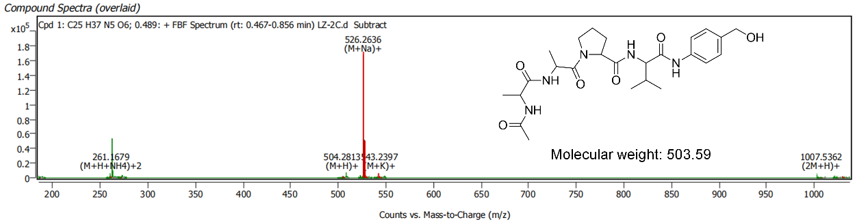
ESI-MS spectrum of AAPV-PABA.
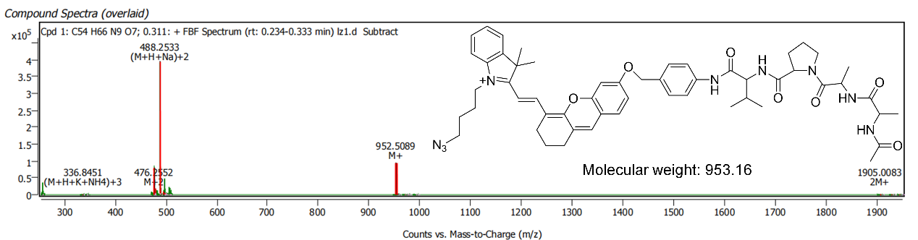
ESI-MS spectrum of NERP.

