Supplements:
Table S1: List of maps and databases used in this study.
Map Name | Producer | Source
Swedish Land Cover Raster NMD generalized 2018 | Naturvårdsverket | http://www.naturvardsverket.se/Sa-mar-miljon/Kartor/Nationella-Marktacke-data-NMD/
Mountain Forest Map | Skogsstyrelsen | https://www.lantmateriet.se/sv/nationella-geodataplattformen/datamangder/grans-for-fjallnara-skog/
Productive Land Raster | Naturvårdsverket | https://geodatakatalogen.naturvardsverket.se/geonetwork/srv/swe/catalog.search#/metadata/9c3310f6-73d5-4ae3-865f-0e16e03d44c8
Nationalparker | Naturvårdsverket | https://metadatakatalogen.naturvardsverket.se/metadatakatalogen/GetMetaDataById?id=bfc33845-ffb9-4835-8355-76af3773d4e0
Naturreservat | Naturvårdsverket | https://metadatakatalogen.naturvardsverket.se/metadatakatalogen/GetMetaDataById?id=2921b01a-0baf-4702-a89f-9c5626c97844
SCI - Natura 2000 | Naturvårdsverket | https://metadatakatalogen.naturvardsverket.se/metadatakatalogen/GetMetaDataById?id=945e918f-8426-4155-8fd6-3f780a85dd8f
SPA – Natura 2000 | Naturvårdsverket | https://metadatakatalogen.naturvardsverket.se/metadatakatalogen/GetMetaDataById?id=a80bf3d7-e70c-42d1-9b8d-8148e53e011d
Biotopskydd | Skogsstyrelsen | https://geodpags.skogsstyrelsen.se/geodataport/feeds/Biotopskydd.xml
Övrig Biotopskydd | Naturvårdsverket | https://metadatakatalogen.naturvardsverket.se/metadatakatalogen/GetMetaDataById?id=c3dd73b1-1c82-4db5-aac3-c8c6f240fa25
Naturvårdsavtal | Skogsstyrelsen | https://geodpags.skogsstyrelsen.se/geodataport/feeds/Naturvardsavtal.xml
Nyckelbiotoper | Skogsstyrelsen | https://geodpags.skogsstyrelsen.se/geodataport/feeds/Nyckelbiotoper.xml
Storskogsbrukets nyckelbiotoper | Skogsstyrelsen | https://geodpags.skogsstyrelsen.se/geodataport/feeds/StorskogsbrNyckelb.xml
Skyddsvarda Statliga Skogar | Naturvårdsverket | https://geodata.naturvardsverket.se/planeringsunderlag_o_strategier/wms?layers=Statlig_Natur_och_Urskogsinventering
IFL_2020 | IFL Mapping Team | https://intactforests.org/data.ifl.html
GSD-Elevation data | Lantmäteriet | https://www.lantmateriet.se/sv/geodata/vara-produkter/produktlista/markhojdmodell-nedladdning-grid-50/
Soil Moisture Index | Naturvårdsverket | https://geodatakatalogen.naturvardsverket.se/geonetwork/srv/swe/catalog.search#/metadata/cae71f45-b463-447f-804f-2847869b19b0
1939 Road Map | Riksarkivet | https://sok.riksarkivet.se/arkiv/MpcDuqySWIH1G22iGEjE31
Vattendragslinjer_nätverk_2016 | SMHI | https://www.smhi.se/data/utforskaren-oppna-data/vattendrag-natverk-svar2016#:~:text=Vattendragslinjer%2C%20%C3%A4r%20linjer%20genom%20sj%C3%B6ar,vattendrag%20med%20vattendragsidentitet%20och%20namn.
Flottning - Underlag och metoder for statusklassning av hydromorfologi | Vattenmyndigherterna | https://viss.lansstyrelsen.se/ReferenceLibrary/51868/PM_Flottning.pdf
Flottningslämningar i Blekinge, Kronoberg och Skåne län – Inventeringar och metodstudie. | Länsstyrelsen i Kronobergs län | https://catalog.lansstyrelsen.se/store/54/resource/DG_2013_15
Jordarter 1:25 000–1:100 000 | SGU | https://apps.sgu.se/kartvisare/kartvisare-jordarter-25-100.html
Clearcuts | Skogstyrelsen. | https://www.skogsstyrelsen.se/laddanergeodata

Table S2: Definition of each naturalness class within the primary forest category, including their proposed names and their size. For more detailed information, see Buchwald (2005).
Primary Forest Naturalness Scale
Naturalness level | Name | Size | Definition
10 | Primeval forest | Landscape | Never modified by civilization even indirectly.
9 | Virgin forest | Forest | Unmodified by man. No signs of selective cutting or grazing.  If any impact of man should no longer be visible AND should have not been greater than native animals.
8 | Frontier forest | Landscape | Presence of limited human traditional activities – that are of low impact. Structure and composition driven by natural disturbance. Patches of different age group. Large enough for wide ranging species.
7 | Near-virgin forest | Forest | Can have been subject to cutting and grazing in the past. But long ago enough that structure and composition now resemble a 9. Patches of different age group
6 | Old-growth forest | Stand | Can have been subject to cutting and grazing in the past.  Have structure of forest in late developmental stage (old trees, range of tree size, dead wood, mixed canopy layer.
5 | Long untouched Forest | Stand | Unmodified by man in the last 60-80 years. Signs of former human activity are visible.

Table S3: Information collected about primary forests.
Administrative Information
FOR_EXT | Forest extent in hectares. Amount of the total area which is registered as forest area
TOT_AREA | Area extent in hectares
PROT_SINCE | Year of first protective measures
PROT_STATUS | Status of protective measures (nature reserve, national park, or NA)
PROT_TYPE | Type of protective measures:  Minimum intervention: is the area left for free development or only some small interventions.  Designed management: for a special purpose and involves a lot of measures taken like felling, cleaning or thinning trees,  Traditional management: management to keep historical practices like haying and grazing in place
CONTACT | Institution responsible for the area
RECENT_MAN | Year of most recent management plan
N2000 | Registered as Natura2000 (Yes=1; No=0)
OWNER | Legal owner of the land
Historical Information
MAX_AGE | Maximum Age
MLAST_DIST_TYPE | The type of most recent man-made disturbance
MLAST_DIST_YEAR | Year of most recent man-made disturbance
MLAST_DIST_INTENSITY | Intensity of man-made disturbance on a scale of 0 to 5. The number should be based on impact and scale. A 5 means that the whole area is heavily affected. A 0 means no impact at all  This can be a combination of different disturbances over time
NLAST_DIST_TYPE | Type of most recent natural disturbance
NLAST_DIST_YEAR | Year of most recent natural disturbance
NLAST_DIST_INTENSITY | Intensity of natural disturbance on a scale of 0 to 5. The number should be based on impact, time since disturbance and scale. A 5 means that the whole area is recently heavily affected. A 0 means no impact at all.  This can be a combination of different disturbances over time.
LOGGING | Impact of past logging on a scale of 0 to 3. The number should be based on impact, time since disturbance and scale.  This only applies to selective logging, clear-cuts are excluded.
THINNING | Records of past thinning (Yes=1, No=0)
CLEANING | Records of past cleaning (Yes=1, No=0)
GRAZING | Records of past grazing (Yes=1, No=0), from cattle or reindeer
CHARCOAL | Records of past charcoal production (Yes=1, No=0)
CHALKING | Records of past chalking (Yes=1, No=0)
Current State and Future Management
DEADWOOD_P | Presence of Deadwood (Yes=1; No=0)
FIRE_PREV | Active fire prevention (Yes=1; No=0)
FIRE_POSSIBLE | Possible prescribed burning (Yes=1; No=0)  If yes, this area should be excluded.
RE_EXOT | Removal of exotic species (Yes=1; No=0)
CLEANING | Cleaning around big old trees (Yes=1; No=0)
DEADWOOD_T | Free to collect deadwood (Yes=1; No=0)
HUNTING | Allowed to hunt (Yes=1; No=0)
RENSKÖTSEL | Allowed to herd reindeers (Yes=1; No=0)
MIL | Used for military training (Yes=1; No=0)
FREE_DEV | Nature left to develop freely (Yes=1; No=0)

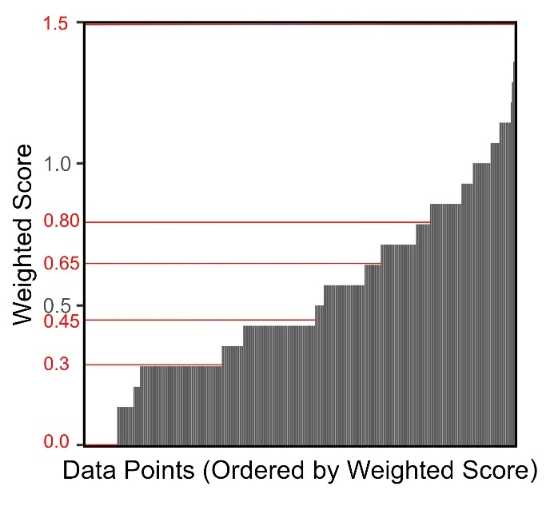
Figure S1: Distribution of the weighted score and breaks are shown in red.

