Supplementary Captions
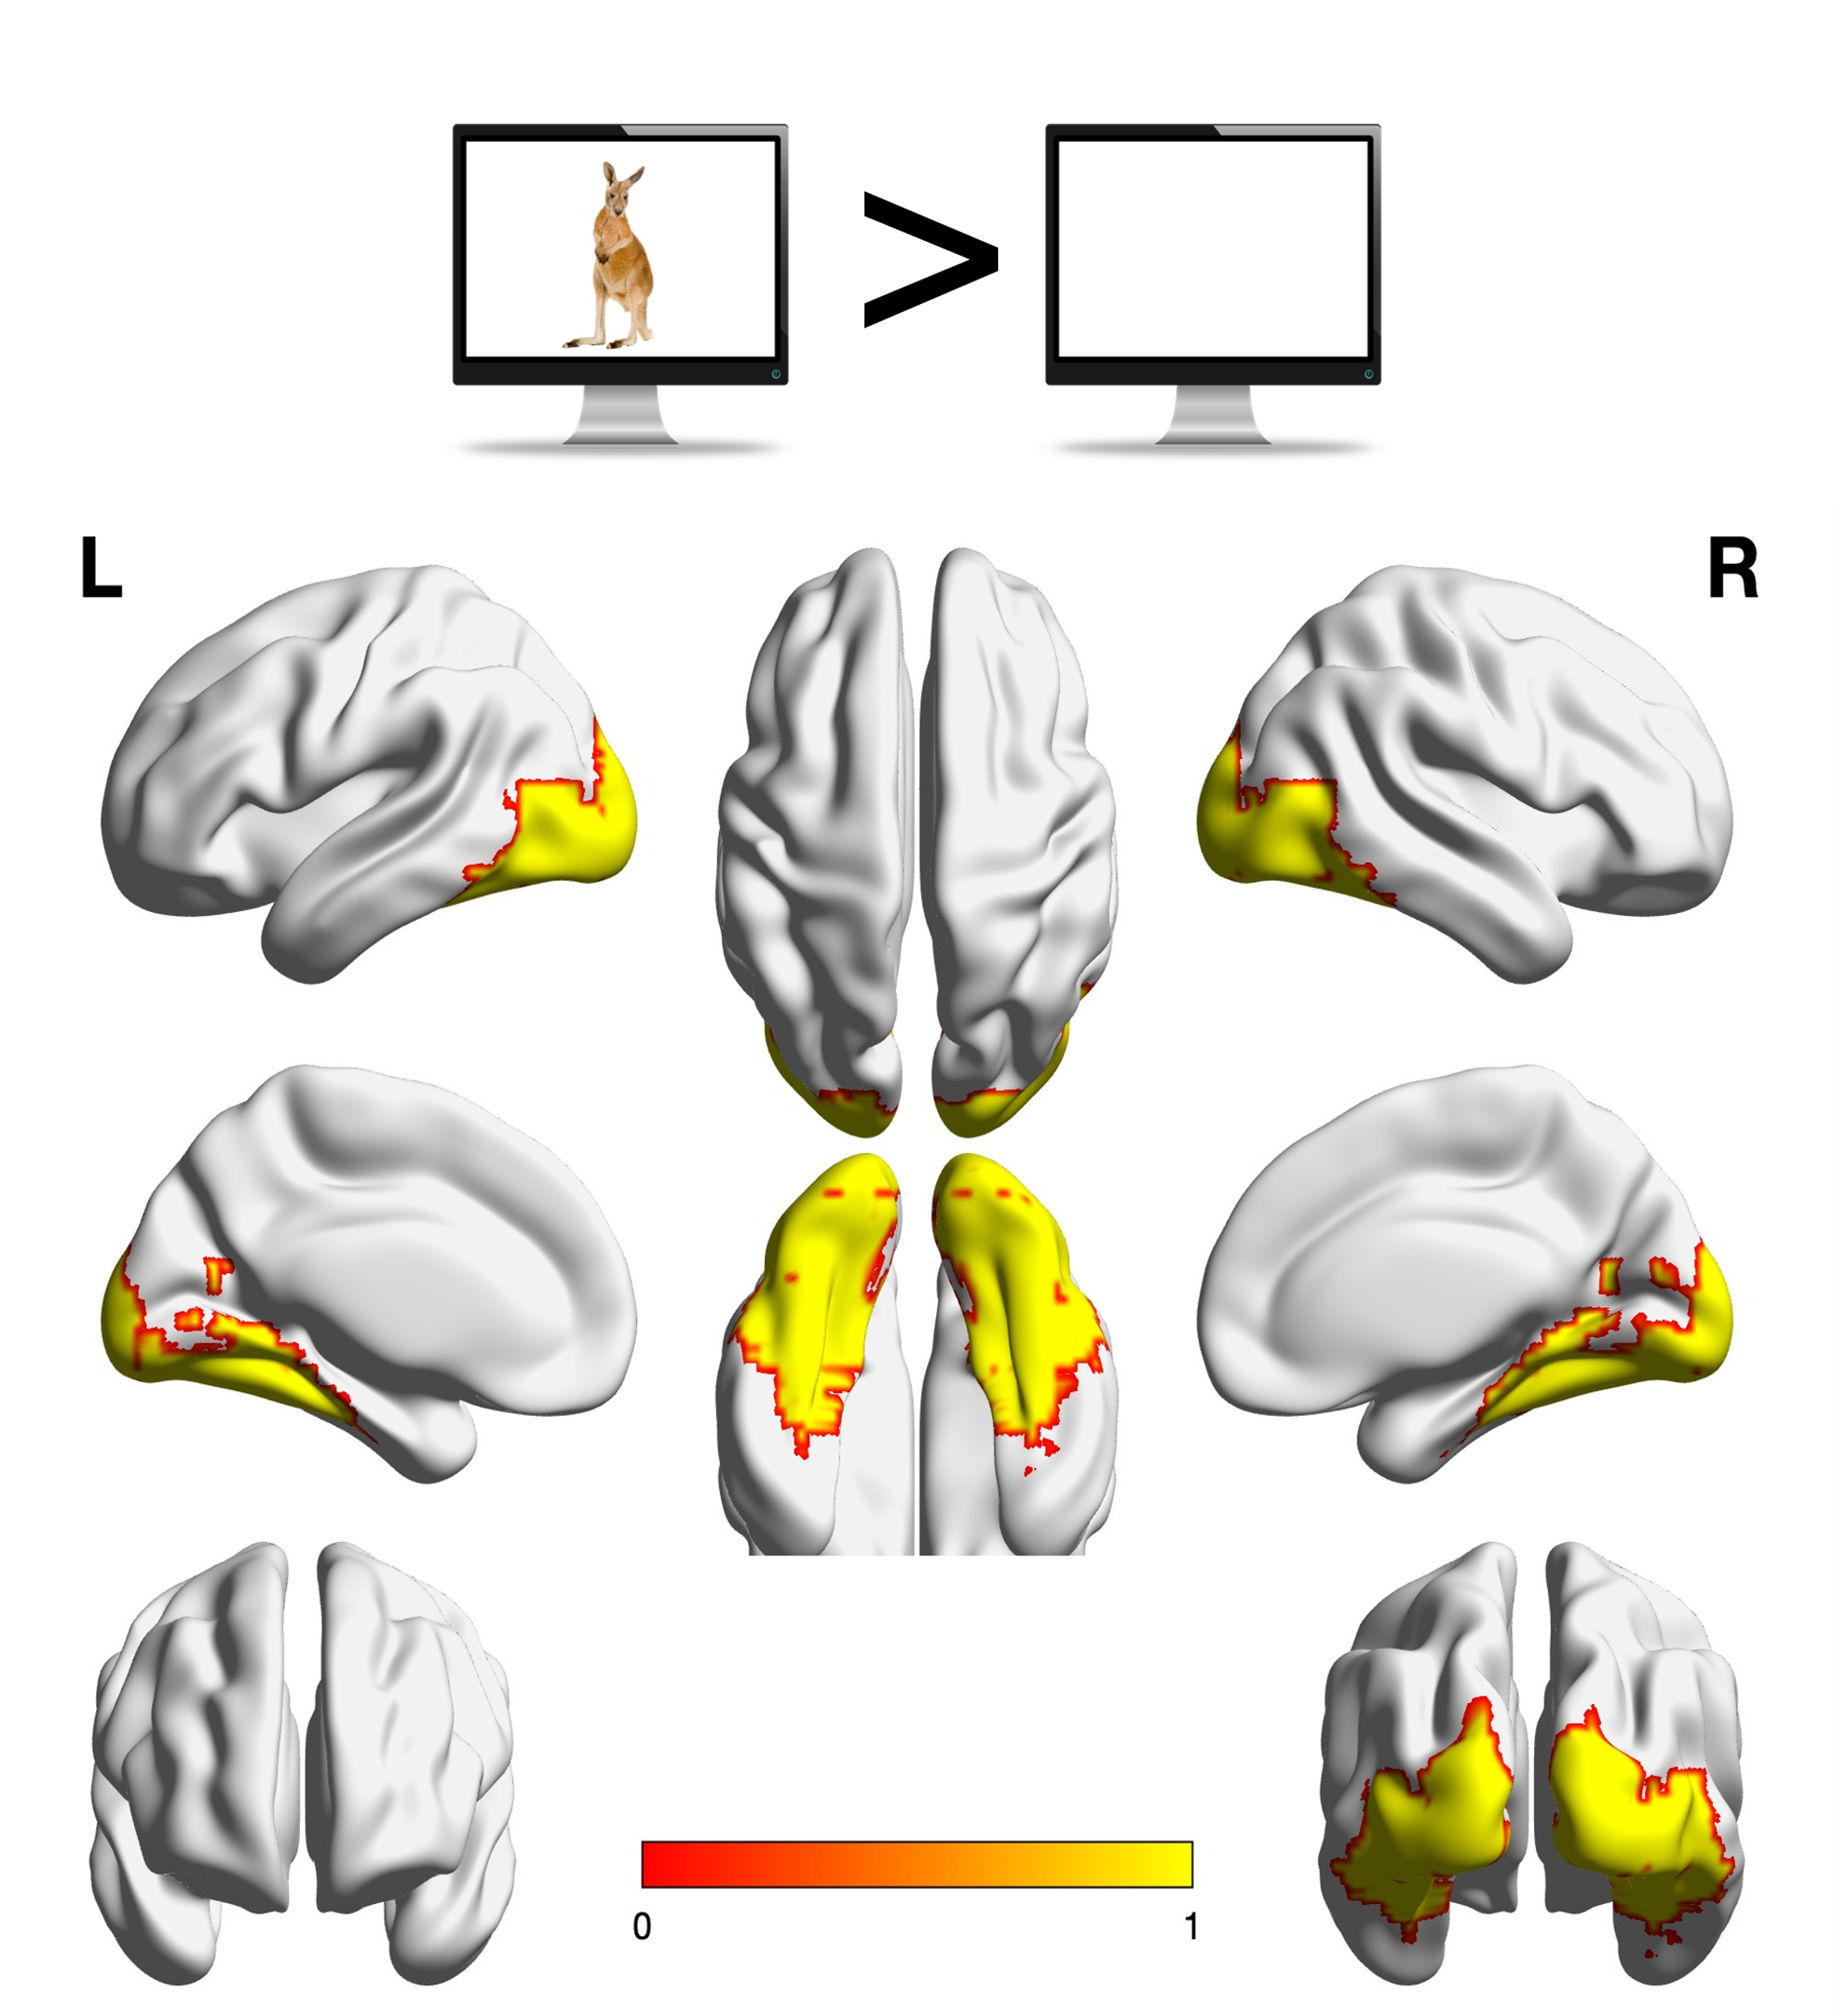
Supplementary Fig. 1. The ventral occipitotemporal cortex (VOTC) mask used in the analyses, defined on the basis of regions showing stronger activation to all pictures relative to baseline in hearing participants from the OPN95 dataset (q < 0.05, FDR-corrected). The functional mask was further constrained by the following anatomical parcels (Harvard–Oxford Atlas, probability > 0.2): the posterior and temporooccipital divisions of the inferior temporal gyrus (#15, #16), the inferior division of the lateral occipital cortex (#23), the posterior division of the parahippocampal gyrus (#35), the lingual gyrus (#36), the posterior division of the temporal fusiform cortex (#38), the temporal occipital fusiform cortex (#39), the occipital fusiform gyrus (#40), the supracalcarine cortex (#47), and the occipital pole (#48).

