Supplementary Material 1: p-values from Kruskal-Wallis non-parametric tests applied to determine significant differences across Alpha diversity assessed using OTU richness, Shannon diversity index, and Pielou’s evenness index for each trophic guild in
 |  | Alpha diversity
GABON |  | OTU richness | Pielou index | Shannon index
Stand type | All (ITS2) | 0,106 | 0,238 | 0,369
Stand type | Saprotrophs (ITS2) | 0,113 | 0,648 | 0,159
Stand type | Pathotrophs (ITS2) | 0,169 | 0,833 | 0,348
Stand type | Symbiotrophs (ITS2) | 0,139 | 0,087 | 0,107
Stand type | AM fungi (SSU) | 0,598 | 0,968 | 0,681
Tree social status | All (ITS2) | 0,829 | 0,938 | 0,990
Tree social status | Saprotrophs (ITS2) | 0,100 | 0,061 | 0,043* (CR)
Tree social status | Pathotrophs (ITS2) | 0,695 | 0,412 | 0,947
Tree social status | Symbiotrophs (ITS2) | 0,625 | 0,095 | 0,437
Tree social status | AM fungi (SSU) | 0,123 | 0,296 | 0,139
DRC |  | OTU richness | Pielou index | Shannon index
Stand type | All (ITS2) | 0,133 | 0,043*  (Minkuku) | 0,101
Stand type | Saprotrophs (ITS2) | 0,137 | 0,060 | 0,115
Stand type | Pathotrophs (ITS2) | 0,184 | 0,903 | 0,266
Stand type | Symbiotrophs (ITS2) | 0,852 | 0,817 | 0,905
Stand type | AM fungi (SSU) | 0,975 | 0,855 | 0,927
Tree social status | All (ITS2) | 0,536 | 0,260 | 0,487
Tree social status | Saprotrophs (ITS2) | 0,877 | 0,517 | 0,869
Tree social status | Pathotrophs (ITS2) | 0,077 | 0,752 | 0,119
Tree social status | Symbiotrophs (ITS2) | 0,961 | 0,724 | 0,990
Tree social status | AM fungi (SSU) | 0,155 | 0,238 | 0,108

Supplementary Material 2: Results from permutational multivariate analyses of variance (PERMANOVA) with 9,999 permutations performed and Bray-Curtis and Jaccard distance matrices. P-values were categorized as follows: p ≤ 0.05 (significant), p ≤ 0.01 (highly significant), and p ≤ 0.001 (very highly significant).

 |  | Beta diversity
GABON |  | Bray-Curtis | Jaccard
Stand type | All (ITS2) | <0,001*** | <0,001***
Stand type | Saprotrophs (ITS2) | <0,001*** | <0,001***
Stand type | Pathotrophs (ITS2) | <0,001*** | <0,001***
Stand type | Symbiotrophs (ITS2) | <0,001*** | <0,001***
Stand type | AM fungi (SSU) | <0,001*** | <0,001***
Tree social status | All (ITS2) | 0,426 | 0,382
Tree social status | Saprotrophs (ITS2) | 0,003** | 0,001**
Tree social status | Pathotrophs (ITS2) | 0,192 | 0,226
Tree social status | Symbiotrophs (ITS2) | 0,008** | 0,008**
Tree social status | AM fungi (SSU) | 0,004** | 0,004**
DRC |  | Bray-Curtis | Jaccard
Stand type | All (ITS2) | 0,475 | 0,454
Stand type | Saprotrophs (ITS2) | 0,043* | 0,033*
Stand type | Pathotrophs (ITS2) | 0,005** | 0,043*
Stand type | Symbiotrophs (ITS2) | 0,021* | 0,031*
Stand type | AM fungi (SSU) | 0,002** | 0,003**
Tree social status | All (ITS2) | 0,097 | 0,101
Tree social status | Saprotrophs (ITS2) | 0,467 | 0,475
Tree social status | Pathotrophs (ITS2) | 0,737 | 0,538
Tree social status | Symbiotrophs (ITS2) | 0,668 | 0,793
 | AM fungi (SSU) | 0,629 | 0,618

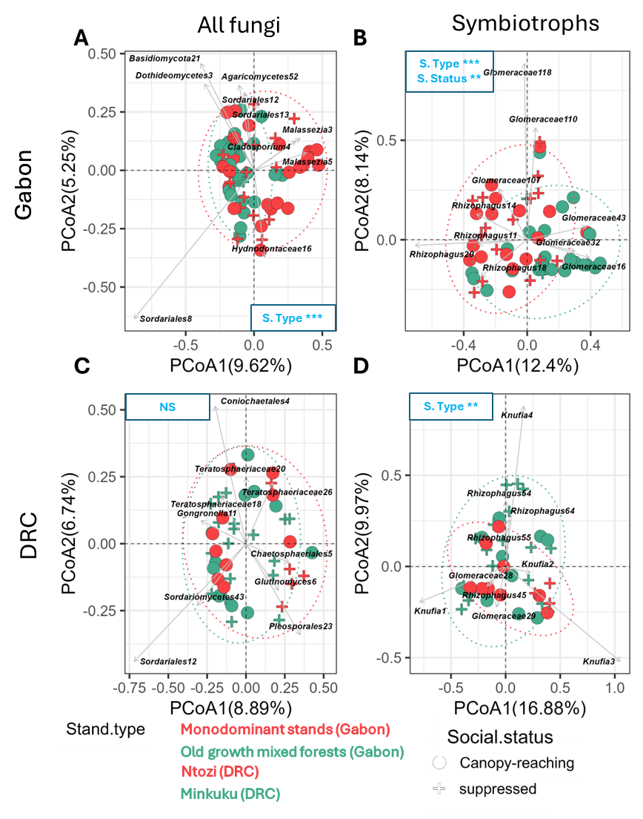
Supplementary Material 3: PCoA plots based on Bray-Curtis dissimilarity matrices on OTUs obtained from Gabon (A,B) and the DRC (C,D) assigned to every fungal OTUs (A,C), and symbiotrophic (B,C) trophic guild obtained from the ITS2 rDNA region. Significant differences between modalities were assessed using permutational multivariate analyses of variance (PERMANOVA) with 9,999 permutations. Blue labels indicate significant differences, with p-values categorized as follows: p ≤ 0.05 (significant), p ≤ 0.01 (highly significant), and p ≤ 0.001 (very highly significant). The variables "S.type" stands for stand type and "S.status" for social status. The 10 taxa that have the highest contributions to the ordinations are labelled in each plot.

