Table 3: Antimicrobial Sensitivity of Ganoderma lucidum Extracts Against Bacterial and Fungal Pathogens

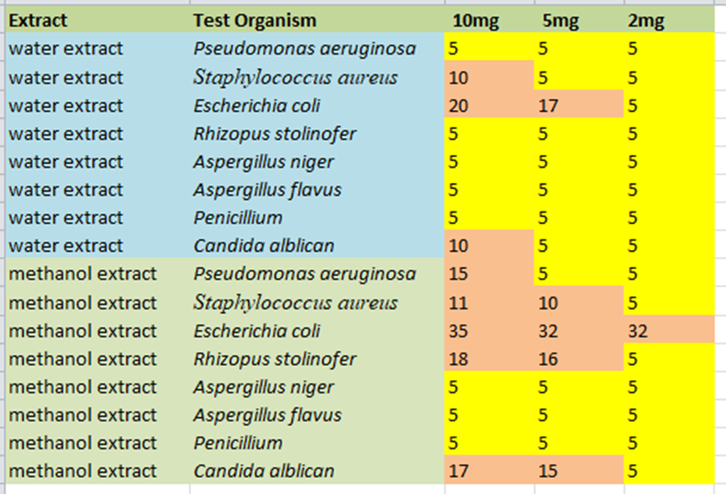

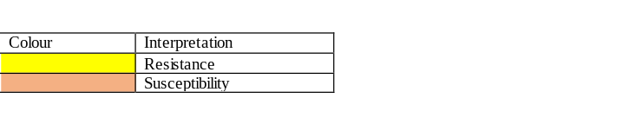

Table 4: Zone of Inhibition of Methanol Extract of different concentrations against some test organisms. Error bars represented the standard errors of the means (±SEM)
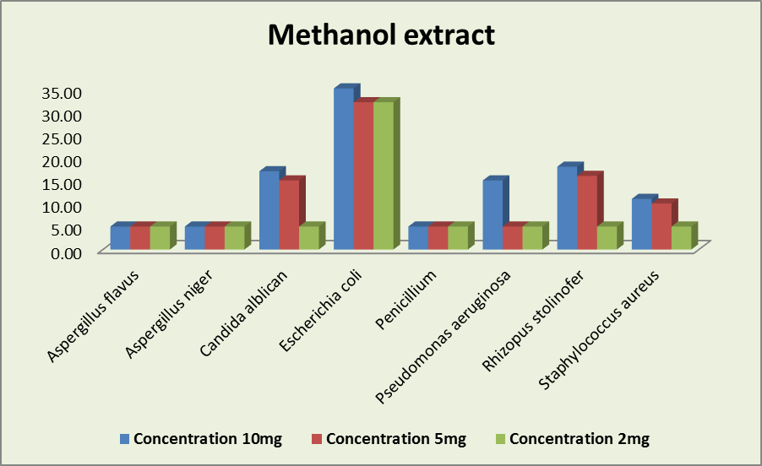

Table 5: Zone of Inhibition of Aqueous Extract of different concentrations against some test organisms. Error bars represented the standard errors of the means (±SEM).
