Supporting Information
Design of Hierarchical Structured Catalysts: SnO₂-Modified TiO₂ Nanotube Arrays Enabling Ultra-Low Overpotential Acidic Oxygen Evolution Reaction

Qingchen Lu^{a,b}, Xiaoyu Huang^{a,b},Yaowen Zhang^{a,b},Dayong Fan, Faming Han, Huidan Lu^{a,b}*, Yongping Liu^{a,b}*

ªGuangxi Colleges and Universities Key Laboratory of surface and interface electrochemistry, College of Chemistry and Bioengineering, Guilin University of Technology, Guilin 541004, P.R. China.
^{b}Guangxi Key Laboratory of Electrochemical and Magneto-chemical, Functional Materials, College of Chemistry and Bioengineering, Guilin University of Technology, Guilin, 541004 P.R. China.
E-mail addresses: lhuidangl@163.com (Huidan Lu), liuyp624@163.com (Yongping Liu)

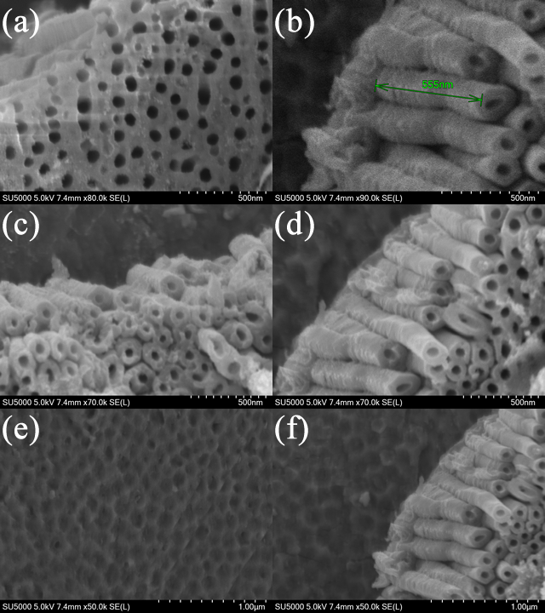
Fig. S1 SEM image of TNT nanotubes. a-d) Nanotube image; e-f) Nanotube barrier layer image.

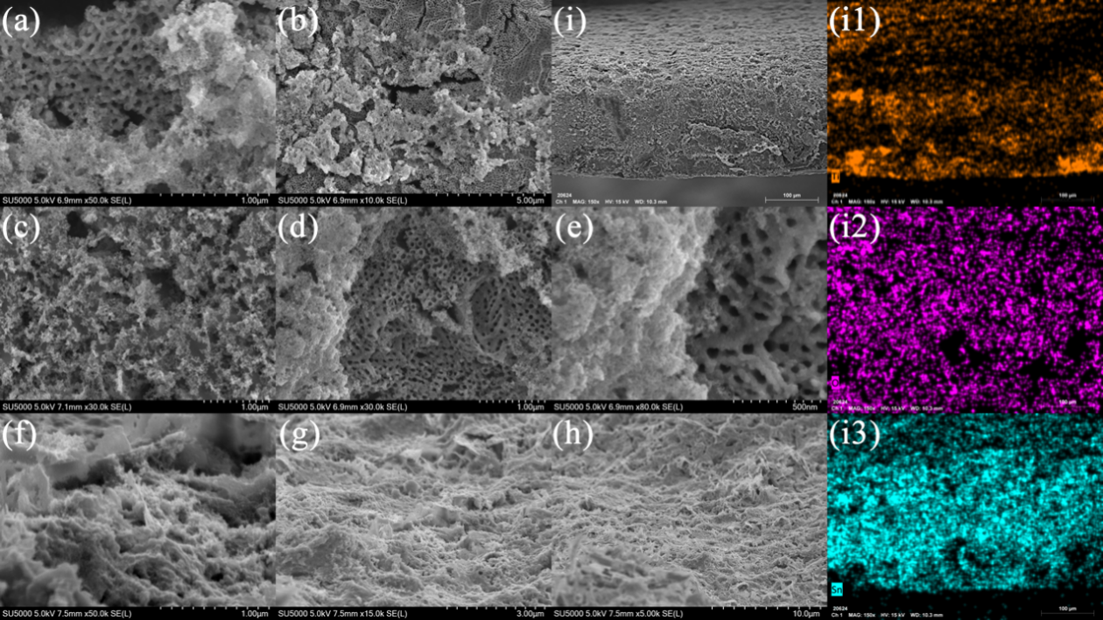
Fig. S2 Morphology of nanotube directly loaded porous SnO₂ at different angles. a-e) Top view; f-i) Side view; i1-i3) i Mapping image.

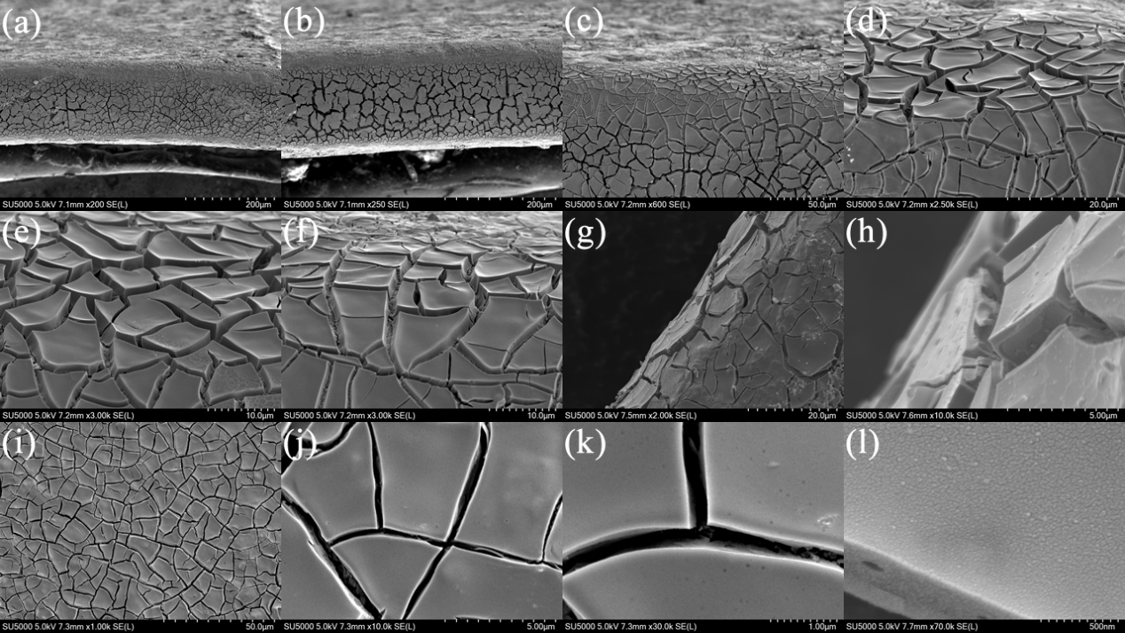
Fig. S3 SEM image of TNT/SnO₂/IrO_{x}. a-h) Side corner image; i-l) Plane image.

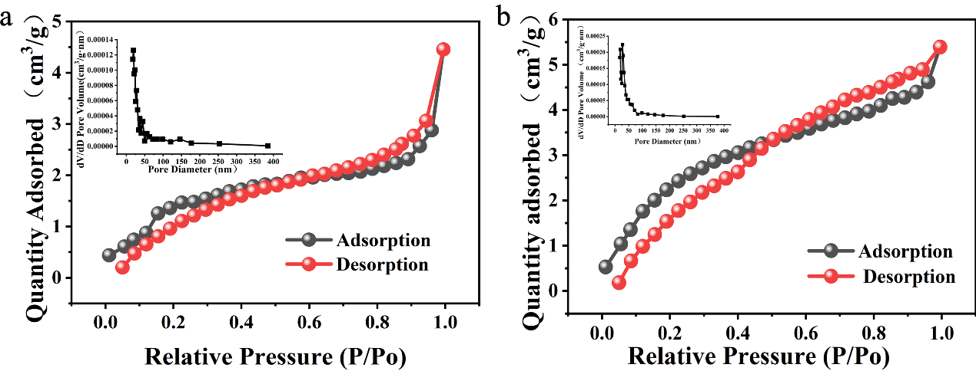
Fig. S4 a) BET chart of TNT/SnO₂/IrO_{x}; b) BET chart of TNT/SnO₂.

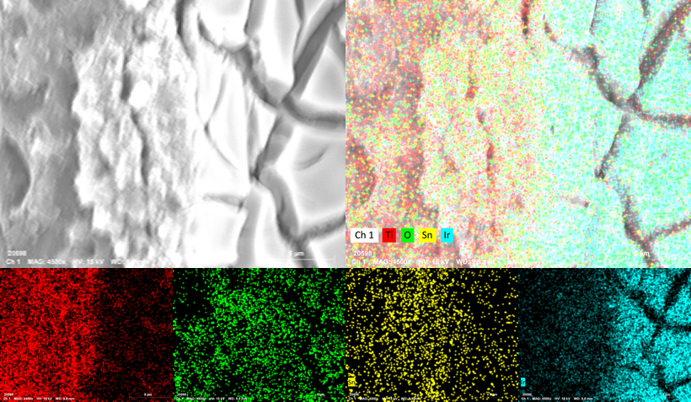
Fig. S5 SEM image and corresponding Mapping image at the critical point.

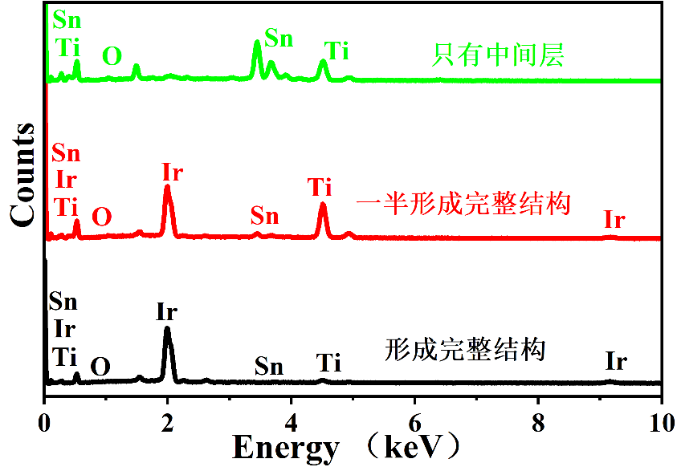
Fig. S6 Various morphologies correspond to EDS maps.

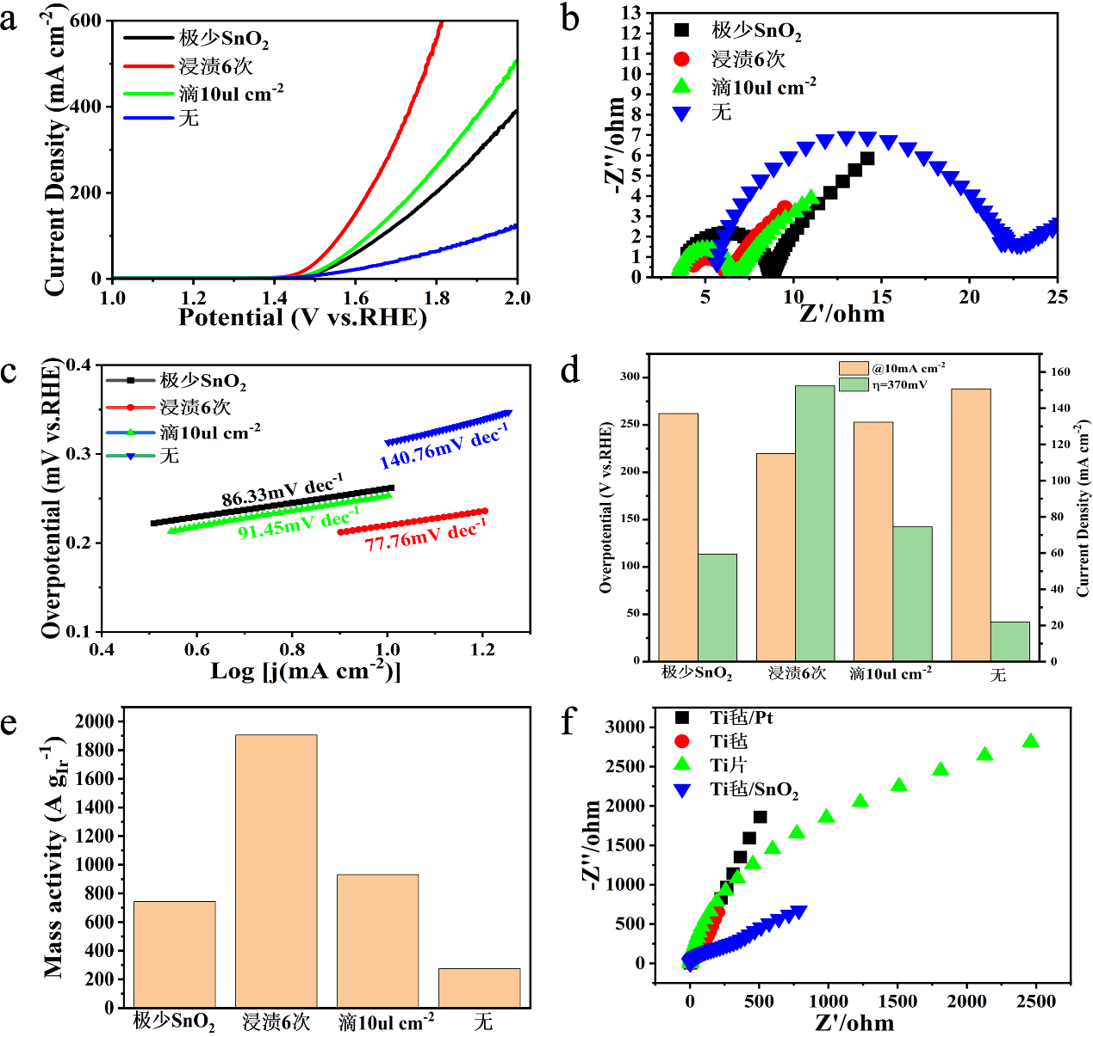
Fig. S7 Comparison of different OER activity (Ir loading with 80 ug cm⁻²) a) The steady-state polarization curve is obtained at a low scanning rate of 1 mV s⁻¹; b) EIS image of different electrocatalysts at 0.5 M H₂SO₄; c) Tafel image of different electrocatalysts in 0.5 M H₂SO₄; d) The overpotential corresponding to 10 mA cm⁻² and the current density corresponding to 370 mV overpotential of different electrocatalysts; e) Mass activity of different catalysts under 370mV overpotential; f) Impedance of Ti with different morphologies in 0.5 M H₂SO₄.

Different amounts of SnO₂ were prepared on TNT by different methods, of which very little SnO₂ was prepared by electrochemical pulse deposition, as shown in the figure, and then the same unit mass of precious metal was dripped on this basis.

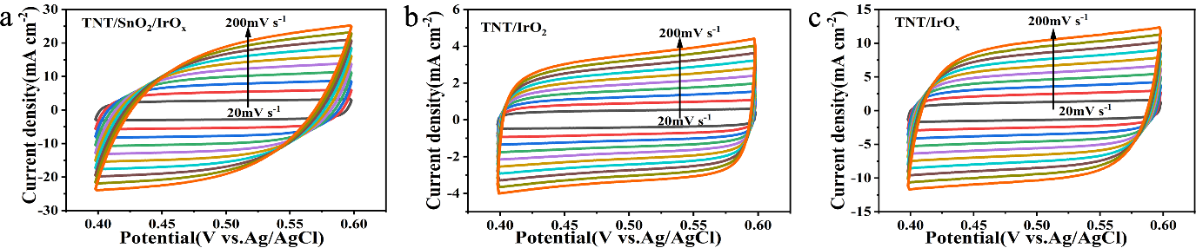
Fig. S8 a-c) CV of TNT/SnO₂/IrO_{x} ,TNT/IrO₂,TNT/IrO_{x} at 20-200 mV s⁻¹ sweep speed.
Electrocatalysts | Electrolyte | Ƞ10 mA cm⁻² (mV) | Tafel slope (mV dec⁻¹) | Stability | References
IrO_{x}@TiO₂ | 0.5 M H₂SO₄ | 255 | 48.8 | 600 h @ 10 mA cm⁻² | [1]
IrO_{x} | 0.5 M H₂SO₄ | 300 | 56 | / | [1]
IrO₂ | 0.5 M H₂SO₄ | 356 | 72 | 70 h @ 10 mA cm⁻² | [1]
Ir/D-ATO | 0.5 M H₂SO₄ | 305 | 49.05 | 250 h @ 1A cm⁻² | [2]
rOx/WO₃ | 0.5 M H₂SO₄ | 260 | 65.4 | 100 h @ 10 mA cm⁻² | [3]
IrO₂@TaO_{x}@TaB | 0.1 M HClO₄ | 279 | 50 | 1500 h @ 2 A cm⁻² | [4]
IrO₂@TaB₂ | 0.1 M HClO₄ | 288 | 42.6 | 120 h @ 1 A cm⁻² | [5]
TiN/IrO₂ | 0.5 M H₂SO₄ | 313 | 65.5 | 140 min @ 10 mA cm⁻² | [6]
Ir/MoS₂ | 0.5 M H₂SO₄ | 270 | 58.31 | / | [7]
Ir- NiCo₂O₄ | 0.5 M H₂SO₄ | 240 | 60 | 2 h @ 10 mA cm⁻² | [8]
Ru@IrO_{x} | 0.05 M H₂SO₄ | 282 | 69 | 24 h @ 1.55 Vs RHE | [9]
Co-RuIr | 0.1 M HClO₄ | 235 | 66.9 | 25 h @ 10 mA cm⁻² | [10]
Ir-Ag NTS | 0.5 M H₂SO₄ | 285 | 61.1 | 6 h @ 5 mA cm⁻² | [11]
Ir/GF | 0.5 M H₂SO₄ | 290 | 46 | 10 h @ 10 mA cm⁻² | [12]
Table. S9 Comparison of OER activity with various advanced acid catalysts reported recently.

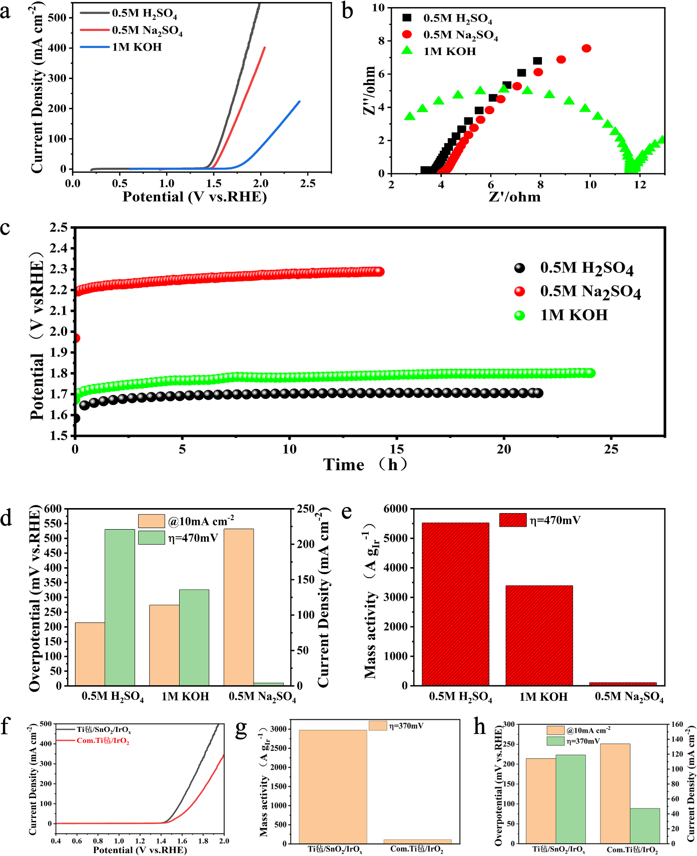
Fig. S10 Comparison of different OER activity (Ir loading with 40 ug cm⁻²) a) The steady-state polarization curve is obtained at a low scanning rate of 1 mV s⁻¹ in 0.5 M H₂SO₄, 1 M KOH and 0.5 M Na₂SO₄; b) EIS image of different electrocatalysts in 0.5 M H₂SO₄, 1 M KOH and 0.5 M Na₂SO₄; c) Chronopotentigrams of catalyst at 0.1 A cm⁻² current density in three electrolytes; d) The overpotential corresponding to 10 mA cm⁻² and the current density corresponding to 370 mV overpotential of different electrocatalysts; e) Mass activity of different catalysts under 370 mV overpotential; f) Steady-state polarization curves of Ti felt /SnO₂/IrO_{x} and Com Ti felt /IrO₂ in 0.5 M H₂SO₄ Impedance of Ti with different morphologies in 0.5 M H₂SO₄; g) Mass activity of both at 370 mV overpotential; h) Overpotential corresponding to 10 mA cm⁻² and current density corresponding to 370 mV overpotential of catalyst in different electrolytes.
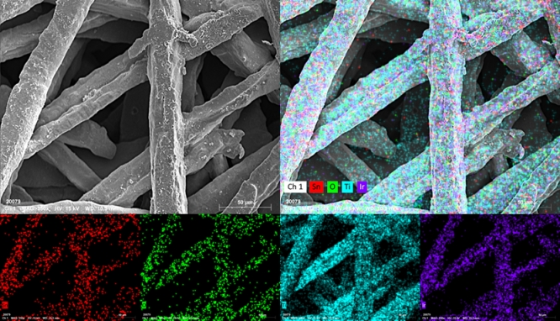
Fig. S11 SEM and corresponding Mapping image of Ti felt/SnO₂/IrO_{x}.

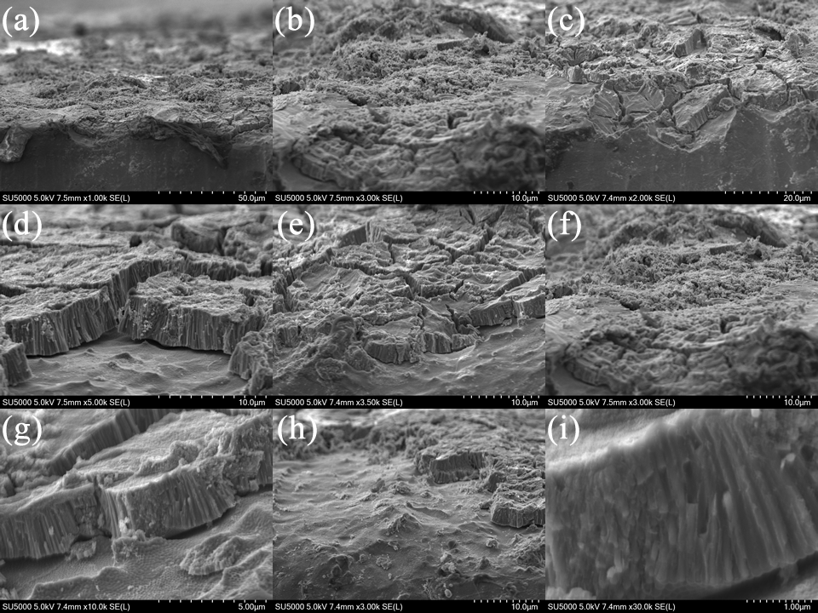
Fig. S12 a-i) Side SEM image of TNT/IrO_{x}.
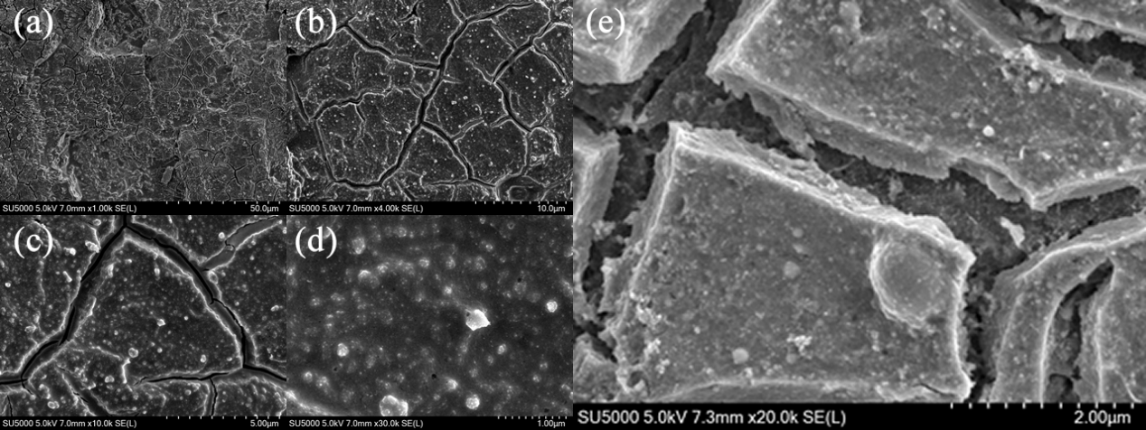
Fig. S13 TNT/SnO₂/IrO_{x} post-CP SEM image. a-d) Morphology after 40 h at 10 mA cm⁻² current density; e) Topography after 200 h at a current density of 30 mA cm⁻².

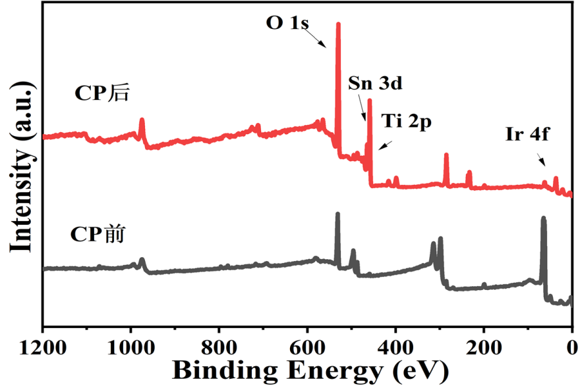
Fig. S14 TNT/SnO₂/IrO_{x} full spectrum of XPS before and after CP.

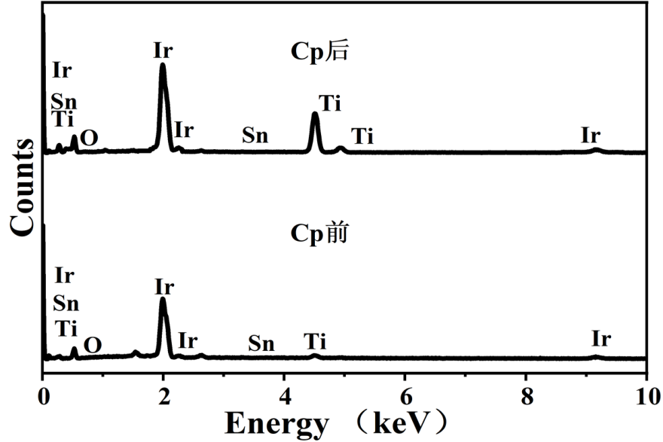
Fig. S15 TNT/SnO₂/IrO_{x} EDS spectra before and after CP.

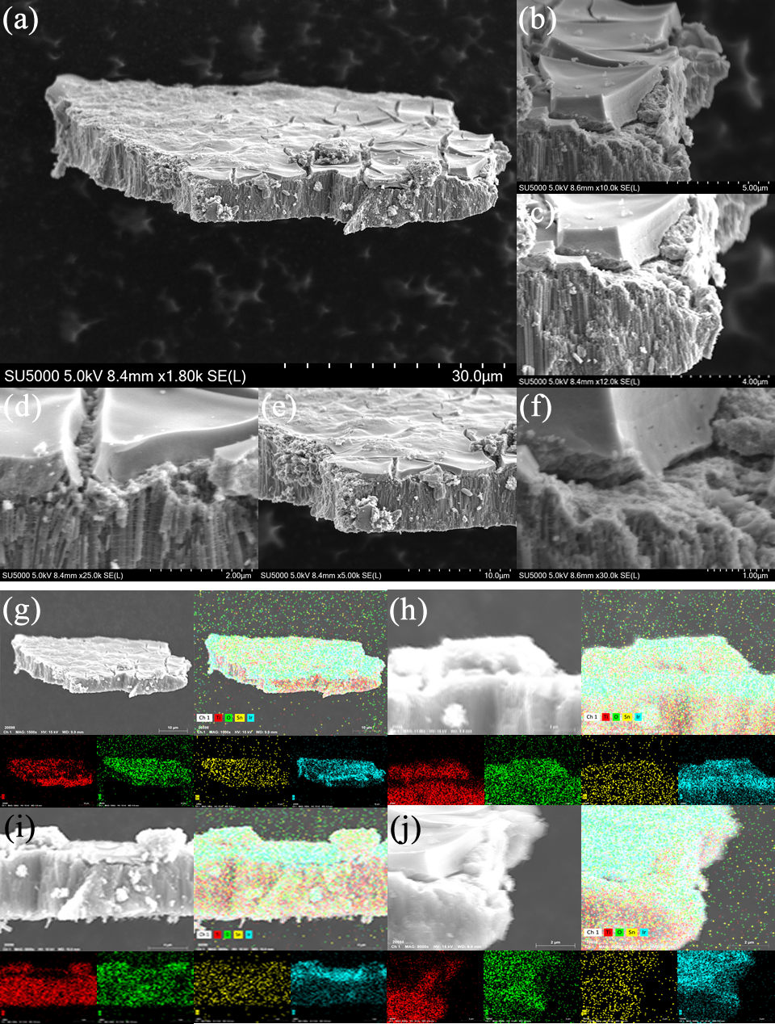
Fig. S16 a-f) SEM image of catalyst on nanotube; g-j) Mapping of various angles.

[1] Yu G, Li R, Hu Y, Lin X, Lin Z, Wu D, Wang G, Hong X (2024) Supporting IrO_{x} nanosheets on hollow TiO₂ for highly efficient acidic water splitting. Nano Res 17:6903-6909
[2] Lee G R, Kim J, Hong D, Kim Y J, Jang H, Han H J, Hwang C-K, Kim D, Kim J Y, Jung Y S (2023) Efficient and sustainable water electrolysis achieved by excess electron reservoir enabling charge replenishment to catalysts. Nat Commun 14
[3] Guan Z, Weng Y, Li J, Li S, Wang K, Lei L, Wang Y, Zhuang L, Xu Z (2024) Interfacial engineering to construct an IrO_{x}/WO₃ hetero-structured catalyst for efficient acidic OER catalysis. New J Chem 48:2505-2514
[4] Wang Y, Zhao Z, Liang X, Zhao X, Wang X, Jana S, Wu Y A, Zou Y, Li L, Chen H, Zou X (2024) Supported IrO₂ Nanocatalyst with Multilayered Structure for Proton Exchange Membrane Water Electrolysis. Adv Mater 36
[5] Wang Y, Zhang M, Kang Z, Shi L, Shen Y, Tian B, Zou Y, Chen H, Zou X (2023) Nano-metal diborides-supported anode catalyst with strongly coupled TaO_{x}/IrO₂ catalytic layer for low-iridium-loading proton exchange membrane electrolyzer. Nat Commun 14
[6] Zhang K, Mai W, Li J, Wang H, Li G, Hu W (2020) Highly scattered Ir oxides on TiN as an efficient oxygen evolution reaction electrocatalyst in acidic media. J Mater Sci 55:3507-3520
[7] Ding M, Feng X, Peng Y, Tong J, Hou B, Xing Y, Zhang W, Wang L, Wu Y, Lv J, Luo C, Xiong D, Zhang S, Ouyang M (2023) Electrolyte induced synergistic construction of cathode electrolyte interphase and capture of reactive free radicals for safer high energy density lithium-ion battery. J Energy Chem 87:207-214
[8] Yin J, Jin J, Lu M, Huang B, Zhang H, Peng Y, Xi P, Yan C-H (2020) Iridium Single Atoms Coupling with Oxygen Vacancies Boosts Oxygen Evolution Reaction in Acid Media. J Am Chem Soc 142:18378-18386
[9] Shan J, Guo C, Zhu Y, Chen S, Song L, Jaroniec M, Zheng Y, Qiao S-Z (2019) Charge-Redistribution-Enhanced Nanocrystalline Ru@IrOx Electrocatalysts for Oxygen Evolution in Acidic Media. Chem 5:445-459
[10] Shan J, Ling T, Davey K, Zheng Y, Qiao S-Z (2019) Transition-Metal-Doped RuIr Bifunctional Nanocrystals for Overall Water Splitting in Acidic Environments. Adv Mater 31
[11] Zhu M, Shao Q, Qian Y, Huang X (2019) Superior overall water splitting electrocatalysis in acidic conditions enabled by bimetallic Ir-Ag nanotubes. Nano Energy 56:330-337
[12] Zhao Y, Luo M, Chu S, Peng M, Liu B, Wu Q, Liu P, de Groot F M F, Tan Y (2019) 3D nanoporous iridium-based alloy microwires for efficient oxygen evolution in acidic media. Nano Energy 59:146-153

