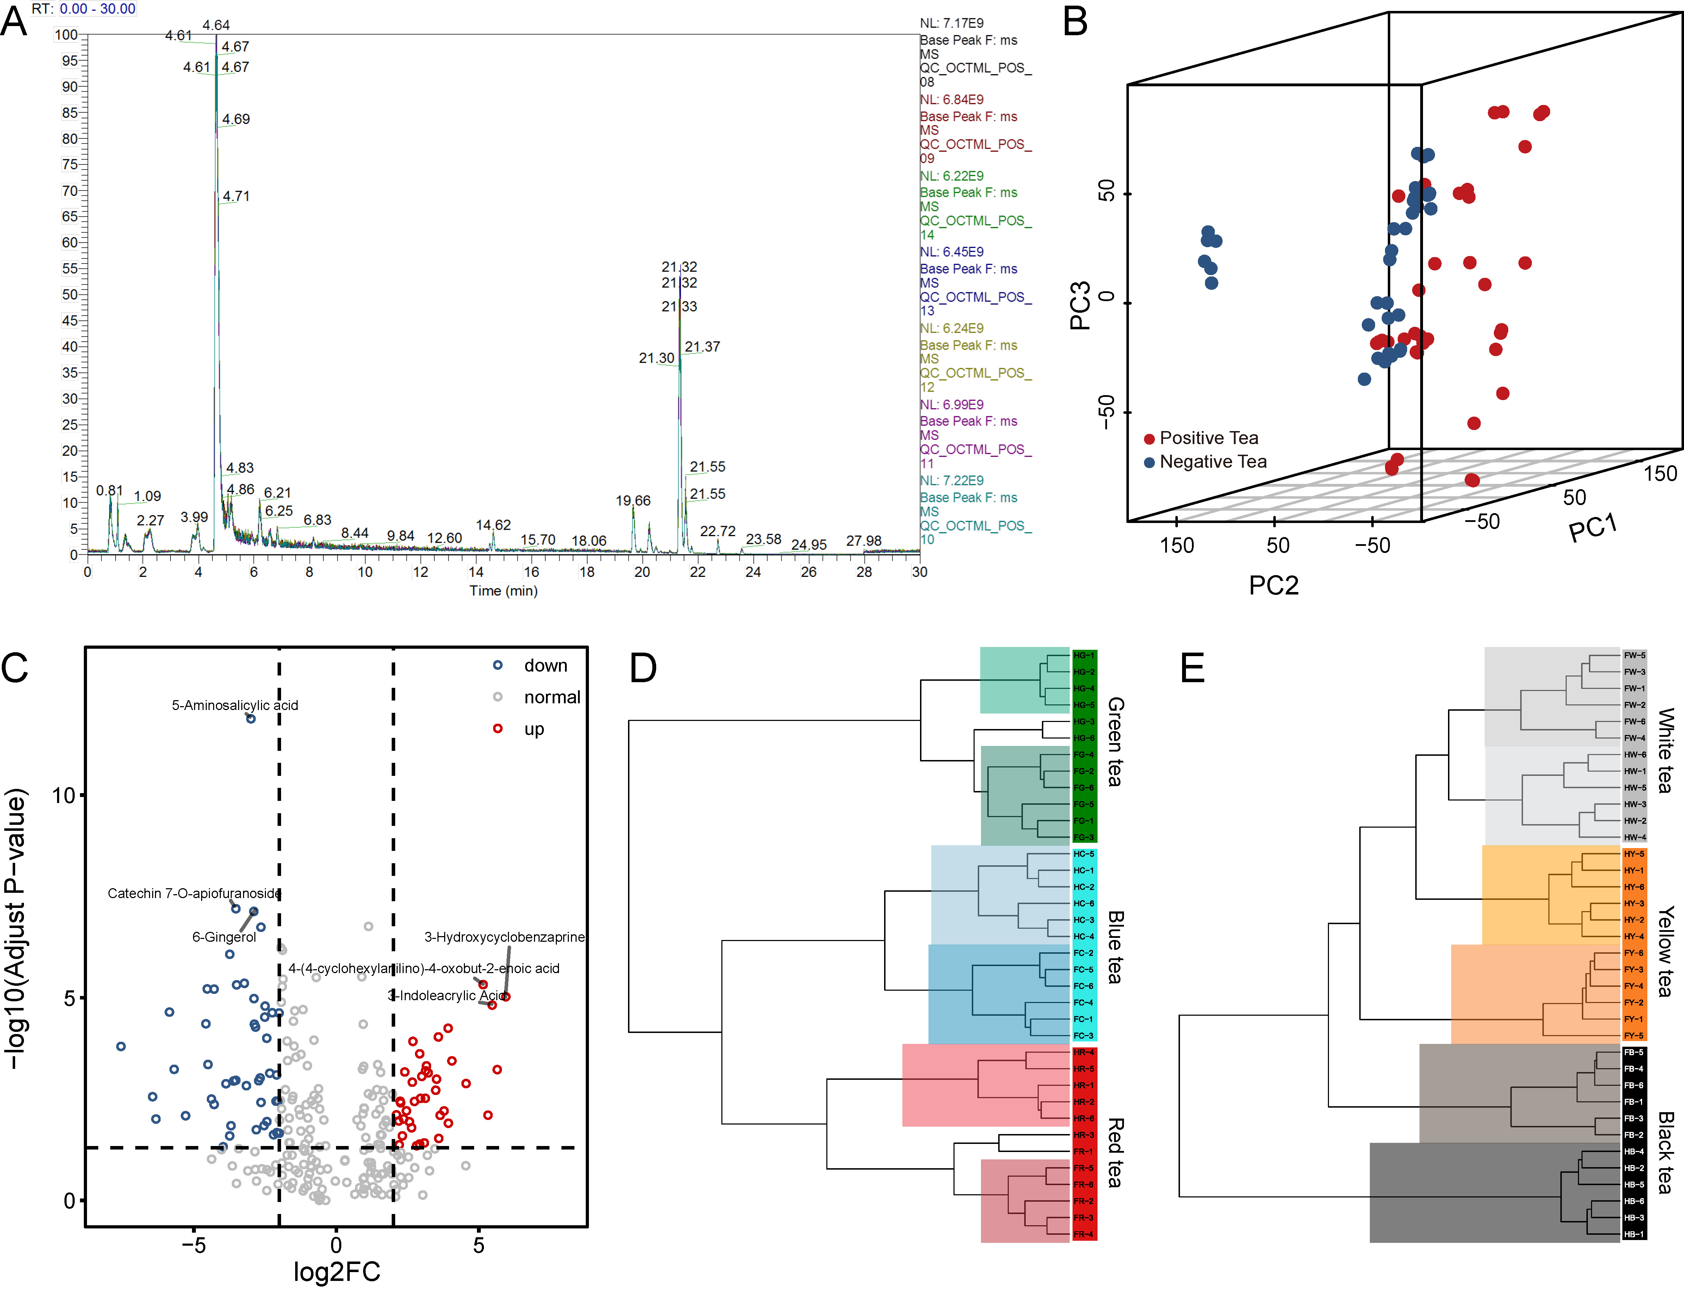
Fig. S1. Untargeted metabolomics of six types of teas. (A) Total ion chromatography of chemical compounds of all QC samples in the positive ionization mode. (B) Principal component analysis (PCA) distributed tea samples according to two major categorizes. (C) Volcano plot of differentially chemical compounds between two major tea categorizes. Black vertical lines highlight Log2FC (fold change) = 2 or -2; black horizontal line represents FDR of 0.05. (D, E) Hierarchical clustering analysis (HCA) of the samples from Positive (D) and Negative (E) tea using the Euclidean distance.

Fig. S2. Differentially altered compounds of pairwise comparisons among six types of teas. (A) Identification of significantly altered compounds among six types of teas using volcano plots (upper right triangles) and PLS-DA (lower left triangles). Compounds with log2 (fold-change) beyond 2.0 or below -2 with adjusted p value lower than 0.05, VIP > 2 were considered as significant alteration. (B) Number of chemical compounds significantly changed in six types of teas. (C) Venn diagram of number of significant higher (left) or lower (right) compounds in one tea type than any of the other five tea types.
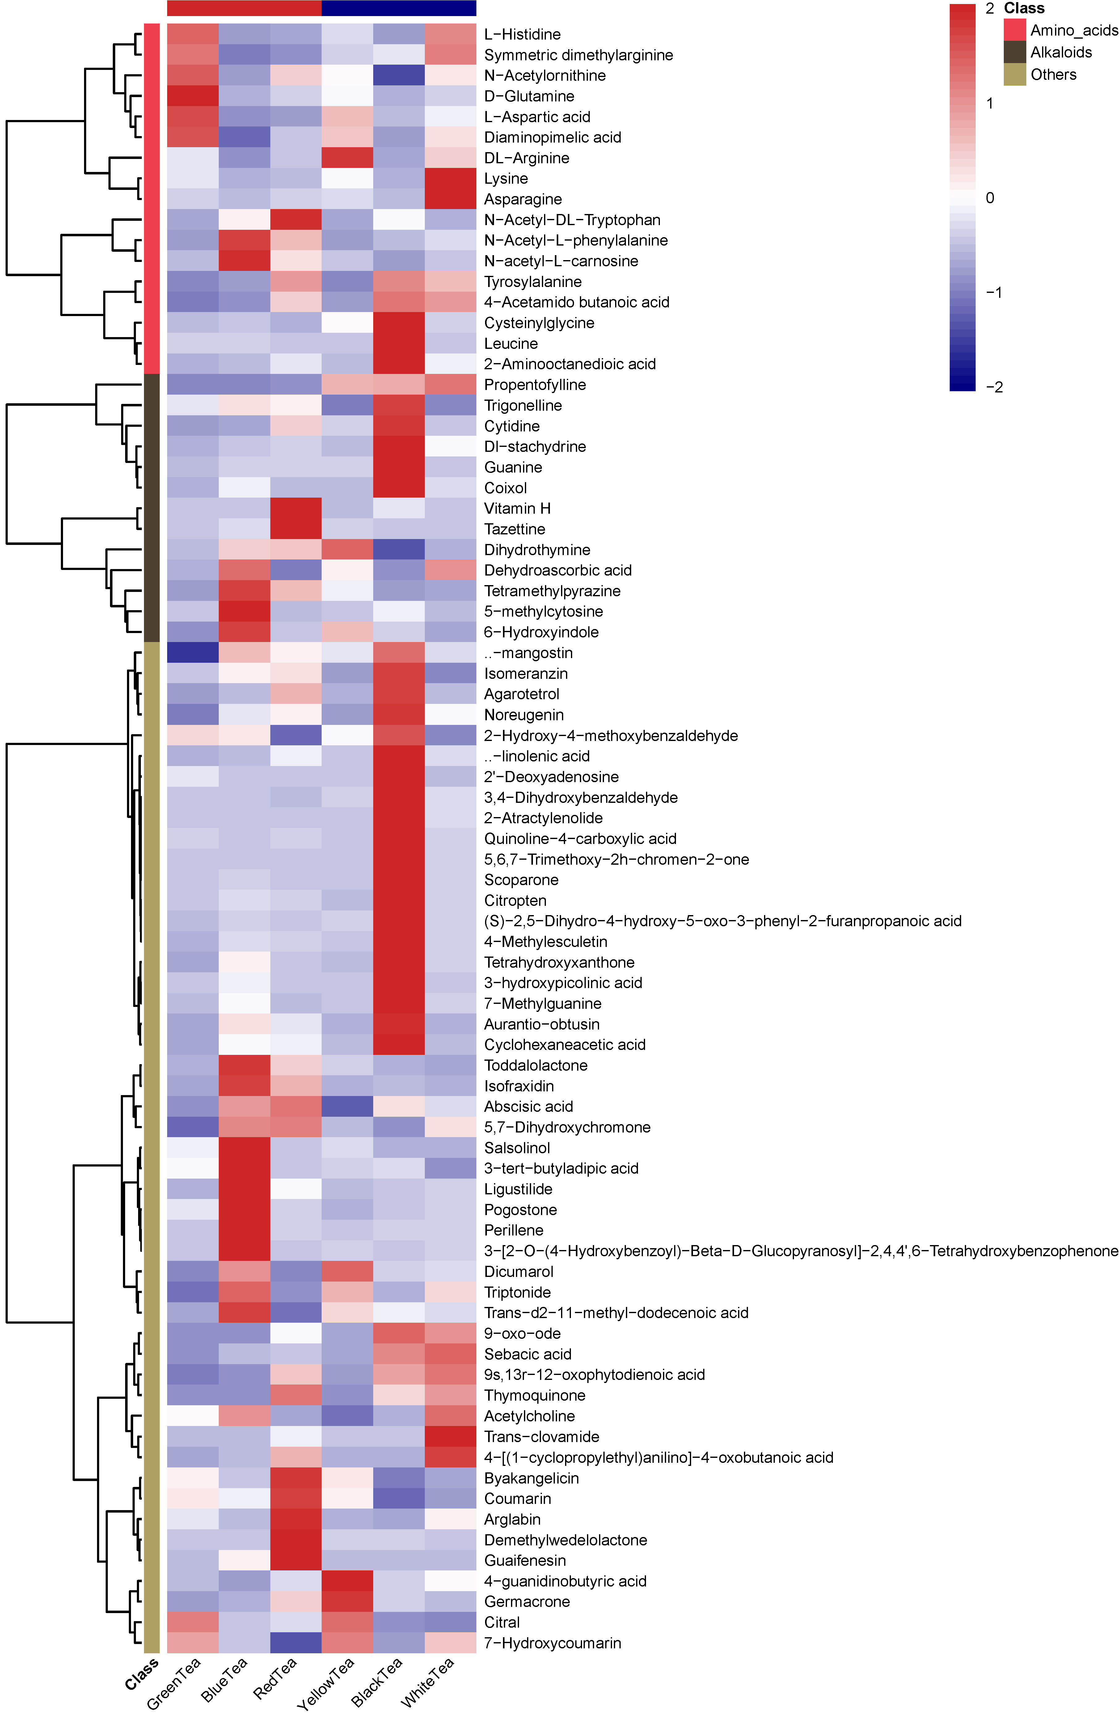
Fig. S3. Heatmap displays the differentially metabolomics features averaged across individuals as the chemical class including amino acids, alkaloids, and others (related to Figure 1E).
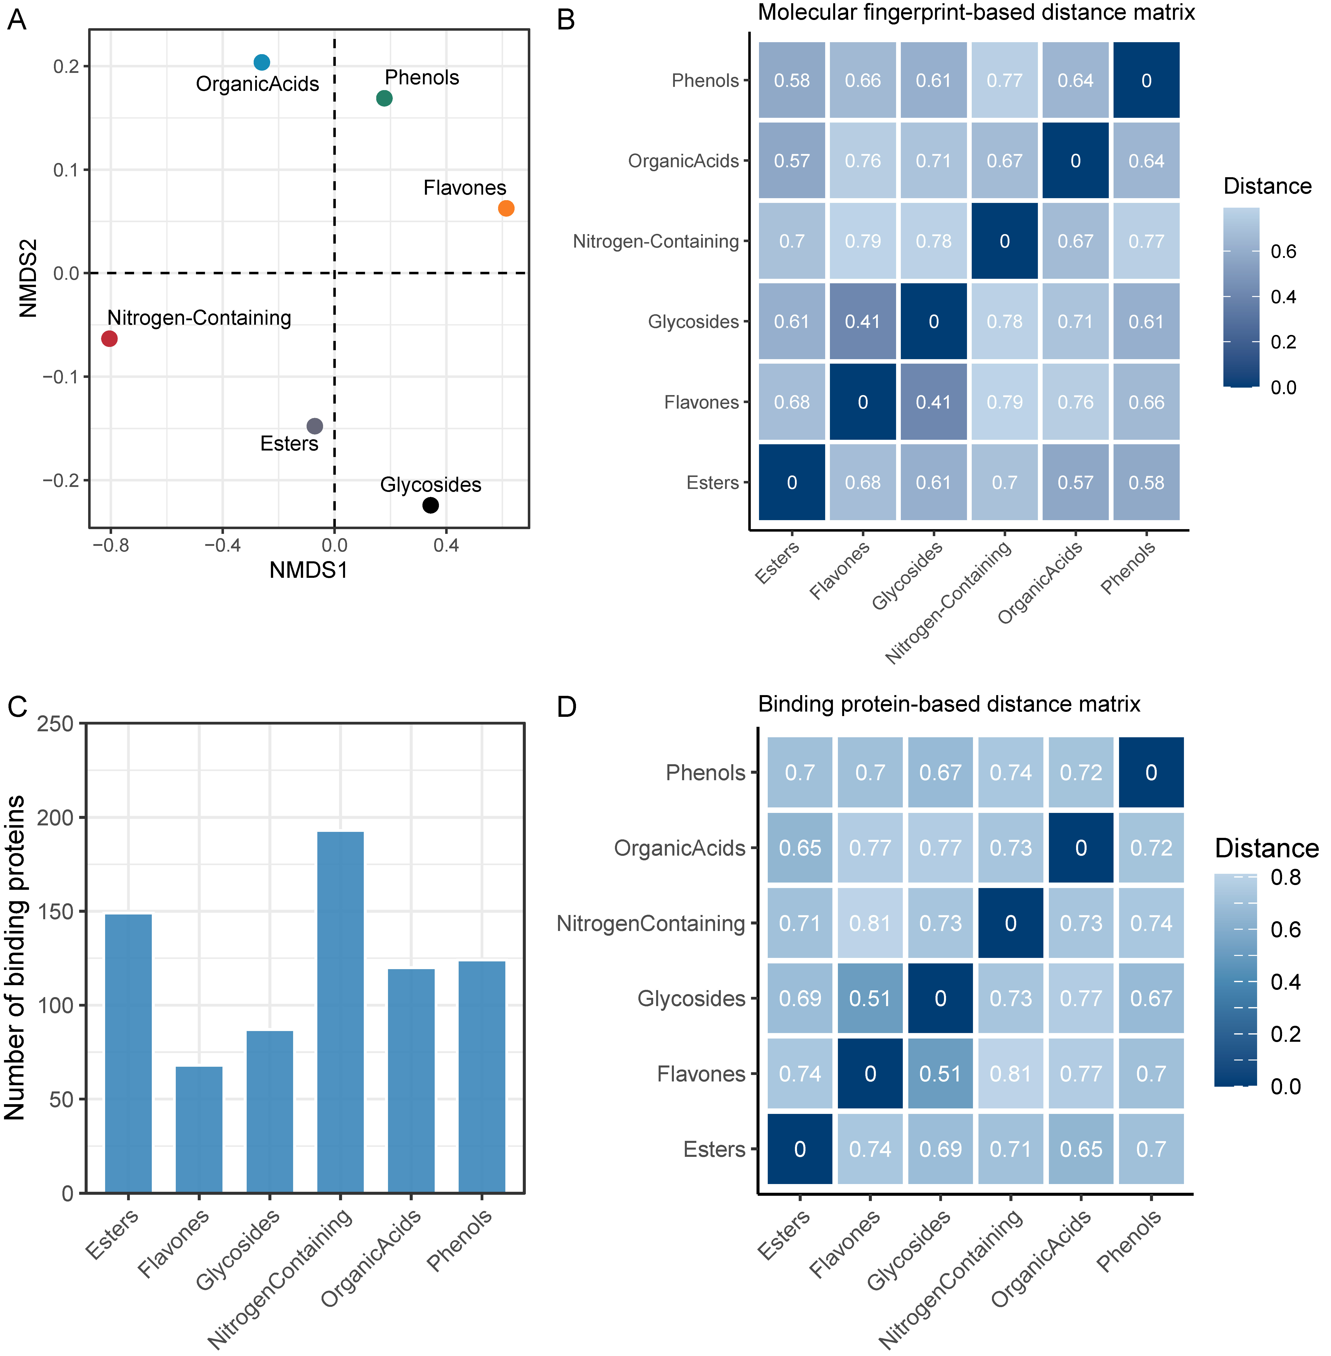
Fig. S4. Compounds similarity among chemical classes across six types of tea and their network distance to disease. (A) Molecular fingerprint-based chemical classes exhibit a structural diversity and distinction. (B) Heatmap showing the similarity of the chemical class pairs based on MACCS molecular fingerprint. (C) Number of the binding targets of six chemical classes. (D) Heatmap showing the similarity of the protein targets among chemical class pairs.
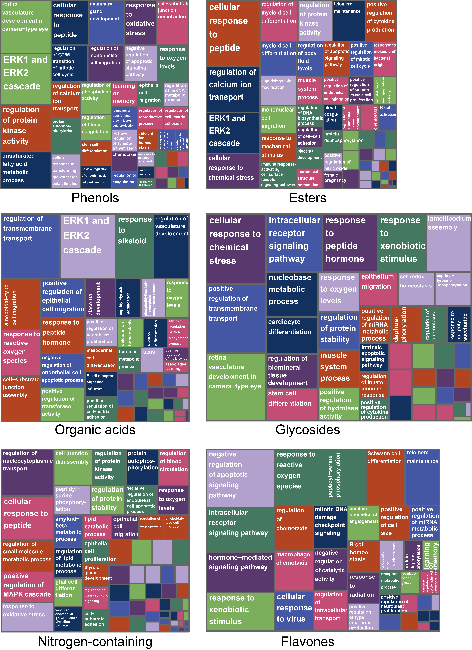
Fig. S5. TreeMap related to GO Biological Process obtained from targets of each chemical class.
Fig. S6. Protein–protein interactions of chemical class targets. The targets of chemical class form connected components in the human interactome. The subnetworks of LCC were depicted. For example, the nitrogen-containing compound targets form multiple connected component (LCC = 135).

Table S1. Processing procedures of six types of teas
Tea types | Water loss | Enzymatic (except green tea) | Enzyme deactivation | Cell-wall broken | Non-enzymatic | Drying
Green tea | Airing | Inherent components | Roasting/baking/steaming | Rolling |  | Roasting
Blue tea | Airing | Shaking and bruising | Baking/roasting | Rolling |  | Roasting
Red tea | Airing | Rolling and fermentation | Baking |  |  | Roasting
Yellow tea | Airing |  | Baking | Rolling | Yellowing | Roasting
Black tea | Airing |  | Roasting | Rolling with heat | Pounding while hot | Airing
White tea | Withering |  | Air-withering |  | Sun-drying | sun-drying
The boxes are the key processing methods of each tea types.

Table S2. The major clinical effects of similar drugs with representative compounds from tea
Representative compounds | Similar drugs | Health benefits | References
oxyresveratrol | curcumin | regulative gastrointestinal tract;  Arthritis  lowering blood glucose level;  anti-inflammation | ¹⁻³
1,2-dicaffeoylquinic acid | amiloxate | Photoprotective | ^{4,5}
N-phenylacetamide | acetaminophen | regulative CNS;  analgesia;  antipyretic effects | ^{6,7}
isoeugenol acetate | drotaverine | menstrual distress;  dysmenorrhea;  antispasmodic drug related to smooth muscle spasms | ^{8,9}
kaempferol-3-rhamnoside | diosmin | liver protection;  anticardiovascular;  neuroprotection | ^{10,11}
isovetixin | flavoxate | hyperglycemic effect  urinary syndromes;  antispasmodic | ^{12,13}

References
1 Scazzocchio, B., Minghetti, L. & D'Archivio, M. Interaction between Gut Microbiota and Curcumin: A New Key of Understanding for the Health Effects of Curcumin. Nutrients 12, doi:10.3390/nu12092499 (2020).
2 Hewlings, S. J. & Kalman, D. S. Curcumin: a review of its effects on human health. Foods 6, 92, doi:10.3390/foods6100092 (2017).
3 Panknin, T. M. et al. Curcumin supplementation and human disease: a scoping review of clinical trials. Int J Mol Sci 24, 4476, doi:10.3390/ijms24054476 (2023).
4 Gunia-Krzyżak, A. et al. Cinnamic acid derivatives in cosmetics: current use and future prospects. Int J Cosmet Sci 40, 356-366, doi:10.1111/ics.12471 (2018).
5 Gholap, A. D. et al. Environmental implications and nanotechnological advances in octocrylene-enriched sunscreen formulations: A comprehensive review. Chemosphere 358, 142235, doi:10.1016/j.chemosphere.2024.142235 (2024).
6 Tan, E., Braithwaite, I., McKinlay, C. J. D. & Dalziel, S. R. Comparison of Acetaminophen (Paracetamol) With Ibuprofen for Treatment of Fever or Pain in Children Younger Than 2 Years: A Systematic Review and Meta-analysis. JAMA Netw Open 3, e2022398, doi:10.1001/jamanetworkopen.2020.22398 (2020).
7 Ohashi, N. & Kohno, T. Analgesic effect of acetaminophen: a review of known and novel mechanisms of action. Front Pharmacol 11, 580289, doi:10.3389/fphar.2020.580289 (2020).
8 Eder, P. et al. Self-Medication with Drotaverine among Patients with Common Abdominal Symptoms and Treatment Efficacy from the Perspectives of Patients and General Practitioners-An Observational, Retrospective, Cross-Sectional Study Using Real-World Data. J Clin Med 11, doi:10.3390/jcm11113156 (2022).
9 Bolaji, O. O., Onyeji, C. O., Ogundaini, A. O., Olugbade, T. A. & Ogunbona, F. A. Pharmacokinetics and bioavailability of drotaverine in humans. Eur J Drug Metab Pharmacokinet 21, 217-221, doi:10.1007/bf03189716 (1996).
10 Lee, S. B. et al. Afzelin ameliorates D-galactosamine and lipopolysaccharide-induced fulminant hepatic failure by modulating mitochondrial quality control and dynamics. Br J Pharmacol 174, 195-209, doi:10.1111/bph.13669 (2017).
11 Huwait, E. & Mobashir, M. Potential and Therapeutic Roles of Diosmin in Human Diseases. Biomedicines 10, doi:10.3390/biomedicines10051076 (2022).
12 Choo, C. Y., Sulong, N. Y., Man, F. & Wong, T. W. Vitexin and isovitexin from the Leaves of Ficus deltoidea with in-vivo α-glucosidase inhibition. J Ethnopharmacol 142, 776-781, doi:10.1016/j.jep.2012.05.062 (2012).
13 Xue, Y. et al. Natural and synthetic flavonoids, novel blockers of the volume-regulated anion channels, inhibit endothelial cell proliferation. Pflugers Arch 470, 1473-1483, doi:10.1007/s00424-018-2170-8 (2018).

