Supplementary
Figure 1:
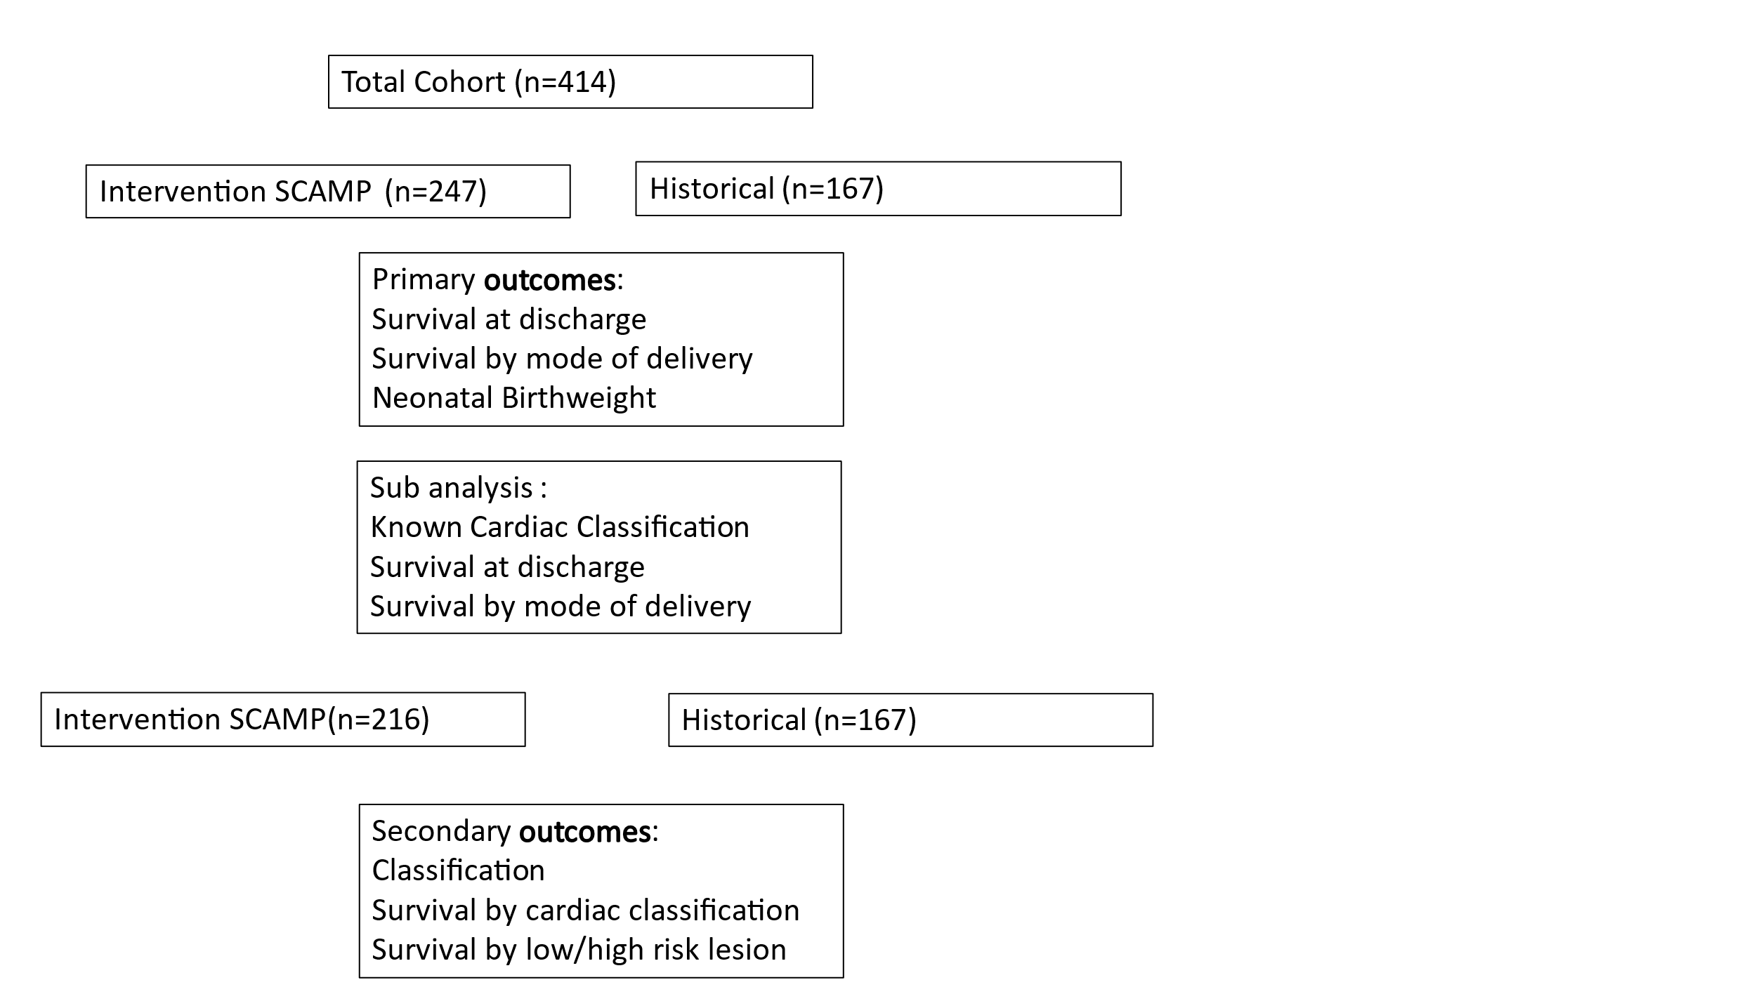
Table 3: Cardiac Classification
Category | Description | Examples
Category 1 | CHD without predicted risk of hemodynamic instability in the delivery room or first days of life | Ventricular septal defects, atrioventricular septal defects
Category 2 | CHD with minimal risk of hemodynamic instability in the delivery room but requires postnatal catheterization/surgery | Ductal-dependent lesions
Category 3 | CHD with likely hemodynamic instability in the delivery room requiring immediate specialty care for stabilization | D-transposition of the great arteries
Category 4 | CHD with expected hemodynamic instability with placental separation, requiring immediate catheterization/surgery to improve survival | Hypoplastic left heart syndrome, D-transposition of the great arteries with restrictive or intact atrial septum
Unknown/other | CHD cases that do not fit into the defined categories | Other unspecified cardiac lesions

