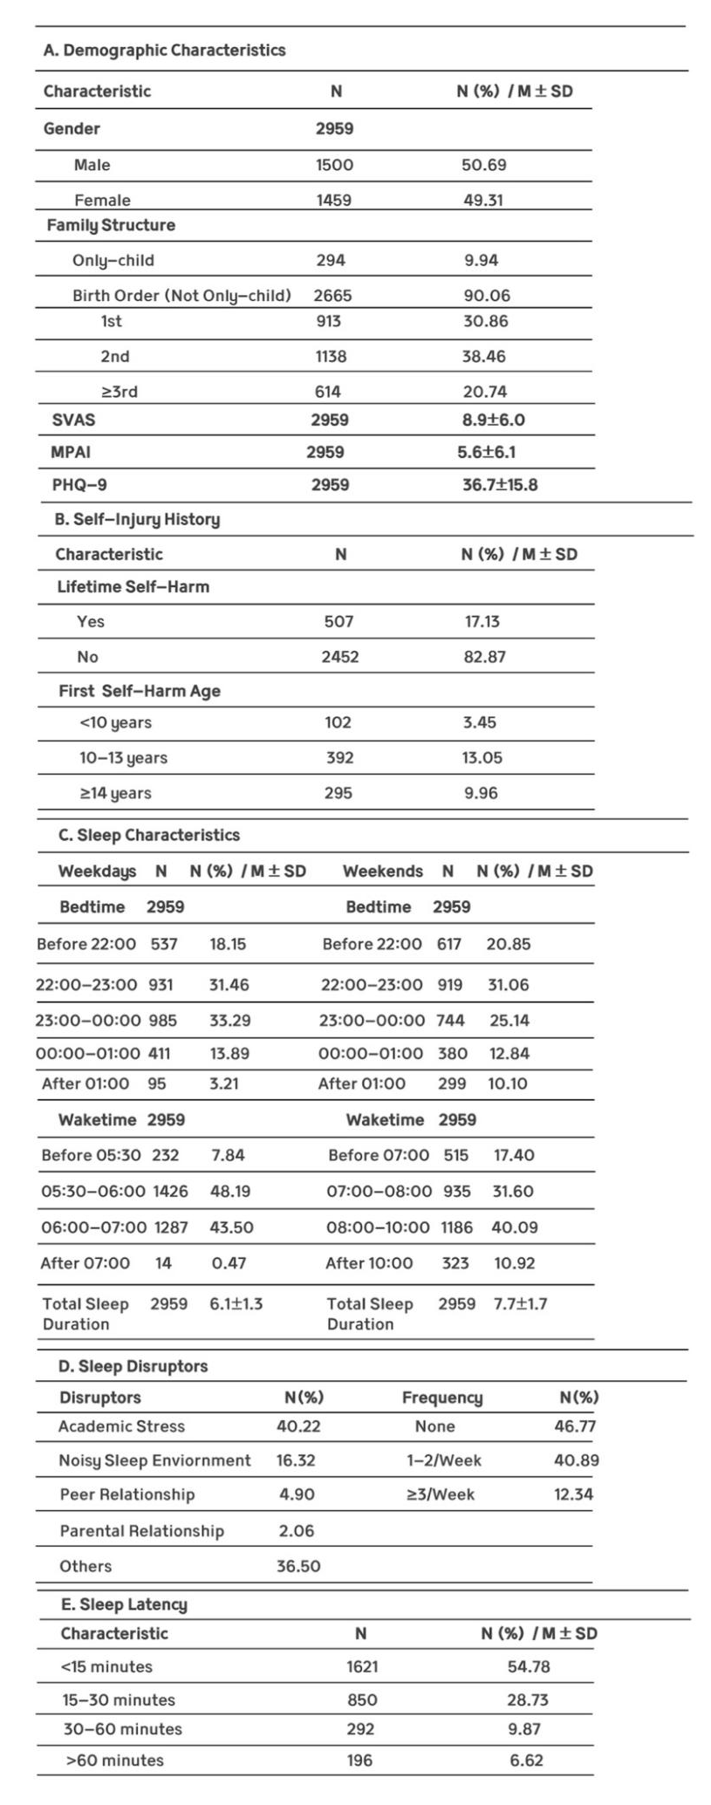
Table. 1 Comprehensive Demographic and Sleep Behavior Profile
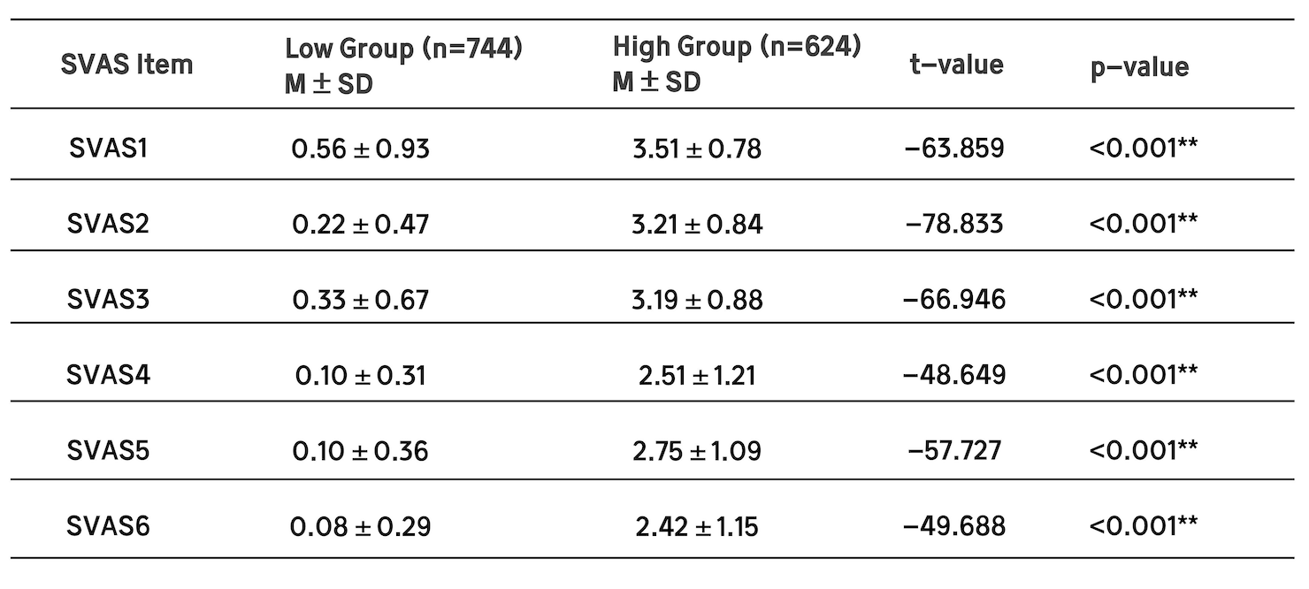
Table. 2 Independent Samples t-Test Results of Short Video Addiction Scale (SVAS) Items Between Low and High Addiction Groups

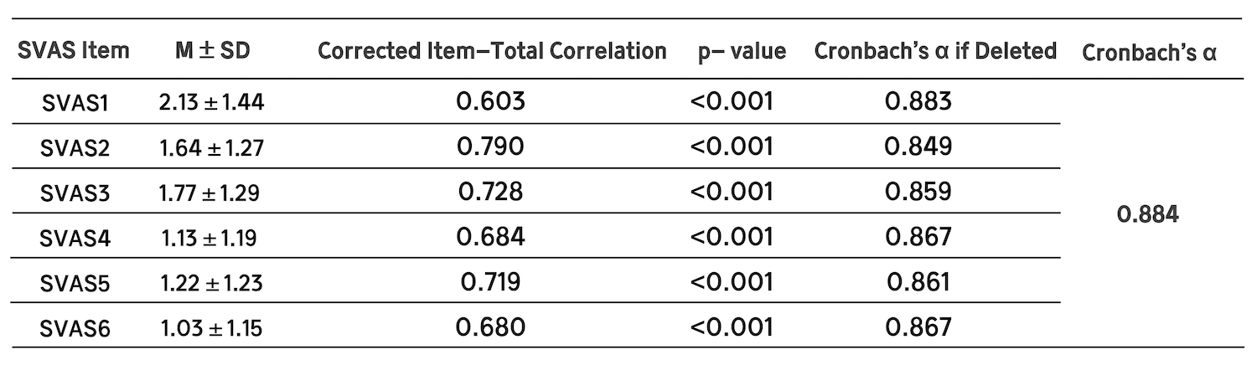
Table. 3 Psychometric Characteristics of the Short Video Addiction Scale (SVAS) Item

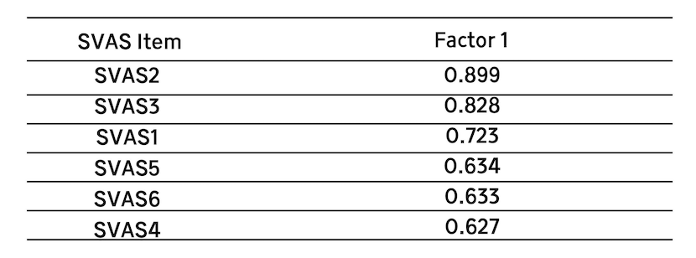
Table. 4 Factor Loadings of EFA for the Short Video Addiction Scale (SVAS) (N=2959)

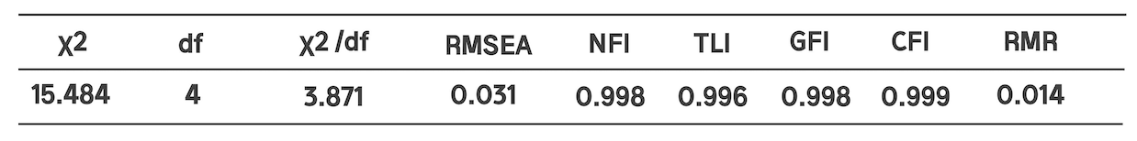
Table. 5 Fit Indices of the Short Video Addiction Scale (SVAS) (N=2959)

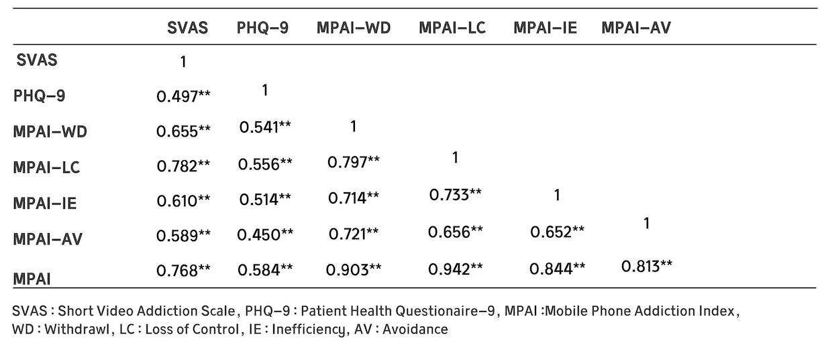
Table. 6 Convergent Validity of the SVAS: Correlations with PHQ-9 and MPAI Subscales (Withdrawal, Loss of Control, Inefficiency, Avoidance) (N=2959)

