Supplementary materials
Surface Passivation Engineering for Stable Optoelectronic Devices via Hydroxyl-Free ZnMgO Nanoparticles
Seongkeun Oh^{1‡}, Jaewhi Choi^{2‡}, Junhyeok Park¹, Young Kyun Choi¹, Taesung Park¹, Awais Ali¹, Junhyuk Ahn¹, Jiwan Kim²*, and Soong Ju Oh¹*
¹Department of Materials Science and Engineering, Korea University, 02841, Republic of Korea
²Department of Advanced Materials Engineering, Kyonggi University, 16227, Republic of Korea

Table S1. Energetic information on a series of HC-ZMO and AC-treated ZMO NP films obtained from the UPS and absorption spectra.
Film sample | Secondary  cut-off (eV) | E_{f} (eV) | Valence band  onset (eV) | Valence band maximum  (eV) | Bandgap  (eV) | CBM  (eV)
UT  ZMO | 17.91 | 3.29 | 3.43 | 6.72 | 3.65 | 3.07
MeOH-treated  ZMO | 17.63 | 3.57 | 3.49 | 7.06 | 3.61 | 3.45
EtOH-treated  ZMO | 17.62 | 3.58 | 3.45 | 7.03 | 3.63 | 3.40
IPA-treated  ZMO | 17.62 | 3.58 | 3.45 | 7.03 | 3.65 | 3.38

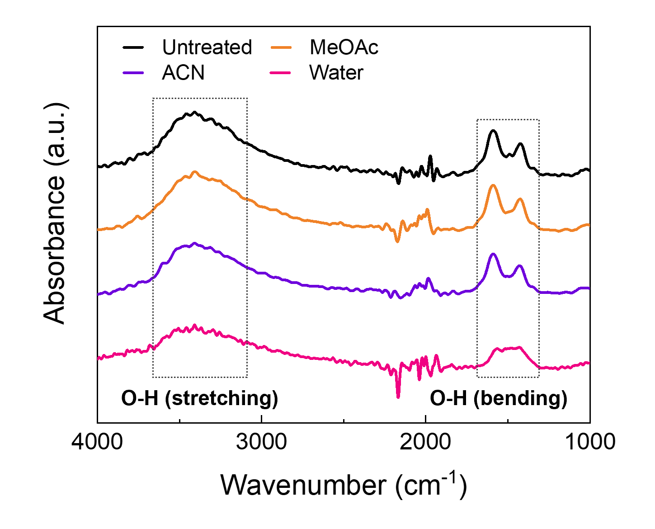
Fig. S1. FT-IR spectra of the ZMO NPs under humid conditions and after treatment with high polarity solvents (MeOAc, ACN, and water).

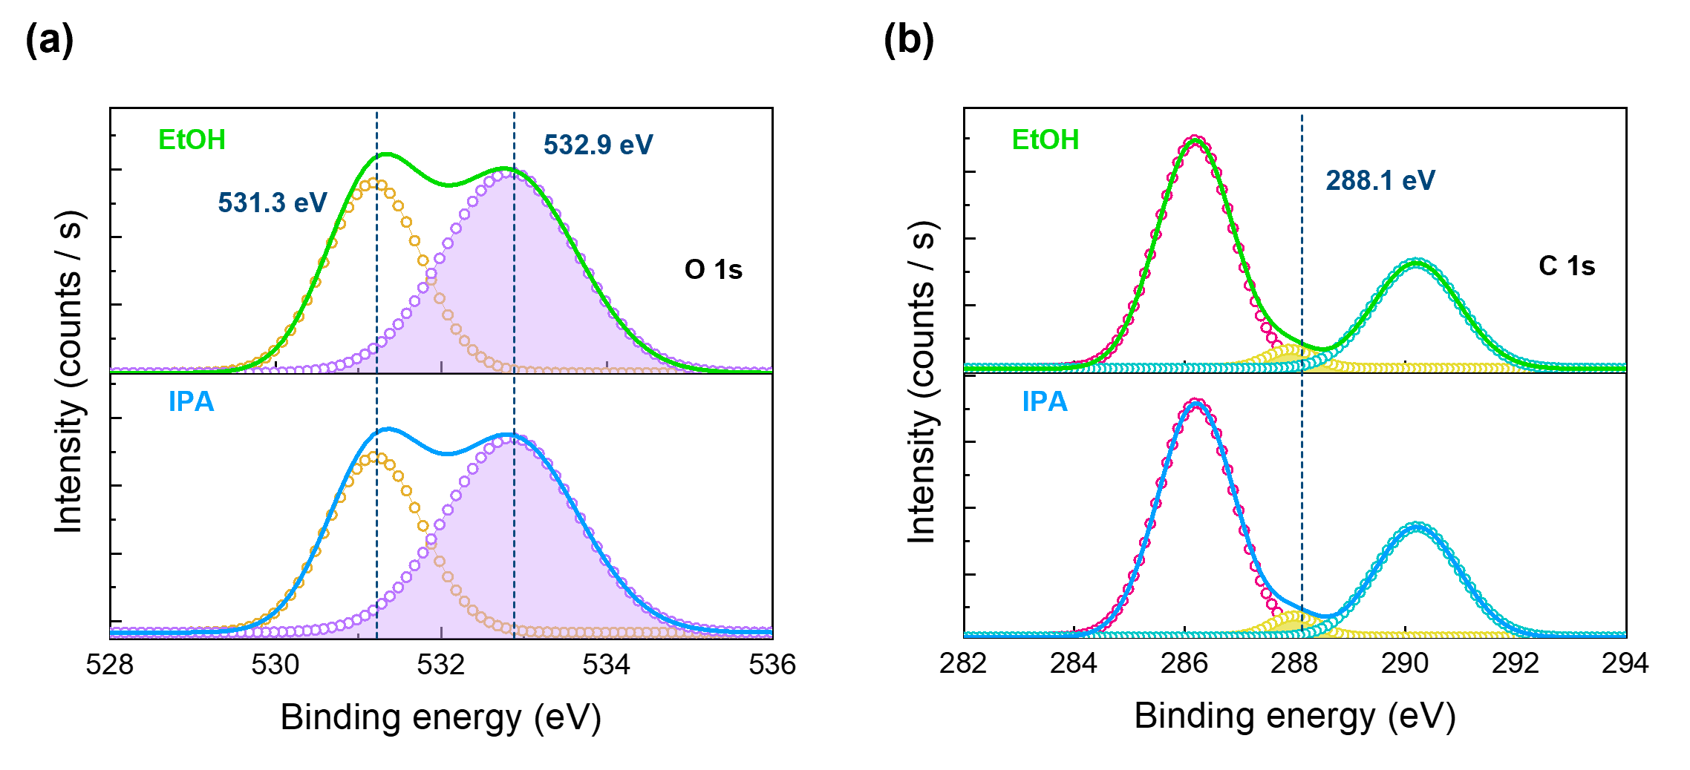
Fig. S2. XPS high-resolution (a) O 1s and (b) C 1s photoelectron peaks of EtOH- and IPA-treated ZMO.

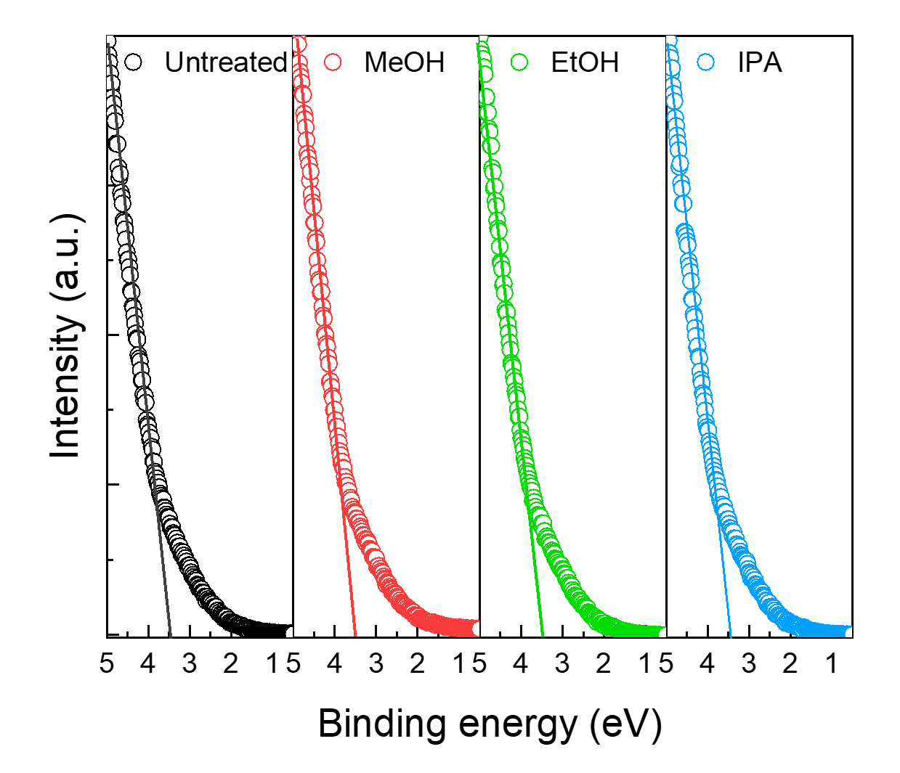
Fig. S3. UPS spectra showing the high-binding energy valence band onset regions of UT-ZMO (black) and MeOH- (red), EtOH- (green), and IPA-treated ZMO (blue) nanofilms.

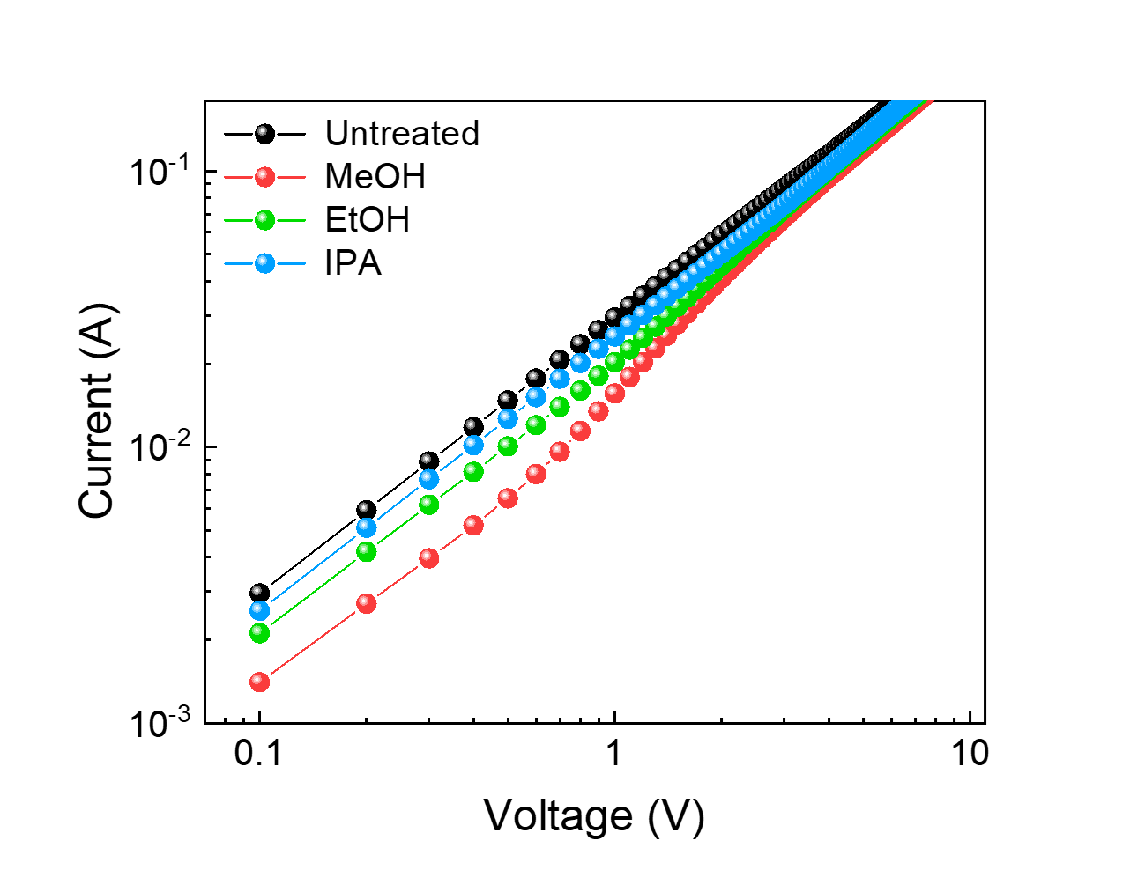
Fig. S4. Current‒voltage characteristics of the EODs (UT-ZMO and MeOH-, EtOH-, and IPA-treated ZMOs) under different conditions.

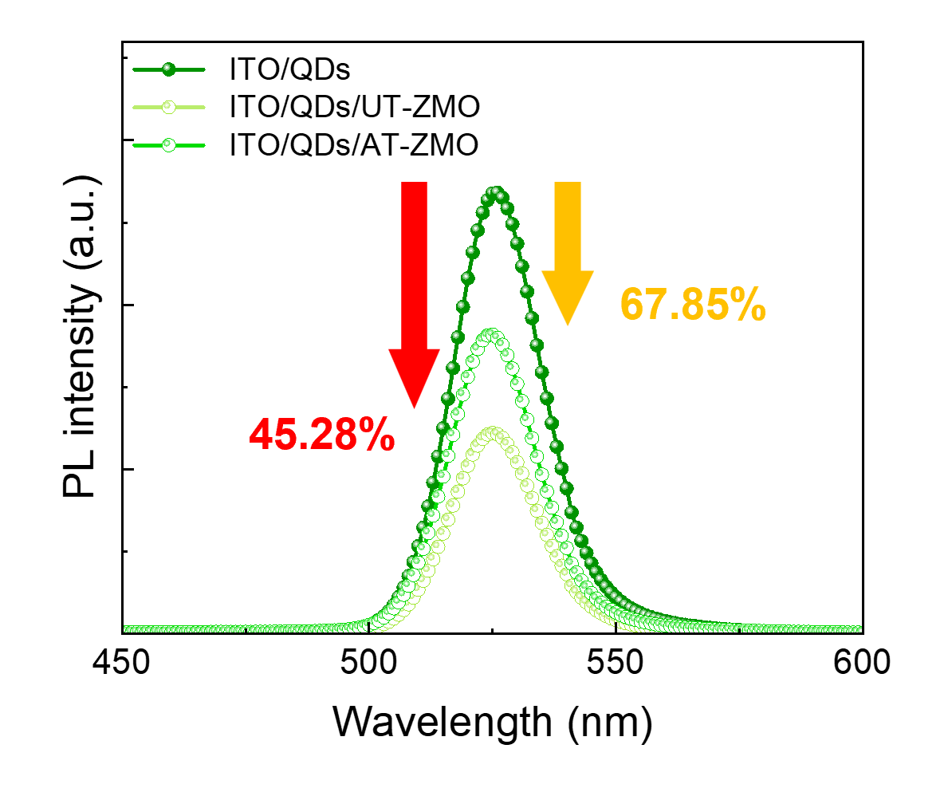
Fig. S5. Variations in the PL intensity of the CdZnSeS/ZnS QD films containing UT-ZMO and MeOH-treated ZMO.

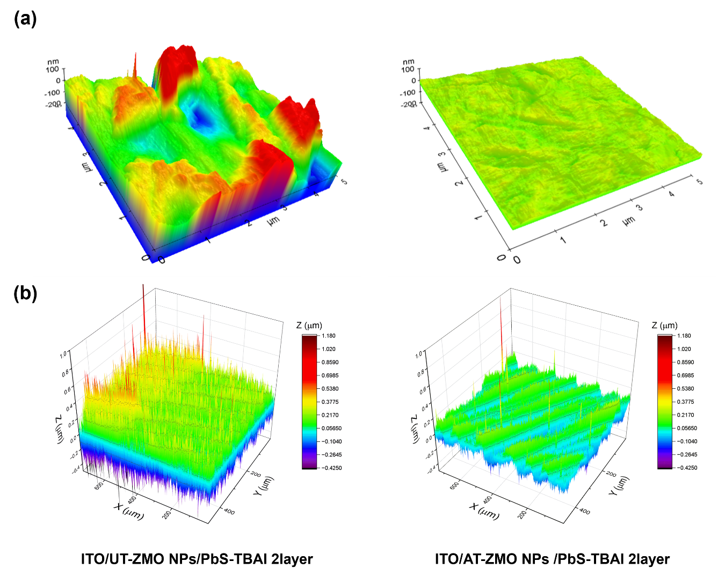
Fig. S6. AFM and optical profiler images of the ITO/ZMO NPs/PbS-TBAI structure under different conditions.

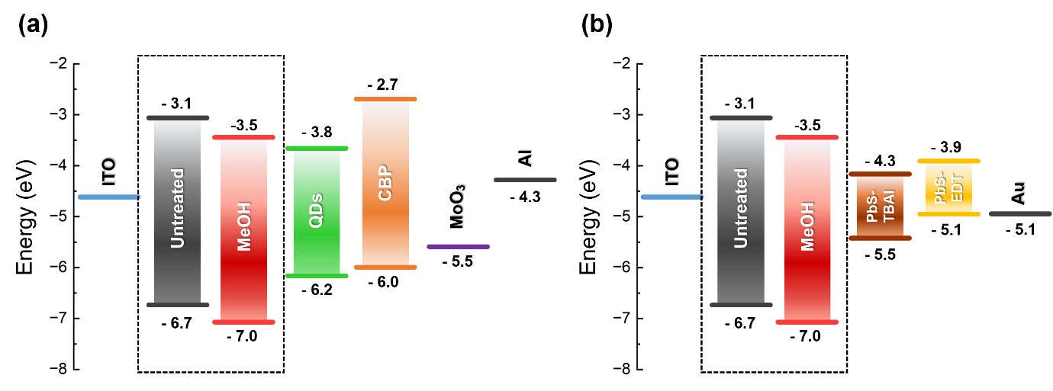
Fig. S7. Energy band levels of the QLEDs and QPDs containing UT-ZMO and MeOH-treated ZMO NP ETLs.

