ANNEXE 1
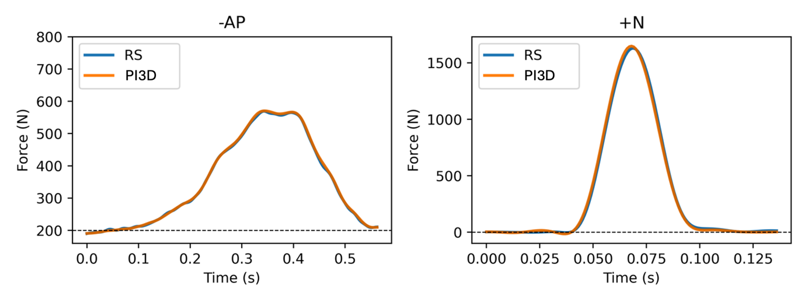
Example of time-synchronized curves for two different conditions: the -AP condition on the left, for which additional force was manually applied to the mass by the operator: +N condition on the right, for which additional force was applied by dropping the mass.

