Appendix A
Climbing behavior of the soft robot on a grooved wood wall.
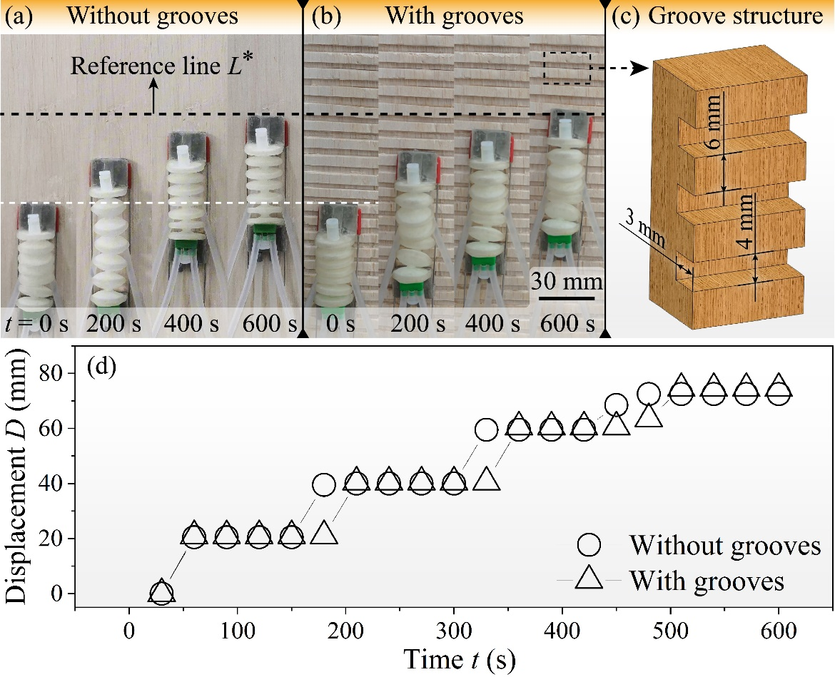
Fig. 13 Climbing behavior of the soft robot on a wood wall: a without grooves; b with grooves; c groove structure; (d) displacement at different time. P = 61.8 kPa, T_{L} = 10 °C, T_{H} = 46 °C, A_{wood} = 6.25 cm², RH = 65 %.
Currently, climbing robots adopting vacuum adsorption strategies will struggle to complete climbing tasks when encountering rough walls. To address the challenge, this research investigated the climbing behavior of the soft robot on a grooved wood wall. Figure 13 demonstrated that the soft robot could easily perform the climbing task on a wood wall with no grooves. The good news was that when the wall was replaced with grooved wood, the climbing behavior of the soft robot remained virtually unchanged. The displacement of the soft robot in both conditions was close to 73.5 mm within t = 600 s.

Appendix B
Table 1 The values of the relevant parameters of Eq. (2) and Eq. (3) in this study.
 | Paper | Wood | PVC | Glass
ε | 1 | 0.96 | 0.92 | 0.85
ω (N) | 122
A_{peak} | 2.5×10⁻⁶A_{wood}

