Supplementary figures

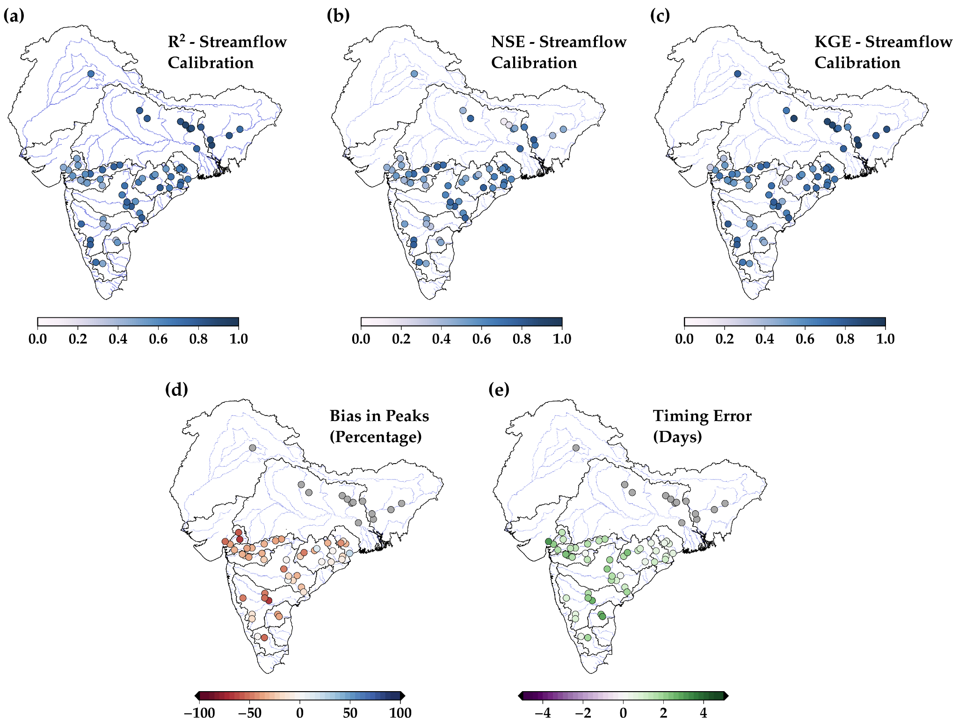

Figure S1: Model calibration for streamflow showing (a) R2, (b) NSE, (c) KGE, (d) bias in peak flows (percentage) and (e) timing error (in days) at the selected gauge stations against daily observed streamflow.

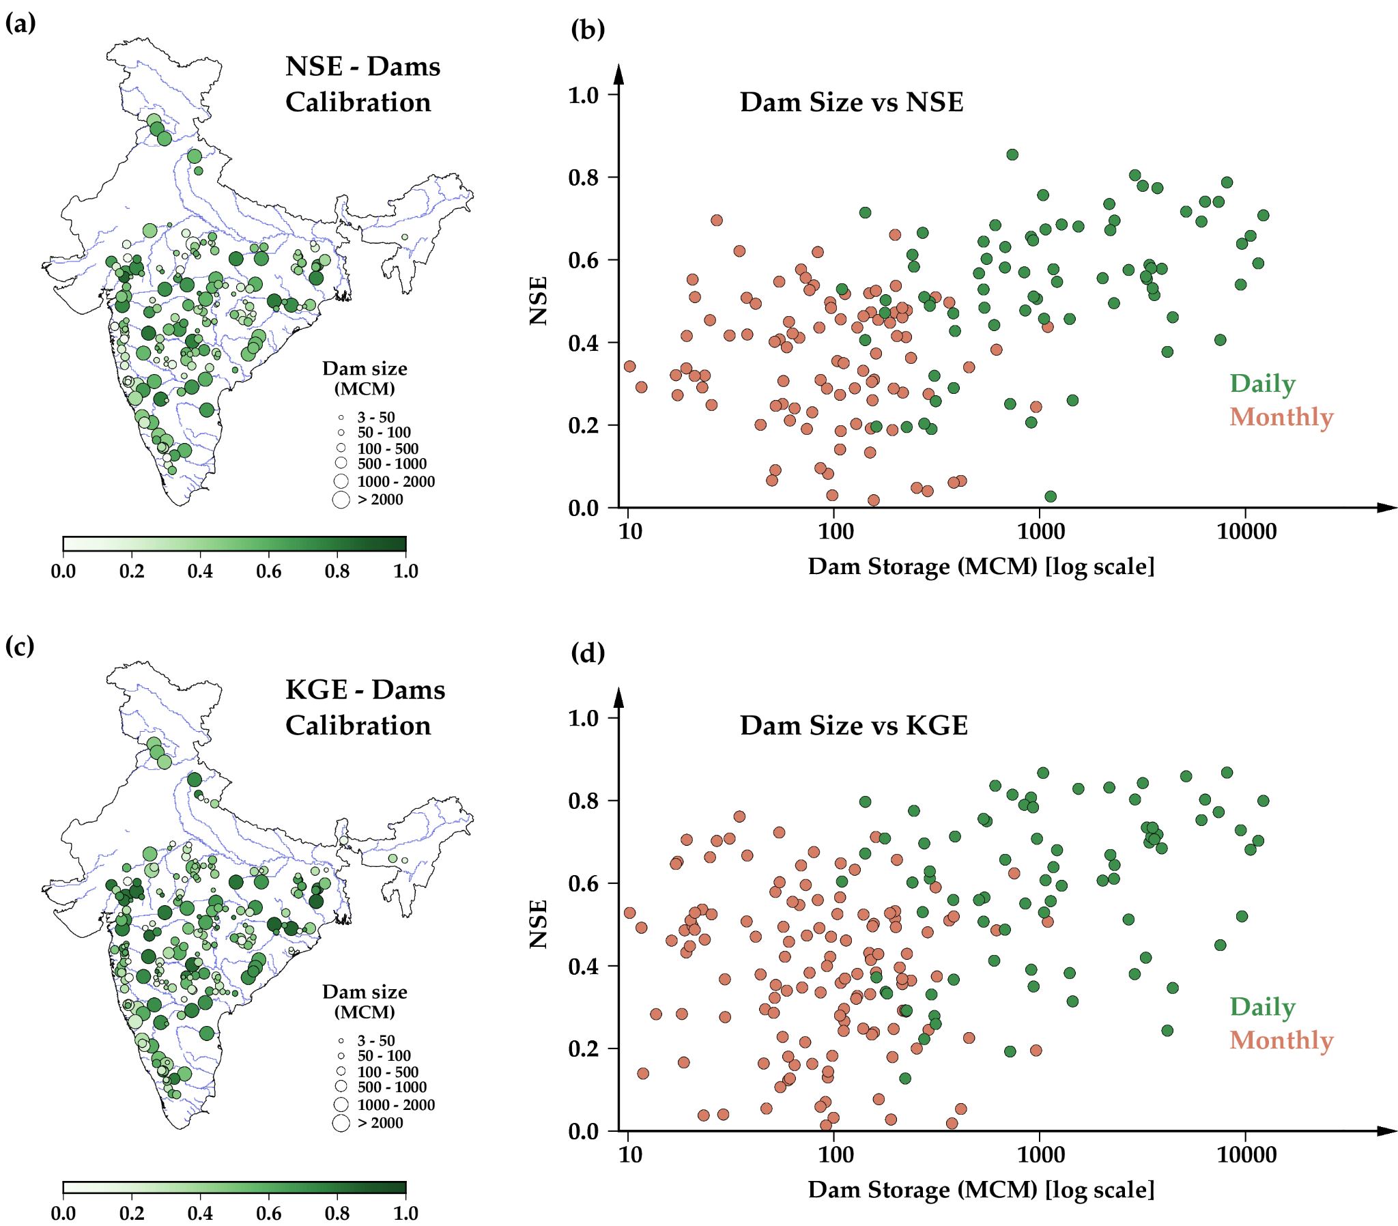

Figure S2: Model calibration results showing (a) NSE of dam storage against the observations, (b) attained skill (NSE) distributed against dam size, (c) KGE of dam storage against the observations, (d) attained skill (KGE) distributed against dam size

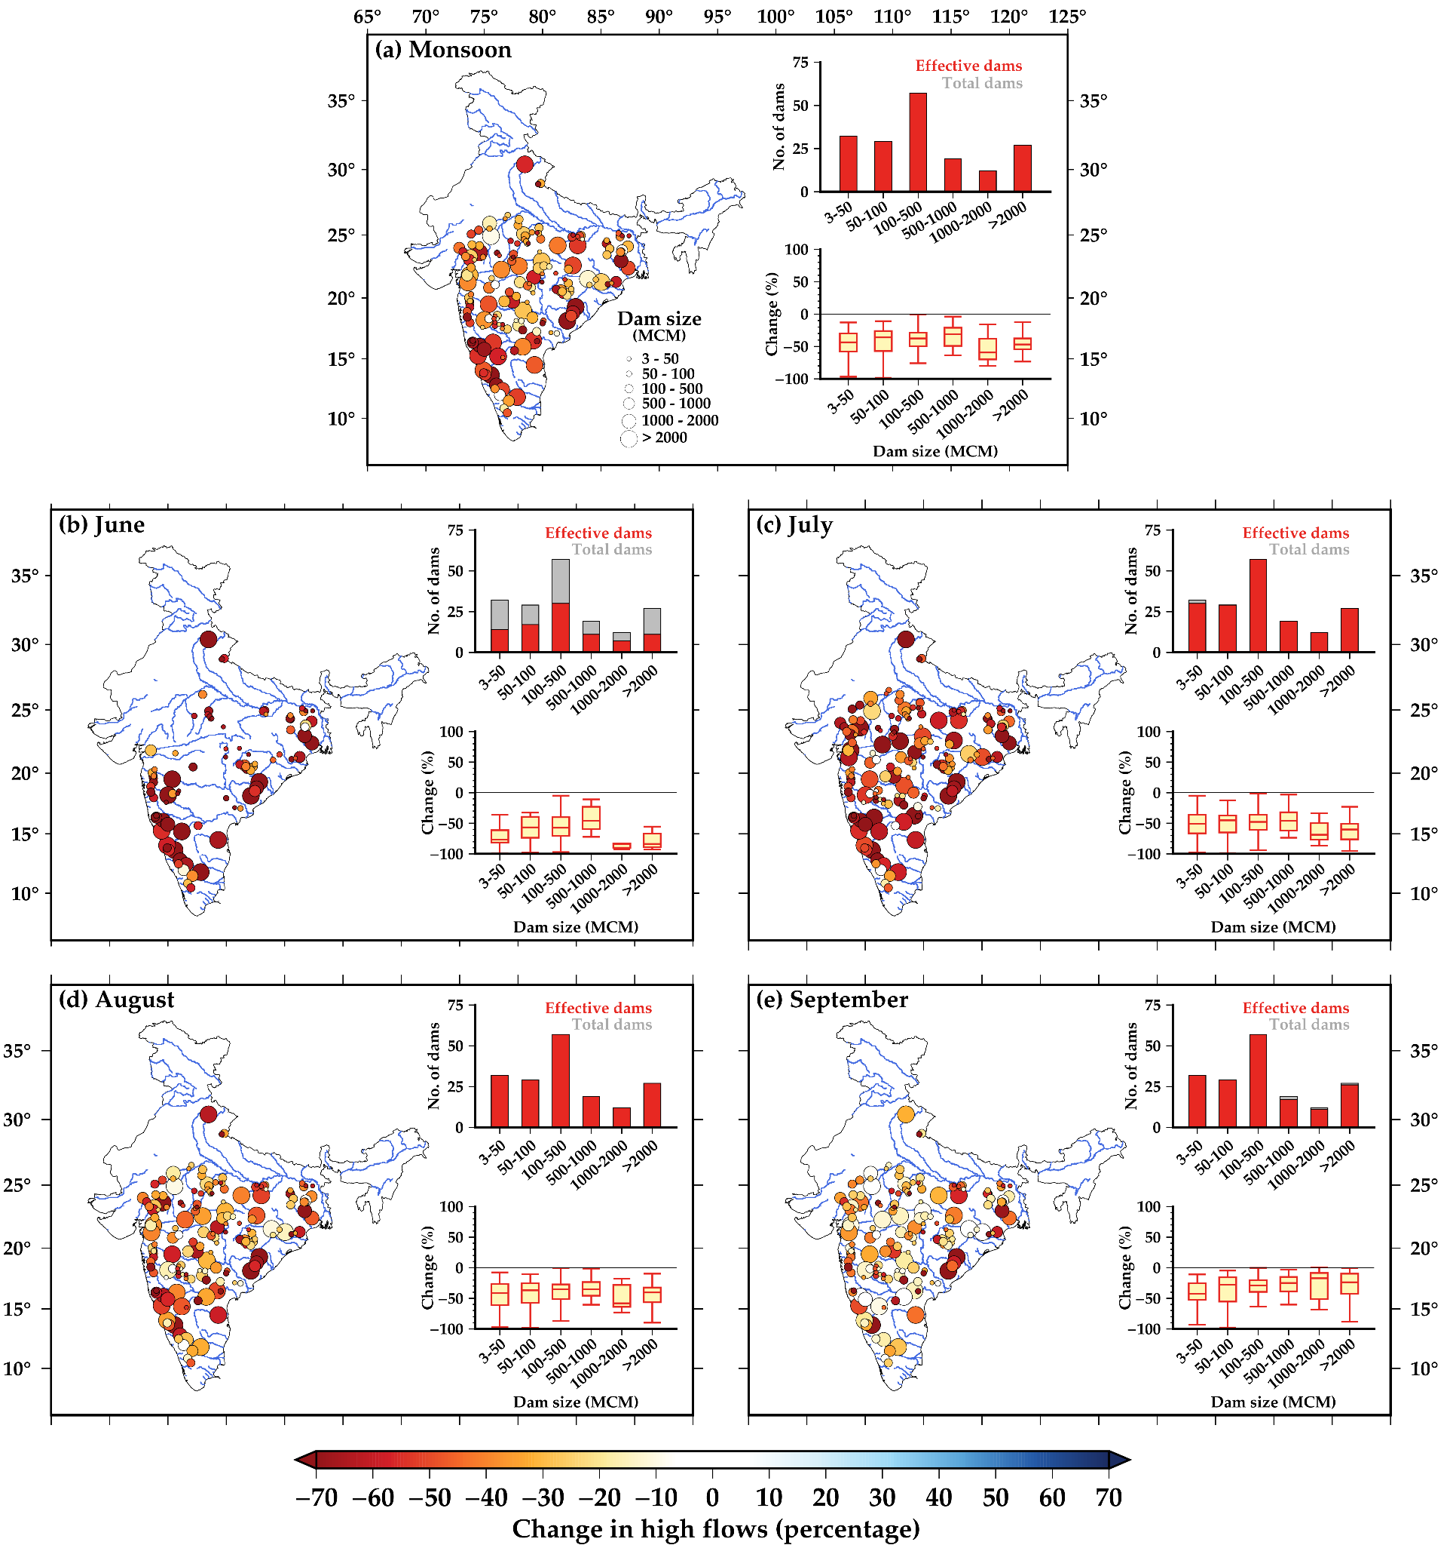

Figure S3: Decrease in the high flows magnitude exceeding 99th percentiles in (a) monsoon and individual months of (b) June, (c) July, (d) August and (e) September in the dam downstream

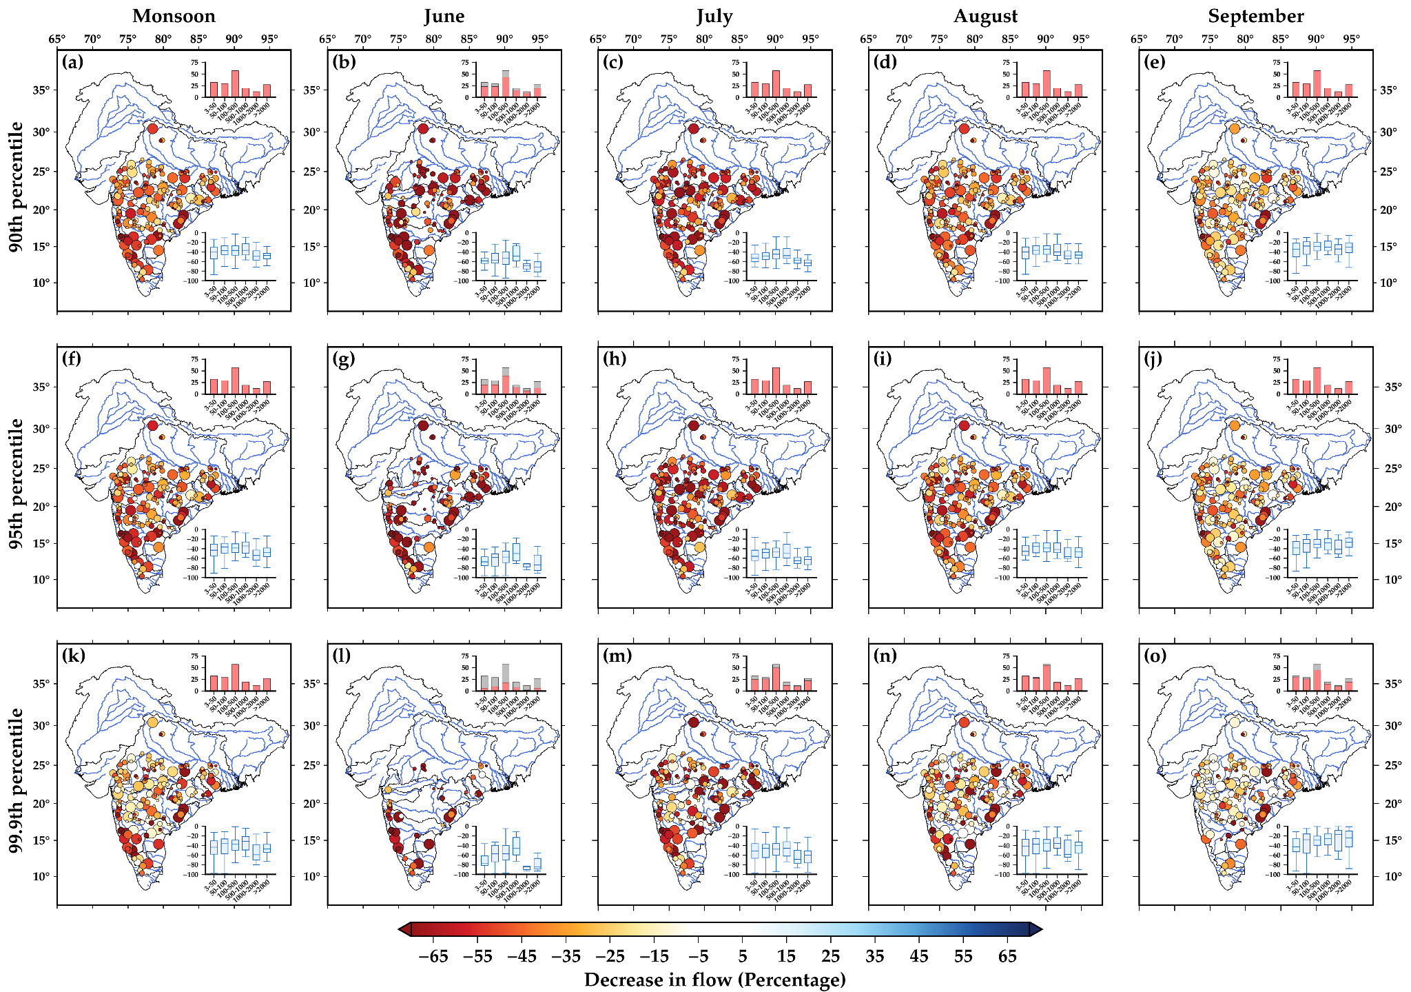

Figure S4: Decrease in the high flows exceeding (a-e) 90th percentile, (f-j) 95th percentile and (k-o) 99th percentile in the monsoon period and individual months of June, July, August and September

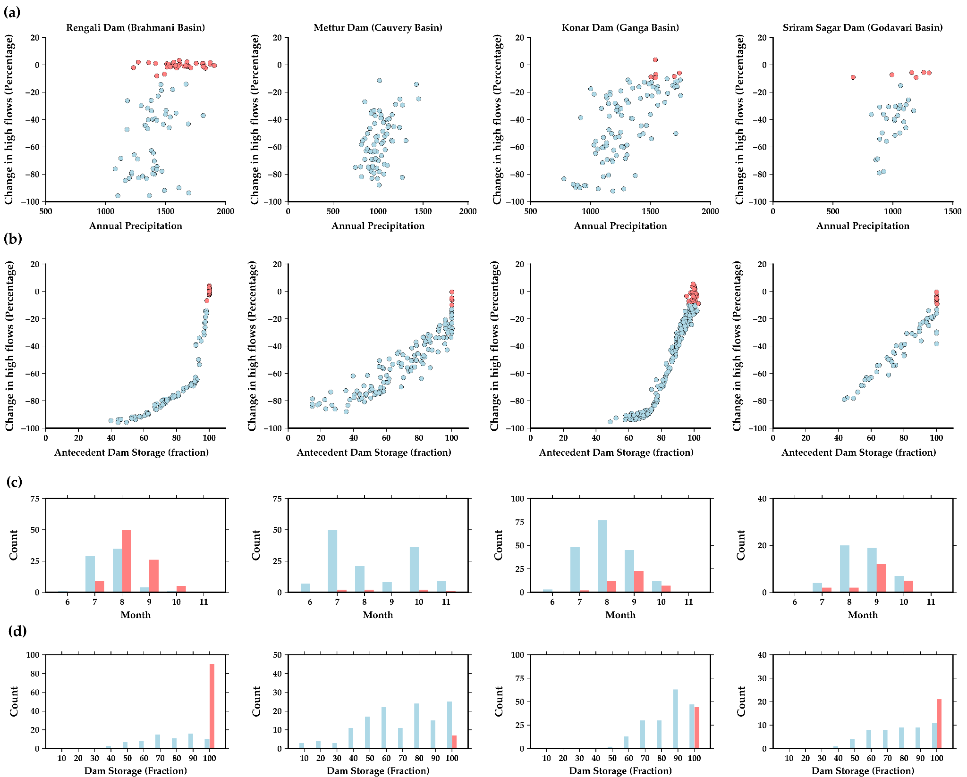

Figure S5: Scatter plot between (a) Annual precipitation in the dam catchment vs percentage change in the high flows, (b) Antecedent dam storage vs percentage change in the high flows (c) months of the occurrence of high flow events (d) Histogram of antecedent dam storage (percentage) when the high flows occurred in both the cases.

