Joint Effects of Low Ambient Temperature and Nocturnal Eating Behavior contributing to Glycolipid Metabolism disorder by changing Gut Microbiota structure
Yinglan Shi¹⁺, Zhaoxia Huang¹⁺, Xiaofang Tang¹, Yongqin Zhang¹, Die Shi¹, Jing Chen¹, Qingxue Wang¹*, Jun Li¹*
¹Guizhou University of Traditional Chinese Medicine, Guiyang 550025, China
* Correspondence: Qingxue Wang (957784686@qq.com), Jun Li (speker@163.com)
+First author: Yinglan Shi and Zhaoxia Huang share the first author
Other authors' email addresses:
2854724406@qq.com(Yinglan Shi)
huangzhaoxia180@gyctcm.edu.cu;( Zhaoxia Huang)
txf0113@163.com (Xiaofang Tang);
zhangyongqin044@gzy.edu.cn (Yongqin Zhang);
1414977193@qq.com (Die Shi);
605728126@qq.com (Jing Chen)
Table S3 Chromatographic data on neurotransmitters in serum
Name | Standard curve | Retention period（min）
5-hydroxytryptamine | y=5.131x-20.855; R²=0.9993 | 7.700
Melatonin | y=5.054x-2.112; R²=0.9998 | 24.100
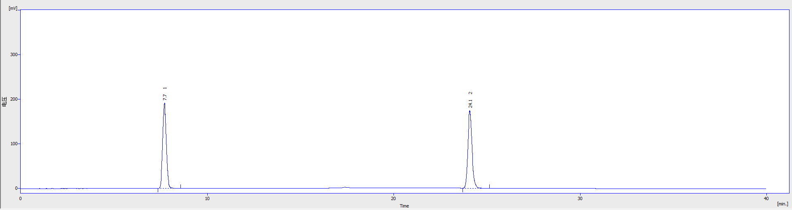
Figure 1 Chromatogram of the standard (1 is 5-hydroxytryptamine; 2 is Melatonin)
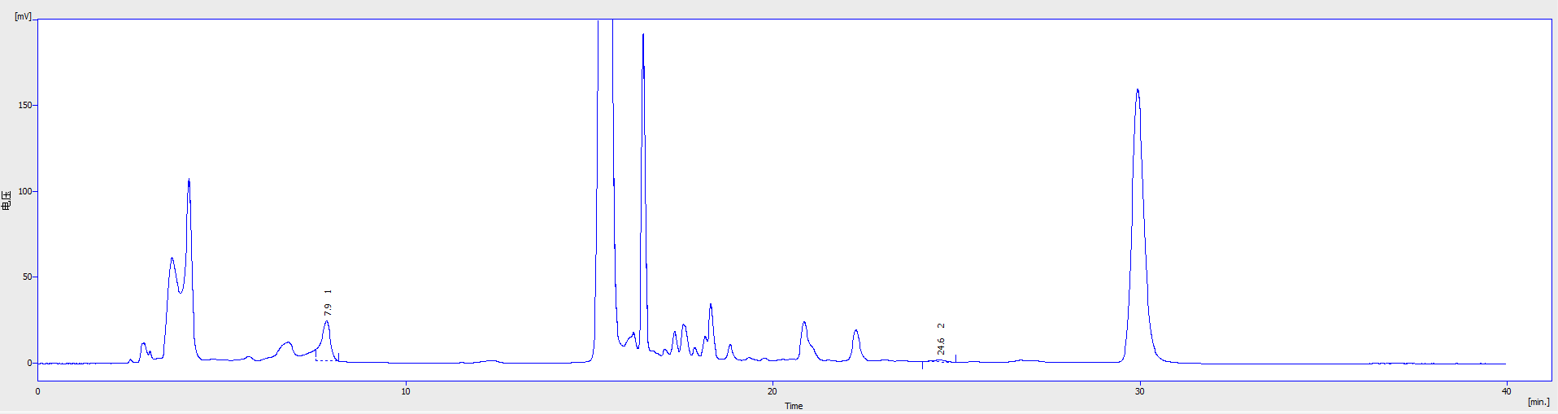
Figure 2 Chromatogram of the sample (1 is 5-hydroxytryptamine; 2 is Melatonin)
Name | Standard curve | Retention period（min）
Norepinephrine | y=0.722x-16.598; R²=0.9996 | 2.900
Dopamine | y=0.0574x-4.681; R²=0.9995 | 3.900

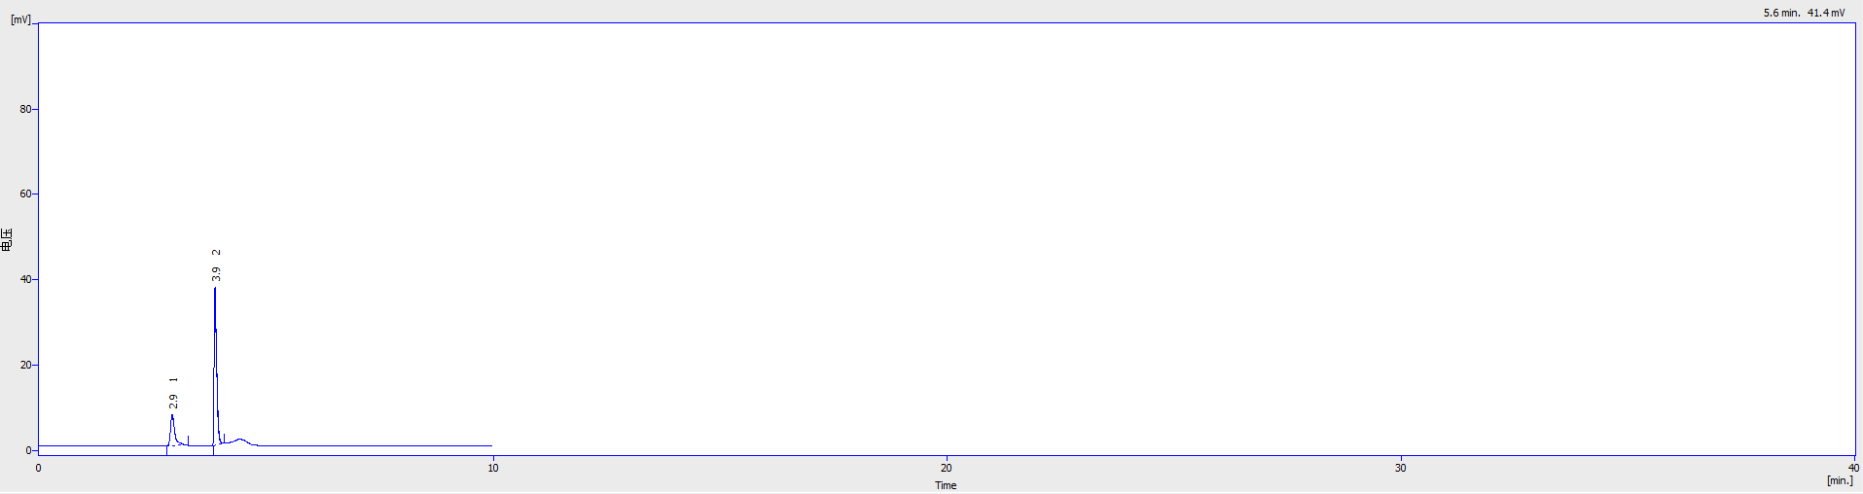
Figure 3 Chromatogram of the standard (1 is Norepinephrine; 2 is Dopamine)
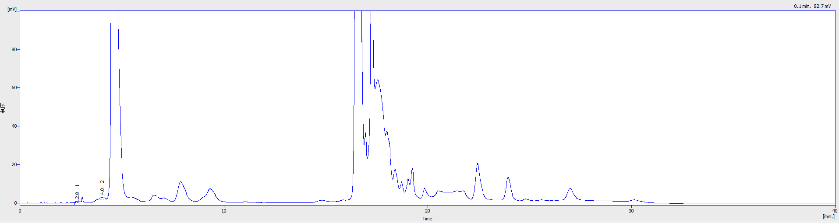
Figure 4 Chromatogram of the sample(1 is Norepinephrine; 2 is Dopamine)

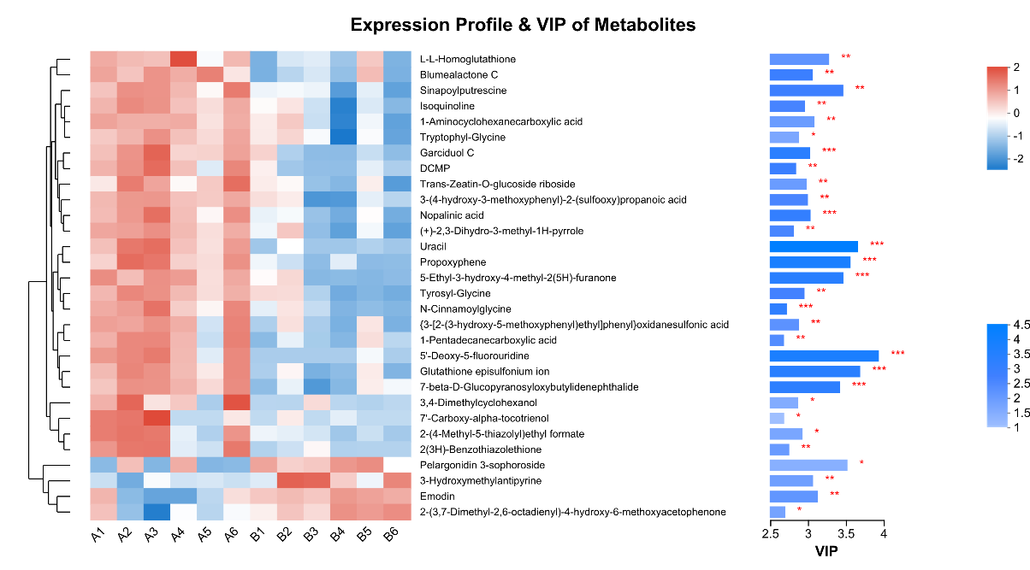
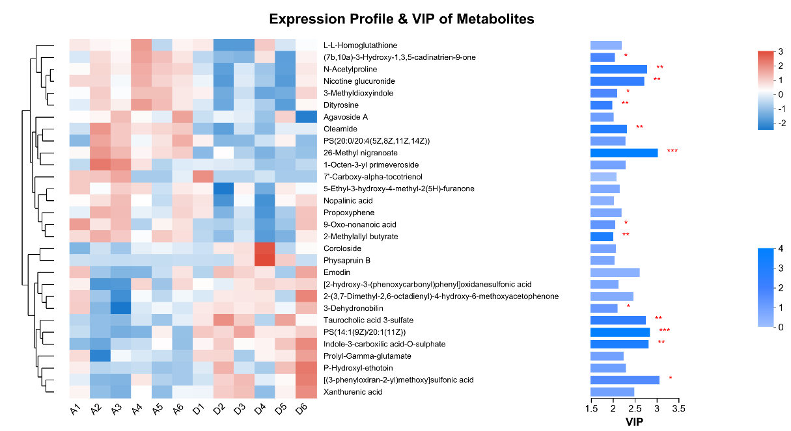
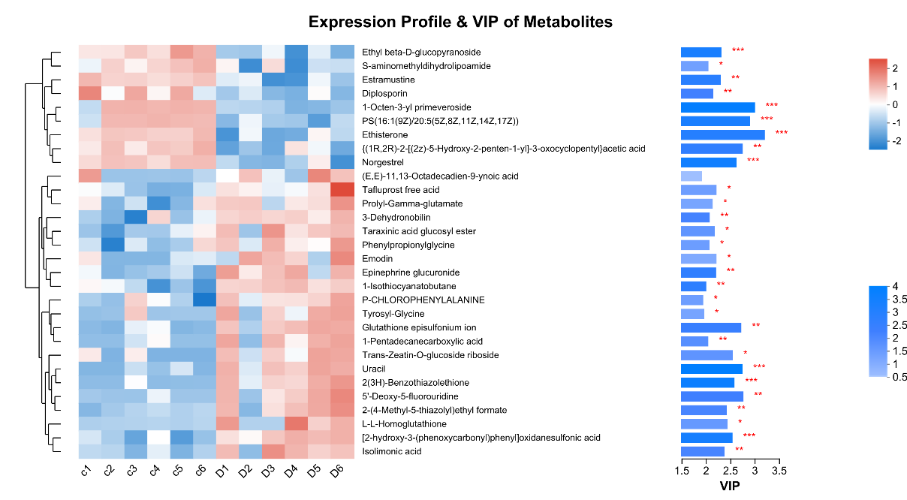
Figure S1 Metabolite expression profiles and VIP values

