Additional file 3. Non-linear relationship between base excess values and the estimated probability of favourable neurological outcome 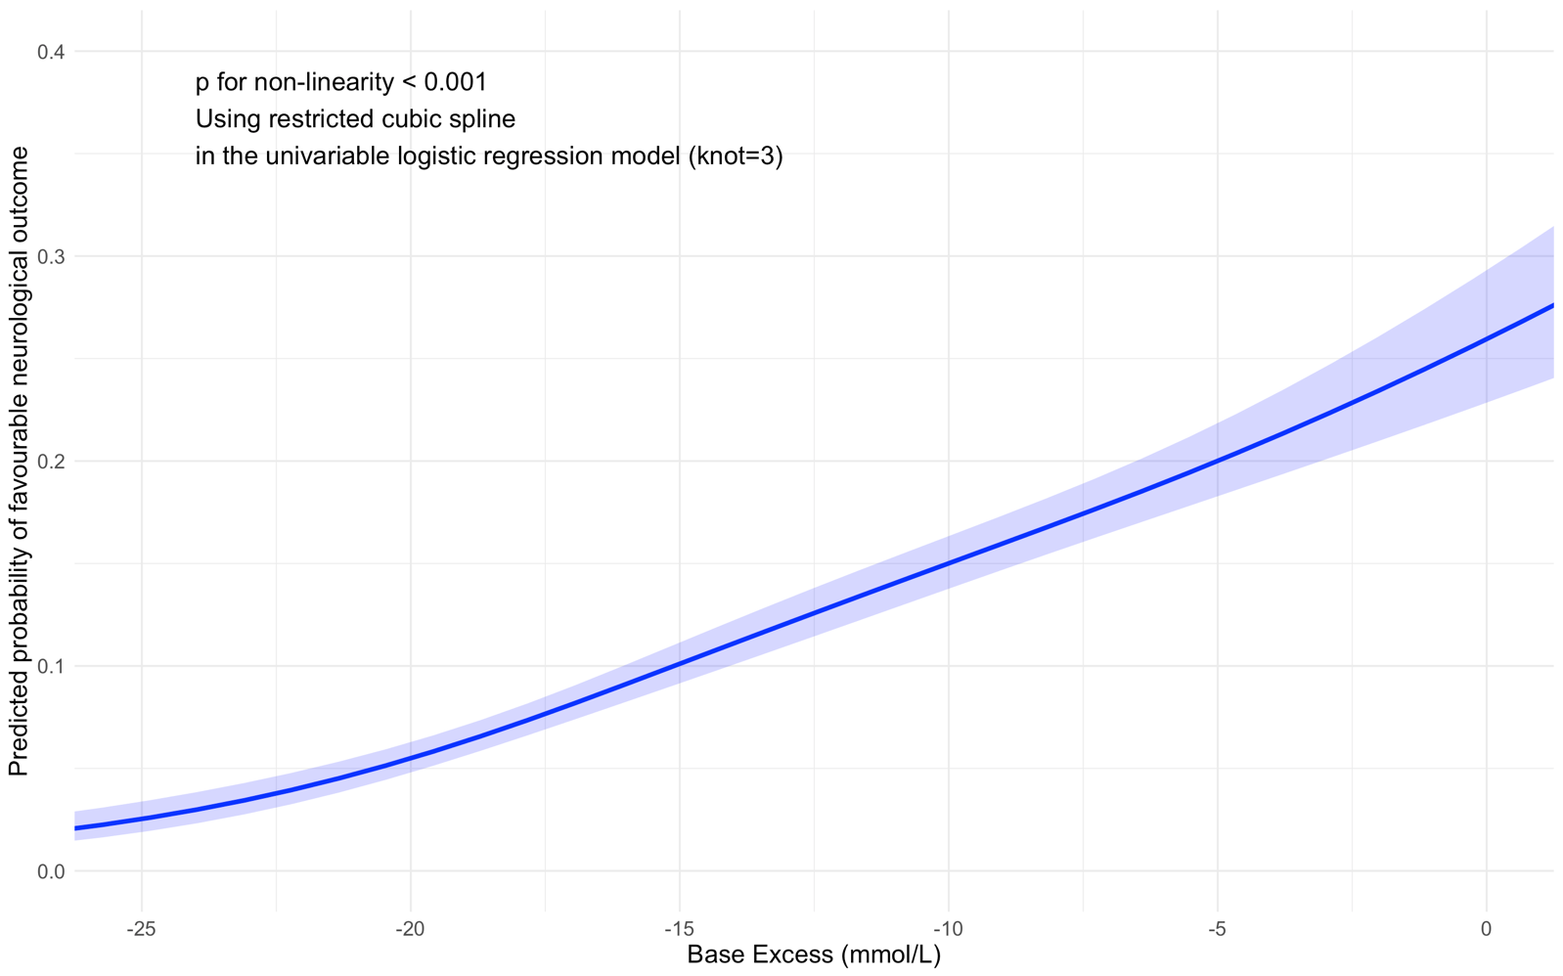
The lines indicate estimated probability, and the shaded areas represent the 95 % confidence intervals.

