Supplementary materials
Table S1 Combined enzymatic and ultrasound-assisted extraction schemes and conditions.
Scheme | Procedure and conditions
EUE | Step 1: pH 4.5, cellulase 0.3% (w/v) and 45°C for 1 h; Step 2: US amplitude: 60%, pH 10 for 40 min
UEE | Step 1: US amplitude: 60%, pH 10 for 40 min; Step 2: pH 4.5, cellulase 0.3% (w/v) and 45°C for 1 h
SEUE | SEUE1: pH 4.5, cellulase 0.3% (w/v) under ultrasonication at 60% amplitude for 40 min; SEUE2: pH 10, cellulase 0.3% (w/v) under US amplitude at 60% for 40 min

Table S2. FAO/WHO model protein and whole egg protein.
 | FAO/WHO (mg/g) model score | Whole egg protein pattern score (mg/g)
Isoleucine | 40 | 54
Leucine | 70 | 86
Lysine | 55 | 70
Methionine + cysteine | 35 | 57
Phenylalanine + tyrosine | 60 | 93
Threonine | 40 | 47
Valine | 50 | 66

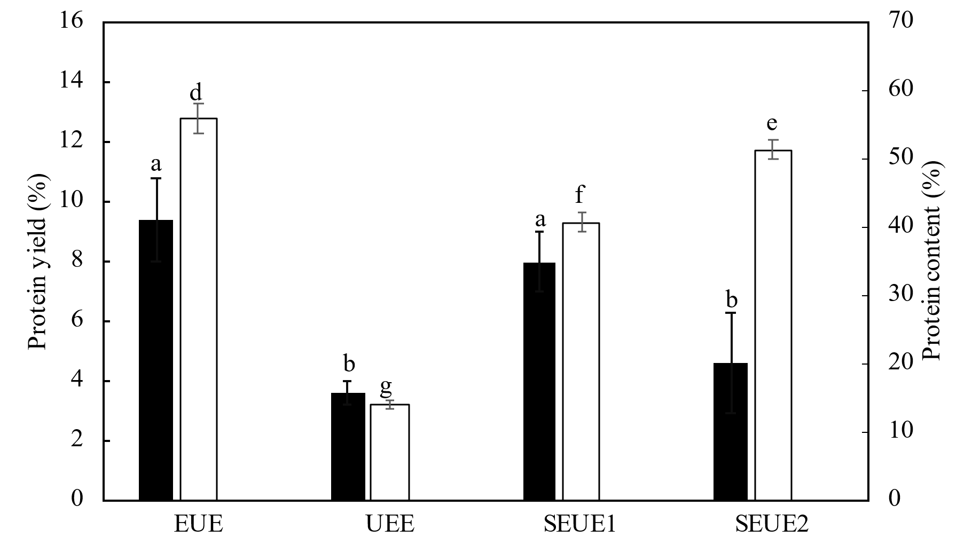
Figure S1 Comparison of protein yields, and protein content attained by different schemes of combined EAE and UAE. Data that lack the same letter indicate a significant difference.

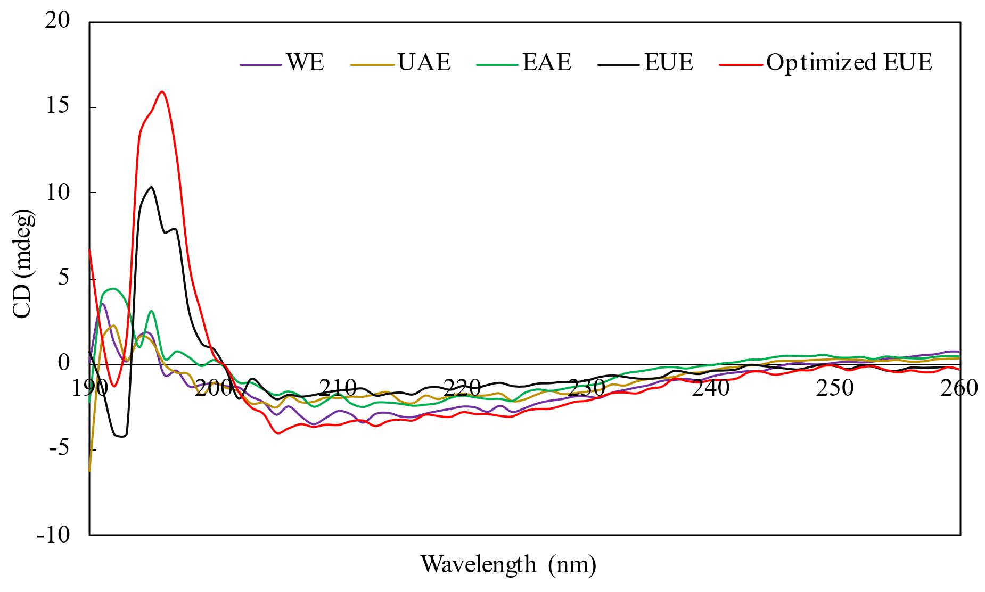
Figure S2 CD spectrum of isolated protein fraction from different extraction methods.

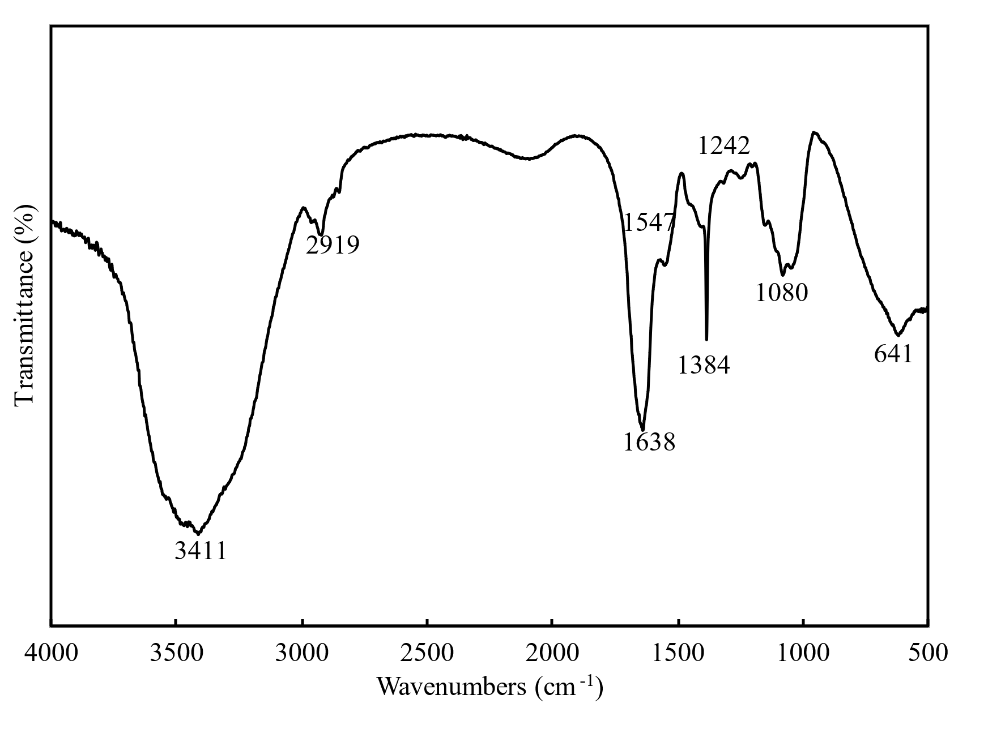
Figure S3 FT-IR spectrum of optimized EUE protein.

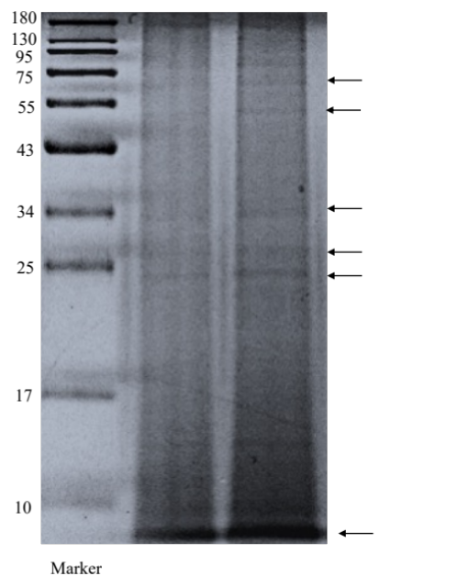
Figure S4 ﻿In SDS-PAGE analysis of EUE protein.

