Supporting information
Acute inflammation induced accelerated vascular remodeling by blood mononuclear cells in vitro

Raghav Soniª, Manabu Shiraiª, Tetsuji Yamaoka^{b} and Atsushi Mahara^{a*}
ªNational Cerebral and Cardiovascular Center Research Institute, Kishibe Shimmachi, Suita Osaka, 564-8565, Japan
^{b}Department of Clinical Engineering, Komatsu University, Ishikawa, Japan

* Corresponding author
Phone: +81-06-6170-1070
Fax: +81-06-6170-1702
Email address:mahara@ncvc.go.jp

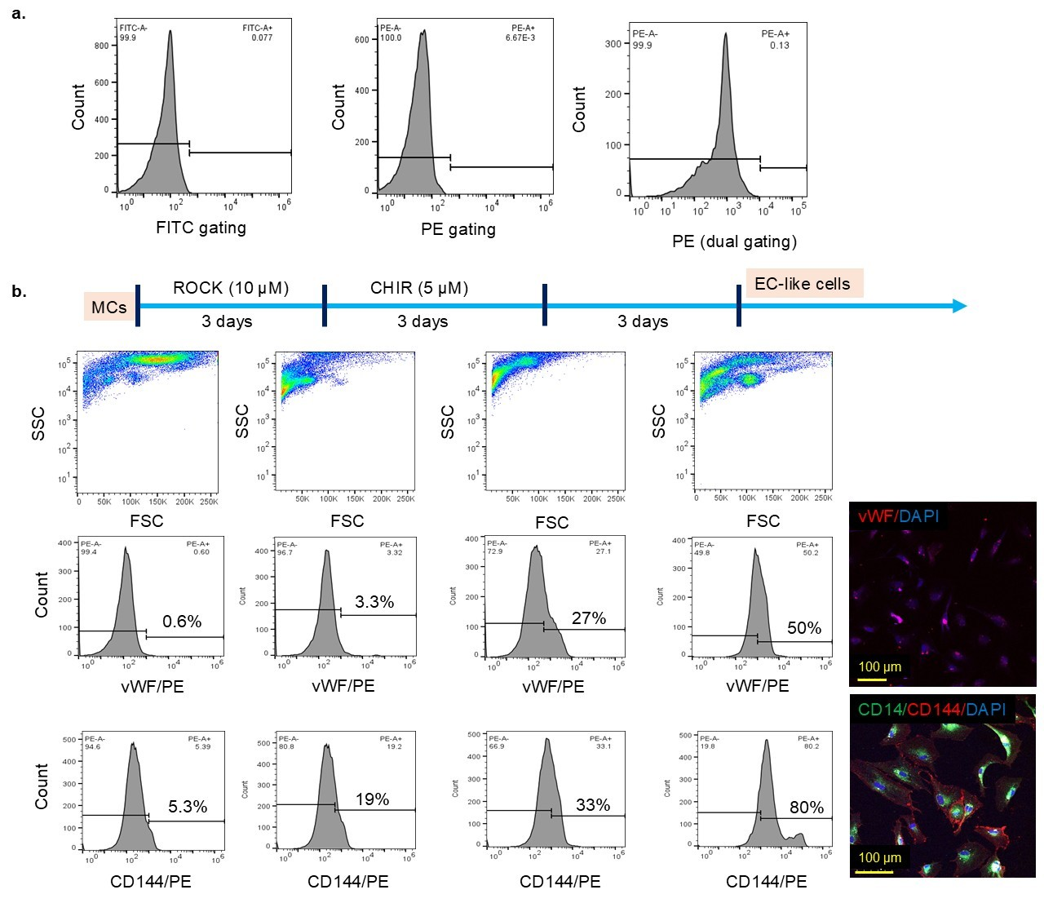
Figure S1. (a) FITC and PE gating were used as controls for the analysis. (b) FSC/SSC analysis and the fraction ratio (%) of vWF and CD144 positive cells were assessed at different stages of differentiation from MCs to EC-like cells.

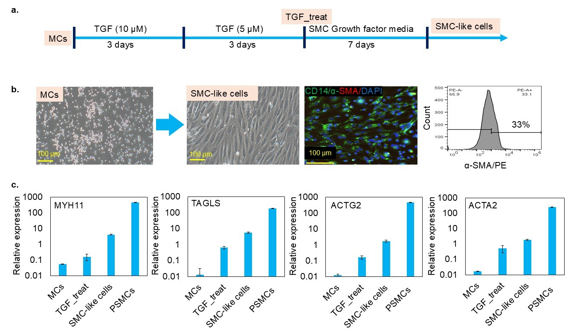
Figure S2. (a) protocol timeline for MCs differentiation towards SMC-like cells. (b) SMC-like cells have spindle-like morphology and 33% of cells stained positive for α-SMA. (c) SMC-specific genes are upregulated during differentiation. Pig smooth muscle cells (PSMCs) were used as a positive reference for comparison.

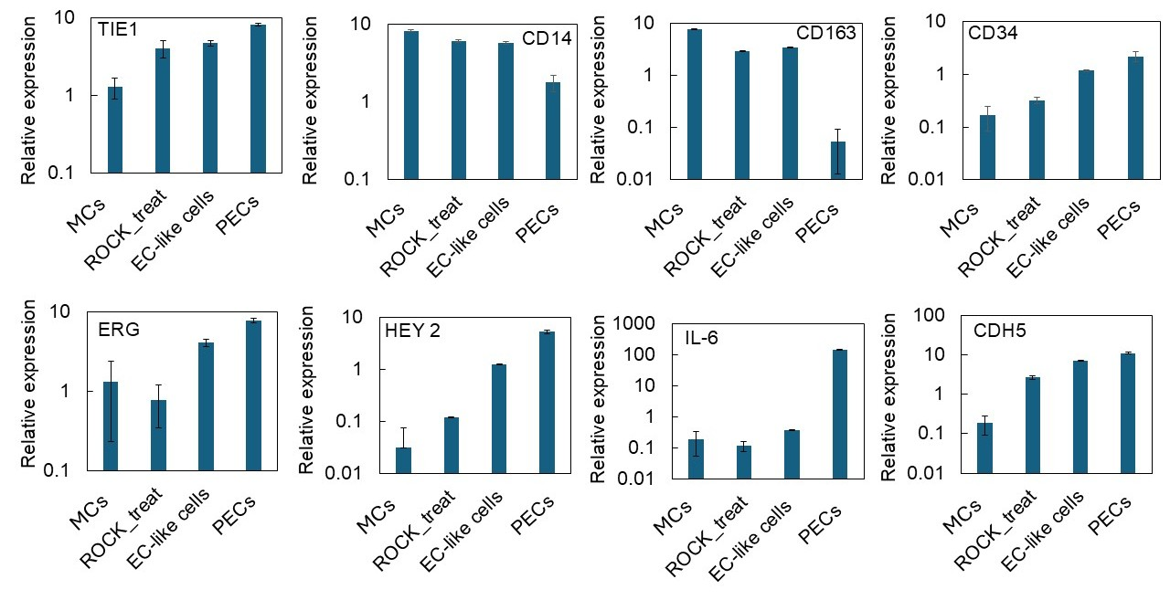
Figure S3. Gene expression profile during the differentiation of MCs into EC-like cells. PECs were used as a positive control in the experiment.

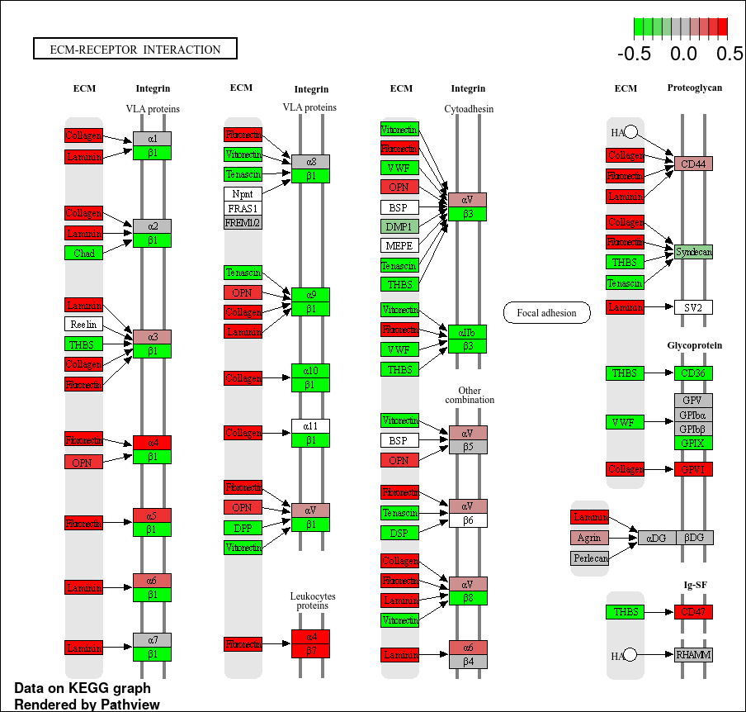
Figure S4. MCs collected after induction of acute inflammation have higher integrin activation for ECM interaction than pre-inflammation MCs.

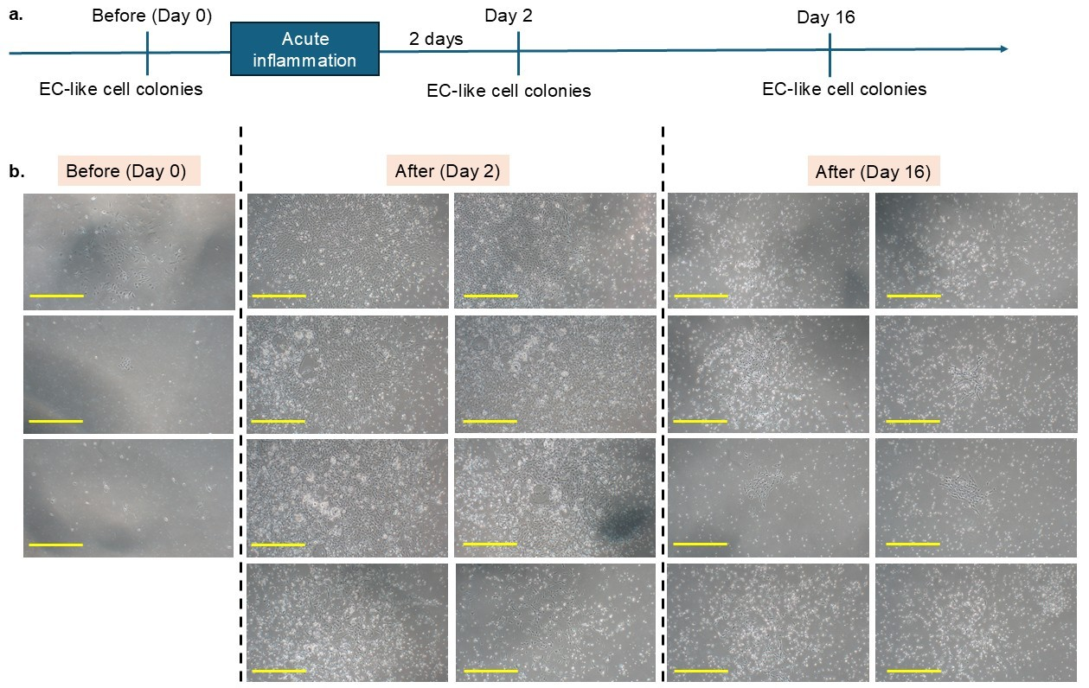

Figure S5. (a) The timeline for blood sample collection, before and after acute inflammation in mini-pigs, and processed for differentiation towards EC-like cells using a ROCK/CHIR protocol. (b) Phase contrast images of all EC-like cell colonies formed with the collected samples in a 10 mm Petri dish.

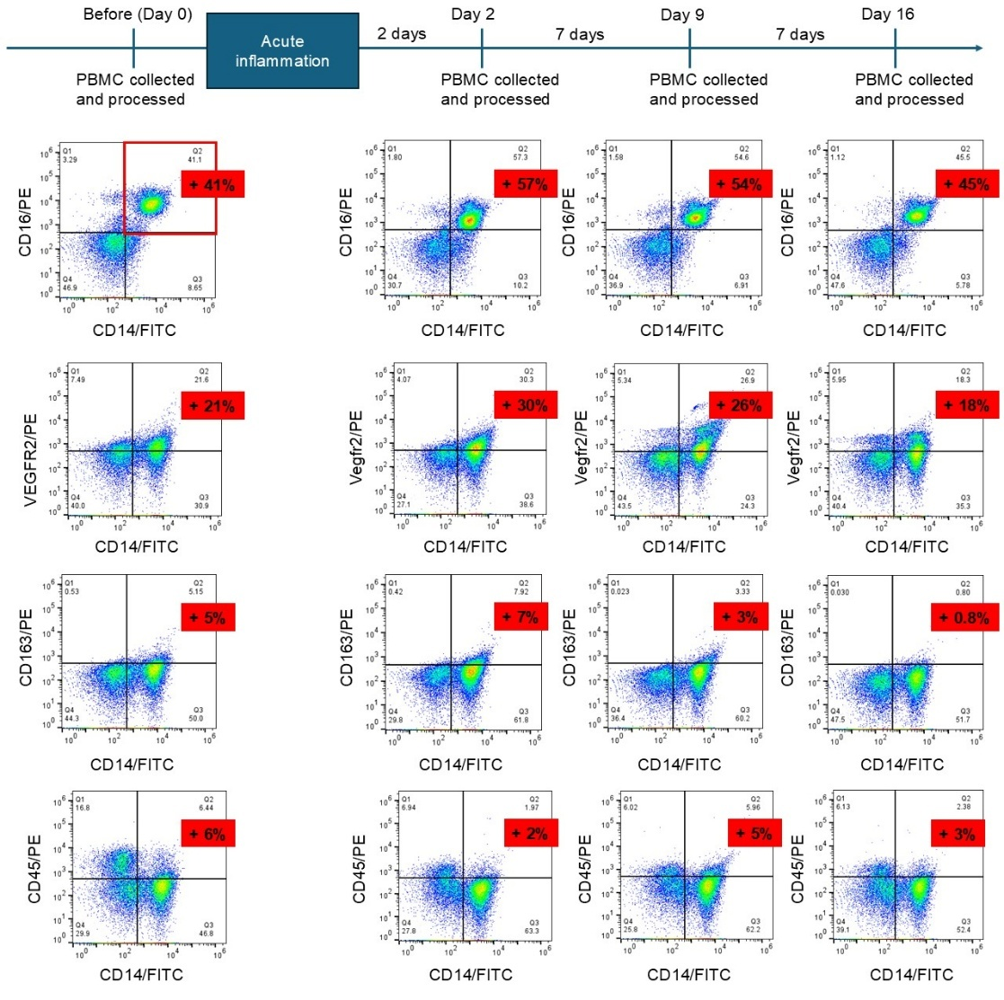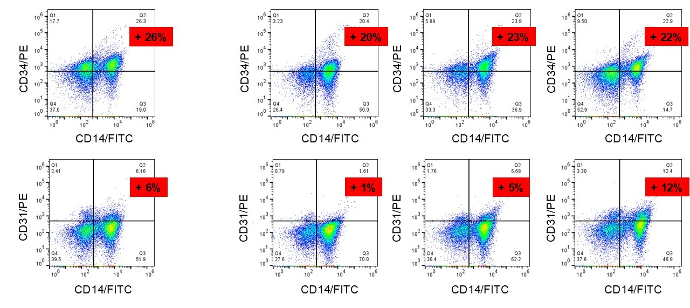
Figure S6. Fraction ratio (%) of CD14/CD16 positive cells in PBMCs processed from blood samples collected before and after acute inflammation as indicated in the timeline.

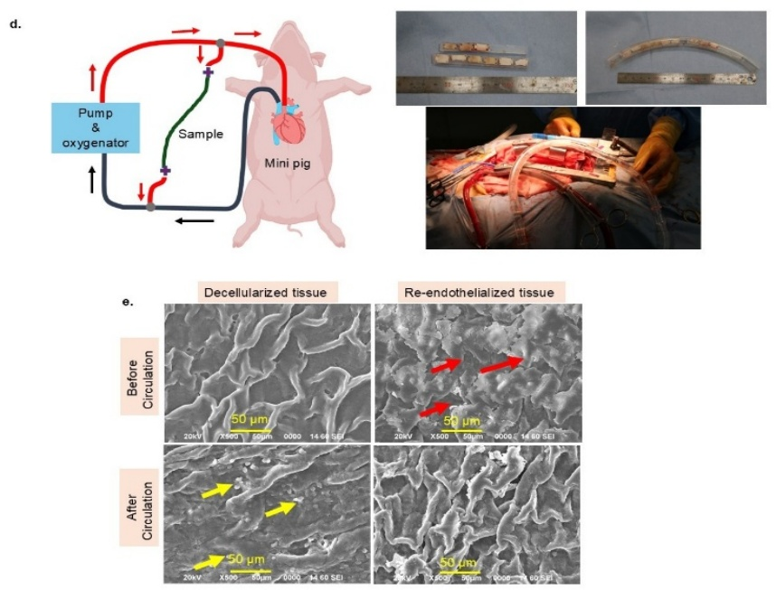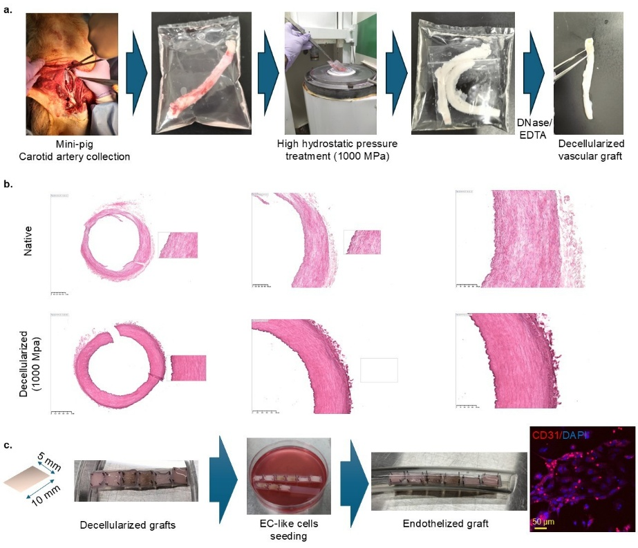
Figure S7. (A) Mini-pig carotid artery was collected and processed using high hydrostatic pressure treatment at 1000 MPa, then followed by DNase/EDTA washing to obtain the decellularized vascular graft. (B) H&E staining confirmed successful decellularization at 1000 MPa. (C) The decellularized vascular graft was cut into small pieces and fixed on a silicon rubber strip using needles as shown. EC-like cells seeded on decellularized grafts and incubated with CD31 stain. Images show proliferated EC-like cells on the graft lumen surface. (D) Re-endothelialized graft kept inside the tube was exposed to blood circulation for 3 hours using the cardiopulmonary bypass system as shown. (E) Surface morphology shows higher attachment of platelets (indicating by yellow arrow) on decellularized tissue; interestingly, re-endothelized tissue covered with EC-like cells (indicating by red arrow) shows lesser platelet adhesion under blood circulation.

Table 1. List of primers used for quantitative PCR.
PECs (gene) | Forward primers | Reverse primers
CD31 | CACCGAGGTCTGGGAACAAA | GGAGCCTTCCGTTCTAGAATATC
vWF | GCCTTCCTGACAAGGTGTGT | GGAGGACGTAAGTGAAGCCC
Ang | AGCGTGGGACTCGGATGT | CTTCCAACAAAGGCTCCTTCC
CD34 | GAGAAAGGCTGGGCGAAGA | GAATGGCCGTTTCTGGAGGT
Notch1 | CAACGTCAATGAGTGCCACA | GATCTCACAGTTGGGTCCTGT
Hey1 | GCAGGTAATGGAGAAAGGATCTG | CTCAGGTAACGGGCGACTTC
GAPDH | ACACTCACTCTTCTACCTTTG | CAAATTCATTGTCGTACCAG

PSMCs (gene) | Forward primers | Reverse primers
MYH11 | AGTTGGAGATCTGGGACCGA | TAATGCTGGCTGCCTCGAAA
TAGLN | CTTCCAGGTCTGGCTGAAGAA | GGCCAGGTCTTTGCCTTCG
ACTG2 | TGTGACCACAGCTGAACGA | ATGGTGATGACCTGTCCGTC
ACTA2 | CCAGAGCAATCAGGGACC | TGTCCCATTCCCACCATCAC
CNN1 | GCCGTGCTATATAAGGGCCG | GGAGCTTATTGATGAACTCGCAAA
GAPDH | ACACTCACTCTTCTACCTTTG | CAAATTCATTGTCGTACCAG

