Supplementary table 1: 70 protein targets including housekeeping proteins and isotype controls used for GeoMx DSP

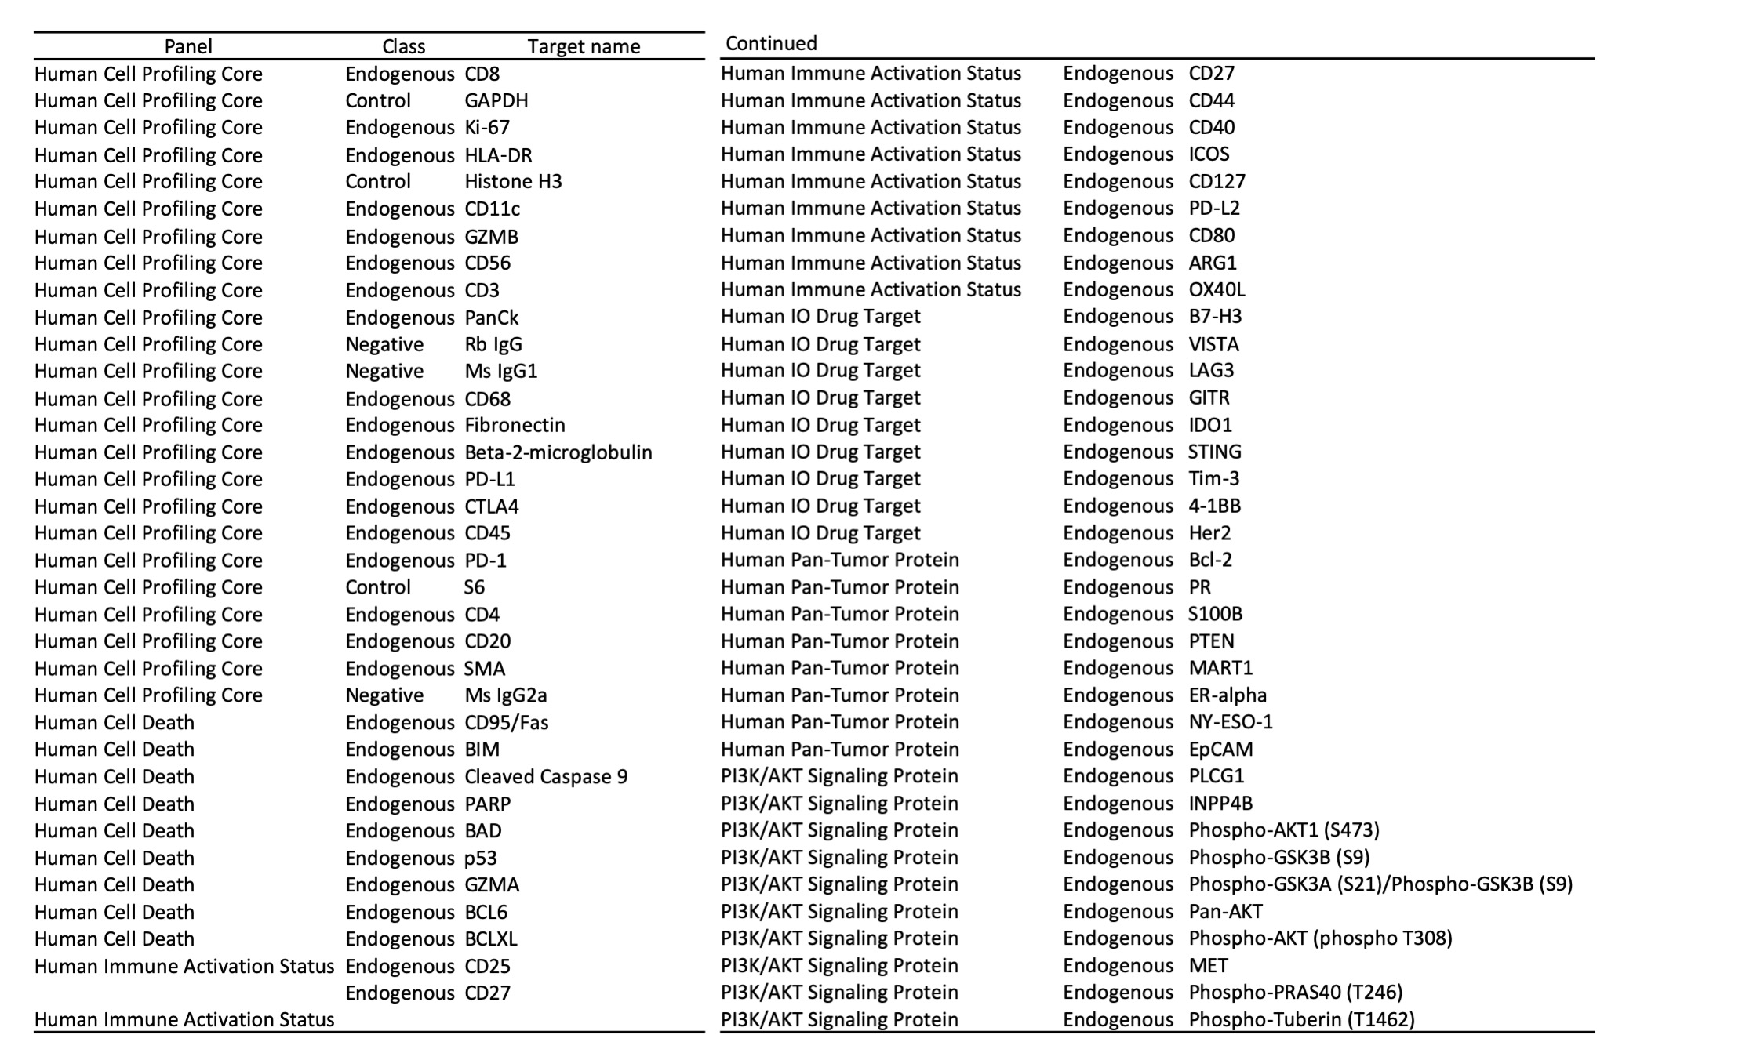

Supplementary table 2: Differential expression of immune signatures in primary and metastatic tumors

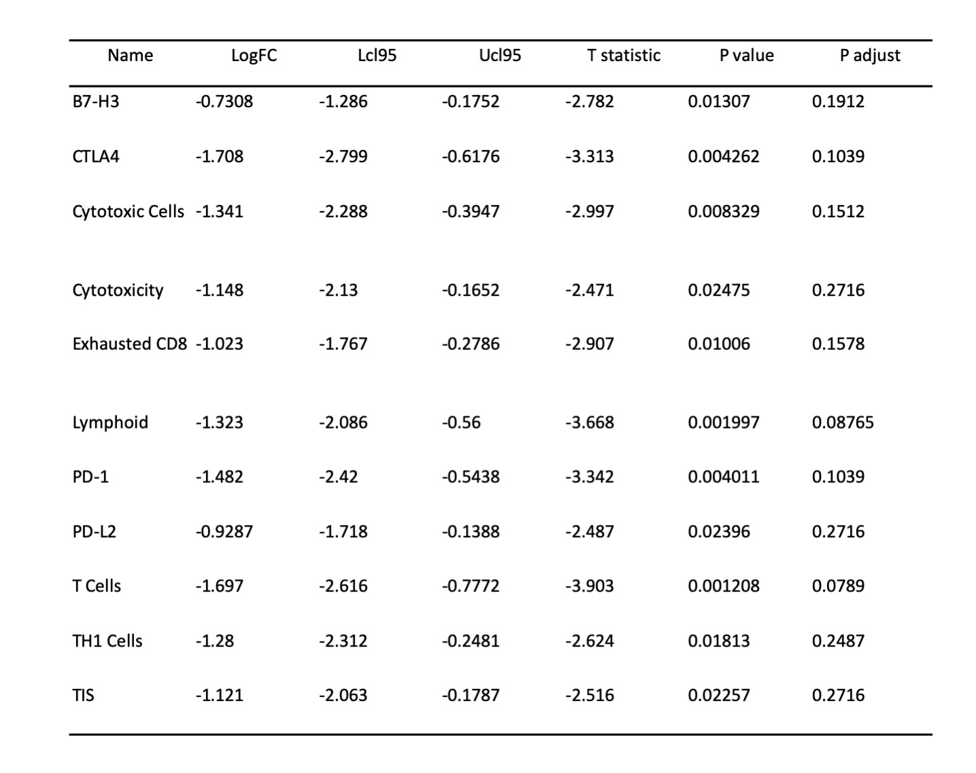

Supplementary table 3: Differential expression of individual genes in primary and metastatic tumors

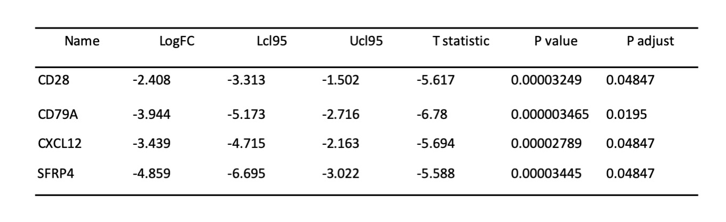

Supplementary table 4: Differential expression of immune signatures in primary and brain metastases
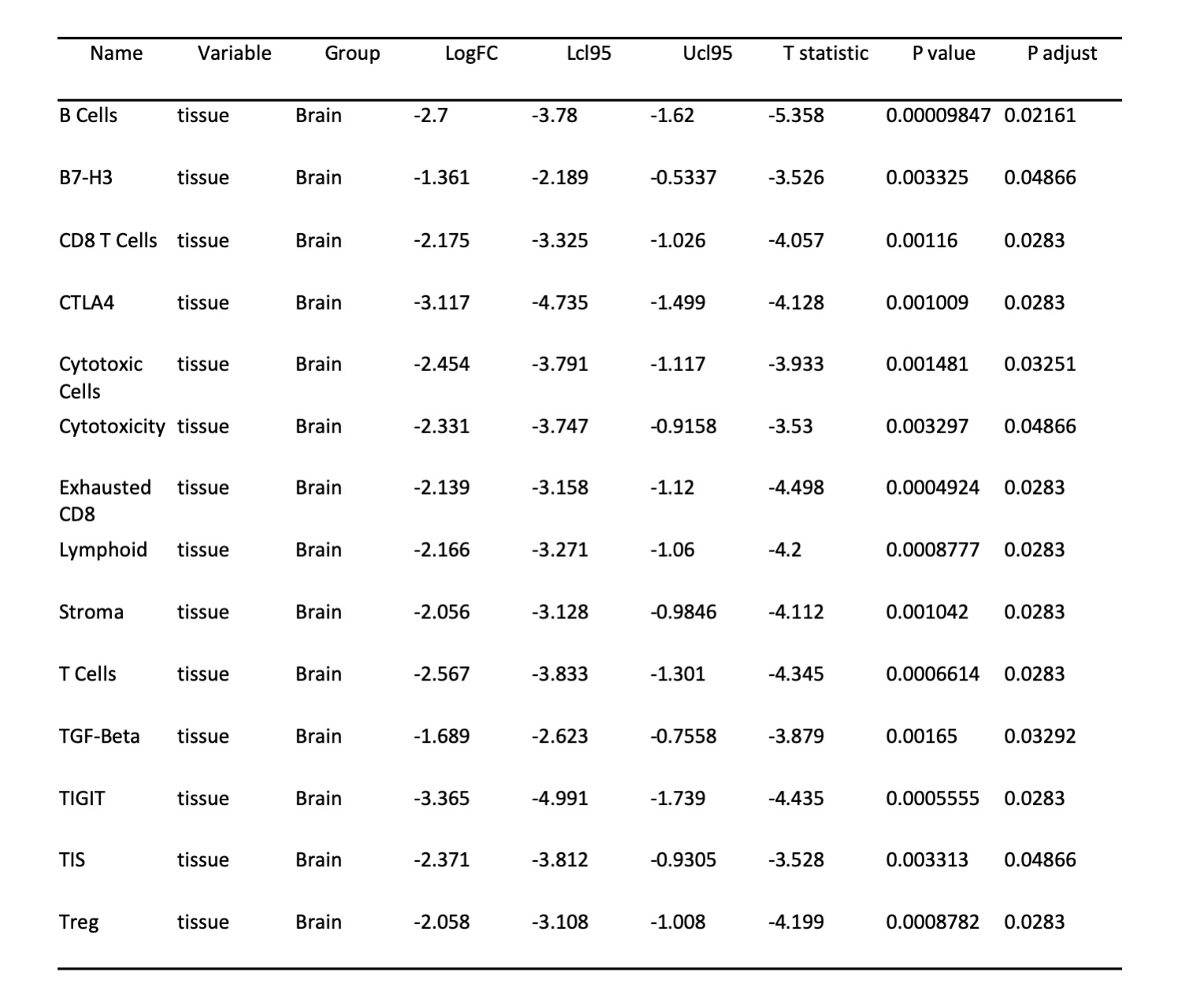

Supplementary table 5: Differential expression of immune markers in different regions of interest (comparing primary and metastatic samples)

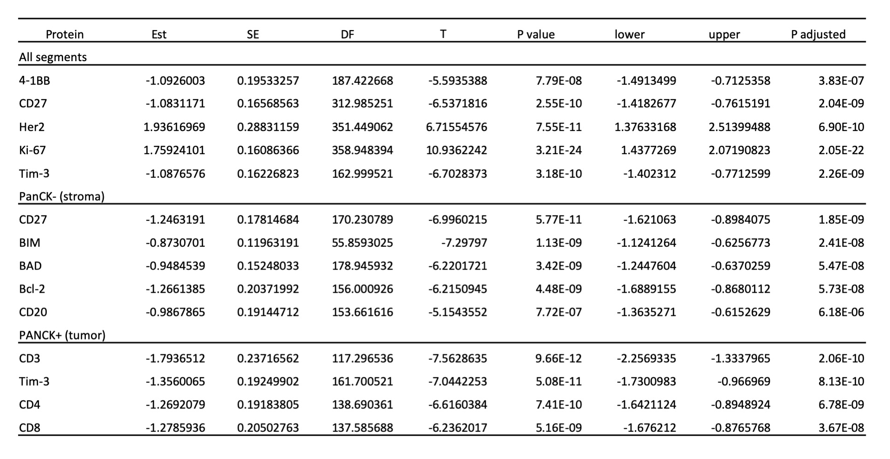

Supplementary table 6: Differential expression of immune markers in different regions of interest (comparing primary tumors and brain metastases)

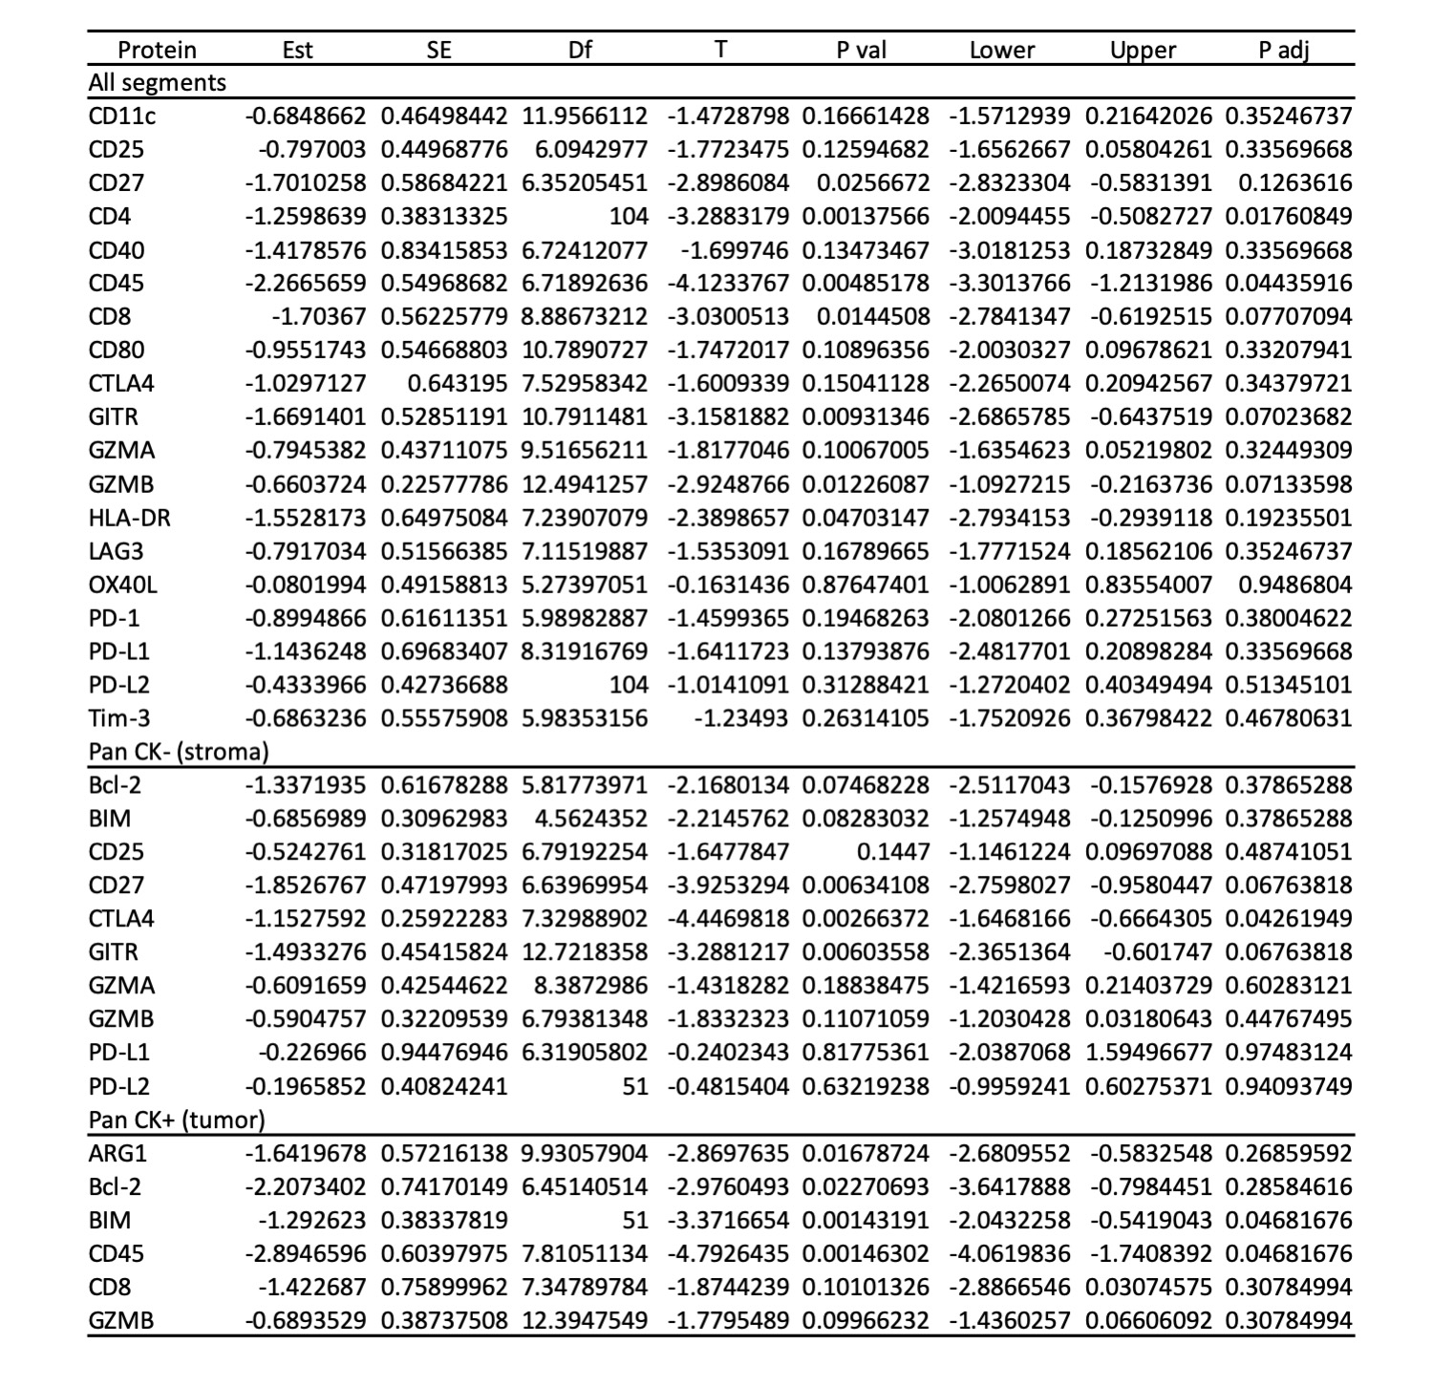

Supplementary figure 1: The signal-to-noise ratio for each of the targets included in GeoMx DSP

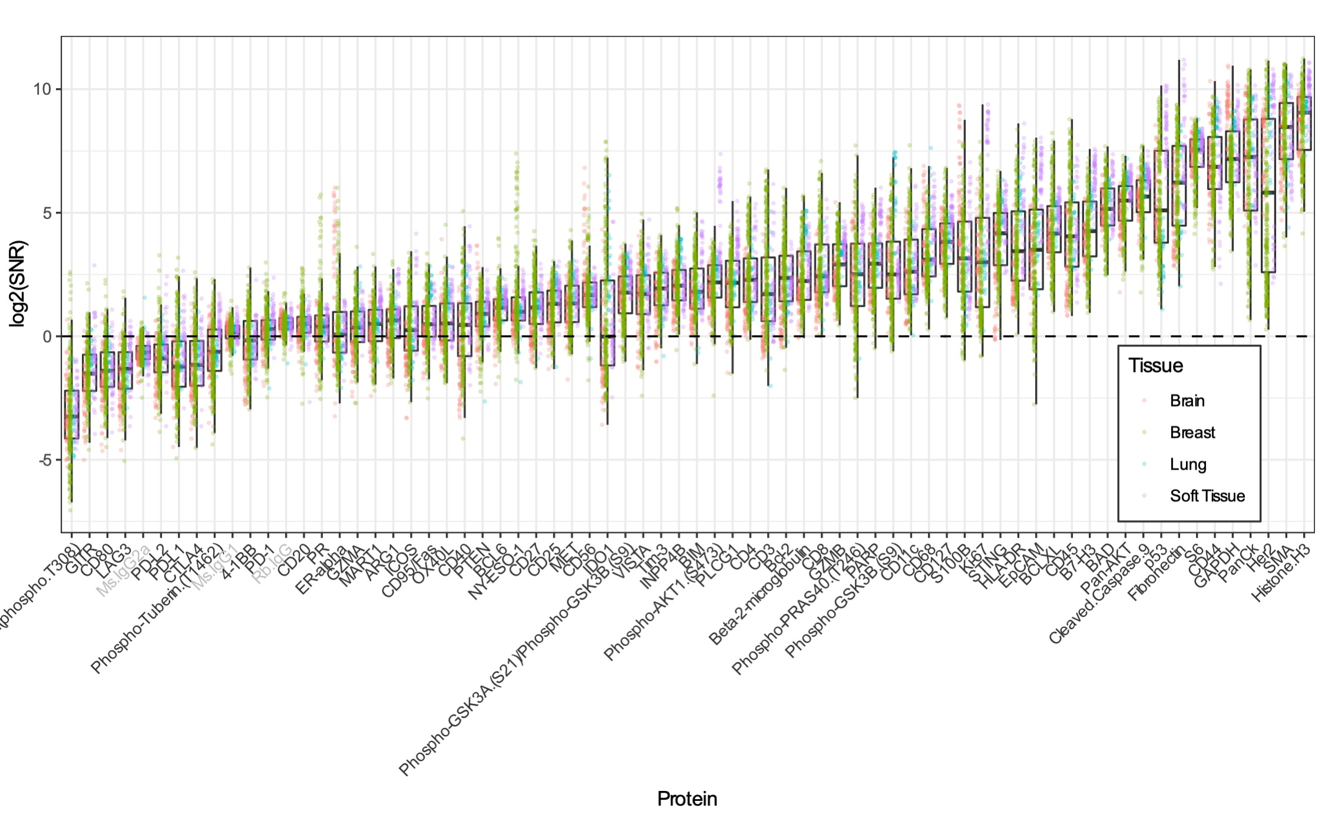

Supplementary figure 2: Treatment and disease history for patients 1 and 2

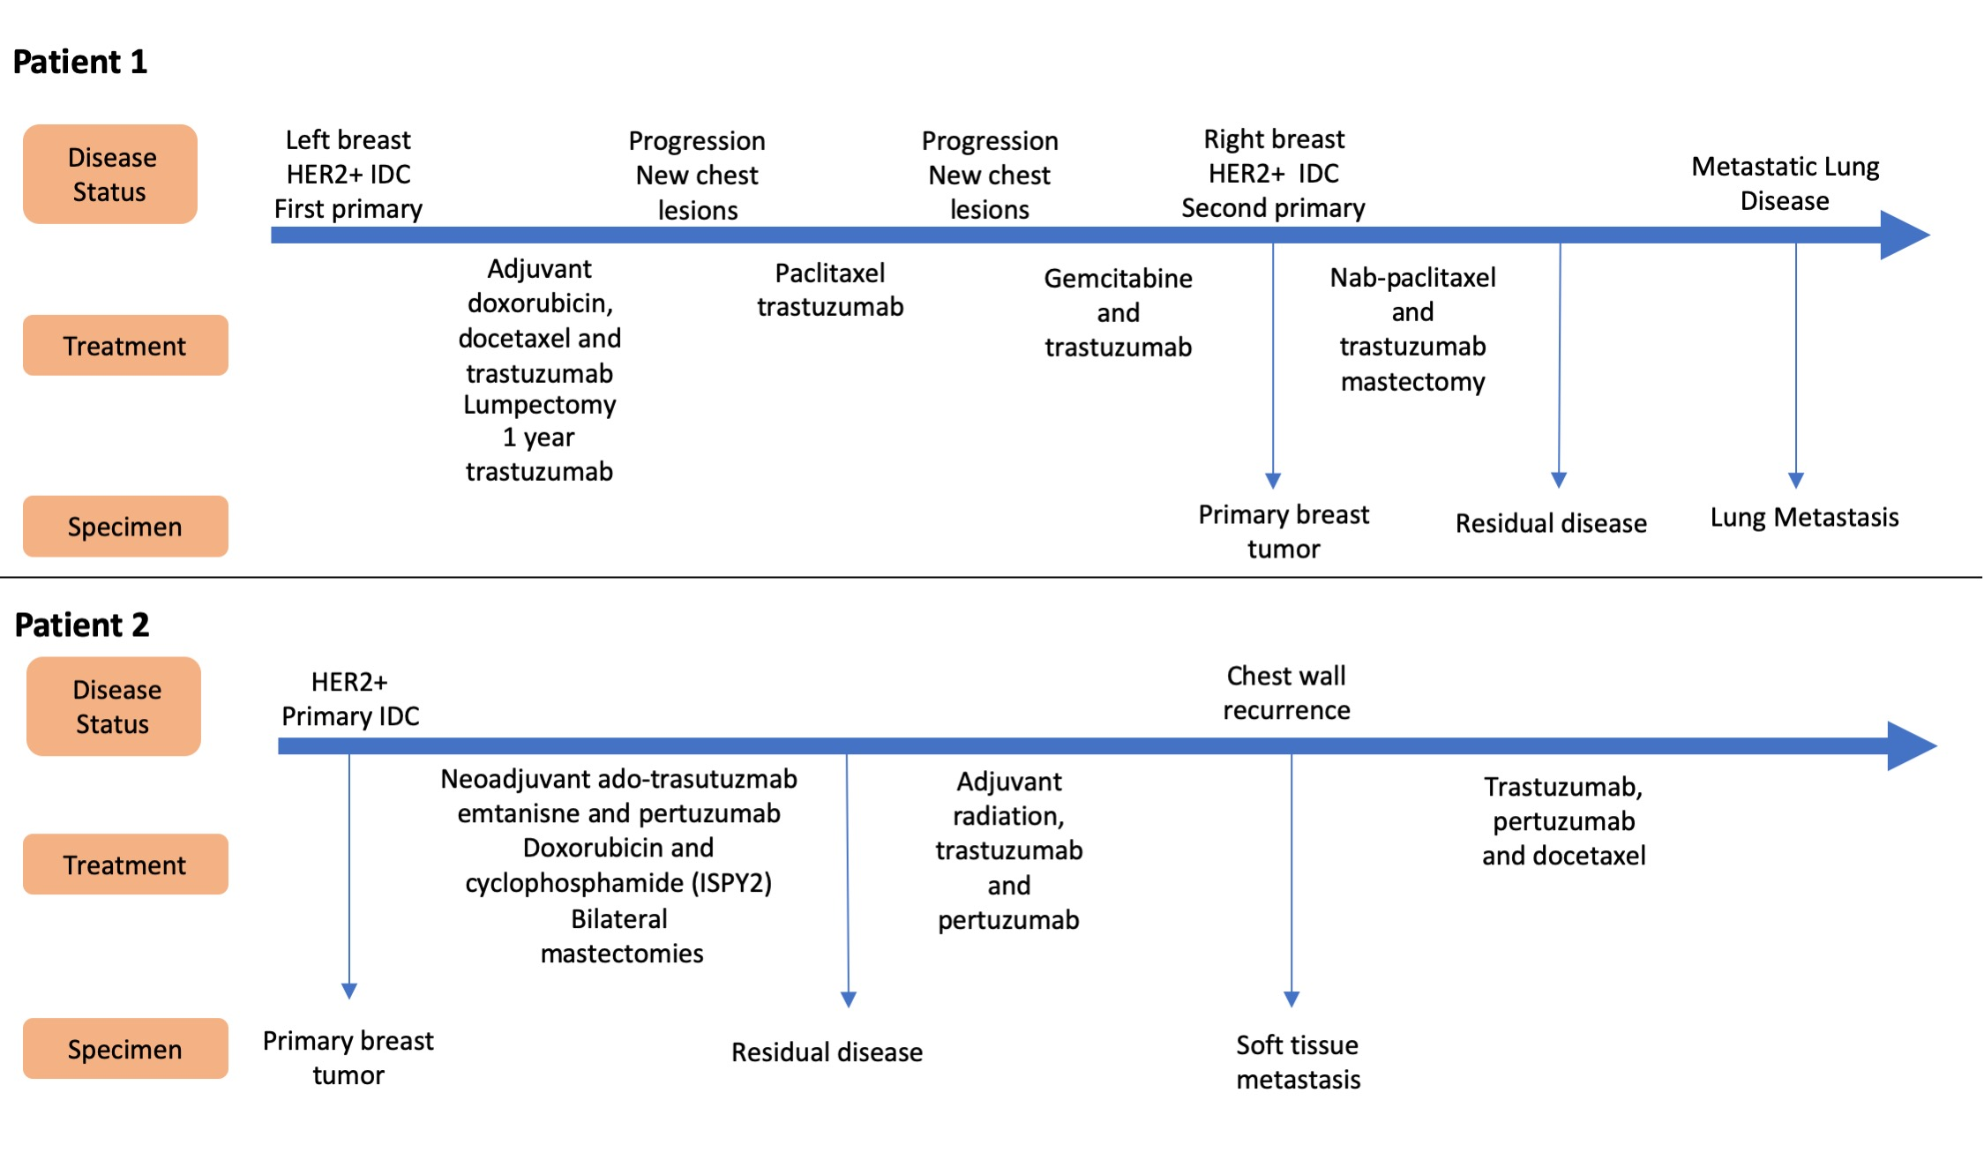

Supplementary figure 3: Treatment and disease history for patients 4, 7 and 8 and longitudinal plots showing protein expression of immune markers. Pink represents expression in PanCK negative stroma and teal is PanCK positive tumor AOIs
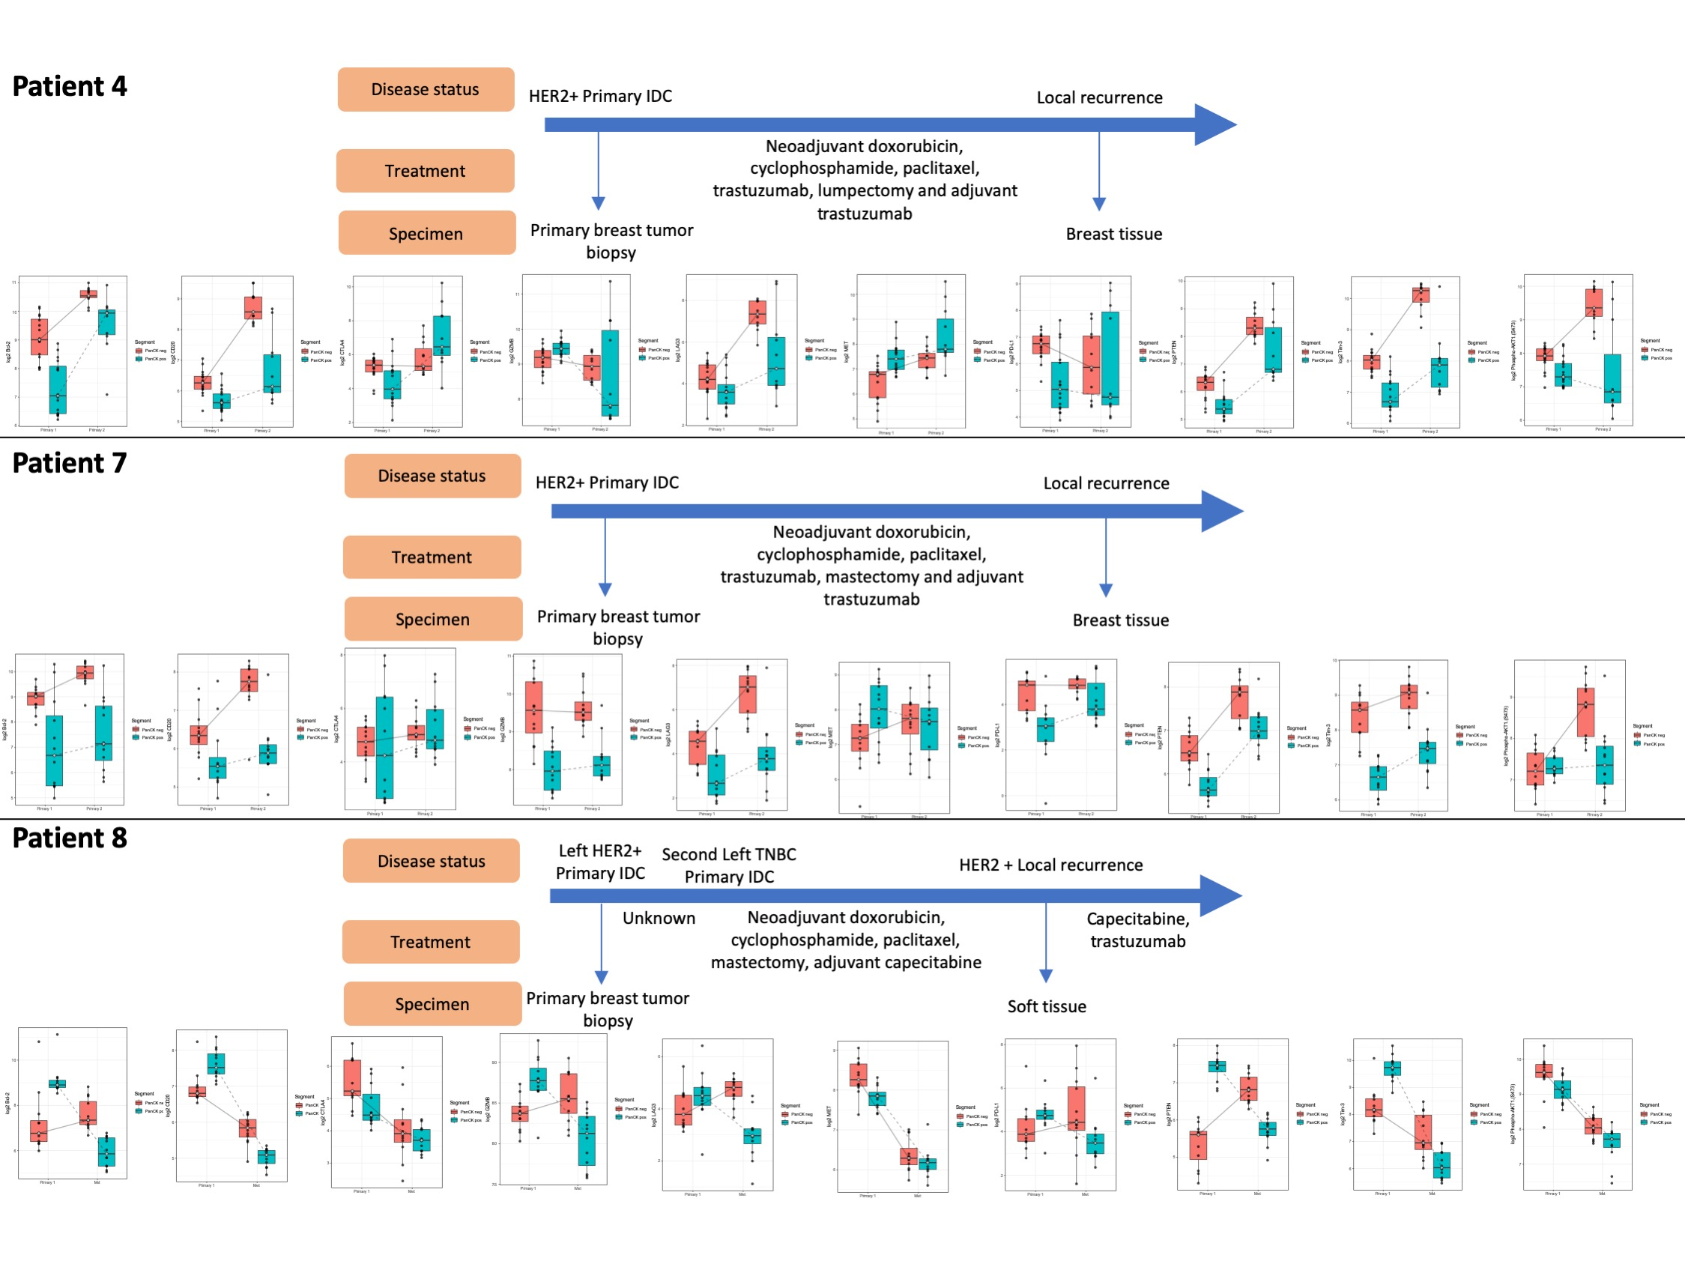

Supplementary figure 4: Gene signatures for each of the PAM50 subtypes
