Table 1 Mean (M), standard deviations (SD), factor loadings (FL_Aw and FL_Ac), communalities (Com), and item-total correlation (I-T) for the two-factor model derived from the CFA
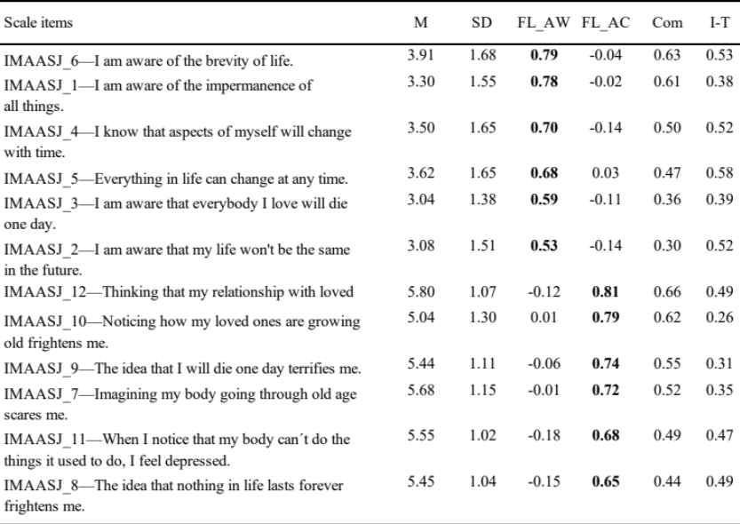

Table 2 Construct validity (i.e., convergent and discriminant validity) and reliability for the final impermanence two-factor model
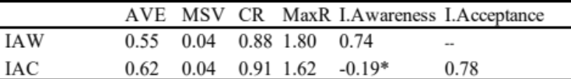
*p < 0.01

Table 3 Model Fit Indices for the impermanence two-factor model
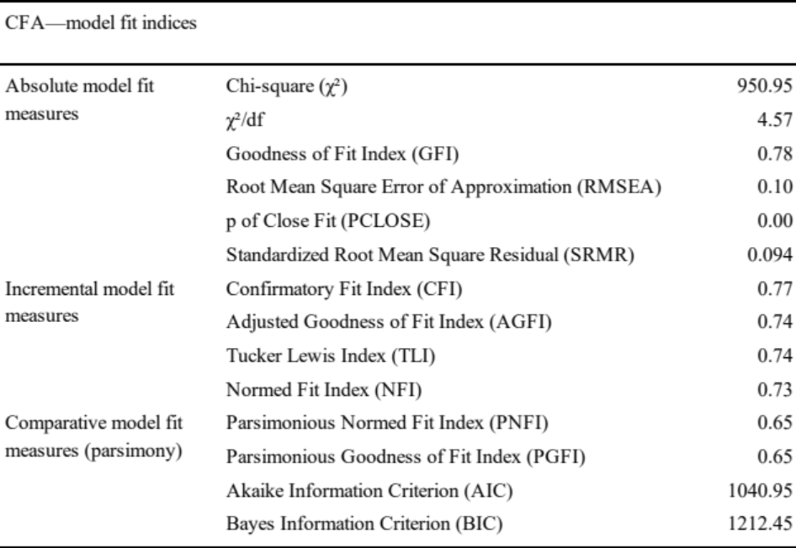

Table 4 factor loadings (FL_Aw, FL_Ac and G (=General factor)), communalities (Com), and item total correlation (I-T) for the bifactor model derived from the CFA
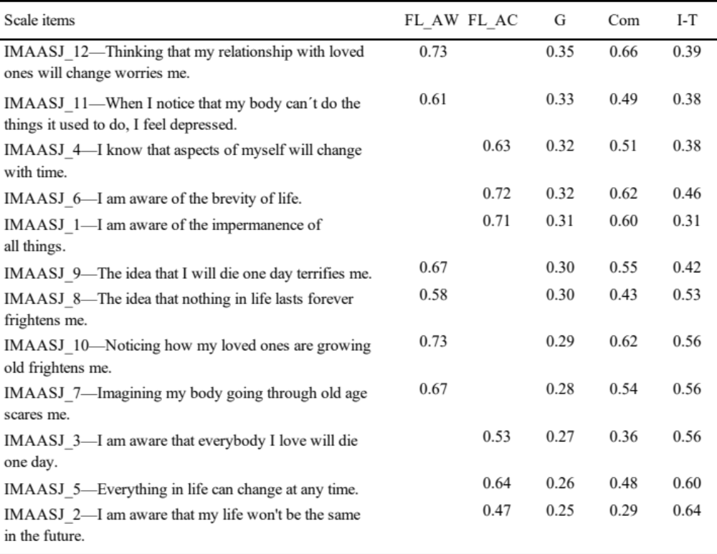

Table 5 Model Fit Indices for the impermanence bifactor model
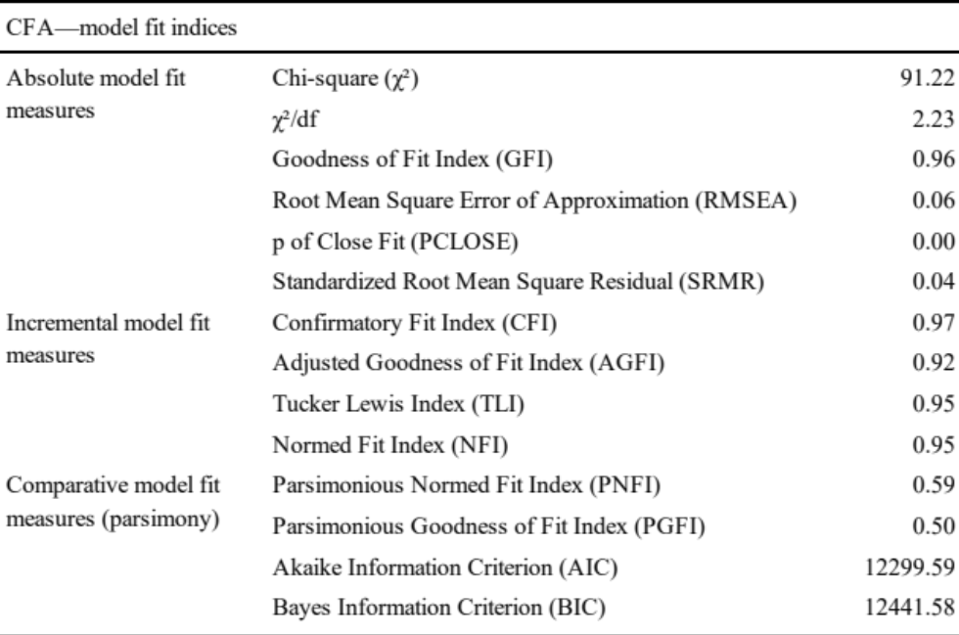
Table 6 Zero-order correlations between all study variables
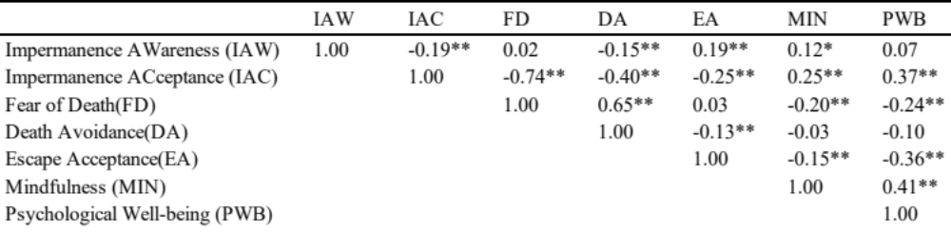
Note. *p < 0.05, ** p < 0.01

