Protonation prerequisite in selective furfural hydrogenation to furfuryl alcohol: a kinetic isotope effect study
Wen Guan, Yunlei Zhang*, Yan Yan*
Institute of Green Chemistry and Chemical Technology, School of Chemistry and Chemical Engineering, Jiangsu University, Zhenjiang, 212013, China

Corresponding authors:
Prof. Yunlei Zhang (jsdxzyl@ujs.edu.cn)
Prof. Yan Yan (dgy5212004@163.com)

Supplementary Methods
1. Experimental section.
1.1. Chemicals.
Copper (II) chloride dihydrate (CuCl₂·2H₂O, AR, >98%), potassium hydroxide (KOH, GR, ≥85.0%), boric acid (H₃BO₃, GR, ≥99.8%), hydrochloric acid (HCl, 36%), acetone (C₃H₆O), acetonitrile (C₂H₃N, AR, >99.0%) were all purchased from Sinopharm Reagent Co., Ltd. (China). Palladium chloride (PdCl₂, ≥99.9%), phosphoric acid (H₃PO₄, HPLC grade, 85-90%), 2-furaldehyde (FF, GC, ≥99.5%), furfuryl alcohol (FA, AR, 98%), 1,2-bisfuran-2-ylethane-1,2-diol (≥95.0%), deuterium oxide (D₂O, 99 atom % D) were purchased from Aladdin Reagent Co., Ltd. (Shanghai, China). Copper foam (CF, 1.0 mm thickness) was provided by Suzhou Kesheng and Metal Materials Co., Ltd. (China).
1.2. Preparation of Pd-Cu.
First, the 1 × 2 cm² CF was ultrasonic cleaned with acetone, 3 M HCl, and water respectively, and then placed in a vacuum drying oven for 8 h. Then, 0.5 M CuCl₂·2H₂O solution was configured as the electrolyte, and the cleaned copper foam was electrochemically deposited for 300 s at -0.21 V vs. RHE. Drying the deposited electrodes in a glove box, and the catalysts were named as Cu. Cu was soaked in PdCl₂ solutions with different concentrations and stirred at room temperature for 15 min, then dried in a vacuum drying oven for 12 h. The concentrations of Pd solution were 0.4 mM, 0.5 mM, and 0.6 mM, respectively. According to the molar ratio of Cu and Pd, the obtained electrodes were renamed as Pd_{0.60}Cu_{0.40}, Pd_{0.73}Cu_{0.27}, and Pd_{0.78}Cu_{0.22}. The cleaned CF was soaked in 0.5 mM PdCl₂ solution and stirred at room temperature for 15 min, drying in a vacuum drying oven for 12 h to obtain the pristine Pd electrode.
1.3. Electrochemical measurements.
All electrochemical measurements for FF reduction were carried out on a CHI660E electrochemical workstation (CH Instruments Inc., Shanghai) in a three-electrode mode at room temperature. The working electrode was the Pd-Cu (1 × 2 cm²), Pt sheet (1 × 1 cm²), and Hg/HgO were used as the counter and reference electrodes, respectively. The measured potentials were referenced to the reversible hydrogen electrode (RHE) according to the following equation:
ERHE = E_{Hg/HgO} + 0.0591 × pH + 0.098
The electrochemical FF reduction was conducted in 40 mL 1.0 M·boric acid aqueous solution containing 20% acetonitrile as the electrolyte, pH = 9.2.
1.4. Product analyses.
The products from the electrochemical FF reduction were determined and analyzed by High Performance Liquid-Chromatography (HPLC, Agilent 1260 Infinity II, Agilent Technologies) equipped with an Agilent C18 column (4.6×250 mm, 5 μm). 0.1 wt% H₃PO₄ solution and C₂H₃N (V: V =85:15) was used as the eluent with a constant flow rate of 1.0 mL·min⁻¹, and the temperature of the column was maintained at 30 °C. Products of FA were analyzed after the chronoamperometry testing at various potentials for 2 h.
1.5. KIE (H/D) experiments.
A 1.0 mL mixture of 1M boric acid and acetonitrile with a volume ratio of 4:1 containing 10 mM FF was added to a reactor with a volume of 2 mL. The electrocatalytic experiment was carried out under -0.46 V vs. RHE condition with 1×0.5 cm Pd_{0.73}Cu_{0.27} catalyst as the working electrode, platinum sheet as the counter electrode, and Ag/AgCl as the reference electrode. The experiment was repeated with deuterated boric acid solution under the same conditions. The solution obtained in the process was detected by HPLC.
1.6. Discrete Fourier Transform (DFT) calculation.
All the calculations are performed in the framework of the density functional theory with the projector augmented plane-wave method, as implemented in the Vienna ab initio simulation package¹. The generalized gradient approximation proposed by Perdew, Burke, and Ernzerhof is selected for the exchange-correlation potential². The long-range van der Waals interaction is described by the DFT-D3 approach³. The cut-off energy for the plane wave is set to 500 eV. The energy criterion is set to 10⁻⁶ eV in iterative solution of the Kohn-Sham equation. A vacuum layer of 15 Å is added perpendicular to the sheet to avoid artificial interaction between periodic images. The Brillouin zone integration is performed using a 2×2×1 and 3×3×1 Monkhorst–Pack⁴ k-meshes for Pd (111) and Pd-O-Cu (220), respectively. All the structures are relaxed until the residual forces on the atoms have declined to less than 0.05 eV/Å.
1.7. In-situ attenuated total reflection infrared (ATR-FTIR) measurements.
The ATR-FTIR spectrometer was based on the Nicolet iS10 spectrometer with a high-sensitivity MCT detector and a heating chamber with a ZnSe window. Firstly, the catalyst was dissolved in ethanol, and then the suspension was coated on the crystal surface of the glass carbon electrode, the electro-chemical reaction tank accessories were assembled, and 3 mL of boric acid/acetonitrile electrolyte mixed with 5 mM FF was added. Stand for 15 min until the system becomes stable. At this time, ATR-FTIR spectra were recorded with an average of 32 scans, and the resolution was 4 cm⁻¹. After deducting the background spectrum, record the stable state for 3 min and then power on, maintain the power state for 30 min, and then power off, continue to record for 15 min. The whole sequence recorded the changes of FF before and after power-on and during power-on. To investigate the adsorption of FF on the catalyst surface, the electrolyte was injected into the crystal surface coated with the catalyst, and the background spectrum was recorded. After the background of the solution was deducted, the FF solution was injected at the same time, the catalyst was adsorbed for 30 min, and the original ATR-FTIR spectra of the solid-liquid surface were recorded.
1.8. In-situ diffuse reflection infrared Fourier transform spectroscopy (DRIFTS) measurements.
DRIFTS experiments were implemented on the Thermal Science Nicolet iS10 spectrometer equipped with a mercury Cadmium telluride (MCT) detector. In a typical process, the catalysts were housed in a Harrick Praying Mantis high-temperature reaction tank with a ZnSe Windows. The reaction chamber was heated to 373.15 K, and the stable system was used as the background spectrum, and then water vapor was introduced to observe the changes of water molecules during the cooling process on the material surface.
2. Characterization devices.
The images of samples were obtained by scanning electron microscopy (SEM JSM-7500F, JEOL, Japan). The X-Ray Diffractometer (XRD, Ultima IV, Rigaku, Japan) patterns were obtained on a Bruker D8 diffractometer using Cu Kα radiation. The scanning range was 10-80° with a scan speed of 5° min⁻¹. X-ray photoelectron spectrometer (XPS, NEXSA, USA) was measured by using a Thermo Fisher Scientific ESCALAB 250 with monochromatized Al X-ray source. All XPS results were corrected by referencing to the C1s speak at 284.6 eV. The content of Cu and palladium in the samples was measured by inductively coupled plasmamass spectrometry (ICP-MS, Agilent 7700e). Electron paramagnetic resonance (ESR) signals of spincaptured radicals were recorded on the Bruker A300 spectrometer to detect carbon radicals in the reaction system. In a three-electrode system, furfural is dispersed in an electrolyte containing DMPO, the prepared material is the cathode, the platinum electrode is the anode, and the reference electrode is Hg/HgO. ESR tests were carried out on the solution before and after electrification under different voltage and pH conditions. X-ray absorption fine-structure spectroscopy measurements were performed at the Pd (or Cu) K-edge. Data were collected at the BL20U1 station in Shanghai Synchrotron Radiation Facility (SSRF), China. Cu foil was used as a reference. The Pd (or Cu) K-edge XANES data were recorded in a transmission mode using an N₂-filled ionization chamber. The storage ring was working at the energy of 3.5 GeV with an average electron current of 250 mA. All samples were pelletized as disks of 10 mm diameter using graphite powder as a binder.

Supplementary Figures

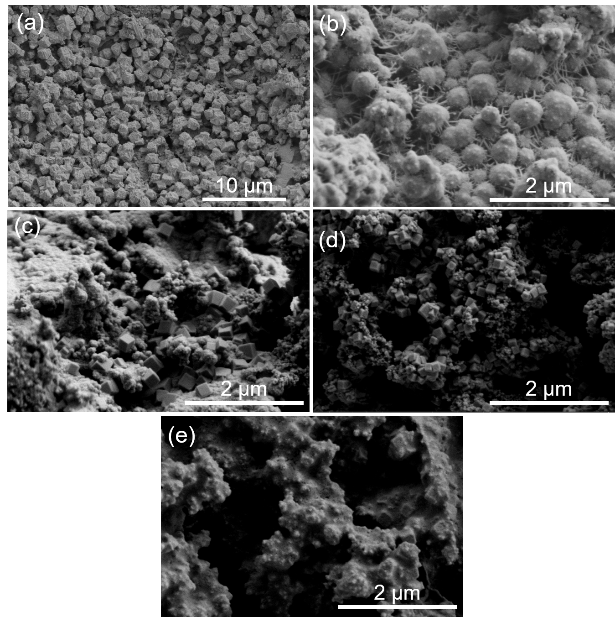
Figure S1. The SEM images of (a) pristine Cu, (b) pristine Pd, (c) Pd_{0.60}Cu_{0.40}, (d) Pd_{0.73}Cu_{0.27}, and (e) Pd_{0.78}Cu_{0.22} electrodes.

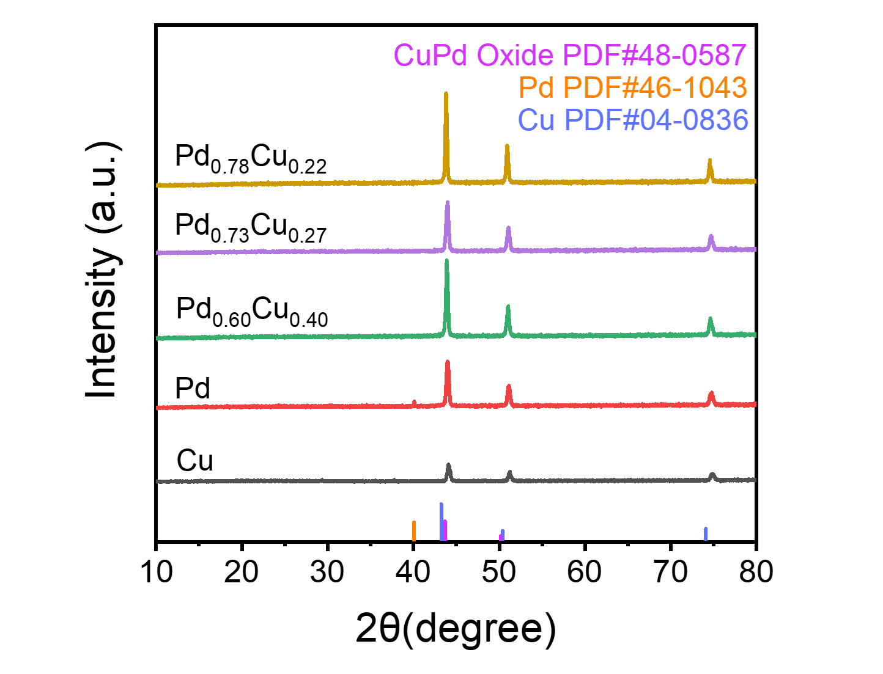
Figure S2. The XRD spectra of pristine Cu, pristine Pd, Pd_{0.60}Cu_{0.40}, Pd_{0.73}Cu_{0.27}, and Pd_{0.78}Cu_{0.22} electrodes.

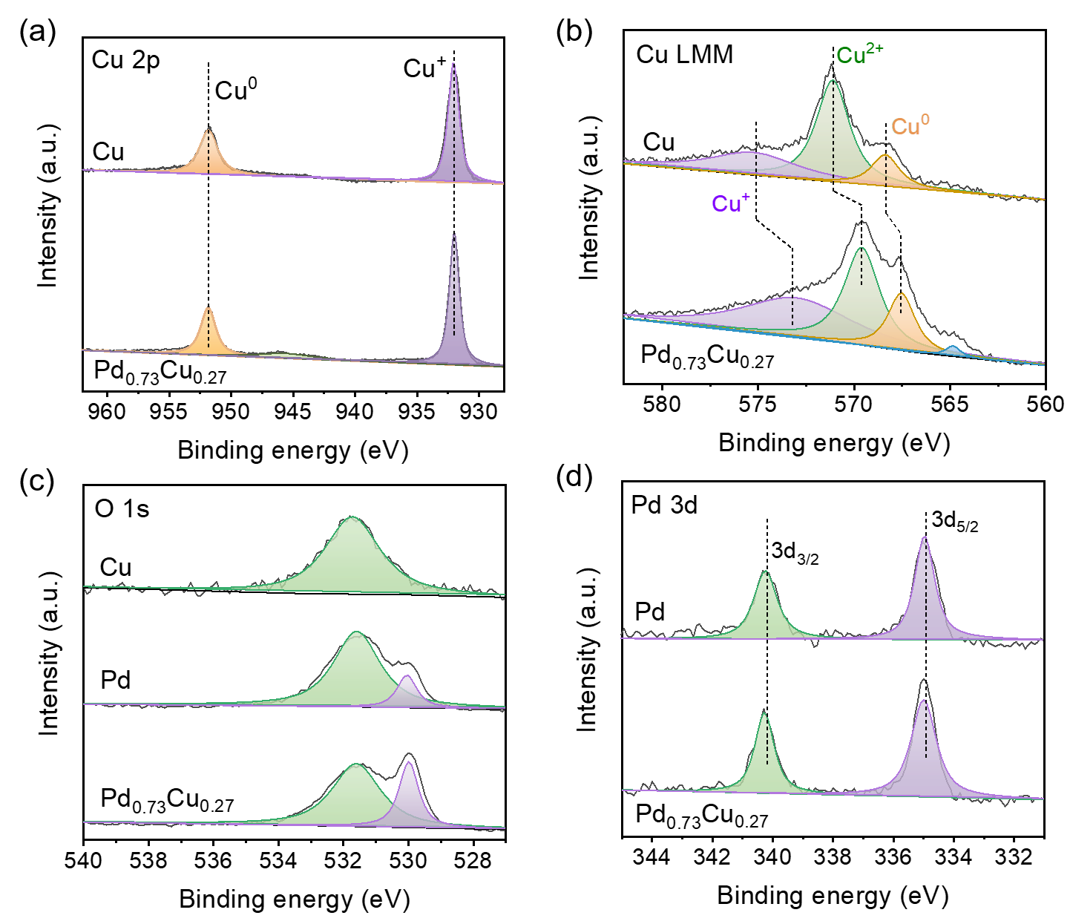
Figure S3. The XPS spectra (a) Cu 2p, (b) Cu LMM, (c) O 1s, and (d) Pd 3d of pristine Cu, pristine Pd, Pd_{0.73}Cu_{0.27} oxide electrodes.
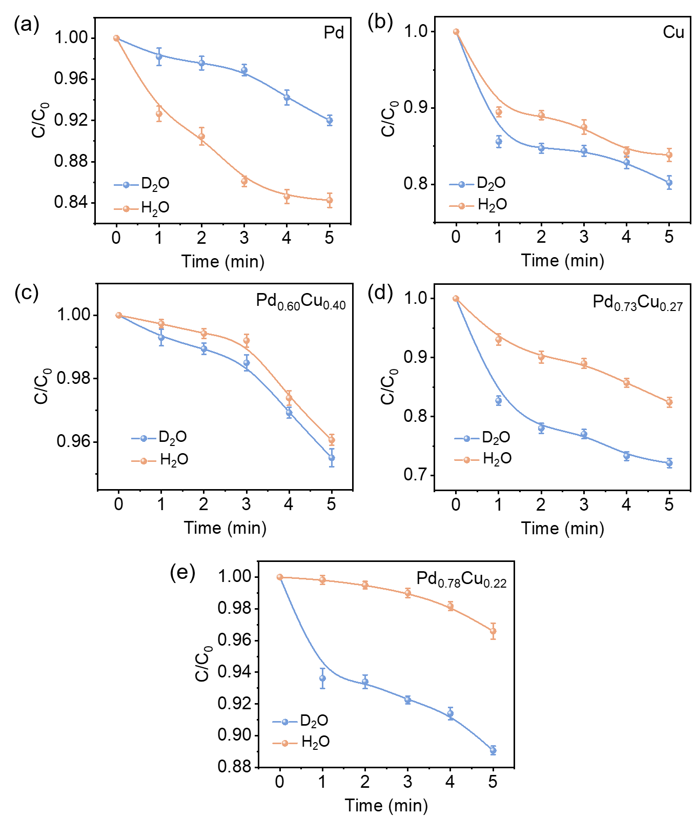
Figure S4. Kinetic characteristics and corresponding KIE values of (a) pristine Pd, (b) pristine Cu, (c) Pd_{0.60}Cu_{0.40}, (d) Pd_{0.73}Cu_{0.27}, and (e) Pd_{0.78}Cu_{0.22} with FF as substrate at -0.46 V vs. RHE (Reaction conditions: 10 mM FF, 1.0 M·boric acid aqueous solution containing 20% acetonitrile as electrolyte, pH=9.2).
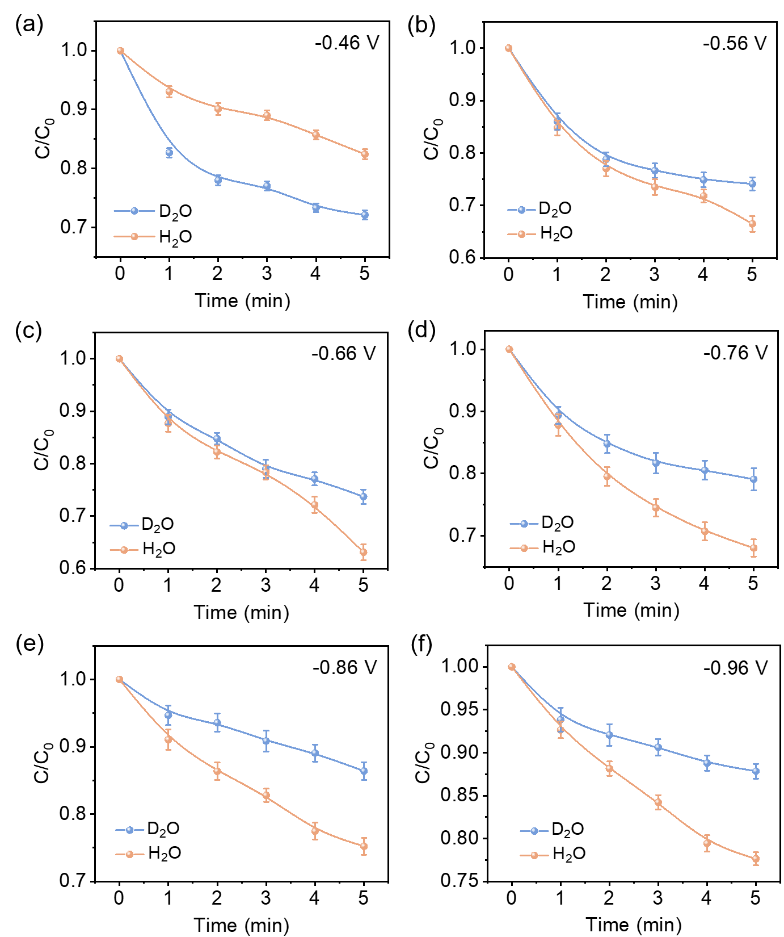
Figure S5. Kinetic characteristics and corresponding KIE values of Pd_{0.73}Cu_{0.27} with FF as substrate at (a) 0.46 V vs. RHE, (b) 0.56 V vs. RHE, (c) 0.66 V vs. RHE, (d) 0.76 V vs. RHE, (e) 0.86 V vs. RHE, and (f) 0.96 V vs. RHE voltages (Reaction conditions: 1.0 M·boric acid aqueous solution containing 20% acetonitrile as electrolyte, pH=9.2).
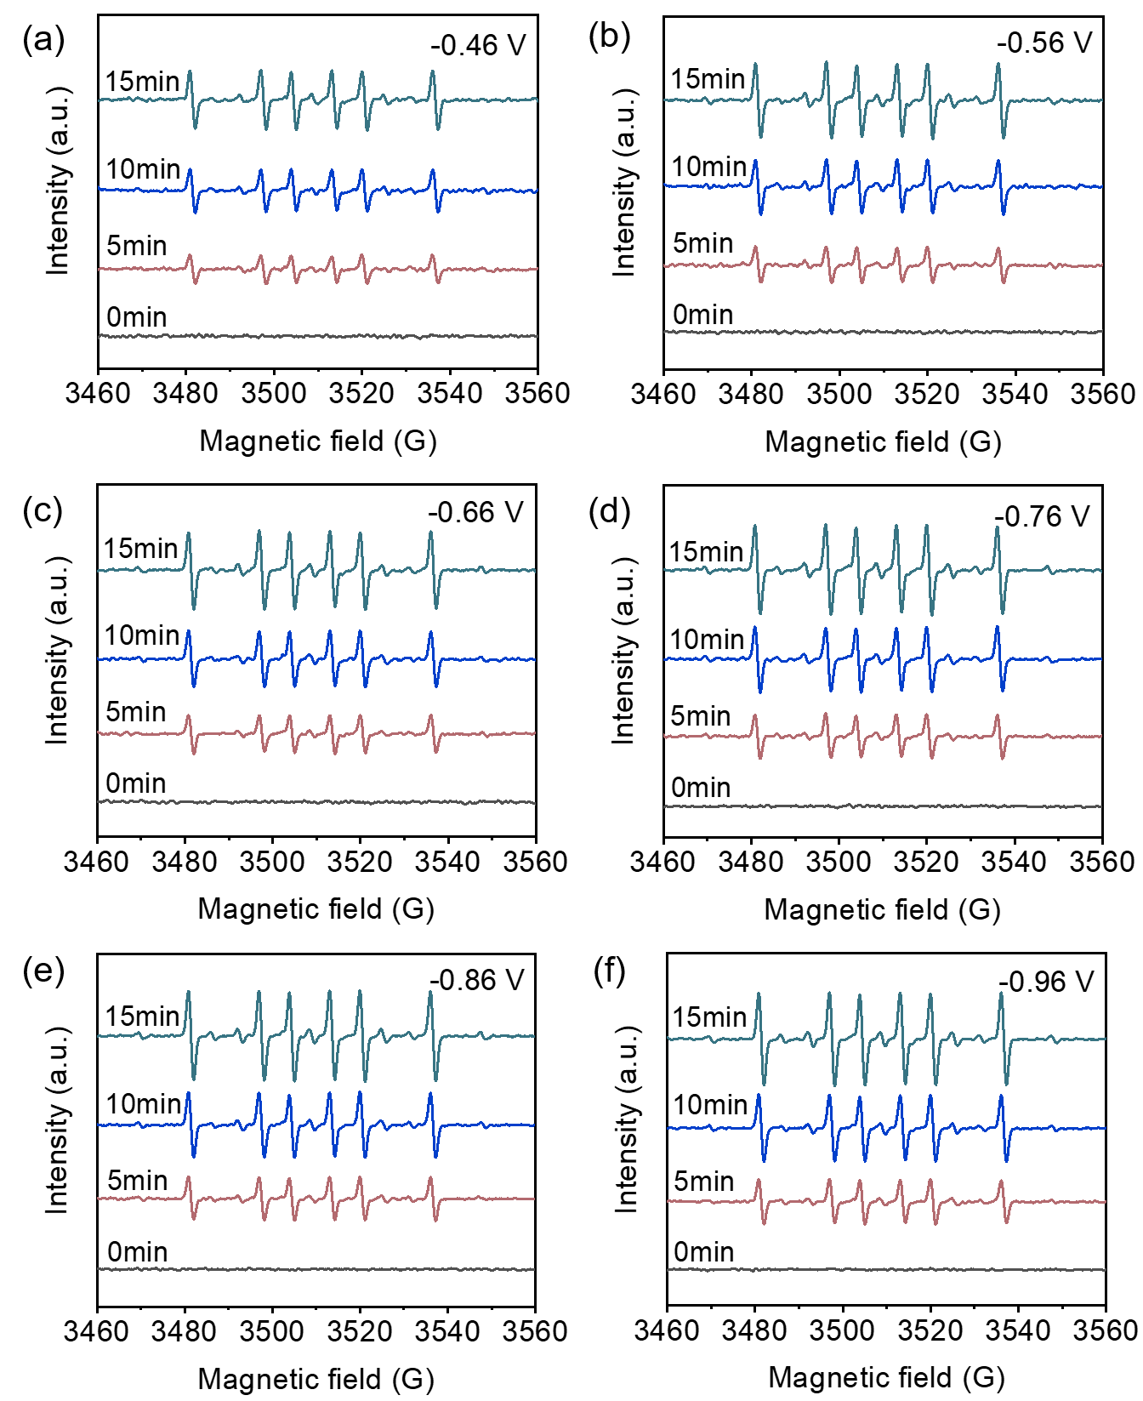
Figure S6. ESR spectra observing DMPO-C* signature after 15 min of FF hydrogenation reaction on Pd_{0.73}Cu_{0.27} electrode with applied voltage (a) 0.46 V vs. RHE, (b) 0.56 V vs. RHE, (c) 0.66 V vs. RHE, (d) 0.76 V vs. RHE, (e) 0.86 V vs. RHE, and (f) 0.96 V vs. RHE (pH =9.2).
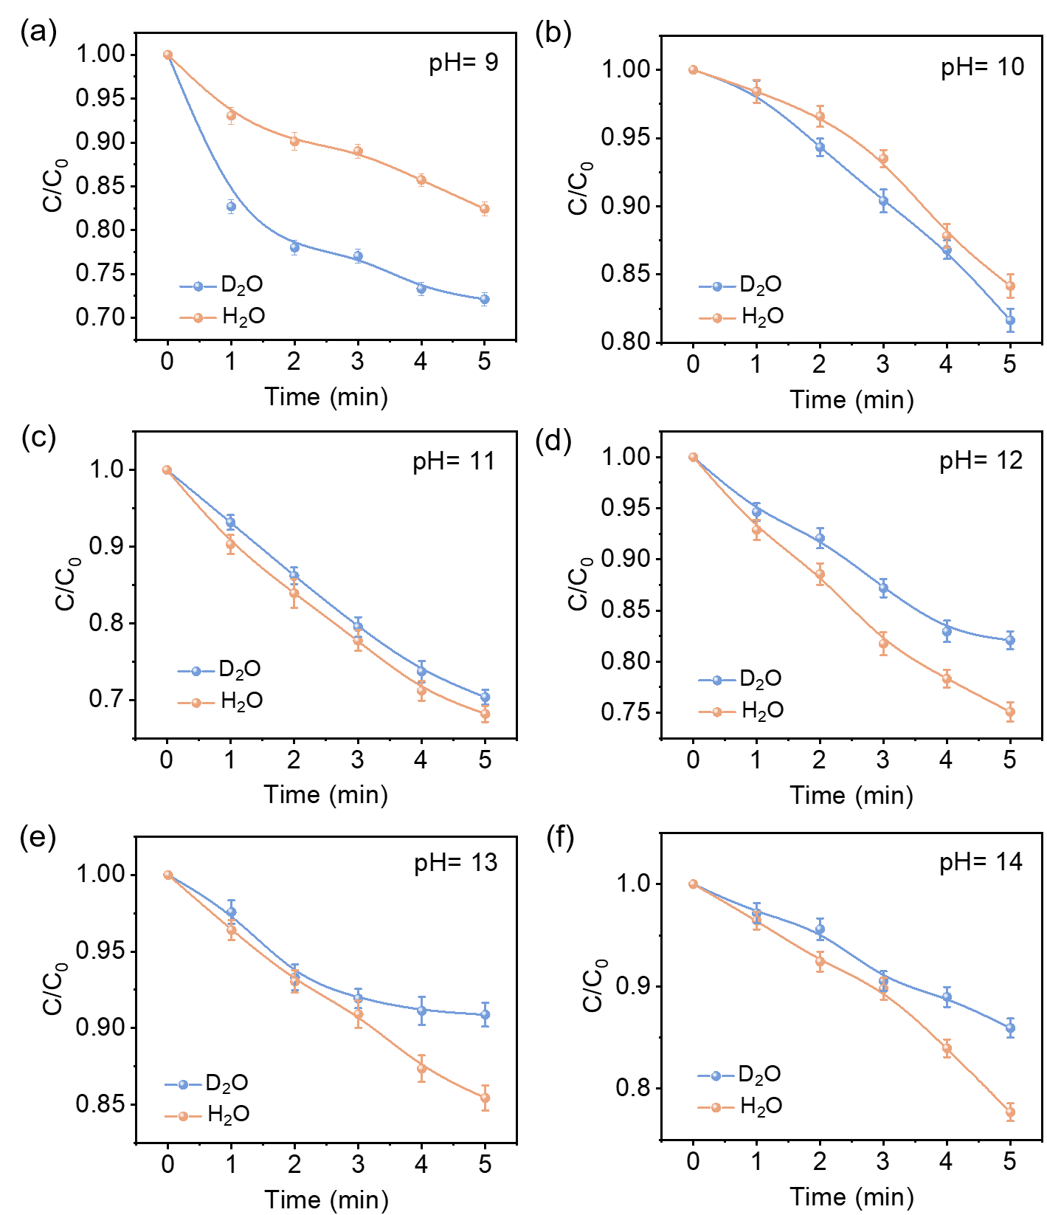
Figure S7. Kinetic characteristics and corresponding KIE values of Pd_{0.73}Cu_{0.27} catalyst with FF as substrate in (a) pH=9, (b) pH=10, (c) pH=11, (d) pH=12, (e) pH=13, and (f) pH=14 electrolytes (Reaction conditions: 0.46 V vs. RHE, 1.0 M·boric acid aqueous solution containing 20% acetonitrile as electrolyte).
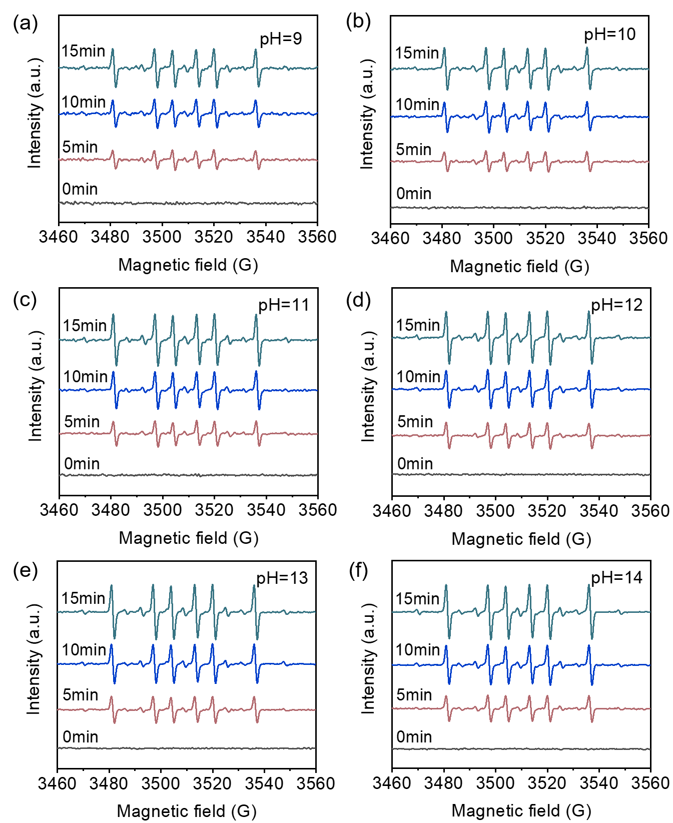
Figure S8. ESR spectra observing DMPO-C* signature after 15 min of FF hydrogenation reaction on Pd_{0.73}Cu_{0.27} electrode within (a) pH=9, (b) pH=10, (c) pH=11, (d) pH=12, (e) pH=13, and (f) pH=14 electrolytes (applied voltage of -0.46 V vs. RHE).
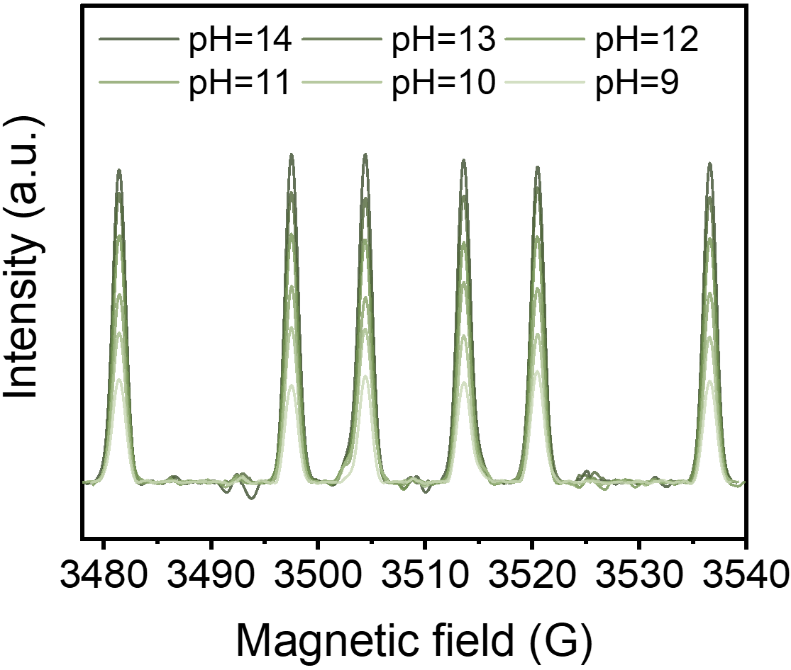
Figure S9. Integral fitting of ESR spectra (DMPO-C*) of Pd_{0.73}Cu_{0.27} at different pH (applied voltage of -0.46 V vs. RHE).

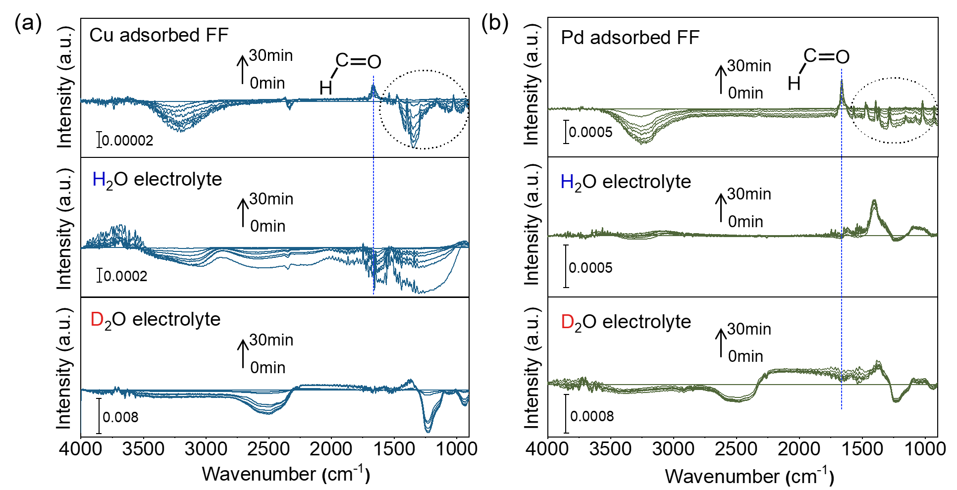
Figure S10. ATR-FTIR spectra in-situ monitored the adsorption FF and the FF to FA hydrogenation on (a) pristine Cu and (b) Pd interface in H₂O/D₂O electrolyte in 30 min.
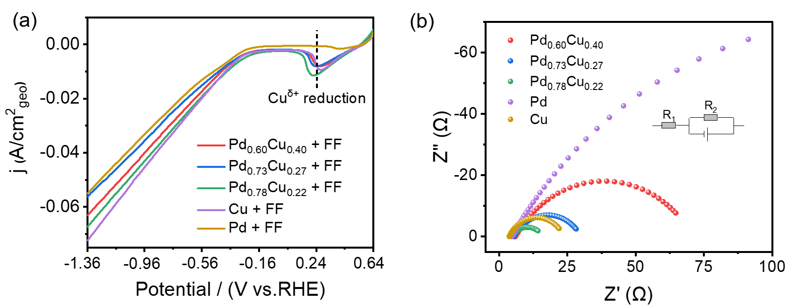
Figure S11. (a) Linear sweep voltammetry (LSV) curves of Pd-Cu electrodes in the electrolyte containing 10 mM FF (1.0 M·boric acid aqueous solution containing 20% acetonitrile as the electrolyte, pH=9.2), (b) Nyquist plots for Pd-Cu electrodes.

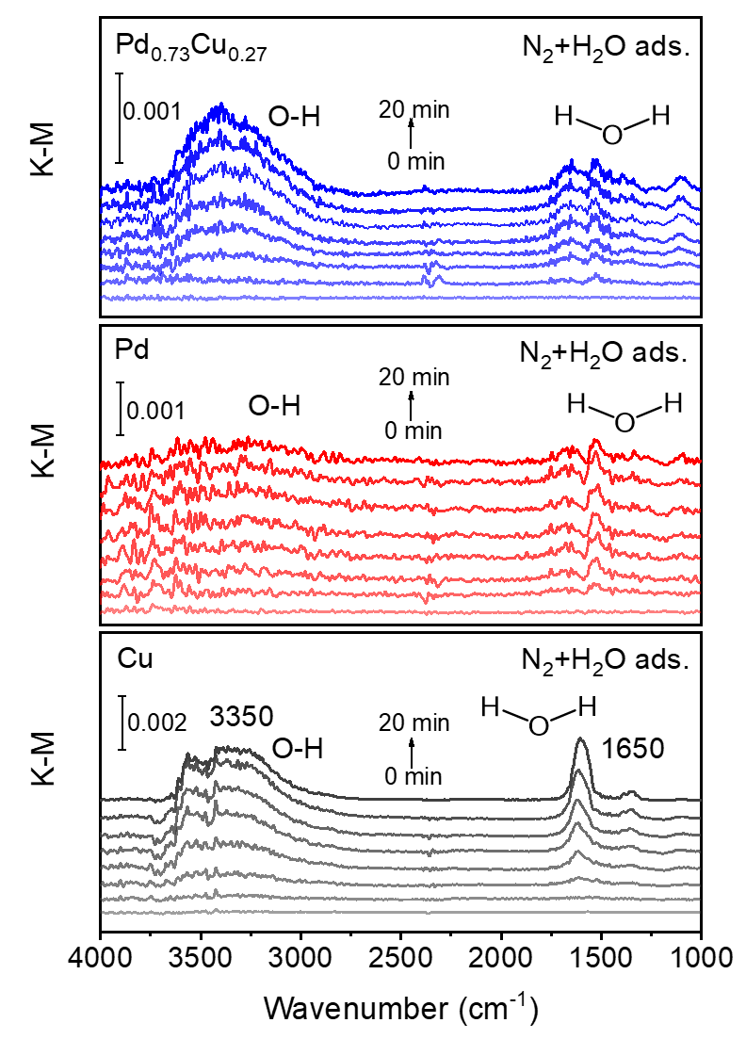
Figure S12. In-situ infrared image of the water after vapor adsorption under Pd_{0.73}Cu_{0.27} oxide, pristine Pd, and Cu interface.

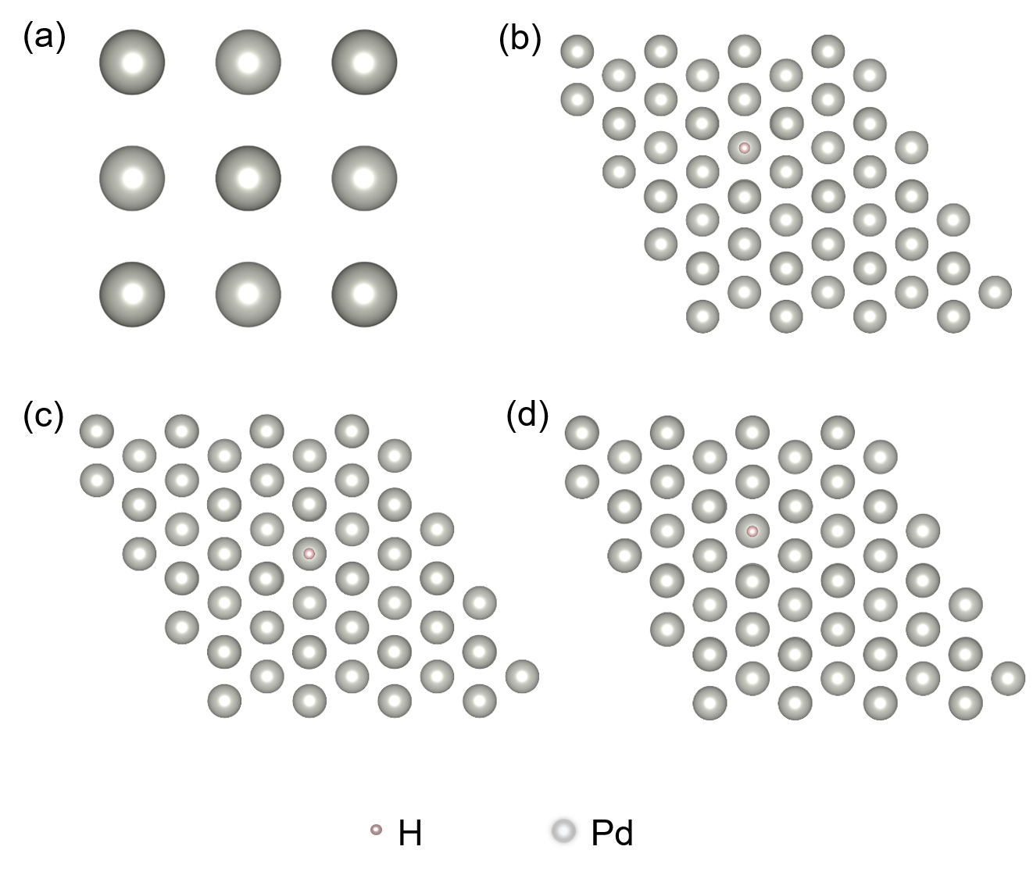
Figure S13. (a) Theoretical calculation model of pristine Pd; Schematic diagram of H adsorption on (b) Pd-Pd bridge site, (c) Pd-Pd-Pd hollow site, and (d) Pd top site.

Supplementary Tables

Table S1. The proportion of metal elements of Pd_{0.60}Cu_{0.40}, Pd_{0.73}Cu_{0.27}, and Pd_{0.78}Cu_{0.22}.
Catalyst | Theoretical value (mg/L) |  | ICP measurement value (mg/L)
Catalyst | Pd | Cu | Pd |  | Cu
Pd_{0.60}Cu_{0.40} | 0.71 | 0.47 |  | 0.5962 | 0.3951
Pd_{0.73}Cu_{0.27} | 0.89 | 0.33 |  | 0.7305 | 0.2691
Pd_{0.78}Cu_{0.22} | 1.06 | 0.30 |  | 0.7843 | 0.2157

Table S2. EXAFS fitting parameters at the Pd K-edge for pristine Pd and Pd_{0.73}Cu_{0.27} (Ѕ02=0.75 from Pd).
Catalyst | shell | CN^{[a]} | R^{[b]} (Å) | σ^{2[c]} (Å²) | ΔE₀^{[d]} (eV) | R factor^{[e]}
Pd | Pd-Pd | 12.00 | 2.73±0.03 | 0.0049 | 6.8±0.4 | 0.003
Pd_{0.73}Cu_{0.27} | Pd-O | 1.7±0.7 | 2.11±0.09 | 0.0017 | 8.4±1.2 | 0.02
Pd_{0.73}Cu_{0.27} | Pd-Cu | 2.9±0.7 | 3.02±0.05 | 0.0022 | 8.4±1.2 | 0.02
Pd_{0.73}Cu_{0.27} | Cu-O | 2.4±0.2 | 1.73±0.02 | 0.0016 | 2.9±0.2 | 0.018
[a] CN: coordination numbers; [b] R: bond distance; [c] σ²: Debye-Waller factors; [d] ΔE₀: the inner potential correction. [e] R factor: goodness of fit. Error bounds that characterize the structural parameters obtained by EXAFS spectroscopy were estimated as CN±20%; R ± 1%; σ² ± 20%.

References
1 Kresse, G. & Joubert, D. From ultrasoft pseudopotentials to the projector augmented-wave method. Physical Review B 59, 1758, dio: https://doi.org/10.1103/PhysRevB.59.1758 (1999).
2 Perdew, J. P. Burke, K. & Ernzerhof, M. Generalized Gradient Approximation Made Simple. Physical Review Letters 77, 3865-3868, dio:10.1103/physrevlett.77.3865 (1996).
3 Grimme, S. et al. A consistent and accurate ab initio parametrization of density functional dispersion correction (DFT-D) for the 94 elements H-Pu. The Journal of Chemical Physics 132, 154104, dio:10.1063/1.3382344 (2010).
4 Chadi, D. J. Special points for Brillouin-zone integrations. Physical Review B 16, 1746, dio:https://doi.org/10.1103/PhysRevB.16.1746 (1977).

