Pantropical and continental stand-level biomass equations

Supplementary file 1 – Forest structure of the 65000 simulated plots.

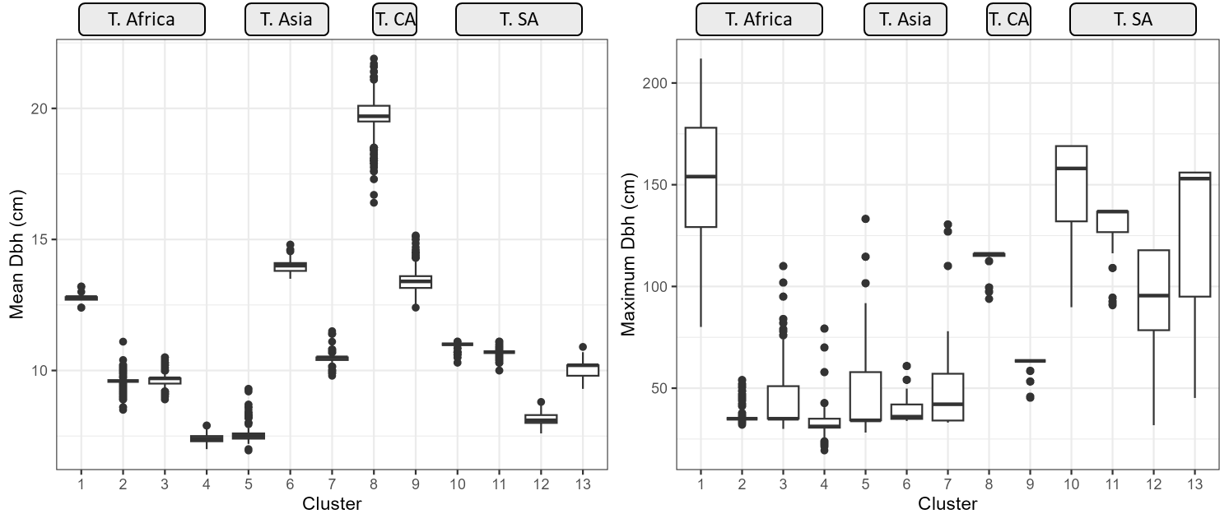
Fig. 1S. Box plots for the mean and maximum diameters at breast height of the trees in the 5000 forests simulated for each cluster. T. is Tropical. CA is Central America. SA is South America.
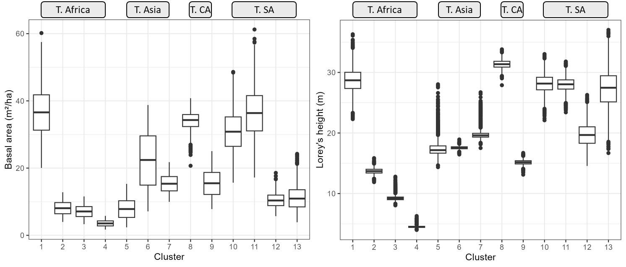
Fig. 2S. Box plots for the basal area and Lorey’s height of the 5000 forests simulated for each cluster. T. is Tropical. CA is Central America. SA is South America.
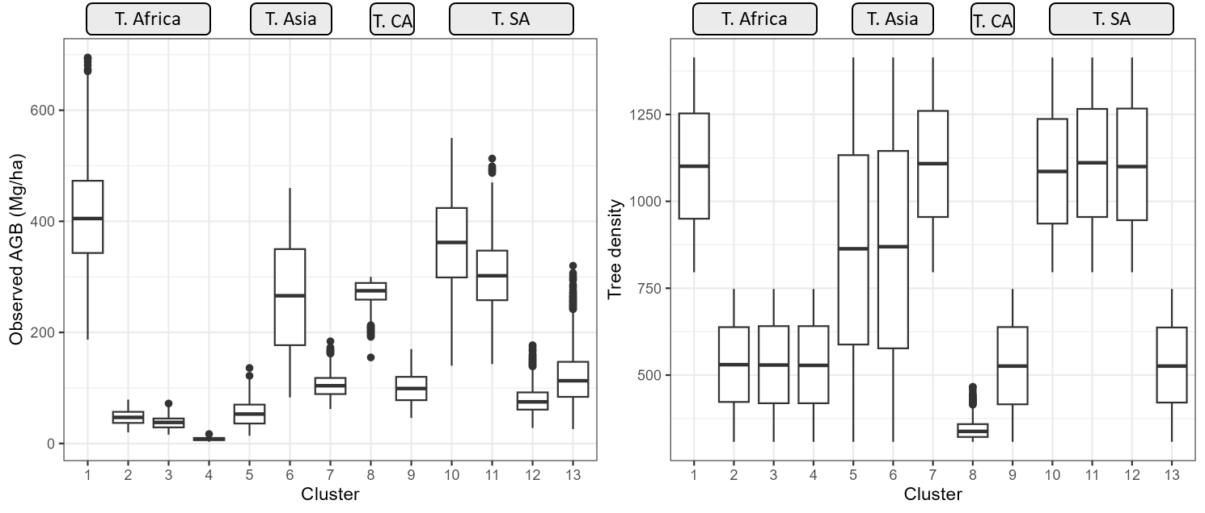
Fig. 3S. Box plots for the observed aboveground biomass and tree density (trees ha⁻¹) of the 5000 forests simulated for each cluster. T. is Tropical. CA is Central America. SA is South America.
Table 1S. Forest type and structure, and climatic conditions of the clusters.
Cluster | Level | Forest type | Tree height class (m)
1 | 5 | Moist forest | <10 m; ≥20 m
2 | 4 | Dry forest | <10 m; 10–20 m
3 | 3 | Dry forest | <10 m
4 | 1 | Dry forest | <10 m
5 | 6 | Dry forest; Moist forest | <10 m; 10–20 m
6 | 6 | Dry forest; Wet forest | <10 m; 10–20 m
7 | 5 | Wet forest | <10 m; 10–20 m; ≥20 m
8 | 6 | Dry forest; Moist forest; Wet forest | <10 m; 10–20 m; ≥20 m
9 | 4 | Dry forest | <10 m; 10–20 m
10 | 5 | Moist forest | <10 m; 10–20 m; ≥20 m
11 | 5 | Wet forest | <10 m; ≥20 m
12 | 1 | Moist forest | ≥20 m
13 | 5 | Dry forest | <10 m; ≥20 m

Table 2S. Spearman’s correlation (n=5000 per cluster) for stand attributes of the simulated plots.
Cluster |  | Mean Dbh | Max. Dbh | Stand AGB | Basal area | Tree density | Lorey’s height
1 | Mean Dbh | 1.00
1 | Max. Dbh | 0.03 | 1.00
1 | Stand AGB | 0.11 | 0.45 | 1.00
1 | Basal area | 0.12 | 0.39 | 0.94 | 1.00
1 | Tree density | 0.03 | 0.13 | 0.74 | 0.87 | 1.00
1 | Lorey’s height | 0.04 | 0.68 | 0.58 | 0.44 | 0.01 | 1.00
2 | Mean Dbh | 1.00
2 | Max. Dbh | 0.05 | 1.00
2 | Stand AGB | 0.09 | 0.21 | 1.00
2 | Basal area | 0.08 | 0.20 | 0.99 | 1.00
2 | Tree density | -0.01 | 0.17 | 0.95 | 0.97 | 1.00
2 | Lorey’s height | 0.12 | 0.20 | 0.24 | 0.15 | 0.03 | 1.00
3 | Mean Dbh | 1.00
3 | Max. Dbh | 0.01 | 1.00
3 | Stand AGB | 0.11 | 0.38 | 1.00
3 | Basal area | 0.11 | 0.30 | 0.99 | 1.00
3 | Tree density | 0.00 | 0.20 | 0.94 | 0.97 | 1.00
3 | Lorey’s height | 0.14 | 0.61 | 0.31 | 0.21 | 0.04 | 1.00
4 | Mean Dbh | 1.00
4 | Max. Dbh | 0.01 | 1.00
4 | Stand AGB | 0.10 | 0.32 | 1.00
4 | Basal area | 0.09 | 0.29 | 0.98 | 1.00
4 | Tree density | 0.01 | 0.22 | 0.94 | 0.98 | 1.00
4 | Lorey’s height | 0.14 | 0.42 | 0.30 | 0.22 | 0.06 | 1.00
5 | Mean Dbh | 1.00
5 | Max. Dbh | 0.04 | 1.00
5 | Stand AGB | 0.08 | 0.46 | 1.00
5 | Basal area | 0.07 | 0.39 | 0.99 | 1.00
5 | Tree density | 0.02 | 0.32 | 0.97 | 0.99 | 1.00
5 | Lorey’s height | 0.12 | 0.72 | 0.31 | 0.21 | 0.10 | 1.00
6 | Mean Dbh | 1.00
6 | Max. Dbh | 0.03 | 1.00
6 | Stand AGB | 0.03 | 0.33 | 1.00
6 | Basal area | 0.03 | 0.33 | 1.00 | 1.00
6 | Tree density | -0.01 | 0.32 | 1.00 | 1.00 | 1.00
6 | Lorey’s height | 0.22 | 0.14 | 0.04 | 0.03 | -0.01 | 1.00
7 | Mean Dbh | 1.00
7 | Max. Dbh | -0.01 | 1.00
7 | Stand AGB | 0.11 | 0.30 | 1.00
7 | Basal area | 0.11 | 0.22 | 0.96 | 1.00
7 | Tree density | 0.01 | 0.12 | 0.90 | 0.97 | 1.00
7 | Lorey’s height | 0.12 | 0.54 | 0.36 | 0.22 | 0.03 | 1.00
8 | Mean Dbh | 1.00
8 | Max. Dbh | -0.03 | 1.00
8 | Stand AGB | 0.22 | 0.20 | 1.00
8 | Basal area | 0.24 | 0.03 | 0.91 | 1.00
8 | Tree density | -0.18 | -0.07 | 0.39 | 0.49 | 1.00
8 | Lorey’s height | 0.02 | 0.19 | 0.37 | 0.18 | -0.37 | 1.00
9 | Mean Dbh | 1.00
9 | Max. Dbh | 0.01 | 1.00
9 | Stand AGB | 0.11 | 0.30 | 1.00
9 | Basal area | 0.11 | 0.27 | 0.99 | 1.00
9 | Tree density | -0.01 | 0.22 | 0.96 | 0.97 | 1.00
9 | Lorey’s height | 0.13 | 0.27 | 0.24 | 0.15 | 0.01 | 1.00
10 | Mean Dbh | 1.00
10 | Max. Dbh | 0.03 | 1.00
10 | Stand AGB | 0.07 | 0.37 | 1.00
10 | Basal area | 0.08 | 0.36 | 0.88 | 1.00
10 | Tree density | 0.05 | 0.13 | 0.60 | 0.80 | 1.00
10 | Lorey’s height | 0.02 | 0.49 | 0.62 | 0.42 | -0.07 | 1.00
11 | Mean Dbh | 1.00
11 | Max. Dbh | -0.01 | 1.00
11 | Stand AGB | 0.11 | 0.25 | 1.00
11 | Basal area | 0.10 | 0.29 | 0.98 | 1.00
11 | Tree density | 0.01 | 0.12 | 0.82 | 0.85 | 1.00
11 | Lorey’s height | 0.05 | 0.32 | 0.43 | 0.41 | 0.01 | 1.00
12 | Mean Dbh | 1.00
12 | Max. Dbh | 0.03 | 1.00
12 | Stand AGB | 0.11 | 0.52 | 1.00
12 | Basal area | 0.12 | 0.48 | 0.86 | 1.00
12 | Tree density | 0.03 | 0.15 | 0.57 | 0.85 | 1.00
12 | Lorey’s height | 0.07 | 0.74 | 0.76 | 0.51 | 0.03 | 1.00
13 | Mean Dbh | 1.00
13 | Max. Dbh | 0.04 | 1.00
13 | Stand AGB | 0.10 | 0.65 | 1.00
13 | Basal area | 0.11 | 0.56 | 0.97 | 1.00
13 | Tree density | 0.03 | 0.20 | 0.64 | 0.78 | 1.00
13 | Lorey’s height | 0.04 | 0.75 | 0.72 | 0.58 | 0.04 | 1.00

Table 3S. Parameter estimates of Models 1–6 for all continents and the pantropical zone.
With Lorey’s height
Continent | Model | $${\hat{β}}_{0}$$ | $${\hat{β}}_{1}$$ | $${\hat{β}}_{2}$$ | $${\hat{β}}_{3}$$ | $${\hat{β}}_{4}$$ | m₇₀
Africa | 1 | 6.1493 | 1.9628 | -1.0098 | 0.1233 | -0.1048 | 14000
Asia | 1 | 8.0522 | 1.5683 | -0.6318 | -1.3196 | 0.1869 | 10500
Central America | 1 | -0.2865 | 0.8354 | 0.1635 | 0.5951 | -0.0125 | 7000
South America | 1 | -4.4710 | 0.7020 | 0.2803 | 1.5340 | 0.1440 | 14000
Pantropical zone | 1 | -0.3066 | 1.0361 | 0.0740 | 0.7618 | -0.1154 | 45500
Africa | 2 | 5.0647 | 1.7699 | -0.8787 | 0.2273 | - | 14000
Asia | 2 | 7.3876 | 1.5519 | -0.6076 | -0.8902 | - | 10500
Central America | 2 | -0.3092 | 0.8348 | 0.1635 | 0.5851 | - | 7000
South America | 2 | -4.9777 | 0.6672 | 0.3340 | 1.8233 | - | 14000
Pantropical zone | 2 | -0.5257 | 1.0166 | 0.0762 | 0.6808 | - | 45500
Africa | 3 | -0.3622 | 1.0021 | - | 0.8319 | - | 14000
Asia | 3 | 5.4807 | 1.3004 | - | -1.4309 | - | 10500
Central America | 3 | 1.0087 | 0.9884 | - | 0.3225 | - | 7000
South America | 3 | -1.1944 | 0.9073 | - | 1.1394 | - | 14000
Pantropical zone | 3 | -0.0616 | 1.0451 | - | 0.6671 | - | 45500
Without Lorey’s height
Africa | 4 | 7.1431 | 2.1186 | -1.1618 | - | -0.1201 | 14000
Asia | 4 | 5.0864 | 1.5483 | -0.6608 | - | 0.0235 | 10500
Central America | 4 | 1.3189 | 1.0715 | -0.0846 | - | 0.2109 | 7000
South America | 4 | 0.9991 | 1.0550 | -0.1850 | - | 0.4821 | 14000
Pantropical zone | 4 | 0.3553 | 1.3199 | 0.0187 | - | 0.1549 | 45500
Africa | 5 | 6.8228 | 2.0385 | -1.1583 | - | - | 14000
Asia | 5 | 5.1392 | 1.5465 | -0.6549 | - | - | 10500
Central America | 5 | 2.5109 | 1.1810 | -0.1836 | - | - | 7000
South America | 5 | 4.1527 | 1.2463 | -0.3897 | - | - | 14000
Pantropical zone | 5 | 0.8729 | 1.4087 | 0.0042 | - | - | 45500
Africa | 6 | 0.3847 | 1.5803 | - | - | - | 14000
Asia | 6 | 1.4371 | 1.2584 | - | - | - | 10500
Central America | 6 | 1.2658 | 1.2249 | - | - | - | 7000
South America | 6 | 1.9189 | 1.1038 | - | - | - | 14000
Pantropical zone | 6 | 0.8972 | 1.4099 | - | - | - | 45500

