Supplementary Fig.
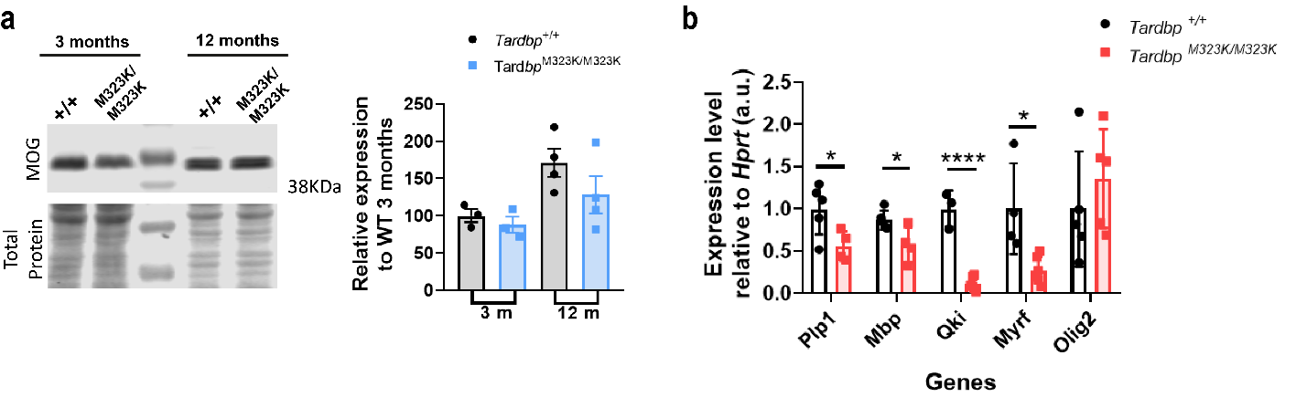
Supplementary Fig. 1. (a) Western blot analysis of MOG protein levels in frontal cortex samples at 3 and 12 months of age, with quantification relative to wild-type (WT) at 3 months. (b) Relative expression of myelin- and oligodendrocyte-related genes (Plp1, Mbp, Qki, Myrf, Olig2) normalized to Hprt in frontal cortex samples from Tardbp^{+/+} and Tardbp^{M323K/M323K} mice. Experimental N per group: 3-5 Tardbp^{+/+} and 3-5 Tardbp^{M323K/M323K}. Data are presented as mean ± SEM. *p < 0.05, ****p < 0.0001.

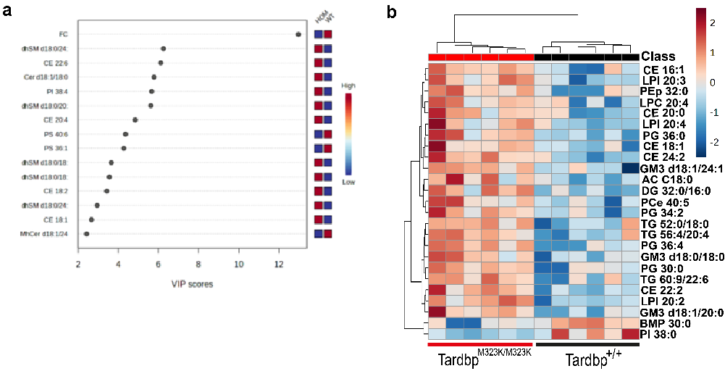
Supplementary Fig. 2. (a) Vip score (b)Heatmap representation of hierarchical clustering of individual samples according to the top 25 statistically significantly different lipid species.
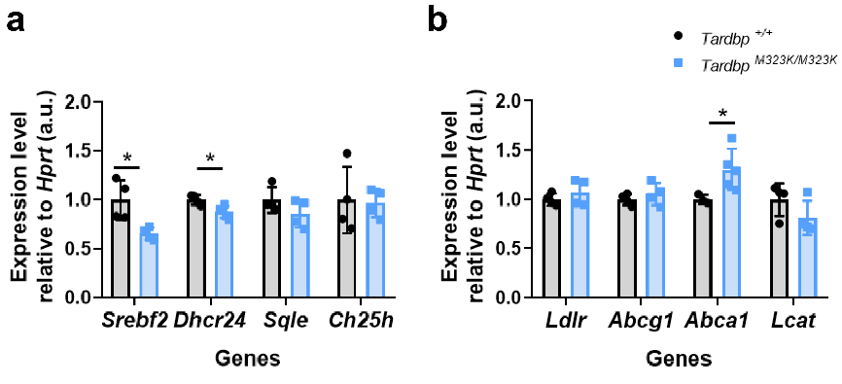
Supplementary Fig. 3. (a) Relative expression of cholesterol synthesis (Srebf2, Dhcr24, Sqle, Ch25h) and (b) cholesterol transport (Ldlr, Abcg1, Abca1, Lcat) normalized to Hprt in frontal cortex samples from Tardbp^{+/+} and Tardbp^{M323K/M323K} mice. Experimental N per group: 4-5 Tardbp^{+/+} and 3-5 Tardbp^{M323K/M323K}. Data are presented as mean ± SEM. *p < 0.05.

