Supplementary Information

Multiscale heterogeneity in gastric adenocarcinoma evolution is an obstacle to precision medicine
Short title: Multiscale heterogeneity in gastric cancer

Christoph Röcken¹, Anu Amallraja², Christine Halske¹,
Luka Opasic³, Arne Traulsen³, Hans-Michael Behrens¹, Sandra Krüger¹, Anne Liu¹,
Jochen Haag¹, Jan-Hendrik Egberts⁴, Philip Rosenstiel⁴, Tobias Meißner²
¹Dept. of Pathology, University Hospital Schleswig-Holstein (UKSH), Campus Kiel, Germany
²Dept. of Molecular and Experimental Medicine, Avera Cancer Institute, Sioux Falls, USA
³Dept. of Evolutionary Theory, Max Planck Institute for Evolutionary Biology,
Plön, Germany
⁴Dept. of General Surgery, Visceral, Thoracic, Transplantation and Pediatric Surgery, University Hospital Schleswig-Holstein (UKSH), Campus Kiel, Germany
⁴Institute for Clinical Molecular Biology, Christian-Albrechts-University, 24105 Kiel, Germany

Supplemental Results
Sequencing data of the discovery cohort
The median sequencing coverage of the discovery cohort was 163x for tumor samples and 170x for non-neoplastic mucosa (Suppl. Table 3). Median tumor purity (computationally assessed by Sequenza) was 33% (12%-98%) (Suppl. Table 7). Raw sequencing data were deposited at the European Genome Archive (EGAS00001004525). The results of the whole exome sequencing of the discovery cohort are summarized in Suppl. Table 4-9.

Validation analyses using Sanger sequencing, pyrosequencing and ddPCR™
Single nucleotide variations (SNV) detected by whole exome sequencing were validated independently in the test cohort using Sanger sequencing, pyrosequencing or ddPCR™ (Suppl. Table 2).
In total, 179 analyses were done and SNVs of the following genes could be validated independently: AKT1 (5 of 5 tissue samples), BRCA1 (5 of 9), BRCA2 (5 of 5), CDH1 (10 of 10), CTNNB1 (6 of 6), FLT4 (6 of 6), IKBKB (11 of 11), IKZF3 (4 of 4), KRAS (5 of 5), LRP1B (12 of 12), MAP2K4 (5 of 5), MCM8 (6 of 6), MLH1 (4 of 4), MUTYH (5 of 5), PAX5 (5 of 5), PIK3CA (4 of 5), POLE (4 of 5), RNF43 (4 of 4), SMAD4 (26 of 26), and TP53 (8 of 9)(Suppl. Table 2). The SNVs of the following genes could not be validated either due to inability of designing an appropriate assay or due to an allele frequency below detection limit: ARID1A, ARID1B, ASXL3, CLOCK, PRRC2A and TP53BP1 (Suppl. Table 2).

Somatic signatures
We analyzed the observed somatic signatures in their 5’ and 3’ base context thus resulting in 96 possible mutation types (52). Based on the exome data, we retrieved the individual mutational signature from each tumor sample in relation to the non-tumorous tissue. We found that the somatic signatures of GCs were consistent with previous reports: signature 1 was found in 48 tumor samples (100%), signature 15 in 48 (100%), signature 18 in 29 (60.4%), signature 10 in 3 (6.3%) and signature 29 in 2 samples (4.2%) (52).

Comparison with published sequencing data
We compared our non-synonymous mutations with published data (Suppl. Table 10). Previously reported prevalent non-synonymous mutations were also present in our cohort, albeit with deviations regarding their individual prevalence (3,5,7,53), which is probably due to patient selection as well as the number of samples analyzed per patient. Mutations found in 6 (67%) patients of our series affected LRP1B; in 5 (56%) patients TP53; in 4 (44%) patients CDKN2A, KMT2D and RNF43; in 3 (33%) patients ABCA10, ARID1B, BCL2, BNC2, MACF1; MYC, NRG1, PTEN and SMAD4; and in 2 (22%) patients BIRC6, CCNE1, CTNNB1, ELF3, ERBB2, FAM135B, GPC5, KMT2C, MLH1, MTOR, NF1, PIK3CA, POLE, RIMS2, ROS1, SMARCA4 and TGFBR2 (Suppl. Table 10). A total of 131 genes (0.03% of all affected genes) showed homogeneously distributed non-synonymous mutations in ≥2 patients (Suppl. Table 11).

SMAD4 expression in the validation cohort
SMAD4 expression was studied using whole tissue sections and a validation cohort of 487 GCs. The clinicopathological patient characteristics are summarized in Table 2.
Weak nuclear immunostaining of tumor cells was found in 430 (88.3%), a moderate in 382 (78.4%) and a strong in 84 (17.2%) GCs. Immunonegative tumor cells were found in 279 GCs (57.3%) cases. Weak cytoplasmic immunostaining of tumor cells was found in 450 (92.4%), a moderate in 307 (63.0%) and a strong in 34 (7.0%) GCs. A complete loss of cytoplasmic immunostaining of tumor cells was found in 255 GCs (52.4%). The percentage area of the four immunostaining categories ranged from 0 to 100% for both, nuclear and cytoplasmic SMAD4 expression, and the combination of the staining categories in each individual case varied. The median HScore was 115 (range 0-300) for nuclear and 100 (range 0-245) for cytoplasmic SMAD4 expression. 22 (4.5%) GCs were completely devoid of any nuclear and 27 (5.5%) for cytoplasmic SMAD4 expression. Nuclear and cytoplasmic immunostaining correlated highly significantly with each other (Pearson's correlation coefficient; p<0.001; data not shown). The expression of SMAD4 was heterogeneous including “grey-scale” as well as “black-and-white”-immunostaining patterns (Figure 5E). The latter showed areas of complete loss of SMAD4 expression clearly demarcated from areas with retained SMAD4 expression (see Figure 5E). A black-and-white expression pattern was found in 181 (37.2%) GCs for nuclear immunostaining and in 170 (34.9%) GCs for cytoplasmic immunostaining.
To explore the putative biological significance of SMAD4 in GC we correlated its expression pattern with various clinicopathological patient characteristics. However, in view of a heterogeneous expression and since we did not know a priori, which “cut off” value, i.e. degree of decreased SMDA4-expression and/or percentage area of SMAD4-loss might be biological relevant we applied a stepwise explorative approach using patient survival as surrogate marker for biological significance: In the first step (Suppl. Figure 3A & 3B; step 1) we dichotomized the cohort at the median HScores, i.e. 100 (for cytoplasmic) and 115 (for nuclear), in step 2 we used the quartile ranges (Q1 to Q4), in step 3 we grouped the quartile ranges (Q1-3 vs. Q4) and finally we explored any absence of SMAD4 expression (IHC=0 vs. IHC>0; step 4) irrespective of the percentage area. We used the log-rank test to find an appropriate cut-off value. Finally, we used the grouped quartile ranges (Q1-3 vs. Q4; step 3) of cytoplasmic SMAD4 expression and the absence of any nuclear SMAD4 expression (IHC=0; step 4) for the correlation with diverse clinicopathological patient characteristics.
Following this dichotomization (Table 2), cytoplasmic SMAD4 expression correlated with local tumor growth (T category) as well as overall and tumor-specific survival (all significant after correction for multiple testing). Nuclear SMAD4 expression was lower in GCs of the distal stomach, diffuse and unclassifiable GCs (according to Lauren), and had a worse outcome, However, none of these correlations proved significant after correction for multiple testing.

Supplemental Tables
Supplemental Table 1 Primer sequences used for Sanger sequencing, pyrosequencing and ddPCR™.
Supplemental Table 2 Sanger sequencing, pyrosequencing and ddPCR™ were used to validate single nucleotide variations detected by whole exome sequencing.
Supplemental Table 3 Sequencing statistics.
Supplemental Table 4 List of non-synonymous mutations found in the discovery cohort.
Supplemental Table 5 List of synonymous mutations found in the discovery cohort.
Supplemental Table 6 List of cancer cell fraction (CCF) non-synonymous mutations
Supplemental Table 7 List of purity- and ploidy status of the discovery cohort
Supplemental Table 8 List of genes with ≥2 non-synonymous mutations per case.
Supplemental Table 9 List of genes with non-synonymous mutations present in the primary tumor of case #5 and its lymph node metastases.
Supplemental Table 10 Comparison of the prevalence of the single nucleotide variations discovered in our test cohort with published data on gastric cancer (3,5,7,53).
Supplemental Table 11 List of genes with non-synonymous mutations present in ≥2 gastric cancers of the discovery cohort.
Supplemental Table 12 Distribution of the copy number variants (CNVs), i.e. homozygous or heterozygous deletion and amplification among the 48 tumor samples of the discovery cohort.
Supplemental Table 13 Pathway analysis including copy number variation on the discovery cohort.
Supplemental Table 13 Multivariate analysis

Supplemental Figures
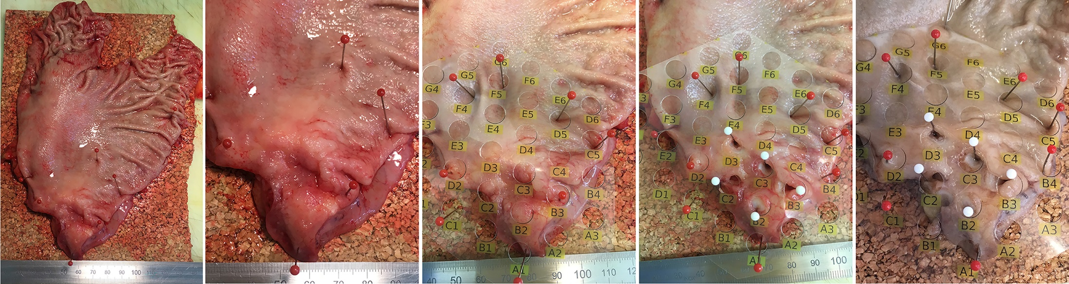Supplemental Figure 1 Tissue sampling procedure of the discovery cohort
The discovery cohort consisted of nine patients with adenocarcinoma of the stomach and esophagogastric junction. Inclusion criteria were appropriate size of the primary tumor (diameter >3 cm) for multiregional tissue sampling without compromising surgical pathological evaluation of the resection specimen. Macroscopic pictures were taken from the surgical resection specimens before and after tissue sampling in order to facilitate anatomical reconstruction of the sampling procedure (from left to right). (A) overview of the gastrectomy specimen; (B) ulcerated tumor in the antral region; (C) a plastic grid with defined wholes for tissue sampling is placed on the tumor; (D) tissue sampling was done with a core needle biopsy; (E) the gastrectomy specimen was fixed in formalin with the grid and subsequently forwarded to gross sectioning. The entire tumor was embedded and usage of the grid facilitated accurate assignment and annotation of the sampling procedure to the paraffin block.

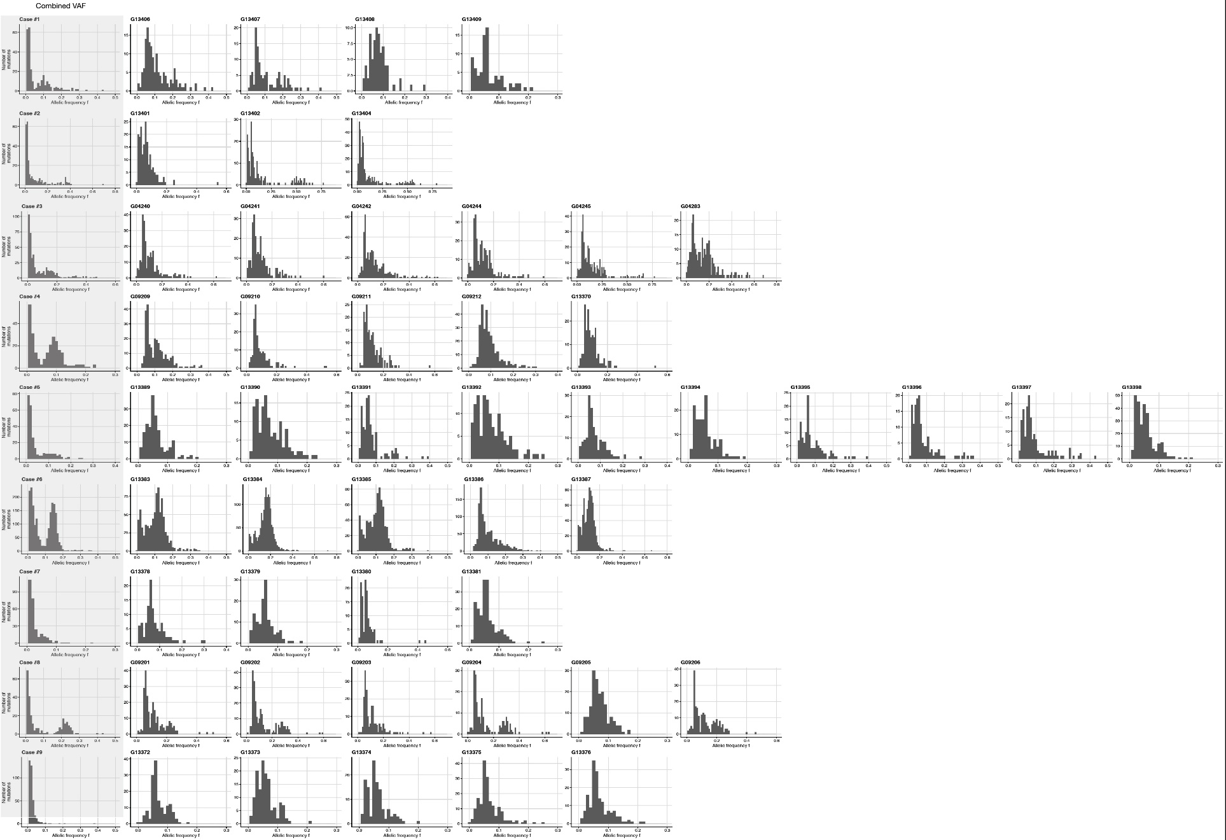
Suppl. Figure 2
Supplemental Figure 2 Variant allele frequency (VAF) histograms generated from the discovery cohort.
Neutrality analysis of samples from nine patients with 3-10 samples. Genomic data of sampled tumours presented as histograms showing the number of variants from genome regions that did not undergo duplication events depending on their allelic frequency f.
The first column (marked grey) shows combined allelic frequencies of all samples combined. For neutral evolution, we would expect a decay of the distribution with 1/f.

Supplemental Figure 3 Kaplan-Meier curves of the validation cohort (SMAD4)
Kaplan-Meier curves are utilized to search by an explorative approach a biologically relevant cut-off value of SMAD4 expression in gastric cancer. In step 1 the HScores for cytoplasmic (A) and nuclear (B) SMAD4 expression are dichotomized at the median, i.e. 100 (for cytoplasmic) and 115 (for nuclear). In step 2 the quartile ranges (Q1 to Q4) are used. In step 3, quartile ranges are grouped (Q1-3 vs. Q4) and in step 4 any absence of SMAD4 expression (IHC=0 vs. IHC>0) irrespective of the percentage area was applied. The p-value of the log-rank test is shown for each analysis.

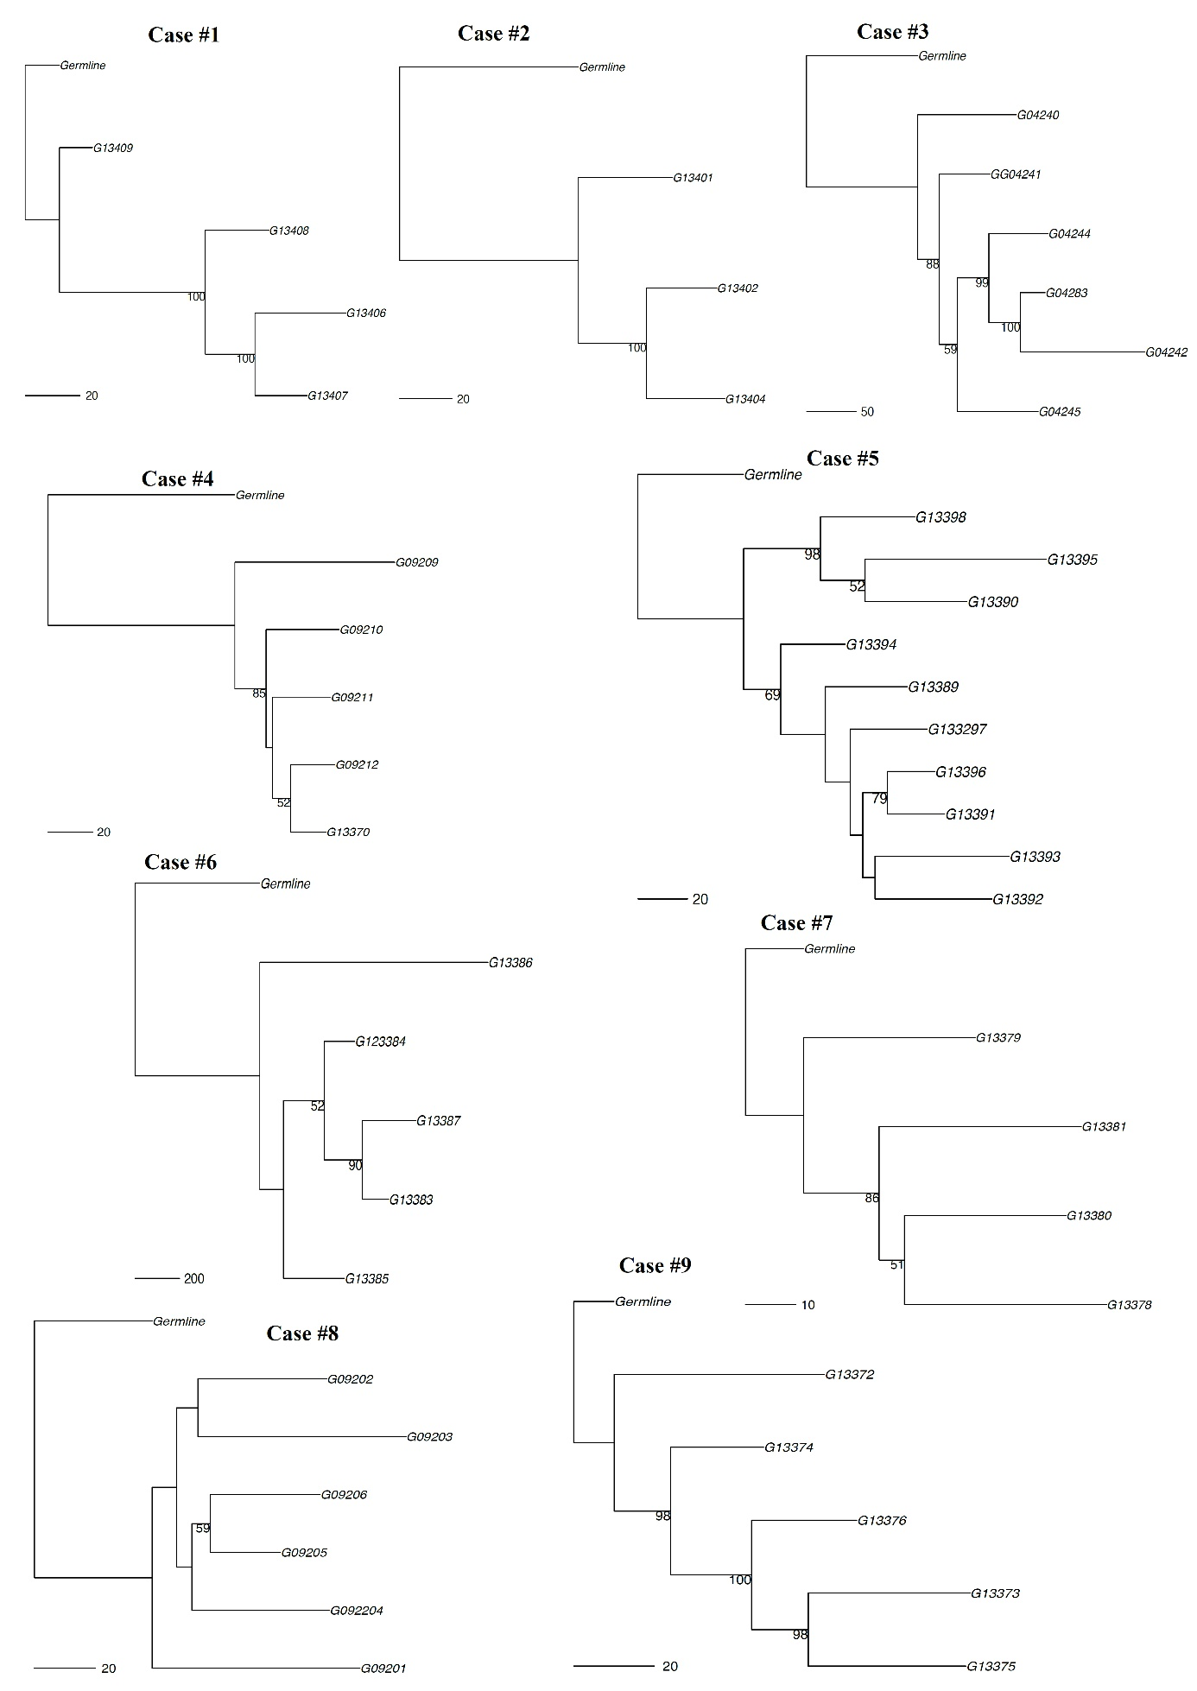
Suppl. Figure 4
Supplemental Figure 4 Maximum parsimony multiregional trees
PHYLIP based maximum parsimony trees in accordance with Lee et al⁵. The trees are based on all non-synonymous variants in a sample and bootstrap values if greater than 50 are labeled.

