Electronic Supplementary Information
Free-standing open space microfluidic devices by dry resist lamination
Rui Liu, Esteban Pedrueza Villalmanzo, Farah Fatima, Aldo Jesorka*
Department of Chemistry and Chemical Engineering, Chalmers University of Technology, Göteborg 412 96, Sweden
*Corresponding author: aldo.jesorka@gomod.eu
1. Measurement of flow rate vs. pressure
Figure S1. Flow rate determination for two channels in the same open space microfluidic device vs. supply pressure.
For a square cross-section, Flow conductance G is determined from the channel dimensions, where Q is the measured flow rate, $∆p$ is the supply pressure, w is the channel width/height, $η$ is the fluid viscosity, and L is the channel length:
$$G=\frac{Q}{∆p}=\frac{1}{R_{hyd}}= \frac{w^{4}}{28.4ηL}$$
$$G=\frac{Q}{∆p}=\frac{1}{R_{hyd}}≈11.0406 \frac{nL}{mbar∙s}$$
For a rectangular cross-section, channel height h and width w are separately introduced:
$$G=\frac{Q}{∆p}= \frac{1}{R_{hyd}}≈ \frac{h^{3}w}{12ηL}\left[1-0.63\frac{h}{w}\right]$$
$$G= \frac{Q}{∆p}=\frac{1}{R_{hyd}}≈8.75 \frac{nL}{mbar∙s}$$
Table S1. Flow rate vs pressure determination by different methods.
 | Calculated from design | Measured | Calculated from Fig.2H
Channel dimensions  (w x h x L/µm) | 75 x 75 x 10091 | - | 75 x 70 x 10091
Conductance  (nL s⁻¹ mbar⁻¹) | 11.04 | 8-9 | 8.75
2. Misalignment using mask aligner with topside alignment.
Earlier process attempts with top side alignment resulted in visible misalignment of the final layer, since the detection of the alignment marks becomes more difficult. This problem becomes more prominent when thicker layers are processed. An image is provided in Fig. S2 for evaluation.
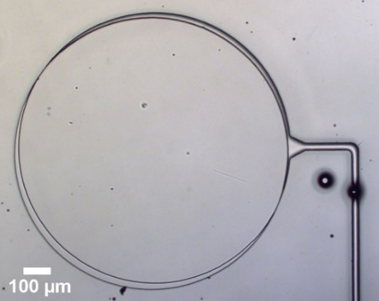
Figure S2. Misalignment between lamination layers observed with topside alignment.
3. Pressure test for open channels.
Figure S3. Pressure test on 3 conducting channels in the same open space microfluidic device presented in the main manuscript.

The pressure test was also performed for conducting (open) channels under otherwise identical conditions, where the pressure loss through the air flow out of the channels was compensated to attain a test pressure of 2 bars.
4. Transfer tape design
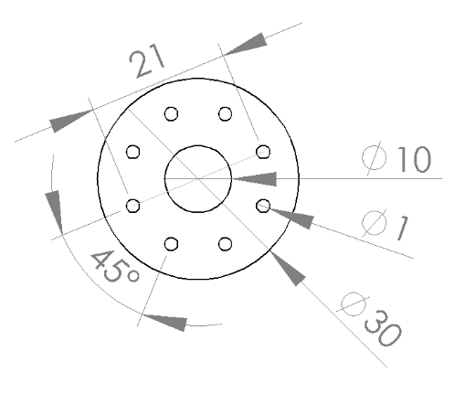
Figure S4. AutoCAD layout for the transfer tape cutting step (units: mm). The center orifice matches the interface block of the setup rather than the smaller opening in the microfluidic chip, facilitating operation of the servo arm for film generation and imaging under the stereo microscope.

5. Supplementary videos:
SI Video 1: Meniscus control of a suspended surfactant film by fluidic flow adjustment;
SI Video 2: Ultrasonic sound application for film stabilization (3x speed);
SI Video 3: Surfactant film development under zero fluid flow conditions;
SI Video 4: Droplet ejection from a suspended surfactant film at 1kHz ~35dB audio frequency application;
SI Video 5: Rotation of a suspended surfactant film at 4 kHz ~35dB audio frequency application.

The rigid surfactant films used in the experiments documented in the videos were produced from a 0.1% sodium dodecyl sulfate solution in deionized water. All images presented in the manuscript were extracted from these videos.

