Supplementary Data
  - Decreased cellular excitability of pyramidal tract neurons in primary motor cortex leads to paradoxically increased network activity in simulated parkinsonian motor cortex
Donald W Doherty^{1,5}, Liqiang Chen^{3,5}, Yoland Smith^{4,5}, Thomas Wichmann^{4,5}, Hong-yuan Chu^{3,5}, William W Lytton^{1,2,5}

¹ Department of Physiology & Pharmacology, SUNY Downstate Medical Center, Brooklyn, NY 11203, USA
² Kings County Hospital, Brooklyn, NY 11203, USA
³ Department of Pharmacology and Physiology, Georgetown University Medical Center, Washington D.C., USA
⁴ Emory National Primate Research Center, Department of Neurology, Udall Center of Excellence for Parkinson’s Disease Research, Emory University, School of Medicine, Atlanta GA 30329 USA
⁵Aligning Science Across Parkinson’s (ASAP) Collaborative Research Network, Chevy Chase, MD, 20815

Experiment ID | Seeds | Condition | State | Mean PT firing rate (Hz) | Standard deviation | Significance (p<value)
sM1_12-12-2023_01 | conn': 4321, 'stim': 1234, 'loc': 4321 | Control | Rest | 11.7 | 9.4
sM1_12-12-2023_02 | conn': 4321, 'stim': 1234, 'loc': 4321 | Parkinsonian | Rest | 14.2 | 7.1 | 0.001
sM1_12-12-2023_03 | conn': 4321, 'stim': 1234, 'loc': 4321 | Control | Activated | 26.8 | 18.2
sM1_12-12-2023_04 | conn': 4321, 'stim': 1234, 'loc': 4321 | Parkinsonian | Activated | 29.7 | 12.7 | 0.001
sM1_04-22-2024_01 | conn': 1592, 'stim': 3752, 'loc': 5368 | Control | Rest | 11.3 | 8.0
sM1_04-22-2024_02 | conn': 1592, 'stim': 3752, 'loc': 5368 | Parkinsonian | Rest | 19.1 | 9.5 | 0.001
sM1_04-22-2024_03 | conn': 1592, 'stim': 3752, 'loc': 5368 | Control | Activated | 25.7 | 18.4
sM1_04-22-2024_04 | conn': 1592, 'stim': 3752, 'loc': 5368 | Parkinsonian | Activated | 29.1 | 11.7 | 0.001
sM1_04-25-2024_01 | conn': 8392, 'stim': 1893, 'loc': 9272 | Control | Rest | 12.4 | 10.2
sM1_04-25-2024_02 | conn': 8392, 'stim': 1893, 'loc': 9272 | Parkinsonian | Rest | 22.8 | 11.9 | 0.001
sM1_04-25-2024_03 | conn': 8392, 'stim': 1893, 'loc': 9272 | Control | Activated | 26.4 | 18.3
sM1_04-25-2024_04 | conn': 8392, 'stim': 1893, 'loc': 9272 | Parkinsonian | Activated | 30.1 | 12.5 | 0.001
sM1_04-26-2024_01 | conn': 3525, 'stim': 3894, 'loc': 6942 | Control | Rest | 13.4 | 10.3
sM1_04-26-2024_02 | conn': 3525, 'stim': 3894, 'loc': 6942 | Parkinsonian | Rest | 24.6 | 12.2 | 0.001
sM1_04-26-2024_03 | conn': 3525, 'stim': 3894, 'loc': 6942 | Control | Activated | 26.6 | 18.3
sM1_04-26-2024_04 | conn': 3525, 'stim': 3894, 'loc': 6942 | Parkinsonian | Activated | 30.7 | 12.4 | 0.001

Table S1. Four datasets, each using different connectivity, stimulation, and neuron location random seeds. Significance (p values) are for Pyramidal Tract (PT) neuron firing frequency between conditions (control or parkinsonian) in a particular state (rest or activated).

Condition | Nap | BK | NaT
Control | 0.0055 | 7.25x10-5 | 0.00086
Parkinsonian | 0.0055 | 7.25x10-4 | 0.0172

Table S2. Pyramidal Tract (PT) neuron parameters were set to the NetPyNE PTcell standard available from the NetPyNE GitHub repository (PTcell from the examples folder) except for the current densities for the 3 channels in this table. The persistent sodium (Nap), big potassium (BK), and transient sodium (NaT) channels. Current densities in pA/pF.

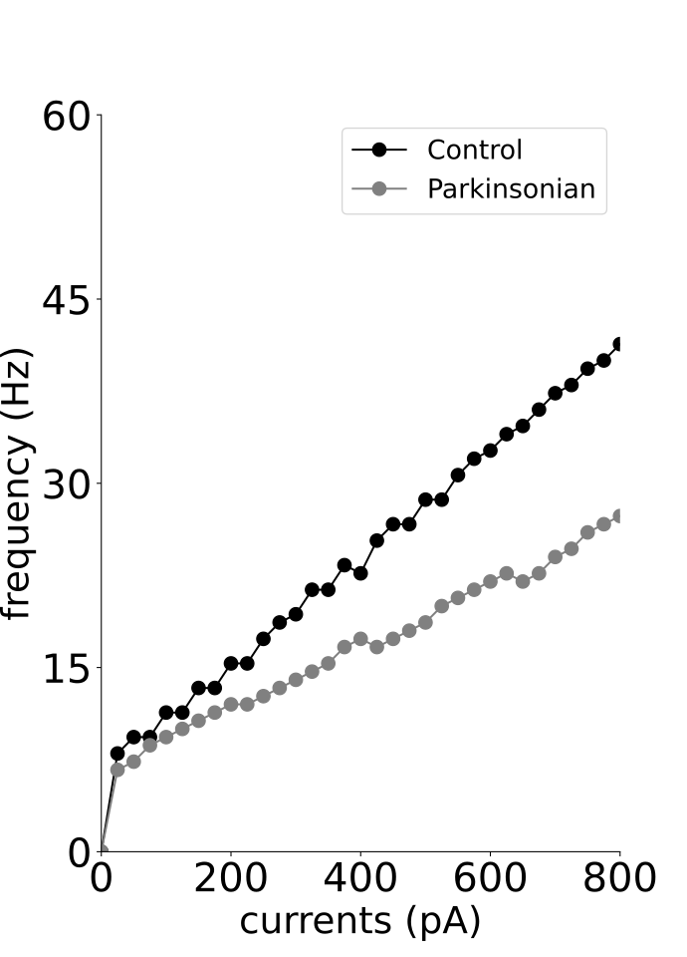
Figure S1. Simulated Pyramidal Tract (PT) neuron current frequency curves for control (black) and parkinsonian (gray) conditions.

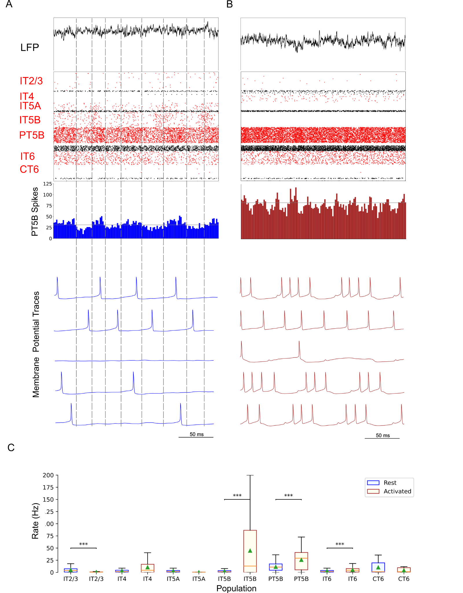

Figure S2. Control condition. A. and B. show the resting state on the left, and the activated state on the right. A. Top-to-bottom: LFP, raster plot (red excitatory; black inhibitory neurons); PT5B spike count histograms (left: dashed lines at half height). B. Examples of PT5B voltage traces -- same 5 (out of 1435) in both states. C. Firing rate statistics (mean, std dev, range, *p<0.05, **p<0.01, ***p<0.001). Data set sM1_04-22-2024.
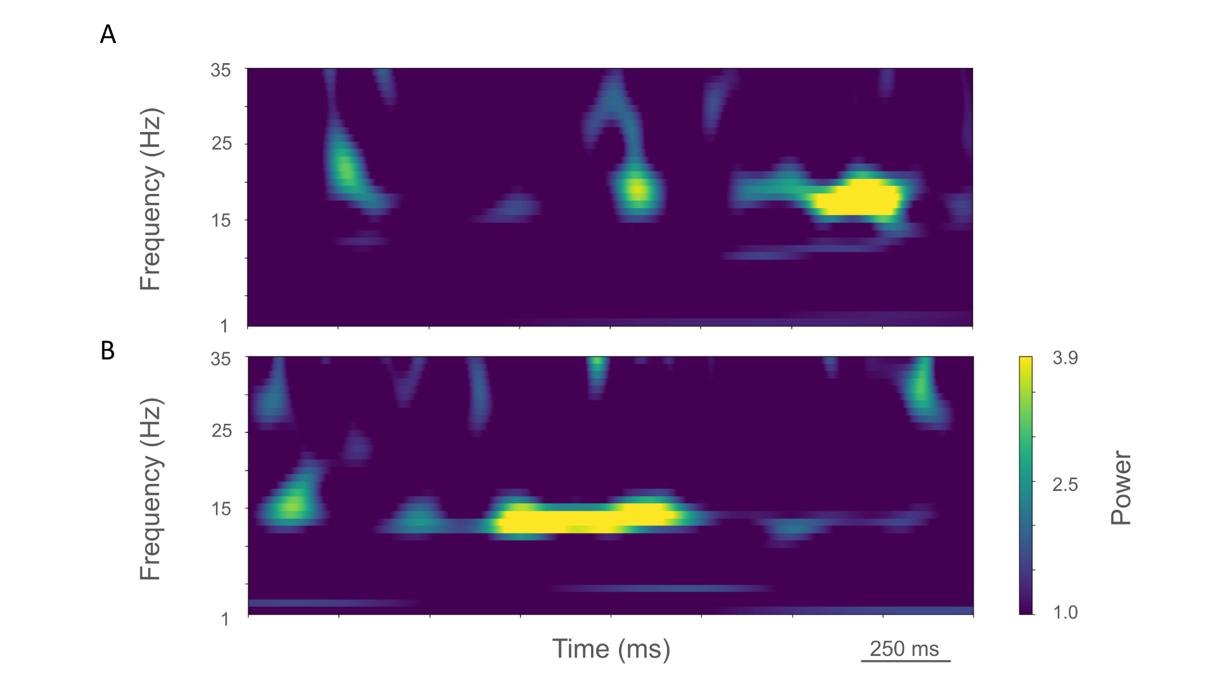

Figure S3. Time-resolved spectrograms of cortical LFPs in the control condition, under rest (A) and activation (B) states. sM1_04-22-2024. Power in bars x 1.0e-5.

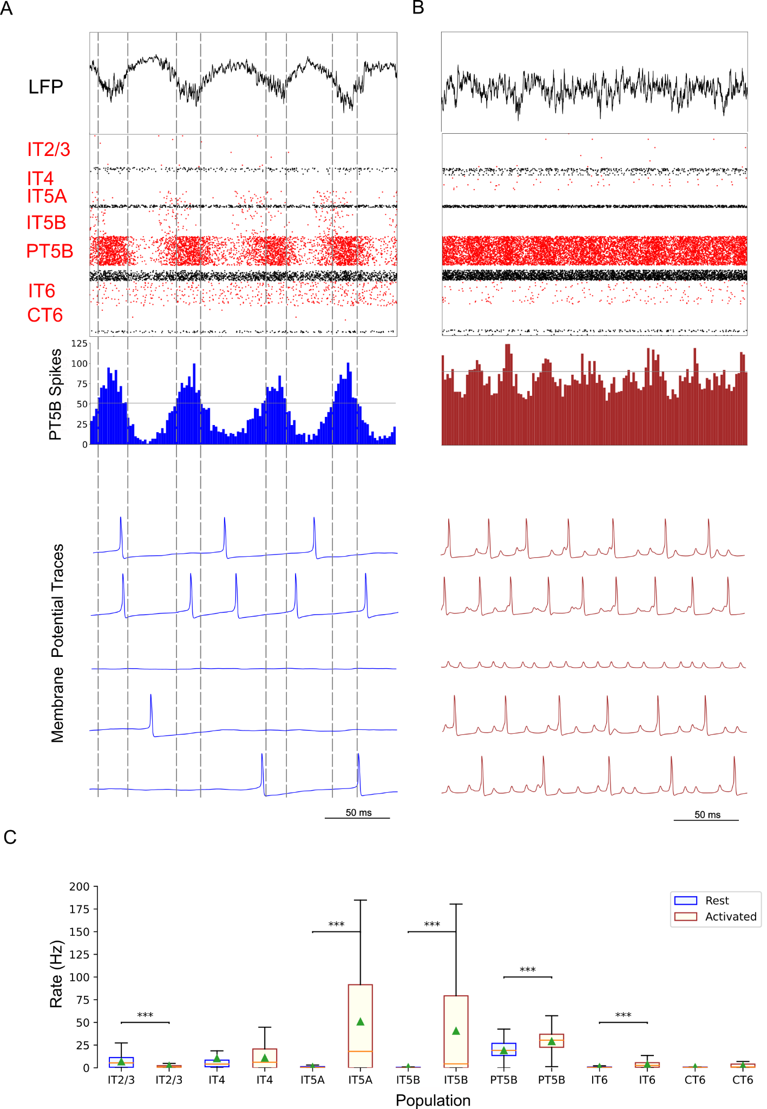
Figure S4. Parkinsonian condition. A. and B. show the resting state on the left, and the activated state on the right. A. Top-to-bottom: LFP record, raster plot (red pyramidal ; black inhibitory neurons), spike count histograms (PT5B; 2 ms bins). B. Examples of PT5B voltage traces. C. Firing rate statistics (mean, std dev, range, *p<0.05, **p<0.01, ***p<0.001). Data set sM1_04-22-2024.

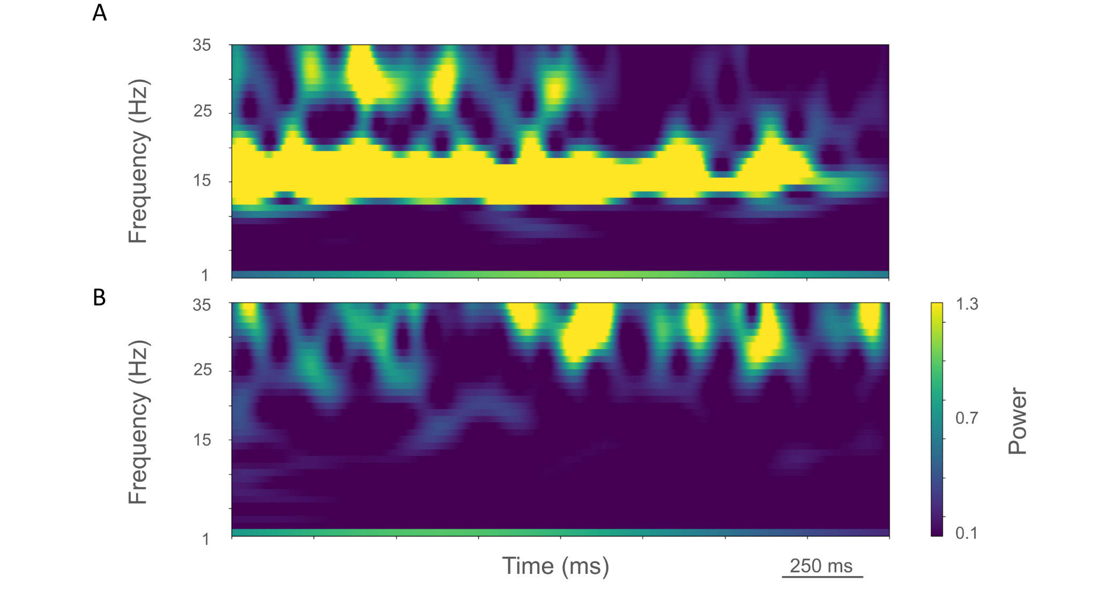

Figure S5. Time-resolved spectrograms of cortical LFPs in the parkinsonian condition, under rest (A) and activation (B) states. sM1_04-22-2024. Power in bars x 1.0e-4.

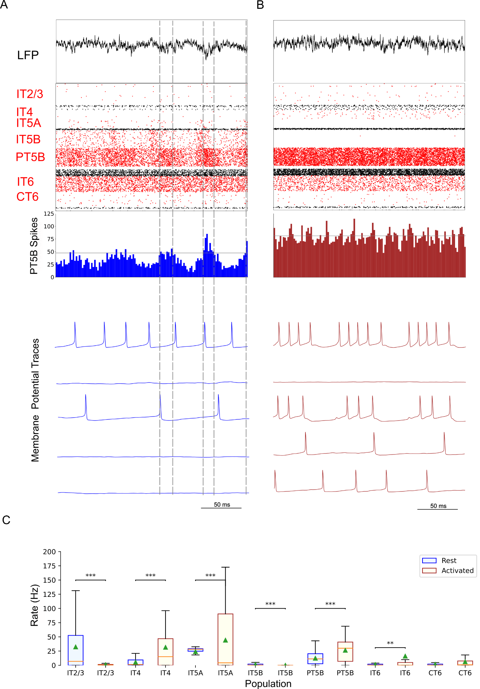

Figure S6. Control condition. A. and B. show the resting state on the left, and the activated state on the right. A. Top-to-bottom: LFP, raster plot (red excitatory; black inhibitory neurons); PT5B spike count histograms (left: dashed lines at half height). B. Examples of PT5B voltage traces -- same 5 (out of 1435) in both states. C. Firing rate statistics (mean, std dev, range, *p<0.05, **p<0.01, ***p<0.001). Data set sM1_04-25-2024.

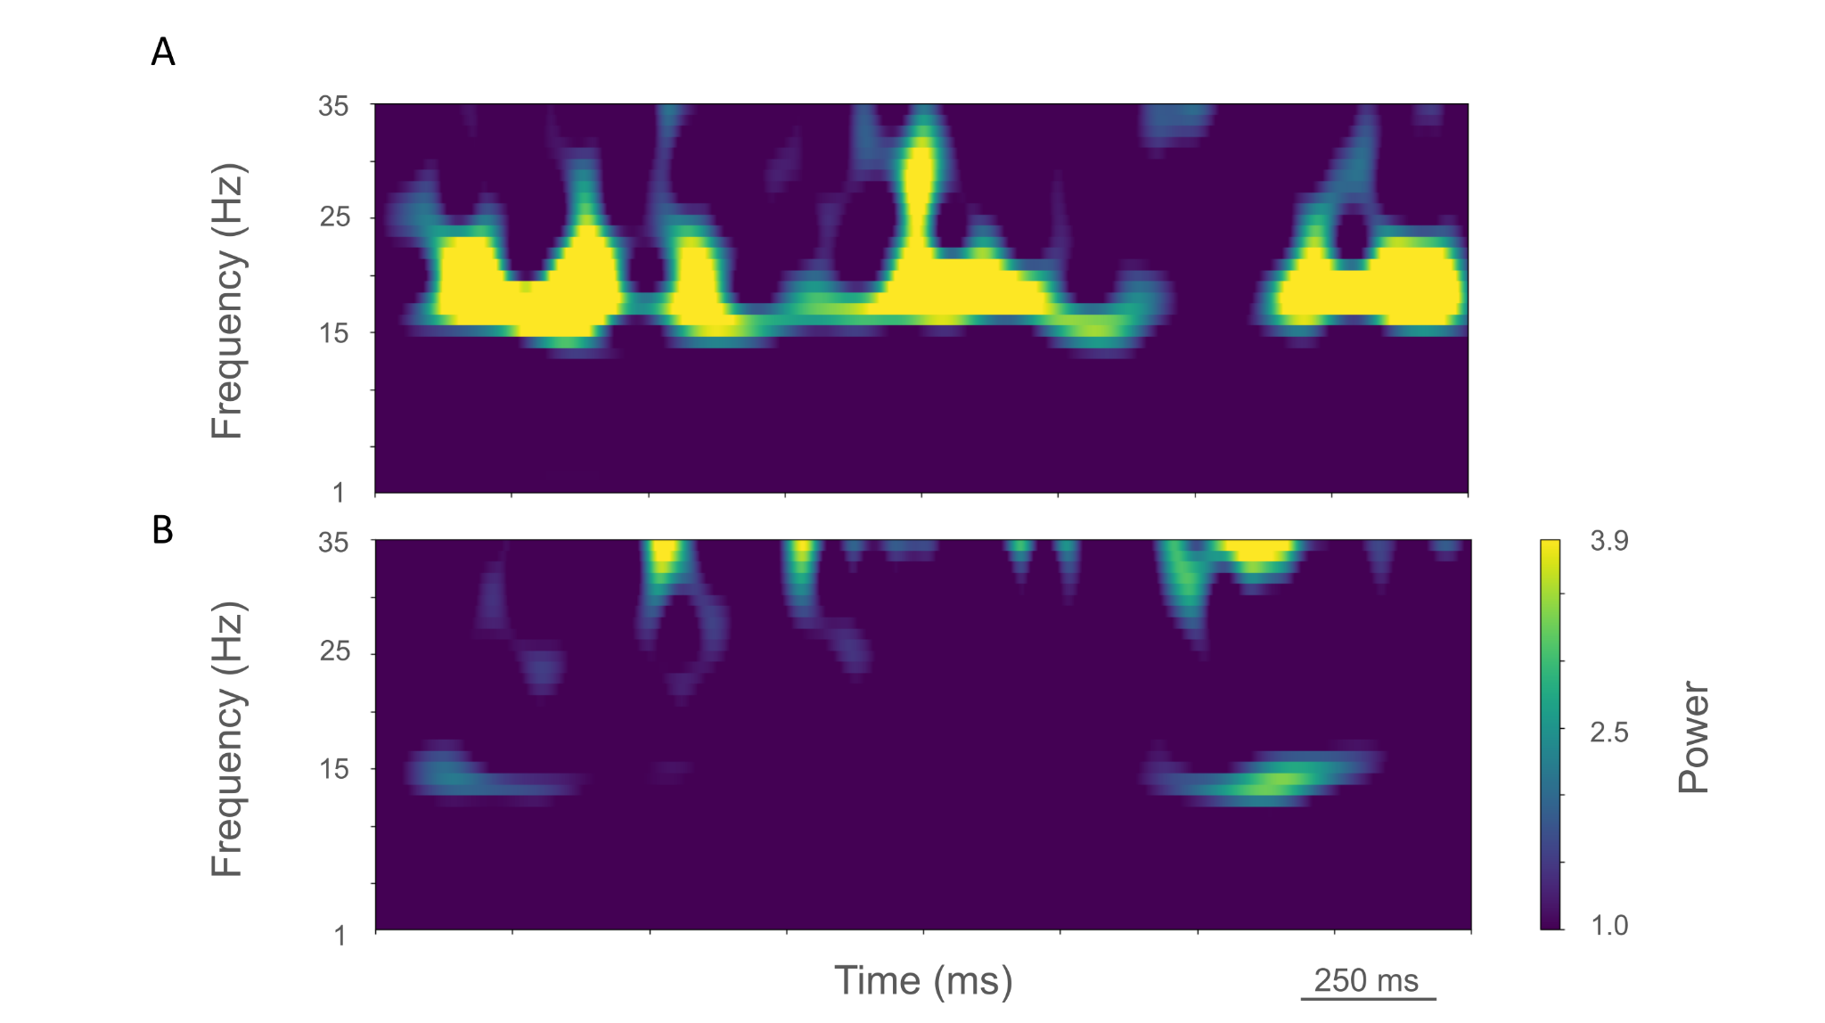

Figure S7. Time-resolved spectrograms of cortical LFPs in the control condition, under rest (A) and activation (B) states. sM1_04-25-2024. Power in bars x 1.0e-5.

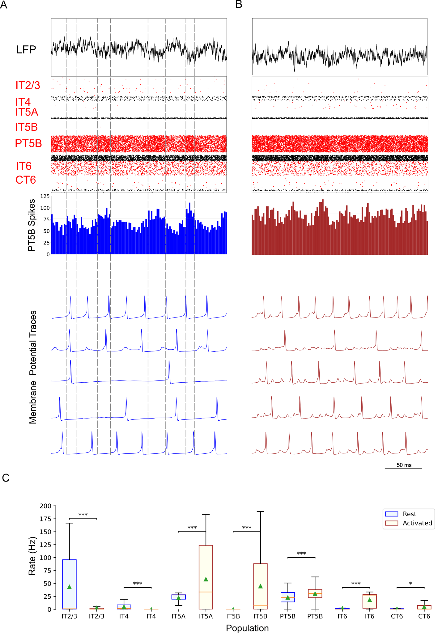

Figure S8. Parkinsonian condition. A. and B. show the resting state on the left, and the activated state on the right. A. Top-to-bottom: LFP record, raster plot (red pyramidal ; black inhibitory neurons), spike count histograms (PT5B; 2 ms bins). B. Examples of PT5B voltage traces. C. Firing rate statistics (mean, std dev, range, *p<0.05, **p<0.01, ***p<0.001). Data set sM1_04-25-2024.

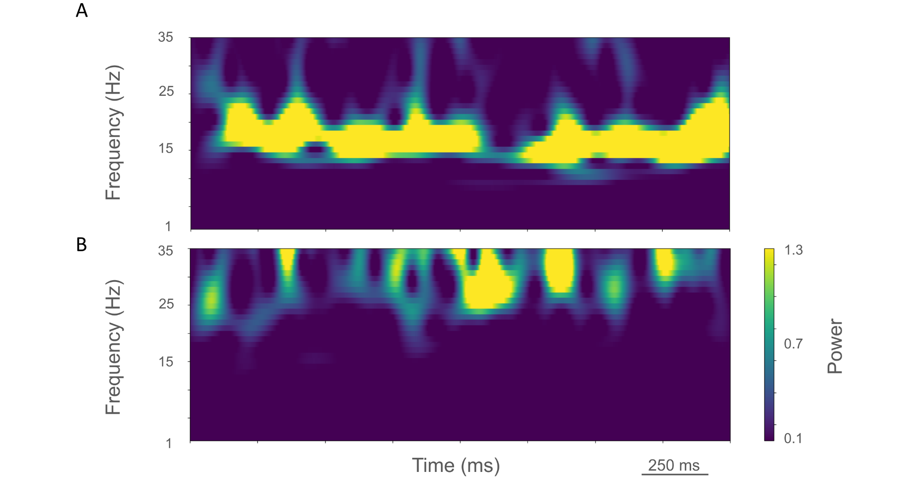

Figure S9. Time-resolved spectrograms of cortical LFPs in the parkinsonian condition, under rest (A.) and activation (B) states. sM1_04-25-2024. Power in bars x 1.0e-4.

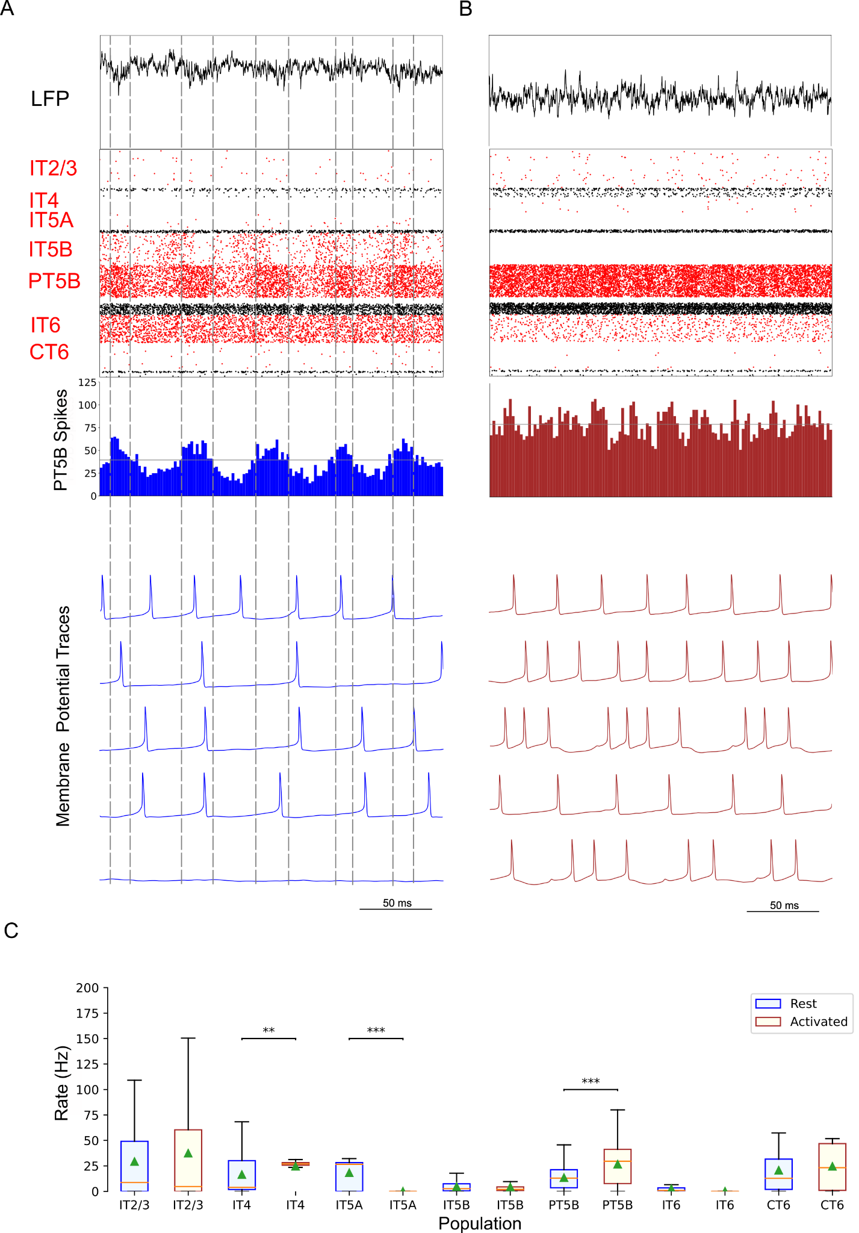

Figure S10. Control condition. A. and B. show the resting state on the left, and the activated state on the right. A. Top-to-bottom: LFP, raster plot (red excitatory; black inhibitory neurons); PT5B spike count histograms (left: dashed lines at half height). B. Examples of PT5B voltage traces -- same 5 (out of 1435) in both states. C. Firing rate statistics (mean, std dev, range, *p<0.05, **p<0.01, ***p<0.001). Data set sM1_04-26-2024.

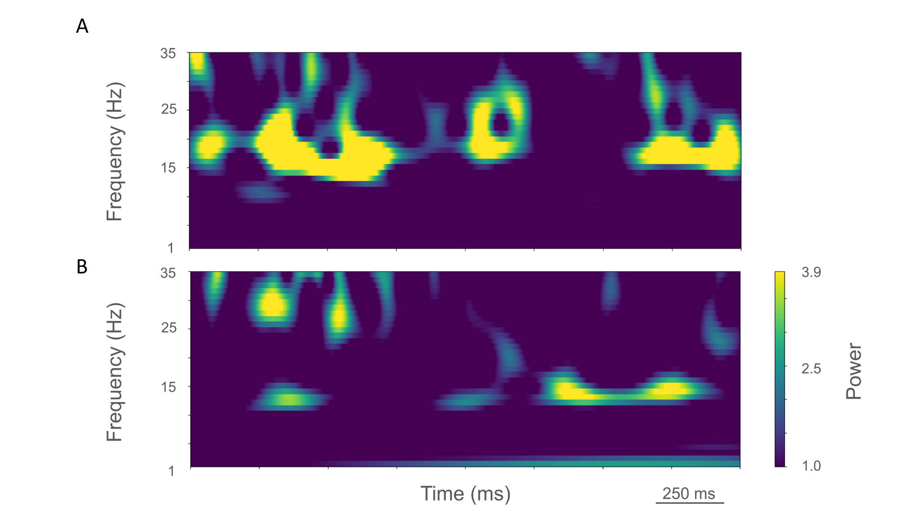

Figure S11. Time-resolved spectrograms of cortical LFPs in the control condition, under rest (A) and activation (B) states. sM1_04-26-2024. Power in bars x 1.0e-5.

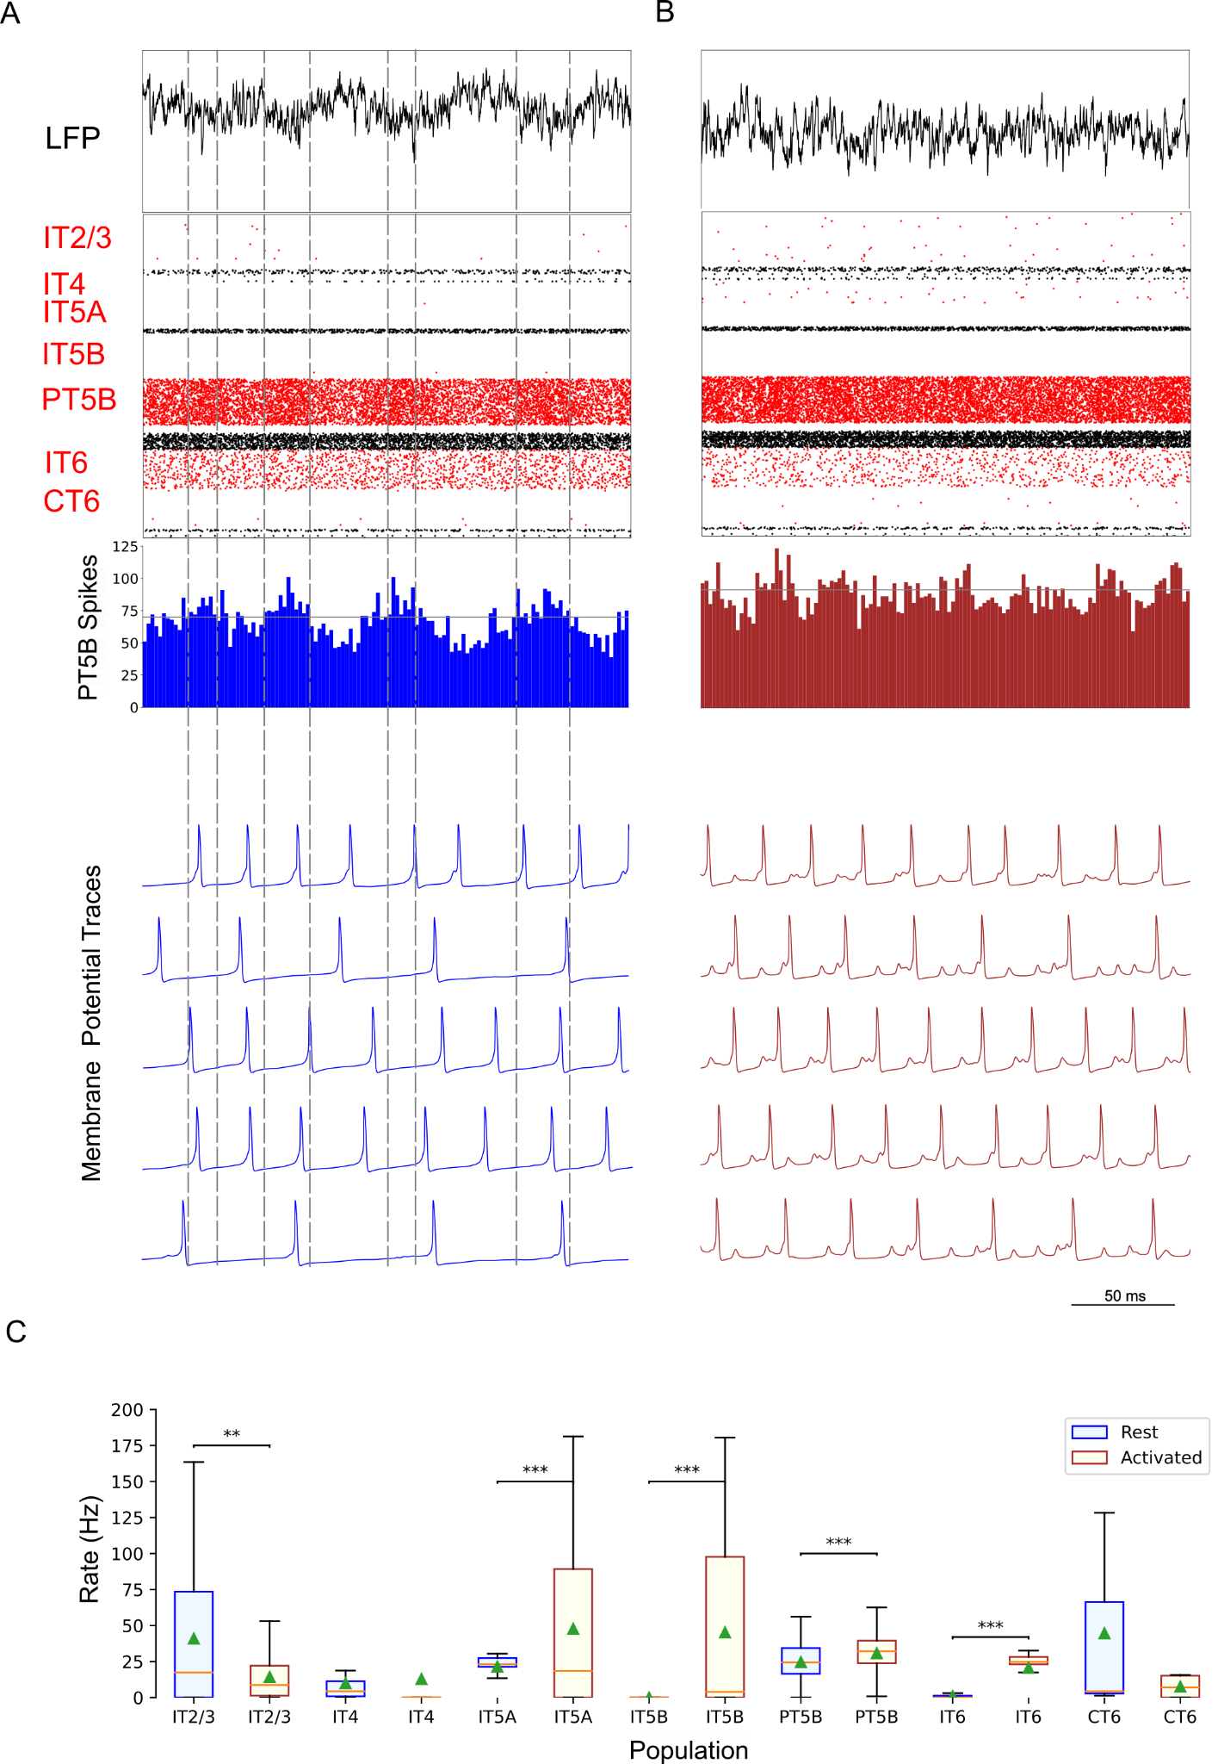

Figure S12. Parkinsonian condition. A. and B. show the resting state on the left, and the activated state on the right. A. Top-to-bottom: LFP record, raster plot (red pyramidal ; black inhibitory neurons), spike count histograms (PT5B; 2 ms bins). B. Examples of PT5B voltage traces. C. Firing rate statistics (mean, std dev, range, *p<0.05, **p<0.01, ***p<0.001). Data set sM1_04-26-2024.

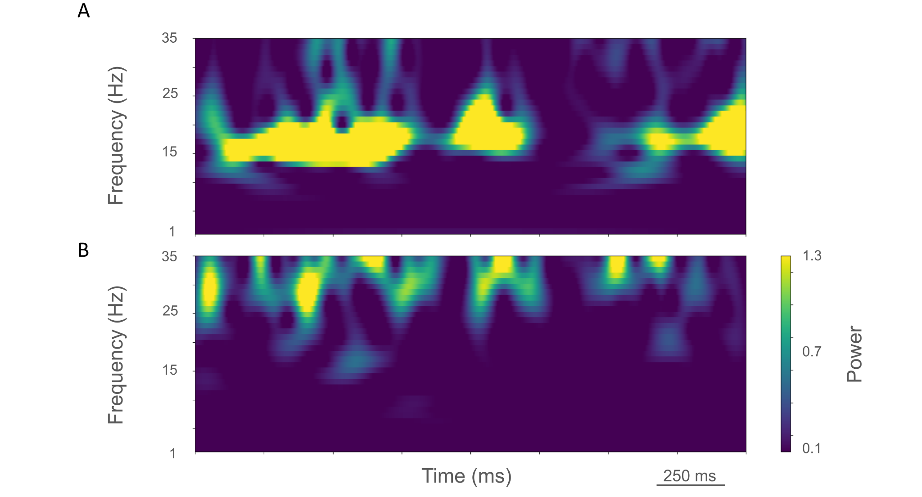

Figure S13. Time-resolved spectrograms of cortical LFPs in the parkinsonian condition, under rest (A) and activation (B) states. sM1_04-26-2024. Power in bars x 1.0e-4.

