Extended Data Table 1. Peason’s correlation coefficients (r) between the normalized high frequency in the frequency domain and the mean elevation of the intertidal (IT) and subtidal (ST) areas of each tidal basin in the annual time series of DEM for the period 1998-2022.
Basin no. | 1 | 2 | 3 | 4 | 5 | 6 | 7 | 8 | 9 | 10 | 11 | 12
IT | 0.23  (**) | 0.62  (***) | 0.95  (***) | 0.92  (***) | 0.89  (***) | 0.69  (***) | 0.55  (**) | 0.69  (***) | 0.61  (**) | 0.71  (***) | 0.51  (**) | 0.64  (***)
ST | -0.60  (**) | -0.90  (***) | -0.87  (***) | -0.82  (***) | -0.82  (***) | -0.04  (*) | -0.85  (***) | -0.18  (**) | 0.36  (**) | -0.18  (*) | 0.73  (***) | -0.95  (***)
Basin no. | 13 | 14 | 15 | 16 | 17 | 18 | 19 | 20 | 21 | 22 | 23 | 24
IT | 0.84  (***) | 0.45  (**) | 0.82  (***) | 0.45  (*) | 0.79  (***) | 0.73  (***) | 0.88  (***) | 0.83  (***) | 0.61  (**) | 0.10  (**) | 0.75  (***) | -0.10  (*)
ST | -0.78  (***) | 0.52  (**) | -0.02  (*) | 0.48  (*) | -0.64  (***) | -0.02  (*) | -0.70  (***) | -0.86  (***) | -0.34  (**) | -0.60  (**) | -0.60  (**) | -0.48  (*)
Note: *: p<0.05; **: p<0.01; ***: p<0.001.
Extended Data Table 2. Mean elevation change rate (mm yr⁻¹) of intertidal (IT) and subtidal (ST) areas of the 24 tidal basins derived from linear regression based on the original data and low-pass filtered data (Solution #2) over the period 1998-2022.
Basin no. |  | 1 | 2 | 3 | 4 | 5 | 6 | 7 | 8 | 9 | 10 | 11 | 12
IT | Original | 1.14 | 5.4 | 13.49 | 11.36 | 9.08 | 8.81 | 3.3 | 5.2 | 9.34 | 8.85 | 4.31 | 8.55
IT | Low-pass  filtered | 0.29 | 5.18 | 13.07 | 10.96 | 7.35 | 7.73 | 1.58 | 3.78 | 2.54 | 3.45 | -0.43 | 3.47
ST | Original | -11.82 | -13.19 | -25.84 | -30.3 | -11.33 | -1.96 | -14.44 | 0.08 | 16.99 | -6.17 | 17.33 | -22.44
ST | Low-pass  filtered | -16.84 | -12.6 | -24.3 | -28.10 | -10.13 | -5.92 | -2.29 | 0.67 | 3.07 | -5.51 | 29.03 | -26.23
Basin no. |  | 13 | 14 | 15 | 16 | 17 | 18 | 19 | 20 | 21 | 22 | 23 | 24
IT | Original | 9.77 | 12.56 | 19.29 | 6.37 | 9.12 | 8.49 | 8.83 | 8.67 | 10.83 | 0.67 | 5.62 | -1.76
IT | Low-pass  filtered | 4.34 | 8.37 | 18.99 | 1.36 | 8.06 | 7.35 | 8.15 | 7.95 | 10.53 | -1.42 | 4.95 | -2.05
ST | Original | -26.67 | 39.88 | 14.61 | 29.27 | -6.16 | -4.95 | -11.81 | -5.59 | -4.38 | -10.27 | -7.47 | -5.21
ST | Low-pass  filtered | -30.33 | 22.43 | 13.08 | 30.50 | -12.54 | -7.08 | -11.07 | -3.99 | -7.2 | -12.28 | 1.66 | -4.74

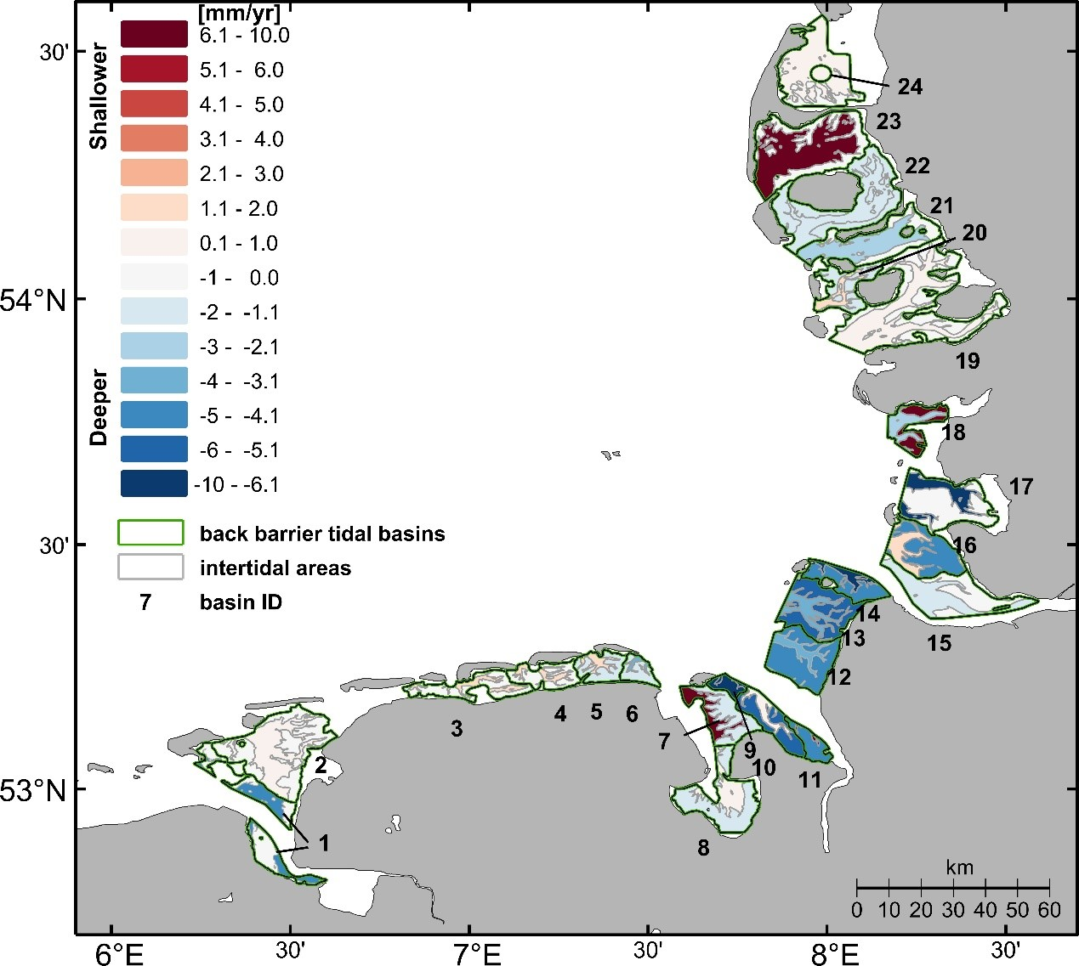
Extended Data Figure 1. Difference in the mean elevation change rate (mm yr⁻¹) of intertidal and subtidal areas of the 24 tidal basins between the original data and low-pass filtered data (Solution #2) for the period 1998-2022. Positive and negative values indicate increased and decreased elevation in the low-pass filtered data than the original data, respectively.

