Contents

Supplementary Figure 1. Global distribution of tidal basins and area of investigation in this study.
Supplementary Figure 2. Number of identified channels including creeks and streams in the Jade Bay from the annual DEM for the period 1998 - 2022.
Supplementary Figure 3. Topography of the Jade Bay, corresponding frequency domain and statistics of bathymetric gradients.
Supplementary Figure 4. Normalized high frequency in the frequency domains of the annual DEM of all 24 tidal basins from 1998 to 2022.
Supplementary Figure 5. Comparison between the mean elevation of intertidal areas of each tidal basin (y-axis on the right) and the normalized high frequency in the frequency domain (y-axis on the left) in the annual time series of DEM from 1998 to 2022.
Supplementary Figure 6. Comparison between the mean elevation of subtidal areas of each tidal basin (y-axis on the right) and the normalized high frequency in the frequency domain in the annual time series of DEM from 1998 to 2022.
Supplementary Figure 7. Comparison of the normalized high frequency of intertidal areas of the 24 tidal basins between the original annual time series of DEM and low-pass filtered DEM (Solution #2) from 1998 to 2022.
Supplementary Figure 8. Supplementary Figure 8. Comparison of the normalized high frequency of subtidal areas of the 24 tidal basins between the original annual time series of DEM and low-pass filtered DEM (Solution #2) from 1998 to 2022.
Supplementary Figure 9. Comparison of the mean elevation of intertidal areas of the 24 tidal basins and corresponding linear regression trendlines between the original annual time series of DEM and low-pass filtered DEM (Solution #2) from 1998 to 2022.
Supplementary Figure 10. Comparison of the mean elevation of subtidal areas of the 24 tidal basins and corresponding linear regression trendlines between the original annual time series of DEM and low-pass filtered DEM (Solution #2) from 1998 to 2022.
Supplementary Figure 11. Examples of artifacts in the annual time series of DEM for individual tidal basins.

Supplementary Table 1. MLW and MHW of the investigated tidal basins derived from Benninghof & Winter ⁹.

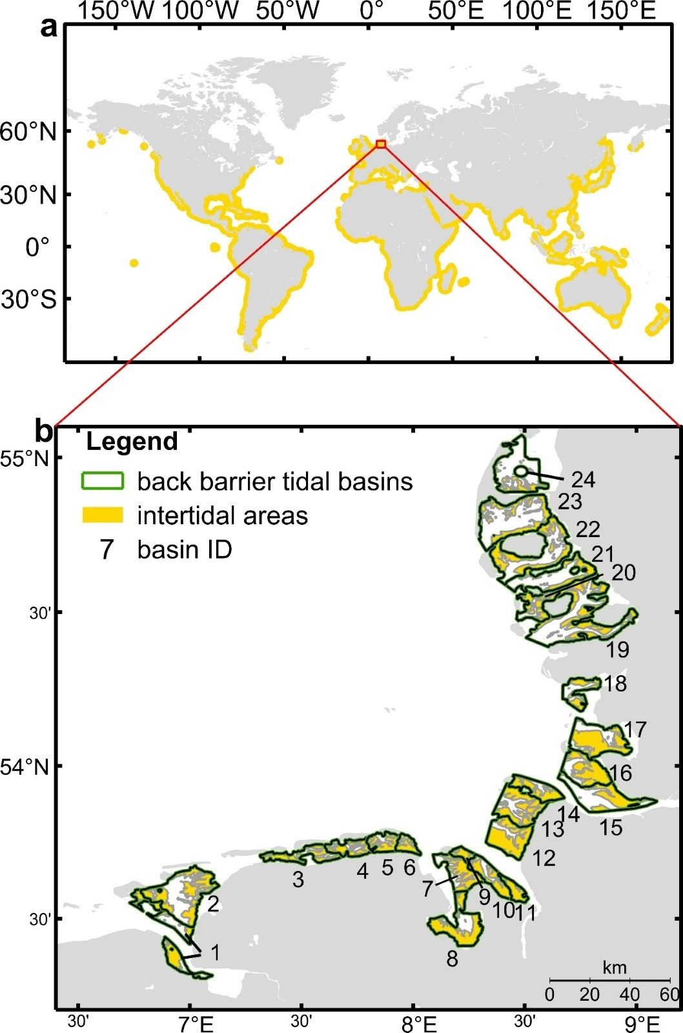
Supplementary Figure 1. Global distribution of tidal basins and area of investigation in this study. a, Global distribution of tidal basins (marked in yellow color) inferred from Murray et al. ¹⁷.b, Geographic outline of the 24 basins in the German Wadden Sea following the definition by Benninghof & Winter ⁹. Intertidal areas are indicated by yellow color.

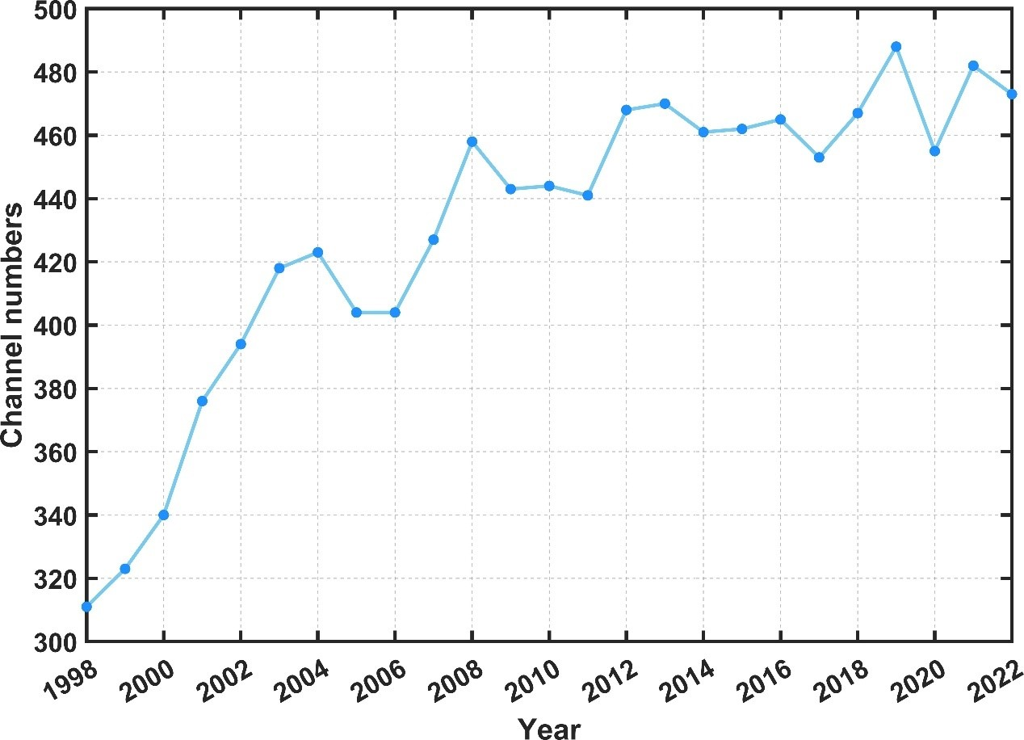
Supplementary Figure 2. Number of identified channels including creeks and streams in the Jade Bay from the annual DEM for the period 1998 - 2022.

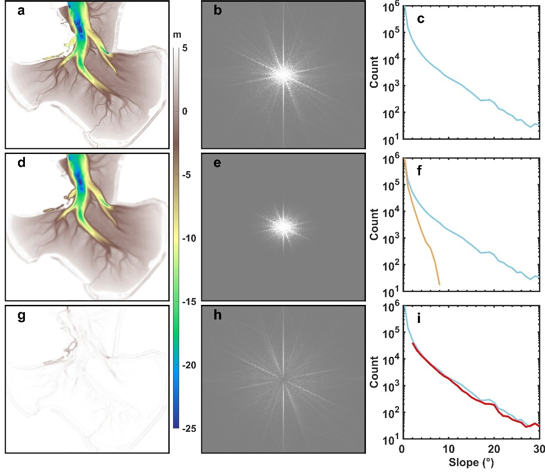
Supplementary Figure 3. Topography of the Jade Bay, corresponding frequency domain and statistics of bathymetric gradients. a, Topography of the Jade Bay. b, Frequency domain of the topography derived by FFT. c, Count of total number of grid cells with specific bathymetric gradient based on (a). d, Topography derived by the Inverse FFT based on the low pass filtered frequencies shown in (e). f, Similar to (c) but based on the low pass filtered topography in (d). g, Topography derived by the Inverse FFT based on the high pass filtered frequencies shown in (h). i, Similar to (c) but based on the topography in (g).
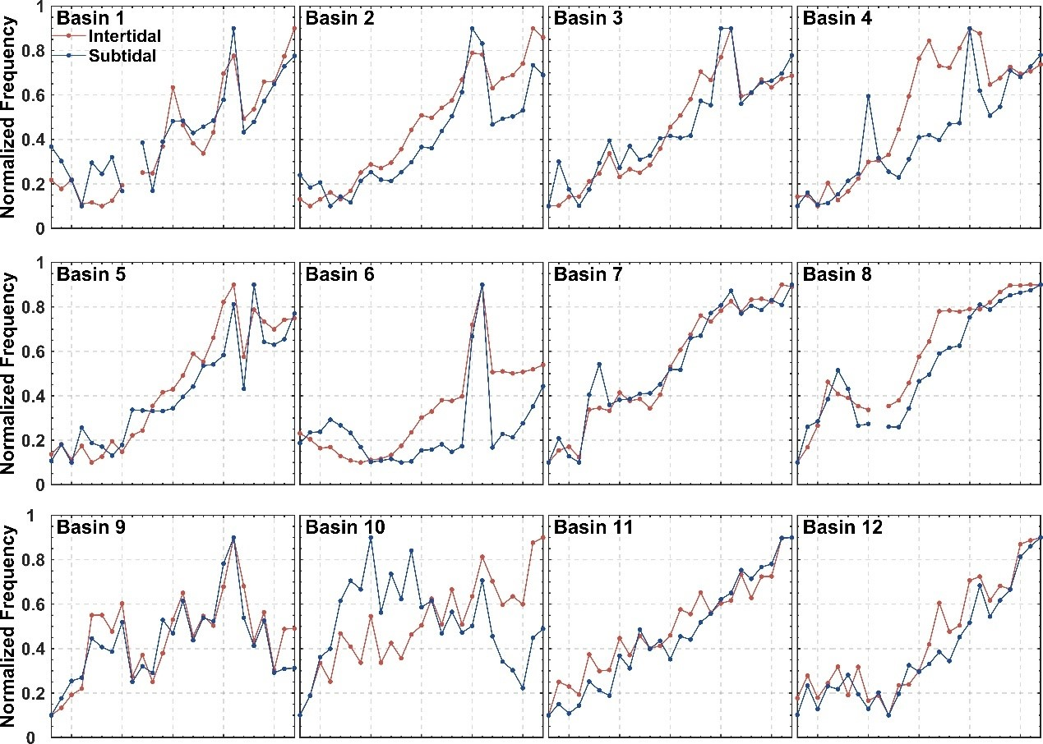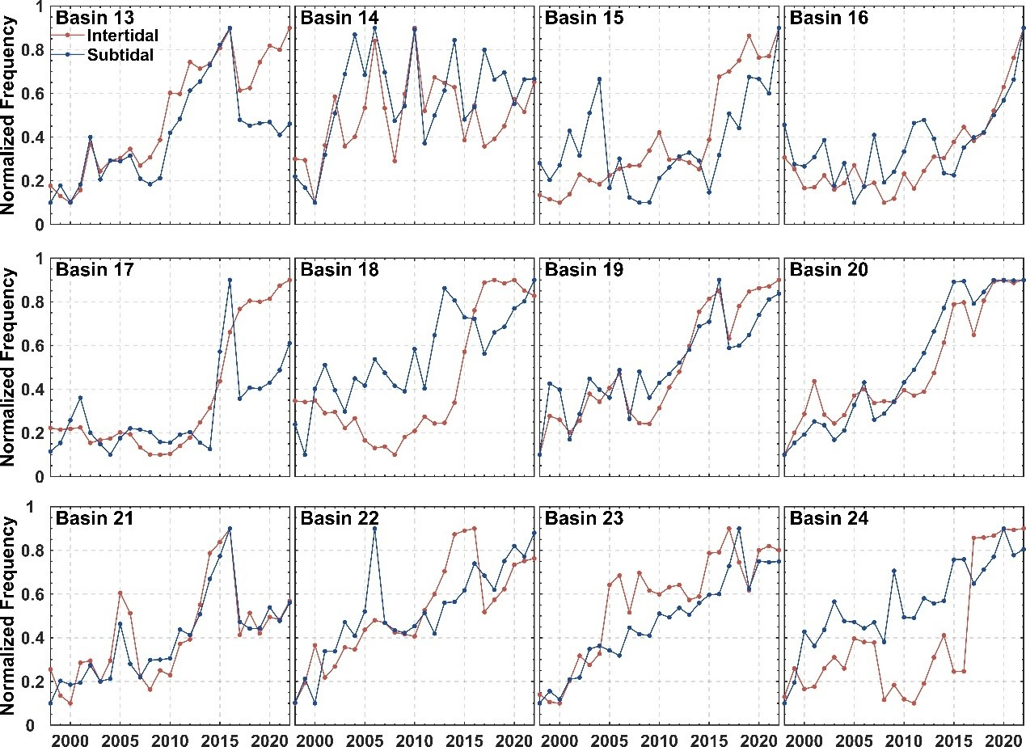
Supplementary Figure 4. Normalized high frequency in the frequency domains of the annual DEM of all 24 tidal basins from 1998 to 2022. Intertidal and subtidal areas of each basin are distinguished.

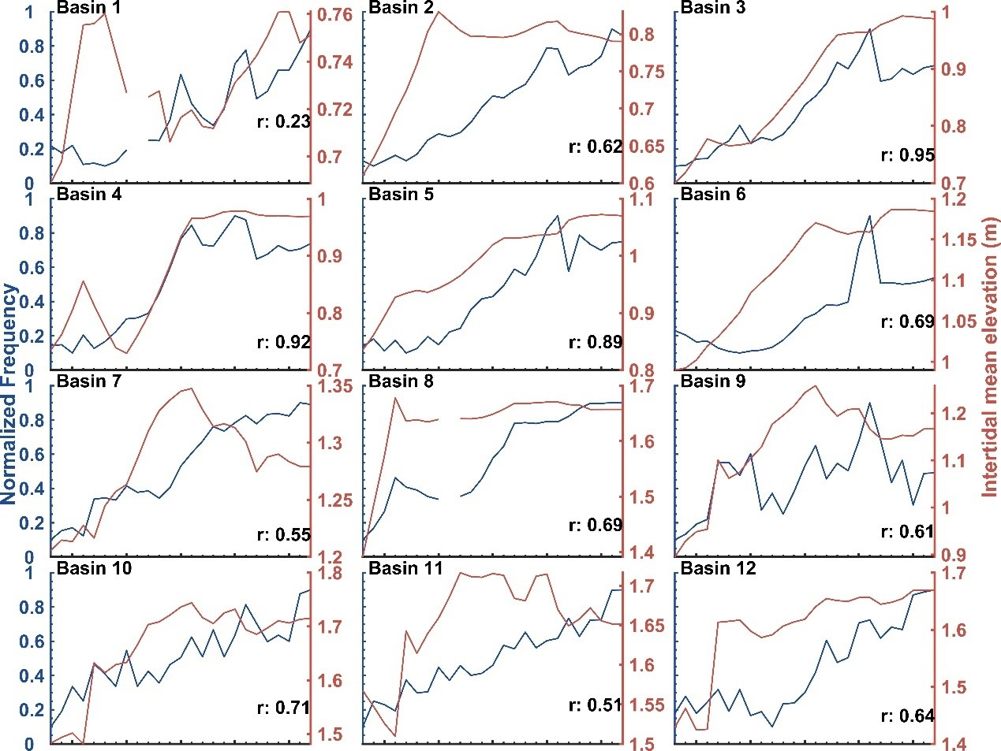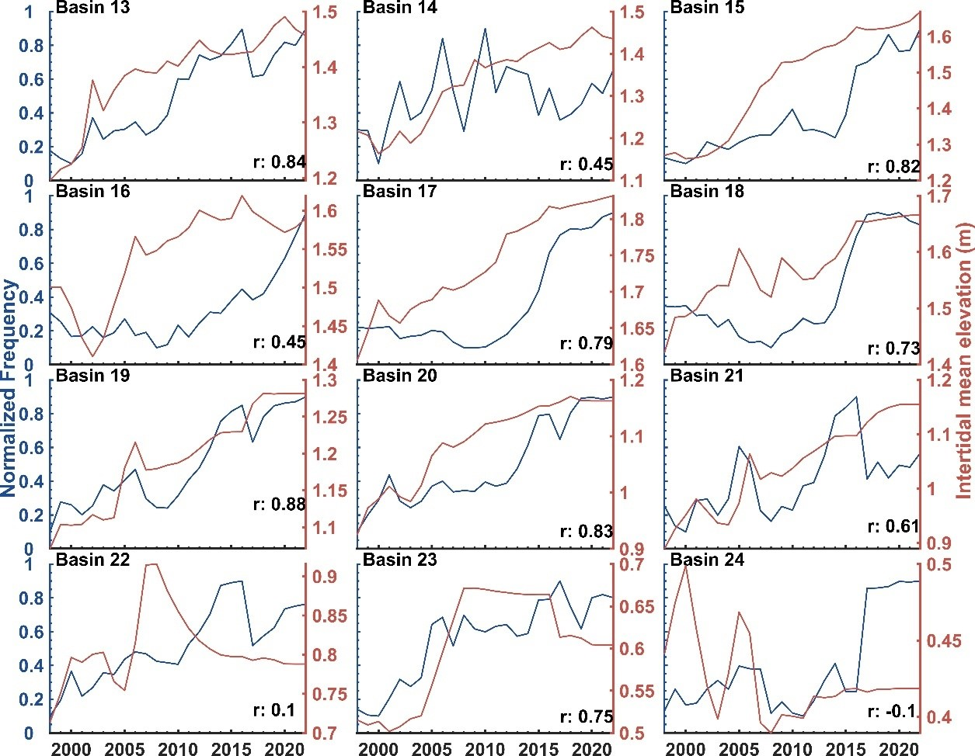
Supplementary Figure 5. Comparison between the mean elevation of intertidal areas of each tidal basin (y-axis on the right) and the normalized high frequency in the frequency domain (y-axis on the left) in the annual time series of DEM from 1998 to 2022.

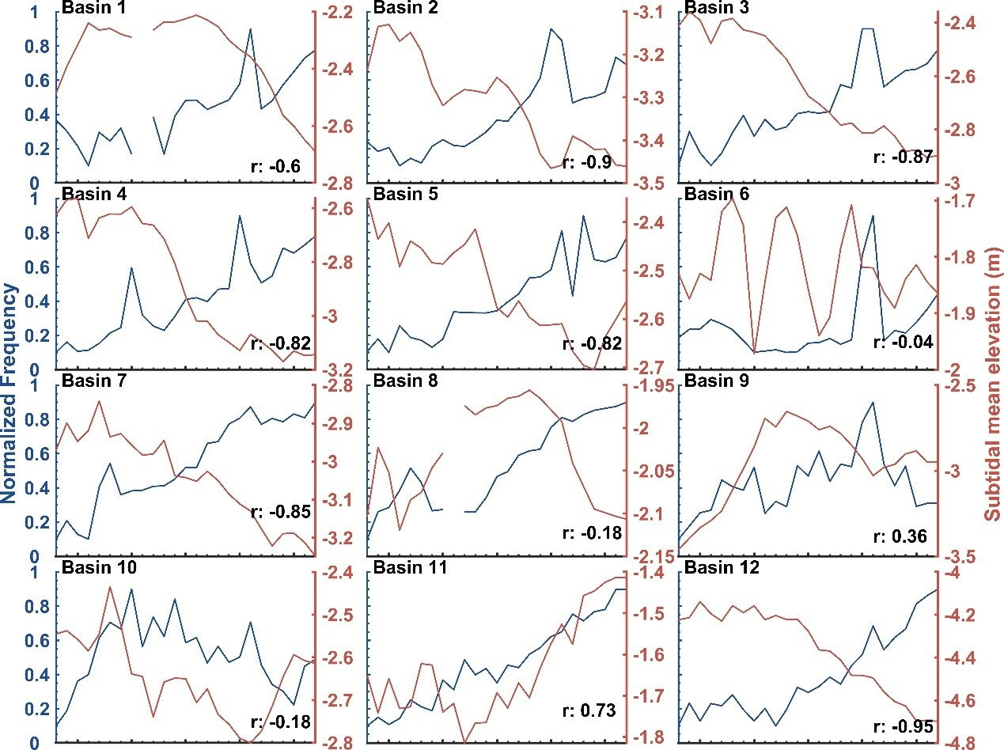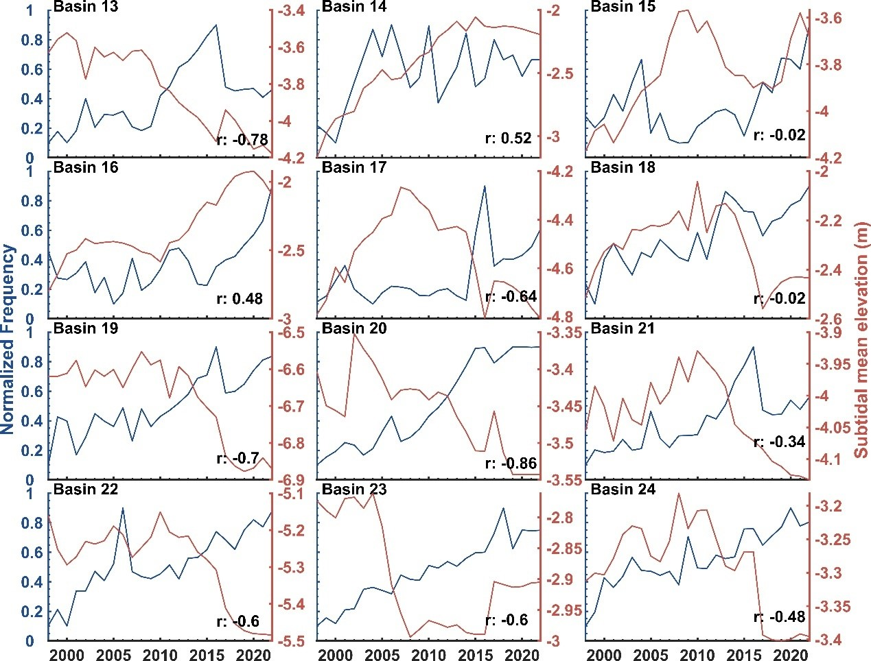
Supplementary Figure 6. Comparison between the mean elevation of subtidal areas of each tidal basin (y-axis on the right) and the normalized high frequency in the frequency domain in the annual time series of DEM from 1998 to 2022.
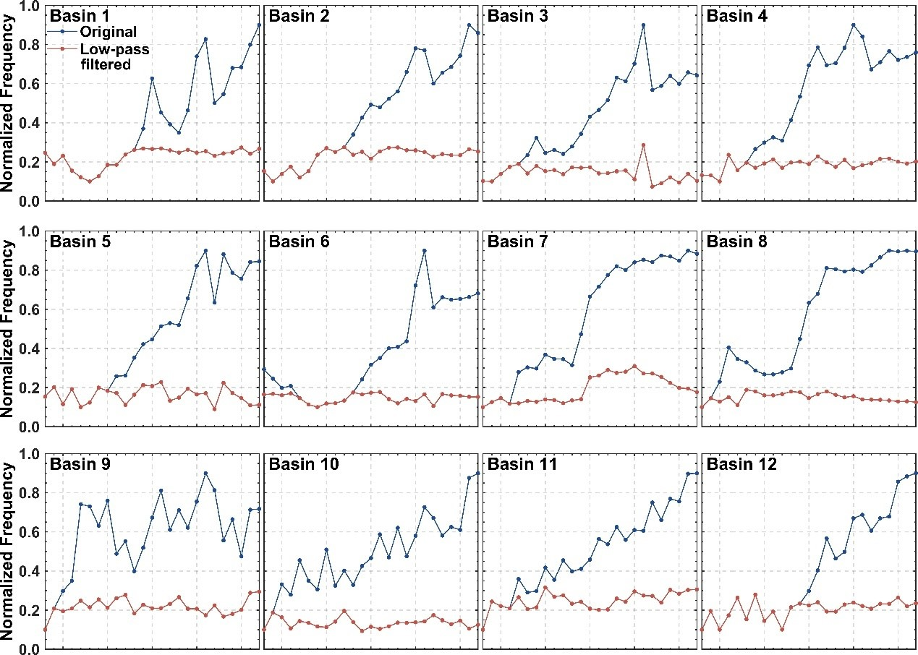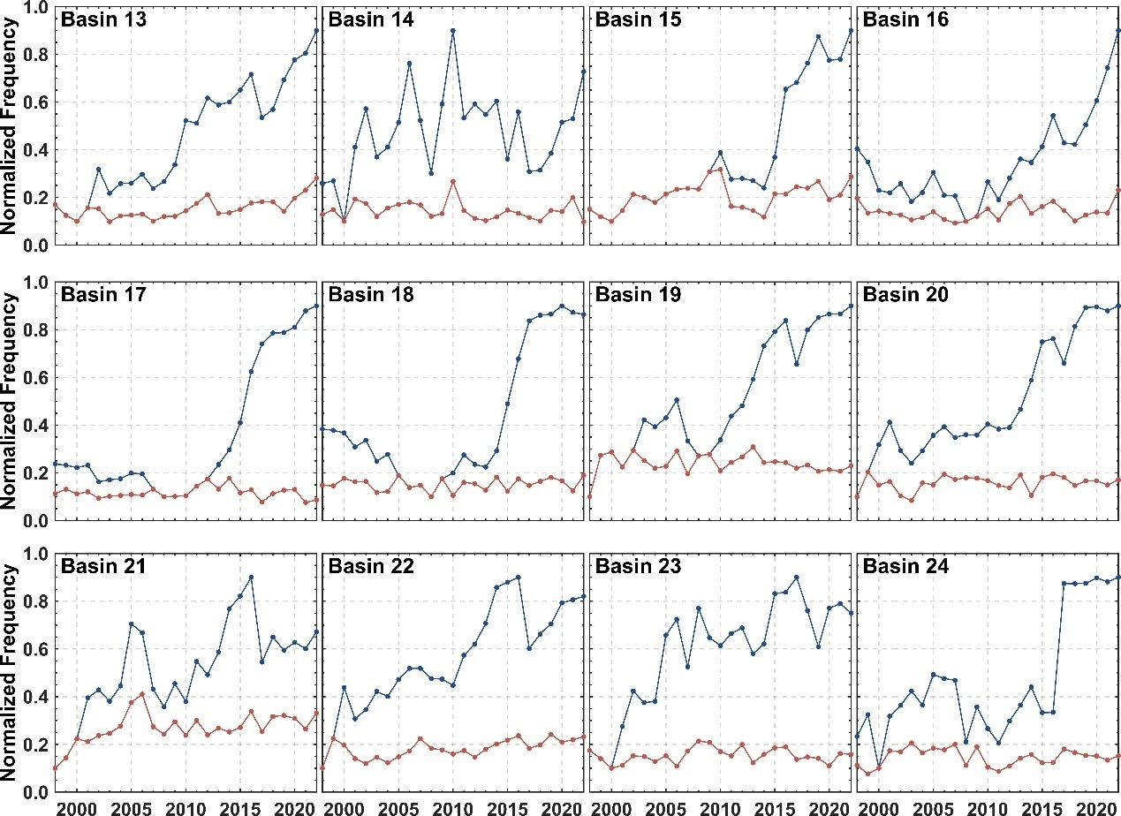
Supplementary Figure 7. Comparison of the normalized high frequency of intertidal areas of the 24 tidal basins between the original annual time series of DEM and low-pass filtered DEM (Solution #2) from 1998 to 2022.
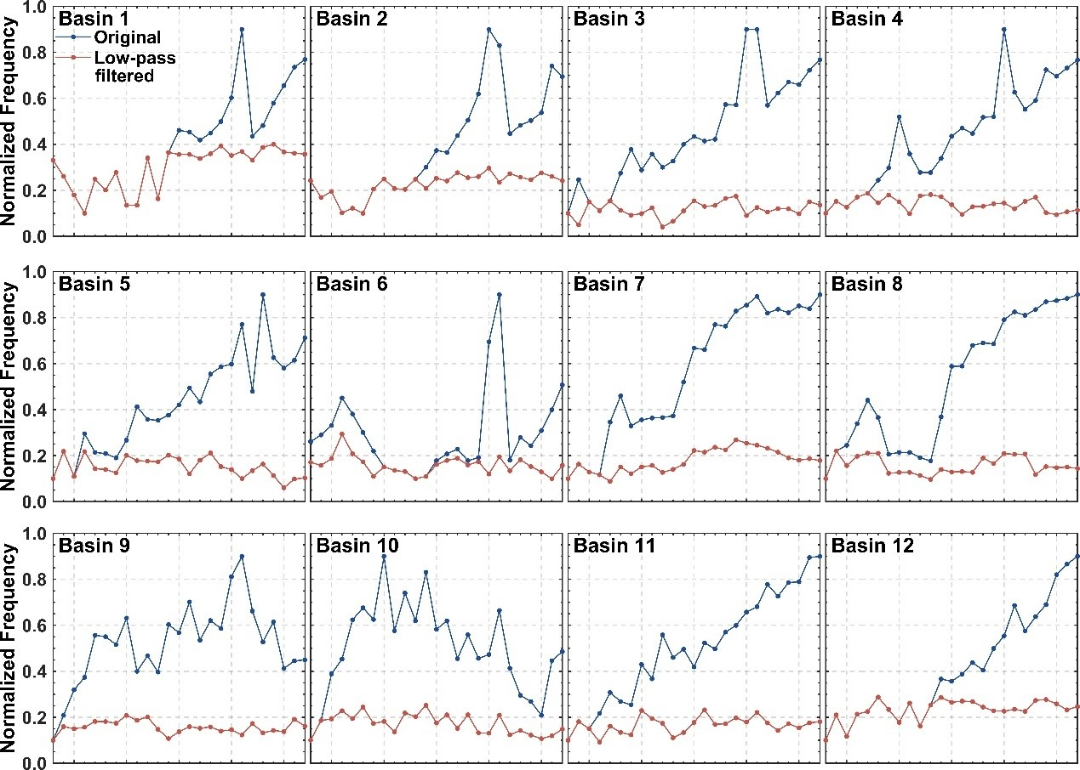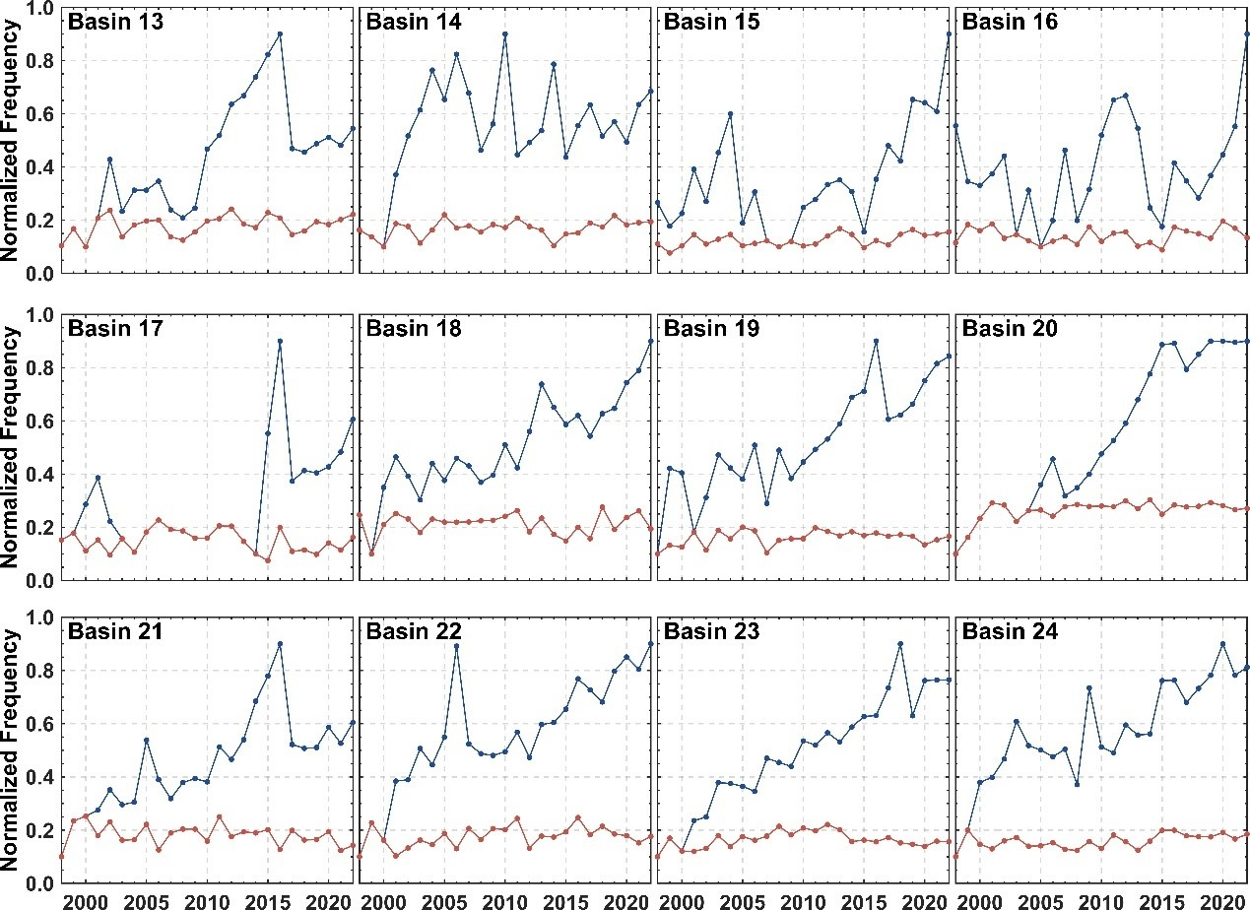
Supplementary Figure 8. Comparison of the normalized high frequency of subtidal areas of the 24 tidal basins between the original annual time series of DEM and low-pass filtered DEM (Solution #2) from 1998 to 2022.
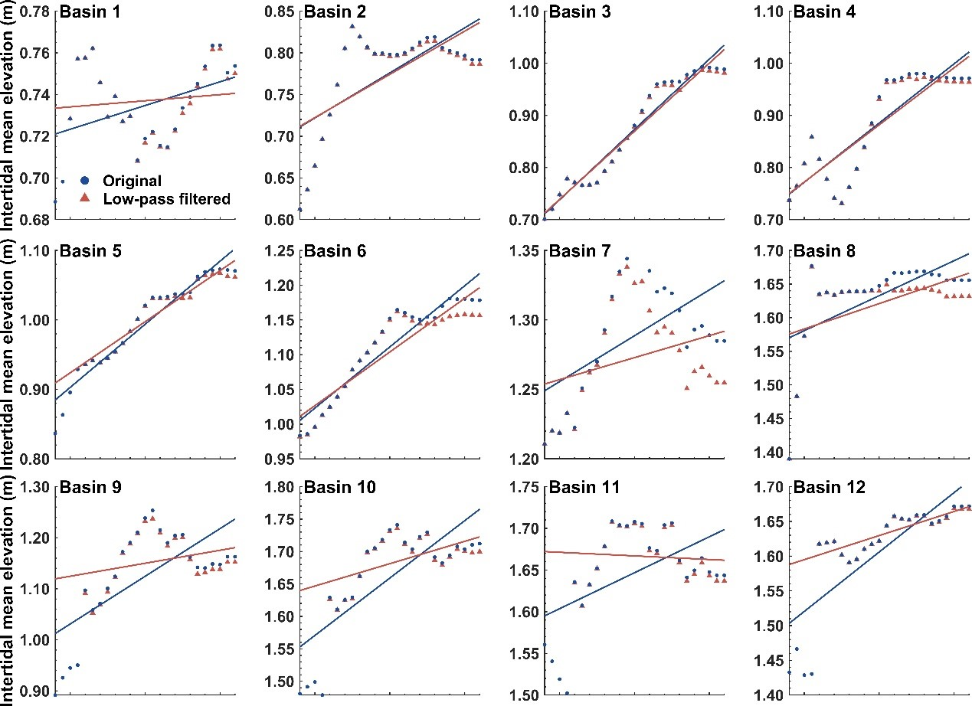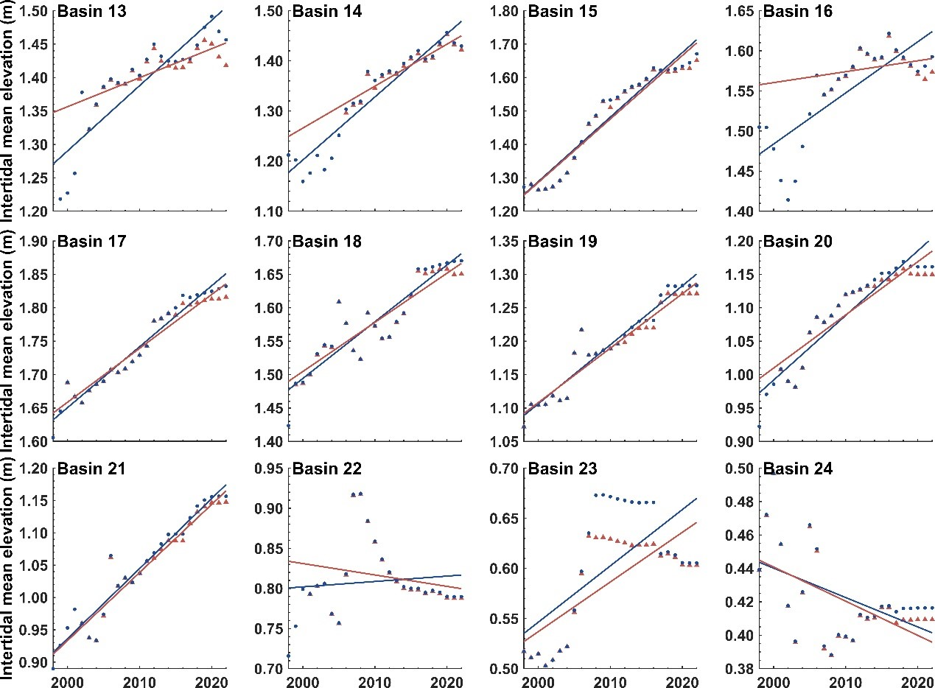
Supplementary Figure 9. Comparison of the mean elevation of intertidal areas of the 24 tidal basins and corresponding linear regression trendlines between the original annual time series of DEM and low-pass filtered DEM (Solution #2) from 1998 to 2022.
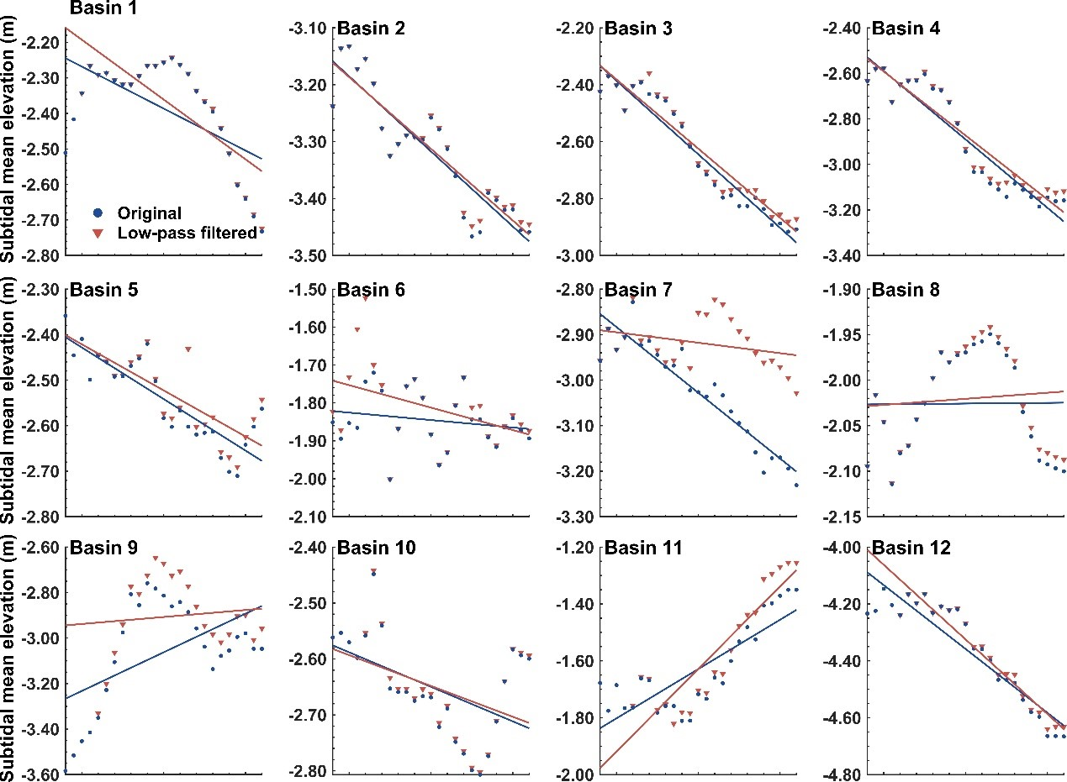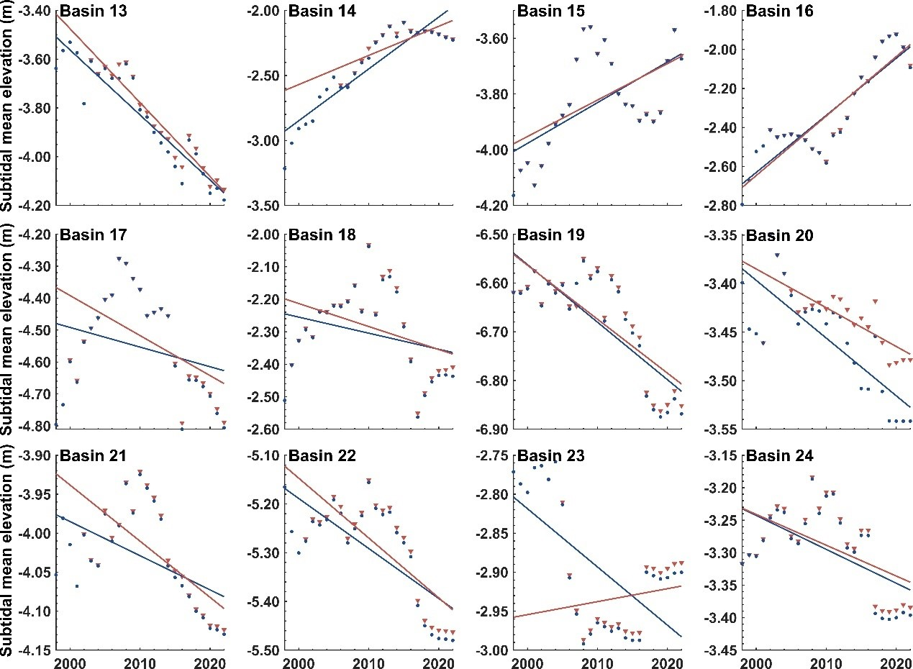
Supplementary Figure 10. Comparison of the mean elevation of subtidal areas of the 24 tidal basins and corresponding linear regression trendlines between the original annual time series of DEM and low-pass filtered DEM (Solution #2) from 1998 to 2022.

Supplementary Figure 11. Examples of artifacts in the annual time series of DEM for individual tidal basins. a, DEM of the Jade Bay for the year 2016 showing an unrealistic strip across the basin. b, Difference in the elevation of the Dorumer Tief (Basin 12) between the year 2001 and 2002 showing an unrealistic systematic lift of the intertidal area.
Supplementary Tabel 1. MLW and MHW of the investigated tidal basins derived from Benninghof & Winter ⁹.
Basin ID | Basin Name | MLW(m) | MHW(m)
1 | Ems-estuary E | -1.22 | 1.20
2 | Osterems | -1.30 | 1.18
3 | Wichter Ee | -1.31 | 1.25
4 | Otzumer Balje | -1.35 | 1.28
5 | Harle 1 | -1.41 | 1.31
6 | Harle 2 | -1.57 | 1.44
7 | Jade | -1.80 | 1.65
8 | Jadebusen | -2.02 | 1.86
9 | Fahrwasser W | -1.67 | 1.58
10 | Fedderwarderpriel | -1.80 | 1.69
11 | Suezpriel | -1.90 | 1.76
12 | Dorumer Tief | -1.73 | 1.59
13 | Neucappeler Tief | -1.60 | 1.50
14 | Duhner | -1.53 | 1.43
15 | Medemrinne | -1.32 | 1.34
16 | Mittelplate | -1.43 | 1.39
17 | Meldorfer Bucht | -1.66 | 1.45
18 | Eidermündung 1 | -1.54 | 1.38
19 | Norderhever | -1.55 | 1.38
20 | Rummelloch | -1.37 | 1.25
21 | Süderaue | -1.38 | 1.30
22 | Norderaue | -1.24 | 1.26
23 | Hörnumtief | -1.07 | 1.03
24 | Lister Tief | -0.98 | 0.96

References

- Benninghoff, M. & Winter, C. Recent morphologic evolution of the German Wadden Sea. Sci. Rep. 9, 9293 (2019). https://doi.org/10.1038/s41598-019-45683-1
- Murray, N.J. et al. The global distribution and trajectory of tidal flats. Nature 565, 222-225 (2019). https://doi.org/10.1038/s41586-018-0805-8

