SUPPLEMENTARY MATERIALS

A Novel Method for In Vivo Gene Editing in the Brain of Guppies Using Unique Nanoparticles as Delivery Vehicles

María Camila Monsalve^{1†}, Miguel A. Vergara^{1†}, María Fernanda Vasquez¹, Laura Ávila¹, Alejandro Martínez¹, Juan C. Cruz^{1*}, Natasha I. Bloch^{1*}

¹ Department of Biomedical Engineering, Universidad de los Andes, Bogotá, Colombia
† Co-first authors

* Correspondence:
Natasha Bloch n.blochm@uniandes.edu.co
Juan C. Cruz jc.cruz@uniandes.edu.co

This PDF file includes:
Supplementary Methods
Figs. S1 to S12
Tables S1

SUPPLEMENTARY FIGURES

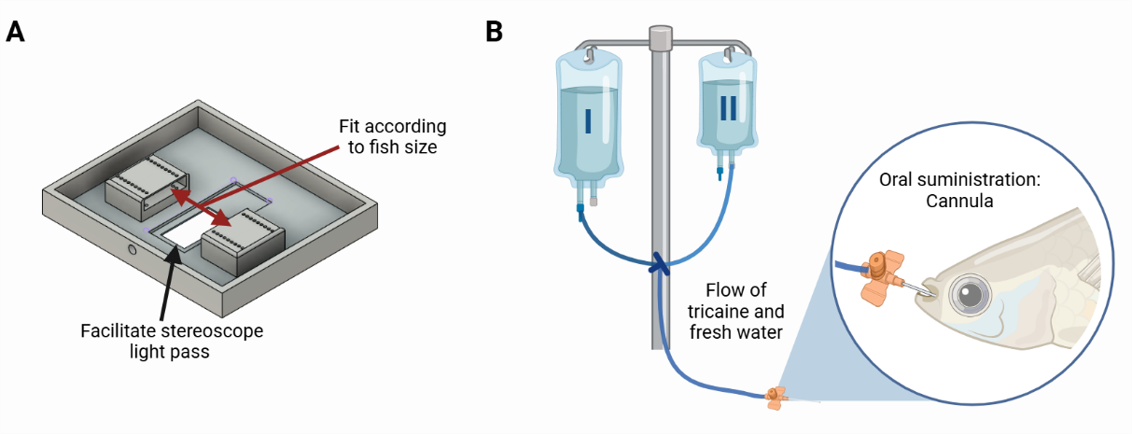
Fig. S1: Surgical Apparatus, Anesthesia and Life Support System (A) Schematic of the custom 3D-printed surgical bed designed for ICV injections, featuring adjustable components to fit different fish sizes and an open section to facilitate stereomicroscope light pass. (B) Schematic of the gravity-fed life support system used for anesthesia maintenance, with dual reservoirs containing tricaine methanesulfonate (MS-222) and freshwater. Anesthetic delivery is controlled via a three-way valve, and administration is performed through an oral cannula to ensure continuous perfusion during surgery.

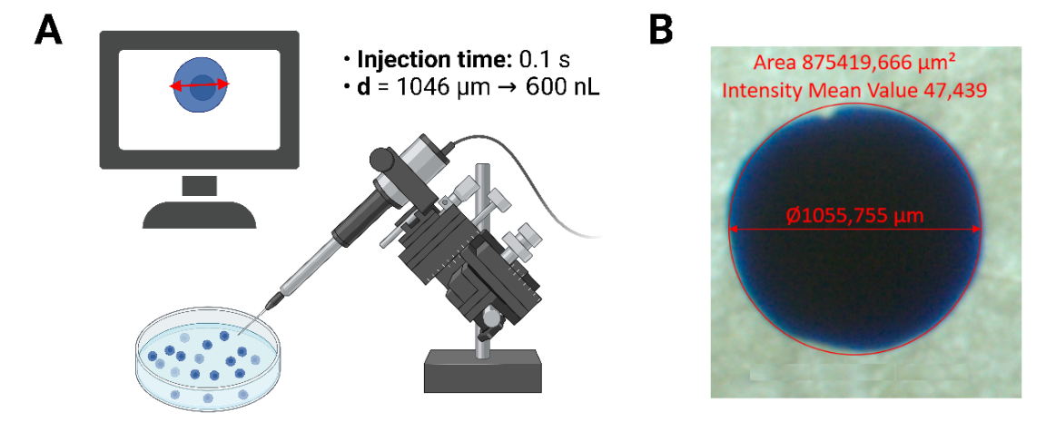
Fig. S2: (A) Diagram for the calibration of the microinjection volume. (B) Calibration of microinjection volume by measuring Evans blue bubble on slide or petri dish before aspiration (using ZenBlue program).
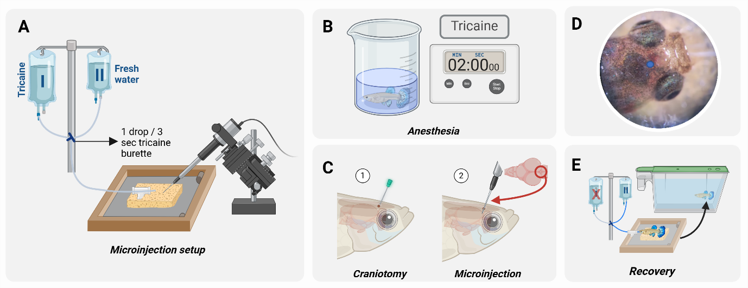
Fig. S3: Microinjection protocol (A) The general setup is prepared with two buretrols: I. buffered tricaine methanesulfonate solution (MS222, 0.25 mg/mL, buffered with Tris Buffer to pH = 7.0) and, II. fresh water. (B) The subject is immersed in tricaine (0.3 mg/mL) until loss of movement. (C) A craniotomy is performed targeting the ridge between the optic tectum and the telencephalon that can be seen by transparency, followed by the microinjection on top of the third ventricle (D) Craniotomy and microinjection site, directly above the third ventricle. (E) Fresh water is administered to start the recovery process.

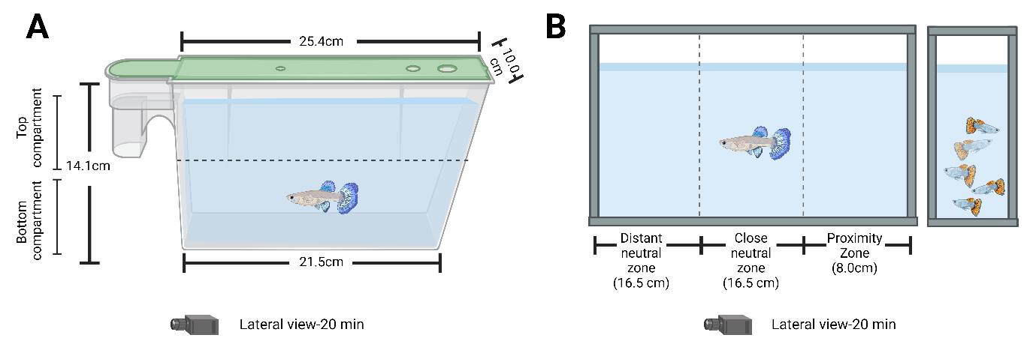
Fig. S4: Behavioral Assays. (A) Novel Tank test: in this assay we measured the time spent in the bottom compartment relative to total time, swimming distance [cm], freezing duration relative to total test time and swimming velocity [cm/s]. (B) Social Interaction test. In this assay we measured the time spent in each zone.

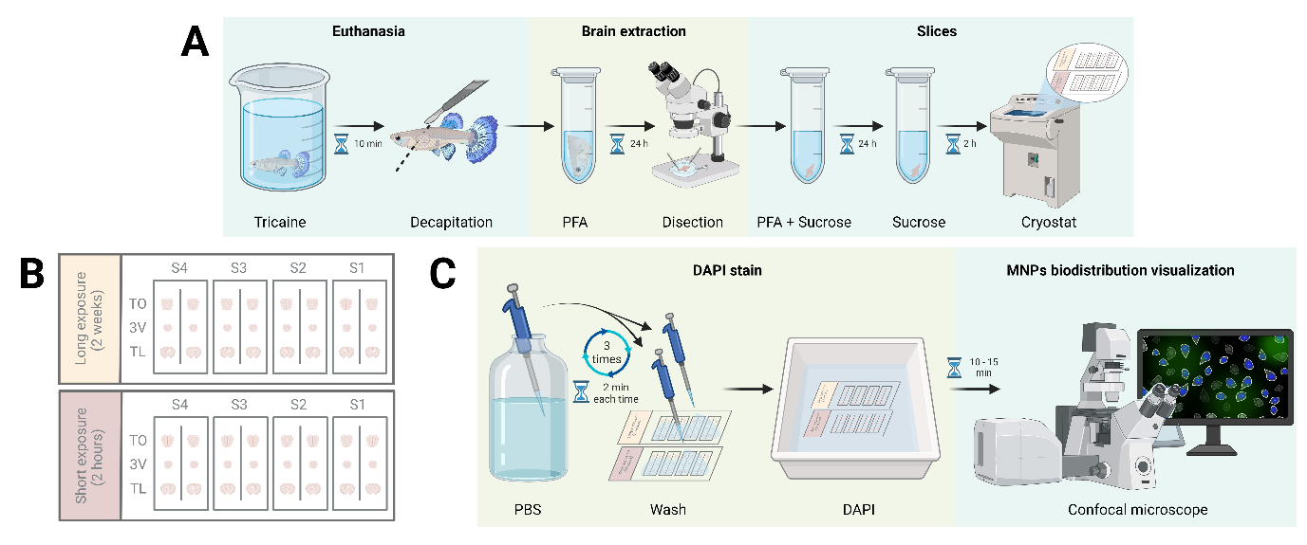
Fig. S5: Cellular uptake assay (A) Sample preparation: the subject was euthanized, the brain was dissected and fixed to perform cryostat brain sectioning. (B) Two groups of four subjects each, were studied: one group was euthanized 2 hours post-injection and the other after 2 weeks. Sections from telencephalon (TL), around the third ventricle (3V) and optic tectum (TO) were obtained for each brain sample. (C) The slides were washed and stained with DAPI, and were then observed and photographed in a confocal microscope.

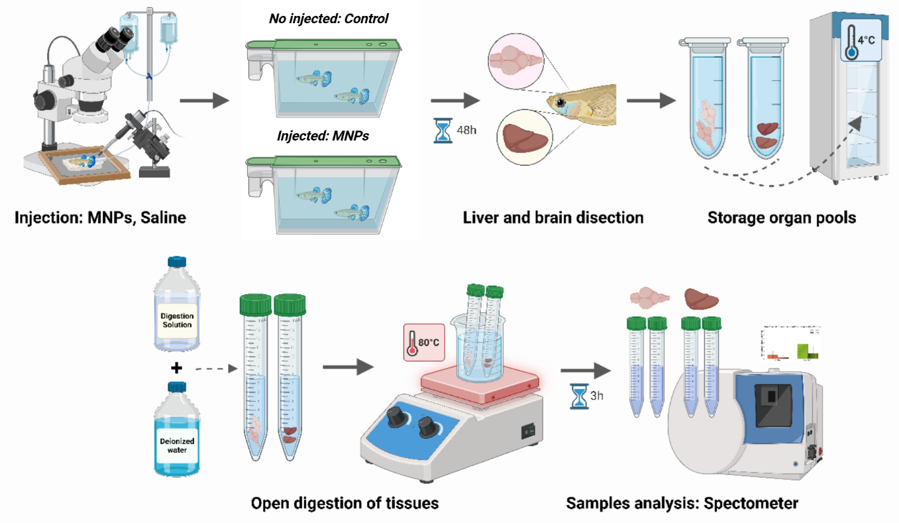Fig. S6: Systemic distribution assay to determine iron concentration in liver and brain using inductively coupled plasma optical emission spectroscopy (ICP-OES).

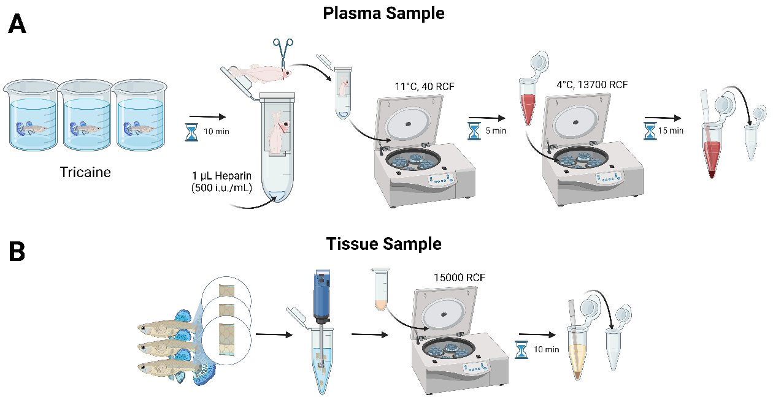
Fig. S7: Hepatic function test – Sample Preparation: (A) For the Plasma sample extraction a pool of three subjects were euthanized, decapitated and centrifuged. (B) For the Tissue sample extraction, a piece from each one of the three subjects was extracted and homogenized together. The supernatant after centrifugation was obtained.

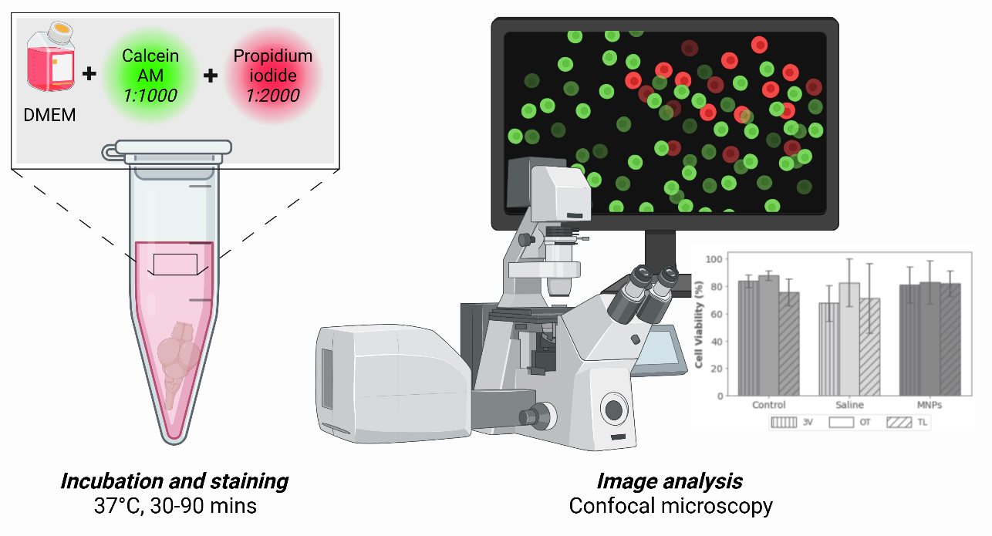
Fig. S8: Cytotoxicity assay. Live/dead cell viability assay using Calcein-AM and Propidium Iodide staining. Viable cells fluoresce green (Calcein-AM), while non-viable cells fluoresce red (PI). Confocal microscopy images were analyzed to quantify cell viability in each experimental group.

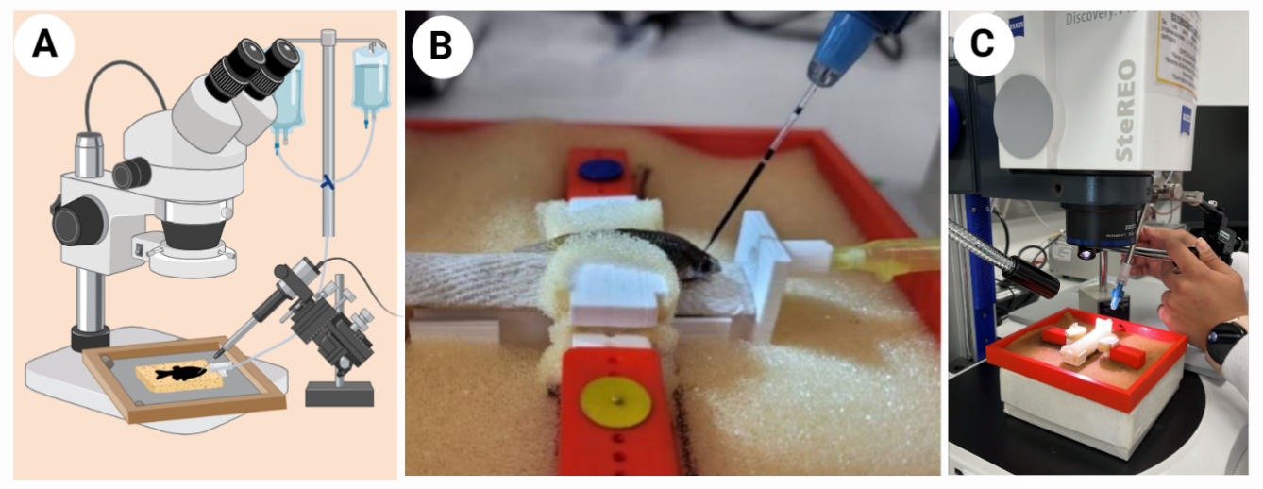
Fig. S9: Microinjection setup: Setup of the workspace for the ICV microinjection procedure showing A) 3D printed custom surgical bed and the microinjector placed under stereomicroscope and B) a female guppy being injected with Evans dye while receiving constant light anesthesia. C) zoom-in of surgical bed setup.

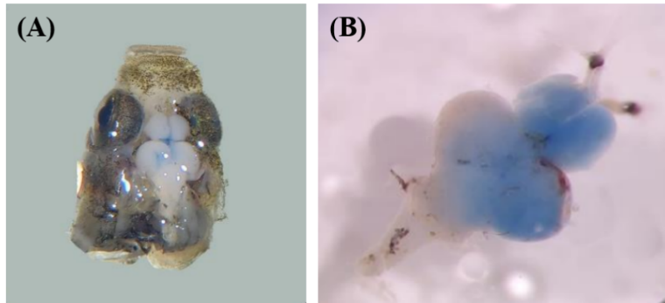
Fig. S10. Brains injected with Evans Blue dye. Examples of individuals injected with Evans blue to standardize injection protocol showing (A) injection site and (B) dye diffusion in brain tissue 2 hours post-injection.

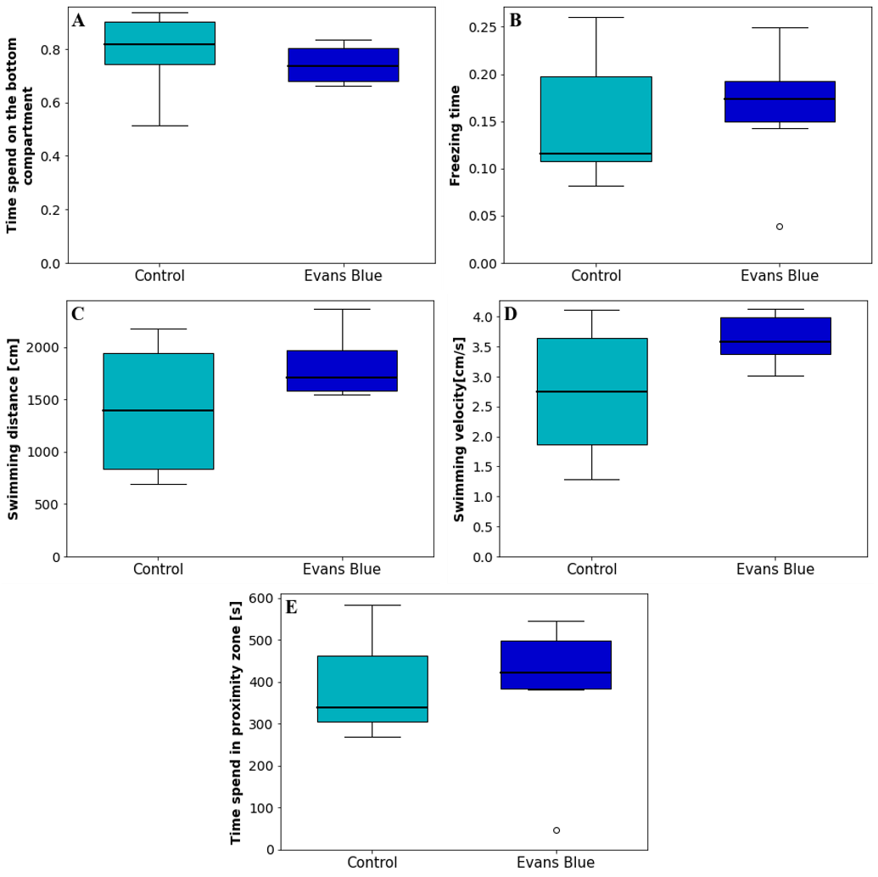
Fig. S11. Behavioral effects after Evans blue ICV injection. Novel tank test (measured 10min after injection): (A) Time spent in bottom compartment relative to total test time, (B) Freezing duration relative to total test time (C) Swimming distance [cm] and (D) Mean swimming velocity [cm/s]. Social interaction test (measured 48h after injection): (E) Time spent in proximity zone [s].

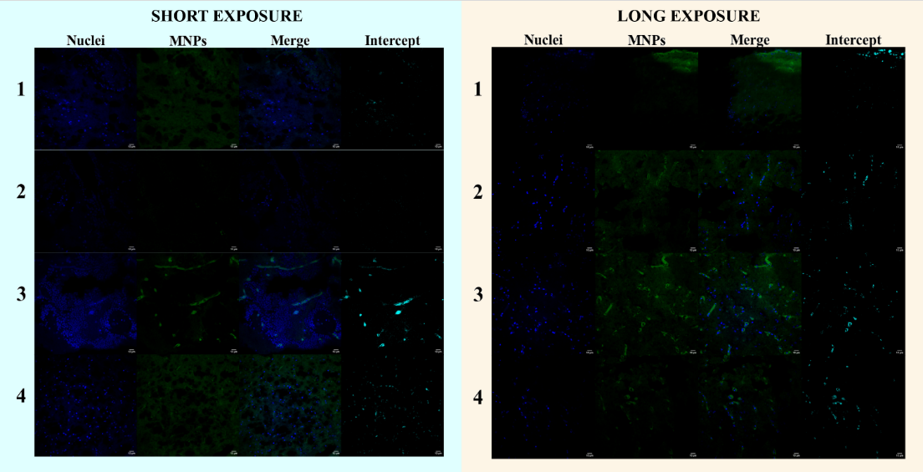
Fig. S12. Results of cellular uptake to estimate nuclear colocalization rate: analysis and processing for each subject cryosections corresponding to tissues around the third ventricle: (A) Nuclei stained with DAPI, (B) MNPs marked with SYBR-Green, (C) overlaid nuclei (blue) with MNPs (green) channels, (D) regions where both signals coincide, indicating nuclear uptake of the MNPs.

SUPPLEMENTARY TABLES

Table S1: Transfection rates: cellular uptake.
Nuclear transfection (intercept between Nuclei and MNPs)
Nuclear transfection  Replicate | Short exposure group |  |  |  | Long exposure group
Nuclear transfection  Replicate | Individual 1 | Individual 2 | Individual 3 | Individual 4 | Individual 1 | Individual 2 | Individual 3 | Individual 4
Nuclei (count) | 387 | 680 | 435 | 398 | 209 | 310 | 276 | 225
Intercept (count) | 194 | 74 | 320 | 117 | 94 | 183 | 172 | 117
% | 50,13% | 10,88% | 73,56% | 29,40% | 44,98% | 59,03% | 62,32% | 52,00%
Average | 40,99% |  |  |  | 54,58%
SD | 26,99% |  |  |  | 7,71%

SUPPLEMENTARY METHODS

Chemicals for nanoparticles synthesis
Iron (II) chloride tetrahydrate (98%), iron (III) chloride hexahydrate (97%), acetic acid glacial (99.7%), sodium hydroxide (NaOH) (98%), and tetramethylammonium hydroxide (TMAH) (40%) were obtained from PanReac AppliChem (Barcelona, Spain). (3-aminopropyl) triethoxysilane (APTES) (98%), N-[3-(dimethylamino)-propyl]-N′-ethylcarbodiimide hydrochloride (EDC) (98%), N-hydroxysuccinimide (NHS) (98%), sodium chloride (NaCl) (99%), glutaraldehyde (25%), amine-PEG12-amine (NH2-PEG12-NH2), dimethyl sulfoxide (DMSO) (99.9%), rhodamine B (95%), phosphate buffered saline (PBS, pH 7.2), Propidium iodide were purchased from Sigma-Aldrich (St. Louis, MO, USA). 3-[(2-aminoethyl) dithiol] propionic acid (AEDP) was purchased from Thermo Fisher Scientific (Waltham, MA, USA). Calcein AM was purchased from Abcam (Cambridge, UK). Buforin II (BUF-II, TRSSRAGLQFPVGRVHRLLRK) was synthesized by GL Biochem Shanghai (Shanghai, China).

Brain ventricle microinjection
Microinjections were performed using a PM 1000 Cell Microinjector (MDI) with 09 PSI balance pressure, 02 PSI hold pressure, vent function activated, and an injection time of 0.1 s. The injection pressure was adjusted to achieve a volume of 600 nL.
To calibrate the injection pressure, tuning was conducted after opening the needle tip. Evans Blue injection was tested by inserting the needle tip into a mineral oil solution, allowing the injected bubble to form a nearly perfect semi-spherical shape upon injection. A photo was taken using the Zen Blue program, and the diameter was measured. Assuming the suspended bubble has the volume of a hemisphere, the expected diameter was 1046 µm. (Fig. S2).

Cellular uptake – Image Processing
We uploaded the .oib files to ImageJ software and assigned each channel the corresponding LUT (1: Blue, 2: Green, 3: Red). We selected a specific Z-plane based on content and image quality, then reduced the stack to a single image based on the chosen Z-plane. We removed the red channel, as it only served to visualize tissue location during Z-plane selection.
To obtain background green-channel intensity, we uploaded the control sample. We converted both the control sample and the green channel of the treatment image to 8-bit. Using the Image Calculator function, we subtracted the control sample from the treatment sample (green channel only) and set the result as the new green channel.
We applied a threshold to both the blue and green channels to isolate the nuclei and MNPs, respectively. For the green channel, we typically set the threshold close to 11.45%.
Jaccard Ratio (IoU)
To calculate the Jaccard Ratio, we used the Image Calculator function to perform an AND operation on the blue-thresholded and green-thresholded images. We analyzed the resulting mask using the Analyze Particles function (size: 0 to infinity), where the obtained area corresponded to the Intersection. Next, we applied the OR operation to the same images and used the resulting area as the Union. We calculated the Jaccard Ratio as follows:
$$IoU=\frac{Intercept}{Union}$$
Nuclear transfection efficiency
To determine nuclear transfection efficiency, the Analyze Particles function was applied to the blue-thresholded image (size: 0.1 to infinity) to record the count value. The previously obtained AND/Intersection mask was then analyzed in the same manner, with the count value registered. The nuclear transfection efficiency was calculated by dividing the latter count by the former.
Hepatic health
Enzymatic assays standardization
We standardized the measurement of blood and tissue samples for each enzyme kit to ensure that absorbance and fluorescence values remained within the range of the standard curve. We then performed enzymatic measurements with slight modifications to reagent quantities to optimize kit efficiency. To minimize systematic errors, we conducted three technical replicates for each biological replicate. We measured AST and ALP activities using plasma samples, while ALT activity was measured in tissue samples. Finally, we analyzed absorbance and fluorescence data using the formulas provided in the respective kit protocols to calculate enzymatic activity.
Protocol adjustment
ALT Enzyme Kit (MAK052, Sigma-Aldrich): we followed the protocol steps outlined in the documentation. We adjusted samples to a final volume of 10 µL (instead of the recommended 20 µL) using the ALT Assay Buffer. We then added 50 µL of Master Reaction Mix to each well containing standards, positive controls, and test samples. Tissue samples were prepared from 50 mg of tissue lysate, ensuring equal amounts were collected from each fish in the pool. For each technical and biological replicate, we used 2 µL of homogenized tissue.
AST Enzyme Kit (ab105135, Abcam): we followed the documented protocol, adjusting samples to a final volume of 25 µL (instead of the recommended 50 µL) using Assay Buffer XIX/Assay Buffer. We then added 50 µL of Reaction Mix to each well containing standards, positive controls, and test samples. For each technical and biological replicate, we used 5 µL of blood plasma.
ALP Enzyme Kit (ab83371, Abcam): we adhered to the protocol and used 1 µL of homogenized tissue (diluted 1:500) for each technical and biological replicate.

Cytotoxicity (Life and dead) – Image processing
We preprocessed images using ImageJ to reduce noise and enhance the color intensity of fluorescent cells. We then measured cell viability through image analysis using a custom Python script. First, we separated images into their corresponding green and red channels, as each channel represented fluorescence from live and dead cells, respectively.
To count the cells in each image, we implemented a segmentation algorithm based on the watershed method. We first reduced noise using morphological operations. Next, we calculated the elevation map of each channel using the Sobel filter, which identified regions with high-intensity variations between the foreground (fluorescent cells) and the background. We obtained segmentation markers using Otsu’s thresholding, as the images exhibited a typical bimodal distribution, making this method well-suited for segmentation.
The resulting segmented images allowed us to count the total number of components, labeling connected components using 8-connectivity. Finally, we determined cell viability by counting the number of components in the green channel as live cells and those in the red channel as dead cells. Viability was then calculated using the following formula:
$$Viability=\frac{live cells}{live cells+dead cells}×100\%$$

