Supplementary Material

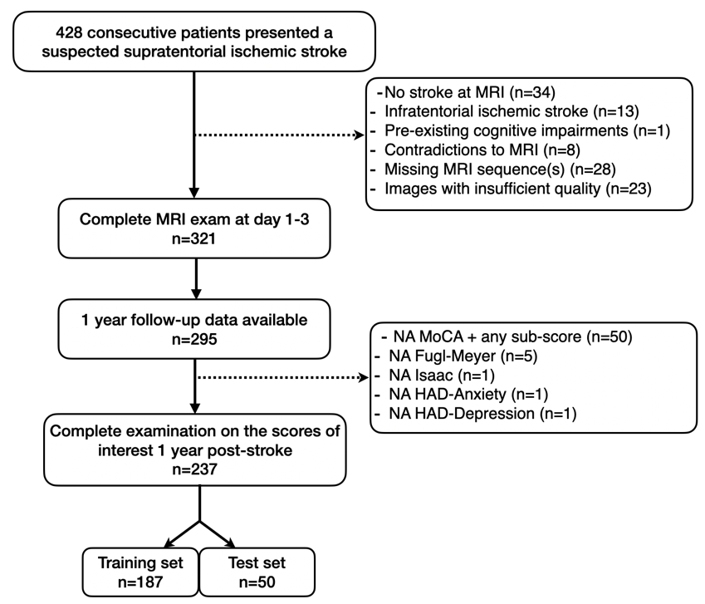
Supplementary Figure 1. Flowchart for the sub-dataset used in the NEURAL2023. NA: non-available.

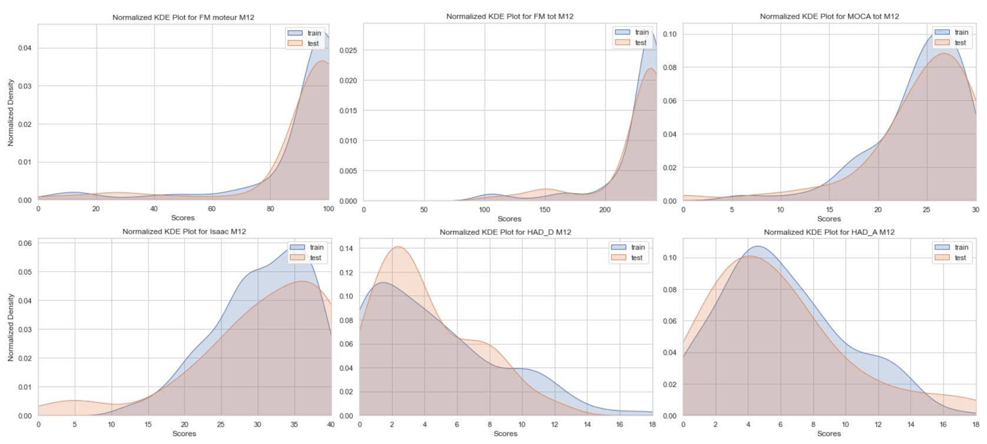

Supplementary Figure 2. Normalized Kernel Density Estimation (KDE) Plots for the scores FM_motor, FM_total, MoCA, IST, Had-A, and HAD-D visualizing the largely overlapping distributions of the continuous training and test set variables.

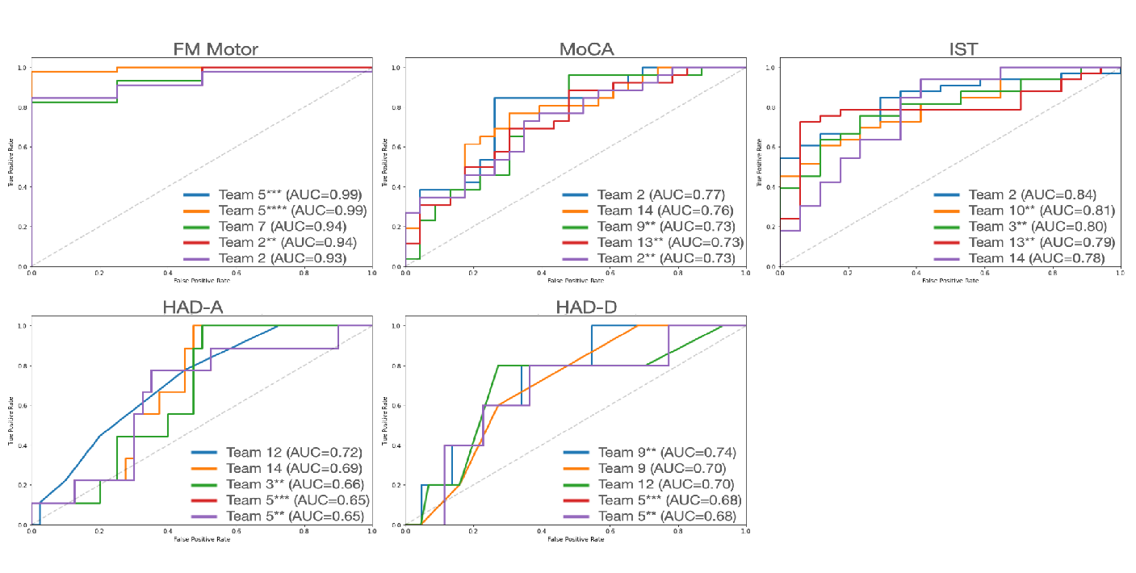

Supplementary Figure 3. ROC Curves for the five best predicting teams on a specific score.
ROC Curves for the five best predicting teams
Supplementary Table 1. Methodological Approaches.

 |  |  | Method |  | Description |  | Example*
 | Producing predictions |  | Artificial Neural Networks (ANNs) |  | Computational models consisting of interconnected nodes organized in layers, which are applied together to process and learn from data; showing the presence of key components such as nodes, layers (input layer, hidden layers, output layer), weights and biases, and an activation function |  | neural network model ‘multi-layer perceptron regressor’; convolutional neural networks with multiple hidden layers
 |  |  | Regression Models |  | Analysis of the relationship between a dependent variable and one or more independent variable(s) |  | Support Vector Machines; Gradient Boosting Trees Regression; unregularized regression; elastic regression, ridge regression
 | Data extraction/ representation |  | Feature Selection |  | additional ways to select a subset of relevant features for the prediction model (if any additional analyses involving evaluation of model performance were implemented); if feature selection was embedded into the model (e.g., L2 regularization in ridge regression), the feature was not considered as used by the team |  | selection of useful features based on MSE; stability selection using partial least squares variables importance
 |  |  | Clustering |  | Techniques used to group together data into clusters, so that the datapoints within the same cluster are more similar to each other than to those in other clusters |  | hierarchical clustering; k-means
 |  |  | Dimension Reduction |  | Reducing the data complexity (e.g., number of input variables in a dataset), while retaining as much information as possible |  | Aggregation of T1 signal intensity quantiles; PCA; translating a 3D image into 2D
 |  |  | Parcellation/Segmentation |  | Based on atlases, division of the brain into distinct regions or parcels for the purpose of analyses (e.g., only taking into account a specific brain region to use as model input) |  | AAL3 segmentation (anatomical parcellation atlas); white matter resting state atlas; white matter atlas; gray matter atlas; Lesion Quantification Toolkit atlas
Prediction validation/ generalization |  | Cross Validation |  | Evaluation of the performance and the generalizability of the model by partitioning the training data into subsets, from which some are used for training and some for validation |  | nested cross validation, k-folds cross validation
 |  | Bootstrapping |  | Statistical resampling technique to estimate the distribution of a sample statistic by repeatedly sampling with replacement from the original data |  | Stability selection with 250 bootstraps to compute feature reliability and apply thresholds

*From the approaches described by the participating teams.

Supplementary Formula 1. Mean Absolute Error.
$$MAE= \frac{1}{n}\sum_{i=1}^{n}{|y_{i}-{\hat{y}}_{i}|}$$
Note: Formula for MAE, where n is the number of observations in the dataset, $y_{i}$ is the true value, and ${\hat{y}}_{i}$ is the predicted value.

Supplementary Formula 2. Mean Squared Error.
$$MSE= \frac{1}{n}\sum_{i=1}^{n}{{(y_{i}-{\hat{y}}_{i})}^{2}}$$
Note: Formula for MSE, where n is the number of observations in the dataset, $y_{i}$ is the true value, and ${\hat{y}}_{i}$ is the predicted value.

Supplementary Table 2: Detailed results of all participating teams’ predictions based on R². The number of the prediction is indicated in the parentheses.
Team/Test | MOCA | IST | FM total | FM motor | HAD-A | HAD-D
1 | 0,01351 | 0,02316 | 0,13986 | 0,15688 | 0,0442 | 0,01069
2 | 0,12275 | 0,34134 | 0,13644 | 0,00056 | 0,08066 | 0,00074
2 (second) | 0,1356 | 0,33093 | 0,22993 | 0,38935 | 0,0017 | 0,00469
3 | 0,05581 | 0,03288 | 0,21143 | 0,2771 | 0,02127 | 0,01484
3 (second) | 0,12786 | 0,16645 | 0,27794 | 0,27211 | 0,13763 | 0,03134
4 | 2,96E-05 | 0,00183 | 0,0793 | 0,02263 | 0,04104 | 0,00644
5 | 0,11564 | 0,07834 | 0,54122 | 0,61031 | 0,06247 | 0,00074
5 (second) | 0,21302 | 0,26255 | 0,14462 | 0,18761 | 0,0573 | 0,01506
5 (third) | 0,30151 | 0,35293 | 0,54122 | 0,61031 | 0,0573 | 0,00523
5 (fourth) | 0,30151 | 0,26255 | 0,14462 | 0,18761 | 0,0573 | 0,00523
6 | 0,0964 | 0,19652 | 0,06736 | 0 | 0 | 0,00897
7 | 0,03343 | 0,00372 | 0,26613 | 0,44306 | 0,00192 | 0,00045
8 | 0,01788 | 0,00829 | 0,06574 | 0,08828 | 0,00672 | 7,50E-05
9 | 0,07174 | 0,07969 | 0,41296 | 0,26276 | 0,00088 | 0,03353
9 (second) | 0,04781 | 0,02058 | 0,01836 | 0,04348 | 0,00025 | 0,01379
9 (third) | 0,16928 | 0,12189 | 0,13951 | 0,05954 | 0,02671 | 0,01291
10 | 0,00229 | 0,01222 | 0,0155 | 0,00205 | 0,00747 | 0,02976
10 (second) | 0,13121 | 0,27921 | 0,26407 | 0,22439 | 0,1039 | 5,27E-08
11 | 0,07917 | 0,00191 | 0,17619 | 0,29507 | 0,02978 | 0,01542
12 | 0,10334 | 0,14672 | 0,04777 | 0,02022 | 0,01815 | 0,0081
13 | 0,00648 | 0,10759 | 0,11906 | 0,2121 | 3,5E-05 | 0,02496
13 (second) | 0,14485 | 0,2963 | 0,23523 | 0,22099 | 0,05248 | 0,02844
14 | 0,16802 | 0,13746 | 0,29525 | 9,76E-05 | 0,0853 | 0,00038
15 | 0,13496 | 0,06262 | 0,18748 | 0,21928 | 0 | 0

Supplementary Table 3: Detailed results of all participating teams’ predictions on MoCA sub-scores based on R². The number of the prediction is indicated in the parentheses.
Team/Test | Visuospatial | Denomination | Attention | Language | Abstraction | Rappel | Orientation
1 | 0,00047 | 0,06724 | 0,04578 | 0,05266 | 0,01446 | 0,00506 | 0,07708
2 | 0,03519 | 0,0137 | 0,22405 | 0,11657 | 0,07207 | 0,03065 | 0,00575
2 (second) | 0,00545 | 0,53908 | 0,17441 | 0,0292 | 0,24319 | 0,12556 | 0,00913
3 | 0,02326 | 0,19019 | 0,06504 | 0,09289 | 0,16818 | 0,00737 | 0,00361
3 (second) | 0,01791 | 0,18252 | 0,1043 | 0,07346 | 0,19457 | 0,02837 | 0,01426
4 | 0,00151 | 0,02171 | 0,13146 | 0,01186 | 0,00033 | 0,06497 | 0,00111
5 | 0,0152 | 0,06568 | 0,22441 | 0,10874 | 0,03333 | 0,00767 | 0,04066
5 (second) | 0,02745 | 0 | 0,23311 | 0 | 0,09617 | 0,0119 | 0,0911
5 (third) | 0,0906 | 0,00179 | 0,23426 | 0,09606 | 0,14625 | 0,00139 | 0,00079
5 (fourth) | 0,0906 | 0,00179 | 0,23311 | 0,00484 | 0,09617 | 0,0119 | 0,0005
6 | 0,02559 |  | 0,03447 | 0,07435 | 0,0249 | 0,12895 | 0,08815
7 | 0,00145 | 0,04116 | 0,18179 | 0,20873 | 0,22386 | 0,07279 | 0,00829
8 | 0,01203 | 0,00163 | 0,00393 | 0,08973 | 0,05076 | 0,00616 | 0,04319
9 | 0,03891 | 0,13889 | 0,26267 | 0,09376 | 0,02133 | 0,01523 | 0,02758
9 (second) | 8,14E-05 | 0,20449 | 0,14663 | 0,02743 | 0,0967 | 0,00521 | 0,00833
9 (third) | 0,01842 | 0,24252 | 0,41999 | 0,12416 | 0,01058 | 0,01308 | 0,06912
10 | 0,00229 | 0,00142 | 0,0031 | 0,00164 | 0,1119 | 0,07807 | 0,04832
10 (second) | 0,06013 | 0,01879 | 0,12984 | 0,14577 | 0,11137 | 0,03089 | 0,02164
11 | 0,01351 | 0,00055 | 0,113 | 0,00248 | 0,14846 | 0,00847 | 0,01743
12 | 0,01892 | 0,00019 | 0,00684 | 0,01589 | 0,00726 | 0,00802 | 0,05738
13 | 0,00646 | 0,07279 | 0,03227 | 0,01343 | 0,10135 | 0,0003 | 0,00036
13 (second) | 0,03863 | 0,15996 | 0,10506 | 0,05504 | 0,17045 | 0,05397 | 0,04292
14 | 0,00295 | 0,00703 | 0,12172 | 0,23893 | 0,01018 | 0,05568 | 0,03875
15 | 0 | 0 | 0 | 0 | 0 | 0 | 0

Supplementary Table 4: Complete Table with ‘optimal recipes’ for all predicted scores for each domain.
FEATURE | FM | MOCA | HAD-A | HAD-D | IST
age | 1 | 0 | 0 | 0 | 1
gender | 1 | 0 | 0 | 0 | 1
DWI | 0 | 0 | 0 | 0 | 0
T1 | 1 | 0 | 0 | 0 | 0
segmented lesions | 1 | 1 | 1 | 1 | 1
FLAIR | 0 | 1 | 0 | 0 | 0
tracts | 1 | 0 | 0 | 0 | 0
parcellation atlases | 1 | 0 | 0 | 0 | 0
disconnectomes | 0 | 0 | 1 | 1 | 0
clustering | 1 | 1 | 0 | 0 | 0
ANNs | 1 | 0 | 1 | 1 | 0
regression | 0 | 0 | 1 | 1 | 1
feature selection | 1 | 1 | 0 | 0 | 0
dimension reduction | 0 | 1 | 0 | 0 | 1
parcellation | 0 | 0 | 0 | 0 | 0
cross validation | 0 | 0 | 0 | 0 | 1
bootstrapping | 0 | 0 | 0 | 0 | 0
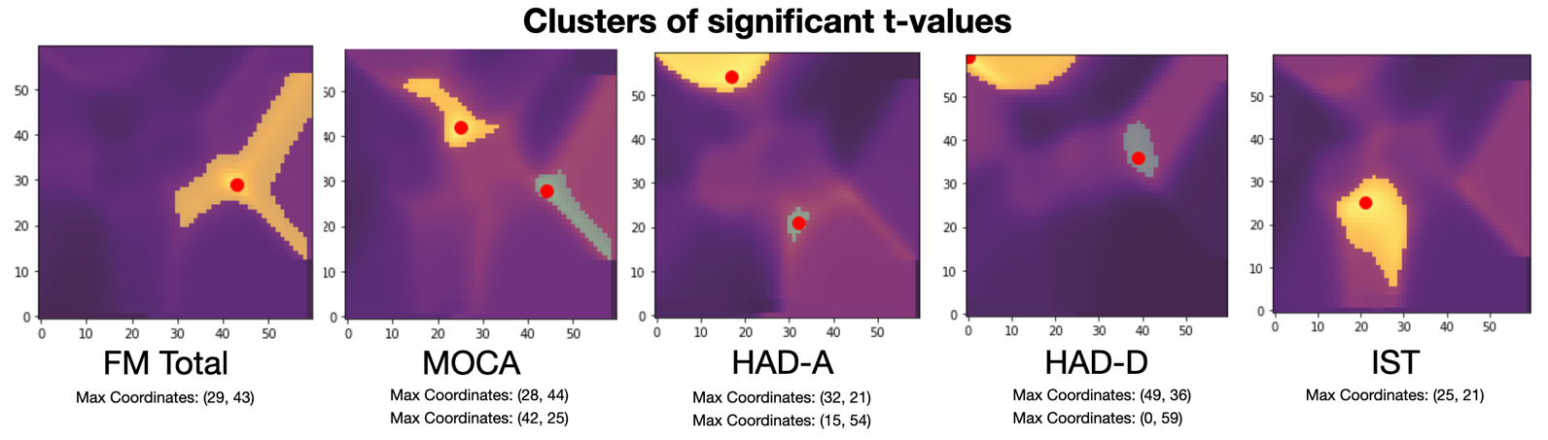

Supplementary Figure 4. Clusters of significant t-values. For MoCA, HAD-A, and HAD-D the number of significant clusters is two, indicating that there are two different ‘optimal recipes’ that can potentially work for predicting these scores.
(40, 36)

Supplementary Table 5: ‘Optimal Recipes’ for the second significant cluster of the scores MoCA, HAD-A, HAD-D. See the corresponding clusters in Supplementary Figure 4 colored in green.
FEATURE | MoCA (2)  coordinates (42, 25) | HAD-A (2)  coordinates (32, 21) | HAD-D (2)  coordinates (40, 36)
age | 1 | 1 | 1
gender | 1 | 1 | 1
DWI | 0 | 0 | 0
T1 | 1 | 1 | 0
lesions | 1 | 1 | 1
FLAIR | 0 | 0 | 0
tracts | 0 | 1 | 0
atlases | 0 | 1 | 0
discos | 0 | 0 | 1
clustering | 0 | 1 | 0
ANNs | 1 | 0 | 0
regression | 1 | 0 | 1
feature selection | 1 | 1 | 1
dimension reduction | 0 | 0 | 0
parcellation | 0 | 0 | 1
cross validation | 0 | 0 | 0
bootstrapping | 0 | 0 | 0

Supplementary Table 6: Mean average error (MAE) and mean squared error (MSE) for team and test. The prediction number of each team is represented by the asterisk.

Domain | Motor |  | Cognitive |  |  |  | Emotional
Test | FM Motor |  | MoCA |  | IST |  | HAD-A |  | HAD-D
Team/Error | MSE | MAE | MSE | MAE | MSE | MAE | MSE | MAE | MSE | MAE
1 | 373,23 | 12,76 | 21,91 | 3,75 | 82,65 | 7,30 | 18,22 | 3,29 | 8,90 | 2,48
2 | 76081,79 | 51,39 | 19,08 | 3,31 | 62,61 | 6,31 | 19,92 | 3,56 | 11,22 | 2,83
2** | 249,92 | 10,95 | 21,11 | 3,44 | 57,83 | 5,72 | 21,72 | 3,59 | 48,39 | 4,62
3 | 306,65 | 10,40 | 20,76 | 3,79 | 81,13 | 6,93 | 17,72 | 3,27 | 9,50 | 2,64
3** | 310,33 | 10,10 | 19,16 | 3,49 | 72,00 | 6,26 | 15,49 | 3,16 | 9,23 | 2,63
4 | 1651,30 | 33,70 | 90,43 | 7,29 | 132,26 | 9,14 | 26,39 | 4,35 | 29,94 | 4,02
5 | 226,69 | 8,80 | 22,87 | 3,73 | 79,34 | 6,78 | 16,75 | 3,34 | 10,39 | 2,77
5** | 329,63 | 10,75 | 18,25 | 3,50 | 68,41 | 6,36 | 16,87 | 3,36 | 9,29 | 2,57
5*** | 226,69 | 8,80 | 14,72 | 2,99 | 56,70 | 5,99 | 16,87 | 3,36 | 9,65 | 2,43
5**** | 329,63 | 10,75 | 14,72 | 2,99 | 68,41 | 6,36 | 16,87 | 3,36 | 9,65 | 2,43
6 | 406,95 | 12,53 | 20,12 | 3,57 | 70,92 | 6,65 | 17,94 | 3,31 | 10,30 | 2,77
7 | 235,23 | 9,57 | 29,07 | 3,87 | 132,29 | 7,84 | 33,78 | 4,29 | 10,67 | 2,65
8 | 755,70 | 17,35 | 30,92 | 4,39 | 117,35 | 8,38 | 24,22 | 4,02 | 14,57 | 3,21
9 | 302,44 | 10,32 | 21,27 | 3,51 | 78,46 | 6,62 | 19,80 | 3,71 | 10,51 | 2,63
9** | 406,59 | 14,69 | 20,58 | 3,35 | 84,09 | 7,41 | 20,94 | 3,86 | 15,21 | 3,45
9*** | 493,36 | 11,79 | 17,69 | 3,16 | 74,36 | 6,65 | 17,95 | 3,34 | 9,02 | 2,46
10 | 491,71 | 12,66 | 22,61 | 3,80 | 93,30 | 7,49 | 20,35 | 3,74 | 11,45 | 3,06
10** | 317,43 | 11,22 | 19,05 | 3,41 | 65,65 | 6,31 | 18,48 | 3,65 | 13,21 | 3,18
11 | 331,57 | 13,53 | 23,03 | 3,79 | 95,55 | 7,42 | 18,19 | 3,28 | 17,79 | 3,37
12 | 739,44 | 18,68 | 54,86 | 5,76 | 160,08 | 10,56 | 21,94 | 3,65 | 11,37 | 2,67
13 | 333,93 | 10,87 | 21,06 | 3,77 | 75,89 | 6,83 | 18,43 | 3,40 | 11,08 | 2,83
13** | 327,64 | 10,96 | 19,14 | 3,45 | 64,23 | 6,13 | 17,12 | 3,39 | 9,45 | 2,67
14 | 457,36 | 12,01 | 22,34 | 3,71 | 72,45 | 6,25 | 17,08 | 3,38 | 15,84 | 3,24
15 | 326,70 | 11,41 | 18,98 | 3,48 | 78,86 | 6,91 | 17,93 | 3,31 | 9,18 | 2,63

