Oceanic Fronts Shape Hemispheric Contrasts in Polar Stratospheric Extremes

Nour-Eddine Omrani¹, Fumiaki Ogawa^{2,} Hisachi Nakamura^{3,4}, Sandro W. Lubis⁵, Noel Keenlyside¹ and Luca Famooss Paolini⁶

¹ Geophysical Institute, University of Bergen and Bjerknes Centre for Climate Research, Bergen, Norway.
² Faculty of Bioresources, Mie University, Tsu, Japan.
³ Research Center for Advanced Science and Technology, University of Tokyo, Tokyo, Japan
⁴ Japan Agency for Marine-Earth Science and Technology, Yokohama, Japan
⁵ Pacific Northwest National Laboratory, Richland, WA, USA
⁶ Department of Physics and Astronomy “Augusto Righi”, University of Bologna, Bologna, Italy

This Supplementary Information provides additional details on the experiments and supporting figures that underpin the main results of the study.

Experiment Name | Land-Sea Thermal Contrast & Orography | SST Front | SSW-frequency per decade
AP_NoFr | No | No | 0
AP_Fr | No | Yes (Zonally averaged) | 0
LSCO_NoFr | Yes | No | 1
LSCO_Fr | Yes | Yes | 8.2
LSCO_AtFr | Yes | Yes (Atlantic Only) | 0.5
LSCO_PFr | Yes | Yes (Pacific Only) | 9.2

Stable. 1: table describing the experiments performed and simulated SSW-frequency in events per decade.

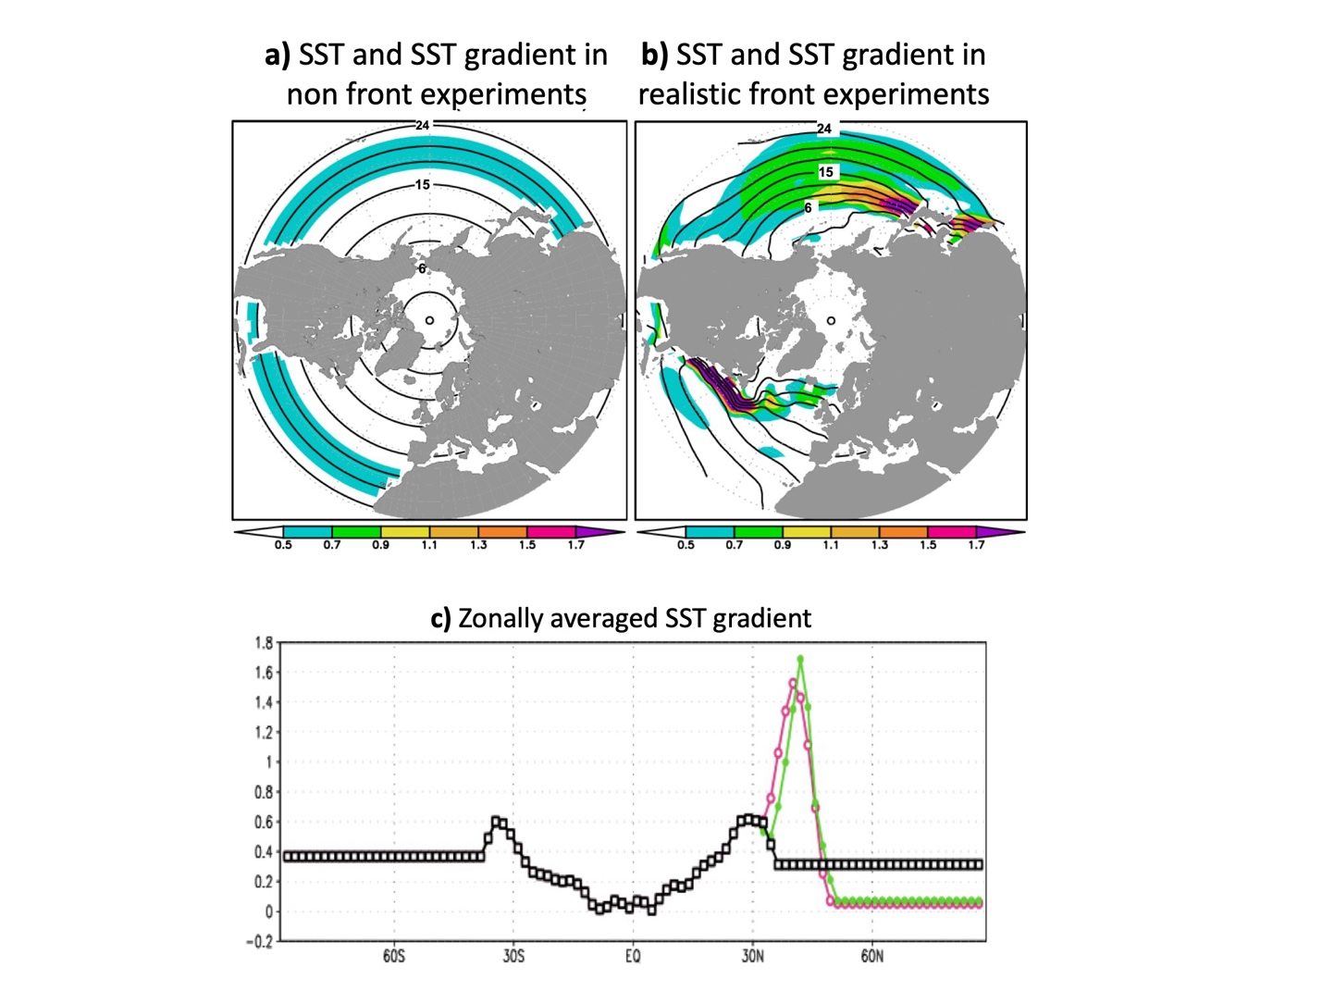
Sfig. 1 SST forcing (taken from Omrani et al. 2019, (1)): (a) and (b) represent the January SST and its meridional gradients plotted for (a) non-front (NF)-experiment and (b) both (Atlantic and Pacific) climatological SST fronts in the LSCO_Fr experiment (Methods). (c) . (c) represents the global zonally averaged SST-gradient used in NF-experiments (in black), and the SST-gradient in the north Atlantic (in green) and north Pacific (in pink) western boundary current.

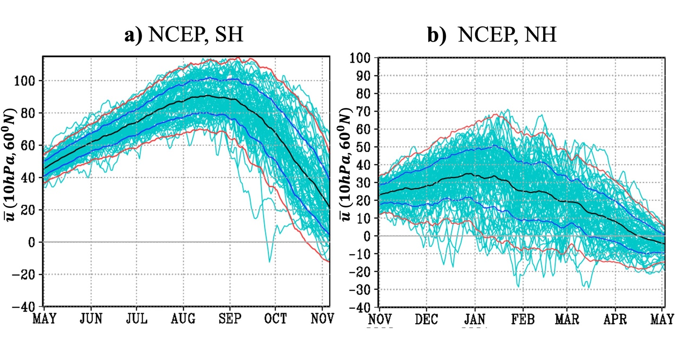
Sfig. 2 Seasonal evolutions of the stratospheric zonally averaged zonal wind (NCEP reanalysis): Like Fig. 1, these panels depict the seasonal evolution on daily timescales of the zonally averaged westerly wind (u) at 10 hPa and 60° in the (a) Southern Hemisphere (SH) and (b) Northern Hemisphere (NH). The black lines indicate the mean seasonal cycle, while the blue and red lines represent the ±1 and ±2 standard deviation margins, respectively. The dark yellow horizontal line denotes the zero-wind threshold, indicating the transition from westerly to easterly winds, which leads to the occurrence of Sudden Stratospheric Warmings (SSWs).

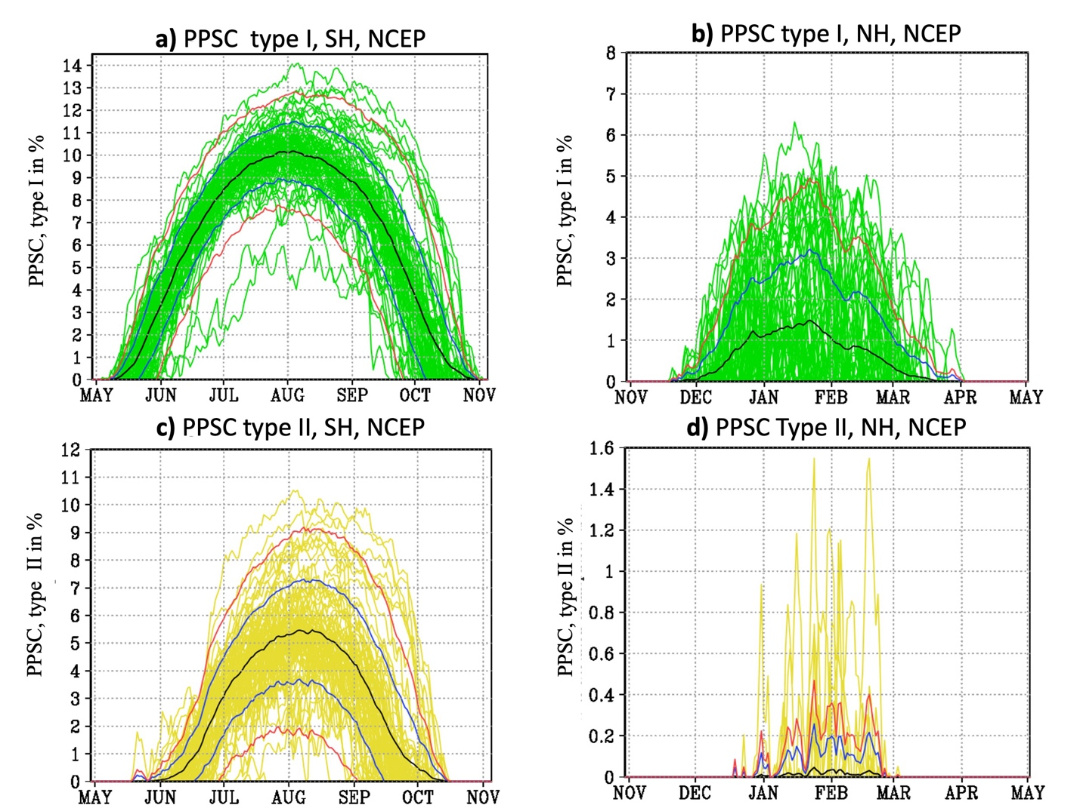
Sfig. 3 Seasonal evolutions of PPSC type I and II (NCEP): Like Fig. 2, these panels illustrate the seasonal evolution of the potential formation of polar stratospheric clouds (PPSC, Methods) for NH and SH using NCEP reanalysis. Panels (a) and (c) depict respectively PPSC type I and II for SH and panels (b) and (d) depict the PPSC type I and II for NH. PPSC I (PPSC I) are defined as the percentage of the hemispheric area where temperatures fall below 195 (188) K. The black lines indicate the mean seasonal cycle, while the blue and red lines represent the ±1 and ±2 standard deviation margins, respectively.

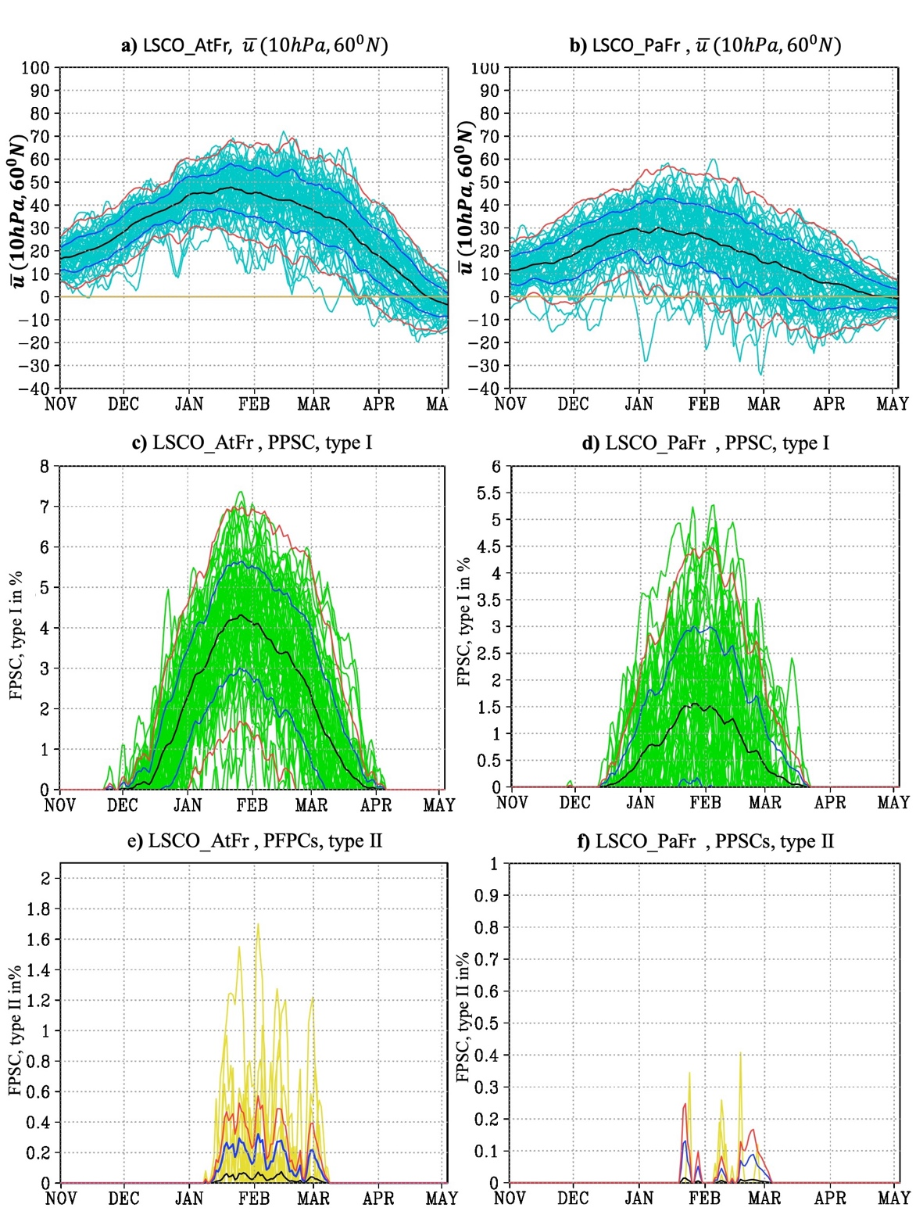

Sfig. 4 Seasonal evolutions of stratospheric zonally averaged zonal wind and PPSC (Atlantic and Pacific experiments): Like Fig. 1, (a) and (b) depict the seasonal evolution of the zonally averaged westerly wind (u) at 10 hPa and 60°N for Atlantic SST-fronts experiment (LSCO_AtFr) and (b) Pacific SST-front experiment (LSCO_PaFr). (c) and (d) represent depict PPSC type I for LSCO_AtFr and LSCO_PaFr experiment respectively. (e) and (f) represent PPSC type II for LSCO_AtFr and LSCO_PaFr experiment respectively. The black lines indicate the mean seasonal cycle, while the blue and red lines represent the ±1 and ±2 standard deviation margins, respectively.

1. N.-E. Omrani et al., Key Role of the Ocean Western Boundary currents in shaping the Northern Hemisphere climate. Sci Rep-Uk 9, 3014 (2019).

