Supplementary Discussion
The optical photos of all samples are displayed in Fig. S2. From a color perspective, a diverse array of hues is exhibited by these samples: P1 and P5 are both white; however, P1 possesses a slight yellowish tone, reminiscent of A1. P2 displays a light pink coloration, P3 appears silver-gray, and P4 is characterized by a cyan hue. The Edison pearl (E1) is pink, while the golden pearl (G1) exhibits a golden hue with a green overtone. The Tahitian pearl (T1) features a green body color integrated with a purple-pink overtone. Currently, the pearl types exhibiting the most diverse color palette in the market are primarily akoya pearls and Edison pearls.
In terms of shape and size, the samples P1 to P5 possess a diameter of approximately 1 cm and exhibit a circular or nearly circular shape, comparable to A1 but slightly smaller. In contrast, the diameters of E1, T1, and G1 are significantly larger. From a luster perspective, pronounced luster is exhibited by the ceramic pearls, imparting a beautiful appearance. This may be attributed to the unique composition of their nuclei, as ceramics generally possess a luster that is brighter than that of shells, which are traditionally used as nuclei.
Utilization of a microscope camera for magnification and observation of the layers of the nine pearl samples reveals distinct imbricated structures. The contour lines of P1-5 are closely arranged, showing no significant differences from those of other seawater pearls (Fig. S3a-f, h, i). In contrast, the contour lines of the freshwater pearl E1 appear relatively loose (Fig. S3g). Therefore, it can be preliminarily deduced that P1-5 are seawater pearls; however, further testing is needed for conclusive identification.
Supplementary Figures
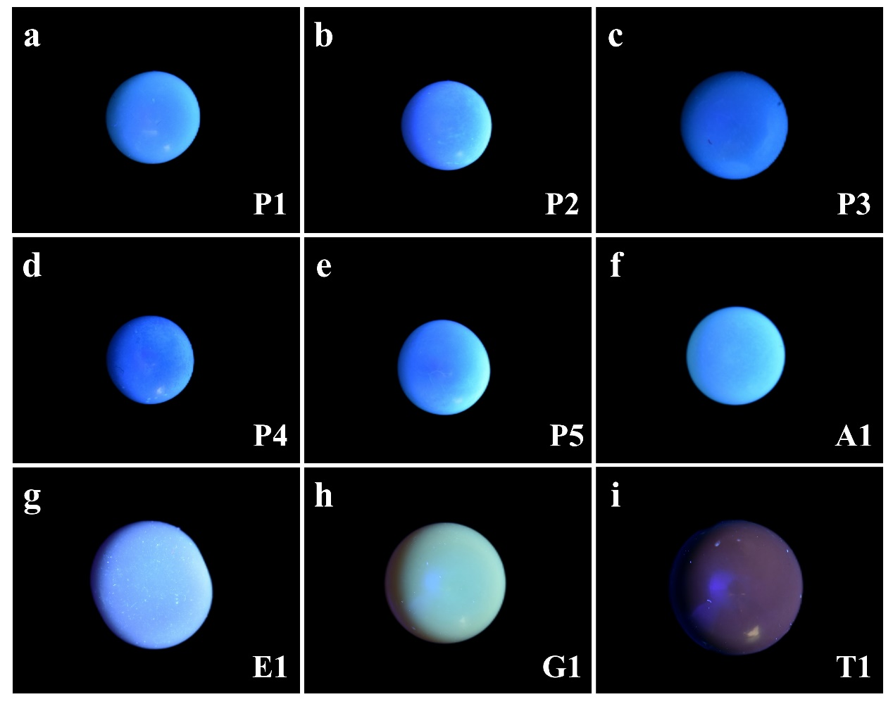
Fig. S1 Fluorescence characteristics of novel ceramic-nucleus cultured pearl samples P1-P5 (a-e) and reference samples A1, E1, G1, T1 (f-i) under long wavelength ultraviolet light.
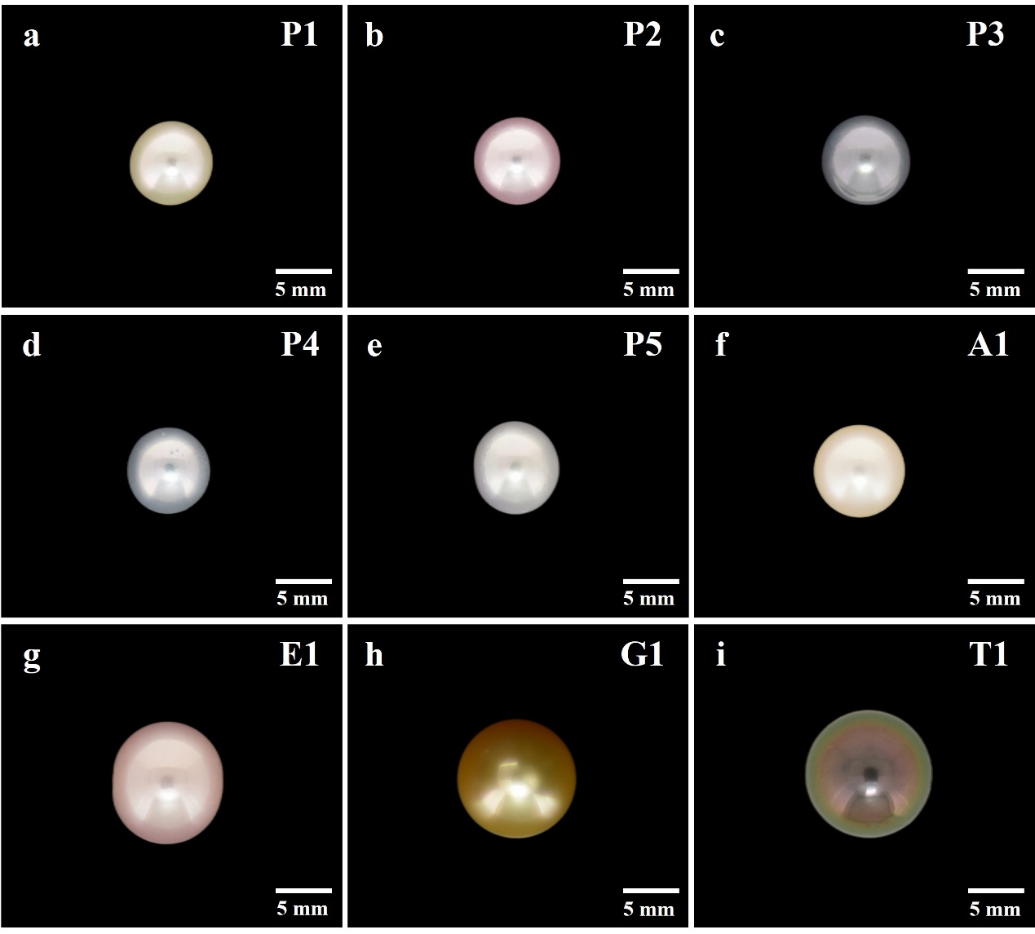
Fig. S2 Nine different pearl samples: (a-e) Novel ceramic-nucleus cultured pearls (P1-P5); Akoya pearl (A1); Edison pearl (E1); Golden pearl from the South Sea (G1); Tahiti pearl (T1).
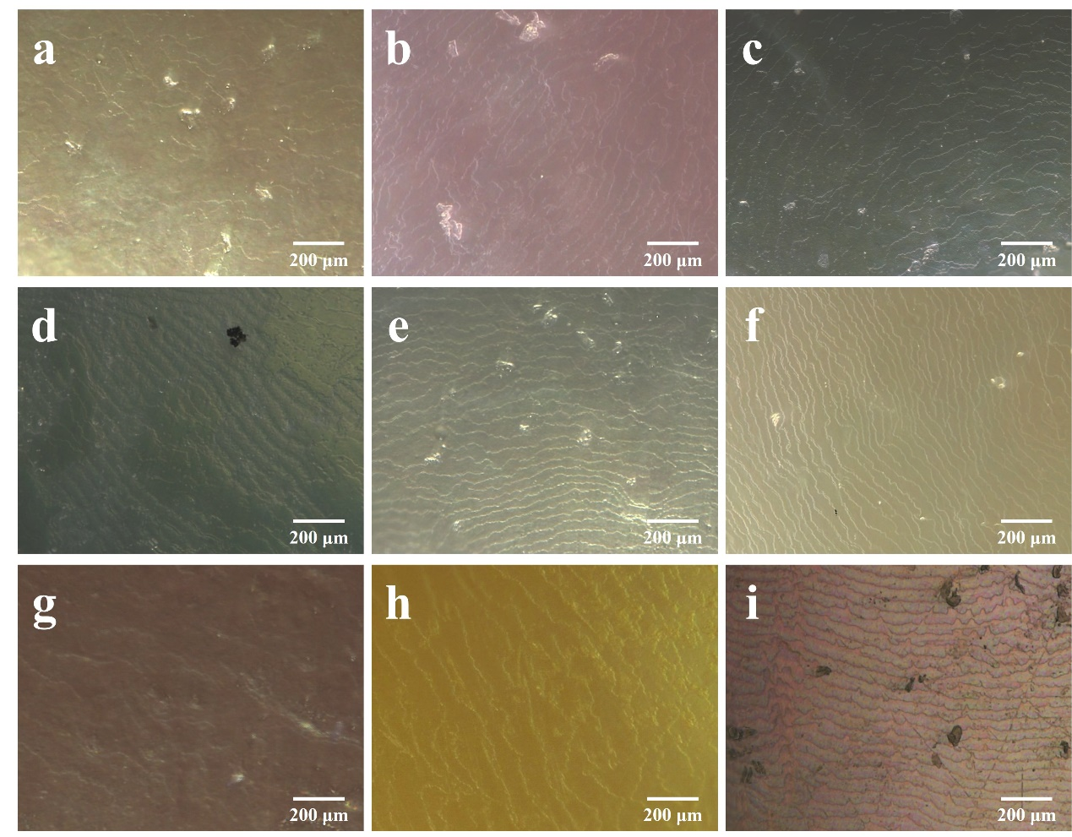 Fig. S3 The surface imbricated structure of novel ceramic-nucleus cultured pearl samples P1-P5 (a-e) and reference samples A1, E1, G1, T1 (f-i).
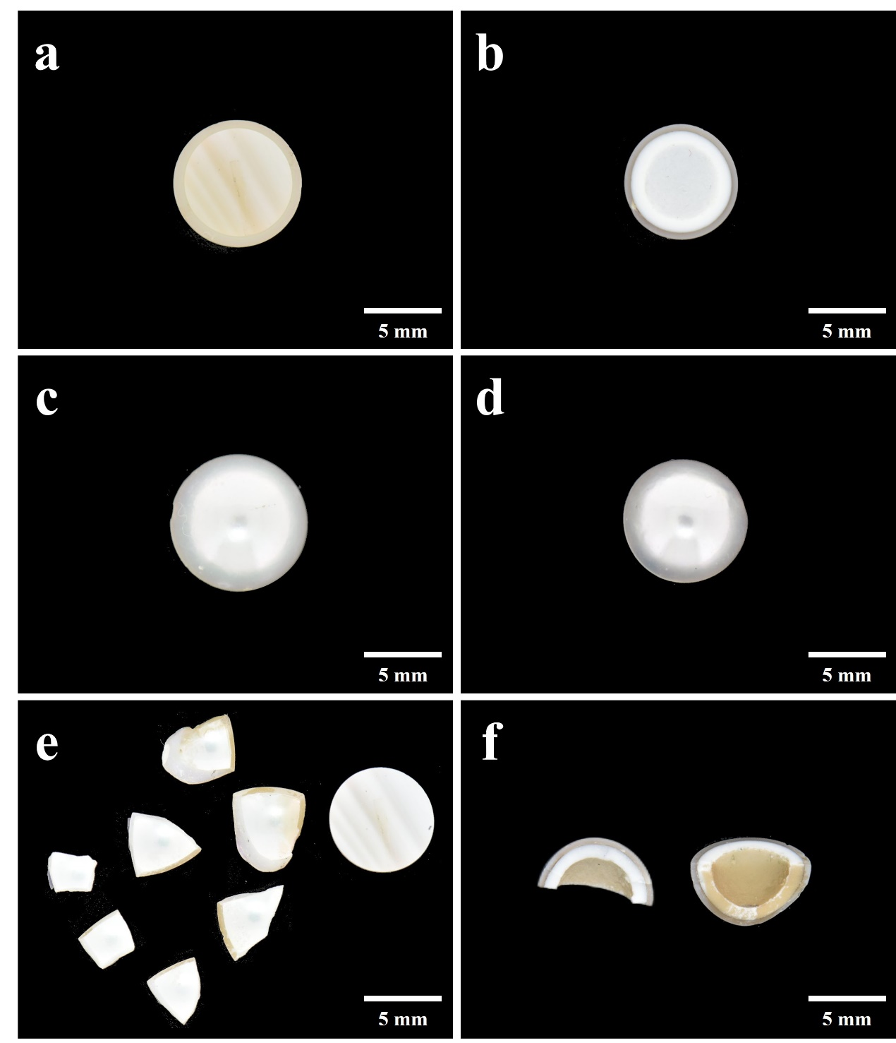
Fig. S4 (a-b) Photos of the interior of P3 and A1 which were cut, (c-d) Photos of the surfaces of A1 and P3 which were cut, (e-f) Photos of fresh cross-sections of A1 and P3.

