Supplementary Information

Comparisons of TWS products with Spherical Harmonics (SH) solution
Figure S1 shows the spatial distribution of Mean Absolute Difference (MAD) among the three TWS products by the SH solution. Overall, the MAD values are quite small across Canada’s landmass, varying mostly within 15 mm, with the highest MAE reaching approximately 40 mm. Regions with MAD exceeding 30 mm accounted for less than 1% of the total area. High MAD values are most concentrated in the coastal regions, including the west coast of British Columbia (BC), the island of Newfoundland, and certain Arctic Coastal-Islands. However, when compared to the local TWS seasonal variation magnitudes (∆TWS), the difference is relatively small along the west coast, and most significant in other coastal areas such as the Arctic Coast-Islands, west to the Hudson Bay, and the island of Newfoundland. Overall, only about 1% of the landmass exhibited a relative difference (MAD/∆TWS) greater than 15%.
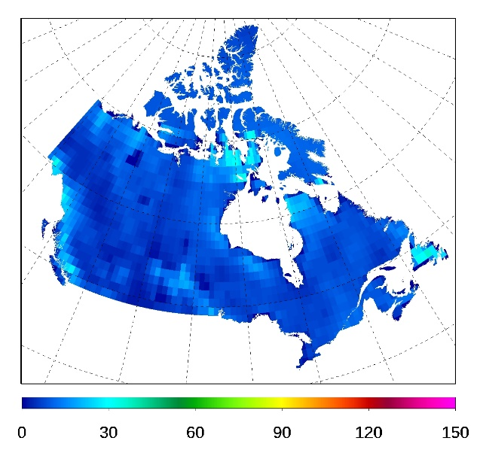
Figure S1. Mean absolute difference (MAD) among the three TWS products by Spherical Harmonics solution. (Left: Spatial distribution of MAD; Right: Histogram of MAD).

Comparisons of TWS products with Mascon solution
The differences among the three TWS products by the Mascon solution (Fig. S2) are significantly larger compared to those by the SH solution, as previously discussed. Regions with MAD greater than 30 mm account for nearly 33% of the landmass, with the highest MAE exceeding 200 mm. High MAD values are primarily observed in the regions with ice-cover, such as the northwestern Pacific Cordillera and the Arctic Cordillera. The relative difference (MAD/∆TWS) follows similar spatial patterns to the MAD distributions. Approximately 10% of the landmass exhibited a relative difference (MAD/∆TWS) greater than 50%.
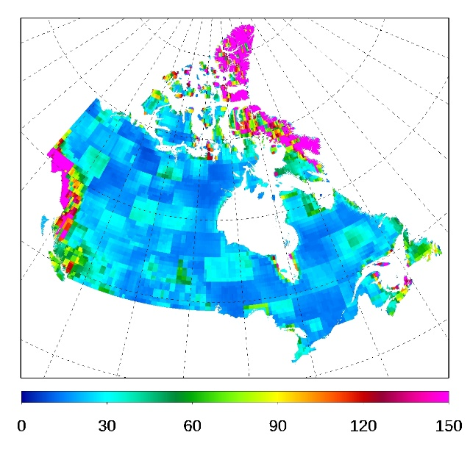
Figure S2. Mean absolute difference (MAD) among the three TWS products by Mascon solution. (Left: Spatial distribution of MAD; Right: Histogram of MAD).

Comparisons between TWS products with SH and Mascon solutions
The differences in TWS between the three SH products and the three Mascon solutions are found to be larger than the differences among the products within each of the two solution groups. As shown in Fig. S3, high MAD values between the SH and Mascon products are more broadly distributed compared to Fig. S2, particularly over the Pacific Cordillera and the Arctic Cordillera. Regions with MAD exceeding 30 mm account for more than 43% of the landmass, which is 10% larger than the area shown in Fig. S2.
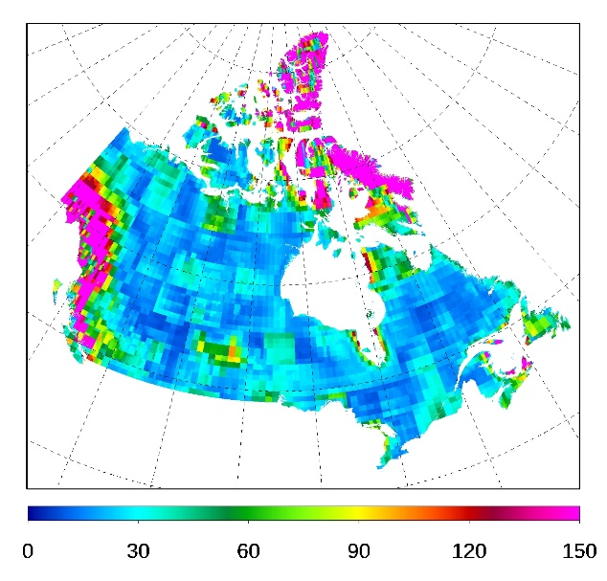
Figure S3. Mean absolute difference (MAD) between the SH products and the Mascon products. (a) Spatial distribution and (b) Histogram of MAD over Canada’s landmass.

Comparisons of TWS trends between SH and Mascon solutions
The spatial patterns of the TWS trends generated using the SH and Mascon products showed high agreement (Fig. S4). These TWS trends were aggregated and compared at the scale of Canadian Drainage Regions. There is a total of 25 Drainage Regions in Canada that drain water to the Pacific Ocean, Arctic Ocean, Atlantic Ocean, Hudson Bay, and Gulf of Mexico (Fig. S5). The 8 drainage regions that drain water to the Pacific Ocean (No. 1-5) and Arctic Ocean (No. 6-8), along with the subarctic Drainage Region of Keewatin-Southern Baffin Island (No. 16), all showed negative TWS trends (Fig. S6). In contrast, the 7 drainage regions on the right side of Fig. S6, located in eastern Canada, showed positive TWS trends. For the remaining Drainage Regions located in the south-central part of the country, the TWS trends were minimal. It is worth noting that three of the 25 Drainage Regions, namely Okanagan-Similkameen (No. 3), Missouri (No. 9), and Saint John-St. Croix (No. 23), have areas smaller than the GRACE original resolution data (~300 km × 300 km). The results for these regions may require additional scrutiny due to potential larger leakage errors. In addition, the Arctic Coast-Island region (No. 8) is composed of many small islands, which could lead to higher uncertainties and leakage errors in its data. Extra caution is advised when using results from these regions.
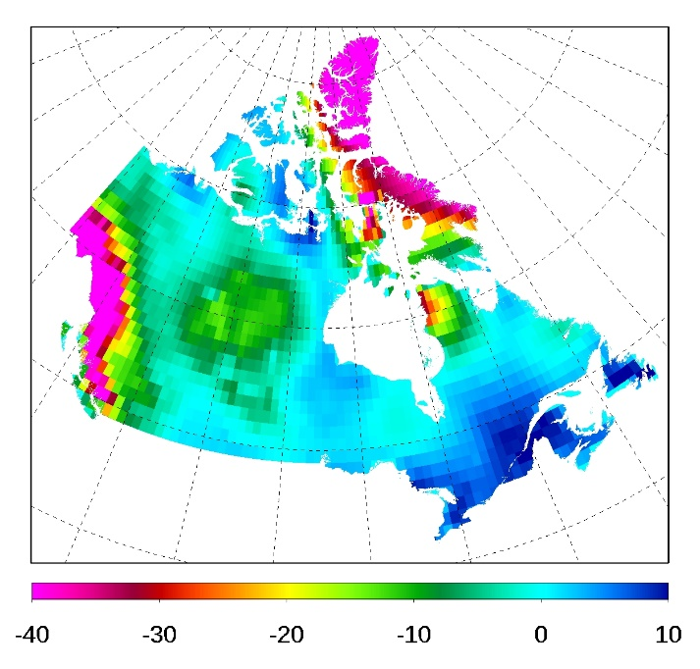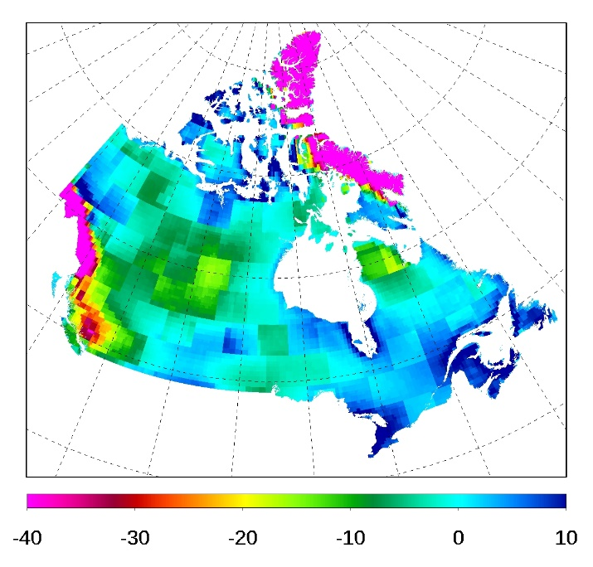
Figure S4. Terrestrial water storage (TWS) trends over April 2002–March 2024 (mm year⁻¹). (Left: Sen’s slope for TWS products by Spherical Harmonics solution. Right: Sen’s slope for TWS products by Mascon solution).

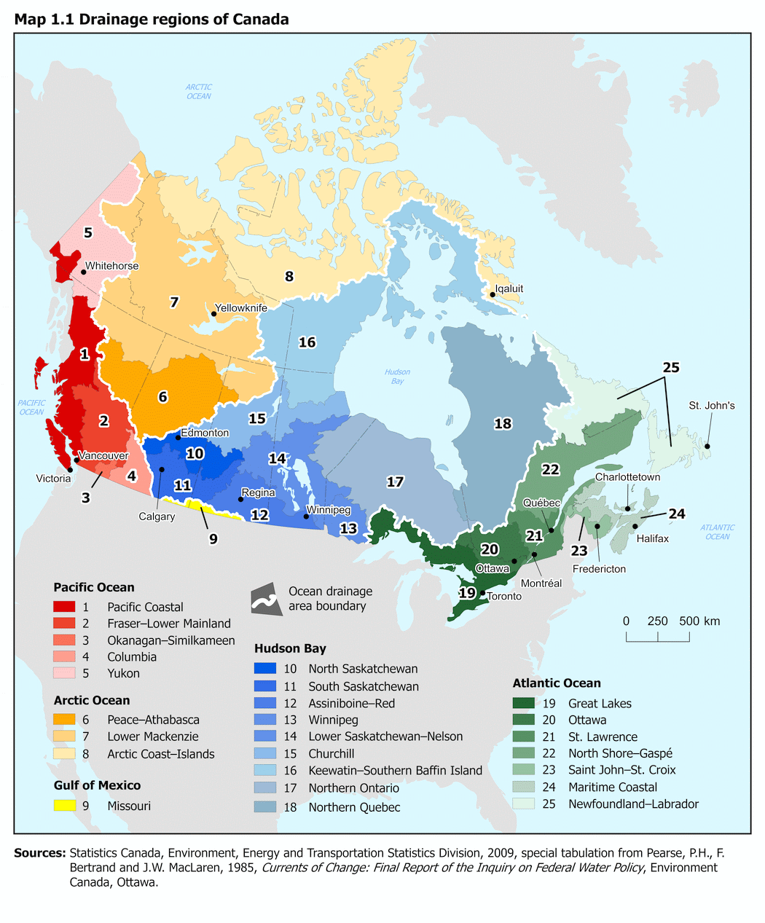
Figure S5. Drainage Regions of Canada

Figure S6. Terrestrial water storage (TWS) trends for 2002–2024 for the 25 Drainage Regions in Canada (see Fig S5 for locations. SH: based on TWS products by Spherical Harmonics solution. Mascon: based on TWS products by Mascon solution).

