Supplementary
In this section, we present the results of experiments performed on other data, which include point cloud simplification results and model reconstruction results.

A. Experimental parameter setting
In this paper, several parameters are set manually, such as the radius $r$ used to determine the spherical neighborhood for the calculation of two feature parameters, the initial number of cluster centers k, and the weight adjustment coefficients a and b used in the formula for the calculation of saliency.
The $r$ in the spherical neighborhood radius is a critical parameter in the knn algorithm that determines the number of neighborhood points and directly affects the calculation of roughness and surface curvature. If the search radius is too large, the model may not fit properly and may not capture the complex structure of the data, increasing the computational cost; on the other hand, if a smaller radius is chosen, the model will be more sensitive and may overfit, resulting in significant differences between the fitted and actual surfaces. Therefore, it is important to choose an appropriate search radius. In this paper, we select a point cloud of civil official stone carved in the imperial tombs of the Northern Song Dynasty for an experiment and set the $r$ values to 0.2%, 0.5%, 1.0%, and 2.0% of the model height to calculate the value of roughness. The value was visualized, and then the distribution of different colors was observed to determine whether the radius was appropriate. FigA.1 shows the visualization results calculated for different radius, and the difference between the roughness values decreases as the radius increases. Table 1 shows the time spent for different values of $r$. The time spent increases with increasing radius, reaching 102 s for $r$ values that are 2.0% of the model height. Considering both accuracy and speed of calculation, the value of $r$ in this paper is set to 0.5% of the model height.
In this paper, we use the points sampled under voxels as the initial clustering centers of k-means clustering, so the size of voxels determines the number of clustering partitions, and the height of the stone carvings of the imperial tombs of the Northern Song Dynasty is generally between 3 and 5 m. More clusters will consume a lot of time. Therefore, we set the voxel size to 2.5%, 7.5%, 10.0%, 12.5%, and 20.0% of the model height for the experiments. Table 2 records the number of initial clustering centers and the time spent on segmentation at different percentages. Considering the speed of clustering, the voxel size of this paper is 12.5% of the model height.
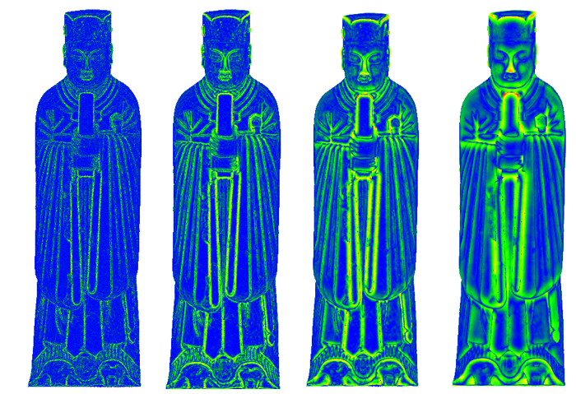
Figure A.1. Visualization results of roughness at different values: (a) r=0.2%; (b) r=0.5%; (c) r=1.0%; (d) r=2.0%
Table 1: The time required for different percentages corresponding to the value of
r | Times/s
0.2% | 8
0.5% | 13
1.0% | 30
2.0% | 102
Table 2: Time spent at different percentages corresponding to voxel size
Voxel | Points | Times/s
2.5% | 751 | 166.4
7.5% | 189 | 67.5
10.0% | 80 | 36.1
12.5% | 28 | 6.6
20.0% | 10 | 5.2
Eq. (7) is the core formula for saliency calculation with two parameters, $a$ and $b$. Different parameters will affect the simplification effect. We set different values of $a$ and b and compare the results for the model’s primary feature region. The parameters corresponding to a, b, c, d and e in Figure 8 are: $a$=0.1, $b$=0.9; $a$=0.3, $b$=0.7; $a$=0.5, $b$=0.5; $a$=0.7, $b$=0.3; $a$=0.9, $b$=0.1; From the visual results, the feature regions of the model in Figure 8a and Figure 8b are severely missing, while Figure 8d and Figure 8e contain many non-feature points; Figure 8c shows the best results. However, different models may require different parameter settings, and to avoid the complicated parameter tuning process, we set the parameters $a$ and $b$ to 0.5 in the experiments in this paper.
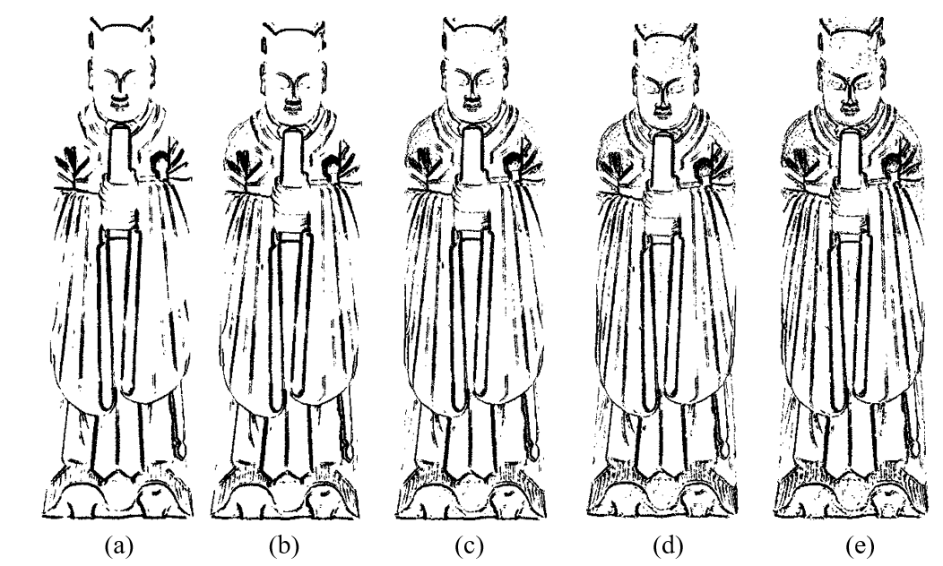
Figure A.2. The primary feature region of the model with different parameter settings

B. Point cloud from SfM
The advantages of the proposed method over other methods can be clearly observed by comparing the simplified results of Auspicious poultry, stone horse and stone elephant under different methods in Fig. B.1 to B.3. Under this method, the simplified model can better retain the detailed features of the original model, such as the shape of the bird, the texture of the horse and the carving details of the elephant. This makes the simplified model more visually realistic and more accurately presents the morphology of the original model. In summary, the comparison of Fig. B.4 to B.6 leads to the conclusion that the method proposed in this paper performs better in the simplified results of the Auspicious poultry, stone horse and stone elephant, preserving the detailed features and reducing the hole, thus improving the quality and accuracy of the simplified models.
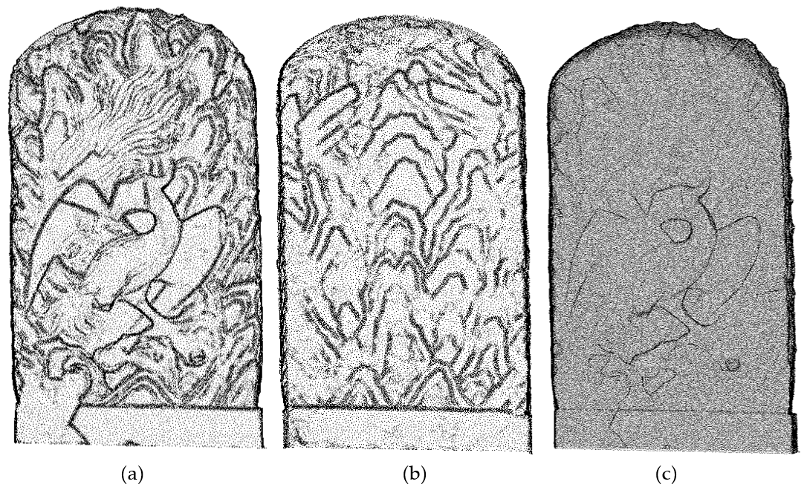
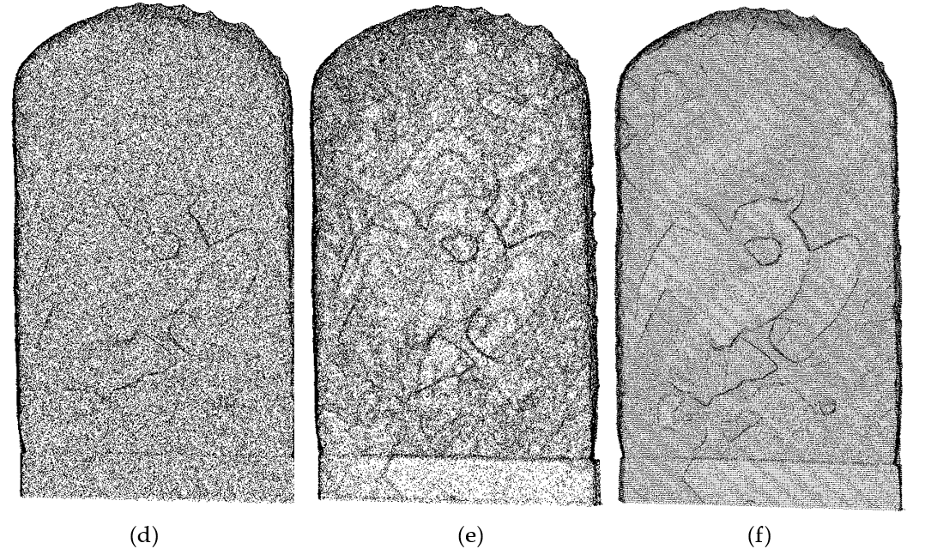
Fig. B.1. Simplified results of Auspicious poultry point clouds: (a) proposed method; (b) PDS; (c) MS; (d) CS; (e) VS
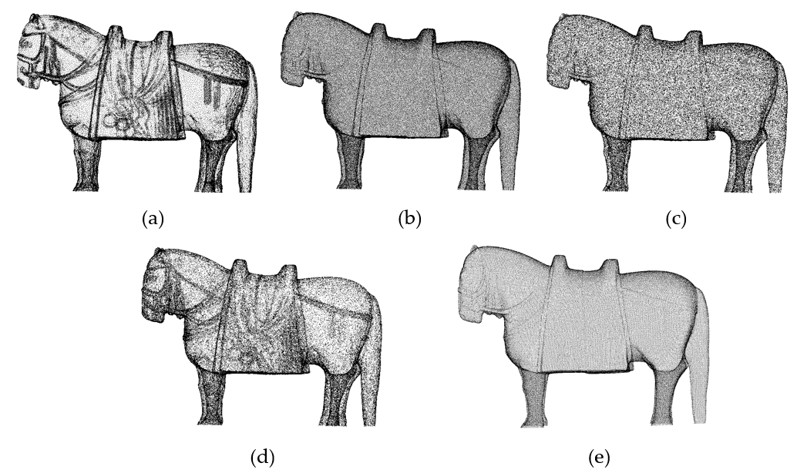
Fig. B.2. Simplified results of Stone horse point clouds: (a) proposed method; (b) PDS; (c) MS; (d) CS; (e) VS
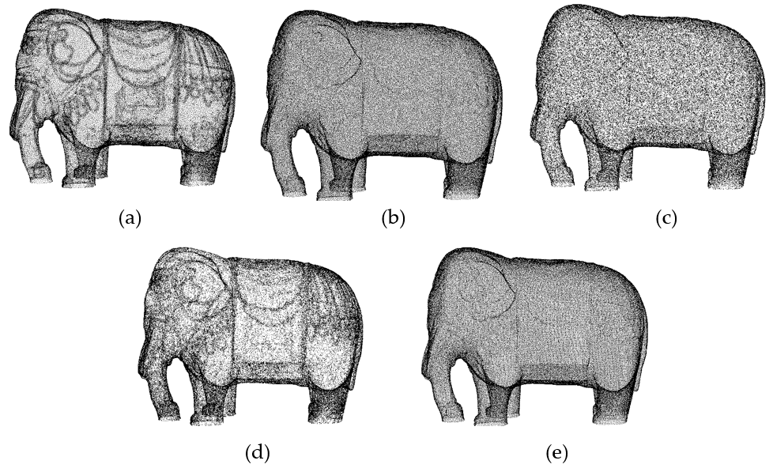
Fig. B.3. Simplified results of Stone elephant point clouds: (a) proposed method; (b) PDS; (c) MS; (d) CS; (e) VS
Figs. B.4 to B.6 show the simplified models of the Auspicious poultry, stone horse and stone elephant under different simplification methods. The superiority of this paper's method in preserving the details of the models can be clearly seen through comparative observations. The method in this paper is able to maintain the clarity of the textures during the simplification process, so that the patterns and details on the surface of the models are still recognizable. In contrast, the simplified models of other methods appear blurred or distorted in terms of textures. In summary, the comparison of Figs. B.4 to B.6 leads to the conclusion that the method proposed in this paper shows better detail retention in the simplified models of the Auspicious poultry, stone horse, and stone elephant, resulting in better performance of the models in terms of details.
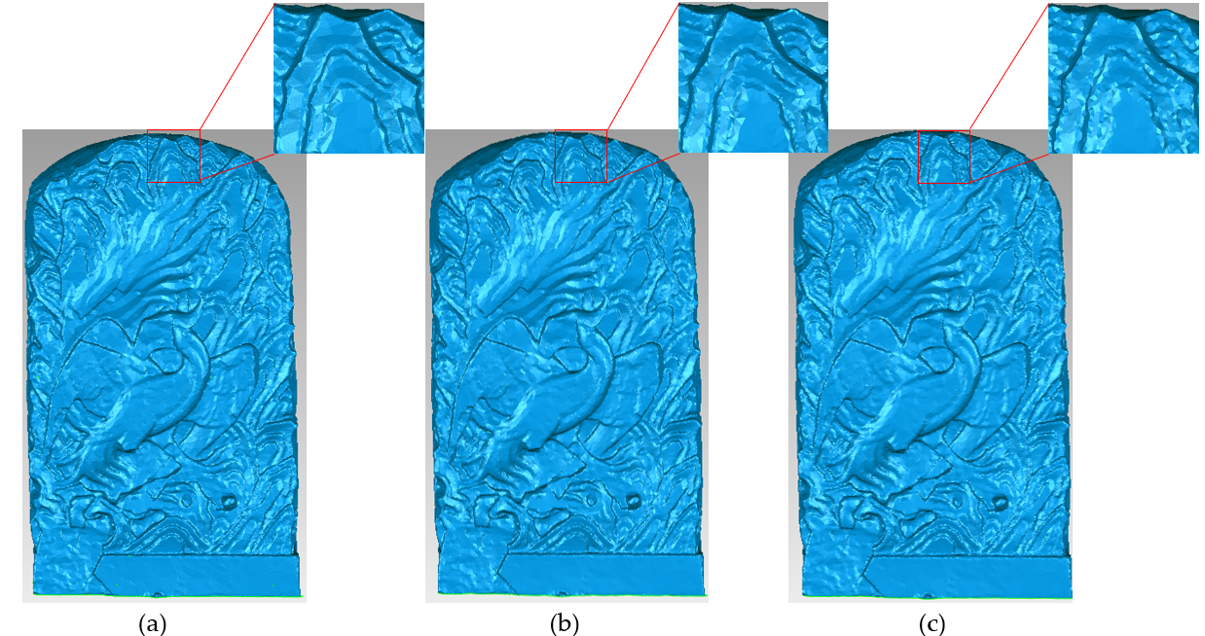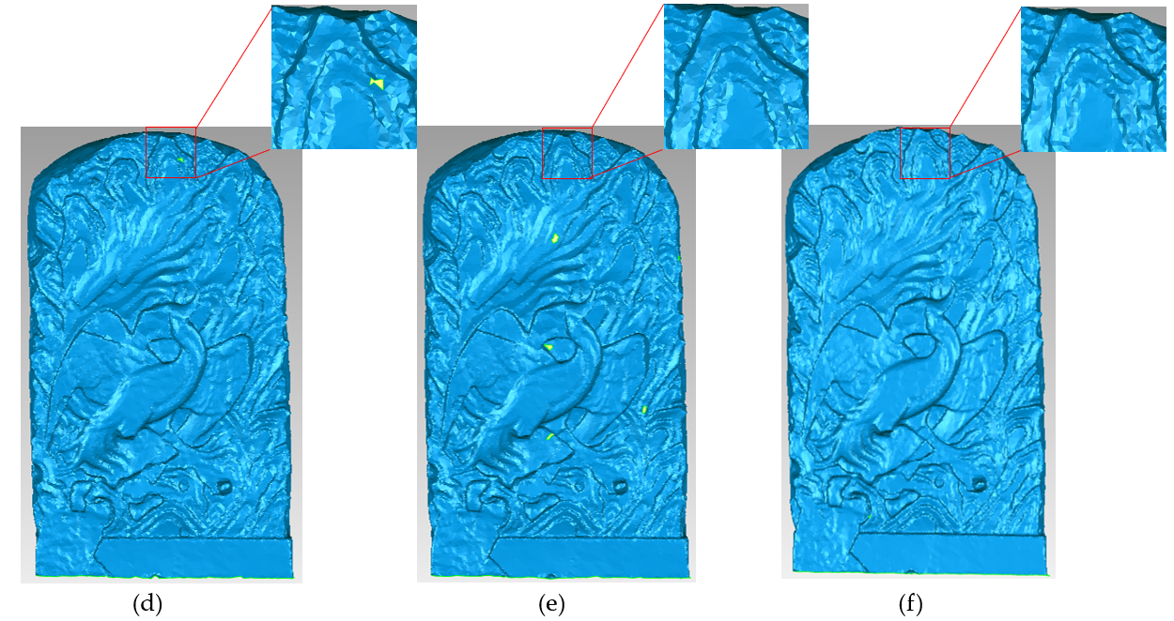
Fig. B.4. Simplified mesh model of Auspicious poultry: (a) Original model;(b) proposed method; (c) PDS; (d) MS; (e) CS; (f) VS
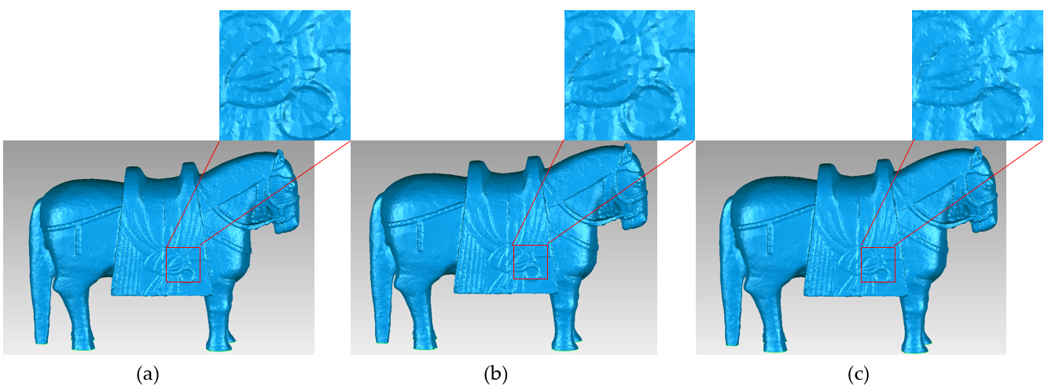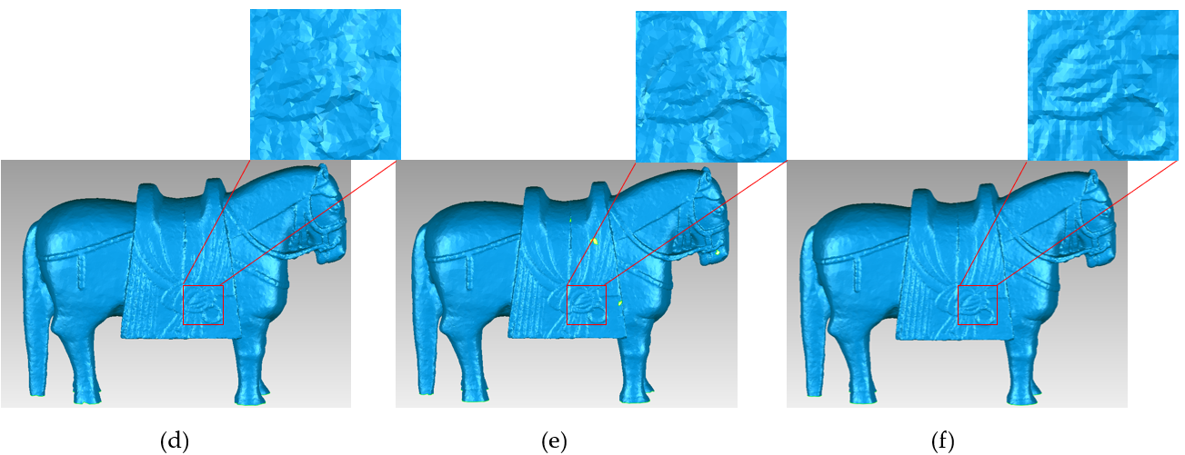
Fig. B.5. Simplified mesh model of Stone horse: (a) Original model ;(b) proposed method; (c) PDS; (d) MS; (e) CS; (f) VS
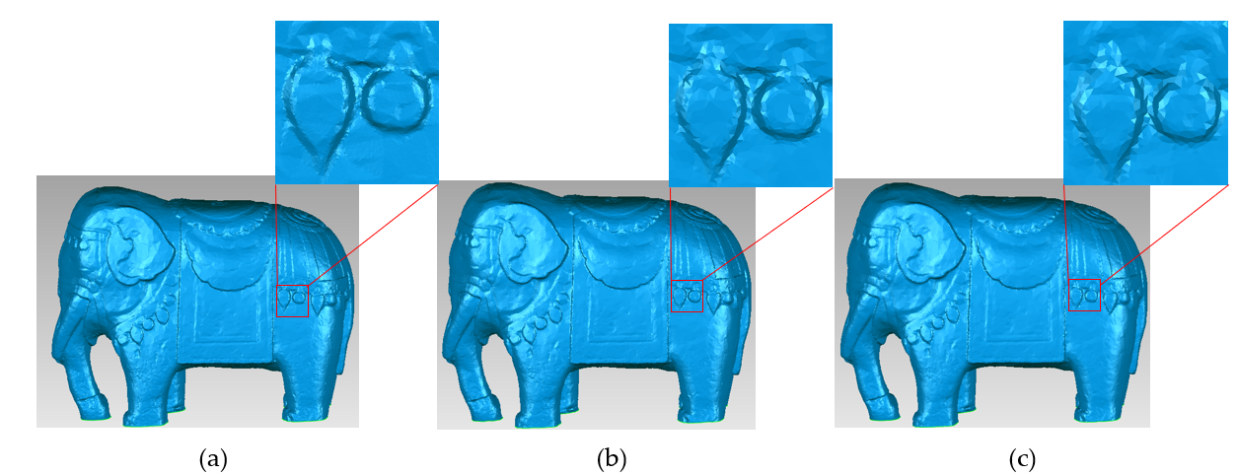
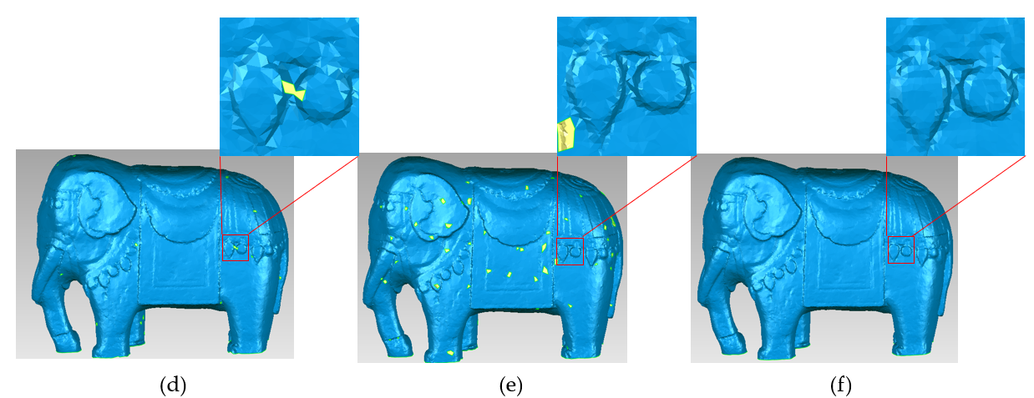
Fig. B.6. Simplified mesh model of Stone elephant: (a) Original model;(b) proposed method;(c) PDS;(d) MS;(e) CS; (f) VS

C. Point cloud from Structured light
Figs. C.1 to C.3 show the simplification results of the terra-cotta warriors and stele point cloud under different simplification methods, while Figs. C.4 to C.6 show the corresponding simplified models. It is observed from these figures that the proposed method in this paper is also applicable to point clouds acquired by other devices and shows excellent performance in the simplification process.
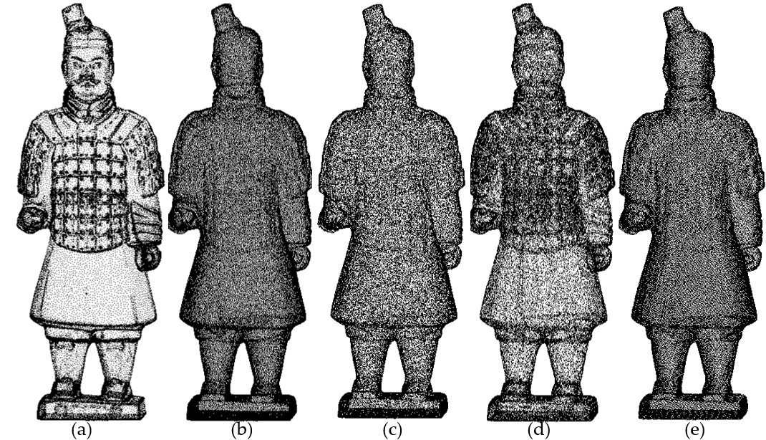
Fig. C.1. Simplified results of the No.2 Terra-cotta warriors point clouds: (a) Original model ;(b) proposed method; (c) PDS; (d) MS; (e) CS; (f) VS
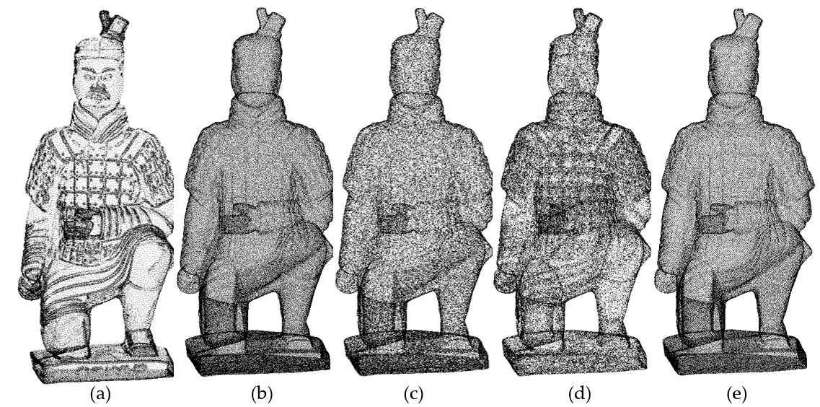
Fig. C.2. Simplified results of the No.3 Terra-cotta warriors point clouds: (a) Original model ;(b) proposed method; (c) PDS; (d) MS; (e) CS; (f) VS
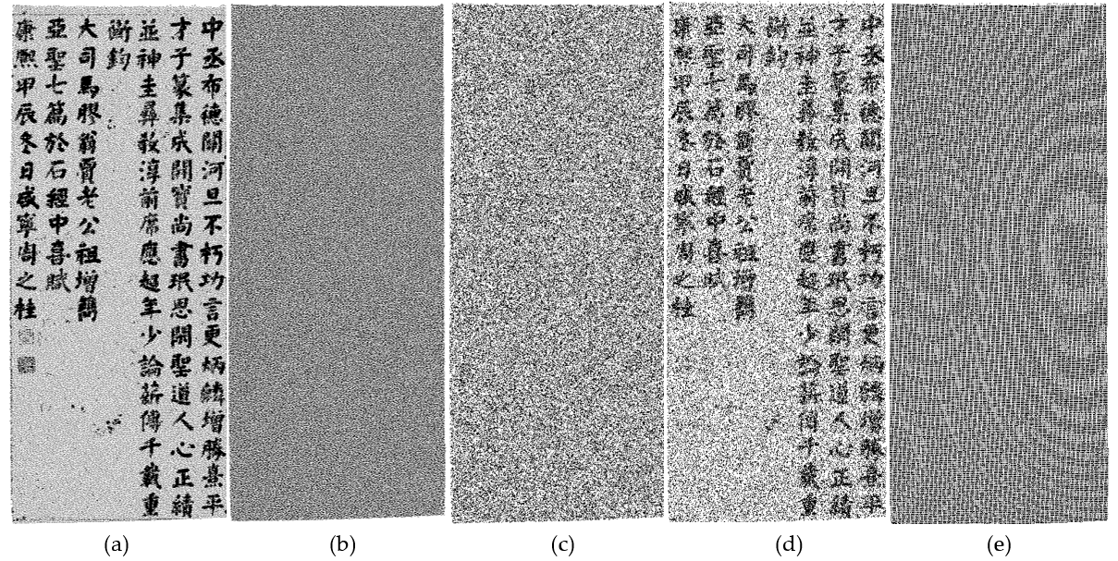
Fig. CC.3. Simplified results of Stele point clouds: (a) proposed method; (b) PDS; (c) MS; (d) CS; (e) VS

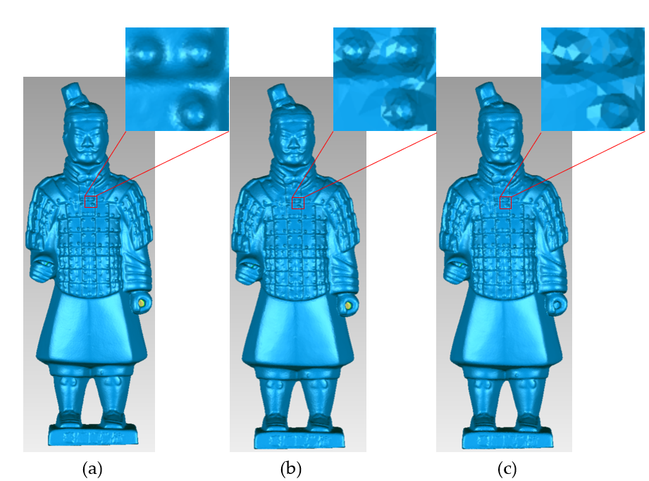
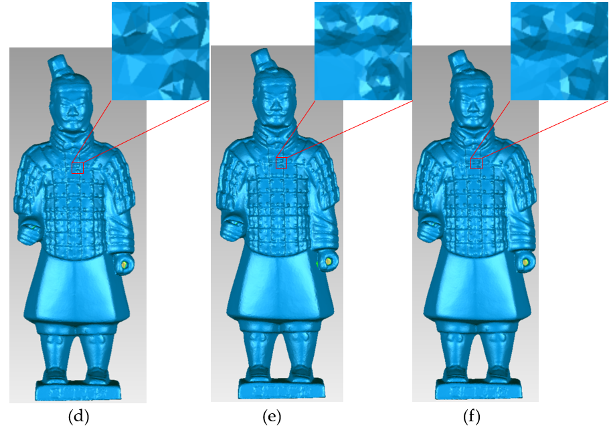
Fig. C.4. Simplified mesh model of No.2 Terra-cotta warriors: (a) Original model;(b) proposed method;(c) PDS;(d) MS;(e) CS; (f) VS
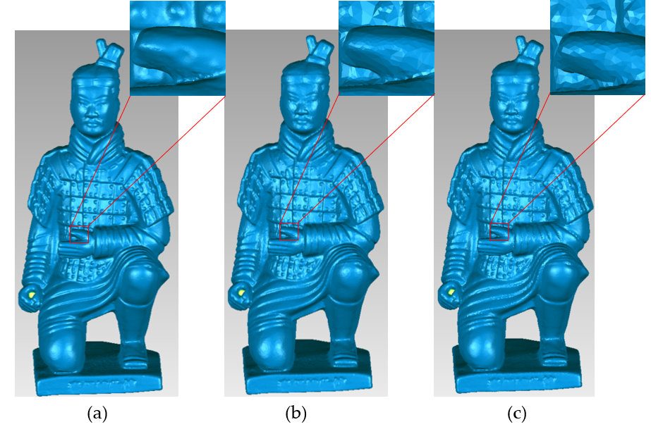
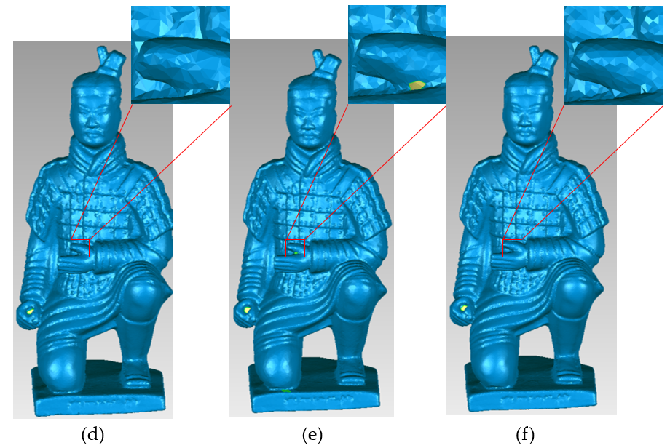
Fig. C.5. Simplified mesh model of No.3 Terra-cotta warriors: (a) Original model;(b) proposed method;(c) PDS;(d) MS;(e) CS; (f) VS

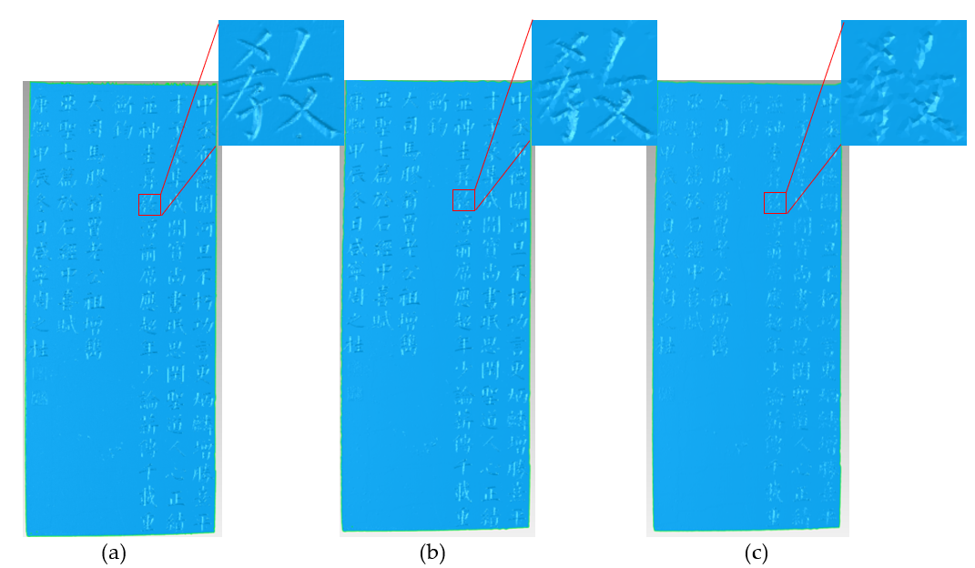
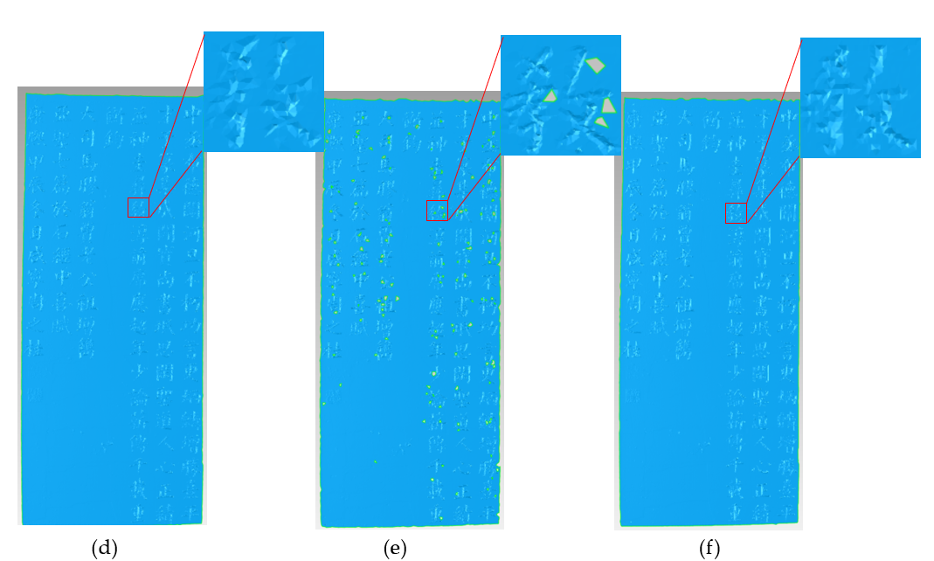
Fig. C.6. Simplified mesh model of Stele: (a) Original model ;(b) proposed method; (c) PDS; (d) MS; (e) CS;(f) VS

D. Point cloud from terrestrial laser scanner
Figures D.1 and D.2 show the simplified results of the point clouds of Civil official and Stone horse under different simplification methods, and Figures D.3 and D.4 show the corresponding simplified models. From these figures, it can be seen that the method proposed in this paper is also applicable to the point clouds acquired from terrestrial stations, and has significant advantages in the simplification results.
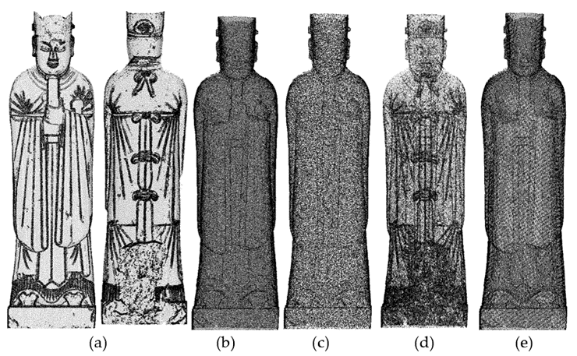
Fig. D.1. Simplified results of Auspicious poultry: (a) Original model ;(b) proposed method; (c) PDS; (d) MS; (e) CS;(f) VS
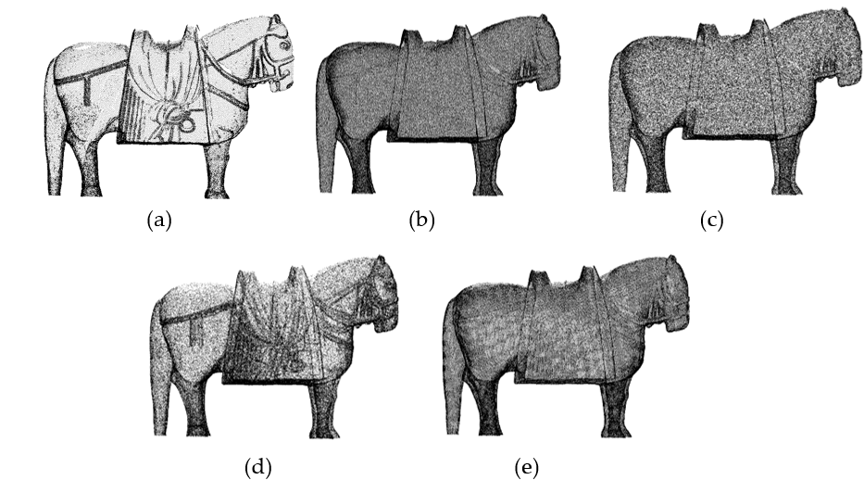
Fig.D.2. Simplified results of Stone horse: (a) Original model ;(b) proposed method; (c) PDS; (d) MS; (e) CS;(f) VS
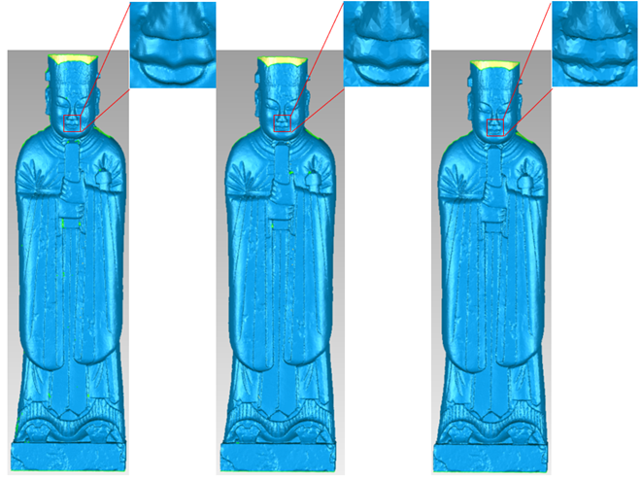
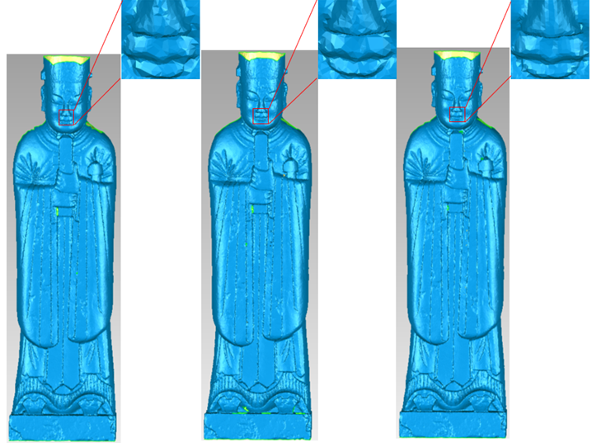
Fig. D.3. Simplified mesh model of Civil official: (a) Original model ;(b) proposed method; (c) PDS; (d) MS; (e) CS;(f) VS
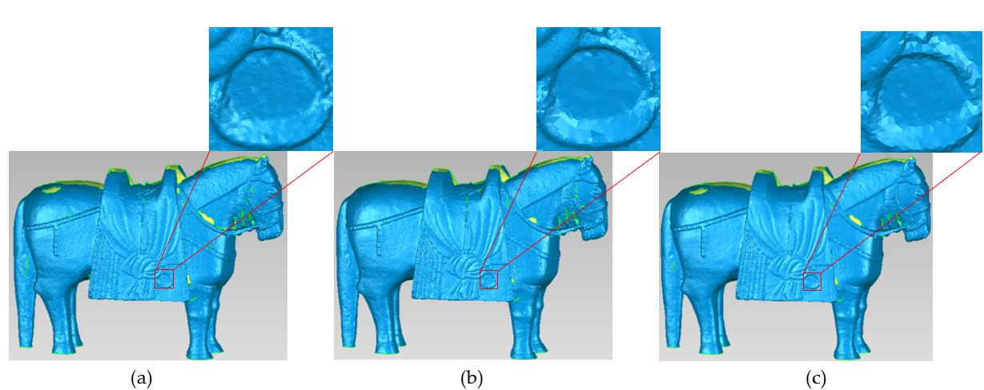
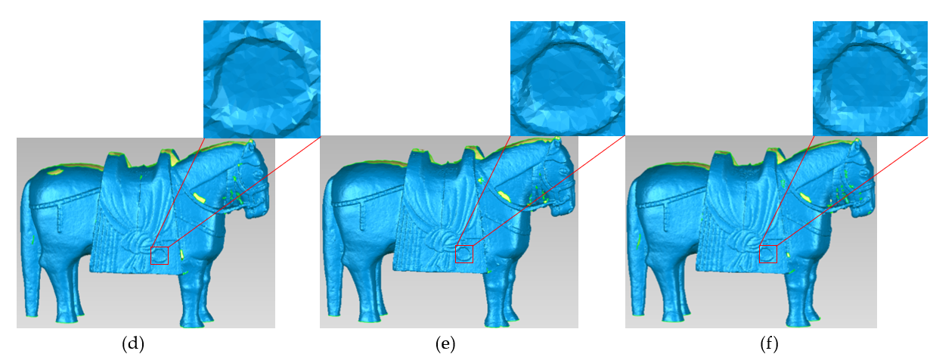
Fig. D.4. Simplified mesh model of Stone horse: (a) Original model ;(b) proposed method; (c) PDS; (d) MS; (e) CS;(f) VS

E. Point cloud from Stanford dataset
Fig. E.1 shows the simplified results for the dragon. At a 96% simplification rate, it can still be noticed that more points are retained on detailed features such as the dragon's head, claws, and scales. Compared with other algorithms, it is virtually impossible to differentiate the detailed features at the same simplification rate. Fig. E.2. shows the simplified models of Dragon in the Stanford dataset under different methods. It can be seen from the Stanford dragon model that several methods generate holes, but the method in this paper generates the least number of holes, and the holes are fine; the CS and MS methods generate the most holes, and the PDS and VS methods generate few holes, but they do not show as much detail as the method in this paper.
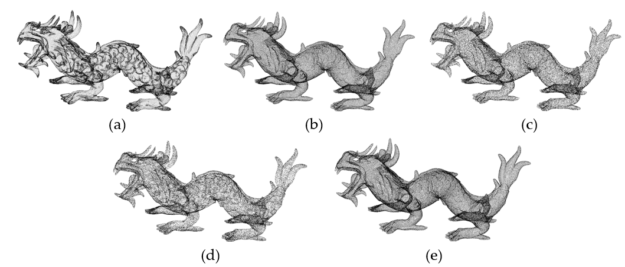
Fig. E.1. Simplified results of Dragon point clouds: (a) proposed method; (b) PDS; (c) MS; (d) CS; (e) VS
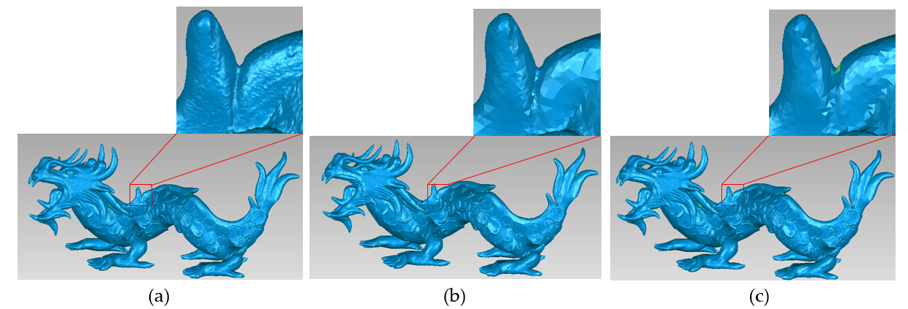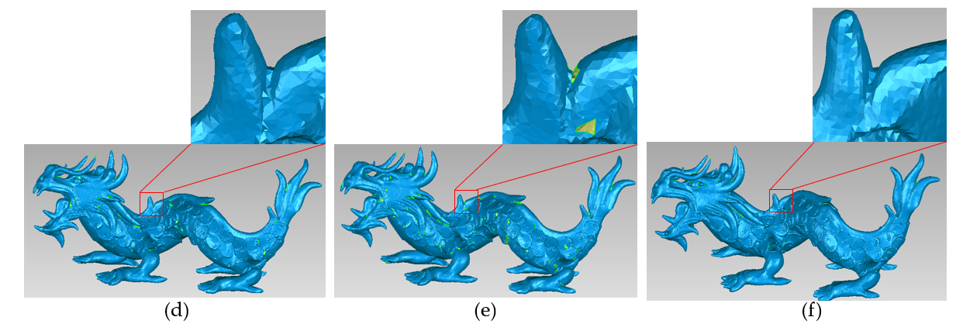
Fig. E.2. Simplified mesh model of Dragon: (a) Original model ;(b) proposed method; (c) PDS; (d) MS; (e) CS; (f) VS

