Supplementary Fig. 1. Representative flow cytometry gating strategy for lymphocyte subpopulation identification. (A) Gating strategy corresponding to the cell suspension obtained from the midbrain of an animal injected with AAV-Control, and (B) from the same region of an animal overexpressing αSyn. In both cases, a plot of side scatter area (SSC-A) vs forward scatter area (FSC-A) plot was used to distinguish cells from debris. Single cells were identified based on FSC-A vs forward scatter height (FSC-H). Viable cells were selected using the ZNIR viability dye. Lymphocytes were defined as the CD11b⁻CD45⁺ population. CD4 and CD8 markers were then used to distinguish lymphocyte subpopulations.

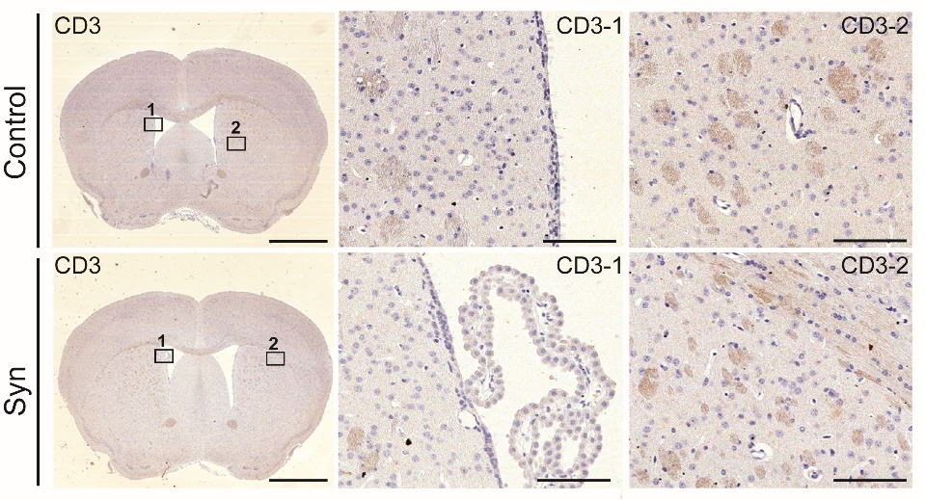
Supplementary Fig. 2. Lymphocyte infiltration in the striatum. Lymphocyte extravasation was analyzed at 2 weeks after AAV9 injection. Representative images of CD3 immunohistochemistry of the striatum of animals receiving the AAV9-Control and AAV9-Syn. The frames indicate different entry sites of lymphocytes into the striatum: through the lateral ventricle and the choroid plexus (frame 1), and blood vessels (frame 2). Magnification bar: 1.5 mm and 100 µm.

Supplementary Fig. 3. Optimization of the αSyn overexpression model. Mice injected with a high viral titer (1.29 x 10¹³ vg/mL) of the AAV9-Control or the AAV9-Syn were sacrificed at 2 weeks, and animals injected with the low viral titer (5.47 x 10¹² vg/mL) were sacrificed at 8 weeks post-surgery. (A) Stereological counts of TH⁺ neurons in the SNpc were normalized to the number of cells in AAV9-Control animals to compare the extent of the dopaminergic lesion. Data are mean ± 95% CI. (B) Representative images corresponding to double immunostaining for TH and mCherry to determine viral protein transduction at 8 weeks. Magnification bar: 20 µM. (C) Representative images of the immunohistochemistry to detect the correct localization of the human αSyn in the striatum and in the SNpc. Magnification bar: 2 mm in the striatum, 900 µm in the midbrain, 200 µm in the amplified insert.

