Figures

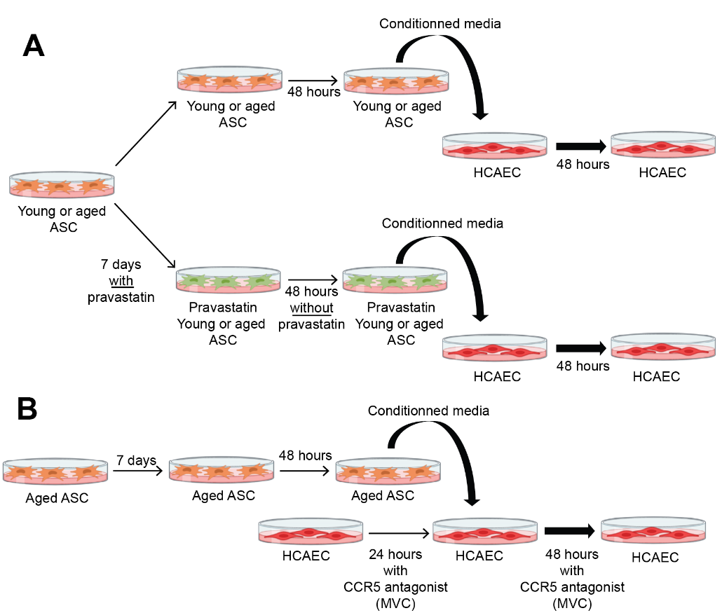

Figure S1: Cell culture protocols used to obtain conditioned media from young- and aged-donor ASCs. Cells were counted and plated at the same density (300 000 cells/cm² in T75 flasks). (A) In some experiments, cells were exposed to 25 μmol/L pravastatin for 7 days. Pravastatin was then removed. CM were collected after a further 48-hour culture. HCAECs were then incubated with the standard media or CM_{young}, CM_{aged}, CM_{prava-young} or CM_{prava-aged}. (B) HCAECs were treated with 1 μg/mL maraviroc 24 hours prior to the CM_{aged} exposure. Maraviroc was then maintained through the 48 hours CM_{aged} exposure.

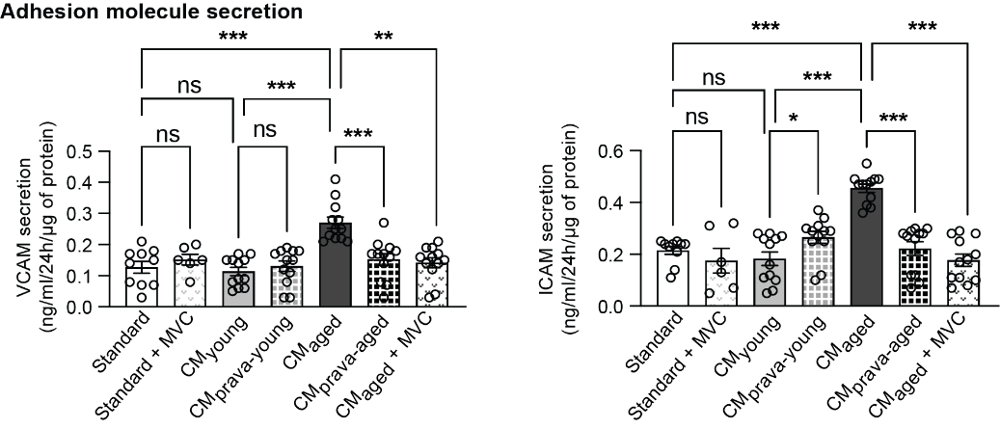

Figure S2: Secretion of adhesion molecules by HCAEC exposed to conditioned media. The levels of adhesion molecules VCAM and ICAM in the culture medium from the last 48 hours were determined by ELISA in the culture media of HCAEC exposed to standard media with or without maraviroc (MVC), or to conditioned media CM_{young}, CM_{aged}, CM_{prava-young} and _{CMprava-aged}, or exposed to aged-donor ASC conditioned media in the presence MVC. The results are expressed as the mean ± SEM (n=6-12). Differences between conditions were determined by two-way ANOVA on raw or transformed data that passed. Spearman’s test for heteroscedasticity and the Shapiro-Wilk test for normality of residuals. *P<0.05, **P<0.01, ***P<0.001.

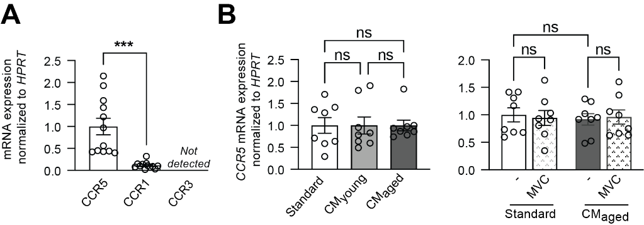

Figure S3: Chemokine receptor expression in HCAEC. (A) mRNA expression level of CCR5, CCR1, CCR3 in HCAEC exposed to standard media were normalized against that of HPRT, and expressed as the mean ± SEM (n=12). (B) HCAECs were exposed to Maraviroc (MVC) (1 µM) 24 hours prior to the exposure to CM_{aged} or standard media. Maraviroc was then maintained through the 48 hours CM_{aged} exposure. mRNA expression level of CCR5, was normalized against that of HPRT, and expressed as the mean ± SEM (n=8). Differences between conditions were determined by one-way ANOVA (A and B left panel) or two way (B Right Panel) on raw data that passed the Brown-Forsythe or Bartlett’s test for heteroscedasticity and the Shapiro-Wilk test for normality of residuals. ***P<0.001.

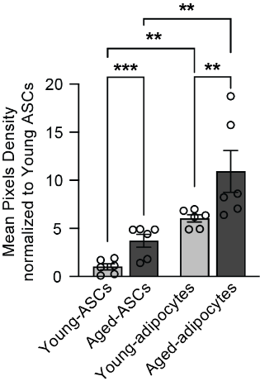

Figure S4: CCL5/RANTES secretion into the culture medium of ASCs or adipocyte-derived from young- or aged-ASCs. Densitometry analysis of adipokine arrays were performed and expressed as the mean ± SEM (n=6). Differences between conditions were determined by two-way ANOVA on raw or transformed data that passed Spearman’s test for heteroscedasticity and the Shapiro-Wilk test for normality of residuals. **P<0.01, *** P<0.001.

