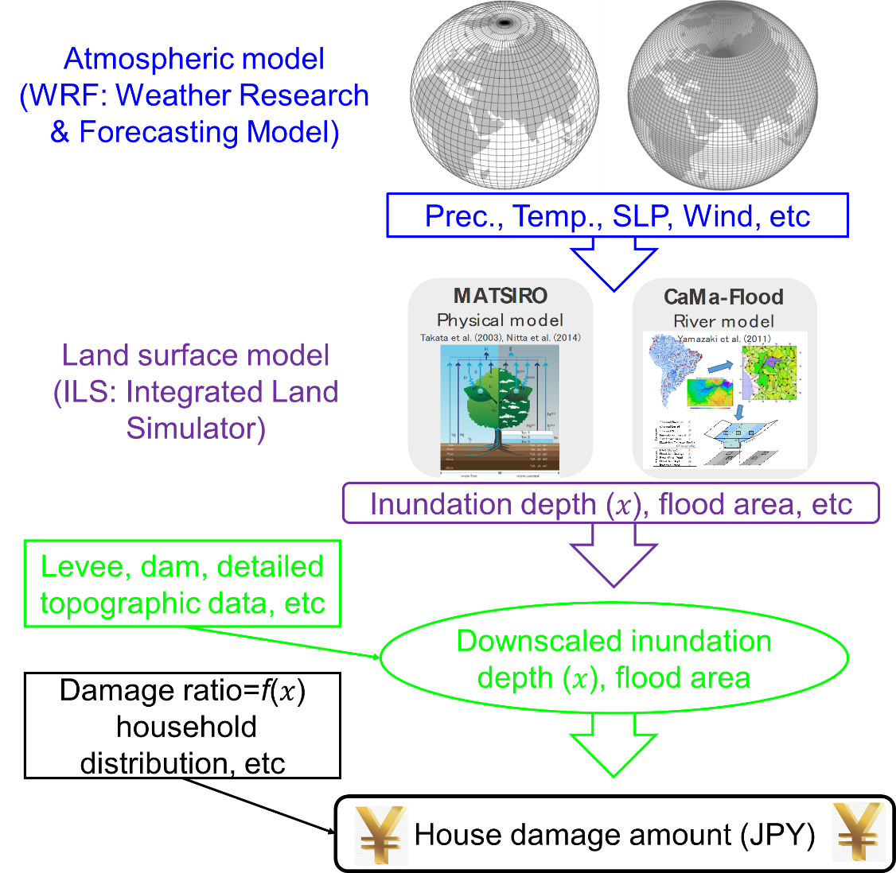
Figure S1. Conceptual framework for assessing flood damage.

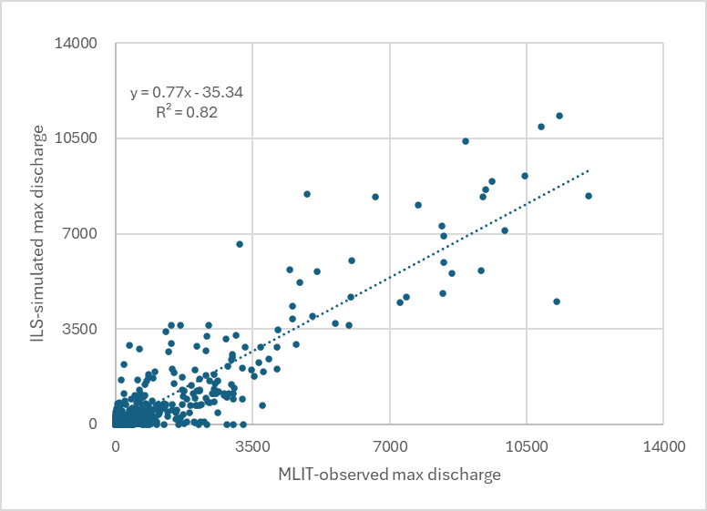
Figure S2. Scatter diagram of the MLIT-observed and corresponding ILS-simulated maximum river discharge (m³ s⁻¹) during the Hagibis passage from 0000 UTC on 12 October to 0000 UTC on 15 October 2019. The correlation coefficient between ILS-simulated and MLIT-observed maximum river discharge is 0.91.

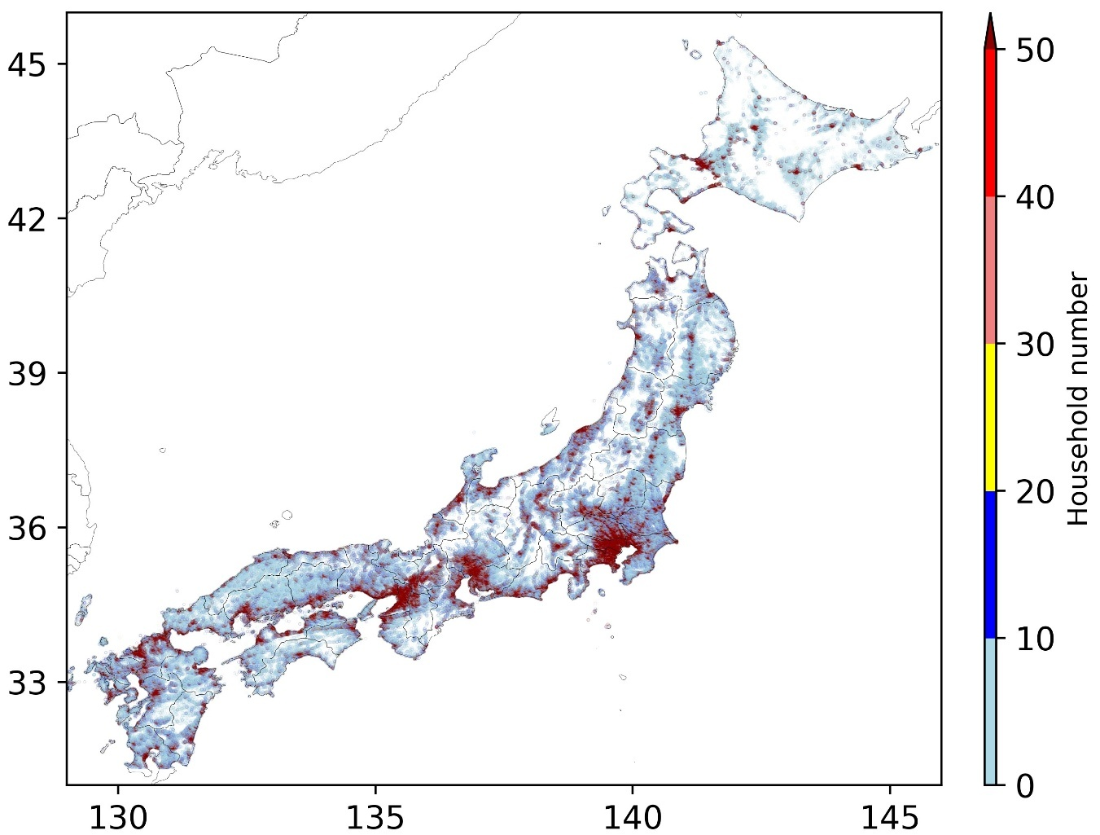
Figure S3. Spatial distribution of household in Japan.

