EXTENDED DATA FIGURES
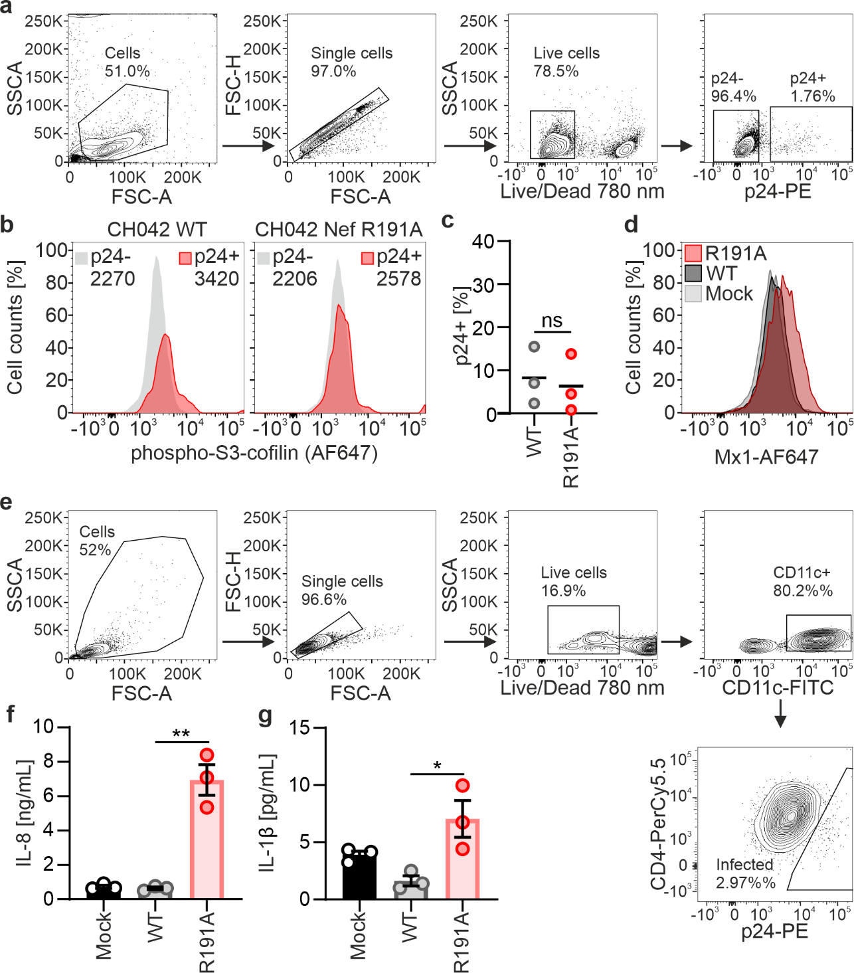
Extended Data Fig. 1 Cofilin phosphorylation activity of Nef and immune activation in primary cells. a-b, Gating strategy (a) and histogram (b) of showing pS3-cofilin phosphorylation in PBMCs from one donor in infected (p24+) cells (red) vs uninfected (p24-) cells (grey) for CH042 WT (left) of CH042 expressing R191A Nef (right). Numbers indicate media fluorescence intensity of pS3-cofilin. c, Percentage of p24+ in cells infected in Fig. 1b. Each point represents one donor. d, Example FACS data of one donor showing intracellular Mx1 levels in infected (p24+) or mock uninfected cells in MDMs infected in Fig. 1b. e, Gating strategy for (e) and (d). Cells are pre-gated on live CD11c+ cells. f-g, IL-8 (D) and IL-1β (I) levels in supernatants of monocyte-derived dendritic cells (moDCs) transduced as in Fig. 1a. Each point represents the mean (±SEM) of one donor (N=3 donors). Statistical analysis was done using paired t tests. p values are indicated as *p < 0.05; **p < 0.01, or not significant (p > 0.05).
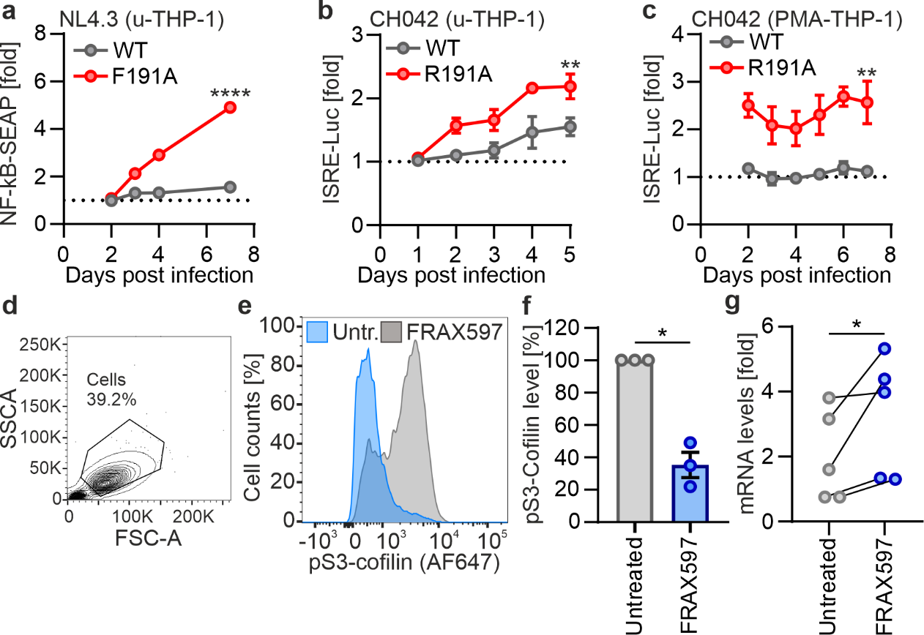
Extended Data Fig. 2 PAK2 is involved in immune sensing. a, Relative NF-κB induction measured by secreted alkaline phosphatase (SEAP) in THP-1 duals cells containing ISRE-Luciferase and NFκB reporter genes infected with VSVg-pseudotyped NL4-3 expressing WT or F191A Nef. Representative experiment performed in triplicates. Repeated-measure two-way ANOVA. b-c, Relative luciferase (LUC) induction in THP-1 duals cells either undifferentiated (b) or PMA-differentiated (c) infected with VSVg-pseudotyped CH042 WT or expressing F191A Nef. Representative experiment performed in triplicates. Repeated-measure two-way ANOVA. d, Example of gating for MDMs treated with FRAX597. e, Representative histogram for phosphor-S3-cofilin analysis in MDMs treated with 25 µM FRAX597. f, Quantification of median fluorescence in (e) normalized to untreated cells. Bars represent mean (±SEM) and points represent donors (N=3 donors). g, qRT-PCR analysis of MX1 mRNA induction in primary MDMs infected with VSVg-pseudotyped HIV-1 CH042 WT 48 hours post-transduction in presence 1 µM FRAX597. Values relative to uninfected cells. Bars represent mean (±SEM), points represent donors (N=5 donors). Unless otherwise indicates statistical analysis was done using ratio paired t tests. p values are indicated as *p < 0.05; **p < 0.01, ****p < 0.001 or not significant (p > 0.05).

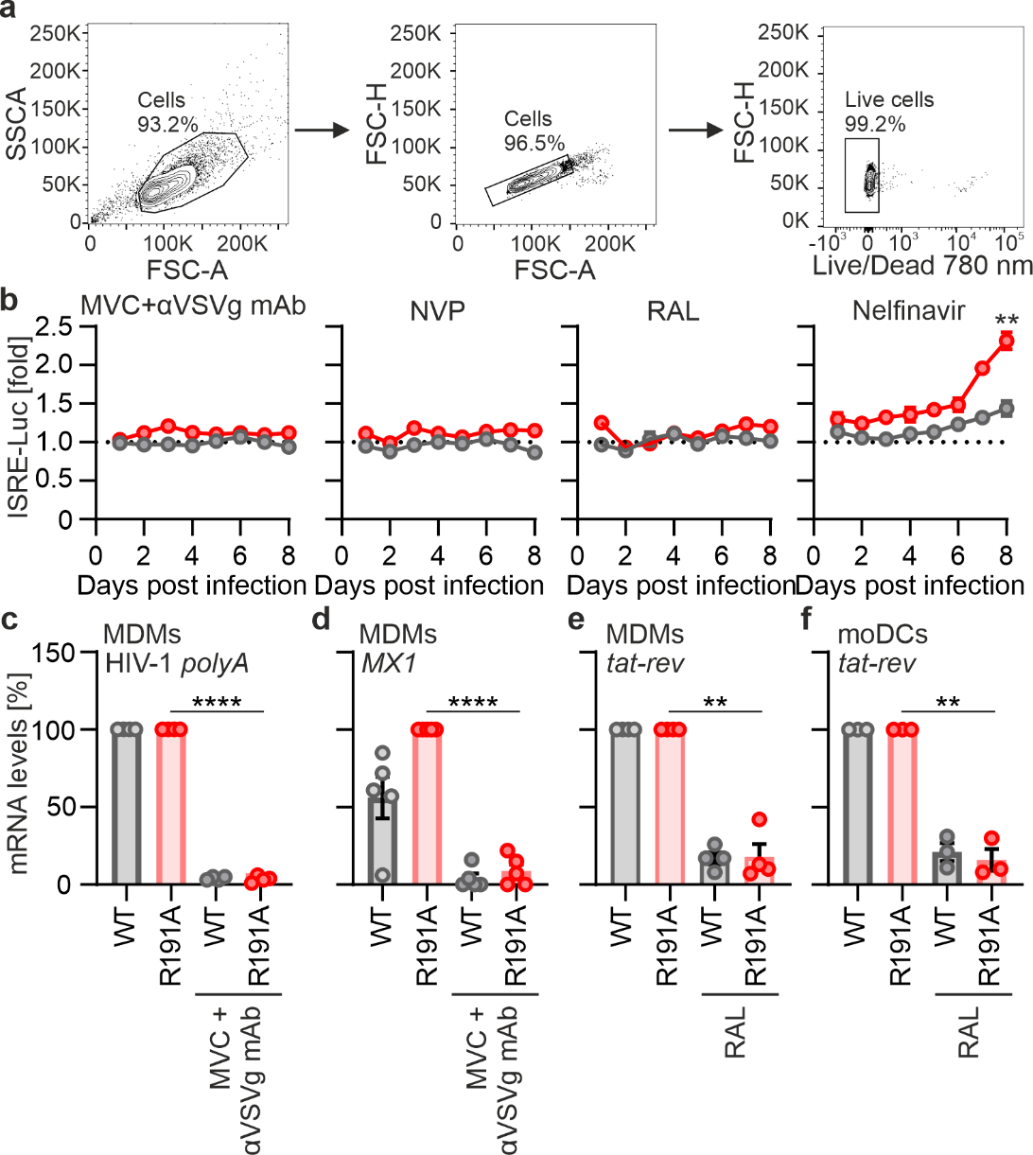
Extended Data Fig. 3 Nef counteracts sensing of a post-integration step. a, Gating strategy for figure 3a. Cells are pre-gated on live cells b, Relative luciferase induction in THP-1 duals reporter cells infected with VSVg-pseudotyped HIV-1 CH042 WT or expressing Nef R191A and treated with Maraviroc (MVC) and anti-VSVg neutralizing antibodies, Nevirapine (NVP), Raltegravir (RAL) or Nelfinavir (NFV). Representative experiment performed in triplicates. Repeated-measure two-way ANOVA. c, qRT-PCR analysis of MX1 mRNA induction in primary MDMs infected with VSVg-pseudotyped HIV-1 CH042 WT or Nef R191A at 48 hours post-transduction in presence of Maraviroc (MVC) and anti-VSVg neutralizing antibodies. Values relative to R191A-infected, untreated cells. Bars represent mean (±SEM), points represent donors (N=5 donors). qRT-CR analysis of HIV-1 RNA polyA in MDMs infected as in (B). Values relative to corresponding infected, untreated cells. Each point represents the mean of one donor measured in duplicates. Bars represent the mean of donors (N=4 donors). e-f, qRT-PCR analysis of HIV tat-rev spliced HIV RNA in primary MDMs (e) or moDCs (f) infected with VSVg-pseudotyped HIV-1 CH042 WT or Nef R191A at 48 hours post-transduction in presence of Raltegravir (RAL). Values relative to corresponding infected, untreated cells. Each point represents the mean of one donor measured in duplicates. Bars represent the mean of donors (N=4 donors). Unless otherwise indicates statistical analysis was done using Welch’s t tests. p values are indicated as *p < 0.05; **p < 0.01, ****p < 0.001 or not significant (p > 0.05).
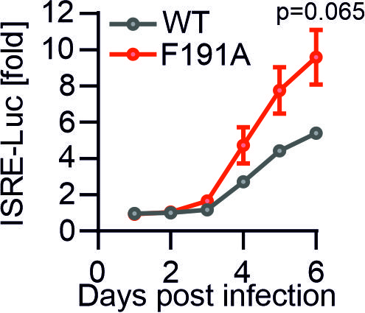
Extended Data Fig. 4 Induction of ISRE-luciferase in parental THP-1 dual cells. Relative luciferase (LUC) induction in THP-1 duals cells containing ISRE-Luciferase and NF-κB reporter genes transduced with VSVg-pseudotyped NL4-3 expressing WT or F191A Nef. Representative experiment performed in triplicates. Repeated measure two-way ANOVA.

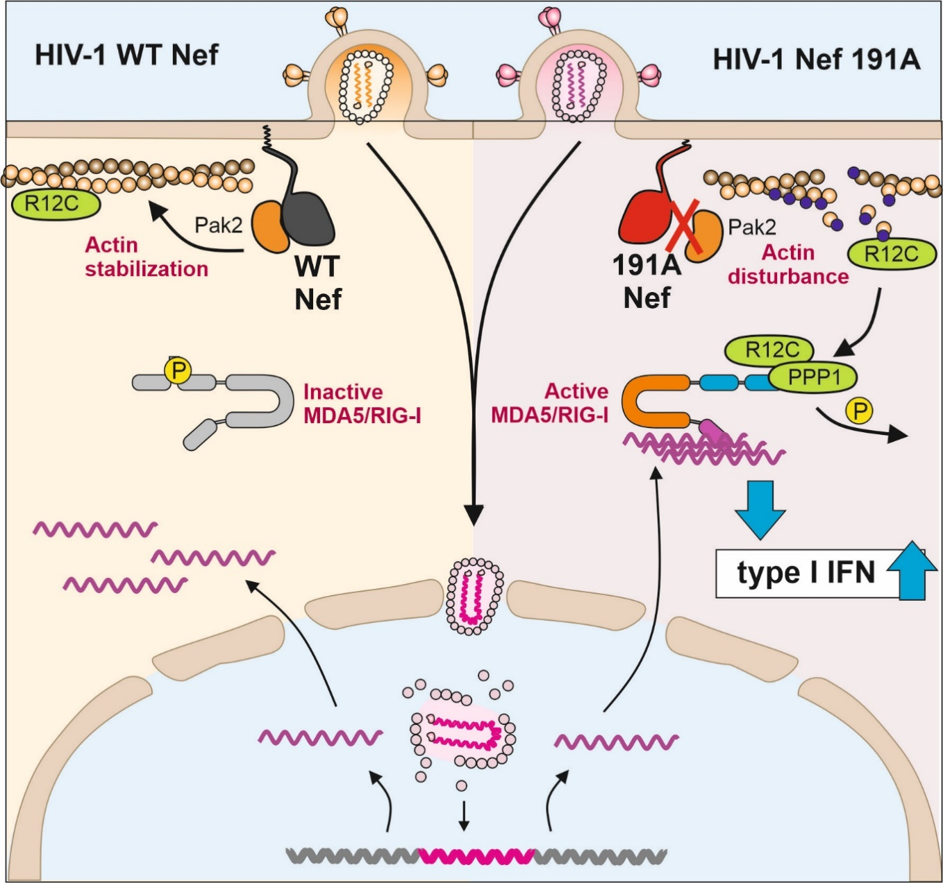Extended Data Fig. 5 Schematic model for Nef-mediated inhibition of HIV-1 post-integration sensing by RLRs. The HIV-1 accessory protein Nef disrupts the priming of RIG-I-like receptors (MDA5/RIG-I) by the protein phosphatase 1 regulatory subunit 12C (R12C), preventing efficient viral sensing. Nef’s interaction with PAK2 inhibits R12C’s re-localization to MDA5, blocking its dephosphorylation and allowing HIV-1 to evade immune detection. Mutations in Nef (F/R191A) that impair its binding to PAK2 result in enhanced interferon responses and increased innate immune activation in immune cells.

