Supplementary Information
Electrically writing a magnetic heliknoton in a chiral magnet
Long Li^{1,2}, Dongsheng Song^{3*}, Weiwei Wang³, Lingyao Kong⁴, Shuisen Zhang^{1,2}, Ning Wang¹, Shilei Zhang⁵, Mingliang Tian^{1,2,4}, Jiadong Zang^{6,7}, Yizhou Liu^{1,2*}, Haifeng Du^{1,2*}
¹Anhui Province Key Laboratory of Low-Energy Quantum Materials and Devices, High Magnetic Field Laboratory, HFIPS, Chinese Academy of Sciences, Hefei 230031, China
²Science Island Branch of Graduate School, University of Science and Technology of China, Hefei 230026, China
³Institutes of Physical Science and Information Technology, Anhui University, Hefei 230601, China
⁴School of Physics and Optoelectronic Engineering, Anhui University, Hefei 230601, China
⁵Institutes of Physical Science and Information Technology, Shanghai Tech University, Shanghai 230601, China
⁶Department of Physics and Astronomy, University of New Hampshire, Durham, NH 03824, USA
⁷Materials Science Program, University of New Hampshire, Durham, NH 03824, USA

*Corresponding authors: dsong@ahu.edu.cn, yzliu@hmfl.ac.cn, duhf@hmfl.ac.cn

Table of Contents
1. Phase diagram of heliknoton creation in another device 3
2. Creation of multiple heliknotons 4
3. Additional magnetic imaging data of a single heliknoton 5
4. Comparison of magnetic contrast between heliknotons and other spin textures 7
5. Current-driven heliknoton dynamics in another device 9
6. Current-driven dynamics of multiple heliknotons 10
7. Influence of defects on heliknoton dynamics 11
8. Sample information and experimental details 13

1. Phase diagram of heliknoton creation in another device
Fig. S1 | Phase diagram of the creation probability of heliknotons with varying current density in another device. a, The probability of heliknoton generation varies with current density. The phase diagram comprises three different regions based on current density variation. In region Ⅰ, no heliknotons are generated. As the current density increases to region Ⅱ, isolated heliknoton and heliknotons coexisted with other spin textures can be created. With a further increase in current density to region Ⅲ, heliknotons mostly mixed with other spin texture are generated. b, Lorentz TEM images under different current densities, red circles indicate heliknoton positions. The pulse width is 40 ns. The Lorentz TEM images in b were obtained at a defocus distance of 700 μm. Scale bars: 300 nm. The device dimensions can be found in Extended Data Table I.

2. Creation of multiple heliknotons
Throughout all our experiments, we have observed the formation of heliknoton dimer and trimer on a few occasions in the regime III, as shown in Fig. S2 (the probability is approximately 1-2 times per 120 nucleation events) and have not observed the heliknoton tetramer or octamer structures discussed in Ref. 1¹. This absence likely reflects the higher energy of heliknoton clusters/crystals relative to single heliknotons in FeGe. Future investigations of heliknoton crystals/clusters require identification of magnetic materials where the heliknoton clusters/crystals have comparable or lower energy than their single forms, thereby achieving experimentally viable formation probabilities. The dynamics of multiple heliknotons will be discussed in Section 6.

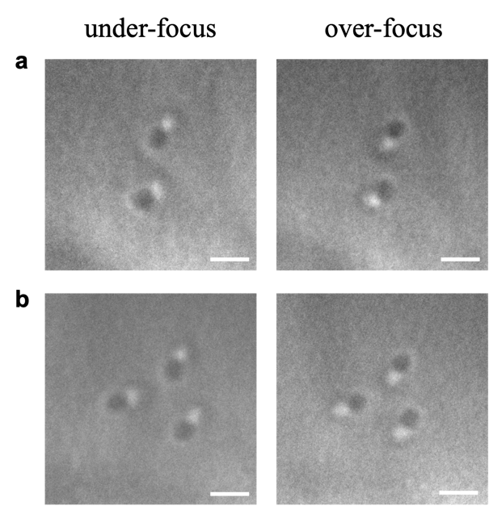
Fig. S2 | Lorentz TEM images of heliknoton dimer and trimer. a, Heliknoton dimer generated by current pulses. b, Heliknoton trimer generated under similar conditions. Scale bar: 100 nm. Defocus: 300 μm.

3. Additional magnetic imaging data of a single heliknoton
Fig. S3 | Electron holography characterization of an isolated heliknoton with conventional device design. a, Experimental magnetic phase obtained by electron holography at different tilt angles. The scale bar is 100 nm. b, Simulated magnetic phase of a heliknoton at different tilt angles. c, Schematic of the rotation of heliknoton around different axis and the corresponding tilt angle. d,e, Simulated (lines) and experimental (dots) $φ_{A}$ (d) and $φ_{B}$ (e) as a function of tilt angle $α$. $φ_{A}$ and $φ_{B}$ represent phase shift extremities as shown in Fig. 3 of the main text.

Fig. S4 | High angle electron holography characterization of an isolated heliknoton in another device. a, Experimental magnetic phase obtained by electron holography at different tilt angles. The scale bar is 100 nm. b, Simulated magnetic phase of the heliknoton shown in Fig. 1a at different tilt angles. c, Schematic of the rotation of heliknoton around x axis and the corresponding rotation angle α. d, Simulated and experimental $φ_{A}$ as a function of tilt angle $α$. e, Simulated and experimental $φ_{B}$ as a function of tilt angle $α$. $φ_{A}$ and $φ_{B}$ are defined as the left and right extremities of the phase shift as shown in Fig. 3 of the main text.

4. Comparison of magnetic contrast between heliknotons and other spin textures

We made detailed comparisons with simulations to provide solid evidence of the heliknoton nucleation. In this section, we also compare our experimental images with other topological spin textures to further validate the observation of heliknotons. We have simulated spin textures for hopfions without a chiral background, a skyrmion-antiskyrmion pair, a toron, a bobber, a vortex, and a biskyrmion. We then simulated the corresponding Lorentz Fresnel images and magnetic phases in electron holography experiments, as shown in Fig. S5.

For most of these spin textures, their magnetic phases and Lorentz images at zero tilt are already distinct from those of a heliknoton. The magnetic phase of a biskyrmion is somewhat similar to that of a heliknoton at zero tilting angle. However, detailed phase distribution at zero tilt and angle dependent magnetic phases are quite different from those of the heliknoton (Fig. S6). Moreover, biskyrmion has only been observed in centrosymmetric magnets rather than chiral magnets since it consists of two skyrmions with opposite chirality². Therefore, the possibility of observing biskyrmions in the current studied chiral magnet can be excluded.

Other than biskyrmion, the skyrmion-antiskyrmion pair may also be confused with a heliknoton. Although their magnetic phases appear similar at zero tilting angle, the magnetic phases at other tilting angles (Fig. S6) display distinct characteristics due to the structural differences: heliknoton possesses a torus-like structure, while skyrmion-antiskyrmion pair exhibits a string-like structure. At zero tilt, the skyrmion-antiskyrmion pair exhibits a much larger magnetic phase shift (~ 5 times greater amplitude) because both the skyrmion and antiskyrmion extend through the entire system along the thickness direction (z-axis here, Fig. S6 bottom). In addition to static features, the current-driven motion of heliknotons also differs from that of skyrmion-antiskyrmion pairs, despite both showing vanishing net emergent magnetic fields. As demonstrated in Fig. S7, upon applying a current pulse, the initial skyrmion-antiskyrmion pair breaks into independent skyrmion and antiskyrmion without reforming the bound state after turning off the current. This is because, unlike heliknotons, skyrmion-antiskyrmion pairs are bound magnetic states. Once the skyrmion and antiskyrmion are separated with certain distances, the lack of a restoring force no longer favors the formation of such bound states^{3,4}.

Based on these results, we can see that the observed magnetic contrast is most consistent with the features of a heliknoton.

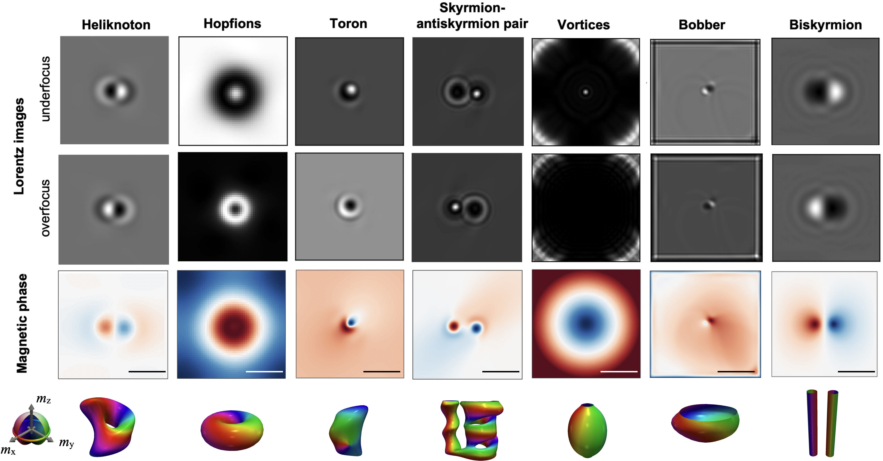
Fig. S5 | Simulated Lorentz images and magnetic phase of diverse spin textures at zero-tilt angle. The plot includes a heliknoton (scale bar: 60 nm), a hopfion without a chiral background (scale bar: 120 nm), a toron (scale bar: 200 nm), a skyrmion-antiskyrmion pair (scale bar: 170 nm), a vortex (scale bar: 110 nm), a bobber (scale bar: 350 nm) and a biskyrmion (scale bar: 60 nm). The window size is adjusted for different spin textures for better visibility. Bottom: The equi-spin surfaces of the corresponding spin textures are shown, demonstrating their shape and topology.

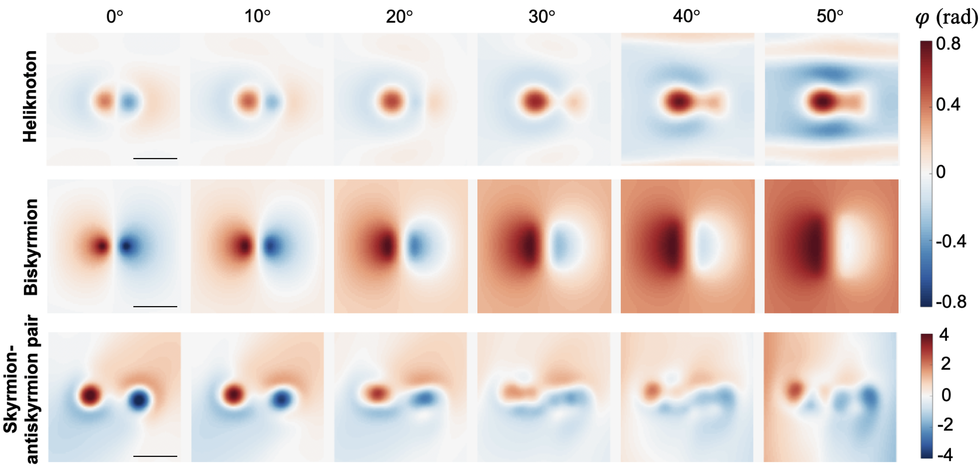
Fig. S6 | Simulated angle-dependent magnetic phase shifts. Top: heliknoton (scale bar: 60 nm). Middle: biskyrmion (scale bar: 60 nm). Bottom: skyrmion-antiskyrmion pair (scale bar: 100 nm). The window size is adjusted for different spin textures for better visibility. The distinct phase distributions confirms that the contrast in our experiments is caused by heliknoton.

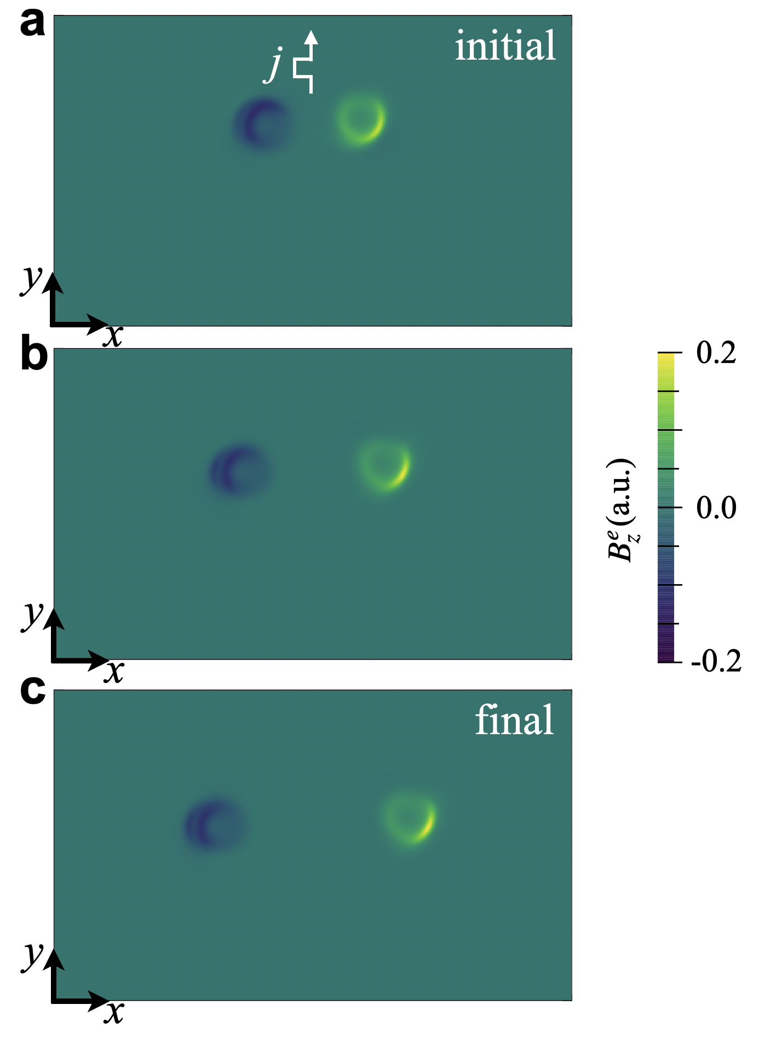
Fig. S7 | Snapshots of the current-driven motion of a skyrmion-antiskyrmion pair. a, Initial position of the skyrmion-antiskyrmion pair before applying the current pulse. Color plots show the emergent magnetic field ${B_{z}^{e}=M}_{0}⋅\left(∂_{x}M_{0}×∂_{y}M_{0}\right)$ ($M_{0}$ is the local magnetic moment) of the skyrmion and antiskyrmion at the central xy-plane of the system. The skyrmion and antiskyrmion can be identified via their opposite emergent magnetic fields. b, Positions of the skyrmion and antiskyrmion under current driving (t=5 ns). c, Final positions of the skyrmion and antiskyrmion. The window size is 600 nm by 360 nm. A 10 ns current pulse with amplitude $1×{10}^{11}$ A/m² is first applied along the y-direction. Then, the simulation is run for another 50 ns and then relaxed. Since the skyrmion and antiskyrmion are almost massless, there are only slight changes in their positions during this process.

5. Current-driven heliknoton dynamics in another device
Fig. S8 | Motion of a single heliknoton in another device. Representative snapshots of single heliknoton motion using successive current pulses. The current density is $j=4.7×{10}^{10}A∙m^{-2}$. The heliknoton still shows nearly vanishing Hall motion. The results were obtained in Device 8 (see Extended Data Table 1). The pulse duration is 40 ns. The Lorentz TEM images in a and b were obtained at a defocus distance of 700 μm. Scale bars: 400 nm. The device dimensions can be found in Extended Data Table I.

Fig. S8 shows the current-driven heliknoton motion obtained from an independent device. These results show the reproducibility of the heliknoton dynamics.
Heliknoton dynamics enter the creep regime (like that shown in Supplementary Video 5) just above the critical current density. At such low current densities, the heliknoton is easily pinned by defects in the chiral magnet, leading to the irregular motion observed. As shown in the video, the trajectories of the heliknoton are not well defined and deviate from the collinear alignment with the current direction. Some “step back” like motions occur when the heliknoton temporarily overcomes a pinning site but is then trapped by another nearby defect. For some current pulses, the heliknoton remains pinned without displacement due to insufficient driving force to overcome the local pinning potential.

6. Current-driven dynamics of multiple heliknotons
For multiple heliknoton dynamics, we observe two different scenarios. In the first case, two isolated heliknotons are nucleated with a large distance between them. Upon applying current pulse, these two heliknotons just behave like single heliknotons and move independently, as shown in Fig. S9a. In the second case, a heliknoton dimer (two heliknotons are in close proximity to each other) is nucleated. During the current-driven motion, the two heliknotons move collectively despite an oscillating change of the distance between them as shown in Fig. S9b. This change in distance could be due to either the pinning at defects or the interaction between heliknotons, which is difficult to determine with the current experimental data.

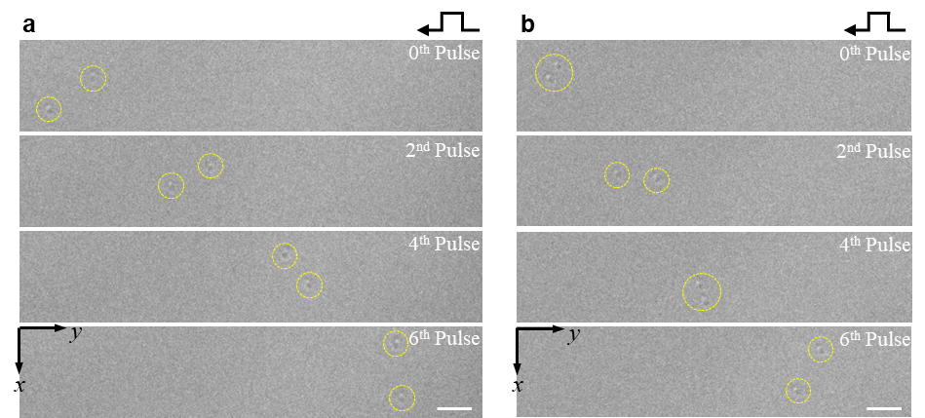
Fig. S9 | Dynamics of multiple heliknotons driven by current pulses. a, Current-driven motion of two isolated heliknotons under current pulses applied along the y-direction. The current density is j = 8.09 × 10¹⁰ A·m⁻² and the pulse duration is 20 ns. For clarity, the positions of the heliknotons are marked by dashed yellow circles. b, Collective motion of two heliknotons which initially form a heliknoton dimer. The current density is j = 7.05 × 10¹⁰ A · m⁻², with the pulse duration of 20 ns. The scale bars in a and b are 300 nm, and the defocus is 700 μm. Movies for these two scenarios can be found in Supplementary Video 10 and 11, respectively.

7. Influence of defects on heliknoton dynamics
The influence of defects on the heliknoton’s dynamics is related to many factors like the impurity concentration and distribution, and the pinning strength. In a simple picture, assuming a tiny concentration of impurities with random distributions, three different regimes may be expected depending on the pinning strength of the defect (ratio of pinning energy to magnetic exchange energy). For weak pinning strength, we expect the heliknoton dynamics would be mostly unalert due to the large energy differences between the heliknoton’s kinetic energy and the pinning energy. For moderate pinning strength, the presence of defects begins to affect the heliknoton dynamics. For example, the defect may pin the heliknoton or affect its orientation and size depending on the location and distance between defects when the driving force is small. For strong pinning strength, the heliknoton will be strongly pinned and the shape and stability of the heliknoton can be altered.
To further confirm these effects, we have performed additional micromagnetic simulations adding magnetic defects (set by introducing easy-axis magnetic anisotropy on a single site). As shown in Fig. S10b, for weak pinning strength, the heliknoton dynamics only slightly deviates from its dynamics in the clean case in Fig. S10a (e.g., the dilation after current pulse is off). For moderate defect strength, a more obvious change of the heliknoton dynamics is found as shown in Fig. S10c. The trajectory of heliknoton and its orientation has been modified by the defects, leading to a small transverse motion. This is also in agreement with our experimental results where the heliknoton deviates a small amount from a perfect straight path due to the pinning of defects. For strong pinning strength, the heliknoton motion is hindered due to the strong pinning and the corresponding plot is not shown here. For skyrmions, skyrmion-defect interactions lead to phenomena such as avalanche effects, localizations, and new universal classes⁵, which are of interest to the equilibrium and nonequilibrium statistical mechanics community. The 3D nature of heliknoton and its unique 3D dynamics combined with defects are expected to generate more interesting physical phenomena along these lines.
In most cases, the dilation is always entangled with the heliknoton’s motion. This leads to an energy change associated with the heliknoton dynamics. Therefore, the heliknoton does have an inertia. This can influence the heliknoton dynamics, so that it keeps moving even after the current is off. As discussed in Ref. 6⁶, the hopfion’s (or heliknoton’s) inertia is determined by its shape and the corresponding magnetic parameters (such as the exchange interaction, Dzyaloshinskii-Moriya interaction, etc.). Such inertia as makes heliknoton dynamics quite different from typical skyrmion dynamics, which is massless in the clean limit (and without boundaries).

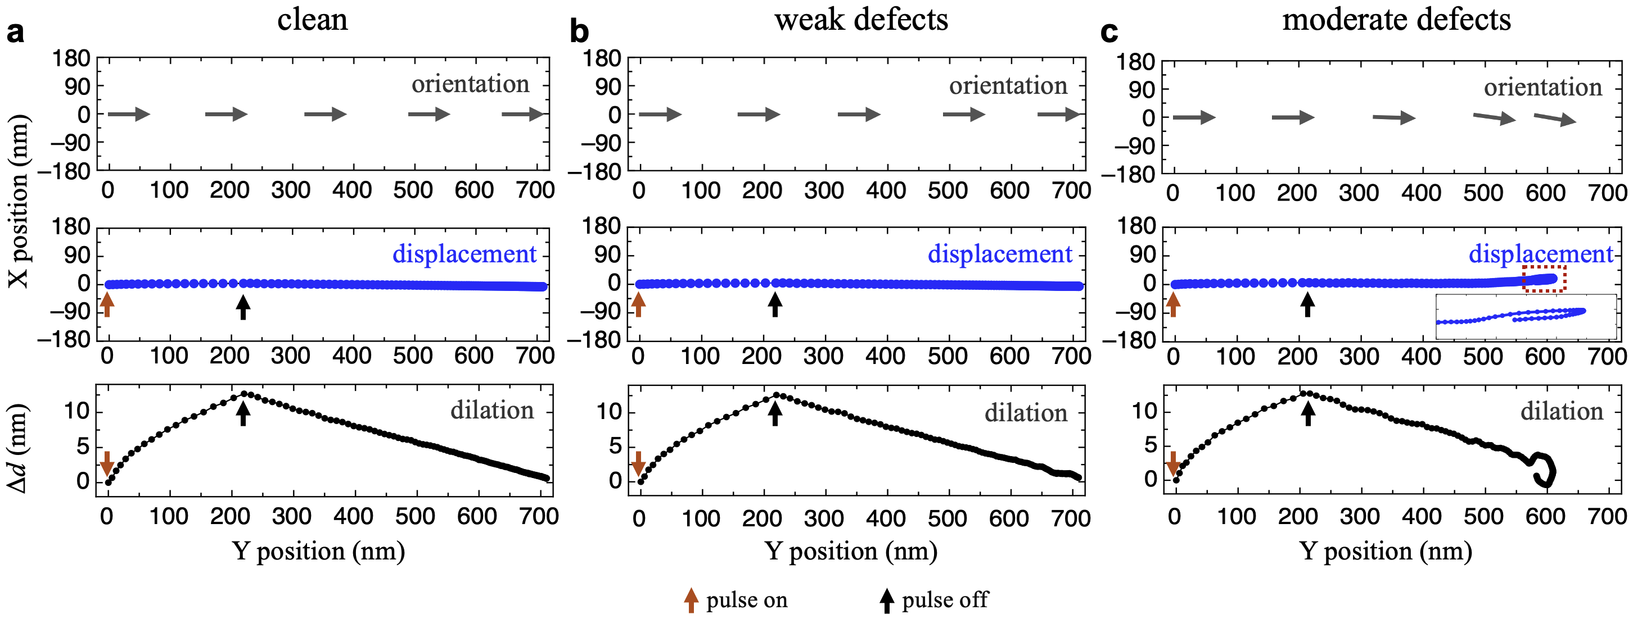
Fig. S10 | Influence of defects on the current-driven heliknoton motion. a, Orientation (top), position (middle), and dilation (bottom) of heliknoton extracted from the simulations in the clean case. b and c, The same plots with data extracted from the simulations with weak defects (b) and moderate defects (c). The inset in c (middle panel) shows an enlarge view of the deflected trajectory (due to defects) within the red dashed box. In the simulations, a current pulse with $j=-1×{10}^{11} A/m^{2}$ is applied along the y-axis for 9 ns and the simulation further run for 60 ns after the pulse is off. 1% magnetic defects have been randomly distributed in the simulated system. We consider the effect of defects by introducing easy-axis type magnetic anisotropy (along the z-axis) at single sites. For weak defects, the anisotropy strength is set to 0.02A, for moderate defects, the anisotropy strength is set to 0.1A (A is the exchange energy).

8. Sample information and experimental details
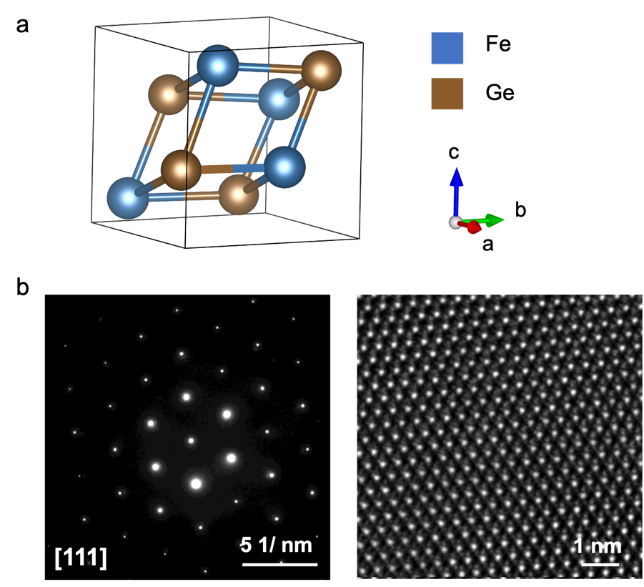
Fig. S11 | Structural characterization of the FeGe lamella. a, Crystal structure of FeGe. b, The selected area electron diffraction (SAED) pattern (left) and high-resolution TEM image (right) of the FeGe lamella.

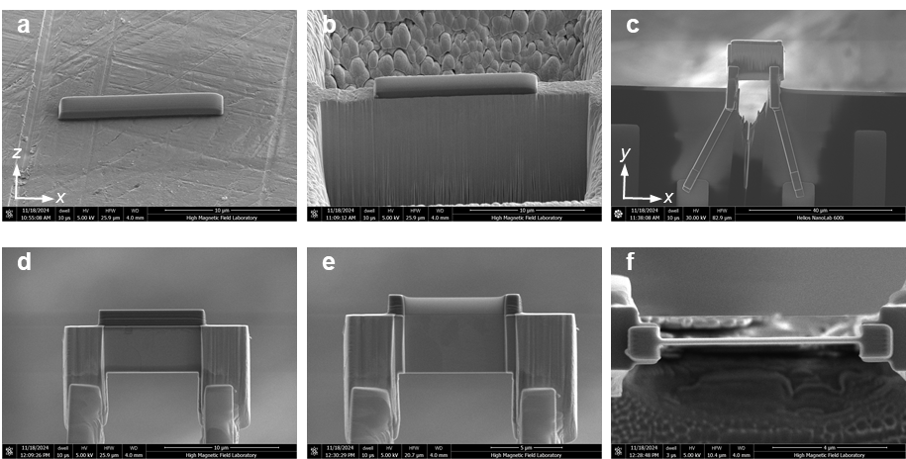
Fig. S12 | Procedure of the FeGe micro-device fabrication for in-situ Lorentz TEM experiments using the FIB-SEM dual-beam system. a, Carbon protection layer is deposited on the FeGe bulk crystal to prevent surface damage during FIB milling. b, A lamella with a thickness of ~1 μm is cut from the bulk. c, The lamella is extracted using a micromanipulator and transferred onto a chip with four Au electrodes. Pt deposition is used to connect both ends of the lamella to two of the electrodes. d, The top and bottom edges of the lamella are trimmed to the desired width, and a new carbon protection layer is deposited on the top surface. e, The lamella is thinned down to ~180 nm for TEM observation. f, Top-view SEM image of the final FeGe micro-device.

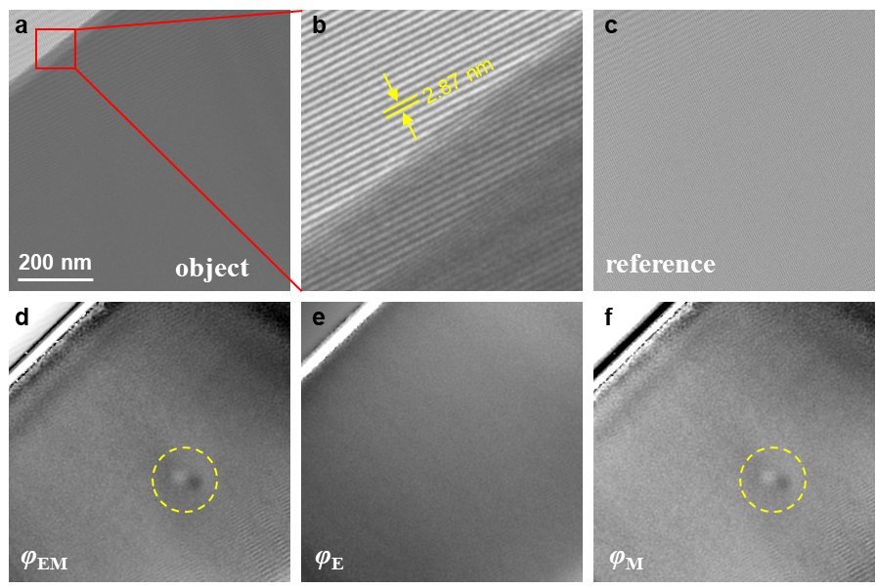
Fig. S13 | Reconstruction procedure of the magnetic phase of a heliknoton using off-axis electron holography. a, Object hologram acquired under zero defocus conditions at 95 K and zero magnetic field. b, Magnified view showing interference fringes with a spacing of 2.87 nm. c, A reference hologram recorded in a vacuum was used to eliminate distortions from the imaging and recording system in the phase reconstruction of each object hologram. d, Total reconstructed experimental phase (φ_{EM}), including both the mean inner potential (φ_{E}) and magnetic (φ_{M}) contributions, the positions of the heliknoton is indicated by dashed yellow circle. e, Mean inner potential contribution to the phase recorded at 300 K. f, Magnetic contribution to the phase obtained by subtracting φ_{E} shown in e from total φ_{EM} shown in d.

Reference
1. Voinescu, R., Tai, J.-S. B. & Smalyukh, I. I. Hopf Solitons in Helical and Conical Backgrounds of Chiral Magnetic Solids. Phys. Rev. Lett. 125, 057201 (2020).
2. Göbel, B., Mertig, I. & Tretiakov, O. A. Beyond skyrmions: Review and perspectives of alternative magnetic quasiparticles. Phys. Rep. 895, 1–28 (2021).
3. Du, H. et al. Interaction of Individual Skyrmions in a Nanostructured Cubic Chiral Magnet. Phys. Rev. Lett. 120, 197203 (2018).
4. Zheng, F. et al. Skyrmion–antiskyrmion pair creation and annihilation in a cubic chiral magnet. Nat. Phys. 18, 863–868 (2022).
5. Reichhardt, C., Reichhardt, C. J. O. & Milošević, M. V. Statics and dynamics of skyrmions interacting with disorder and nanostructures. Rev. Mod. Phys. 94, 035005 (2022).
6. Lin, K. et al. Inertial motion of a magnetic hopfion in the framework of internal local modes. Phys. Rev. B 110, 094429 (2024).

