Supporting information for
Transcriptional specialization shapes abnormal cortical morphological similarity gradients in Wilson's disease.
Yuqi Song^{1#}, Weiqi Wang^{1#}, Sheng Hu³, Yulong Yang¹, Chuanfu Li¹, Kou Xu¹, Zilong Li¹, Taohua Wei^{1,2*}, Wenming Yang^{1,2*}
Author affiliations:
1 The First Affiliated Hospital of Anhui University of Chinese Medicine, Hefei, Anhui, China
2 Key Laboratory of Xin'An Medicine, Ministry of Education, Hefei, Anhui, China
3 School of Medical Information Engineering, Anhui University of Chinese Medicine; Hefei, Anhui, China
Correspondence to: Wenming Yang
Department of Neurology, The First Affiliated Hospital of Anhui University of Chinese Medicine, Hefei, Anhui, 230000, China
Email: yangwm8810@126.com
Correspondence may also be addressed to: Taohua Wei
Department of Neurology, The First Affiliated Hospital of Anhui University of Chinese Medicine, Hefei, Anhui, 230031, China
Email: weitaohua@foxmail.com
Running title: Genetics of the cortical microstructure
Summary:
2 Supplementary Color Figures
3 Supplementary Tables

Supplementary Figure 1
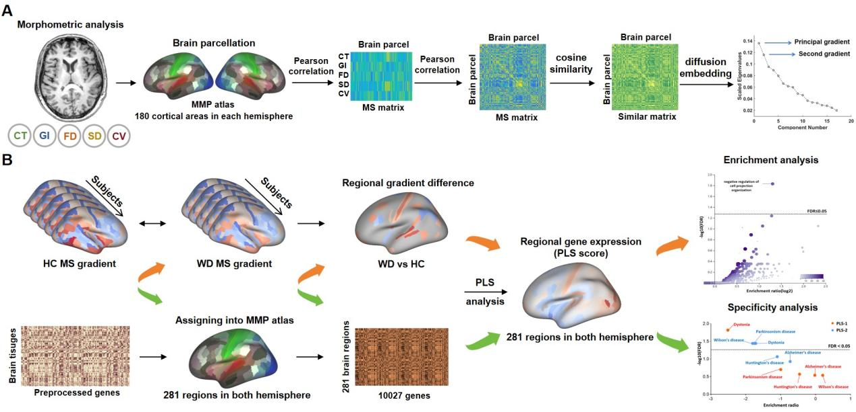
Supplementary Figure 1 Study overview. (A) Similarity gradient analysis for cortical morphological. Five morphological indicators of the cortex were extracted, followed by establishment of the MS matrix through Pearson correlation analysis between any two cortical ROI nodes. The MS matrix was applied to the diffusion graph embedding method to calculate the connectome gradient. (B) MS gradient and gene expression in WD groups and HC groups were mapped onto 360 cortical packages. PLS regression analysis was then conducted to assess the relationship between MS gradient differences and gene expression. Finally, enrichment and specificity analyses identified the biological processes affected by gradient perturbation. WD, Wilson’s disease; HC, healthy control; PLS, partial least squares.

Supplementary Figure 2
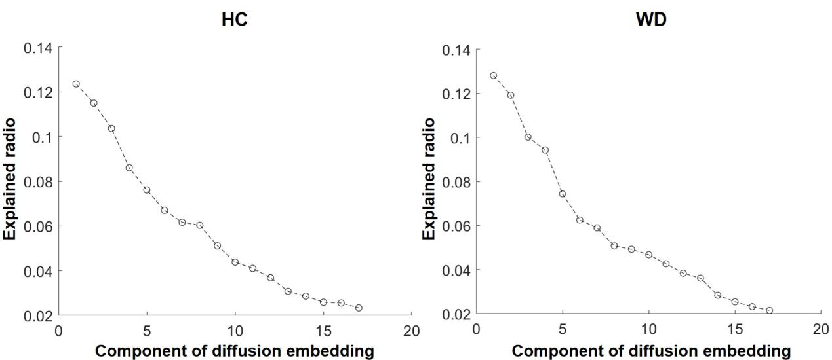
Supplementary Figure 2 The averaged explained ratio (λ values). The first gradient explained 13.1% ± 0.4% of the total variance in the WD group and 12.9% ± 0.6% of the total variance in the HC group. The secondary gradient explained 12.0% ± 0.5% of the total variance in the WD group and 11.6% ± 0.5% of the total variance in the HC group. WD, Wilson’s disease; HC, healthy control.

Supplementary Tables
Supplementary Table 1 The lists of candidate genes used for disease specificity analysis are presented in Fig. 4 and 5.
A | ATP7B,PKHD1,NPC1,PKD1,GAA,ZEB2,APP,GBA1,LMNA,PSEN1,VWF,APOE,NOD2,DYNC1H1,GBE1,LRRK2,MFN2,MPZ,PKD2,SMPD1,SLC17A5,SQSTM1,GLA,PRNP,ABCA4,TNF,IGHMBP2,SNCA,ATP7A,RET,G6PC1,AARS1,NAGLU,PRKN,HEXA,MAPT,VCP,IL10,DNM2,IL6,PYGM,KIF1B,PMP22,TERT,COL1A1,HEXB,PINK1,GALC,GARS1,TGFB1,CYBB,GJB1,BCKDHB,EGR2,RPL36A-HNRNPH2,SLC37A4,ABCA1,INF2,DBT,MED25,NDRG1,LAS1L,PSAP,CEP290,PIK3CA,PSEN2,MARS1,ACE,HFE,TP53,PARK7,LRP5,HBB,LRSAM1,SERPINA1,CYBA,PHKA2,PRKAG2,GYS1,NPC2,BDNF-AS,ENG,LIPA,IL1B,NOTCH1,NCF2,IL10RA,TNFRSF11B,EDNRB,CLCN5,UMOD,ELP1,CTLA4,HTT,HSPB1,RYR1,SOD1,HLA-DRB1,IFNG,LITAF
B | APP,PSEN1,APOE,PKHD1,MAPT,NPC1,PKD1,GAA,GBA1,AGL,PSEN2,TNF,PRNP,SNCA,VCP,LMNA,LOC106627981,LRRK2,VWF,NEFL,DYNC1H1,NOD2,SQSTM1,GBE1,ACE,HFE,SMPD1,MFN2,MPZ,NOS3,BACE1,PRKN,MPO,ATP7B,MT-ND1,IL6,BDNF-AS,ABCA4,IL10,GDAP1,PINK1,SLC17A5,AARS1,G6PC1,GRN,RET,DNM2,TGFB1,ABCA1,SORL1,FIG4,KIF1B,TERT,PMP22,COL1A1,HEXB,NAGLU,ABCA7,GALC,CYBB,GARS1,PARK7,EGR2,IL1B,CDKN2B-AS1,SYNJ1,PIK3CA,MIR146A,GJB1,CSF1R,LRP5,PLAU,TREM2,ATP7A,PSAP,NPC2,DBT,NDRG1,NOTCH1,TP53,MIR29A,HFE-AS1,MIR34A,CEP290,HLA-DRB1,GFAP,MIR22,HTT,IFNG,MTMR2,PLEKHG5,SOD1,LRSAM1,BDNF,SERPINA1,MORC2,LIPA,CYBA,MTHFR,TRPV4
C | GBA1,LRRK2,SNCA,PRKN,MAPT,LOC106627981,NPC1,GAA,PARK7,PINK1,AGL,PSEN1,APP,APOE,LMNA,DYNC1H1,NOD2,MFN2,SMPD1,SQSTM1,NEFL,PSAP,PRNP,NR4A2,GBE1,VCP,ATP7B,PKD2,SYNJ1,GLA,TNF,PINK1-AS,ABCA4,MT-ND1,AARS1,UCHL1,GDAP1,ATXN3,SLC17A5,FIG4,BDNF-AS,PRKAG2,G6PC1,RET,IL10,ATXN2,HEXA,IL6,VPS13C,PLA2G6,SLC6A3,PYGM,DNM2,NAGLU,GALC,ATP13A2,H19,DNAJC13,VPS35,SNCAIP,KIF1B,POLG,COL1A1,TERT,PSEN2,DNAJC6,CYBB,RPL36A-HNRNPH2,GRN,GARS1,ACE,GJB1,BCKDHB,TGFB1,TARDBP,TH,BCKDHA,ATP7A,SPG11,TBP,DBT,ABCA1,CEP290,PIK3CA,GIGYF2,HTT,GUCY2D,GDNF,SOD1,MT-ND5,IL1B,LAMP2,HFE,LRP5,FGD4,TP53,MARS1,MALAT1,IFNG,NPC2
D | GAA,NPC1,AGL,HTT,PSEN1,GBA1,APP,PRNP,DYNC1H1,APOE,LRRK2,MFN2,GBE1,NEFL,BDNF-AS,LOC106627981,SQSTM1,MAPT,ATP7B,SNCA,PSEN2,GLA,PRKN,VCP,GDAP1,TNF,AARS1,HEXA,PINK1,DNM2,KIF1B,IL6,TERT,CYBB,GARS1,TGFB1,GJB1,INF2,PARK7,SYNJ1,SLC37A4,NDRG1,ABCA1,MEG3,TP53,ACE,MARS1,NPC2,SERPINA1,GYS1,TUG1,LOC109461479,MIR132,IL1B,LIPA,MORC2,STXBP2,MIR22,HSPB1,ELP1,PFKM,UMOD,MIR29A,CTLA4,GFAP,HLA-DRB1,GDNF,CBS,BDNF,NEAT1,SOD1,H19,IFNG,TRIM2,ATXN3,AR,MIR29C,LAMP2,UCHL1,JPH3,ITCH,TPP1,HLA-DQB1,ATP2A2,TARDBP,POLG,SLC19A3,TBP,YARS1,TLR4,MT-ND1,MIR21,PYGL,COPA,MPO,CYP27A1,GANAB,PINK1-AS,SEC63,MTHFR
E | GCH1,SGCE,TOR1A,ATP1A3,TH,THAP1,CASD1,SLC6A3,ANO3,KMT2B,GNAL,TUBB4A,SPR,PRKRA,SLC2A1,KCTD17,TAF1,CIZ1,ACTB,TIMM8A,HPCA,LOC130055692,DRD2,SLC30A10,EIF2AK2,PANK2,TBC1D24,SHQ1,DYT15,COL6A3,PRRT2,SLC39A14,CHROMR,SLC18A2,DYT7,NR4A2,MT-ND6,MECR,VPS16,PLA2G6,C19orf12,PLEKHG2,PNKD,DYT21,DYT13,DYT23,SCN2A,MT-ND1,DYT17,BCAP31,IMPDH2,CACNA1B,LOC130063295,TSPOAP1,LOC129934069,FA2H,MT-ND4,NPC1,WDR45,SQSTM1,AOPEP,MT-ND3,MECP2,ATP5MC3,AFG3L2,SCP2,VPS11,GNB1,MVP-DT,KCNN2,NKX2-1,PCDH12,CACNA1A,ARX,SFTA3,SLC2A1-DT,WARS2,RHOBTB2,ATP13A2,GJC2,PRKN,NUP54,RNF14,LOC126863256,SERAC1,SLC19A3,CASK,DRD5,CSTB,SLC18A2-AS1,TBP,LOC109610631,AFG2B,ADCY5,FITM2,EIF2B5,WDR73,ARF3,SPG11,CAMK2B
(A) Wilson’s disease, (B) Alzheimer’s disease, (C) Parkinson’s disease,(D) Huntington’s disease, (E) Dystonia
Supplementary Table 2 Between-group differences in the first gradient scores of the
subnetworks in the mean maps.
Subnetworks | t | P_{FDR}
Visual | -2.211 | 0.0282154903
Somatomotor | -5.407 | 0.0000001912
Auditory | 3.786 | 0.0002048387
Dorsal-Attention | 3.272 | 0.0012668345
Ventral-Attention | -2.005 | 0.0464050948
Frontoparietal | 0.071 | 0.9435931855
Cingulo-Opercular | 5.829 | 0.0000000236
Default | -0.931 | 0.3530419242
Abbreviations: FDR, false discovery rate.
Supplementary Table 3 Between-group differences in the second gradient scores of the subnetworks in the mean maps.
Subnetworks | t | P_{FDR}
Visual | -8.188 | 0.00000000000
Somatomotor | -2.175 | 0.03084835011
Auditory | -2.751 | 0.00651051423
Dorsal-Attention | 7.91 | 0.00000000000
Ventral-Attention | 1.236 | 0.21811103634
Frontoparietal | 6.298 | 0.00000000204
Cingulo-Opercular | -1.416 | 0.15849869675
Default | 0.055 | 0.95612242970
Abbreviations: FDR, false discovery rate.

